1. Update the Example3 (Filter depts based on location) so that drop-down list provide an option "All Depts". Update the child component location accordingly.

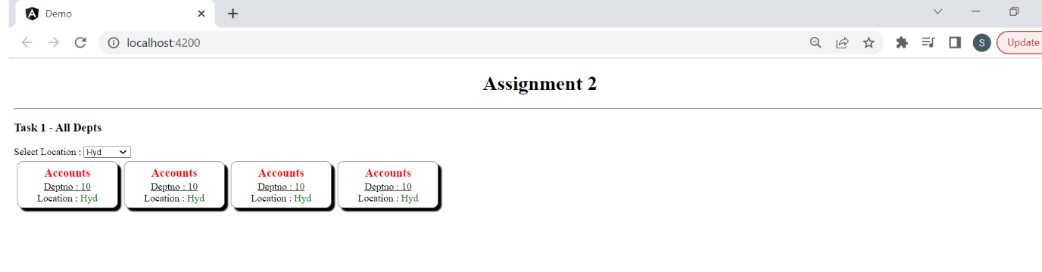

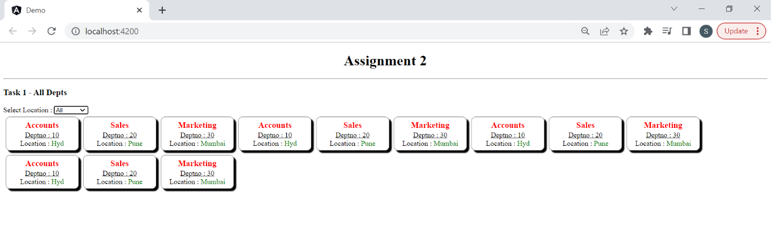

2. Create Employee List component that accepts job as input parameter. Display the list of employees based on the selected Job.

a . app.component.html

<emp-list [job]="selectedJob"></emp-list>

b. emp list will display all the employee details in cards format (same as dept example).

c. Display job roles as hyperlinks in parent component.

d. Display the employee details based on the selected job hyerplink

3. How to implement data sharing between siblings using @input and @output decorator.

