1. Create an Angular components to create vehicle Registration Form and Implement the following validations using Template Driven Forms

1. Owner Name --- Required

2. Contact Number ---- Required , should contain 10 digits

3. Owner Email --- Required, Email

4. Vehicle Registration Number ---- Should be proper format --- (Eg: TS10AB1234)

5. Address : Required

--------------------------------------------------------------------------------

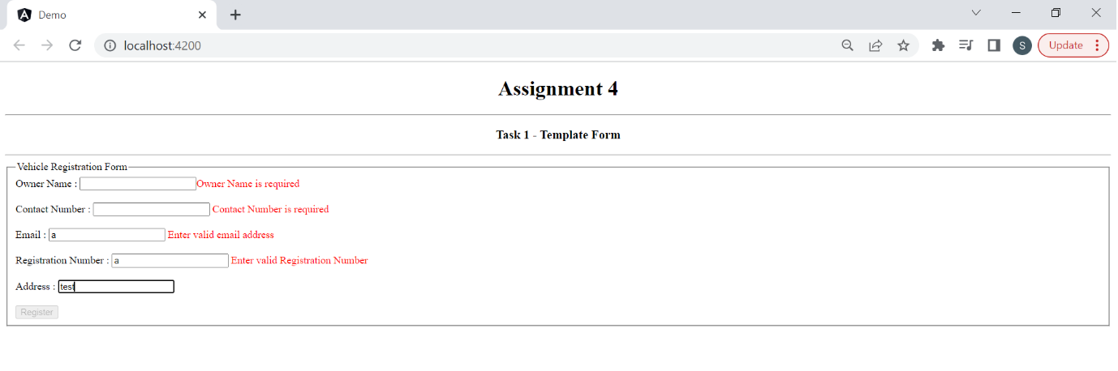

2. Create an Angular components to create vehicle Registration Form and Implement the following validations using Reactive Forms

1. Owner Name --- Required

2. Contact Number ---- Required , should contain 10 digits

3. Owner Email --- Required, Email

4. Vehicle Registration Number ---- Should be proper format --- (Eg: TS10AB1234)

5. Address : Required

6. Model : Max 10 characters

7. Color : Required

8. Year : 2012 to 2022

----------------------------------------------------------------------------------------------------------------------------

