1. Create an angular component to implement the following requirements:

a. create an observable object that send the depts object

b. subscribe in button click event

c. display the dept deails in div tag

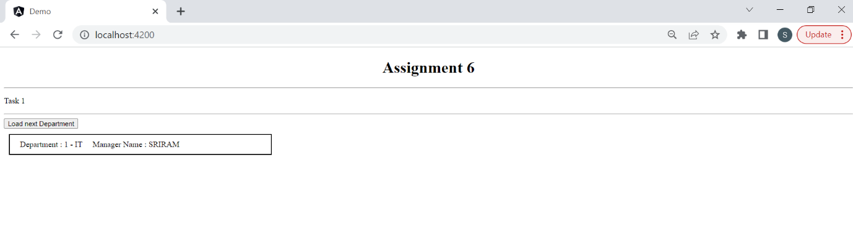

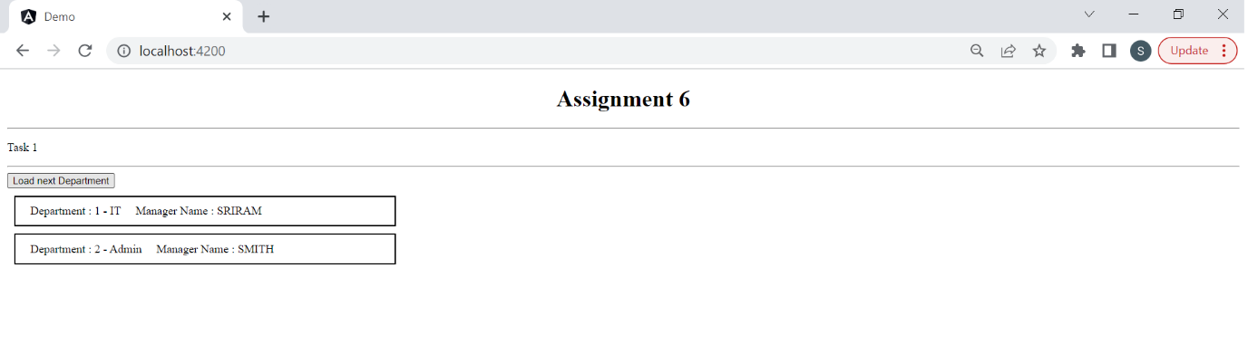

2. Create an angular component to implement the following requirements:

a. create an observable object that returns set of city names using "of" operator.

b. use rxjs operators that returns the results into uppercase format. (Hint: Use pipe, map operators).

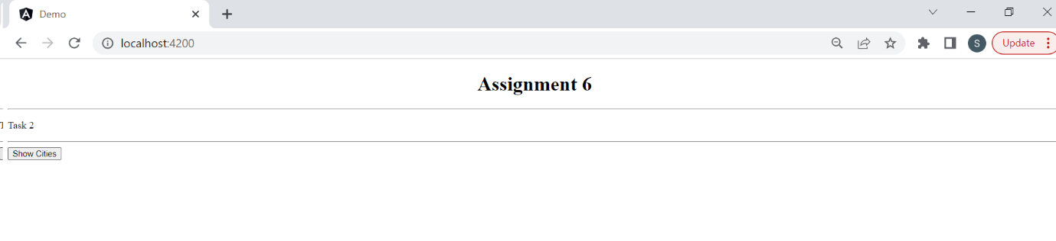

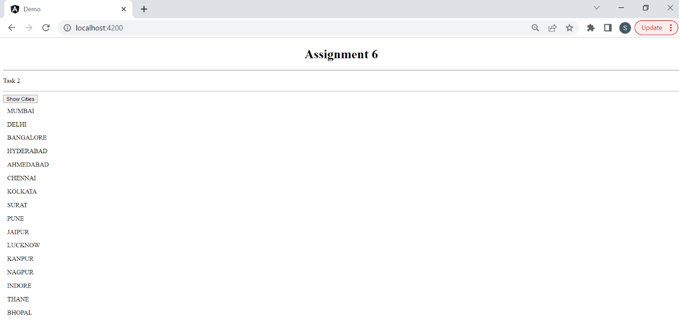

3. How to use filter operator in RxJS, do with an example.

