1. Try to implement the same routing and security concepts from the scratch in your angular project.

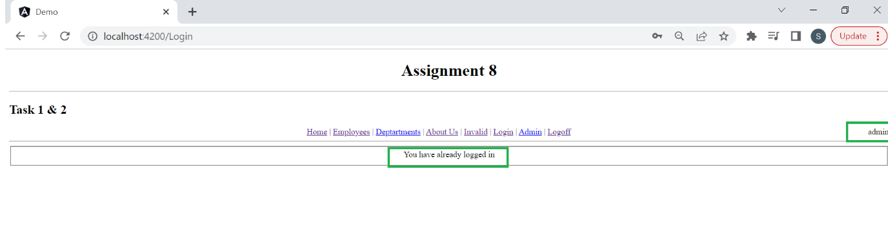

2. Update the following items:

1. Add "Logout" functionality in app module.

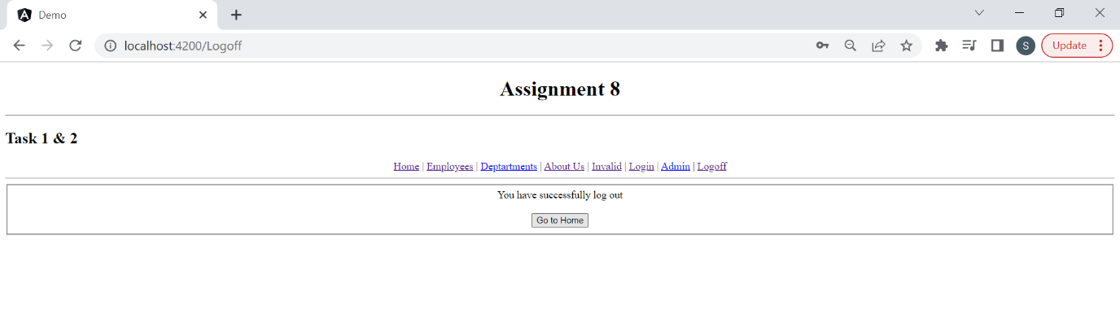

1. How to show/hide links for specific user?

