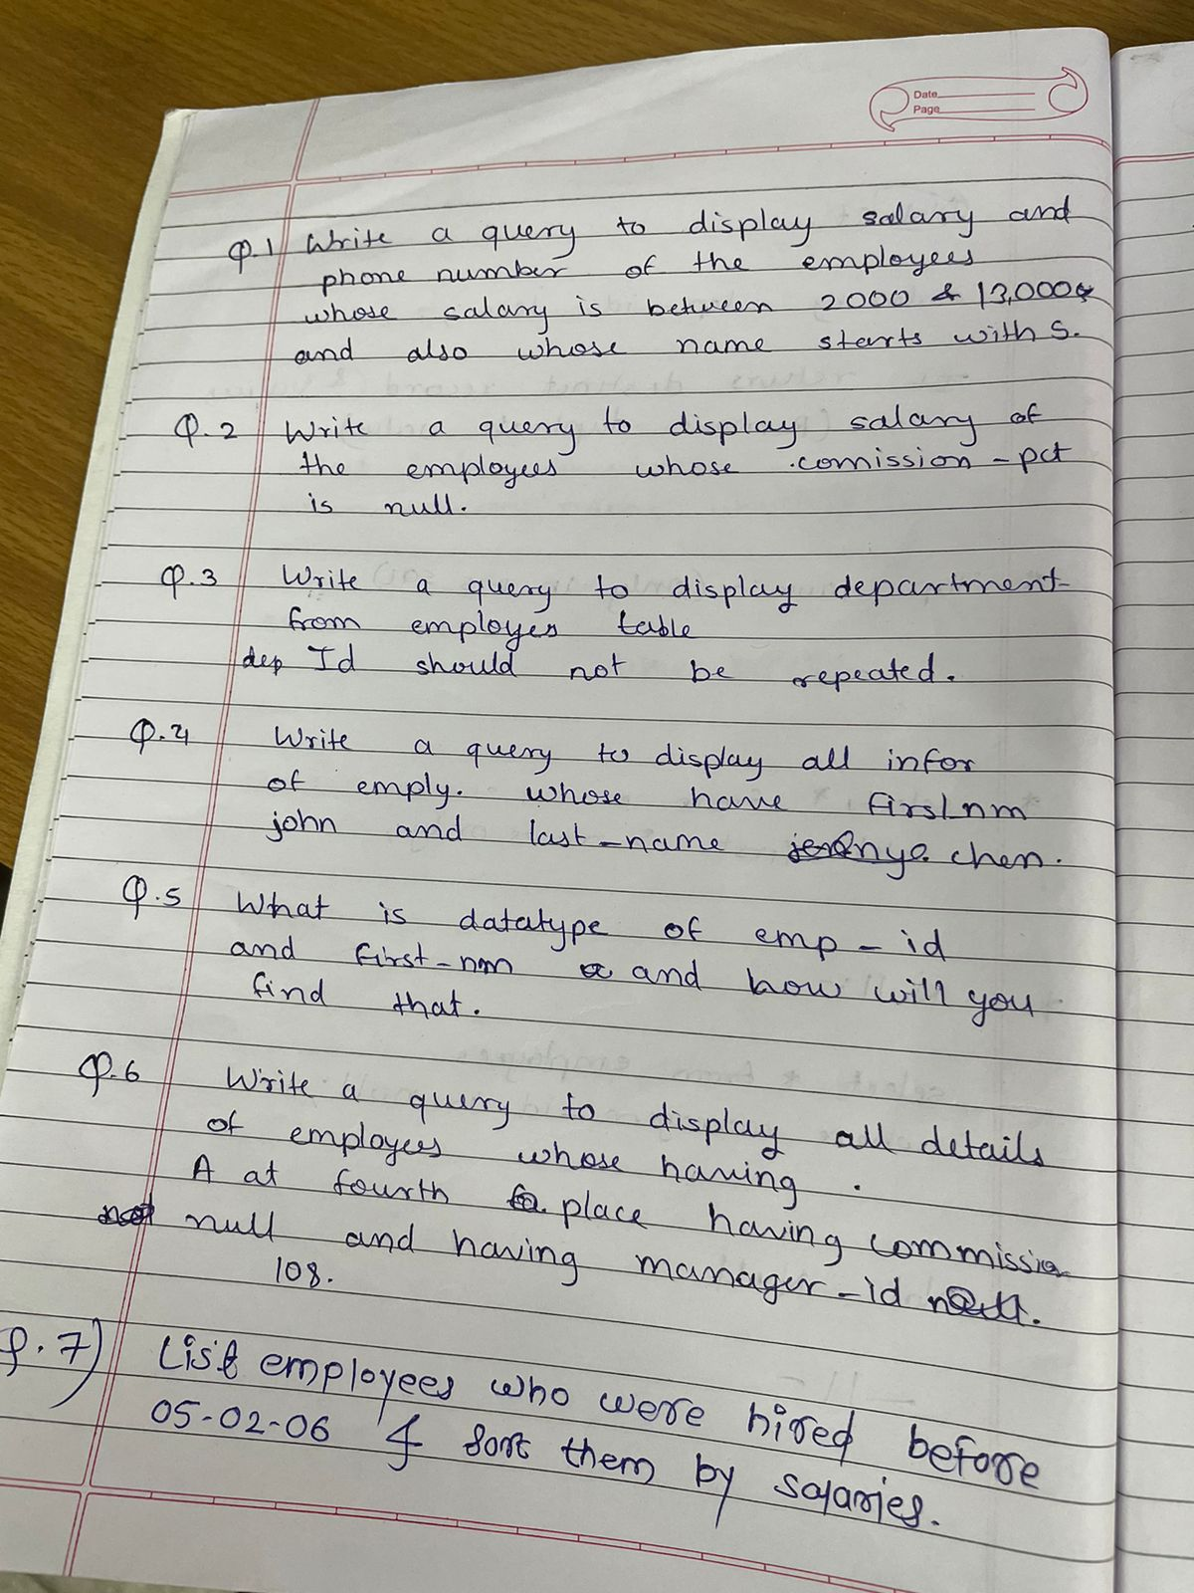

select*from employees;

select phone_number, salary from employees

where salary between 2000 and 12000

AND first_name like 'S%';

select salary from employees

where commission_pct is null;

select distinct department_id from employees;

select*from employees

where first_name='John' and last_name='Chen';

desc employees;

select*from employees

where first_name like '___a%' and commission_pct is null and manager_id=108;

select*from employees

where hire_date > date '05-02-06'

order by salary asc;

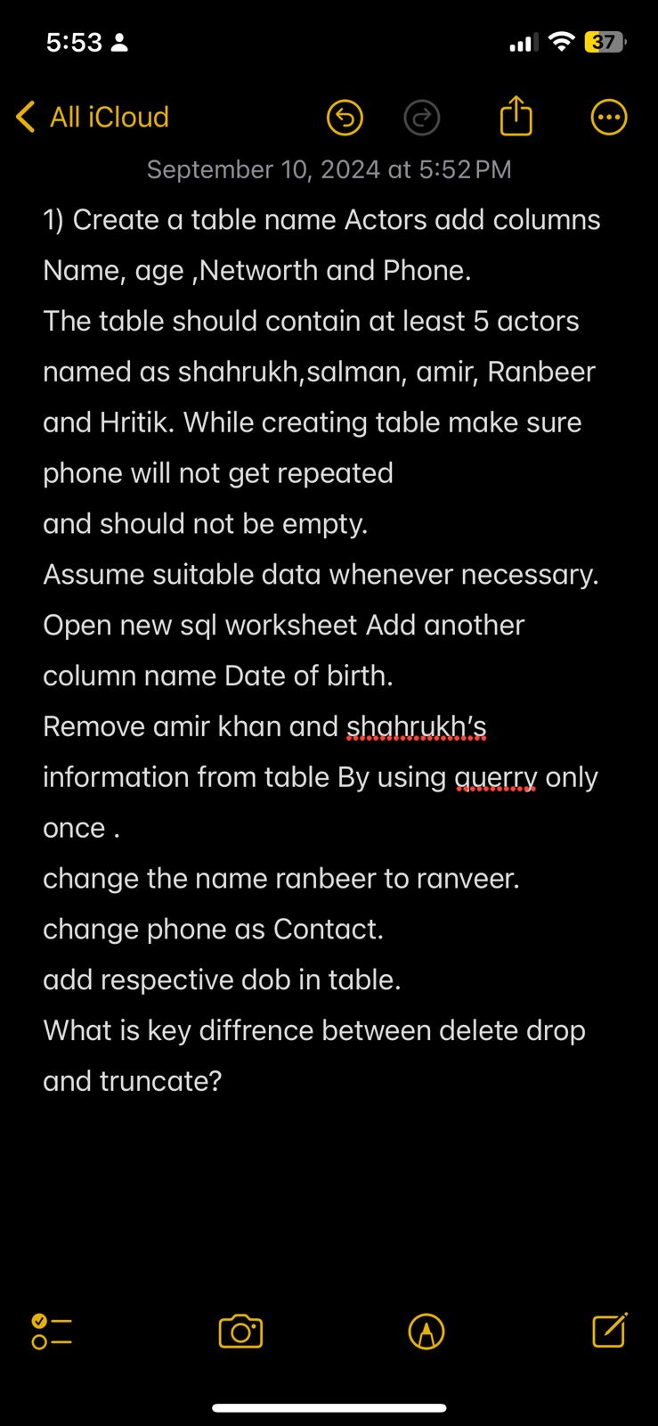

Create table Actors

(

first_name VARCHAR2(50),

age number(3),

networth number(10),

phone int unique not null

);

insert all

into actors (first_name ,age ,networth,phone )

values ('Shahrukh','50','400000', '367997940')

into actors (first_name ,age ,networth,phone )

values ('Salman','53','300000', '367997140')

into actors (first_name ,age ,networth,phone )

values ('Amir','55','500000', '267997140')

into actors (first_name ,age ,networth,phone )

values ('Ranbeer','38','350000', '327997140')

into actors (first_name ,age ,networth,phone )

values ('Hritik','54','550000', '327997120')

select*from dual;

**NEW WORKSHEET**

select*from actors;

alter table actors

add birth_date Date;

delete from actors

where first_name= 'Amir' or first_name ='Shahrukh' ;

update actors

set first_name= 'Ranveer'

where first_name= 'Ranbeer';

alter table actors

rename column phone to contact;

update actors

set birth_date= '05-02-06'

where first_name= 'Salman';

update actors

set birth_date= '07-02-06'

where first_name= 'Ranveer';

update actors

set birth_date= '08-02-06'

where first_name= 'Hritik';

--delete: the delete command is used to remove rows and its specified contents

--drop: the drop command is used to remove a column,table and datebase entirely

--truncate: the truncate command is used when the structure is supposed to be mantained but the content has to be removed