1). Execute the script shown in the video.
Step 1 Versions Contsriants
Changing in terraform providers version may get us into incompatability issues.
By default terraform will always try to downlaod the latest version of provider available from registry.
To make sure to use the specific version provider we can add the provider block in configuration.
Example:
terraform {
required_providers {
local = {
source = "hashicorp/local"
version = "2.9.1"
}
}
}
- version = "2.9.1" --> download the exact version
- version = "!=2.3.0" --> will not use the mentioned version
- version = "< 2.3.0" --> lesses than the mention version
- version = "> 2.3.0" --> greater than the given version
- version = "~> 2.3.0" --> specific version or higher version.
Implementation:
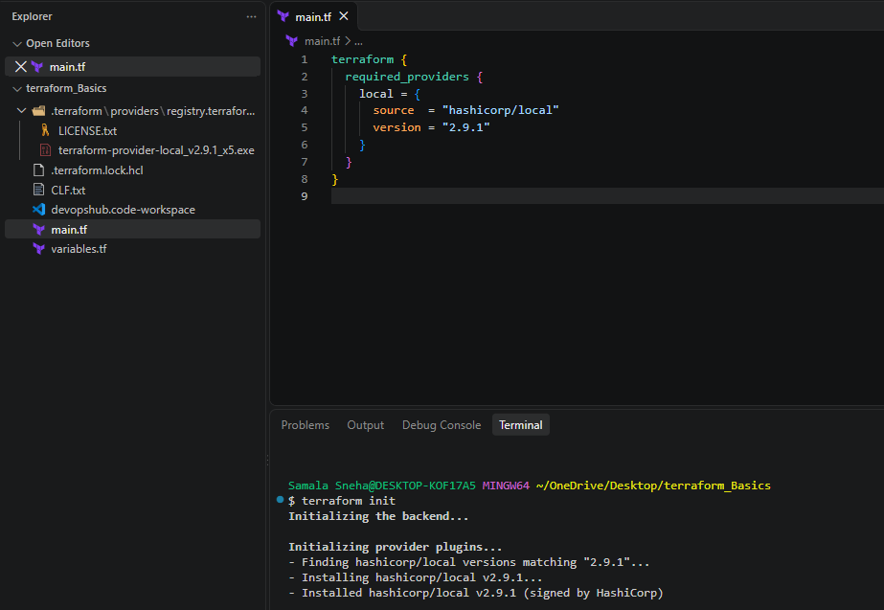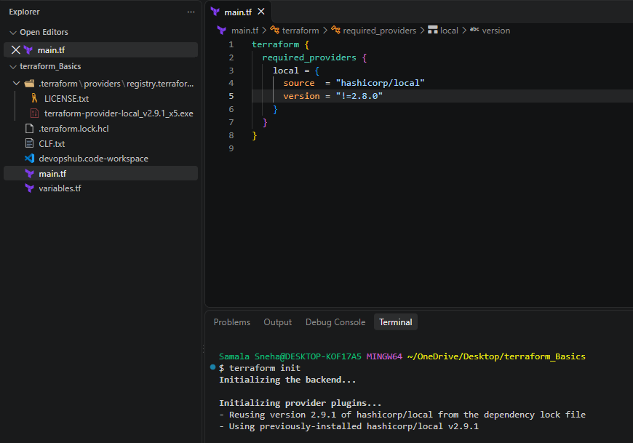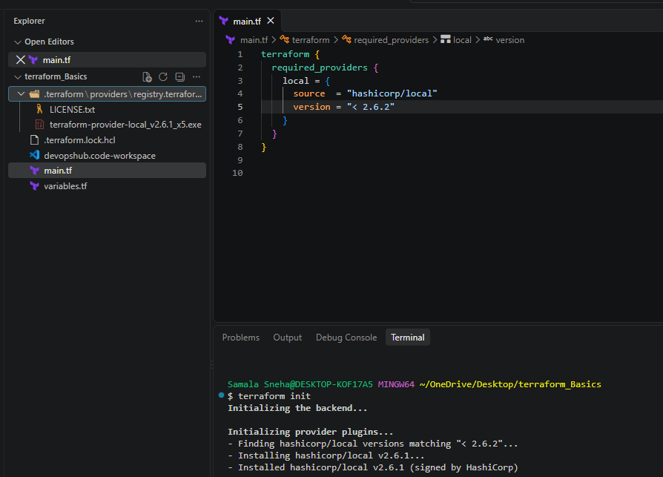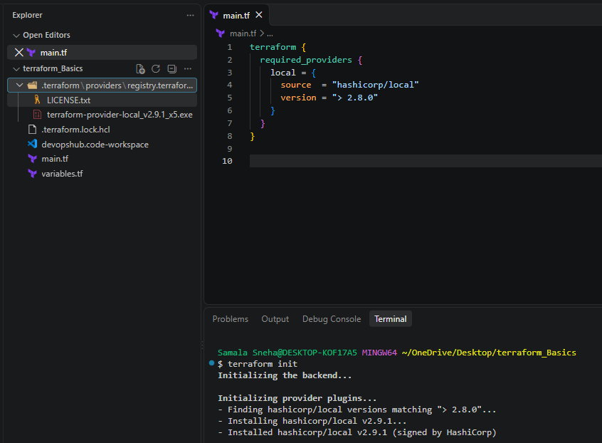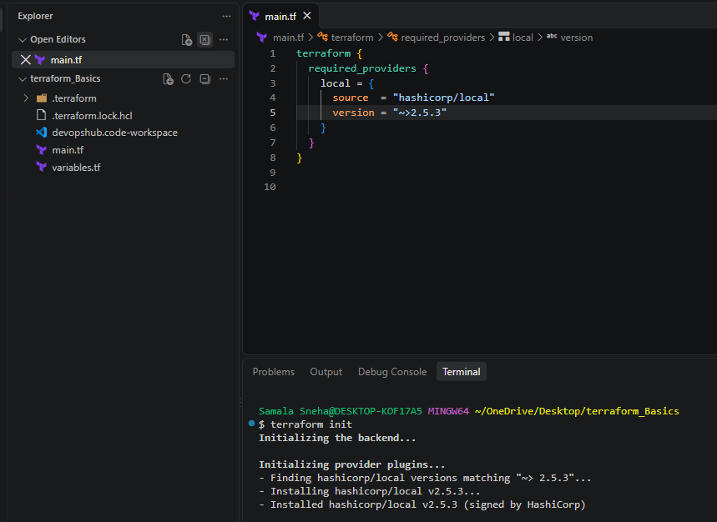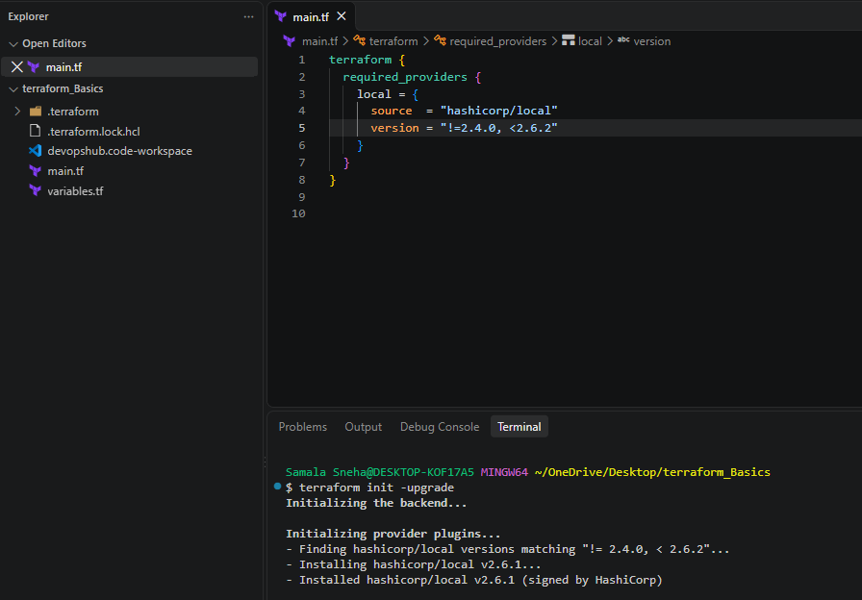

Step 2 Data Source
Apart from terraform we have multiple other tools where the infra can be created.
Ex: ansible,salt,puppet,bash script,manual process.

Data sources are used to read the content of the infrastructure
for example if we want terraform to read the content of the file which has been created by any other tool.
create a file called in dogs.txt in the same terrafrom working directory.

main.tf
======
resource "local_file" "my-file" {
filename = "sunith.txt"
content = data.local_file.DLF.content
}
data "local_file" "dog" {
filename = "DLF.txt"
}

Difference between resources and data ?

Resources starts with keyword resource
resource are used to create,modify,delete the infra

Data source strat with keyword data.
data sources are used to read the infrastructure.

Implementation:
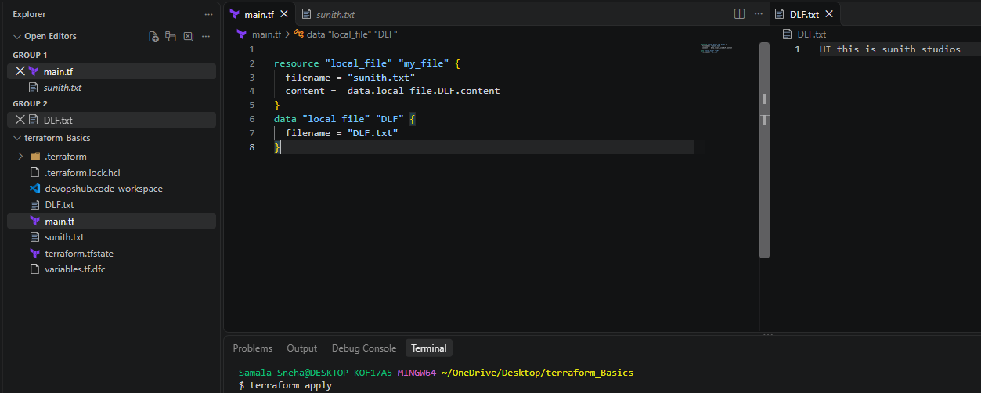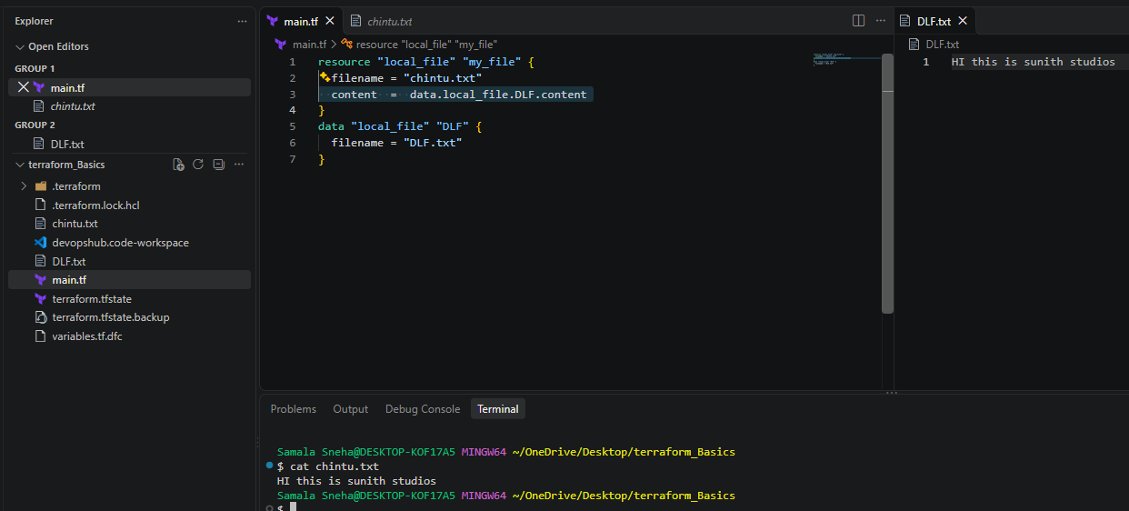

Step : Meta-Arguments
Meta arguments are used if we want to create multiple resources.
Meta arguments can be used within any resource block to change the behaviour of the resources.
Examples for meta arguments:
- Depends_on
- lifecycle rules
- Count
- For_each

Example of count:
================
If we use count as 3 then it will create 3 files with pet[0],pet[1],pet[2]

resource "local_file" "my-file" {
filename = "sunith.txt"
content = "this is for count argument"
count = 3
}

This is not the idela way to use because these are getting replaced.

resource "local_file" "my-file" {
filename = var.filename[count.index]
content = "this is for count argument"
count = 3
}

variables.tf

variable "filename" {
default = [
"BMW.txt"
"Mercedes.txt"
"Porsche.txt"
]
}

Still we have problem in the above configuration,if in future the list of varibles then we need to change the count value manually.
to avoid this we can use the inbuilt lenth function in terraform.

resource "local_file" "my-file" {
filename = var.filename[count.index]
content = "this is for count argument"
count = lenght(var.filename)
}

variables.tf

variable "filename" {
default = [
"BMW.txt"
"Mercedes.txt"
"Porsche.txt"
]
}

But when we want to update/destroy any one file then we will see un wanted results in count as count will store the output in list and works on index number.

to overcome the issue we have for_each meta argument.

Example of for_each:
====================
main.tf:

resource "local_file" "my_file" {
filename = each.value
for_each = var.filename
}

variables.tf
============
variable "filename" {
type=set(string) --> list type will throw error for_each argument.
default = [
"BMW.txt"
"Mercedes.txt"
"Porsche.txt"
]
}
or if you want to use list varibale then we can change the main.tf with toset inbuilt function.

main.tf:

resource "local_file" "my_file" {
filename = each.value
for_each = toset(var.filename)
}

variables.tf
============
variable "filename" {
default = [
"BMW.txt"
"Mercedes.txt"
"Porsche.txt"
]
}

Count will store the output as list and identified based on indexnumber
foreach store the output as map and identified based on filename.

Implementation:
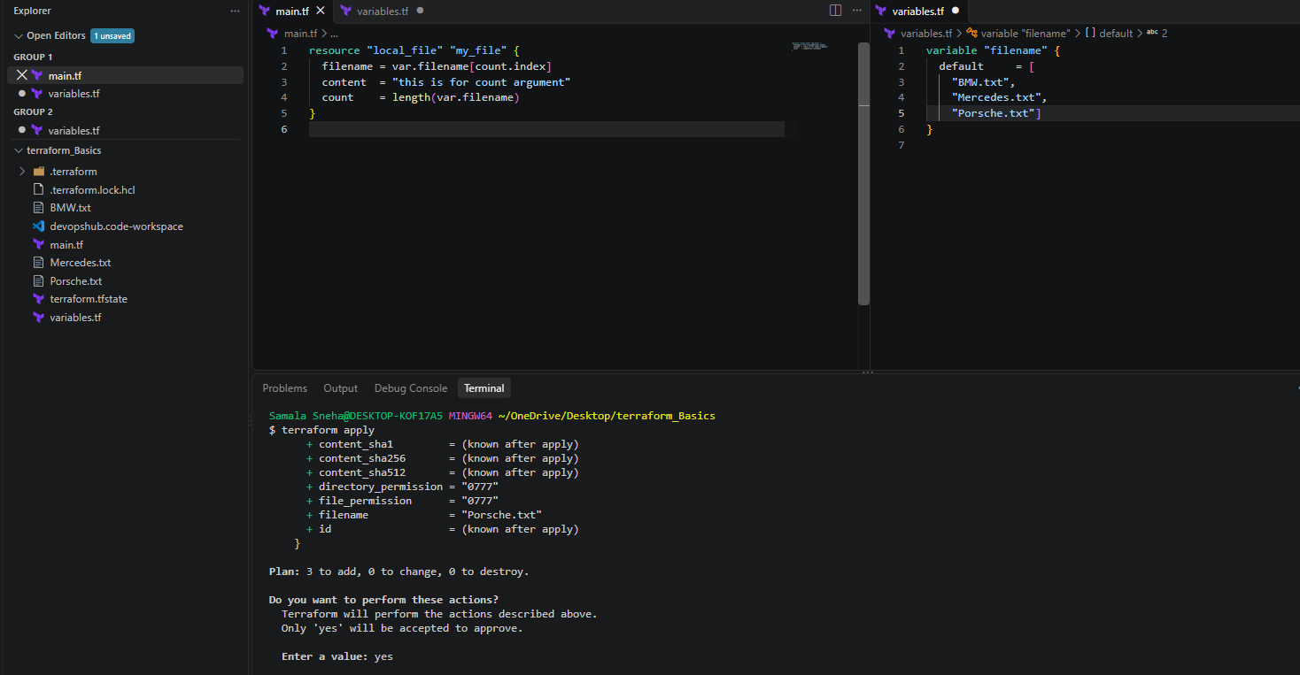
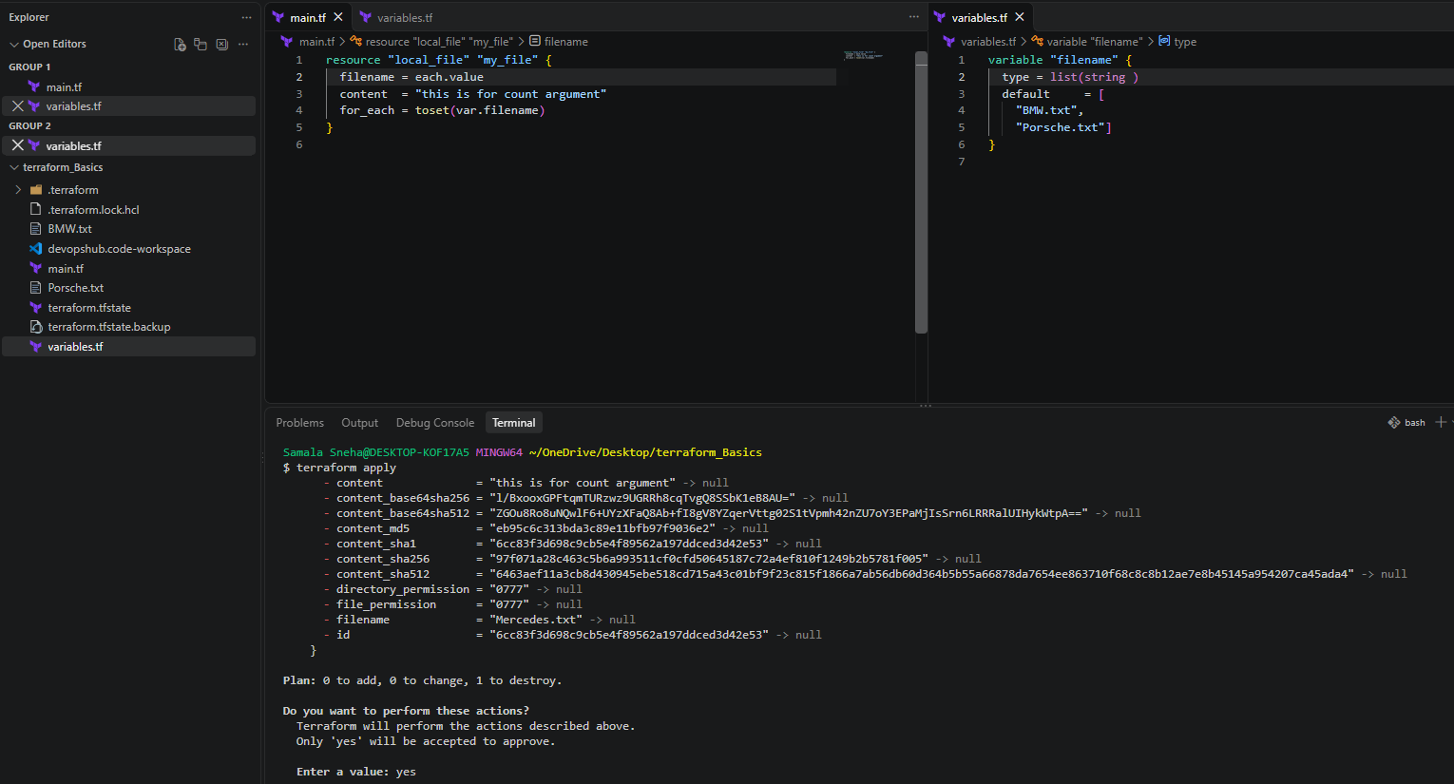

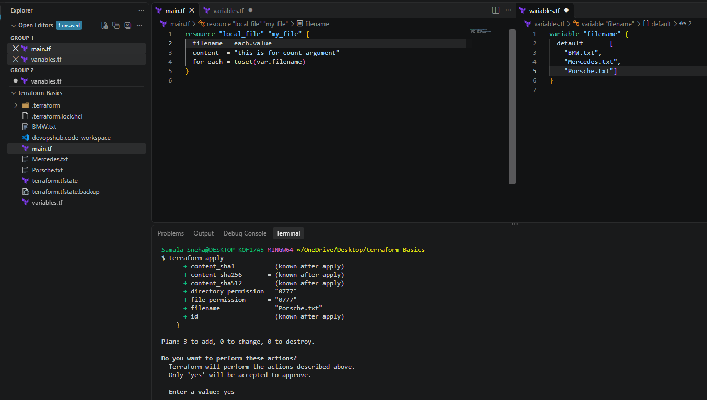

Step 4 : Create a IAM User with using Terraform
resource "aws_iam_user" "admin-user" {
name = "sunith"
tags = {
description = "Tech sunith kumar"
}
}

Then
Terraform init
terraform apply
Step 5 : Attach a Policy to that User
resource "aws_iam_user" "admin-user" {
name = "sunith"
tags = {
description = "Tech sunith kumar"
}
}
resource "aws_iam_policy" "admin-user" {
name = "admin-user-policy"
policy = <<EOF
{
"Version": "2012-10-17",
"Statement": [
{
"Effect": "Allow",
"Action": "*",
"Resource": "*"
}
]
}
EOF
}
resource "aws_iam_user_policy_attachment" "admin-user-attachment" {
user = aws_iam_user.admin-user.name
policy_arn = aws_iam_policy.admin-user.arn
}

Implementation:
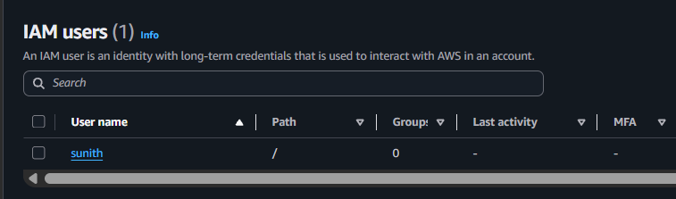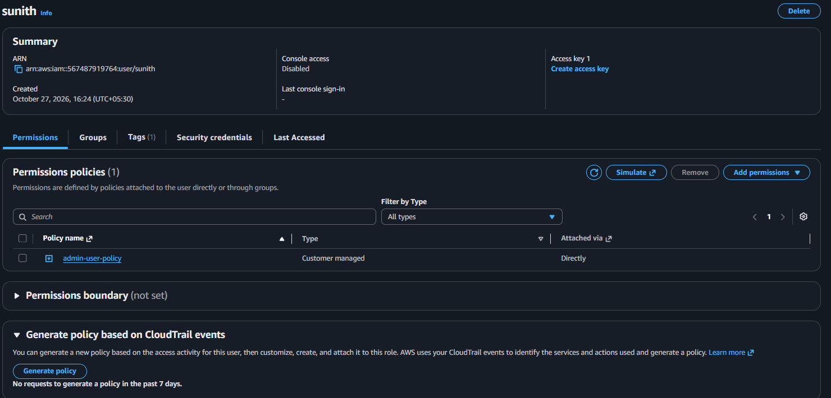

Step 7: Create a file for JSON format for policy and attach policy to user
Admin-Policy.json
{
"Version": "2012-10-17",
"Statement": [
{
"Effect": "Allow",
"Action": "*",
"Resource": "*"
}
]
}

Main.tf
resource "aws_iam_user" "admin-user" {
name = "Devops-admin"
tags = {
description = "Tech chintu"
}
}
resource "aws_iam_policy" "admin-user" {
name = "admin-user-policy"
policy = file("Adin-policy.json")

}
resource "aws_iam_user_policy_attachment" "admin-user-attachment" {
user = aws_iam_user.admin-user.name
policy_arn = aws_iam_policy.admin-user.arn
}

Implementation:
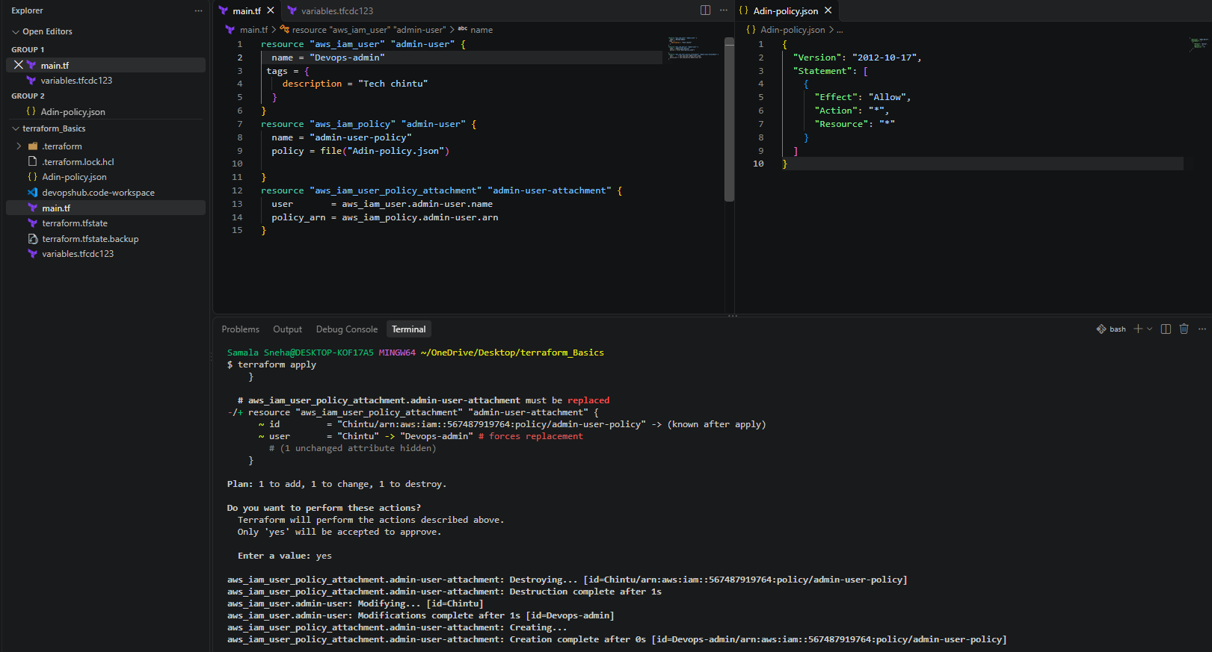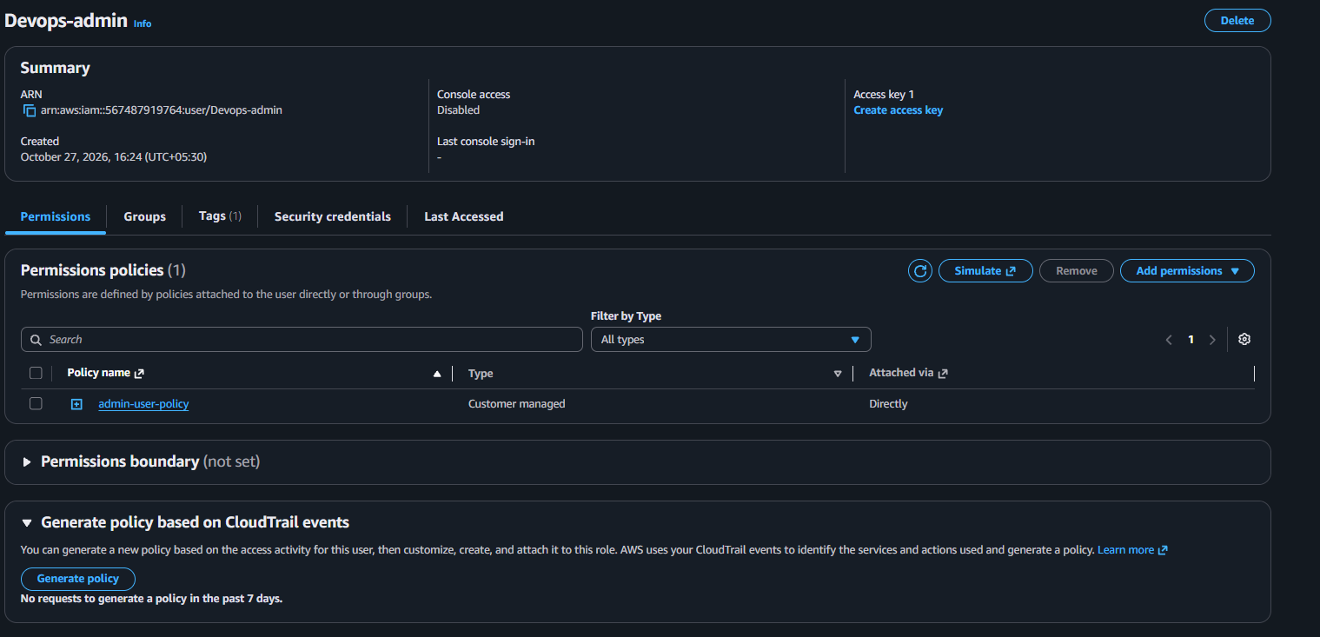
Conclusion
successfully implemented all the script shown in the video.

2). Integrate Terraform in Jenkins using the Terraform plugin.
Task 2: Integrate Terraform in Jenkins Using Terraform Plugin
1. Objective
To integrate Terraform with Jenkins using a Declarative Pipeline and automate the creation of resources using Terraform configuration.
2. Purpose
The purpose of this task is to understand how Jenkins Pipeline can execute Terraform commands to initialize providers, create an execution plan, apply the configuration, and verify the generated resources.
In this lab, Terraform creates a local text file and generates a random pet name using the local and random providers. No AWS infrastructure is created.
3. Implemented Clear Steps
Step 1: Install and Verify Terraform
Terraform was installed on the Amazon EC2 instance.
Command: terraform -version
Output:
Terraform v1.17.0
on linux_amd64
Terraform executable path: /usr/bin/terraform
The Jenkins service user was also verified to have permission to execute Terraform:
sudo -u jenkins /usr/bin/terraform -version
Step 2: Configure Terraform in Jenkins
- Log in to the Jenkins dashboard.
- Navigate to Manage Jenkins → Tools.
- Locate Terraform installations.
- Configure the following values:
  - Name: Terraform-Local
  - Install directory: /usr/bin
  - Install automatically: Unchecked
- Click Save.
This configuration identifies the existing Terraform installation for Jenkins.
Step 3: Create a Jenkins Pipeline Job
- Open the Jenkins Dashboard.
- Click New Item.
- Enter the job name: terraform-pipeline-lab
- Select Pipeline.
- Click OK.
- Scroll to the Pipeline section.
- Set Definition to Pipeline script.
- Paste the following Declarative Pipeline script.
Step 4: Configure the Pipeline Script
pipeline {
agent any

stages {
stage('Create Terraform Files') {
steps {
writeFile file: 'main.tf', text: '''
terraform {
required_providers {
local = {
source = "hashicorp/local"
}
random = {
source = "hashicorp/random"
}
}
}

resource "local_file" "my_pet" {
filename = "sunitChintu2.txt"
content = "My Aim is to only move Forward2"
}

resource "random_pet" "sunith" {
prefix = "chintu"
separator = "."
length = 1
}
'''
}
}

stage('Terraform Init') {
steps {
sh '/usr/bin/terraform init'
}
}

stage('Terraform Plan') {
steps {
sh '/usr/bin/terraform plan'
}
}

stage('Terraform Apply') {
steps {
sh '/usr/bin/terraform apply -auto-approve'
}
}

stage('Verify Output') {
steps {
sh '''
cat sunitChintu2.txt
/usr/bin/terraform output || true
ls -l sunitChintu2.txt
'''
}
}
}
}
Click Save.
Step 5: Execute the Pipeline
- Open the terraform-pipeline-lab job.
- Click Build Now.
- Click the generated build number.
- Open Console Output.
- Verify that the stages execute successfully and the build finishes with:
Finished: SUCCESS
The Pipeline performs these operations:
- Create Terraform Files: Creates main.tf inside the Jenkins workspace.
- Terraform Init: Downloads and initializes the required providers.
- Terraform Plan: Checks the changes Terraform intends to make.
- Terraform Apply: Creates the resources described in the configuration.
- Verify Output: Displays the generated text file and checks that it exists.
Step 6: Verify the Generated File
The Jenkins workspace is: /var/lib/jenkins/workspace/terraform-pipeline-lab/
Run the following command on the EC2 instance:
sudo cat /var/lib/jenkins/workspace/terraform-pipeline-lab/sunitChintu2.txt
Expected output: My Aim is to only move Forward2
The file was successfully created, and its contents matched the Terraform configuration.
The workspace also contains:
- main.tf — Terraform configuration file.
- sunitChintu2.txt — File created by the local_file resource.
- terraform.tfstate — Terraform state file tracking the managed resources.
The random_pet.sunith resource generates a name with the chintu prefix and a period separator. Its generated name can be checked in the Terraform state or with an appropriate Terraform output.
Important: The terraform.tfstate file contains resource state information. Do not publish it to a public repository.
Implementation:
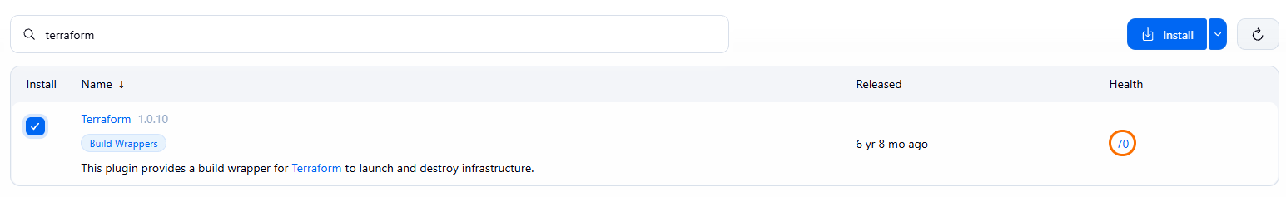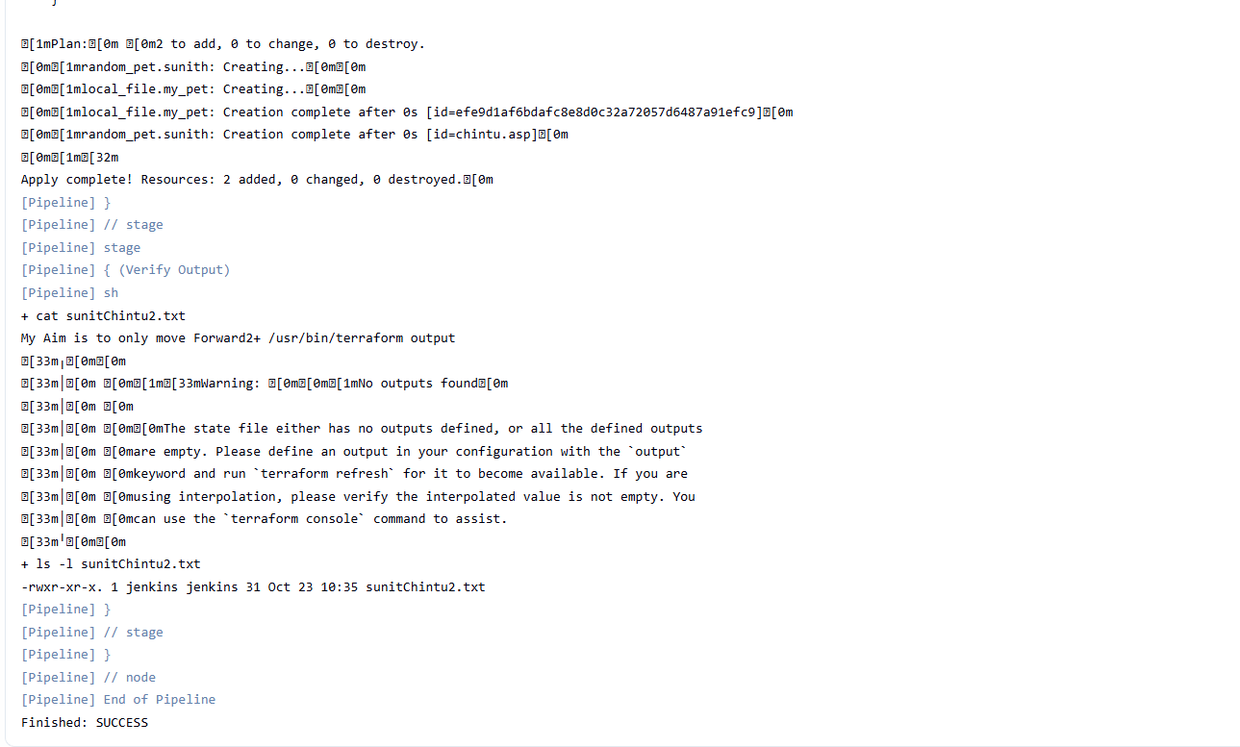
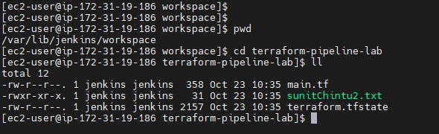
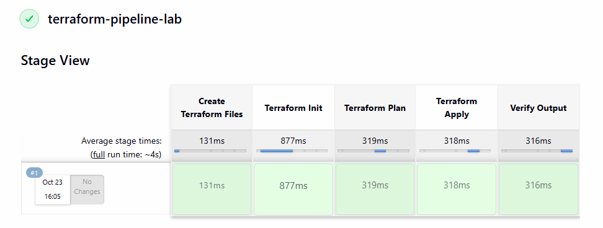
4. Conclusion
Terraform was successfully integrated into a Jenkins Declarative Pipeline. The Pipeline initialized the required providers, generated a plan, applied the Terraform configuration, and created sunitChintu2.txt with the expected content.
This lab demonstrated how Jenkins Pipeline automates Terraform execution and verifies the result without creating AWS infrastructure.
3). Create a CI/CD pipeline for a Nodejs Application: github.com/betawins/Trading-UI.git
Trading-UI Frontend CI/CD Using Jenkins and PM2
1. Objective
Implement a complete Continuous Integration and Continuous Deployment (CI/CD) pipeline for the Trading-UI React frontend application using Jenkins on Amazon Linux 2023.
The pipeline automates:
- GitHub source-code checkout.
- Environment verification.
- Node.js dependency installation.
- Enzyme test configuration and Axios mocking.
- Unit testing.
- React production build.
- Deployment using PM2.
- HTTP verification.

2. Project and Environment Details
Component | Configuration
Operating system | Amazon Linux 2023
EC2 login user | ec2-user
Jenkins service user | jenkins
Jenkins version | 2.580.1
Jenkins job | Trading-UI-CICD
Git repository | https://github.com/betawins/Trading-UI.git
Git branch | master
Jenkins workspace | /var/lib/jenkins/workspace/Trading-UI-CICD
Node.js | v22.23.4
npm | 10.9.9
Git | 2.50.1
PM2 | 7.1.1
React | 16.9.0
Frontend port | 3000
Deployment directory | /var/lib/jenkins/trading-ui-deploy
Staging directory | /var/lib/jenkins/trading-ui-staging
Jenkins URL | http://13.218.96.47:8080/
Frontend URL | http://13.218.96.47:3000/
Successful build | Jenkins Build #10
Installation note: The environment versions and successful Build #10 results were confirmed in the previous work. The installation commands below provide a reproducible setup for Amazon Linux 2023; they are not a claim that every original installation command was preserved verbatim.

3. Objective of the Installation Phase
Prepare the EC2 instance with all required tools before configuring Jenkins.
Required components:
- Git for source-code checkout.
- Java for Jenkins.
- Jenkins for pipeline orchestration.
- Node.js and npm for the React application.
- PM2 for serving the production frontend.
- curl for HTTP verification.
4. Verify the EC2 Environment
Connect to the EC2 instance using SSH and run:
whoami
cat /etc/os-release
uname -a
df -h
free -h
The interactive Linux user in this environment is ec2-user. Jenkins executes pipeline shell commands as the jenkins service account.
5. Install Base Packages
Update the package metadata and install required utilities.
sudo dnf update -y
sudo dnf install -y \
git \
curl \
wget \
tar \
gzip \
fontconfig
Verify:
git --version
curl --version | head -n 1
wget --version | head -n 1

6. Install Java
Install Amazon Corretto 21 on Amazon Linux 2023. sudo dnf install -y java-21-amazon-corretto
Verify: java -version
Jenkins requires a supported Java runtime. Verify the installed Java version before starting Jenkins.

7. Install Jenkins
Add the Jenkins stable RPM repository and install the Jenkins package.
sudo wget -O /etc/yum.repos.d/jenkins.repo \
https://pkg.jenkins.io/rpm-stable/jenkins.repo
sudo rpm --import \
https://pkg.jenkins.io/rpm-stable/jenkins.io-2023.key
sudo dnf install -y jenkins
Enable and start the service: sudo systemctl enable --now jenkins
sudo systemctl status jenkins --no-pager
If this is a new Jenkins installation, retrieve the initial administrator password:
sudo cat /var/lib/jenkins/secrets/initialAdminPassword
Open Jenkins in a browser: http://<EC2-PUBLIC-IP>:8080/
Security: Follow the current official Jenkins installation instructions if the repository key or installation procedure changes. Do not bypass package-signature verification.
8. Install Node.js and npm
The verified environment used Node.js v22.23.4 and npm 10.9.9.
For a fresh Amazon Linux 2023 installation, install the Node.js 22 major version:
curl -fsSL https://rpm.nodesource.com/setup_22.x | sudo bash -
sudo dnf install -y nodejs
Verify:
node --version
npm --version

command -v node
command -v npm
The working environment exposed Node.js at /usr/bin/node.
Verify that Jenkins can access Node.js and npm:
sudo -u jenkins -H bash -lc '
node --version
npm --version
command -v node
command -v npm
'
The interactive user's PATH and Jenkins's PATH may differ. If Jenkins cannot find Node.js or npm, configure the Jenkins job or service environment to include the installation directory.

9. Install PM2
Install PM2 globally: sudo npm install --global pm2
Verify:
command -v pm2
pm2 --version
/usr/bin/pm2 --version
The verified environment used PM2 7.1.1, with its executable at /usr/bin/pm2.
Verify PM2 under the Jenkins account:
sudo -u jenkins -H bash -c '
cd /var/lib/jenkins
/usr/bin/pm2 --version
/usr/bin/pm2 status
'
Important: Run PM2 commands from /var/lib/jenkins when operating as the Jenkins account. This avoids working-directory permission problems associated with the restricted /home/ec2-user directory.
10. Configure EC2 Security Group Rules
Configure inbound access in the EC2 security group.
Port | Purpose | Recommended source
22/TCP | SSH administration | Your public IP
8080/TCP | Jenkins web interface | Your public IP
3000/TCP | Trading-UI frontend | Your public IP
Restrict access to authorized addresses. Do not leave Jenkins exposed to the entire internet unless there is a specific, controlled requirement.
11. Verify Required Tools as Jenkins
Run:
sudo -u jenkins -H bash -lc '
node --version
npm --version
git --version
/usr/bin/pm2 --version
command -v curl
'
These tools must be available to the Jenkins service account because the pipeline runs under that account.

12. Configure the Jenkins Job
Configure the job as follows:
- Open or create the Jenkins job Trading-UI-CICD.
- If creating a new job, choose Pipeline.
- Open the job configuration.
- Find the Pipeline section.
- Select Pipeline script.
- Paste the complete script in Section 14.
- Save the job.
- Select Build Now.
- Open Console Output to monitor execution.
The repository is checked out directly by the pipeline, so a separate SCM configuration is not required for this Pipeline-script approach.
13. Complete Jenkins Pipeline Script
The following is the complete pipeline associated with the successful Build #10 workflow. Use the entire script rather than combining fragments from different versions.
pipeline {
agent any

options {
timeout(time: 20, unit: 'MINUTES')
timestamps()
}

environment {
APP_NAME = 'Trading-UI'
APP_PORT = '3000'
DEPLOY_DIR = '/var/lib/jenkins/trading-ui-deploy'
STAGING_DIR = '/var/lib/jenkins/trading-ui-staging'
NODE_OPTIONS = '--openssl-legacy-provider'
}

stages {
stage('1. Checkout') {
steps {
git branch: 'master',
url: 'https://github.com/betawins/Trading-UI.git'
}
}

stage('2. Verify Environment') {
steps {
sh '''
set -eu
node --version
npm --version
git --version
/usr/bin/pm2 --version
command -v curl
'''
}
}

stage('3. Install Dependencies') {
steps {
sh '''
set -eu

npm install --legacy-peer-deps --omit=optional

npm install \
--no-save \
--legacy-peer-deps \
--omit=optional \
enzyme-adapter-react-16@1.15.7

node -e '
console.log(
"React:",
require("react/package.json").version
);
console.log(
"Enzyme:",
require("enzyme/package.json").version
);
console.log(
"Adapter:",
require("enzyme-adapter-react-16/package.json").version
);
'
'''
}
}

stage('4. Configure Enzyme and Mock Backend') {
steps {
sh '''
set -eu
mkdir -p src

cat > src/setupTests.js <<'EOF'
import Enzyme from 'enzyme';
import Adapter from 'enzyme-adapter-react-16';

Enzyme.configure({
adapter: new Adapter()
});

jest.mock('axios', () => {
const makeResponse = () => Promise.resolve({
status: 200,
data: {
status: 'SUCCESS',
data: [],
totalPrice: 0,
trending: []
}
});

const client = {
get: jest.fn(() => makeResponse()),
post: jest.fn(() => makeResponse()),
put: jest.fn(() => makeResponse()),
patch: jest.fn(() => makeResponse()),
delete: jest.fn(() => makeResponse()),
request: jest.fn(() => makeResponse())
};

client.create = jest.fn(() => client);

return {
__esModule: true,
default: client,
...client
};
});
EOF

test -s src/setupTests.js
echo "Enzyme adapter and Axios test mock configured."
'''
}
}

stage('5. Run Unit Tests') {
steps {
sh '''
set -eu

echo "Running tests except the excluded Purchase test."

CI=true npm test -- \
--watchAll=false \
--runInBand \
--forceExit \
--testPathIgnorePatterns=src/__tests__/Purchase/Purchase.test.js
'''
}
}

stage('6. Build Production Files') {
steps {
sh '''
set -eu

export NODE_OPTIONS=--openssl-legacy-provider
CI=false npm run build

if [ ! -s build/index.html ]; then
echo "Production index.html was not generated."
exit 1
fi

echo "Production build completed."
ls -lah build/
'''
}
}

stage('7. Deploy with PM2') {
steps {
sh '''
set -eu

test -s build/index.html

rm -rf "$STAGING_DIR"
mkdir -p "$STAGING_DIR"
cp -a build/. "$STAGING_DIR/"
test -s "$STAGING_DIR/index.html"

cd /var/lib/jenkins

if /usr/bin/pm2 describe "$APP_NAME" >/dev/null 2>&1; then
/usr/bin/pm2 delete "$APP_NAME"
fi

rm -rf "$DEPLOY_DIR"
mv "$STAGING_DIR" "$DEPLOY_DIR"

/usr/bin/pm2 serve \
"$DEPLOY_DIR" \
"$APP_PORT" \
--spa \
--name "$APP_NAME"

/usr/bin/pm2 save
/usr/bin/pm2 status
'''
}
}

stage('8. Verify HTTP') {
steps {
sh '''
set -eu
cd /var/lib/jenkins

ATTEMPTS=0

until curl --fail --silent \
http://127.0.0.1:3000/ \
-o /tmp/trading-ui-response.html
do
ATTEMPTS=$((ATTEMPTS + 1))

if [ "$ATTEMPTS" -ge 15 ]; then
echo "Frontend HTTP verification failed."

/usr/bin/pm2 logs Trading-UI \
--lines 50 \
--nostream || true

exit 1
fi

sleep 2
done

test -s /tmp/trading-ui-response.html
grep -qi '<html' /tmp/trading-ui-response.html

echo "SUCCESS: Local HTTP verification passed."
/usr/bin/pm2 status
'''
}
}
}

post {
always {
echo 'Trading-UI-CICD pipeline execution finished.'
}

success {
echo 'SUCCESS: Selected tests, production build, PM2 deployment, and local HTTP verification completed.'
echo 'Test exclusion: src/__tests__/Purchase/Purchase.test.js'
echo 'Frontend URL: http://13.218.96.47:3000/'
echo 'Public access requires inbound TCP port 3000 in the EC2 security group.'
}
}
}
14. Explanation of Each Pipeline Stage
Stage 1 — Checkout
The pipeline clones the master branch from the GitHub repository.
Repository:
https://github.com/betawins/Trading-UI.git
The successful build checked out commit:
d3555e39b908103ac6d099560b70a64e6dee18f0
Stage 2 — Verify Environment
Checks the installed Node.js, npm, Git, PM2, and curl versions and availability.
Stage 3 — Install Dependencies
Installs the npm packages using:
npm install --legacy-peer-deps --omit=optional
The project uses an older React toolchain. The command accommodates peer-dependency conflicts and skips optional dependencies.
The pipeline then installs the React 16 Enzyme adapter without saving it as a project dependency:
npm install --no-save --legacy-peer-deps --omit=optional enzyme-adapter-react-16@1.15.7
Stage 4 — Configure Enzyme and Mock Axios
Creates src/setupTests.js with:
- Enzyme configuration.
- React 16 adapter configuration.
- An Axios mock for unit tests.
- Mock responses for HTTP methods such as GET, POST, PUT, PATCH, and DELETE.
The mock makes tests independent of a live backend response. It does not verify that the actual backend is reachable.
Stage 5 — Run Unit Tests
Runs the test suite in non-interactive CI mode:
CI=true npm test -- --watchAll=false --runInBand --forceExit --testPathIgnorePatterns=src/__tests__/Purchase/Purchase.test.js
The Purchase.test.js file is excluded from this successful run. Therefore, the test result represents the selected tests, not every test in the repository.
Stage 6 — Build Production Files
The project uses an older Webpack toolchain, so the build uses:
export NODE_OPTIONS=--openssl-legacy-provider
CI=false npm run build
The build directory contains the generated production assets, including build/index.html.
CI=false allows the build to complete with the existing ESLint warnings. It should not be interpreted as proof that all warnings have been resolved.
Stage 7 — Deploy with PM2
The pipeline:
- Creates a staging directory.
- Copies the generated production files.
- Removes the existing PM2 application if present.
- Replaces the deployment directory with the staging files.
- Starts PM2's static-file server on port 3000.
- Saves the PM2 process list.
Deployment directory:
/var/lib/jenkins/trading-ui-deploy
PM2 application name:
Trading-UI
Stage 8 — Verify HTTP
The pipeline requests the application locally:
http://127.0.0.1:3000/
It retries the request, checks that the downloaded HTML file is non-empty, verifies that it contains an HTML element, and displays PM2 status.
This verifies the local frontend HTTP endpoint. It does not independently verify public access or backend API functionality.
15. Run the Jenkins Pipeline
- Open the Trading-UI-CICD job.
- Select Build Now.
- Open the active build.
- Select Console Output.
- Follow the stages through completion.
- Confirm the build result is SUCCESS.
The successful execution previously recorded was Build #10.
16. Verify the Deployment from the EC2 Terminal
Run:
sudo -u jenkins -H bash -c '
cd /var/lib/jenkins
/usr/bin/pm2 status
curl -I http://127.0.0.1:3000/
'
Verify the deployed HTML file:
sudo -u jenkins -H bash -c '
test -s /var/lib/jenkins/trading-ui-deploy/index.html &&
echo "Production index.html exists."
'
17.Implementation:
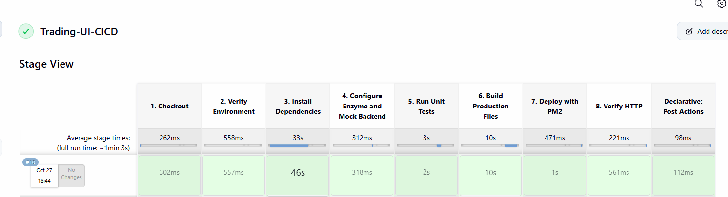
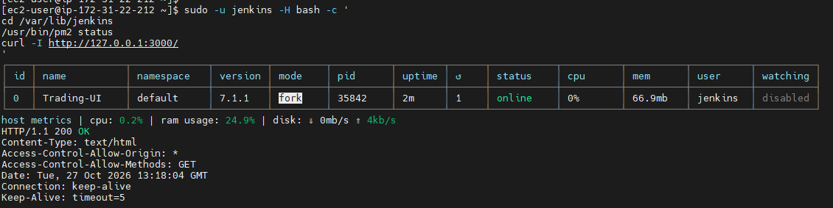
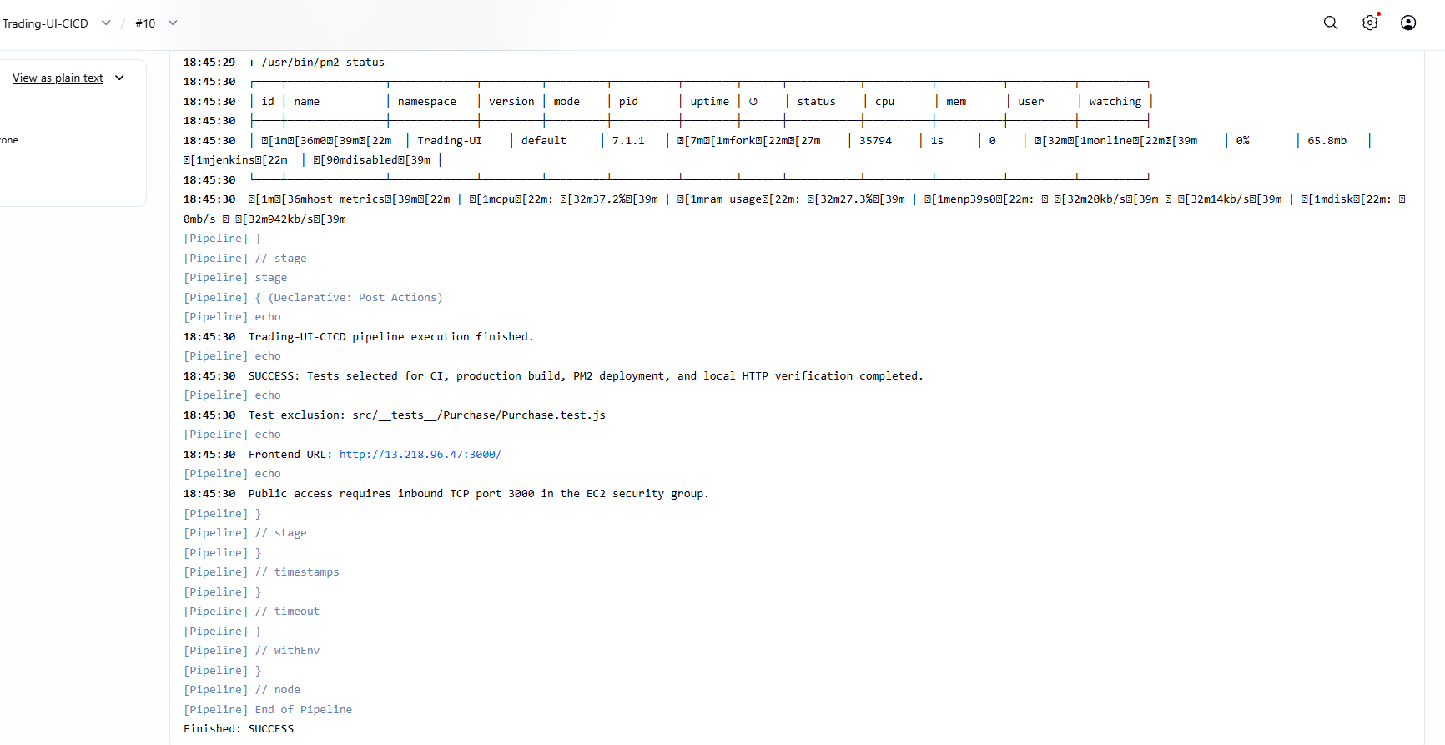
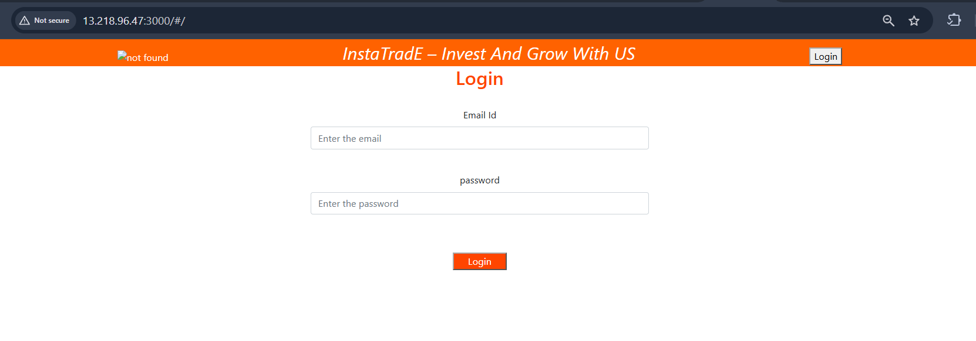
18. Conclusion
The Trading-UI frontend CI/CD pipeline was successfully executed on the Amazon Linux EC2 environment.
Jenkins checked out the source code, installed dependencies, configured the unit-test environment, ran the selected tests, generated the React production build, deployed the files using PM2, and verified the local HTTP endpoint.
The frontend was also confirmed to open through the public browser URL:
http://13.218.96.47:3000/
This document contains the installation procedure, Jenkins configuration, complete pipeline script, deployment commands, verification steps, and results needed to understand and reproduce the recorded frontend CI/CD workflow.

4). Explain 10 Maven commands.
Practical: 10 Essential Apache Maven Commands
1. Objective
To understand and execute 10 essential Apache Maven commands used in Java project development, compilation, testing, packaging, dependency management, and artifact deployment.
2. Purpose
Apache Maven is a build automation and project management tool primarily used for Java projects. It manages project dependencies and automates tasks through a configuration file named pom.xml (Project Object Model).
The purpose of this practical is to learn how to:
- Verify Maven installation and Java configuration.
- Clean previously generated build files.
- Validate and compile project source code.
- Run automated tests.
- Package a Java application.
- Install artifacts into the local Maven repository.
- Inspect project dependencies.
- Verify the build and publish artifacts to a remote Maven repository.

Verify the Environment
Execute the following commands in the terminal:
java -version
mvn -version
Navigate to the project directory: cd /path/to/your/project
ls
Confirm that the pom.xml file exists in the current directory.
Replace /path/to/your/project with your actual project directory.
4. Implementation Steps
Step 1: Check Maven Version
Command:
mvn -version
Purpose: Displays the installed Maven version, Maven home, Java version, and operating system details.
Expected Result: Maven and Java environment information is displayed.
Verification: Confirm that Maven is installed correctly and recognizes the expected Java version.
Step 2: Clean the Project
Command:
mvn clean
Purpose: Removes generated build output, usually the target directory.
Expected Result: Maven completes the clean phase successfully.
Verification: Check whether the previous target directory has been removed.
Step 3: Validate the Project
Command:
mvn validate
Purpose: Runs the project validation phase and any checks configured for that phase.
Expected Result: Maven completes validation if no errors occur.
Verification: Check the final build status in the terminal.
Step 4: Compile the Source Code
Command:
mvn compile
Purpose: Compiles the main Java source code.
Expected Result: Compiled class files are generally created inside target/classes.
Verification:
ls target/classes
The directory should exist when the project contains compilable source files and compilation succeeds.
Step 5: Run Automated Tests
Command:
mvn test
Purpose: Executes the project's configured automated tests.
Expected Result: Maven displays the test execution results and build status.
Verification: Review the test summary and, when configured, the reports under target/surefire-reports/.
Step 6: Package the Application
Command:
mvn package
Purpose: Executes the required earlier lifecycle phases and packages the application according to the project configuration.
Expected Result: A JAR or WAR file is generally generated inside the target directory.
Verification:
ls target
Identify the generated .jar or .war file.
Step 7: Install the Artifact Locally
Command:
mvn install
Purpose: Builds the project and installs its artifact into the local Maven repository.
Expected Result: The artifact is stored in the local repository, usually ~/.m2/repository.
Verification: Check for BUILD SUCCESS and confirm that the artifact exists in the local repository.
Step 8: Verify the Build
Command:
mvn verify
Purpose: Runs the build lifecycle through the verification phase, including preceding phases and configured verification checks.
Expected Result: Maven reports a successful build if all required phases and checks pass.
Verification: Review the build status, test reports, and any configured verification results.
Step 9: Display the Dependency Tree
Command:
mvn dependency:tree
Purpose: Displays the direct and transitive dependencies used by the project.
Expected Result: Maven prints the dependency hierarchy in the terminal.
Verification: Review the dependency names and versions to investigate dependency conflicts or unexpected libraries.
Step 10: Deploy the Artifact to a Remote Repository
Command:
mvn deploy
Purpose: Publishes the built artifact to the remote Maven repository configured for the project.
Expected Result: Maven uploads the artifact when repository configuration, credentials, permissions, and build phases are correct.
Verification: Check for BUILD SUCCESS and confirm that the artifact is available in the configured repository manager.
Important: This command publishes an artifact to a Maven repository. It does not automatically deploy a web application to a Tomcat server or an EC2 instance.
5. Summary of Maven Commands
No. | Command | Purpose
1 | mvn -version | Verify Maven and Java versions
2 | mvn clean | Remove generated build output
3 | mvn validate | Validate the project
4 | mvn compile | Compile main source code
5 | mvn test | Run automated tests
6 | mvn package | Create a JAR or WAR artifact
7 | mvn install | Install the artifact locally
8 | mvn verify | Run verification checks
9 | mvn dependency:tree | Display the dependency hierarchy
10 | mvn deploy | Publish the artifact remotely
6. Conclusion
In this practical, 10 essential Apache Maven commands were studied to understand the build lifecycle of a Java application.
These commands help verify the development environment, clean old build output, validate and compile code, execute automated tests, package applications, manage dependencies, and publish artifacts.
Maven is an important tool in DevOps and Jenkins CI/CD pipelines because it provides a standardized and repeatable process for building and verifying Java applications before release or deployment.

