Task 1: Install Terraform on Windows PC
1. Objective
To install Terraform on a Windows PC, configure the system PATH, and verify the installation using Git Bash.
2. Purpose
Terraform is an Infrastructure as Code (IaC) tool developed by HashiCorp. It allows DevOps engineers to define, provision, and manage infrastructure using configuration files.
Installing Terraform is the first step toward automating infrastructure deployment and integrating Terraform with Jenkins CI/CD pipelines.
3. Clear Steps
Step 1: Download Terraform
- Open the official HashiCorp installation page: https://developer.hashicorp.com/terraform/install
- Select the Windows AMD64 package if using a 64-bit Windows PC.
- Download the ZIP archive.
Step 2: Extract Terraform
- Create the folder C:\Terraform.
- Extract the downloaded ZIP archive.
- Confirm that terraform.exe exists at:
C:\Terraform\terraform.exe
Step 3: Configure the PATH
- Open Windows Search.
- Search for Edit the system environment variables.
- Open Environment Variables.
- Under User variables, select Path and click Edit.
- Add the following entry:
C:\Terraform
- Save the changes and reopen Git Bash.
Step 4: Verify the Terraform installation
Execute the following command in Git Bash: terraform -version
Observed output:
Terraform v1.14.3
on windows_amd64
Step 5: Verify the executable location
Execute: which terraform
Observed output: /c/terraform/terraform
This confirms that Git Bash can locate the Terraform executable.
Implementation:
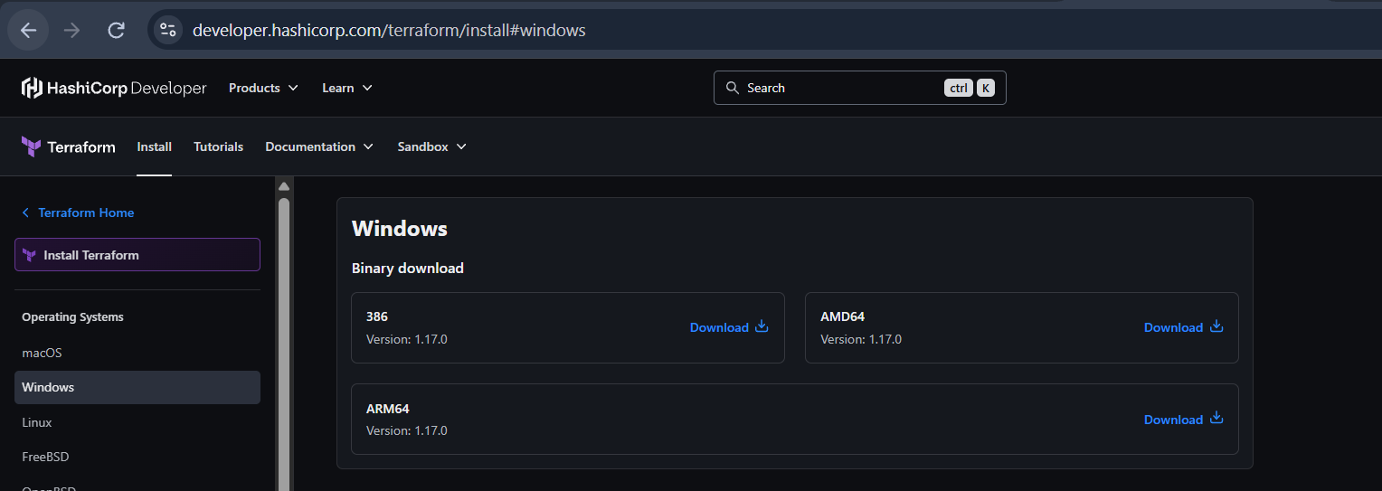
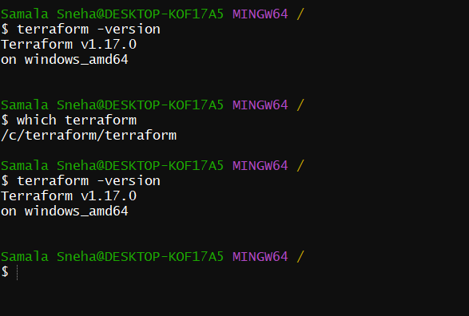
4. Conclusion
Terraform was successfully installed on the Windows PC and verified using Git Bash. The installed version is Terraform 1.14.3 for Windows AMD64. The executable is accessible through the PATH, and the environment is ready for the next Terraform lab activities.

Task 2: Create and Execute Terraform Templates Shown in video
1. Objective
To create and execute Terraform configuration templates in Visual Studio Code using the Local and Random providers.
2. Purpose
Terraform is an Infrastructure as Code (IaC) tool used to define and manage resources through configuration files.
Visual Studio Code is used to write and edit Terraform files, while the Git Bash terminal is used to execute Terraform commands.
This practical demonstrates how Terraform creates a local file and generates a random pet name using Terraform providers.
3. Clear Steps
Step 1: Open VS Code
- Open Visual Studio Code.
- Create or open the Terraform project folder.
- Create a new file named main.tf
Step 2: Write the Terraform configuration
Enter the following code in main.tf:
resource "local_file" "my_pet" {
filename = "pets.txt"
content = "i love my snupi"
}

resource "random_pet" "sunith" {
prefix = "chintu"
separator = "."
length = 3
}
Save the file using Ctrl + S.
Step 3: Understand the configuration
Resource 1: Local file
resource "local_file" "my_pet" {
filename = "pets.txt"
content = "i love my snupi"
}
- resource: Declares a resource managed by Terraform.
- local_file: Identifies the resource type provided by the Local provider.
- my_pet: The Terraform resource's local name.
- filename: Specifies the file to create.
- content: Specifies the text written into the file.
Expected result: A file named pets.txt containing i love my snupi.
Resource 2: Random pet
resource "random_pet" "sunith" {
prefix = "chintu"
separator = "."
length = 3
}
- random_pet: Generates a random pet-style name.
- sunith: The Terraform resource's local name.
- prefix: Adds chintu at the beginning of the generated name.
- separator: Uses a dot between name components.
- length: Requests three name components.
The generated name is stored in Terraform state. The exact name depends on the generated result and the resource's lifecycle.
Step 4: Initialize Terraform
Open the VS Code terminal and navigate to the directory containing main.tf.
Execute: terraform init
Purpose:
- Initializes the Terraform working directory.
- Downloads the required Local and Random provider plugins.
- Creates the .terraform directory.
- Creates or updates .terraform.lock.hcl.
Expected result: Terraform initializes successfully.
Step 5: Format and validate the configuration
Format the configuration: terraform fmt
Validate it: terraform validate
Expected result: Success! The configuration is valid.
Step 6: Review the Terraform plan
Execute: terraform plan
Terraform previews the resources it intends to create or modify.
For a fresh working directory with no existing managed resources, the plan should show the local file and random pet resources being created.
Step 7: Apply the configuration
Execute: terraform apply
Review the proposed changes and type yes when prompted.
Terraform creates the resources specified in the configuration.
Step 8: Verify the local file
Execute: cat pets.txt
Expected output: i love my snupi
You can also open pets.txt in VS Code to verify the contents.
Step 9: Verify the random pet resource
Execute: terraform state list
The output should include:
local_file.my_pet
random_pet.sunith
To inspect the generated name, execute:
terraform state show random_pet.sunith
Look for the id attribute, which contains the generated pet name.
Implementation:
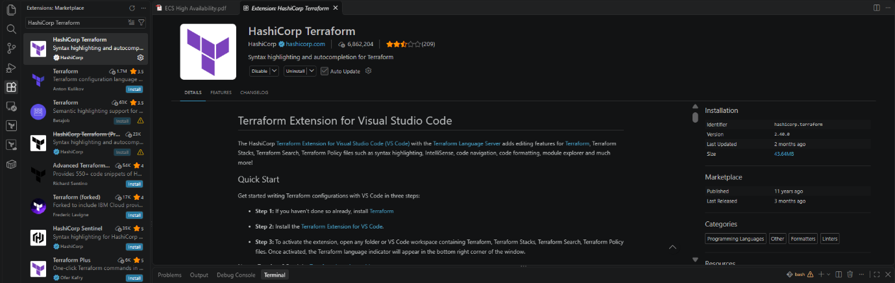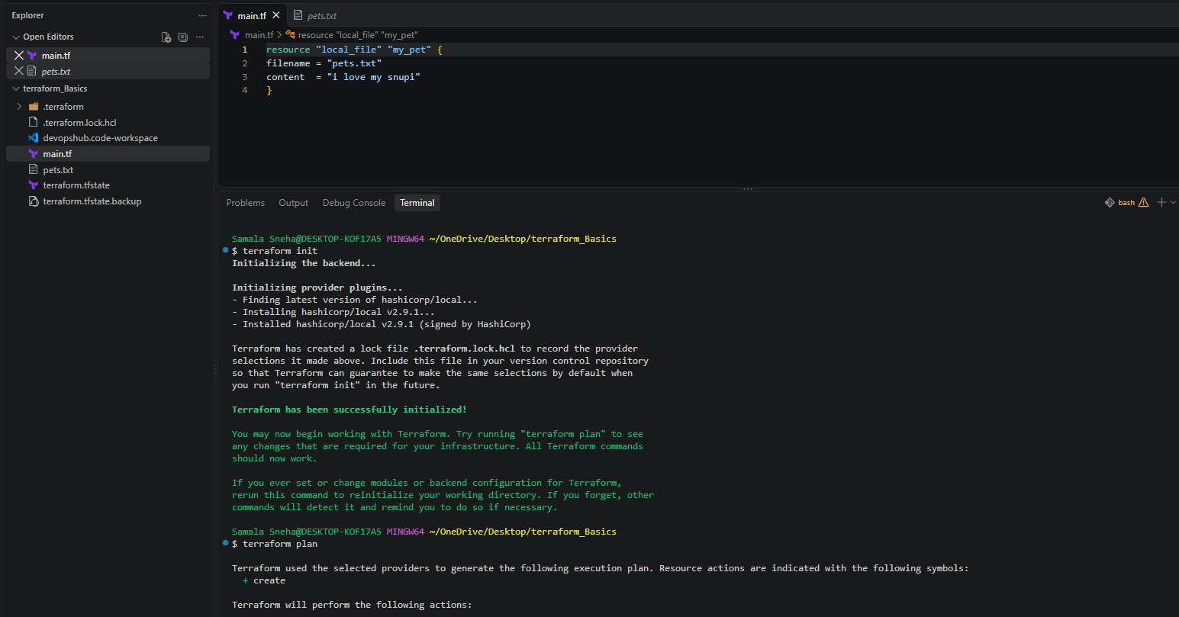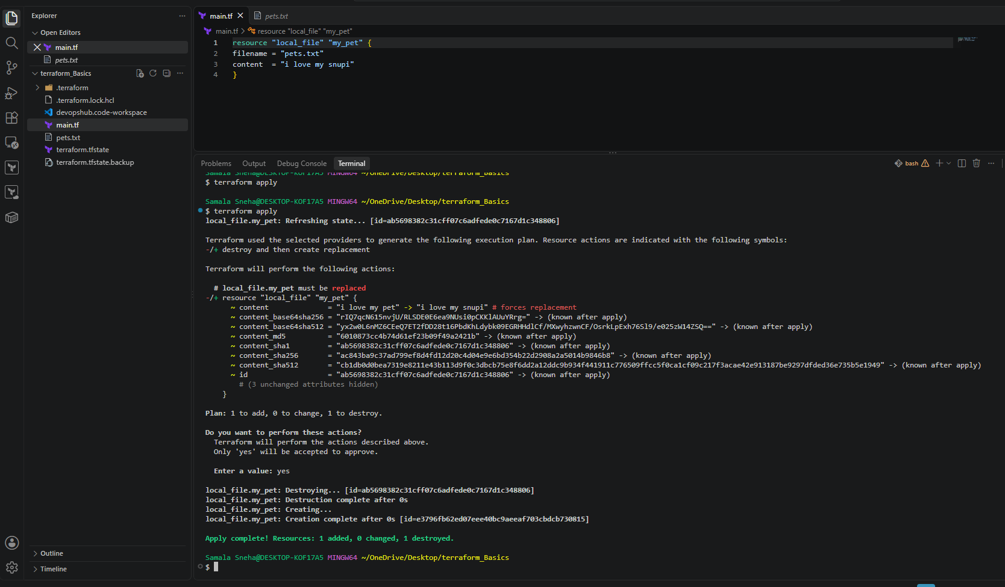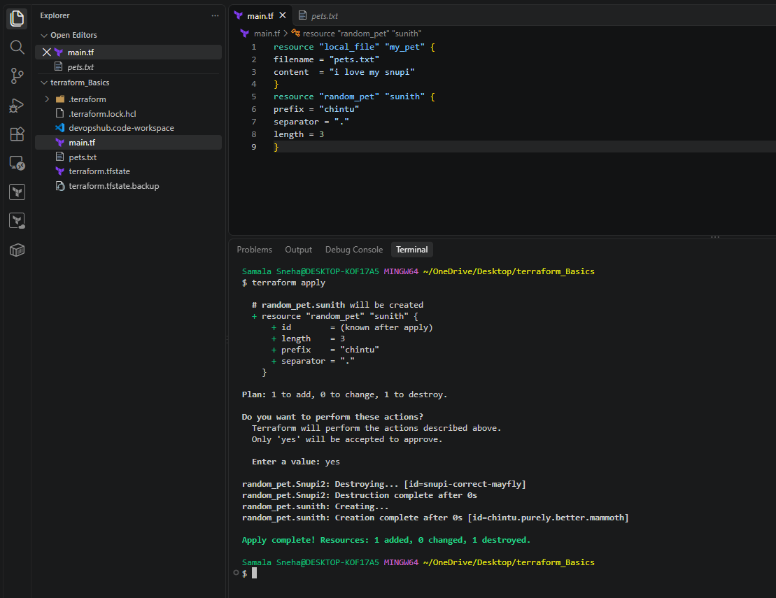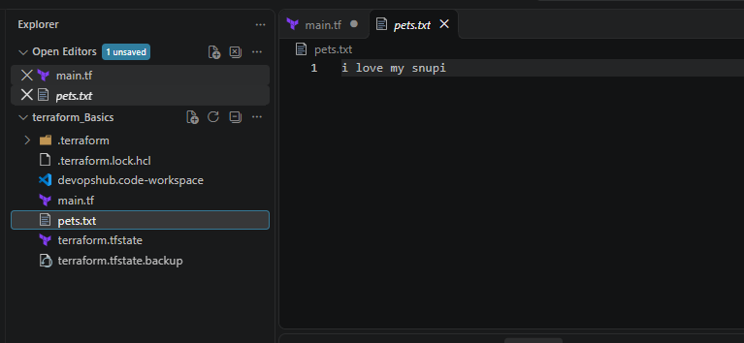
4. Conclusion
The Terraform template was successfully created and executed in Visual Studio Code. The Local provider was used to create a text file, and the Random provider was used to generate a pet-style name.
This exercise demonstrated how to define resources in Terraform configuration files, initialize providers, validate code, review a plan, apply changes, and verify managed resources.
The practical provides a foundation for understanding Terraform providers and integrating Terraform into automated DevOps workflows.
Task 3: Note down Below points (Terraform Init, Plan, Apply, and Provider)
1. Objective
To understand and execute the Terraform commands terraform init, terraform plan, and terraform apply, and to understand the role of Terraform providers.
2. Purpose
Terraform uses configuration files to define resources and manage their lifecycle. The init, plan, and apply commands are essential parts of the Terraform workflow. Providers allow Terraform to interact with external platforms and services.
These concepts are important for infrastructure automation, AWS provisioning, and Jenkins CI/CD integration.
3. Clear Steps
Step 1: Open the Terraform project
- Open VS Code.
- Open the folder containing the existing main.tf.
- Open Terminal → New Terminal.
- Confirm that the terminal is in the project directory.
Step 2: Understand Terraform Init
Execute: terraform init
Purpose:
- Initializes the working directory.
- Downloads required provider plugins.
- Prepares Terraform for subsequent commands.
- Creates or updates .terraform.lock.hcl.
Expected result:
Terraform has been successfully initialized!
Step 3: Understand Terraform Plan
Execute: terraform plan
Also Called as: DRY RUN
Purpose:
- Reads the Terraform configuration.
- Compares the desired configuration with the current state.
- Displays the proposed changes.
For a fresh configuration containing the two resources, the expected summary is:
Plan: 2 to add, 0 to change, 0 to destroy.
If the resources already exist and match the configuration, Terraform may report no changes.
Step 4: Understand Terraform Apply
Execute: terraform apply
Review the plan and type yes when prompted.
Purpose:
- Applies the planned configuration changes.
- Creates, updates, or removes resources as necessary.
- Updates Terraform state to record managed resources.
Verify the local file: cat pets.txt
Expected output: i love my snupi
Verify Terraform state: terraform state list
Expected resource addresses:
local_file.my_pet
random_pet.sunith
Step 5: Understand Terraform Providers
A provider is a plugin that allows Terraform to manage resources for a particular platform or service.
The current configuration uses:
- Local provider (hashicorp/local) — creates and manages local files.
- Random provider (hashicorp/random) — generates random values such as pet-style names.
Provider requirements can be declared in the Terraform configuration:
terraform {
required_providers {
local = {
source = "hashicorp/local"
}
random = {
source = "hashicorp/random"
}
}
}
After saving the configuration, execute: terraform init
Then validate it: terraform validate
Expected result: Success! The configuration is valid.
4. Conclusion
The Terraform init, plan, apply, and provider concepts were studied using the existing local-file and random-pet configuration.
The practical demonstrates how Terraform initializes providers, previews configuration changes, applies changes, and tracks managed resources through state.
These concepts provide the foundation for integrating Terraform into Jenkins pipelines and automating infrastructure deployment.
Task 4: Integrate a sample Terraform template with Jenkins Pipeline
1. Objective
To integrate Terraform with Jenkins and execute a sample Terraform configuration through a Jenkins Pipeline, including initialization, validation, planning, applying, and verification.
2. Purpose
Jenkins is an automation server used to build and execute CI/CD pipelines. Terraform is an Infrastructure as Code tool used to manage infrastructure through configuration files.
Integrating Terraform with Jenkins allows DevOps engineers to automate infrastructure workflows, validate configuration changes, review execution plans, and provision resources through pipeline stages.
In this practical, Jenkins and Terraform were installed on an AWS EC2 Linux instance. A Jenkins Pipeline was configured to execute a sample Terraform project using the Local and Random providers.

3. Clear Steps
Step 1: Launch an EC2 instance
- Sign in to the AWS Management Console.
- Open the EC2 service in the us-east-1 region.
- Launch an Amazon Linux 2023 instance.
- Configure a suitable instance type and storage.
- Configure a security group allowing SSH access on port 22 from the administrator's IP and Jenkins web access on port 8080 from the administrator's IP.
- Launch the instance and wait until it is running and its status checks pass.
Step 2: Install Java and Git
Connect to the EC2 instance and execute: sudo dnf update -y
sudo dnf install -y wget git java-21-amazon-corretto
Verify Java: java -version
Verify Git: git --version
Step 3: Install Jenkins
Configure the official Jenkins stable repository:
sudo wget -O /etc/yum.repos.d/jenkins.repo \
https://pkg.jenkins.io/rpm-stable/jenkins.repo
Import the repository signing key:
sudo rpm --import \
https://pkg.jenkins.io/rpm-stable/jenkins.io-2026.key
Install Jenkins: sudo dnf install -y Jenkins
Enable and start Jenkins: sudo systemctl enable --now jenkins
Verify the service: sudo systemctl status jenkins --no-pager
Step 4: Install Terraform
Configure the HashiCorp repository: sudo dnf install -y yum-utils shadow-utils
sudo yum-config-manager --add-repo \
https://rpm.releases.hashicorp.com/AmazonLinux/hashicorp.repo
Install Terraform: sudo dnf install -y terraform
Verify: terraform -version
The Jenkins console confirmed Terraform v1.17.0 on Linux AMD64.

Step 5: Configure Jenkins
- Retrieve the initial administrator password:
sudo cat /var/lib/jenkins/secrets/initialAdminPassword
- Open Jenkins in a browser: http://YOUR_EC2_PUBLIC_IP:8080
- Enter the initial administrator password.
- Install the suggested plugins.
- Create the administrator account.
- Complete the setup wizard and open the Jenkins dashboard.
Step 6: Create a Jenkins Pipeline job
- Open the Jenkins dashboard.
- Click New Item.
- Enter the name terraform-sample-pipeline.
- Select Pipeline.
- Click OK.
- Scroll to the Pipeline section.
- Set Definition to Pipeline script.
Step 7: Configure the Pipeline script
Enter the following code in the Pipeline script editor:
pipeline {
agent any

stages {
stage('Check Tools') {
steps {
sh 'terraform -version'
sh 'git --version'
}
}

stage('Create Terraform File') {
steps {
writeFile file: 'main.tf', text: '''
terraform {
required_providers {
local = {
source = "hashicorp/local"
}
random = {
source = "hashicorp/random"
}
}
}

resource "local_file" "my_pet" {
filename = "pets.txt"
content = "i love my snupi"
}

resource "random_pet" "sunith" {
prefix = "chintu"
separator = "."
length = 3
}
'''
}
}

stage('Terraform Init') {
steps {
sh 'terraform init -input=false'
}
}

stage('Terraform Validate') {
steps {
sh 'terraform fmt -check'
sh 'terraform validate'
}
}

stage('Terraform Plan') {
steps {
sh 'terraform plan -input=false -out=tfplan'
}
}

stage('Terraform Apply') {
steps {
sh 'terraform apply -input=false -auto-approve tfplan'
}
}

stage('Verify Resources') {
steps {
sh 'cat pets.txt'
sh 'terraform state list'
}
}
}
}
Click Save.

Step 8: Execute the pipeline
- Open the terraform-sample-pipeline job.
- Click Build Now.
- Open build #1.
- Click Console Output.
- Review the output of each stage.

Step 9: Verify the execution results
The console output confirmed: Terraform initialization
Terraform has been successfully initialized!
Terraform validation
Success! The configuration is valid.
Terraform plan Plan: 2 to add, 0 to change, 0 to destroy.
Terraform apply Apply complete! Resources: 2 added, 0 changed, 0 destroyed.
File verification i love my snupi
Terraform state
local_file.my_pet
random_pet.sunith
Final Jenkins build status Finished: SUCCESS
Implementation:
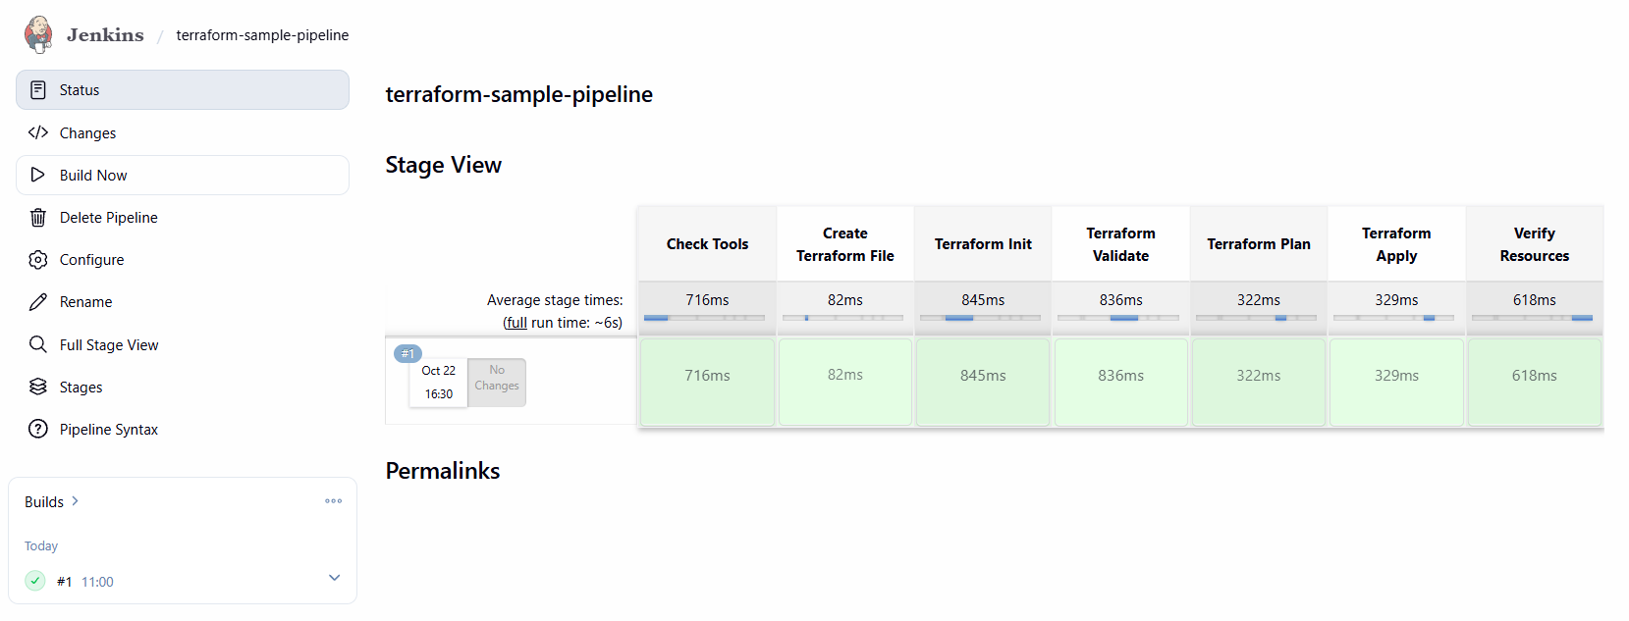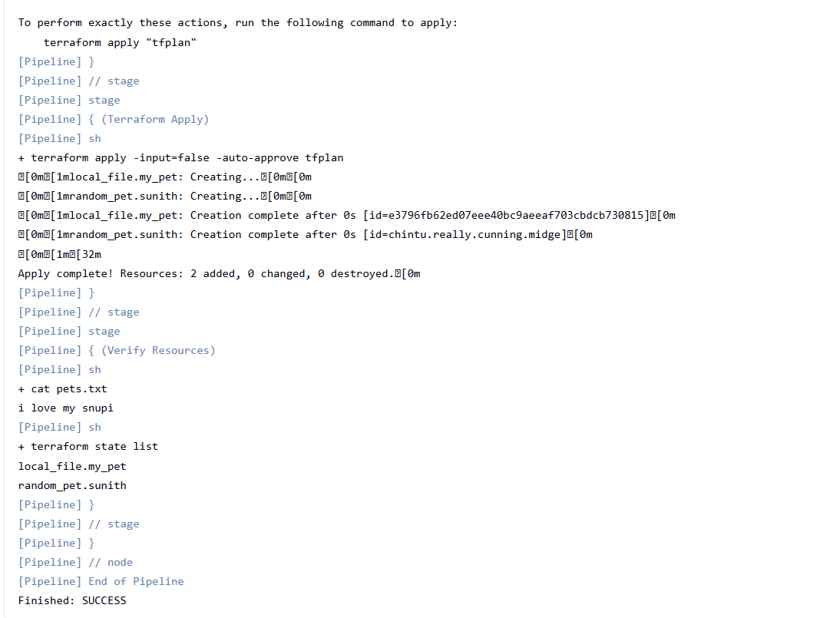
4. Conclusion
Terraform was successfully integrated with Jenkins on an AWS EC2 Linux instance. The Jenkins Pipeline executed the Terraform initialization, validation, planning, application, and verification stages successfully.
The Local provider created pets.txt containing the expected text, and the Random provider generated a pet-style name. Terraform state confirmed that both resources were managed successfully.
This practical demonstrated how Jenkins can automate Terraform execution through a CI/CD pipeline and established a foundation for future infrastructure automation projects.

