RETAIL RFM ANALYSIS

INTRODUCTION
- This project focuses on customer analysis using RFM (Recency, Frequency, Monetary) model.
- The aim is to understand customer behavior and segment them based on their purchasing patterns.

OBJECTIVE
- To analyze customer purchase behavior
- To segment customers based on RFM values
- To identify loyal and high-value customers

TOOLS USED
- Python (Pandas, NumPy)
- Excel
- Power BI
- SQL

DATA DESCRIPTION
- Collected retail transaction dataset
- Cleaned the data using Python
- Calculated:
  - Recency (last purchase date)
  - Frequency (number of purchases)
  - Monetary (total spending)
- Segmented customers based on RFM scores
- Visualized the results using Power BI dashboard

VISUALIZATION

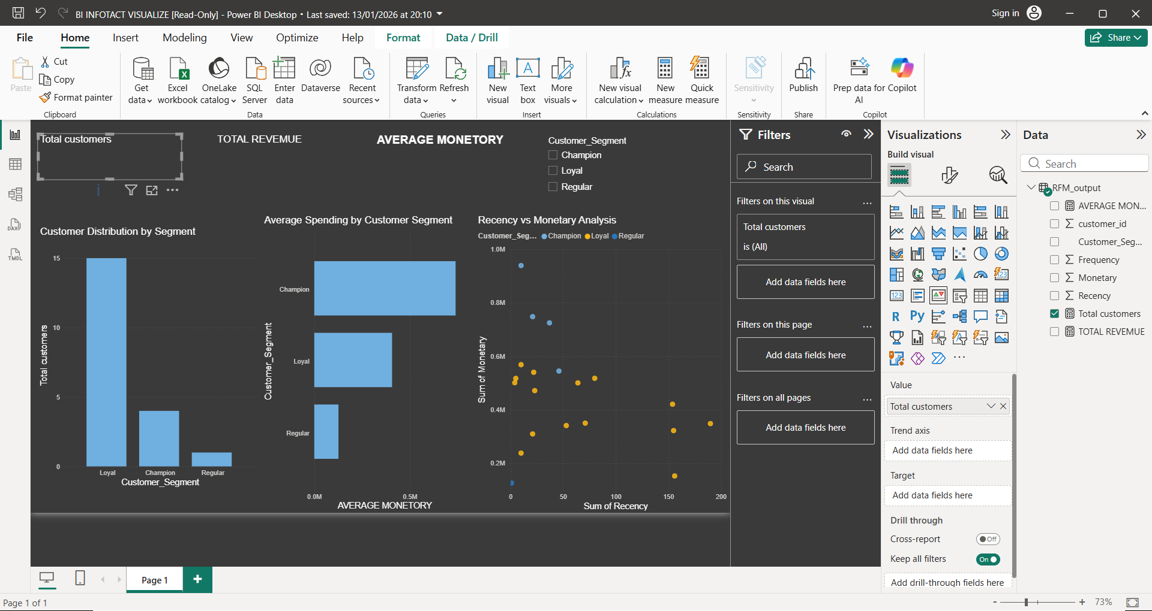

CONCLUSION
- The RFM analysis helped in identifying different customer segments such as loyal customers, regular customers, and at-risk customers.
- This helps businesses to make better marketing decisions.

