
(An Autonomous Institution, Affiliated to Anna University, Chennai)
Sports Analytics: Esports Player Performance and
Tournament Insights Using Power BI
AD23632 – FRAMEWORK FOR DATA AND VISUAL ANALYTICS
Submitted by
Name: SUNITHA T
Register Number: 241501224
Department: Artificial Intelligence and Machine Learning
Submitted to
Ms. AKSHAYA V
Academic Year: 2026–2027
TABLE OF CONTENTS
Abstract 3
Chapter 1: Introduction 4
Chapter 2: Tools and Technologies Used 5
Chapter 3: Dataset Description 6
Chapter 4: Methodology 7
Chapter 5: Power BI Dashboard and Visualizations 8
Chapter 6: Results and Discussion 12
Chapter 7: Advantages, Limitations and Future Enhancements 13
Chapter 8: Dashboard Output and Conclusion 14
ABSTRACT
The Sports Analytics project analyzes esports tournament performance records using a structured dataset and Microsoft Power BI. The dataset contains 2,800 player-match records covering 497 distinct player IDs, six teams, five player roles, five maps, and five match types (Qualifier, Group Stage, Playoff, Semi-Final, and Final). Each record includes combat statistics (kills, assists, deaths), accuracy, reaction time, a fatigue index, a performance score, a win probability, the match outcome, and an MVP award flag.
The Power BI report contains five pages. The first is an overview page with map-level comparisons, kills versus assists, MVP award distribution, and outcome-by-map comparisons. The second compares teams by win probability. The third examines how performance score is shared between MVP and non-MVP records across match types. The fourth compares player roles across several performance measures. The fifth shows the sum of record_id across teams and player roles. The project demonstrates how visual analytics can help users explore player performance, team standing, and tournament patterns.
CHAPTER 1: INTRODUCTION
1.1 Introduction
Sports analytics applies data analysis and visualization to performance records, match outcomes, and player statistics. Esports, or competitive video gaming, generates detailed per-player data in every match, which makes it well suited to analytics. This project uses a dataset of esports tournament player performance and a Power BI report to summarize map-wise performance, team win probability, MVP awards, and role-based comparisons.
1.2 Problem Statement
Tournament datasets contain many rows and attributes. Reviewing them manually makes it difficult to compare teams, roles, maps, and match stages. A visual analytics solution helps summarize records and present comparisons clearly.
1.3 Objectives
- Explore the esports performance dataset and its attributes.
- Compare map-wise totals of fatigue, performance, assists, accuracy, and deaths.
- Compare kills and assists across the dataset.
- Examine how MVP awards relate to performance score across match types.
- Compare teams by win probability and examine team and role composition.
- Compare player roles across multiple performance measures.
- Build a multi-page Power BI report.
1.4 Scope of the Project
The analysis covers 2,800 records, 497 distinct player IDs (IDs range from 1 to 500), 6 teams, 5 player roles, 5 maps, and 5 match types as represented in the supplied dataset. Results describe this dataset and are not a live tournament feed.
CHAPTER 2: TOOLS AND TECHNOLOGIES USED
2.1 Microsoft Power BI
Power BI is used to create interactive report pages and visualizations. The supplied PBIX file includes clustered column charts, a bar chart, a scatter chart, pie charts, a 100% stacked area chart, a donut chart, and a text box title.
2.2 Tabular Dataset
The data is held in a single table named esports_player_performance_tournament_analytics, imported into the Power BI data model. Such tabular data can also be stored as CSV and inspected using spreadsheet software, Python libraries, and Power BI.
2.3 Python and Pandas
Python and Pandas can be used to inspect the dataset, check data types, detect missing or duplicate rows, and calculate summary statistics.
2.4 Technologies Summary
Technology | Purpose
Tabular dataset (CSV) | Stores player-match data in rows and columns.
Microsoft Power BI | Creates charts and report pages.
Python | Supports data inspection and preprocessing.
Pandas | Loads and summarizes the dataset.
CHAPTER 3: DATASET DESCRIPTION
3.1 Dataset Overview
The Power BI data model contains one table, esports_player_performance_tournament_analytics, with 2,800 rows and 16 columns. The dataset includes record and player identifiers, team and role information, map and match type, combat statistics, accuracy, reaction time, fatigue, performance score, win probability, match outcome, and an MVP award flag.
3.2 Important Attributes
Attribute | Description
record_id | Unique identifier for each record (1 to 2,800).
player_id | Identifier for a player (1 to 500).
team_name | Team of the player: CyberX, Phantom Squad, Red Vortex, Team Alpha, Team Nova, or Titan Esports.
player_role | Role of the player: Entry Fragger, Flex, IGL, Sniper, or Support.
map_played | Map on which the match was played (five maps).
match_type | Tournament stage: Qualifier, Group Stage, Playoff, Semi-Final, or Final.
kills / assists / deaths | Combat statistics recorded for the player in the match.
accuracy_percent | Shooting accuracy as a percentage.
reaction_time_ms | Reaction time in milliseconds.
fatigue_index | Fatigue measure between 0 and 1.
performance_score | Overall performance score for the record.
win_probability | Win probability value between 0.47 and 1.00.
match_outcome | Match result: Win or Loss.
mvp_award | Whether the player received the MVP award (Yes or No).
3.3 Dataset Quality Checks
Basic inspection found 0 missing cells and 0 fully duplicated rows in the data table. These checks do not guarantee that every value is semantically valid. In particular, match_outcome contains 2,793 Win records and only 7 Loss records, which is a highly skewed distribution that should be considered when interpreting results.
CHAPTER 4: METHODOLOGY
4.1 Project Workflow
Dataset → Data Inspection → Data Preparation → Power BI Import → Visualizations → Interpretation
4.2 Data Inspection and Preparation
- Load the dataset and inspect rows and columns.
- Check column names, data types, missing values, and duplicate records.
- Confirm team, role, map, match type, outcome, and MVP fields.
- Aggregate records by map, team, role, match type, outcome, and MVP award.
- Build report visuals in Power BI.
4.3 Dashboard Development
The supplied PBIX file contains five report pages. The visuals use sums of numeric fields (such as kills, assists, performance score, and win probability) and counts of records, grouped by map, team, role, match type, match outcome, and MVP award.
4.4 Interpretation
The visuals compare map-level totals, kills versus assists, team win probability, MVP share of performance score by match type, role-level totals, and the share of record_id by team and role.
CHAPTER 5: POWER BI DASHBOARD AND VISUALIZATIONS
Dashboard Overview
The report contains five pages, each designed around a different analytical question. The charts below reproduce the visuals of each page from the supplied data.
5.1 Page 1: Performance Overview
The first page carries the title “E SPORTS ANALYTICS” and four visuals: a clustered column chart of map totals, a scatter chart by MVP award, a pie chart of kills and assists, and a clustered column chart by match outcome and map. Dust Arena has the highest total performance score (26,260.36) and Skyline the lowest (23,814.60). Neon City has the most records (576) and the highest totals for assists (4,671) and deaths (5,925). Kills total 41,643 against 22,478 assists, so kills make up 64.9% of the two combined.
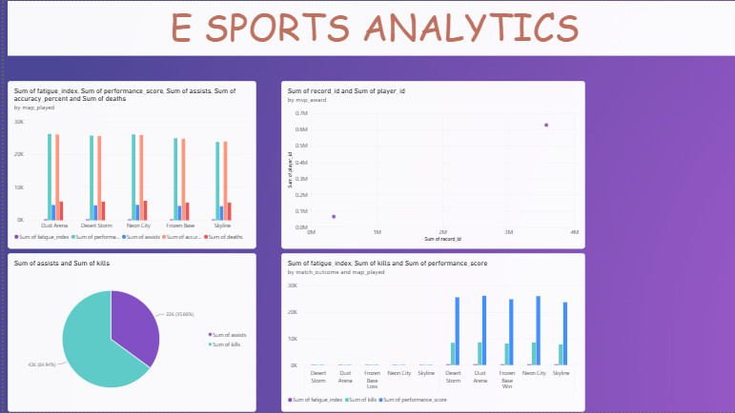
Figure 5.1: Page 1 – Performance Overview
5.2 Page 2: Team Win Probability
The second page is a pie chart of summed win probability by team. Phantom Squad has the largest share (448.01, or 17.46%), followed by Red Vortex (442.42) and CyberX (435.08). Team Nova has the smallest share (404.12, or 15.75%). Because these are sums, a team with more records contributes more; by average win probability, Team Nova is actually highest (0.923).
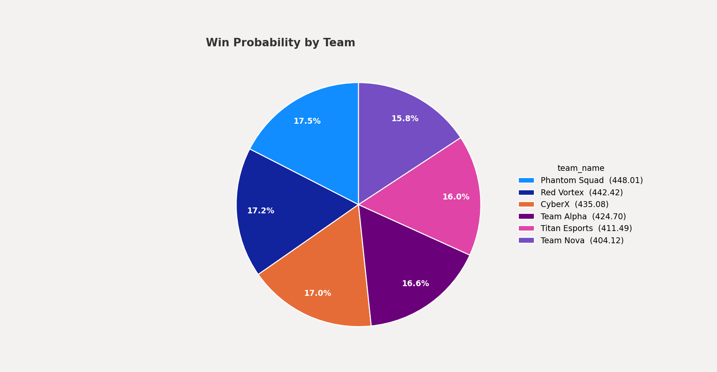
Figure 5.2: Page 2 – Win Probability by Team
5.3 Page 3: MVP Share by Match Type
The third page is a 100% stacked area chart of performance score by match type, split by MVP award. MVP records account for 14.3% of total performance score in the Group Stage, 12.6% in Playoffs, 12.5% in Finals, 11.6% in Semi-Finals, and 9.5% in Qualifiers. The Group Stage also has the most MVP records (59).
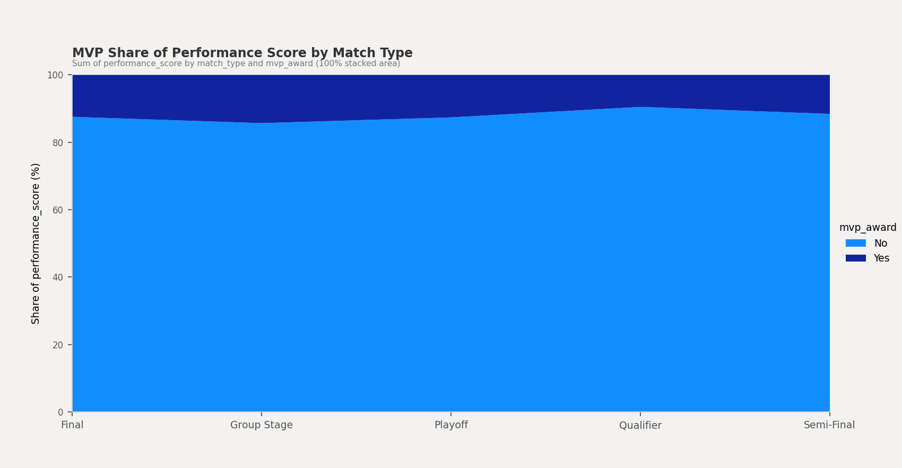
Figure 5.3: Page 3 – MVP Share of Performance Score by Match Type
5.4 Page 4: Player Role Comparison
The fourth page is a bar chart that compares player roles on summed reaction time, player ID, performance score, kills, fatigue index, and deaths. Entry Fragger has the highest totals on most measures (performance score 26,615.11 and kills 8,769), while Support has the lowest. Part of this difference reflects record counts, since Entry Fragger has the most records (584) and Support the fewest (537).
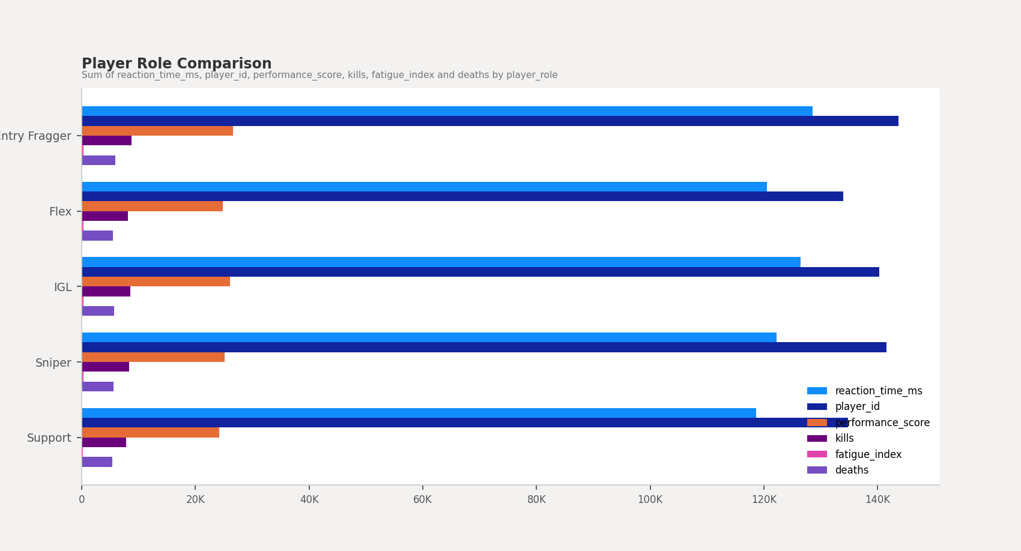
Figure 5.4: Page 4 – Player Role Comparison
5.5 Page 5: Record ID by Team and Role
The fifth page is a donut chart of the sum of record_id by team and player role, with a total of about 4M. Phantom Squad has the largest team share (18.2%) and Titan Esports the smallest (15.7%). The largest single team-role segment is Red Vortex Entry Fragger (4.07%) and the smallest is Team Nova Flex (2.58%). Because record_id is only an identifier, these segment sizes mainly reflect how many records each team-role group has (for example, Phantom Squad has 487 records and Team Nova 438).
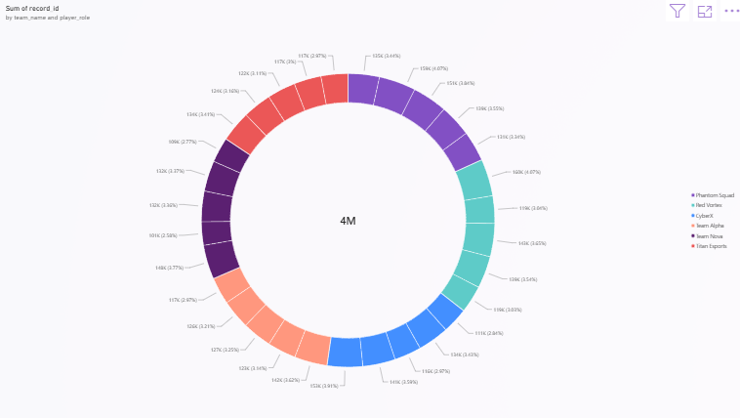
Figure 5.5: Page 5 – Sum of record_id by Team and Player Role
CHAPTER 6: RESULTS AND DISCUSSION
6.1 Results
- The dataset contains 2,800 records covering 497 distinct player IDs, 6 teams, and 5 player roles.
- Match outcomes are 2,793 Win and 7 Loss records.
- 239 records (8.5%) carry an MVP award.
- Phantom Squad has the highest summed win probability (448.01); Team Nova has the lowest (404.12).
- Dust Arena has the highest total performance score (26,260.36); Skyline has the lowest (23,814.60).
- Kills total 41,643 and assists total 22,478.
- MVP records average a performance score of 64.42, compared with 43.52 for non-MVP records.
- Entry Fragger has the most records (584) and the highest totals on most role measures.
6.2 Discussion
The dashboard combines map, team, role, match-stage, and award information. These findings are descriptive. Most visuals use summed values, so groups with more records tend to show larger totals; averages or percentages would give a fairer comparison. The findings do not establish why a team won or whether any attribute caused a better performance.
CHAPTER 7: ADVANTAGES, LIMITATIONS & FUTURE ENHANCEMENTS
7.1 Advantages
- Summarizes player-match records visually.
- Makes map, team, and role comparisons easier.
- Shows how MVP awards relate to performance across match stages.
- Highlights team and role composition.
- Provides a multi-page report in Power BI.
7.2 Limitations
- Results depend on the supplied dataset’s correctness.
- Outcomes are heavily skewed (2,793 wins against 7 losses), limiting win-versus-loss comparisons.
- Several visuals sum fields such as player_id, record_id, and reaction_time_ms, which are not meaningful as totals.
- Sums are influenced by the number of records in each group; averages would be fairer.
- Counts alone do not explain the causes behind outcomes.
- The dashboard is not live unless connected to an updating source.
7.3 Future Enhancements
- Add slicers for team, role, map, and match type.
- Use averages and percentages (for example, average performance score and MVP rate) instead of raw sums.
- Add a kill/death ratio measure.
- Analyze the relationship between fatigue index, reaction time, and performance score.
- Add drill-through pages for individual teams or players.
- Validate the outcome and win probability fields.
CHAPTER 8: DASHBOARD OUTPUT AND CONCLUSION
8.1 Dashboard Output
Figure 8.1: Power BI dashboard output (Page 1)
8.2 Conclusion
The Sports Analytics project demonstrates how esports tournament data can be explored and summarized using Microsoft Power BI. The report presents map-level performance, kills versus assists, MVP award distribution, team win probability, role comparisons, and team-role composition through visualizations.
The project provides practical experience in dataset inspection, aggregation, visual analytics, and dashboard presentation. Findings remain limited to the records and fields available in the supplied dataset.

