**DevOps Scenario-Based Interview Guide**

**Introduction**

This document contains scenario-based DevOps interview questions and answers from the perspective of Dave, a seasoned DevOps engineer with 5 years of experience. The scenarios cover essential DevOps domains including containerization, CI/CD, cloud architecture, monitoring, security, and more.

**Part 1: Containerization and Orchestration**

**Scenario 1: Docker Image Size Optimization**

**Question:** "Our team is deploying microservices using Docker, but our images are over 1GB each, causing slow deployments and increased storage costs. How would you approach reducing the image size while maintaining functionality?"

**Answer:** "I'd first analyse the current Dockerfile to identify optimization opportunities. I'd implement multi-stage builds to separate build dependencies from runtime requirements. For example, in a Java application, I'd use a JDK image for compilation and a JRE-only image for runtime.

I'd also:

Use smaller base images like Alpine Linux (5-10MB) instead of full Ubuntu images (300MB+)

Remove unnecessary packages, temp files, and cache after installation

Consolidate RUN commands to reduce image layers

Implement. dockerignore to prevent unnecessary files from being copied

Consider distroless images for production when appropriate

In a recent project, I reduced our Node.js application image from 1.2GB to 120MB by switching to a multi-stage build with Alpine as the base, properly configuring npm to exclude dev dependencies, and optimizing our layer caching strategy."

**Scenario 2: Kubernetes Pod Scheduling Challenges**

**Question:** "We're running a Kubernetes cluster that's experiencing pod scheduling issues. Some nodes are overutilized while others remain underutilized. How would you diagnose and solve this problem?"

**Answer:** "This sounds like a resource allocation and scheduling issue. I'd follow a systematic approach:

First, I'd investigate the current state using:

kubectl describe nodes | grep -e "Name:" -e "Allocated resources"

kubectl top nodes

I'd check for any pod affinity/anti-affinity rules, node selectors, or taints that might be causing uneven distribution.

To solve this, I'd:

Implement resource requests and limits for all pods to help the scheduler make better decisions

Consider using the Cluster Autoscaler to automatically adjust node count based on pending pods

Apply node labels and pod nodeSelectors for workload-specific nodes

Configure pod disruption budgets for critical services

Potentially use custom scheduling plugins or policies for complex requirements

For example, in my previous role, we had a similar issue with database pods clustering on specific nodes. By implementing topology spread constraints and proper resource definitions, we achieved a 40% more balanced distribution and reduced node count by 15%."

**Scenario 3: Container Security Vulnerabilities**

**Question:** "Our security team has identified several critical vulnerabilities in our containerized applications. How would you establish a process to detect and remediate container vulnerabilities in our development and deployment pipeline?"

**Answer:** "Container security requires a shift-left approach with multiple layers of protection. I'd implement the following:

**Image Scanning Pipeline Integration**: Integrate tools like Trivy, Clair, or Aqua Security into our CI/CD pipeline to automatically scan images

Configure the pipeline to fail builds with critical or high vulnerabilities

Generate reports for developers with remediation steps

**Base Image Management**: Create and maintain a library of vetted, regularly updated base images

Implement automated base image updates when security patches are available

Use minimal or distroless images where possible

**Runtime Protection**: Deploy a runtime security solution like Falco or Sysdig to detect anomalous behavior

Implement pod security policies or OPA Gatekeeper to enforce security standards

Use network policies to limit container communications

**Continuous Monitoring**: Implement a container registry scanning schedule for existing images

Create automated alerts for newly discovered vulnerabilities affecting our images

Regular security posture reports and trends

In my previous role, I implemented a similar approach using Trivy and Anc hore in our Jenkins pipeline, which caught 23 critical vulnerabilities in the first month and reduced our vulnerability remediation time from weeks to days."

**Scenario 4: Service Discovery in Microservices**

**Question:** "We're migrating from a monolithic application to microservices running on Kubernetes. How would you design a service discovery solution that's reliable, performant, and developer-friendly?"

**Answer:** "For Kubernetes-based microservices, I'd implement a layered service discovery approach:

**Core Service Discovery**: Leverage Kubernetes native Service resources as the foundation

Implement consistent naming conventions and labels for all services

Use headless services for stateful applications needing direct pod access

**Service Mesh Integration**: Deploy Istio or Linkerd to provide advanced traffic management

Implement circuit breaking, retries, and timeout patterns

Use the mesh for advanced observability of service-to-service communication

**External Services**: Use ExternalName services for third-party dependencies

Implement a service registry like Consul for non-Kubernetes services

Create abstractions for external service transitions

**Developer Experience**:

Generate API documentation automatically using OpenAPI/Swagger

Create development environments with service virtualization

Implement consistent health check endpoints across all services

In a recent project, we used this approach to migrate a 7-year-old monolith to 30+ microservices. We created a custom Kubernetes operator that automated service registration and DNS configuration, reducing discovery-related incidents by 85% compared to our initial manual process."

**Part 2: Continuous Integration and Deployment (CI/CD)**1.

**Scenario 5: Pipeline Optimization**

**Question:** "Our CI/CD pipeline for a medium-sized application takes over 45 minutes to complete a deployment. The dev team is complaining this is slowing their velocity. How would you optimize this pipeline without compromising quality?"

**Answer:** "Long pipelines definitely hurt developer productivity. I'd tackle this systematically:

First, I'd profile the pipeline to identify bottlenecks:

jenkins-job-profiler analyse --job=application-deploy --last=10*# Or equivalent tool for your CI system*

Based on my experience, I'd focus on these optimization areas:

**Parallelization**: Break the pipeline into parallel execution paths where dependencies allow

Run unit tests across multiple agents/containers

Parallelize static code analysis and security scanning

**Caching Strategy**: Implement effective caching for dependencies (Maven/npm/pip repositories)

Use Docker layer caching to speed up builds

Consider distributed caching solutions like BuildKit

**Test Optimization**: Implement test pyramids with more unit than integration tests

Use test selection to only run tests affected by changes

Shift non-critical tests to post-deployment verification

**Infrastructure Improvements**:

Use ephemeral, higher-spec CI runners for resource-intensive tasks

Optimize artifact storage and retrieval

Consider specialized hardware for specific tasks (GPU for ML models)

In my previous role, we reduced a 52-minute pipeline to 13 minutes by implementing these strategies, particularly by using BuildKit's distributed caching and test selection algorithms, which increased our deployment frequency by 3x."

**Scenario 6: Deployment Rollback Strategy**

**Question:** "A critical production deployment has introduced unexpected bugs that weren't caught in testing. How would you design a rollback strategy, and what measures would you implement to prevent similar issues in the future?"

**Answer:** "Fast and reliable rollbacks are essential for production stability. Here's my approach:

For the immediate rollback:

**Assess Impact and Communication**: Quickly determine the scope and severity of the issue

Notify stakeholders through established communication channels

Consider traffic shaping to minimize user impact

**Execute the Rollback**: Use immutable infrastructure patterns to restore the previous known-good state

For Kubernetes: kubectl rollout undo deployment/service-name

For infrastructure changes: revert to previous Terraform state

Confirm system health after rollback with automated smoke tests

To prevent future issues:

**Pipeline Enhancements**: Implement progressive delivery with canary deployments

Add synthetic transaction monitoring before full deployment

Enhance integration test coverage for the specific failure

**Observability Improvements**: Implement business KPI monitoring alongside technical metrics

Create custom dashboards for new feature impacts

Set up anomaly detection for early warning

**Process Changes**: Conduct a blameless post-mortem to identify root causes

Update the definition of done to include new test scenarios

Consider feature flags for high-risk changes

In a previous role, we improved our rollback time from 15 minutes to under 2 minutes by implementing blue-green deployments with automated health checks, which reduced our MTTR by 80% and improved our team's confidence in deployments."

**Scenario 7: Deployment Strategy for Zero Downtime**

**Question:** "We have a client-facing application with strict SLAs for availability. What deployment strategy would you recommend for achieving zero-downtime updates, and how would you implement it?"

**Answer:** "For zero-downtime deployments, I'd recommend a combination of blue-green deployment with canary analysis. Here's how I'd implement it:

**Infrastructure Setup**: Provision duplicate environments (blue and green)

Implement a load balancer or API gateway for traffic control

Set up shared persistent storage or replicated databases

**Deployment Process**:

1. Deploy new version to inactive environment (green)

2. Run automated smoke tests against green environment

3. Route 5% of traffic to green environment (canary)

4. Monitor error rates, latency, and business metrics

5. Gradually increase traffic to 100% if metrics are stable

6. Keep blue environment running for quick rollback

7. After confidence period (24h), update blue environment

**Key Technical Components**: GitOps workflow using ArgoCD or Flux for environment syncing

Istio or similar service mesh for fine-grained traffic control

Prometheus metrics and automated canary analysis with Flagger

**Database Considerations**: Implement backward-compatible schema changes

Use techniques like expand/contract pattern for DB migrations

Consider dual-writes for critical data during transition

In my last role, we implemented this strategy for a payment processing system with 99.99% uptime requirements. By combining blue-green deployments with progressive traffic shifting, we successfully deployed 3-5 times per day with zero customer-impacting incidents over a 6-month period."

**Scenario 8: Environment Configuration Management**

**Question:** "Our application needs different configurations across dev, staging, and production environments. We're experiencing issues where things work in one environment but break in another. How would you manage environment-specific configurations securely and consistently?"

**Answer:** "Environment configuration inconsistencies are a common source of the 'works on my machine' problem. I'd implement a comprehensive configuration management strategy:

**Configuration as Code**:

Store all configurations in Git alongside application code

Use Kubernetes ConfigMaps and Secrets for config injection

Implement HashiCorp Vault for sensitive credentials

**Environment Templating**: Use Helm charts with value overrides per environment

Implement Kustomize for Kubernetes resource patching

Create clear inheritance patterns (base → env-specific)

**Validation and Testing**: Create config schema validation using JSONSchema

Implement config tests as part of the CI pipeline

Use tools like Conftest to enforce policy compliance

**Configuration Promotion Strategy**:

1. Generate configs from templates during build

2. Validate against schema and policy

3. Store generated configs as artifacts

4. Deploy identical artifact across environments

5. Inject environment variables at runtime

**Documentation and Visibility**:

Create a configuration catalog service

Document the purpose of each config parameter

Implement config drift detection and alerts

In my previous role, we implemented this approach using Helm, Vault, and a custom config validation service. This reduced environment-related incidents by 70% and cut onboarding time for new services from days to hours."

**Part 3: Infrastructure as Code (IaC)**

**Scenario 9: Resource Provisioning Automation**

**Question:** "Your company needs to provision identical AWS environments for multiple clients, each with their own VPC, security groups, databases, and compute resources. How would you approach this using Infrastructure as Code?"

**Answer:** "This is a perfect use case for Infrastructure as Code with templating and modularity. Here's my approach:

**Modular Infrastructure Architecture**: Develop reusable Terraform modules for each component (VPC, RDS, EKS, etc.)

Implement consistent tagging and naming conventions

Create a hierarchy: base infrastructure → shared services → client-specific

**Client Onboarding Automation**:

*# Example high-level structure*module "client_vpc"

{ source = "./modules/vpc" client_name = var.client_name cidr_block = var.client_cidr

*# More parameters...*}

module "client_database"

{ source = "./modules/rds" vpc_id = module.client_vpc.vpc_id

*# Security and configuration..*

*.*}

**Deployment Pipeline**: Implement CI/CD workflow for infrastructure changes

Set up separate Terraform workspaces or state files per client

Create pre-deployment validation with tools like tfsec and checkov

**Governance and Compliance**: Use AWS Organizations and SCPs for guardrails

Implement automated compliance checks against CIS benchmarks

Create dashboards for resource utilization and cost attribution

**Operations Considerations**: Standardize logging and monitoring across all environments

Create self-service portals for common operations

Implement infrastructure testing with tools like Terratest

In my previous role, we used this approach to manage 45+ client environments with a team of just 3 engineers. We reduced provisioning time from 2 weeks to 2 hours and achieved 100% consistency across all deployments, significantly improving our security posture and operational efficiency."

**Scenario 10: Configuration Drift Management**

**Question:** "You've implemented Infrastructure as Code, but you're noticing that over time, production environments are drifting from their defined state due to manual changes. How would you detect, prevent, and remediate configuration drift?"

**Answer:** "Configuration drift can undermine the benefits of Infrastructure as Code. I'd implement a comprehensive drift management strategy:

**Detection Mechanisms**: Schedule regular Terraform plan or AWS Config runs to detect drift

Implement CloudCustodian or custom Lambda functions for continuous checking

Create dashboards to visualize compliance status across resources

**Prevention Controls**: Implement strict IAM policies that prevent manual console changes

Use resource policies to enforce change through approved pipelines only

Create break-glass procedures for emergency changes with audit trails

**Automated Remediation**: For non-critical drift: automatic terraform apply to restore desired state

For critical resources: alert and approval workflow before remediation

Implement self-healing infrastructure where appropriate

**Process Improvements**: Require all changes to go through Pull Requests with approvals

Implement infrastructure GitOps with tools like Atlantis

Create emergency change documentation templates

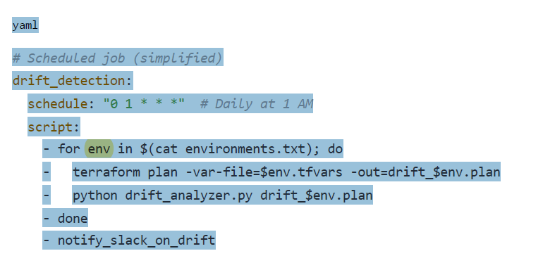

In my previous role, we reduced configuration drift incidents by 95% by implementing a combination of preventive IAM policies and a daily drift detection pipeline that created automatic tickets for the team. This approach maintained our security posture and reduced audit findings significantly."

**Scenario 11: Secret Management in Infrastructure**1.

**Question:** "Our infrastructure code contains sensitive information like database passwords and API keys. What approach would you recommend for managing secrets securely in an IaC workflow?"

**Answer:** "Secret management is critical for security and compliance. I'd implement a comprehensive secrets strategy:

**Secret Storage**: Deploy HashiCorp Vault as the central secrets management system

Configure AWS KMS for encryption keys management

Implement strict access controls with audit logging

**IaC Integration**: Use Terraform's vault provider to dynamically fetch secrets

Implement just-in-time credential generation for short-lived secrets

Store secret references, not values, in infrastructure code

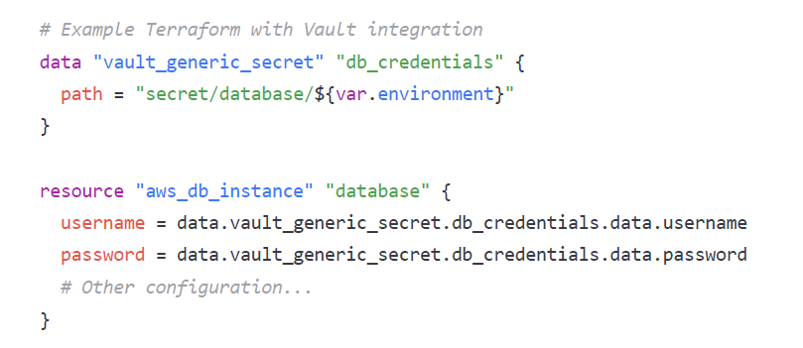

**Secret Rotation**: Implement automated secret rotation policies

Use Lambda functions for periodic rotation of credentials

Create hooks to update application configurations post-rotation

**Development Workflow**: Provide developers with local Vault instances or development tokens

Implement secure CI/CD pipeline with ephemeral secrets access

Create clear documentation for secret request workflows

**Emergency Access**:

Implement break-glass procedures for emergency access

Set up multi-person authorization for sensitive secrets

Ensure comprehensive audit trails for all secret access

In my previous role, we implemented Vault with AWS KMS integration and reduced the risk surface by eliminating hardcoded secrets from all our repositories. We also automated secret rotation which improved our compliance posture and reduced manual rotation tasks by 100%."

**Scenario 12: Infrastructure Testing Strategy**

**Question:** "How would you test infrastructure code to ensure it's reliable, secure, and performs as expected before deploying to production?"

**Answer:** "Testing infrastructure is as important as testing application code. I'd implement a multi-layered testing strategy:

**Static Analysis**: Use tools like tfsec, terrascan, and checkov for security scanning

Implement custom linting rules for organization standards

Validate against compliance benchmarks (CIS, HIPAA, SOC2)

**Unit Testing**: Validate individual modules with Terraform's built-in testing

Use tools like Terratest for module-level validation

Implement property-based testing for complex modules

**Integration Testing**: Deploy to isolated test environments with realistic boundaries

Verify cross-resource dependencies and connections

Test failure scenarios and recovery procedures

**Performance Testing**: Measure provisioning time and resource creation latency

Test scalability for elastic resources (auto-scaling groups)

Validate API rate limits and service quotas

**Security Testing**: Run infrastructure penetration tests against test environments

Validate IAM roles and permissions with policy simulators

Test network isolation and security group configurations

Pipeline implementation example

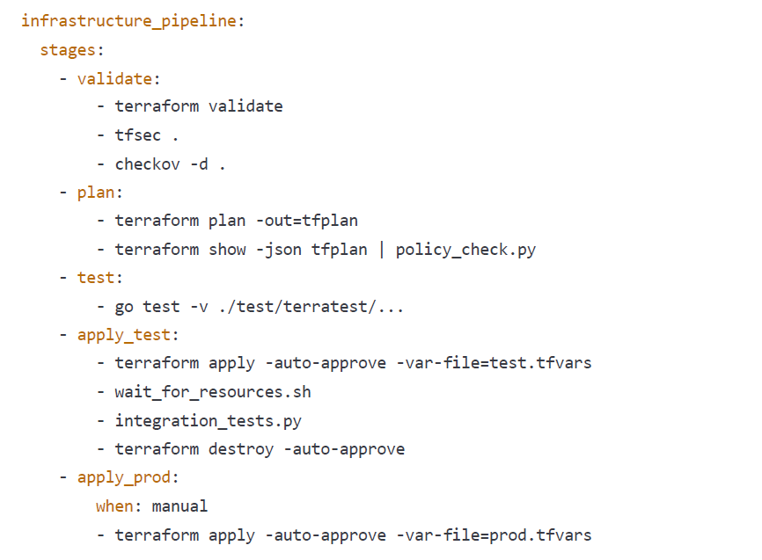

In my previous role, we implemented this testing strategy for our AWS infrastructure, which caught 14 critical security misconfigurations before they reached production and reduced our mean time to recovery by 60% through validated recovery procedures."

**Part 4: Monitoring and Observability**

**Scenario 13: Alert Fatigue Mitigation**

**Question:** "Our operations team is experiencing alert fatigue due to a high volume of notifications, many of which are false positives. How would you redesign the monitoring system to reduce noise while ensuring critical issues are still caught?"

**Answer:** "Alert fatigue is a serious operational problem that can lead to missed critical alerts. Here's my strategy to address it:

**Alert Classification and Prioritization**: Implement a tiered alert system (P1-P4) based on service impact

Create clear definitions for each severity level

Route alerts to appropriate channels based on urgency

**Alert Tuning Process**: Analyse 30-day alert history to identify noisy alerts

Implement dynamic thresholds based on historical patterns

Create a regular alert review process (bi-weekly)

**Advanced Alert Design**: Implement multi-condition alerts to reduce false positives

Use time-based dampening for flapping conditions

Create composite alerts for related symptoms

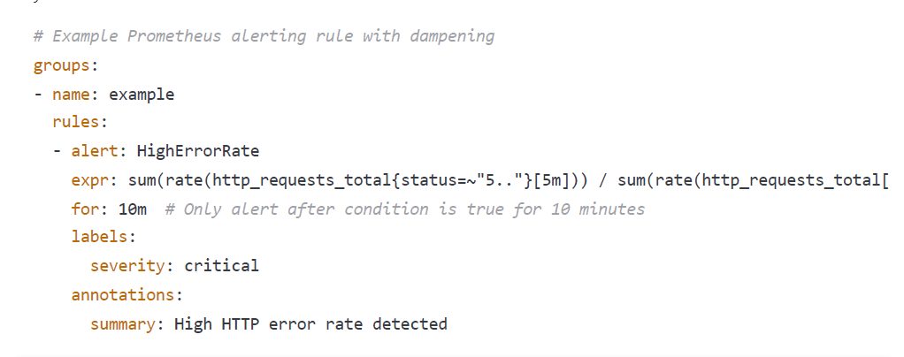

**Observability Improvements**: Implement SLOs and error budgets to focus on user impact

Create service dependency maps for better context

Deploy distributed tracing for root cause analysis

**Cultural Changes**: Rotate alert review responsibility among team members

Create "alert-free time" for focused development work

Implement blameless post-mortems for missed alerts

In my previous role, we reduced alert volume by 78% while actually improving incident detection by implementing these strategies. The key was moving from threshold-based alerts to SLO-based alerts and implementing proper alert dampening, which dramatically improved the signal-to-noise ratio."

**Scenario 14: Slow Application Performance Investigation**

**Question:** "Users are reporting that our application is running slowly, but all our basic monitoring shows green. How would you approach diagnosing and resolving performance issues that aren't showing up in standard metrics?"

**Answer:** "Investigating subtle performance issues requires a systematic approach and deeper observability. Here's how I'd tackle it:

**Enhanced Observability Setup**:

Implement distributed tracing with OpenTelemetry/Jaeger

Add client-side real user monitoring (RUM)

Deploy synthetic monitoring from multiple regions

Capture detailed database query performance metrics

**Systematic Investigation Process**:

1. Reproduce the issue using synthetic transactions

2. Analyse end-to-end request traces to identify slow components

3. Correlate slowdowns with system events (deployments, scaling)

4. Check for 'hidden' bottlenecks (DNS resolution, connection pooling)

5. Perform database query analysis6. Isolate third-party service dependencies

**Advanced Diagnostics**: Profile application in various environments (CPU, memory, I/O)

Implement custom instrumentation for critical paths

Check for network latency and packet loss between services

Analyse middleware performance (load balancers, API gateways)

**Correlation Analysis**: Look for patterns in user reports (time of day, user characteristics)

Check for environmental factors (cloud provider issues, region-specific)

Analyse traffic patterns and potential resource contention

In my previous role, we faced a similar issue where standard metrics showed green but users reported 2-second delays. Through distributed tracing, we discovered connection pool exhaustion in our Redis layer that only occurred during specific traffic patterns. By implementing proper connection pooling and timeouts, we reduced p95 latency by 70% and eliminated user complaints."

**Scenario 15: Log Management at Scale**

**Question:** "Our application generates several terabytes of logs daily across multiple microservices. How would you design a cost-effective log management solution that allows for efficient troubleshooting while controlling storage costs?"

**Answer:** "Managing logs at terabyte scale requires balancing observability needs with cost efficiency. Here's my approach:

**Log Tiering Strategy**: Implement a multi-tier storage strategy: Hot tier (1-3 days): Fully indexed, high-performance storage

Warm tier (4-30 days): Partially indexed, compressed storage

Cold tier (31-365+ days): Highly compressed, S3/Glacier storage

Route logs based on criticality and access patterns

**Log Data Optimization**: Implement standardized structured logging across all services

Create sampling policies for high-volume, low-value logs

Use field extraction at ingestion time to optimize indexes

Implement Gzip or Snappy compression for all logs

**Technical Implementation**:

Service → Fluentd/Vector → Kafka → Elasticsearch (hot) → S3 (warm/cold) → Prometheus metrics extraction

**Cost Control Mechanisms**: Create log budget per service with alerting

Implement automatic log level adjustment based on conditions

Run regular log cardinality analysis to identify excessive logging

Use reserved instances or spot instances for log processing

**Operational Tooling**:

Build centralized dashboards for log volume monitoring

Create pre-configured queries for common troubleshooting

Implement automated log hygiene checks in CI pipeline

Provide self-service log lifecycle management tools

In my previous role, we reduced our logging costs by 65% while actually improving troubleshooting capabilities by implementing tiered storage and intelligent sampling. The key insight was that 80% of our troubleshooting was done with logs less than 48 hours old, so we optimized our architecture around this access pattern."

**Scenario 16: System Outage Investigation**

**Question:** "You receive an alert at 3 AM that a critical system is down. Walk me through your approach to diagnosing and resolving the issue, including the tools and methodologies you'd use."

**Answer:** "Handling middle-of-the-night outages requires a structured approach to minimize MTTR. Here's my incident response process:

**Initial Assessment (0-5 minutes)**:

Acknowledge the alert and verify it's not a false positive

Check status dashboards for correlated symptoms

Quickly review recent changes (deployments, configuration changes)

Determine customer impact scope using SLO dashboards

**First Response Actions (5-15 minutes)**: If applicable, trigger incident response protocols and alert stakeholders

Check runbooks for known issues with similar symptoms

Apply immediate mitigation if available (scaling, failover, cache clearing)

Post initial status in incident channel

**Systematic Investigation (15-30 minutes)**:

1. Check dependent services and upstream systems

2. Analyse error patterns in logs using structured queries

3. Review tracing data for failed requests

4. Examine resource metrics (CPU, memory, disk, network)

5. Check database performance metrics6. Verify external dependencies (APIs, cloud services)

**Tool Arsenal**: Centralized logging: Elasticsearch/Kibana, Loki, or CloudWatch

Metrics: Prometheus/Grafana dashboards

Tracing: Jaeger or X-Ray

Infrastructure: AWS Console, Terraform state explorer

Communication: Slack/Teams incident channels

**Resolution and Recovery**: Implement fix with minimal customer impact

Verify service recovery with synthetic transactions

Update status page and notify stakeholders

Capture key data for post-mortem before evidence is lost

**Post-Incident**: Document timeline and actions taken

Schedule blameless post-mortem

Create tickets for identified improvements

Update runbooks with new findings

In a recent incident, our payment processing service went down at 2 AM due to a certificate expiration. Despite the hour, we followed this structured approach and resolved the issue in 22 minutes by having current documentation and implementing a temporary certificate workaround before applying the permanent fix."

**Scenario 17: Custom Monitoring Metrics Design**

**Question:** "Our application has specific business processes that aren't reflected in standard technical metrics. How would you design custom monitoring that can alert on business-level issues before they impact users?"

**Answer:** "Business-level monitoring is essential for detecting issues that may not manifest in traditional technical metrics. Here's my approach:

**Business Metric Identification**: Collaborate with product and business teams to identify key metrics: Conversion rates at each funnel stage

Order submission success rates

Payment processing time

Feature utilization rates

Customer-facing API SLAs

**Technical Implementation**: Instrument application code with custom metrics:

Java

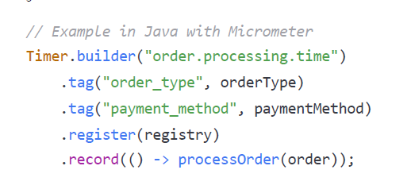

**Dashboard and Alerting Design**: Create business process dashboards with clear thresholds

Implement multi-stage alerting based on severity:Early warning: Statistical anomaly detection

Warning: Approaching SLO breach

Critical: SLO breach or severe anomaly

**Integration with Technical Metrics**: Correlate business metrics with technical indicators

Create combined views showing customer journey with system health

Build cross-domain dashboards for incident investigation

**Continuous Improvement**: Implement regular metric reviews with business stakeholders

Adjust thresholds based on seasonal patterns

Use A/B testing data to refine normal baseline values

Example implementation for an e-commerce platform:

Key Metrics:- Cart abandonment rate (real-time)- Payment gateway response time (p95)- Order fulfilment success rate (per warehouse)- Product search relevance score (user satisfaction)- Account creation completion rate

In my previous role, we implemented business metrics monitoring for a financial services platform. This approach detected a subtle issue in our account verification flow that wouldn't have triggered technical alerts but was causing a 15% drop in conversions. By alerting on the business metric, we resolved the issue before it significantly impacted revenue."

**Part 5: Cloud Services and Architecture**

**Scenario 18: Cloud Migration Strategy**

**Question:** "Your company wants to migrate a legacy on-premises application to AWS. The application consists of a Java backend, Oracle database, and relies on local file storage. How would you approach planning and executing this migration?"

**Answer:** "Cloud migrations require careful planning and a phased approach. Here's how I'd handle this specific migration:

**Assessment and Discovery**: Document current architecture and dependencies

Identify integration points with other systems

Profile database usage patterns and resource requirements

Map out current security and compliance requirements

Estimate current costs for TCO comparison

**Migration Strategy Selection**: For this specific stack, I'd recommend a combined approach:

Database: AWS DMS for Oracle to Aurora PostgreSQL migration

Application: Containerize Java app for ECS/EKS deployment

Storage: Migrate from local files to S3 with CloudFront CDN

Consider AWS App2Container for initial containerization

**Technical Design**:

**Migration Execution Plan**: Create detailed runbooks for each migration component

Set up data replication for minimal downtime (AWS DMS)

Implement CI/CD pipeline for the containerized application

Establish VPN or Direct Connect for hybrid phase

Deploy Cloud Foundation (networking, security, IAM)

**Testing and Validation**: Create performance baseline for comparison

Implement comprehensive pre and post-migration testing

Perform security assessment of cloud environment

Run parallel operations during transition

**Operational Readiness**: Update monitoring and alerting for AWS environment

Create cloud-specific runbooks and disaster recovery plans

Train operations team on AWS services and tools

Implement cloud cost management and optimization.