schema.sql

Query for creating schema

-- Create Product_Category table
CREATE TABLE Product_Category (
id INTEGER PRIMARY KEY AUTOINCREMENT,
name VARCHAR(100) NOT NULL,
desc TEXT,
created_at TIMESTAMP DEFAULT CURRENT_TIMESTAMP,
modified_at TIMESTAMP DEFAULT CURRENT_TIMESTAMP,
deleted_at TIMESTAMP
);

-- Create Product table
CREATE TABLE Product (
id INTEGER PRIMARY KEY AUTOINCREMENT,
name VARCHAR(100) NOT NULL,
desc TEXT,
SKU VARCHAR(50) NOT NULL,
category_id INT,
inventory_id INT,
price DECIMAL(10, 2) NOT NULL,
discount_id INT,
created_at TIMESTAMP DEFAULT CURRENT_TIMESTAMP,
modified_at TIMESTAMP DEFAULT CURRENT_TIMESTAMP,
deleted_at TIMESTAMP,
FOREIGN KEY (category_id) REFERENCES Product_Category(id),
FOREIGN KEY (inventory_id) REFERENCES Product_Inventory(id),
FOREIGN KEY (discount_id) REFERENCES Discount(id)
);

-- Create Product_Inventory table
CREATE TABLE Product_Inventory (
id INTEGER PRIMARY KEY AUTOINCREMENT,
quantity INT NOT NULL,
created_at TIMESTAMP DEFAULT CURRENT_TIMESTAMP,
modified_at TIMESTAMP DEFAULT CURRENT_TIMESTAMP,
deleted_at TIMESTAMP
);

-- Create Discount table
CREATE TABLE Discount (
id INTEGER PRIMARY KEY AUTOINCREMENT,
name VARCHAR(100) NOT NULL,
desc TEXT,
discount_percent DECIMAL(5, 2) NOT NULL,
active BOOLEAN DEFAULT 1,
created_at TIMESTAMP DEFAULT CURRENT_TIMESTAMP,
modified_at TIMESTAMP DEFAULT CURRENT_TIMESTAMP,
deleted_at TIMESTAMP
);

Output:

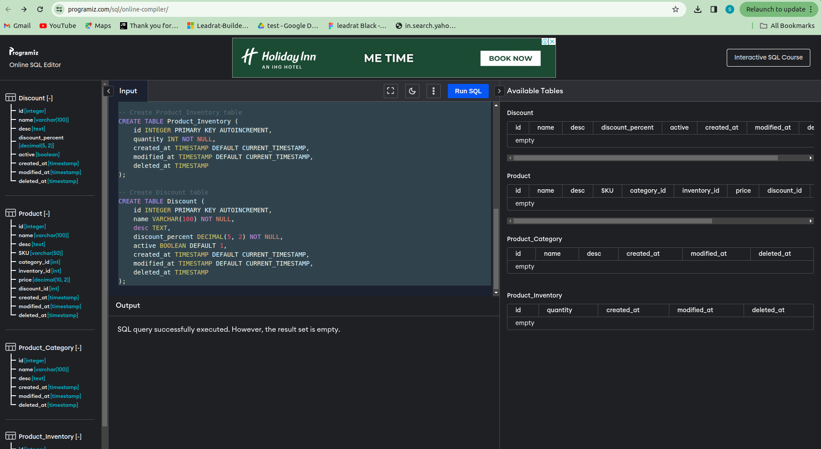

Query for insert data

INSERT INTO Product_Category (name, desc) VALUES ('Electronics', 'Category for electronic products');
INSERT INTO Product_Category (name, desc) VALUES ('Clothing', 'Category for clothing products');

INSERT INTO Product_Inventory (quantity) VALUES (100);
INSERT INTO Product_Inventory (quantity) VALUES (500);

INSERT INTO Discount (name, desc, discount_percent, active)
VALUES ('Summer Sale', 'Discount for summer season', 20.00, 1);

INSERT INTO Discount (name, desc, discount_percent, active)
VALUES ('Clearance Sale', 'Clearance discount', 30.00, 1);

INSERT INTO Product (name, desc, SKU, category_id, inventory_id, price, discount_id)
VALUES ('Laptop', 'High-performance laptop', 'SKU123', 1, 1, 1200.00, 1);

INSERT INTO Product (name, desc, SKU, category_id, inventory_id, price, discount_id)
VALUES ('T-shirt', 'Cotton T-shirt', 'SKU456', 2, 2, 25.00, NULL);

Output:

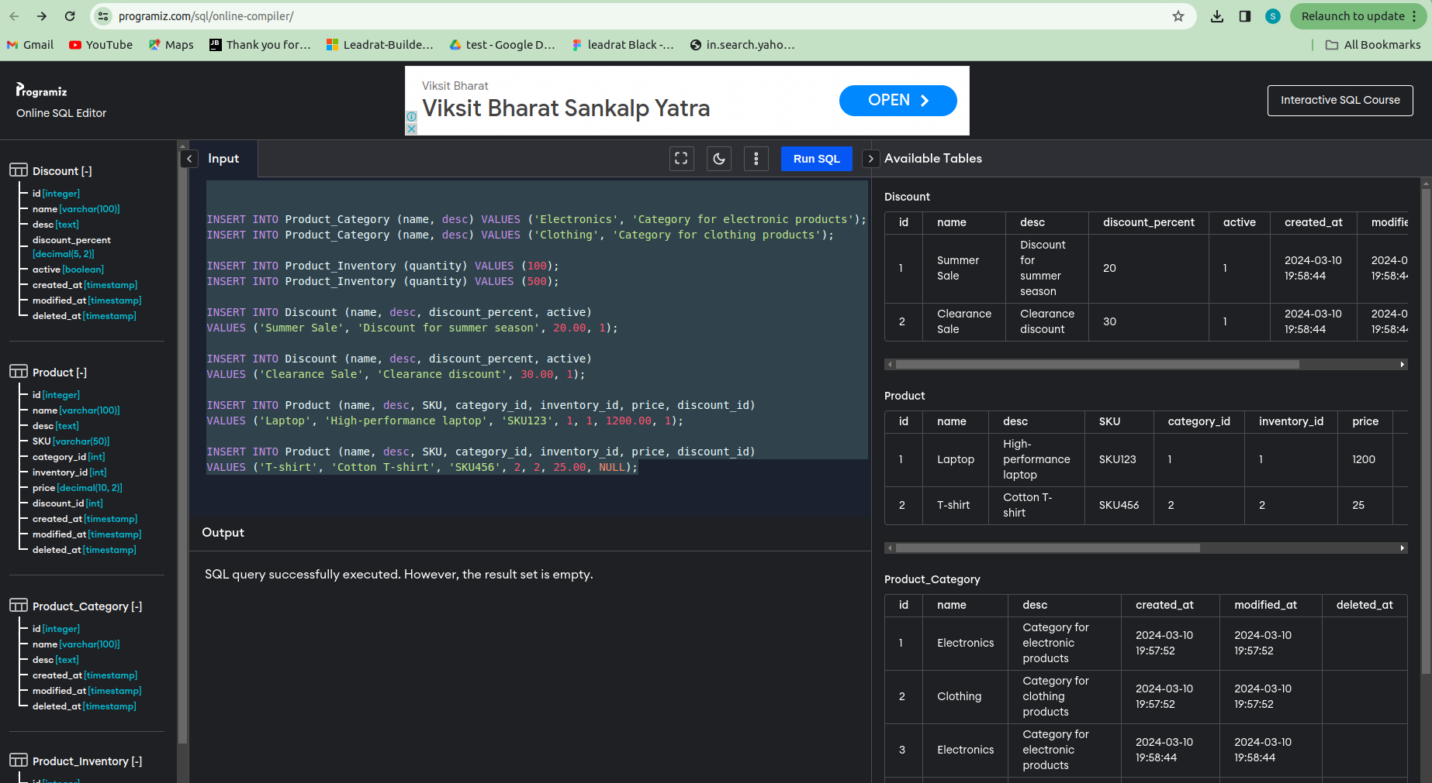

Query for deleted_at (using for Product_Category Table )

UPDATE Product_Category
SET deleted_at = CURRENT_TIMESTAMP
WHERE id = 2;

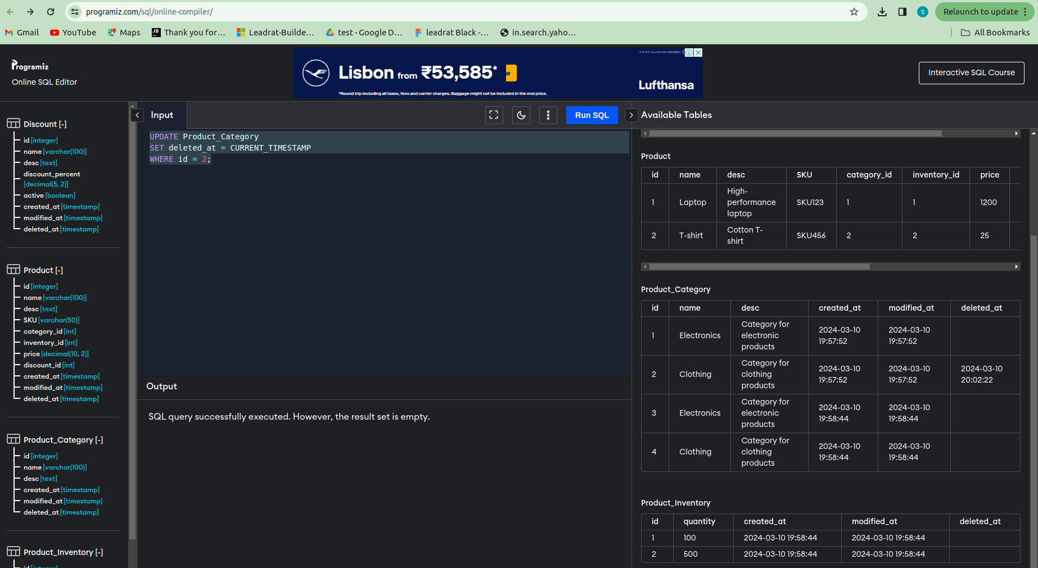
Output:

