Sunitha Pandirla

[sunithapandirla.bootcamp@justit.co.uk]

R & Power BI

Data cleaning & Visualization

*This document explains data cleaning with R program commands and data visualization with Power BI tool*

Contents

**Step1:** InitialExploratory Analysis 3

a) Load data in R studio as new R script file 3

b) Take a look at the data 3

c) Load library: 3

**Step 2:** Clean data 5

a) Check for missing Values: 5

b) Drop missing (Null) values 5

**Step 3:** Exploratory Data Analysis 8

1) Summary Statistics 8

2) Scatterplot 9

3) Bar Chart 10

**Step 4:** Export clean data 10

a) Writing dataframe.R file to csv file 10

**Step 5**: Import “clean_df.csv” into Power BI Desktop 12

a) Loading CSV File to Power BI Desktop 12

**Step 6:** Create Power BI Dashboard 13

a) Film Ratings, Profit and Worldwide Gross 13

b) Top 10 Films (Profit, worldwide gross, Rotten Tomatoes, Audience score) 14

c)Profit, Worldwide Gross, Rotten Tomatoes and Audience Score by Genre of the Film 15

4) Profit, worldwide gross, Rotten Tomatoes and Audience score by Lead Studio 16

5) Films Per Year and Their Audience Score 17

**Advantages :** PowerBI Data reporting 18

**Aim:** This Assignment is to clean the data in ‘R’ and convert refined data into a csv file and

Visualize the data and analyze the performance of Hollywood movies in Power BI .

**Data columns**: Title, genre, studio, profitability, and ratings for the movies released between 2007-2012.

**Source**: [*InformationIsBeautiful.net*](https://www.informationisbeautiful.net/data/)

# **Step1:** InitialExploratory Analysis

## Load data in R studio as new R script file

*df1<- read.csv("https://public.tableau.com/app/sample-data/HollywoodsMostProfitableStories.csv")*

## Take a look at the data

*View(df1)*

## c) Load library:

*install.packages("tidyverse")*

*library(tidyverse)*

d)check data Types

*dim(df1)*

It shows that there are 74 rows and 8 columns in the data frame df1

*str(df1)*

This command gives the Data types of The different columns

# **Step 2:** Clean data

## Check for missing Values:

*colSums(is.na(df1))*

This command checks for total number of null values per column in the data frame df1

## b) Drop missing (Null) values

check for number of Rows before dropping the null values.

*nrow(df1)*

There are 74 rows before dropping the null values.

*df<-na.omit(df1)*

This R command removes the rows which contain Null values from dataframe.

*nrow(df1)*

This command now shows 70 rows after removing the null values

# **Step 3:** Exploratory Data Analysis

## Summary Statistics

*summary(df1)*

This gives summary of statistics of all columns with int data type (min, max, mean, median,1st quantile,3rd quantile).

## Scatterplot

*ggplot(df1, aes(x=Lead.Studio, y=Rotten.Tomatoes..,color="orange")) + geom_point()+ scale_y_continuous(labels = scales::comma)+coord_cartesian(ylim = c(0, 110))+theme(axis.text.x = element_text(angle = 90,))*

## Bar Chart

*ggplot(df1, aes(x=Year)) + geom_bar()*

# **Step 4:** Export clean data

## Writing dataframe.R file to csv file

*write.csv(df1, "clean_df1.csv")*

This command writes the cleaned data frame in to csv file in your local computer folder.

# **Step 5**: Import “clean_df.csv” into Power BI Desktop

## a) Loading CSV File to Power BI Desktop

1. Use get (csv file) option in Power BI and load (cleaned_df1.csv) file in power BI
2. Transform Year column data type from int to Year type in power query of Power BI

1. click close & apply and click on Report View
2. The data visualized graphically by using measures from clean_df1 Table under “**Data**” pane where the numerical columns are aggregated automatically.
3. The Report View also has Dash board pages, Filters and Visualizations pane

# **Step 6:** Create Power BI Dashboard

## **Film Ratings, Profit and Worldwide Gross**

The above dashboard consists of 5 slides.

1. Average Rotten Tomatoes score of the film genre (Pie chart)
2. Profitability by Lead studio produced the film (Clustered column chart)

-Highest for Independent, followed by Disney studios

1. Audience scores for each film (Multi row card)
2. Sum of worldwide gross per genre (Treemap)

-Highest for comedy, followed by Romance.

1. Count of film by Year (Donut chart)

## **Top 10 Films (Profit, worldwide gross, Rotten Tomatoes, Audience score)**

## **c)Profit, Worldwide Gross, Rotten Tomatoes and Audience Score by Genre of the Film**

## **Profit, worldwide gross, Rotten Tomatoes and Audience score by Lead Studio**

## **Films Per Year and Their Audience Score**

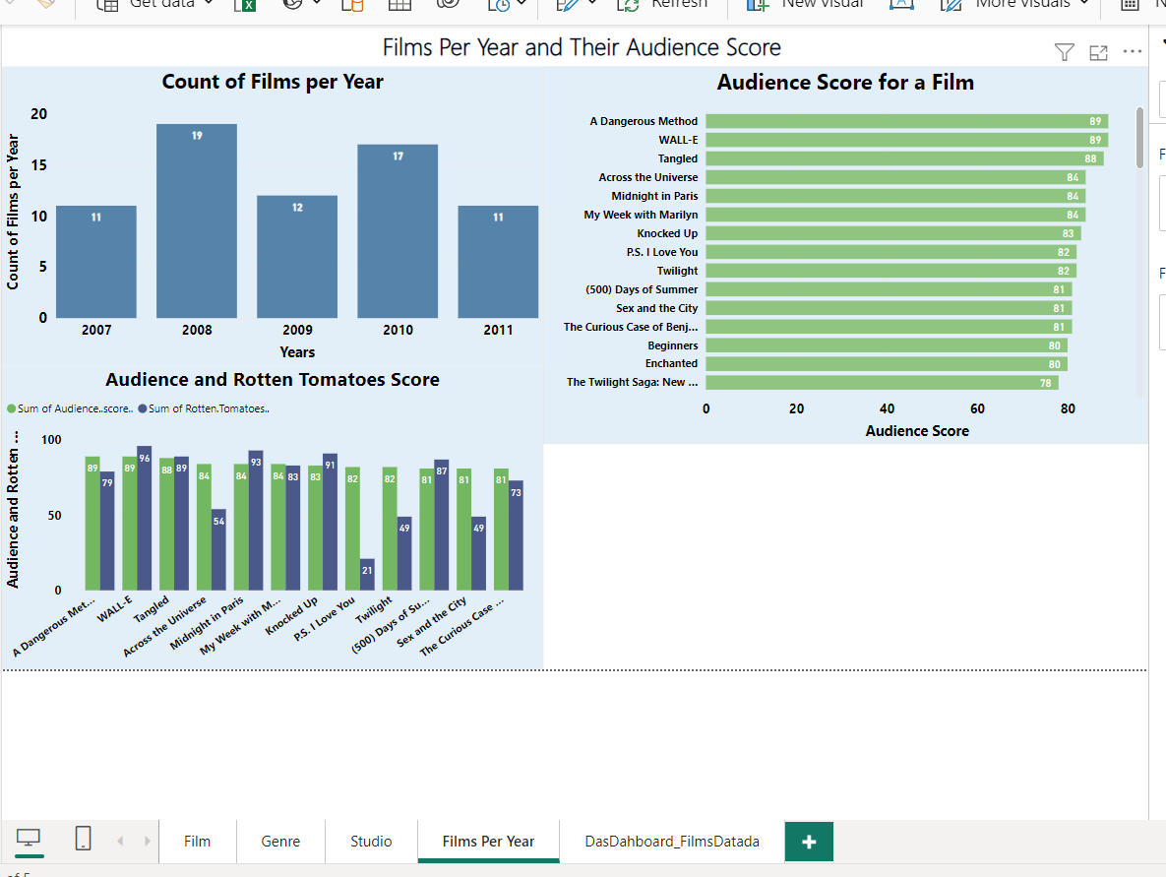

# **Advantages :** PowerBI Data reporting

**Data Visualization**: Power BI allows users to create interactive and visually appealing reports and dashboards, making it easier to understand complex data at a glance.

**Integration**: It seamlessly integrates with various data sources, including Excel, SQL databases, cloud services like Azure, and many others, allowing users to pull data from multiple sources into a single report.

**Real-Time Analytics**: With its ability to connect to live data sources, Power BI enables users to perform real-time analytics, providing insights into the latest trends and patterns