Sunitha Pandirla

Just IT

SQL ASSIGNMENT

WORLD DB SQL Queries

# 

Contents

SQL queries of “World” database 2

Task 1 2

Task 2 3

Task 3 4

Task 4 6

Task 5 7

Task 6 8

Task 7 9

Task 8 10

Task 9 11

Task 10 (Join Queries) 13

# SQL queries of “World” database

## Task 1

Using count, get the number of cities in the US.

Select CountryCode, count (Name) as no_of_Cities

from city table

WHERE CountryCode = "USA”.

## Task 2

Find out what the population and average life expectancy for people in Argentina (ARG) is.​

SELECT Name AS Country, Population,LifeExpectancy AS avg_lifeExpectancy

FROM country

WHERE Name = "Argentina";

## Task 3

Using ORDER BY, LIMIT what country has the highest life expectancy?​

SELECT Name AS country,LifeExpectancy

FROM country

ORDER BY LifeExpectancy DESC

LIMIT 1;

## Task 4

Select 25 cities around the world that start with the letter 'F' in a single SQL query.​

SELECT Name as city_name

FROM city

WHERE Name LIKE "F%"

LIMIT 25;

## Task 5

Create a SQL statement to display columns Id, Name, Population from the city table and limit results to first 10 rows only.​

SELECT ID,Name as city_name,Population

FROM city

LIMIT 10;

## Task 6

Create a SQL statement to find only those cities from city table whose population is larger than 2000000.​

SELECT Name AS city_name, Population

FROM city

WHERE Population > 2000000

ORDER BY Population DESC;

## Task 7

Create a SQL statement to find all city names from city table whose name begins with “Be” prefix.​

SELECT Name as city_name

FROM city

WHERE Name LIKE "Be%";

## Task 8

Create a SQL statement to find only those cities from city table whose population is between 500000-1000000.​

SELECT Name As city_name,Population

FROM city

WHERE Population BETWEEN 500000 AND 1000000

ORDER BY Population DESC;

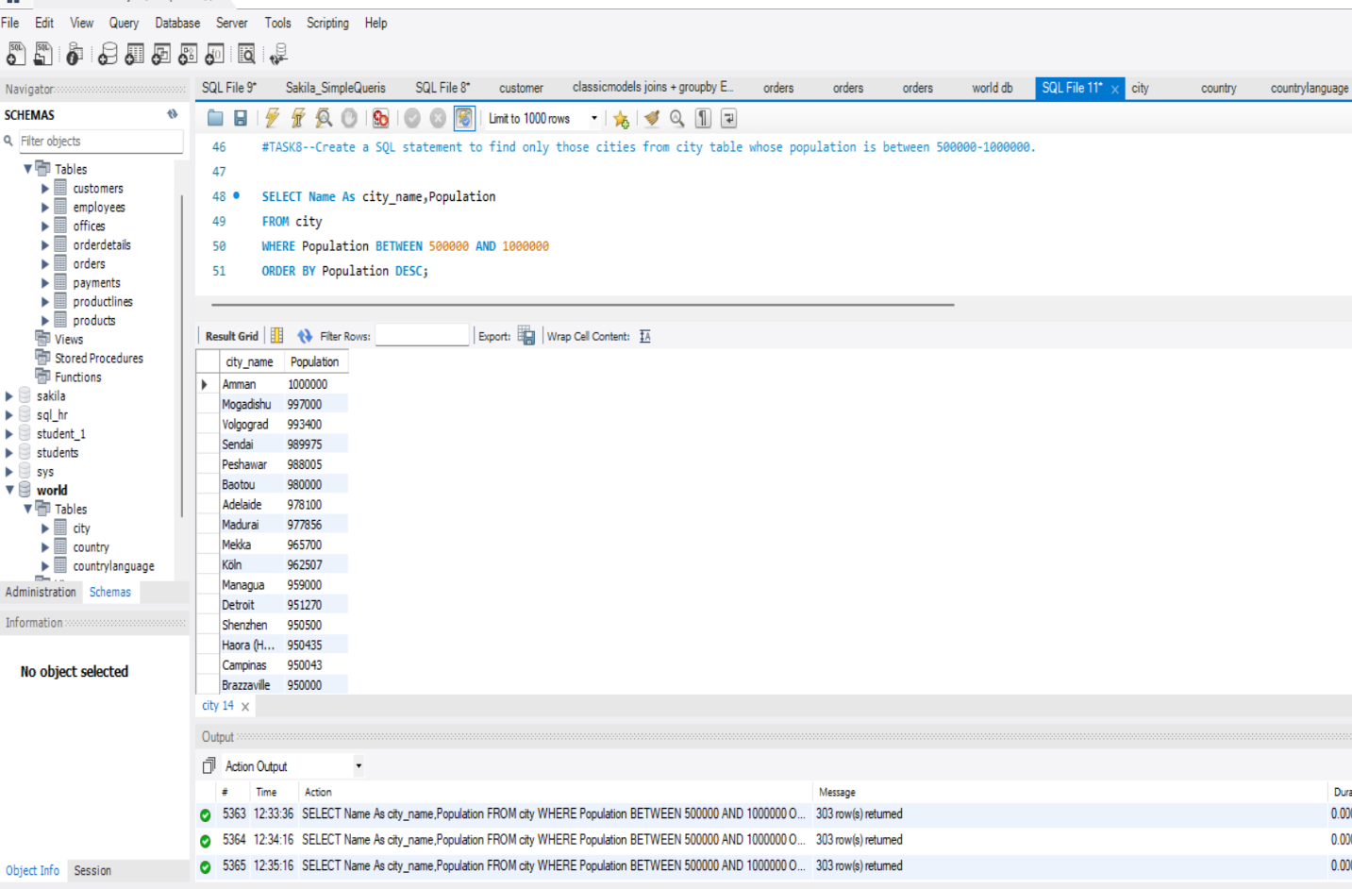

## Task 9

Create a SQL statement to find a city with the lowest population in the city table.​

SELECT Name AS city_name,Population

FROM city

ORDER BY Population

LIMIT 1;

--Option2--

SELECT Name As city_name, Population

FROM city

WHERE Population = (SELECT MIN(Population)FROM city);

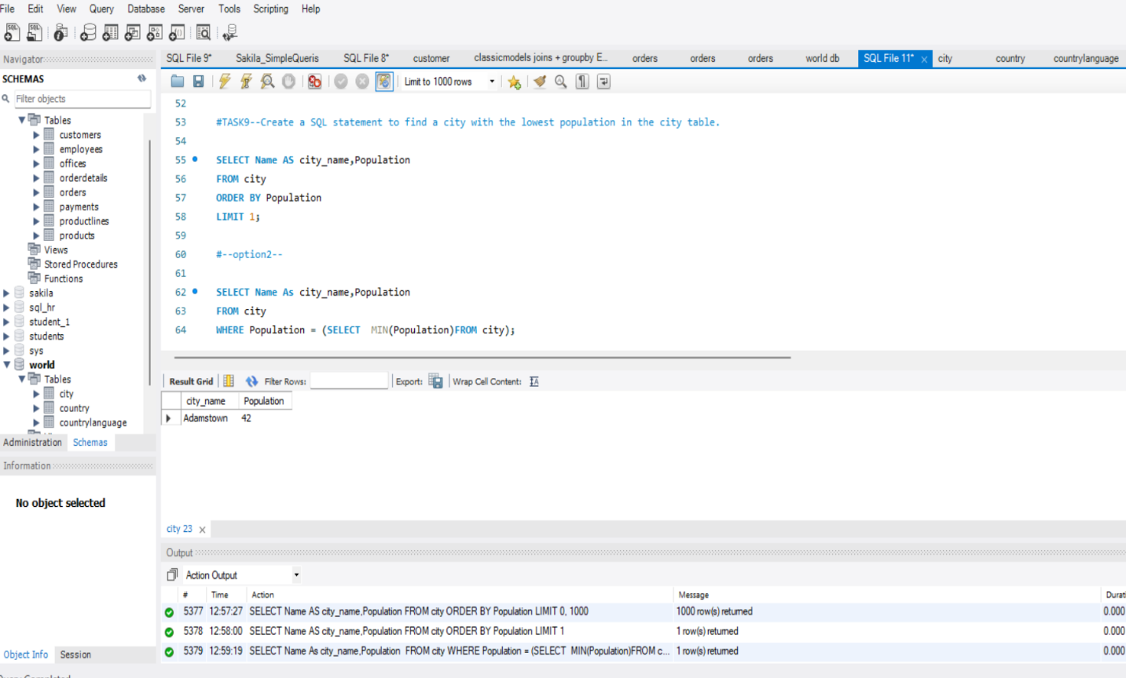

## Task 10 (Join Queries)

1. Create a SQL statement to find the capital of Spain (ESP).​

SELECT country.Name AS country_name,city.Name As capitalCity_name,country.Code

FROM city

INNER JOIN country

ON city.ID = country.Capital

WHERE Code = "ESP";

Create a SQL statement to list all the languages spoken in the Caribbean region.​

SELECT Region,Language

FROM country

INNER JOIN countrylanguage

ON country.Code = countrylanguage.CountryCode

WHERE Region = "Caribbean"

ORDER BY Language;

1. Create a SQL statement to find all cities from the Europe continent.​

SELECT Continent,city.Name AS city_name

FROM country

INNER JOIN city

ON country.Code = city.CountryCode

WHERE Continent ="Europe"

ORDER BY city.Name;

