CHAPTER V
OBSERVATION & RESULTS
1. Age
Table 1: Descriptive Statistics for Age
Statistic | Value
n (valid) | 116
Mean ± SD | 56.69 ± 12.57
Median (IQR) | 56.00 (46.75–66.50)
Range | 30.00 – 88.00

Fig 1: Distribution of Age
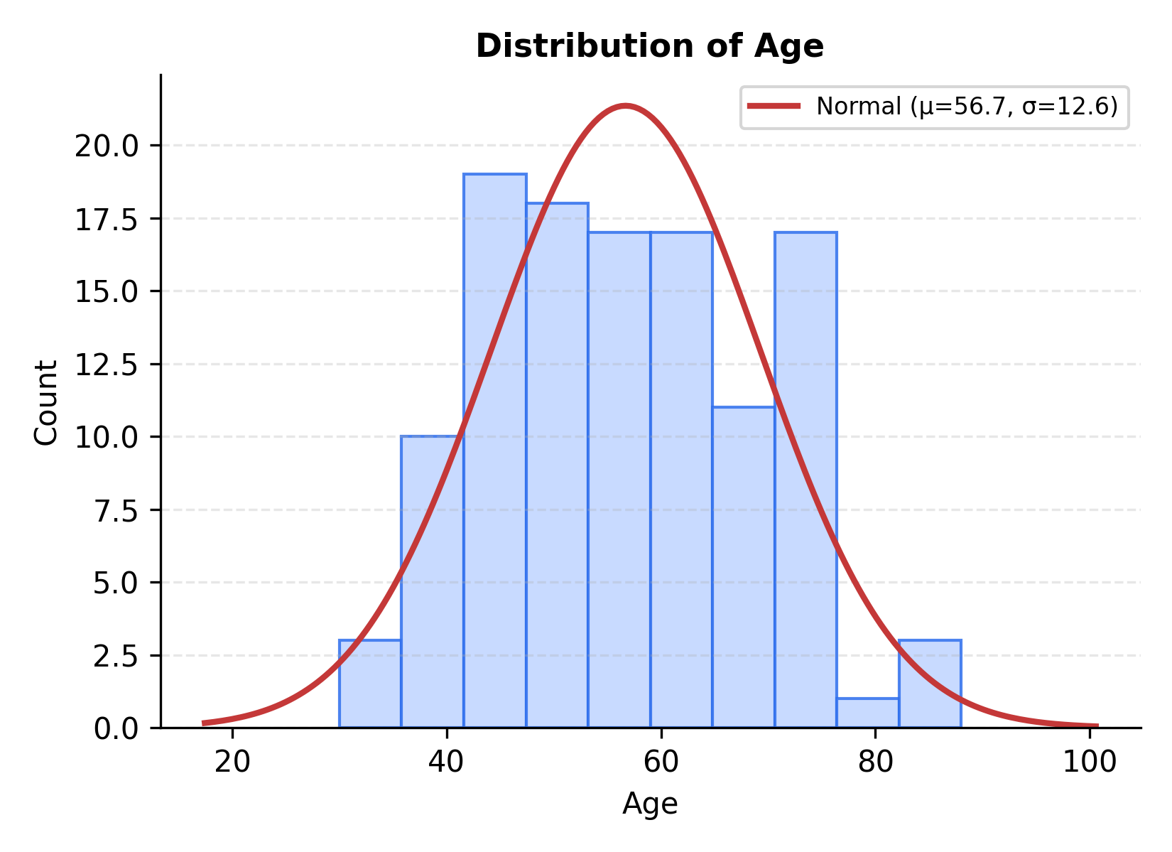

Table 2: Age by Pr Groups
PR | n | Median | IQR (Q1-Q3) | Mean ± SD
No | 44 | 55.00 | 45.75 – 60.25 | 55.00 ± 12.26
Postive | 1 | 70.00 | 70.00 – 70.00 | 70.00 ± nan
Yes | 71 | 56.00 | 47.50 – 68.50 | 57.55 ± 12.74
Total | 116 | 56.00 | 46.75 – 66.50 | 56.69 ± 12.57

Fig 2: Age by Pr
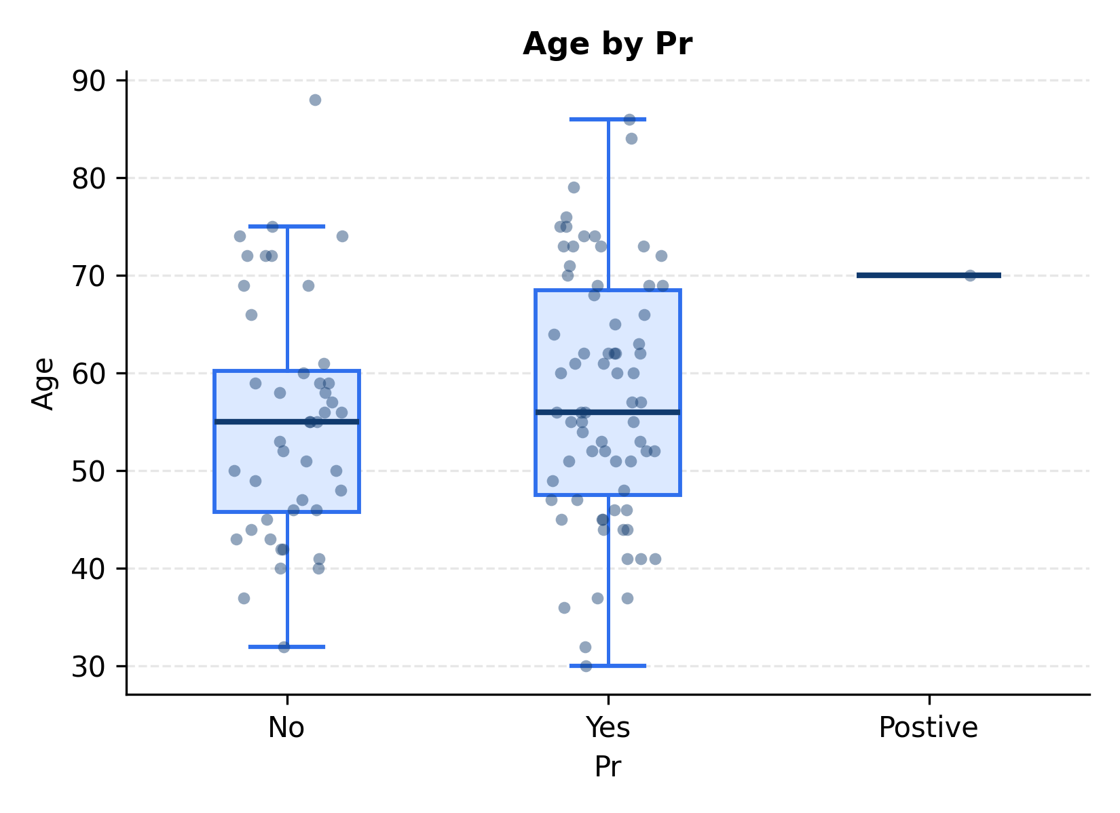

Interpretation: Age was compared across Pr categories in 116 patients using the Kruskal-Wallis H test. No statistically significant difference was identified across Pr groups (H = 1.511, p = 0.219).
2. Laterality
Table 3: Frequency Distribution of Laterality
Laterality | n | Percent (%)
Left | 60 | 51.7
Right | 50 | 43.1
Right | 5 | 4.3
Left | 1 | 0.9
Total | 116 | 100.0

Fig 3: Bar Chart — Distribution of Laterality
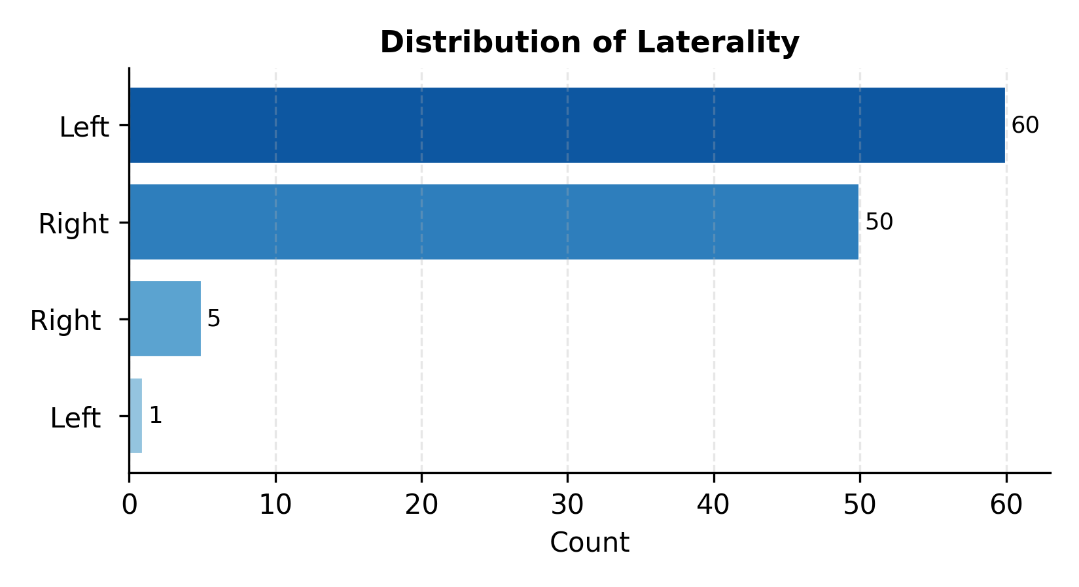

Table 4: Distribution of Laterality by Pr
Laterality | No | Postive | Yes | Total
Left | 19 (31.7%) | 1 (1.7%) | 40 (66.7%) | 60
Left | 0 (0.0%) | 0 (0.0%) | 1 (100.0%) | 1
Right | 24 (48.0%) | 0 (0.0%) | 26 (52.0%) | 50
Right | 1 (20.0%) | 0 (0.0%) | 4 (80.0%) | 5
Total | 44 (37.9%) | 1 (0.9%) | 71 (61.2%) | 116

Fig 4: Laterality Distribution Across Pr Groups
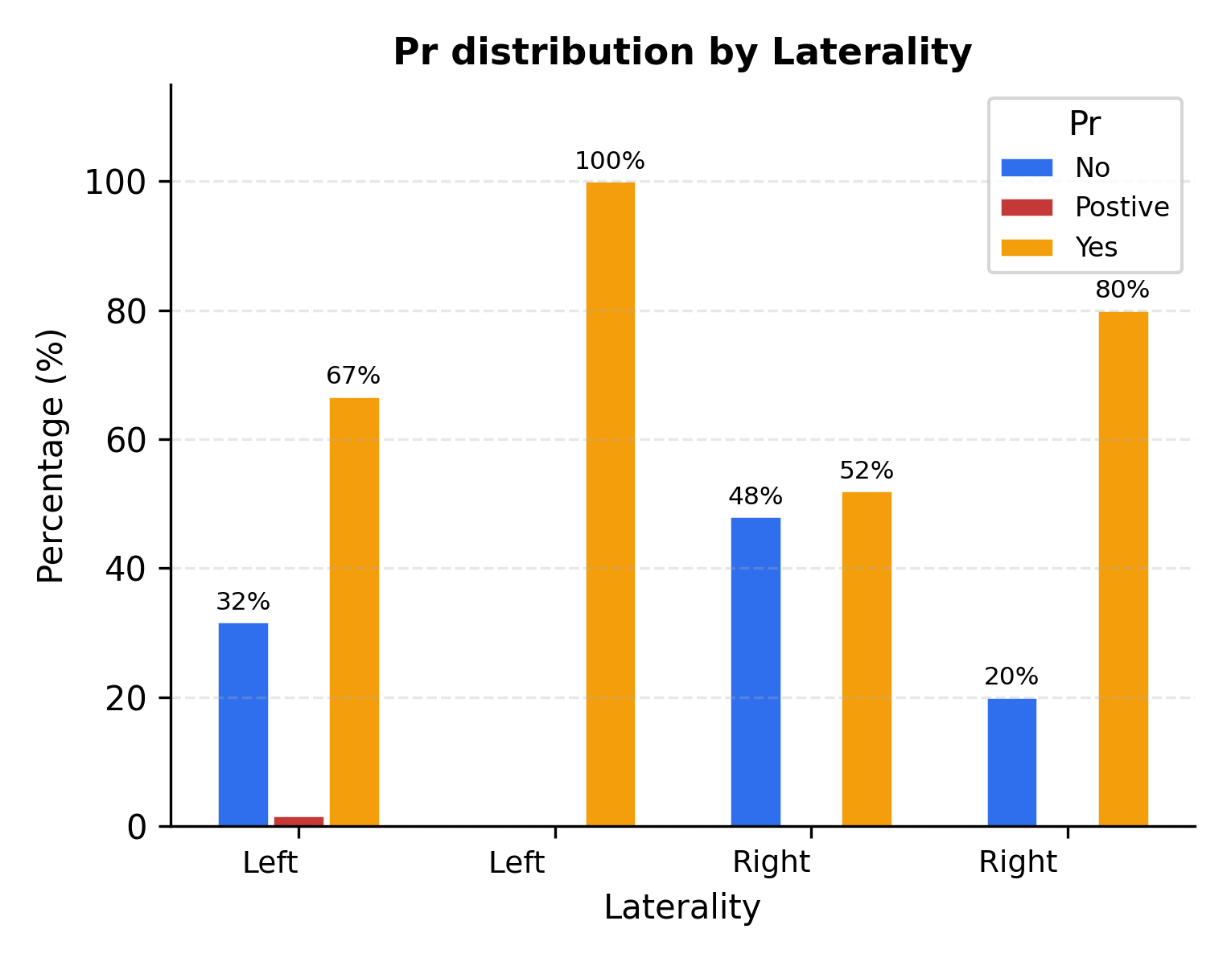

Interpretation: The association between Laterality and Pr was assessed using the chi-square test of independence (n = 116). No statistically significant association was found between Laterality and Pr (χ² = 5.213, df = 6, p = 0.517). Cramér's V was 0.150, indicating a weak degree of association between the two variables.
3. Tumour Size (cm)
Table 5: Frequency Distribution of Tumour Size (cm)
Tumour size (cm) | n | Percent (%)
>2 but <=5 | 62 | 53.4
>5 | 18 | 15.5
>1 but <= 2 | 17 | 14.7
>2 but <=5 | 11 | 9.5
Ulceration and / or ipsilateral satellite nodules and / or edema (including peau d'orange) of the  skin which do not meet the criteria for inflammatory carcinoma | 5 | 4.3
>0.5 but <=1 | 3 | 2.6
Total | 116 | 100.0

Fig 5: Bar Chart — Distribution of Tumour Size (cm)
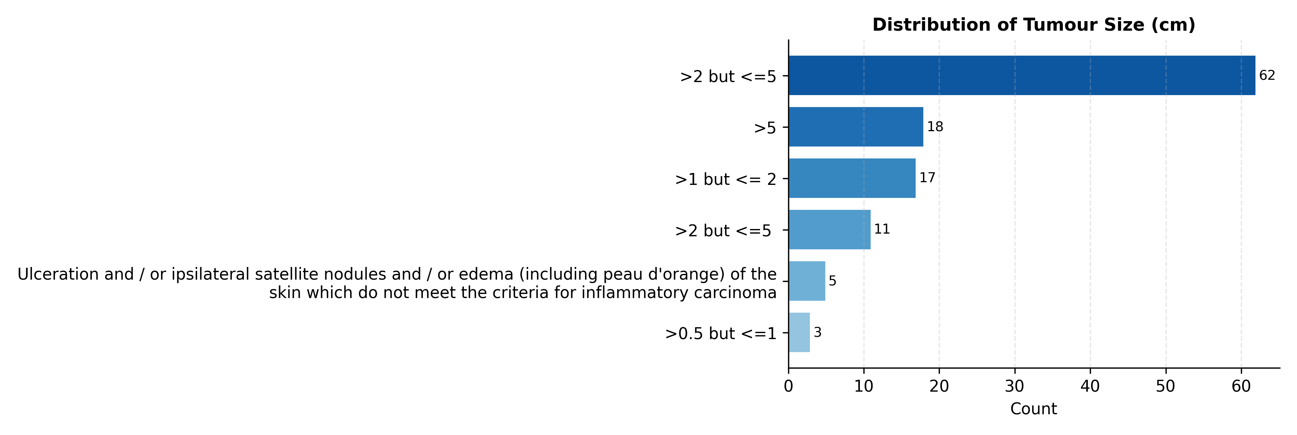

Table 6: Distribution of Tumour Size (cm) by Pr
Tumour size (cm) | No | Postive | Yes | Total
>0.5 but <=1 | 2 (66.7%) | 0 (0.0%) | 1 (33.3%) | 3
>1 but <= 2 | 6 (35.3%) | 0 (0.0%) | 11 (64.7%) | 17
>2 but <=5 | 23 (37.1%) | 1 (1.6%) | 38 (61.3%) | 62
>2 but <=5 | 3 (27.3%) | 0 (0.0%) | 8 (72.7%) | 11
>5 | 8 (44.4%) | 0 (0.0%) | 10 (55.6%) | 18
Ulceration and / or ipsilateral satellite nodules and / or edema (including peau d'orange) of the  skin which do not meet the criteria for inflammatory carcinoma | 2 (40.0%) | 0 (0.0%) | 3 (60.0%) | 5
Total | 44 (37.9%) | 1 (0.9%) | 71 (61.2%) | 116

Fig 6: Tumour Size (cm) Distribution Across Pr Groups
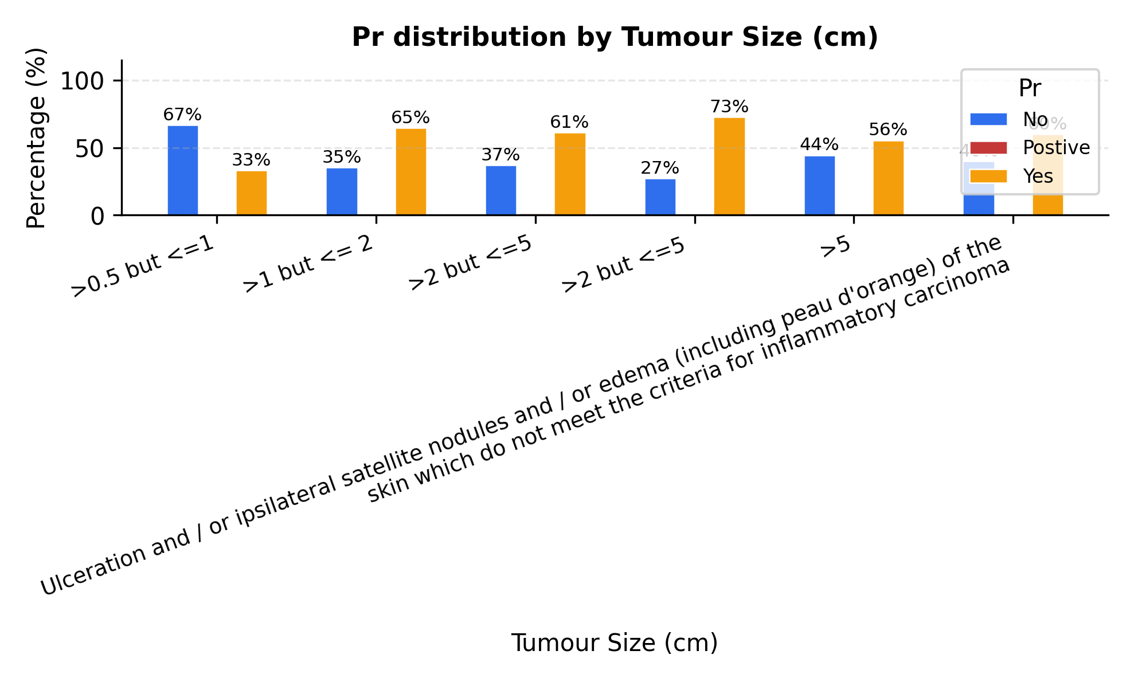

Interpretation: The association between Tumour Size (cm) and Pr was assessed using the chi-square test of independence (n = 116). No statistically significant association was found between Tumour Size (cm) and Pr (χ² = 2.852, df = 10, p = 0.985). Cramér's V was 0.111, indicating a weak degree of association between the two variables.
4. Histological Type
Table 7: Frequency Distribution of Histological Type
Histological type | n | Percent (%)
2.0 | 86 | 74.1
3.0 | 25 | 21.6
1.0 | 5 | 4.3
Total | 116 | 100.0

Fig 7: Pie Chart — Distribution of Histological Type
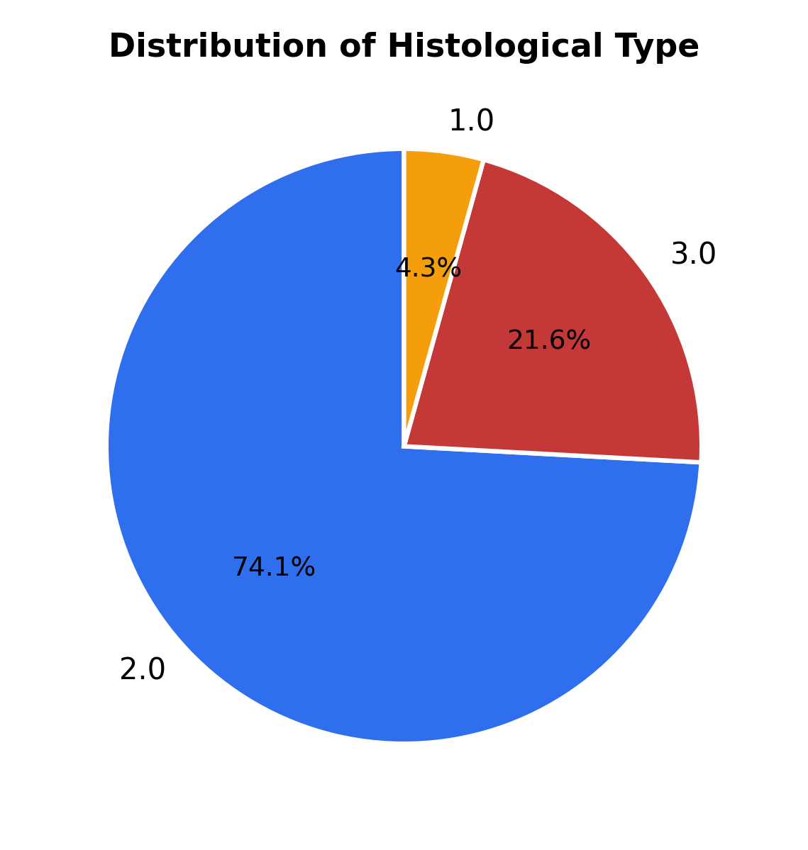

Table 8: Distribution of Histological Type by Pr
Histological type | No | Postive | Yes | Total
1.0 | 0 (0.0%) | 0 (0.0%) | 5 (100.0%) | 5
2.0 | 23 (26.7%) | 1 (1.2%) | 62 (72.1%) | 86
3.0 | 21 (84.0%) | 0 (0.0%) | 4 (16.0%) | 25
Total | 44 (37.9%) | 1 (0.9%) | 71 (61.2%) | 116

Fig 8: Histological Type Distribution Across Pr Groups
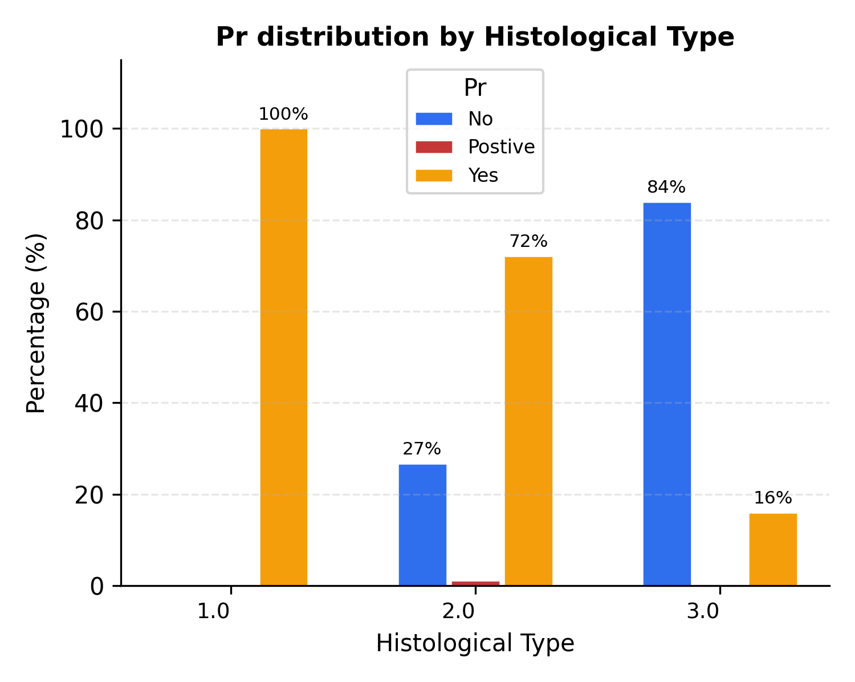

Interpretation: The association between Histological Type and Pr was assessed using the chi-square test of independence (n = 116). A statistically significant association was identified (χ² = 30.313, df = 4, p < 0.001). Cramér's V was 0.361, indicating a moderate degree of association between the two variables.
5. Pt
Table 9: Frequency Distribution of Pt
pT | n | Percent (%)
T2 | 71 | 61.2
T3 | 19 | 16.4
T1c | 17 | 14.7
T4b | 5 | 4.3
T1b | 3 | 2.6
mT2 | 1 | 0.9
Total | 116 | 100.0

Fig 9: Bar Chart — Distribution of Pt
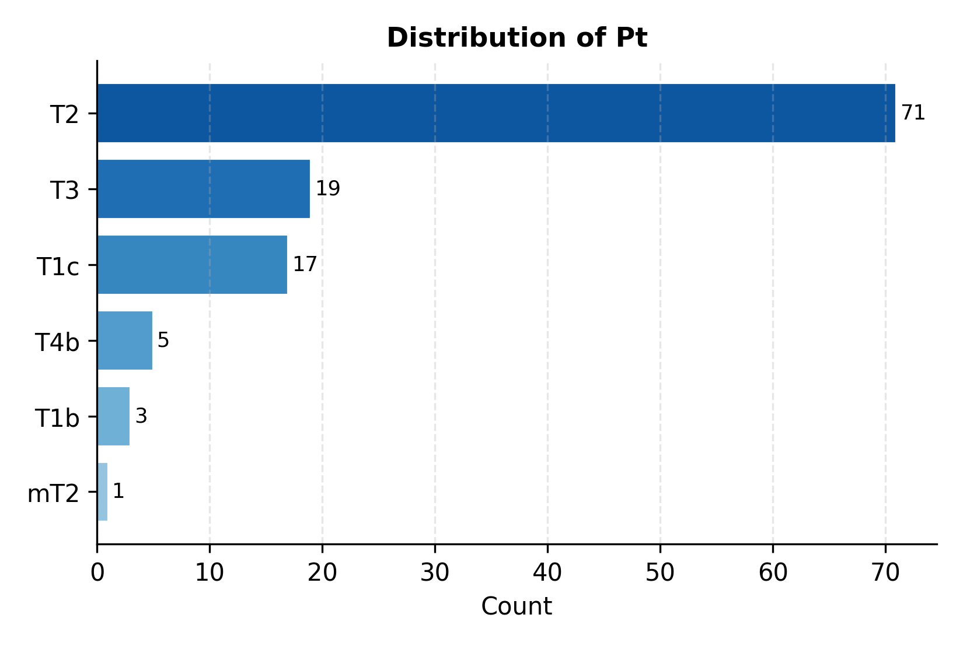

Table 10: Distribution of Pt by Pr
pT | No | Postive | Yes | Total
T1b | 2 (66.7%) | 0 (0.0%) | 1 (33.3%) | 3
T1c | 6 (35.3%) | 0 (0.0%) | 11 (64.7%) | 17
T2 | 26 (36.6%) | 1 (1.4%) | 44 (62.0%) | 71
T3 | 8 (42.1%) | 0 (0.0%) | 11 (57.9%) | 19
T4b | 2 (40.0%) | 0 (0.0%) | 3 (60.0%) | 5
mT2 | 0 (0.0%) | 0 (0.0%) | 1 (100.0%) | 1
Total | 44 (37.9%) | 1 (0.9%) | 71 (61.2%) | 116

Fig 10: Pt Distribution Across Pr Groups
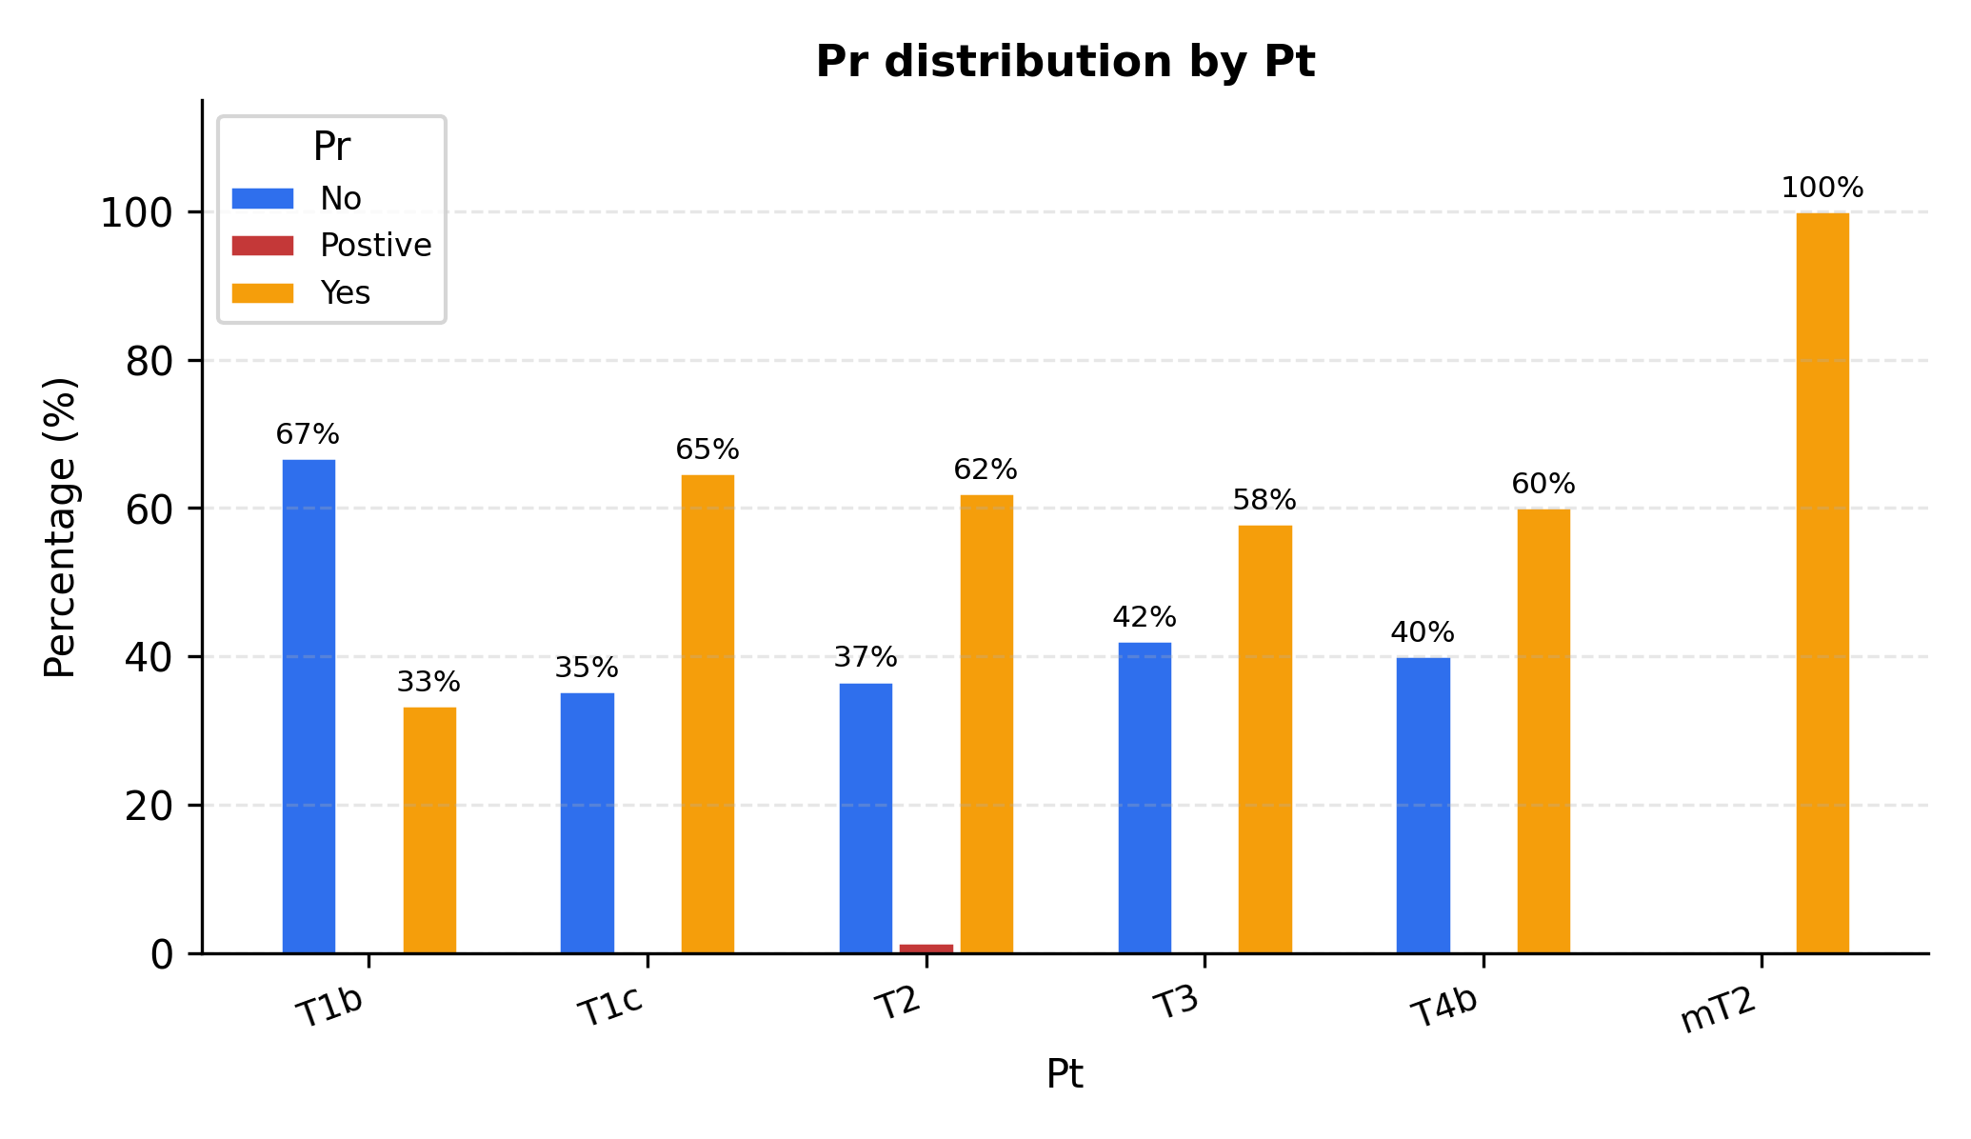

Interpretation: The association between Pt and Pr was assessed using the chi-square test of independence (n = 116). No statistically significant association was found between Pt and Pr (χ² = 2.525, df = 10, p = 0.991). Cramér's V was 0.104, indicating a weak degree of association between the two variables.
6. Nodal Status
Table 11: Frequency Distribution of Nodal Status
Nodal status | n | Percent (%)
N0 | 58 | 50.0
N1a | 28 | 24.1
N3a | 13 | 11.2
N2a | 13 | 11.2
N not assigned | 2 | 1.7
N not assigned | 1 | 0.9
NO | 1 | 0.9
Total | 116 | 100.0

Fig 11: Bar Chart — Distribution of Nodal Status
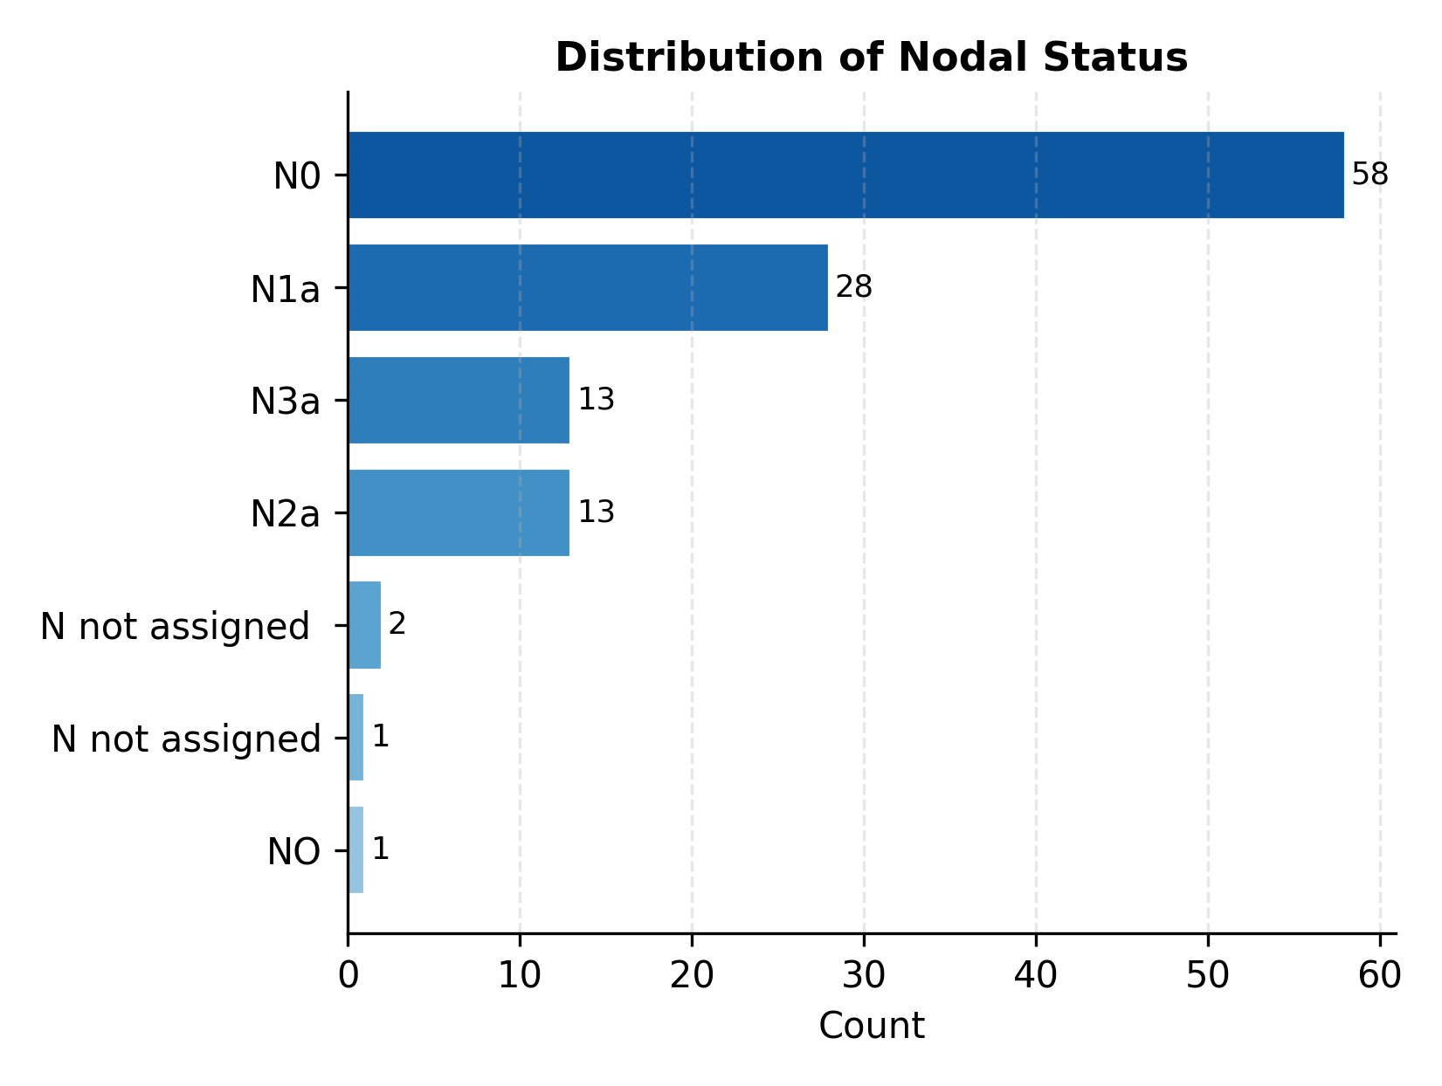

Table 12: Distribution of Nodal Status by Pr
Nodal status | No | Postive | Yes | Total
N not assigned | 1 (100.0%) | 0 (0.0%) | 0 (0.0%) | 1
N not assigned | 0 (0.0%) | 0 (0.0%) | 2 (100.0%) | 2
N0 | 28 (48.3%) | 1 (1.7%) | 29 (50.0%) | 58
N1a | 11 (39.3%) | 0 (0.0%) | 17 (60.7%) | 28
N2a | 2 (15.4%) | 0 (0.0%) | 11 (84.6%) | 13
N3a | 2 (15.4%) | 0 (0.0%) | 11 (84.6%) | 13
NO | 0 (0.0%) | 0 (0.0%) | 1 (100.0%) | 1
Total | 44 (37.9%) | 1 (0.9%) | 71 (61.2%) | 116

Fig 12: Nodal Status Distribution Across Pr Groups
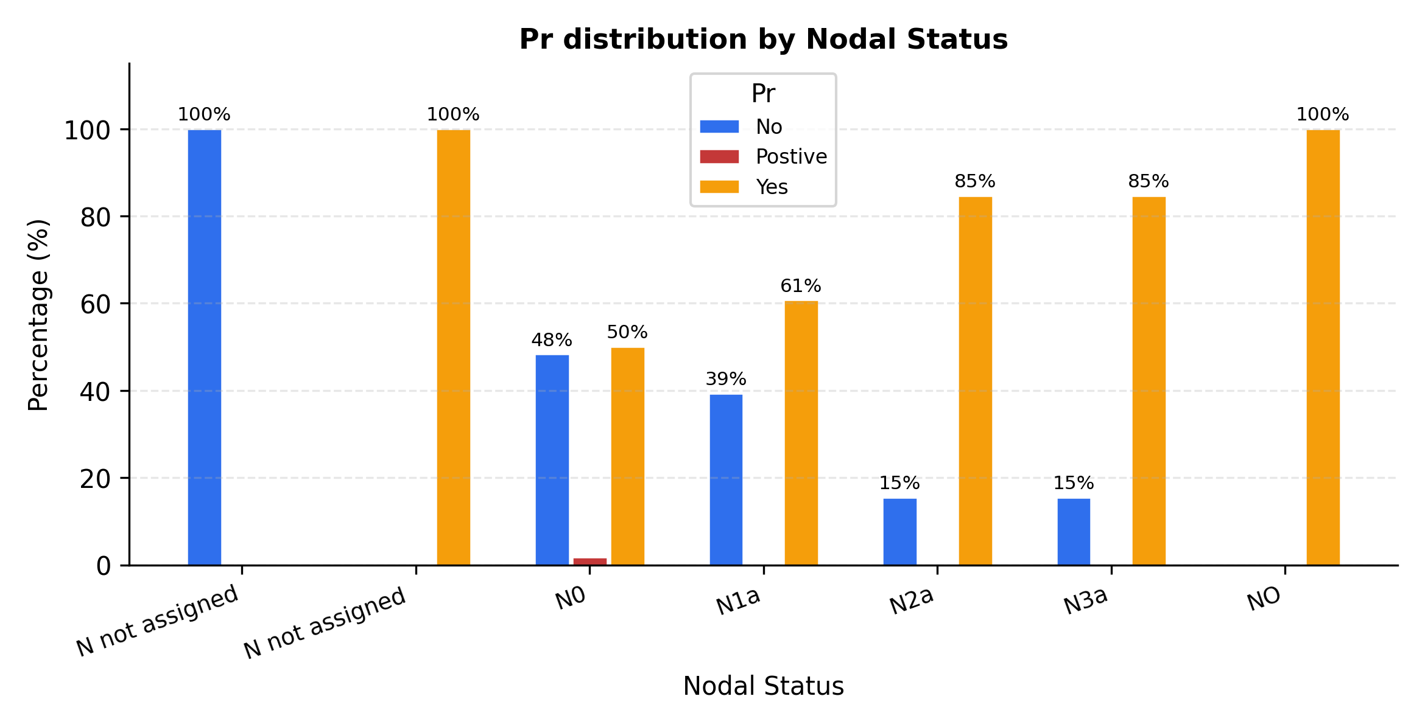

Interpretation: The association between Nodal Status and Pr was assessed using the chi-square test of independence (n = 116). No statistically significant association was found between Nodal Status and Pr (χ² = 13.157, df = 12, p = 0.358). Cramér's V was 0.238, indicating a weak degree of association between the two variables.
7. Ene
Table 13: Frequency Distribution of Ene
ENE | n | Percent (%)
No | 107 | 92.2
Yes | 9 | 7.8
Total | 116 | 100.0

Fig 13: Pie Chart — Distribution of Ene
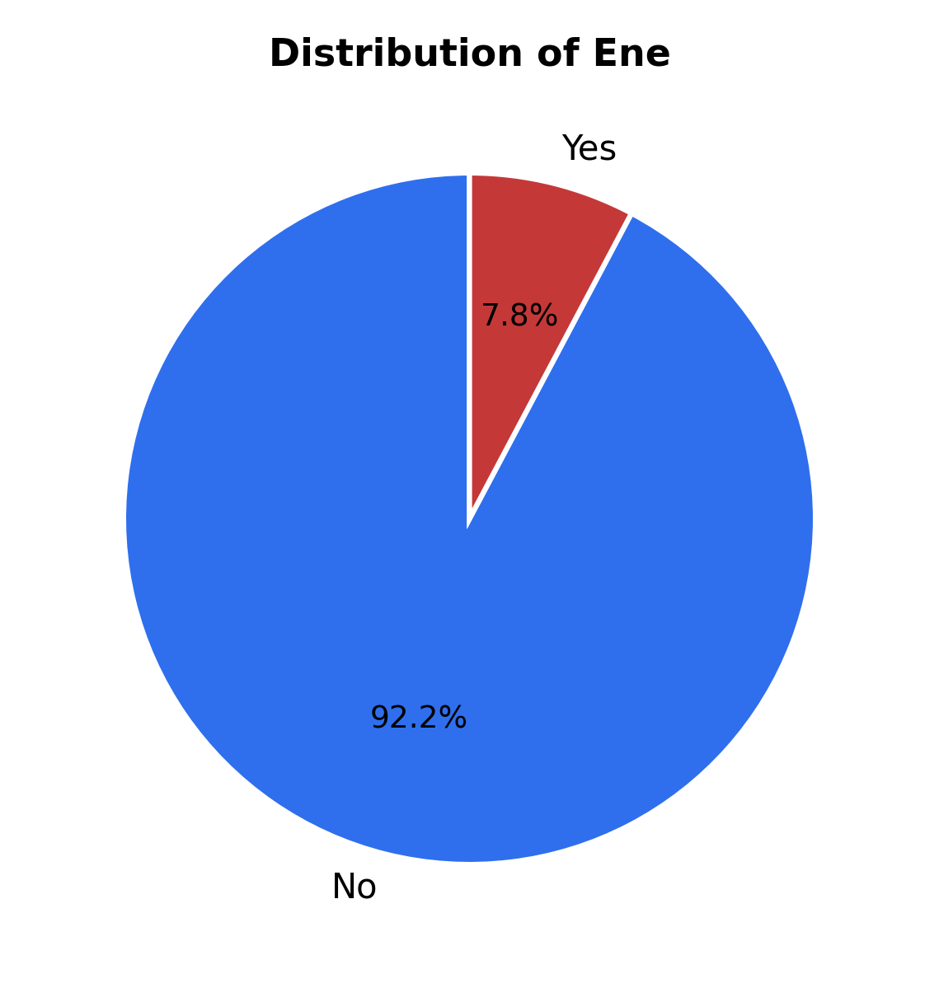

Table 14: Distribution of Ene by Pr
ENE | No | Postive | Yes | Total
No | 43 (40.2%) | 1 (0.9%) | 63 (58.9%) | 107
Yes | 1 (11.1%) | 0 (0.0%) | 8 (88.9%) | 9
Total | 44 (37.9%) | 1 (0.9%) | 71 (61.2%) | 116

Fig 14: Ene Distribution Across Pr Groups
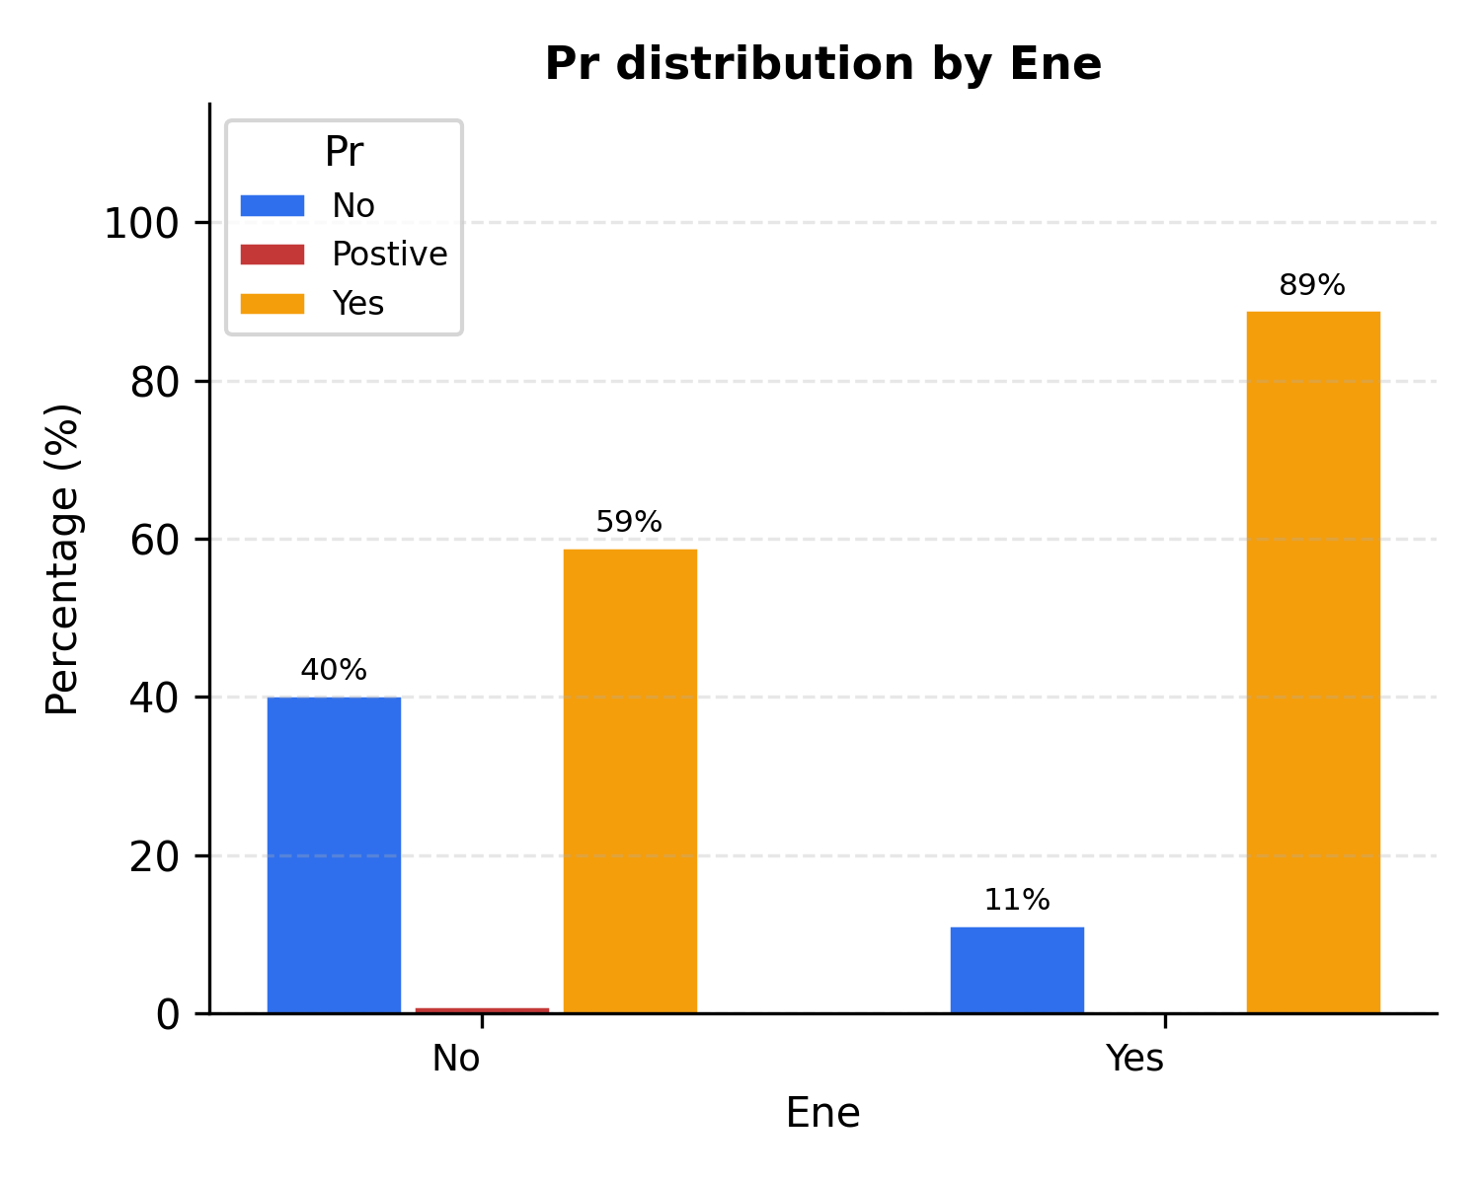

Interpretation: The association between Ene and Pr was assessed using the chi-square test of independence (n = 116). No statistically significant association was found between Ene and Pr (χ² = 3.156, df = 2, p = 0.206). Cramér's V was 0.165, indicating a weak degree of association between the two variables.
8. Er
Table 15: Frequency Distribution of Er
ER | n | Percent (%)
Yes | 72 | 62.1
No | 42 | 36.2
Postive | 2 | 1.7
Total | 116 | 100.0

Fig 15: Pie Chart — Distribution of Er
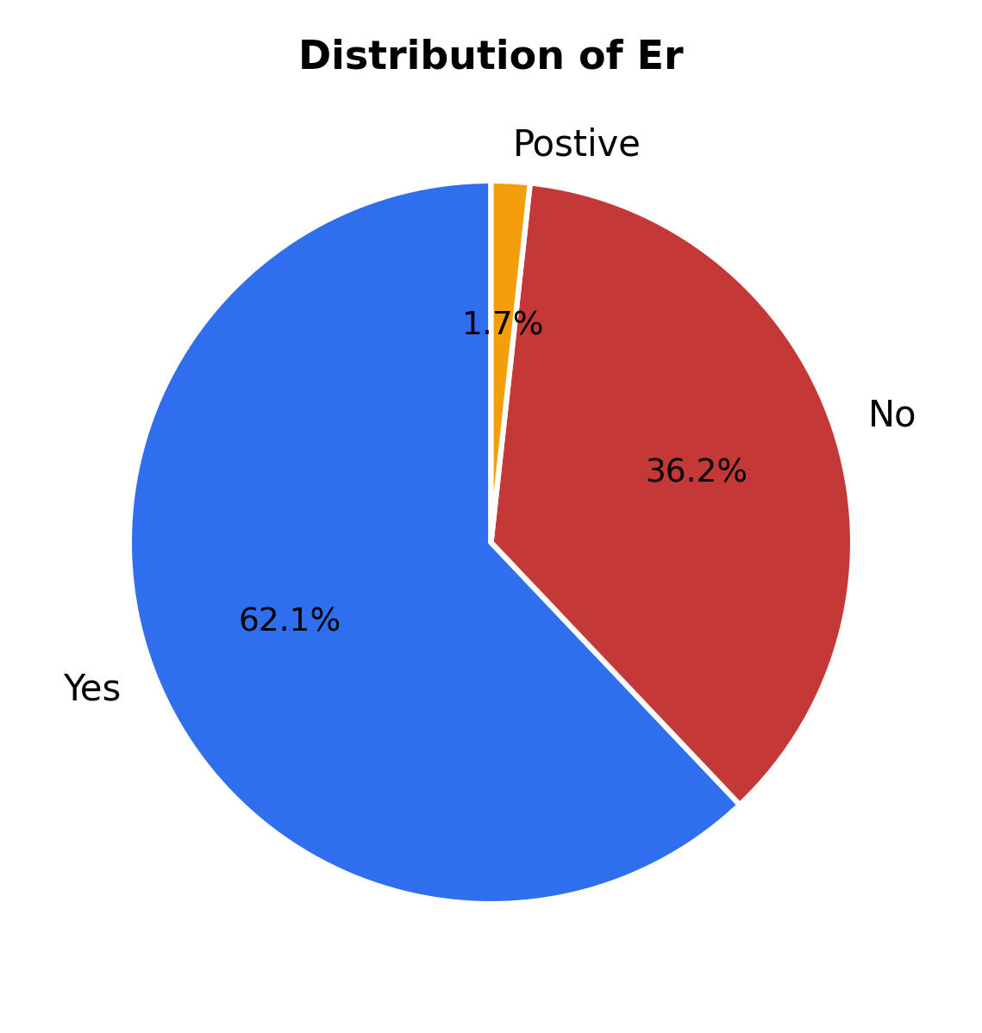

Table 16: Distribution of Er by Pr
ER | No | Postive | Yes | Total
No | 39 (92.9%) | 0 (0.0%) | 3 (7.1%) | 42
Postive | 0 (0.0%) | 1 (50.0%) | 1 (50.0%) | 2
Yes | 5 (6.9%) | 0 (0.0%) | 67 (93.1%) | 72
Total | 44 (37.9%) | 1 (0.9%) | 71 (61.2%) | 116

Fig 16: Er Distribution Across Pr Groups
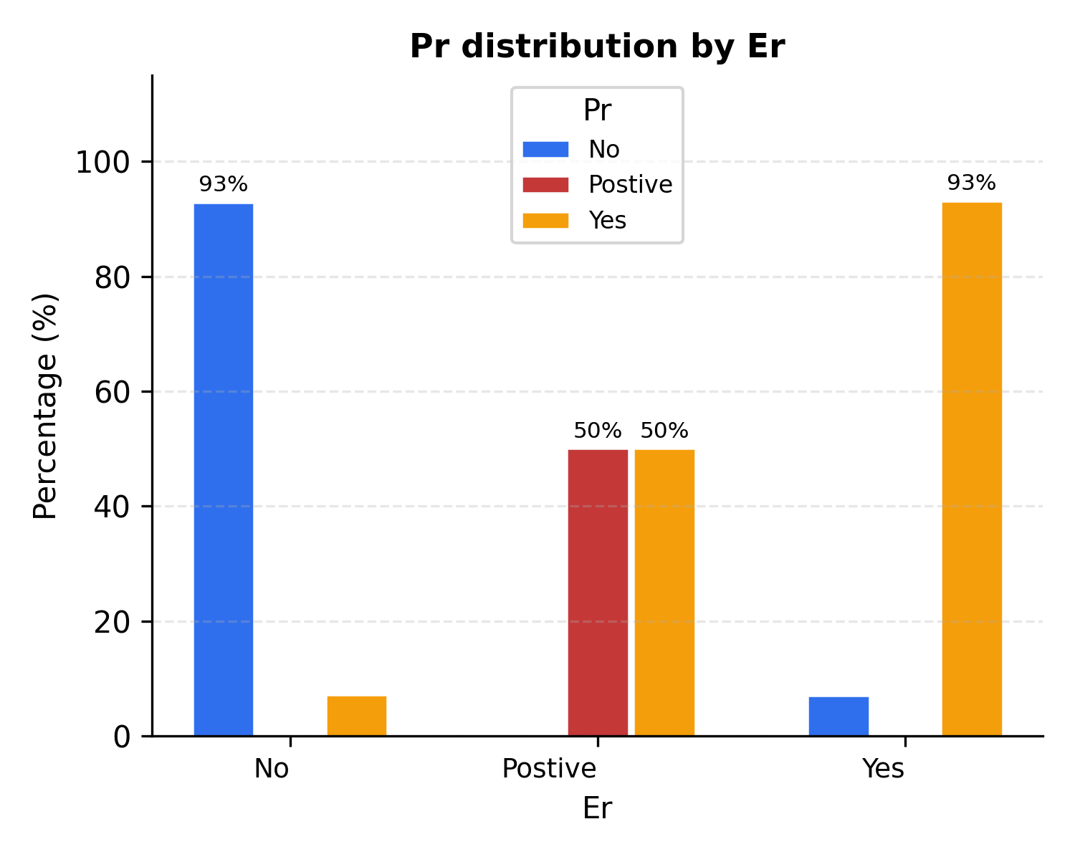

Interpretation: The association between Er and Pr was assessed using the chi-square test of independence (n = 116). A statistically significant association was identified (χ² = 141.419, df = 4, p < 0.001). Cramér's V was 0.781, indicating a strong degree of association between the two variables.
9. Her2neu
Table 17: Frequency Distribution of Her2neu
Her2Neu | n | Percent (%)
Negative | 53 | 45.7
3+ | 28 | 24.1
2+ | 15 | 12.9
1+ | 10 | 8.6
Positive | 8 | 6.9
1 | 1 | 0.9
Negative | 1 | 0.9
Total | 116 | 100.0

Fig 17: Bar Chart — Distribution of Her2neu
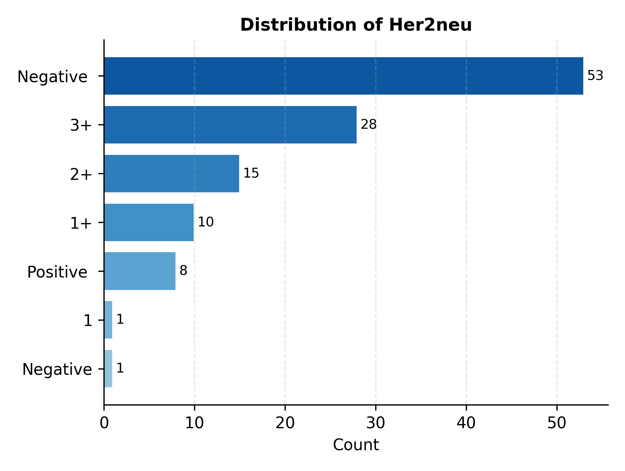

Table 18: Distribution of Her2neu by Pr
Her2Neu | No | Postive | Yes | Total
1 | 0 (0.0%) | 0 (0.0%) | 1 (100.0%) | 1
1+ | 2 (20.0%) | 0 (0.0%) | 8 (80.0%) | 10
2+ | 6 (40.0%) | 0 (0.0%) | 9 (60.0%) | 15
3+ | 12 (42.9%) | 1 (3.6%) | 15 (53.6%) | 28
Negative | 0 (0.0%) | 0 (0.0%) | 1 (100.0%) | 1
Negative | 23 (43.4%) | 0 (0.0%) | 30 (56.6%) | 53
Positive | 1 (12.5%) | 0 (0.0%) | 7 (87.5%) | 8
Total | 44 (37.9%) | 1 (0.9%) | 71 (61.2%) | 116

Fig 18: Her2neu Distribution Across Pr Groups
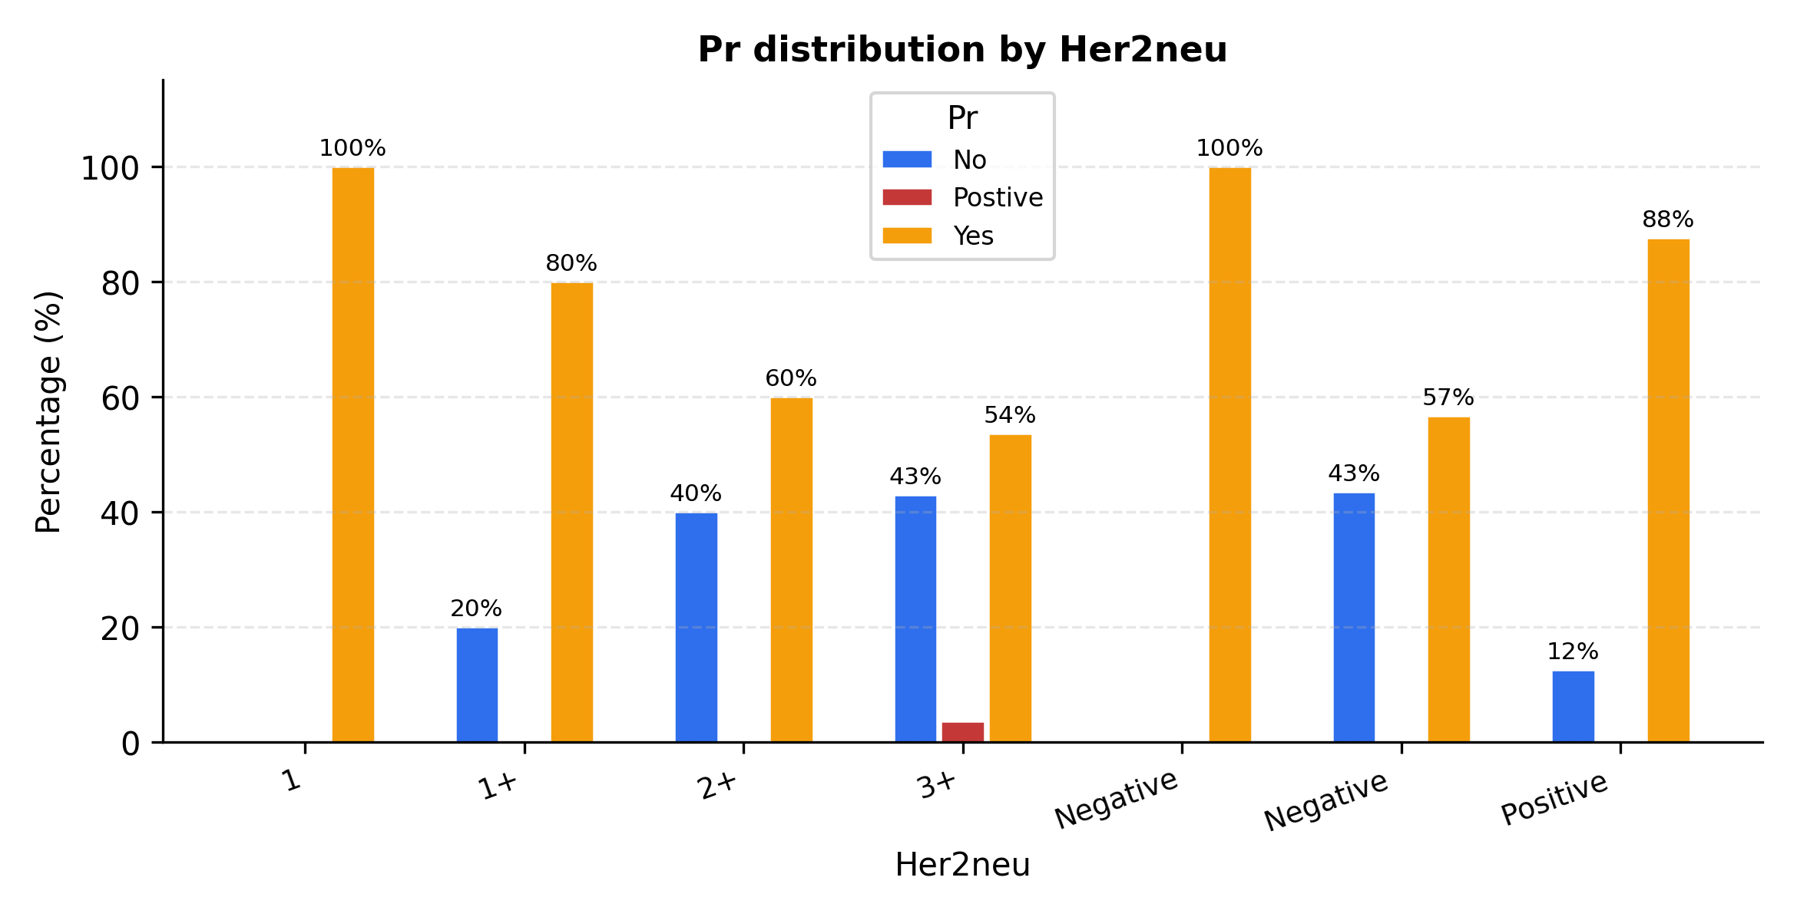

Interpretation: The association between Her2neu and Pr was assessed using the chi-square test of independence (n = 116). No statistically significant association was found between Her2neu and Pr (χ² = 9.153, df = 12, p = 0.690). Cramér's V was 0.199, indicating a weak degree of association between the two variables.
10. Ar
Table 19: Frequency Distribution of Ar
AR | n | Percent (%)
Yes | 87 | 75.0
No | 28 | 24.1
Postive | 1 | 0.9
Total | 116 | 100.0

Fig 19: Pie Chart — Distribution of Ar
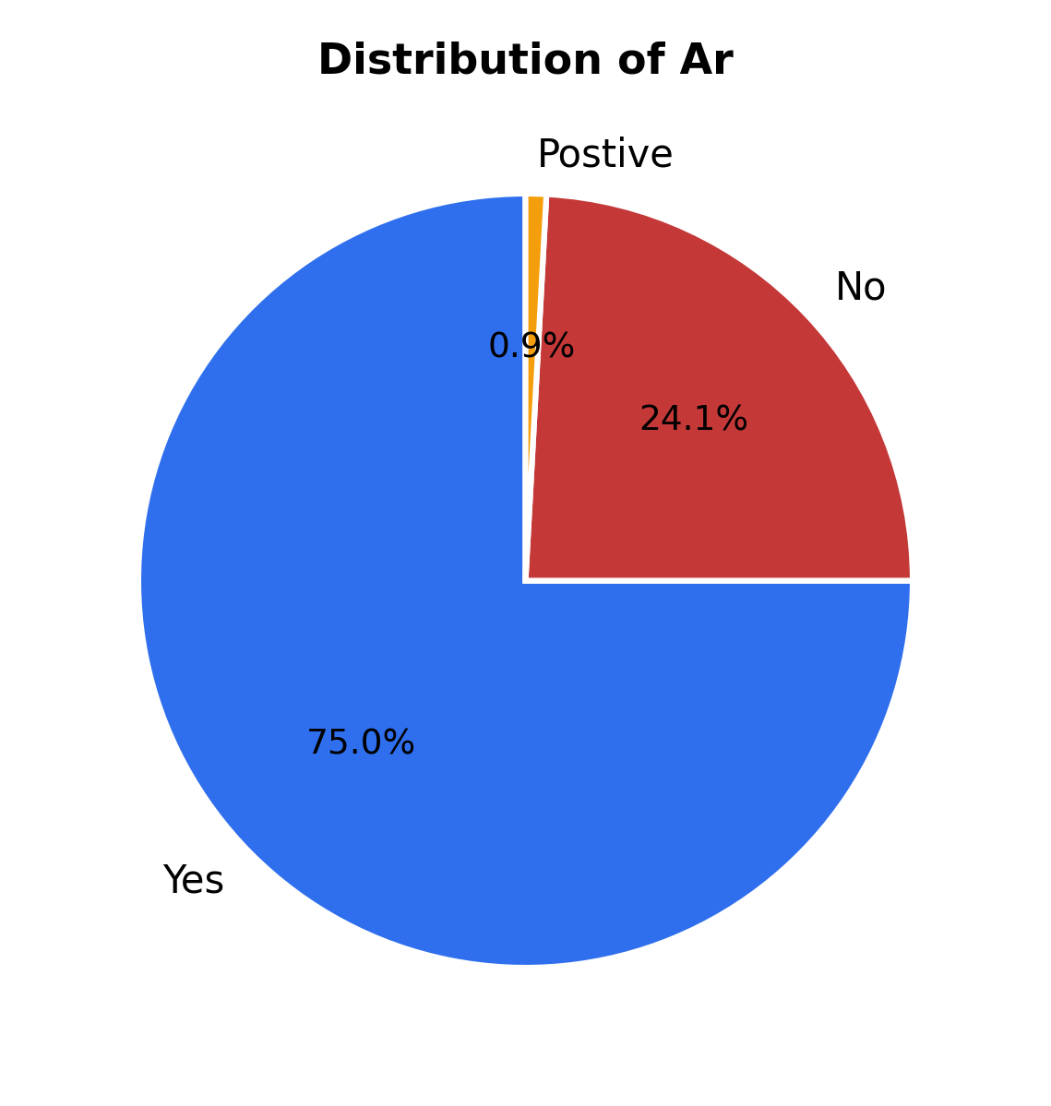

Table 20: Distribution of Ar by Pr
AR | No | Postive | Yes | Total
No | 20 (71.4%) | 0 (0.0%) | 8 (28.6%) | 28
Postive | 0 (0.0%) | 1 (100.0%) | 0 (0.0%) | 1
Yes | 24 (27.6%) | 0 (0.0%) | 63 (72.4%) | 87
Total | 44 (37.9%) | 1 (0.9%) | 71 (61.2%) | 116

Fig 20: Ar Distribution Across Pr Groups
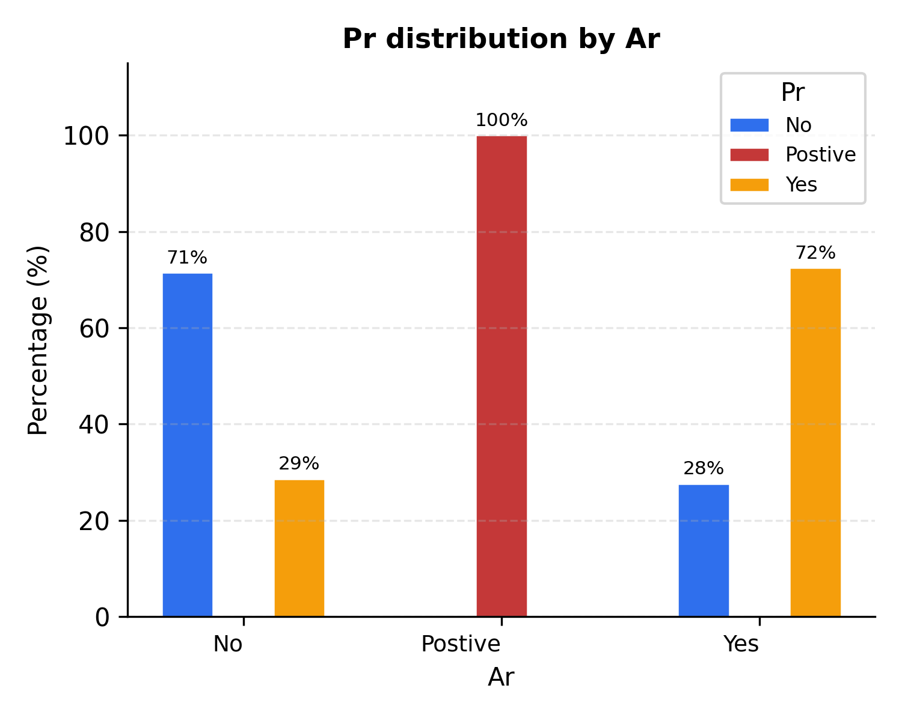

Interpretation: The association between Ar and Pr was assessed using the chi-square test of independence (n = 116). A statistically significant association was identified (χ² = 133.387, df = 4, p < 0.001). Cramér's V was 0.758, indicating a strong degree of association between the two variables.
11. Egfr
Table 21: Frequency Distribution of Egfr
EGFR | n | Percent (%)
No | 77 | 66.4
Yes | 38 | 32.8
Patchy positive | 1 | 0.9
Total | 116 | 100.0

Fig 21: Pie Chart — Distribution of Egfr
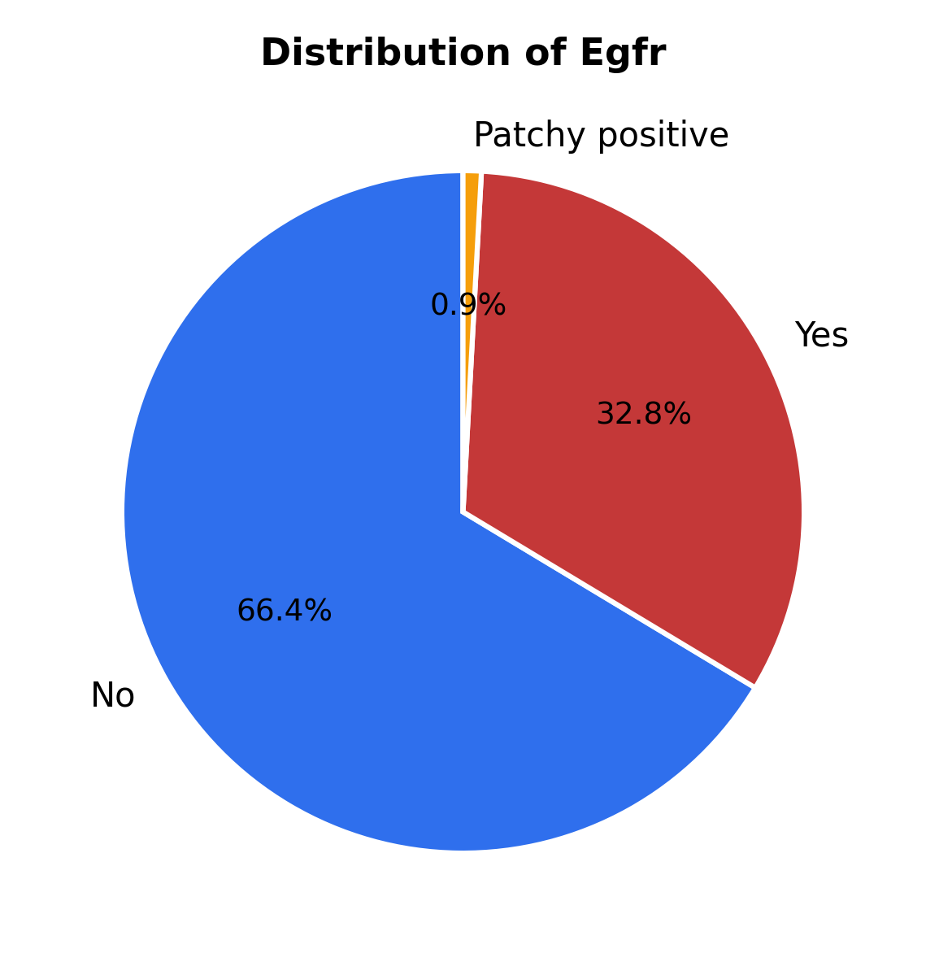

Table 22: Distribution of Egfr by Pr
EGFR | No | Postive | Yes | Total
No | 18 (23.4%) | 1 (1.3%) | 58 (75.3%) | 77
Patchy positive | 0 (0.0%) | 0 (0.0%) | 1 (100.0%) | 1
Yes | 26 (68.4%) | 0 (0.0%) | 12 (31.6%) | 38
Total | 44 (37.9%) | 1 (0.9%) | 71 (61.2%) | 116

Fig 22: Egfr Distribution Across Pr Groups
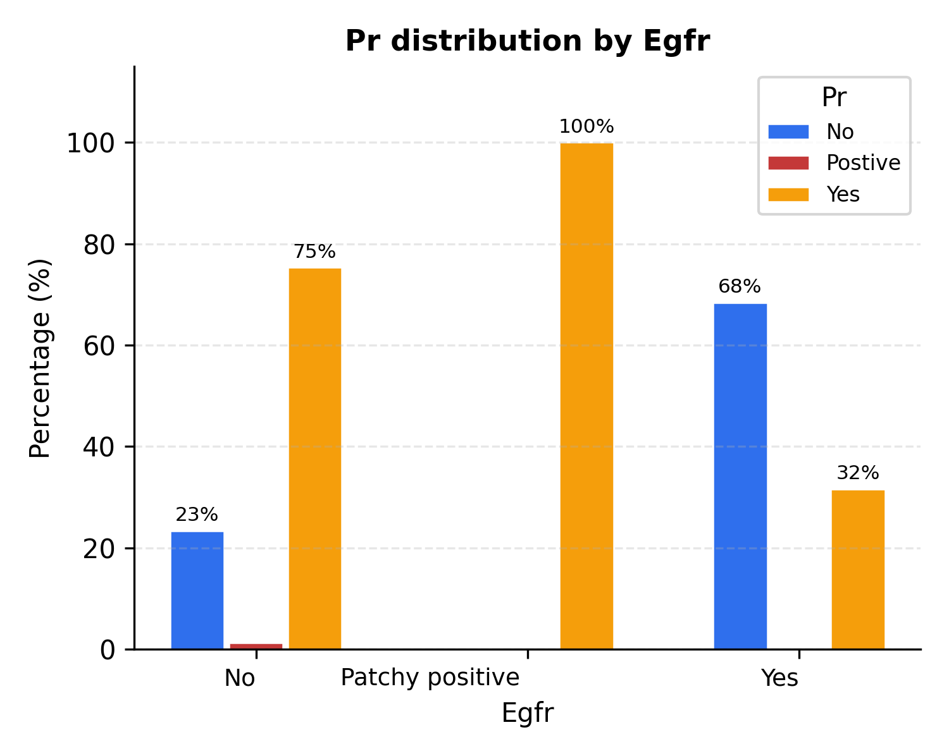

Interpretation: The association between Egfr and Pr was assessed using the chi-square test of independence (n = 116). A statistically significant association was identified (χ² = 22.702, df = 4, p < 0.001). Cramér's V was 0.313, indicating a moderate degree of association between the two variables.
12. Ki67
Table 23: Frequency Distribution of Ki67
Ki67 | n | Percent (%)
>=14% | 94 | 81.0
<14% | 18 | 15.5
>=14 | 3 | 2.6
>= 14% | 1 | 0.9
Total | 116 | 100.0

Fig 23: Bar Chart — Distribution of Ki67
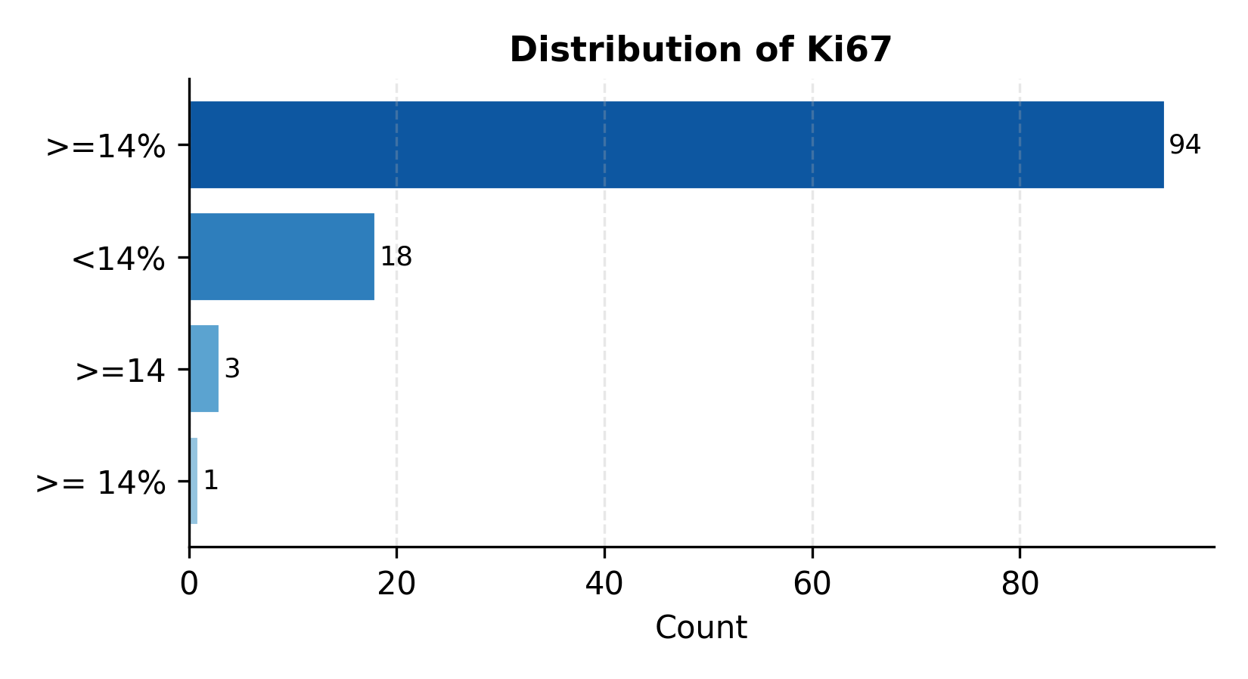

Table 24: Distribution of Ki67 by Pr
Ki67 | No | Postive | Yes | Total
<14% | 2 (11.1%) | 0 (0.0%) | 16 (88.9%) | 18
>= 14% | 0 (0.0%) | 0 (0.0%) | 1 (100.0%) | 1
>=14 | 1 (33.3%) | 0 (0.0%) | 2 (66.7%) | 3
>=14% | 41 (43.6%) | 1 (1.1%) | 52 (55.3%) | 94
Total | 44 (37.9%) | 1 (0.9%) | 71 (61.2%) | 116

Fig 24: Ki67 Distribution Across Pr Groups
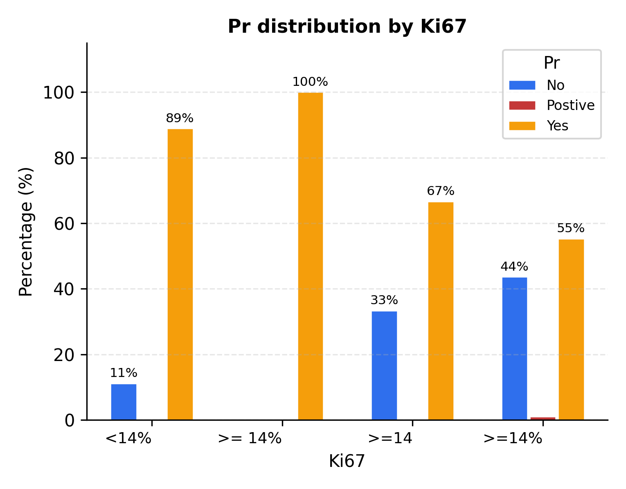

Interpretation: The association between Ki67 and Pr was assessed using the chi-square test of independence (n = 116). No statistically significant association was found between Ki67 and Pr (χ² = 7.891, df = 6, p = 0.246). Cramér's V was 0.184, indicating a weak degree of association between the two variables.
13. Molecular Subtype
Table 25: Frequency Distribution of Molecular Subtype
Molecular subtype | n | Percent (%)
Luminal B | 43 | 37.1
Triple negative | 22 | 19.0
Her2neu | 20 | 17.2
Luminal A | 14 | 12.1
Her2neu | 14 | 12.1
Triple Negative | 1 | 0.9
Her2Neu | 1 | 0.9
Her2Neu | 1 | 0.9
Total | 116 | 100.0

Fig 25: Bar Chart — Distribution of Molecular Subtype
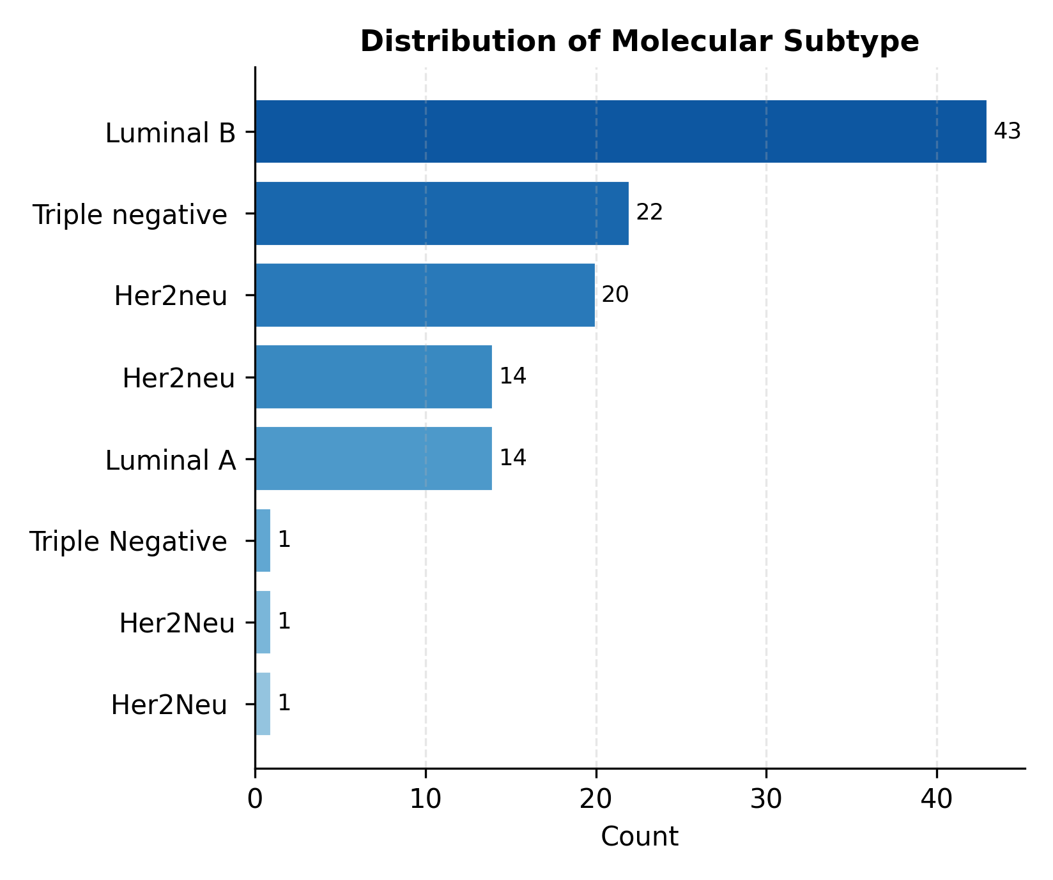

Table 26: Distribution of Molecular Subtype by Pr
Molecular subtype | No | Postive | Yes | Total
Her2Neu | 1 (100.0%) | 0 (0.0%) | 0 (0.0%) | 1
Her2Neu | 1 (100.0%) | 0 (0.0%) | 0 (0.0%) | 1
Her2neu | 4 (28.6%) | 0 (0.0%) | 10 (71.4%) | 14
Her2neu | 10 (50.0%) | 1 (5.0%) | 9 (45.0%) | 20
Luminal A | 0 (0.0%) | 0 (0.0%) | 14 (100.0%) | 14
Luminal B | 5 (11.6%) | 0 (0.0%) | 38 (88.4%) | 43
Triple Negative | 1 (100.0%) | 0 (0.0%) | 0 (0.0%) | 1
Triple negative | 22 (100.0%) | 0 (0.0%) | 0 (0.0%) | 22
Total | 44 (37.9%) | 1 (0.9%) | 71 (61.2%) | 116

Fig 26: Molecular Subtype Distribution Across Pr Groups
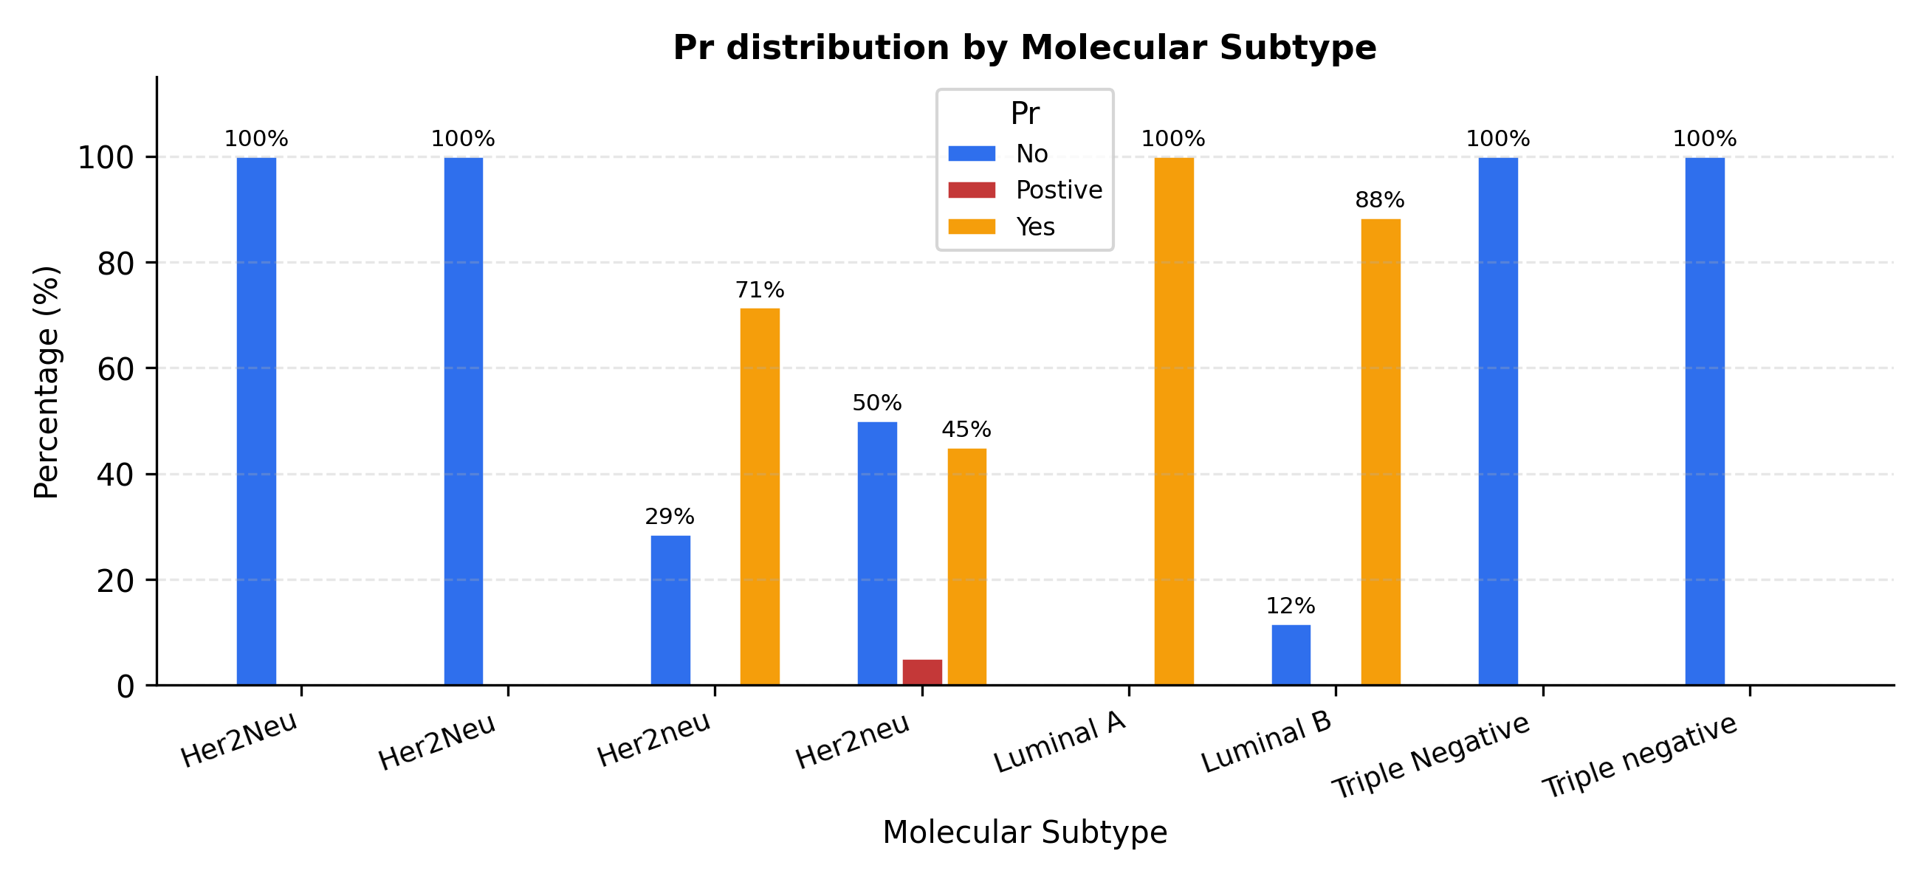

Interpretation: The association between Molecular Subtype and Pr was assessed using the chi-square test of independence (n = 116). A statistically significant association was identified (χ² = 69.462, df = 14, p < 0.001). Cramér's V was 0.547, indicating a strong degree of association between the two variables.
14. Dcis
Table 27: Frequency Distribution of Dcis
DCIS | n | Percent (%)
No | 56 | 48.3
Yes | 56 | 48.3
nan | 1 | 0.9
High grade | 1 | 0.9
Low grade | 1 | 0.9
Intermediate grade | 1 | 0.9
Total | 116 | 100.0

Fig 27: Bar Chart — Distribution of Dcis
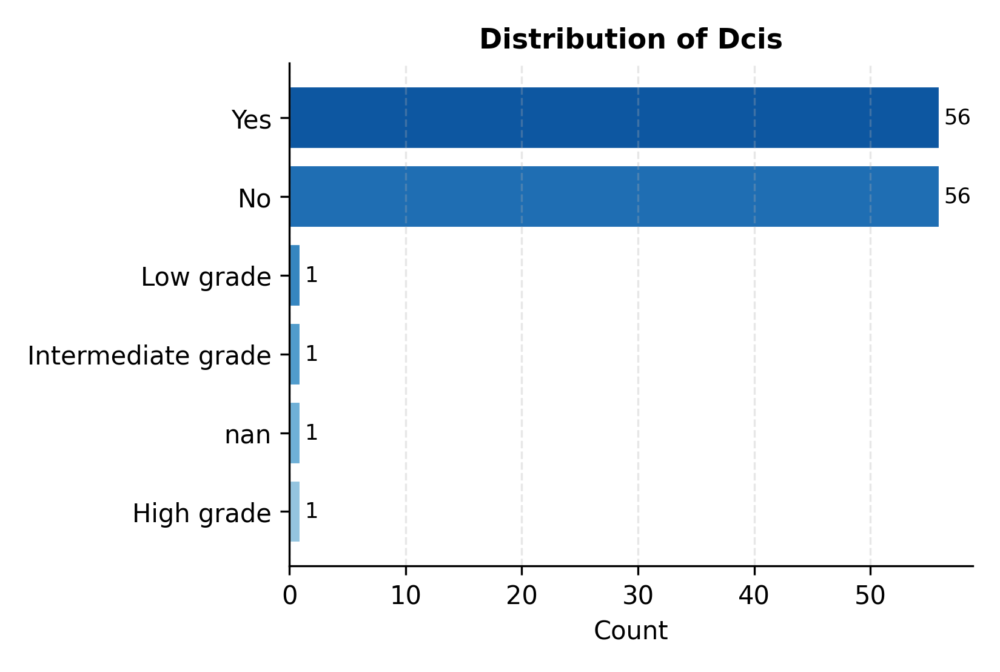

Table 28: Distribution of Dcis by Pr
DCIS | No | Postive | Yes | Total
High grade | 0 (0.0%) | 0 (0.0%) | 1 (100.0%) | 1
Intermediate grade | 0 (0.0%) | 0 (0.0%) | 1 (100.0%) | 1
Low grade | 0 (0.0%) | 0 (0.0%) | 1 (100.0%) | 1
No | 25 (44.6%) | 0 (0.0%) | 31 (55.4%) | 56
Yes | 18 (32.1%) | 1 (1.8%) | 37 (66.1%) | 56
Total | 43 (37.4%) | 1 (0.9%) | 71 (61.7%) | 115

Fig 28: Dcis Distribution Across Pr Groups
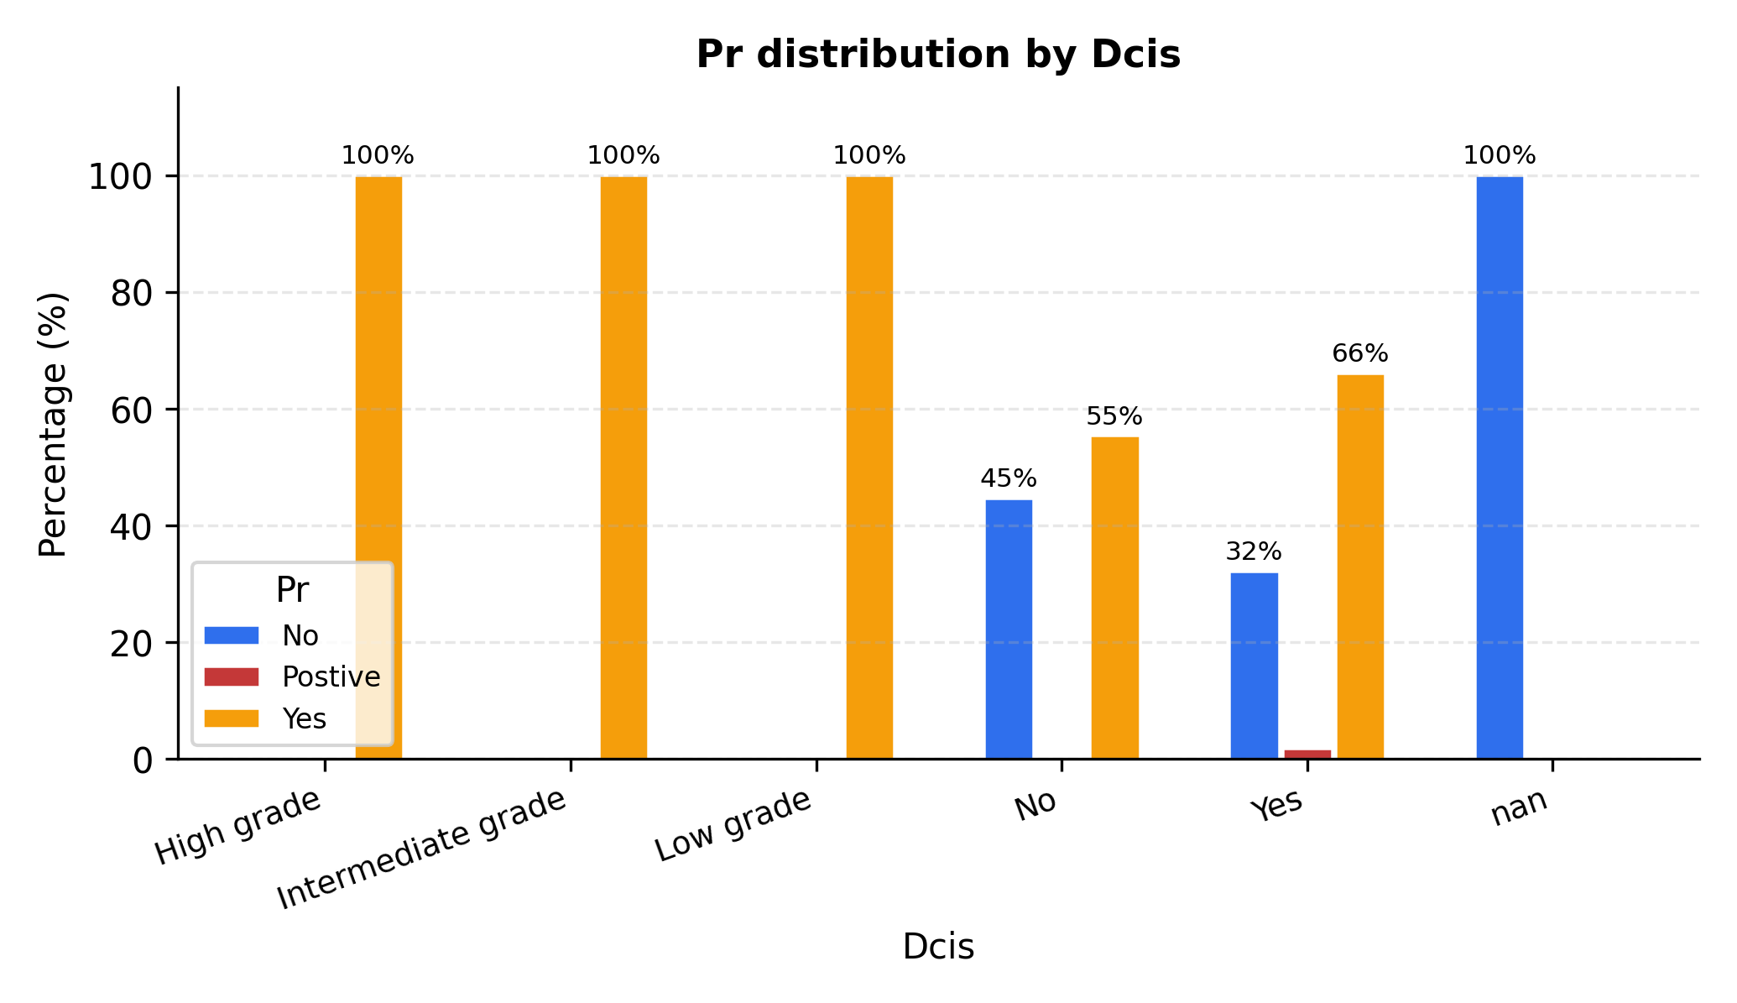

Interpretation: The association between Dcis and Pr was assessed using the chi-square test of independence (n = 115). No statistically significant association was found between Dcis and Pr (χ² = 4.626, df = 8, p = 0.797). Cramér's V was 0.142, indicating a weak degree of association between the two variables.
15. Lvi
Table 29: Frequency Distribution of Lvi
LVI | n | Percent (%)
No | 90 | 77.6
Yes | 24 | 20.7
nan | 1 | 0.9
Abse | 1 | 0.9
Total | 116 | 100.0

Fig 29: Bar Chart — Distribution of Lvi
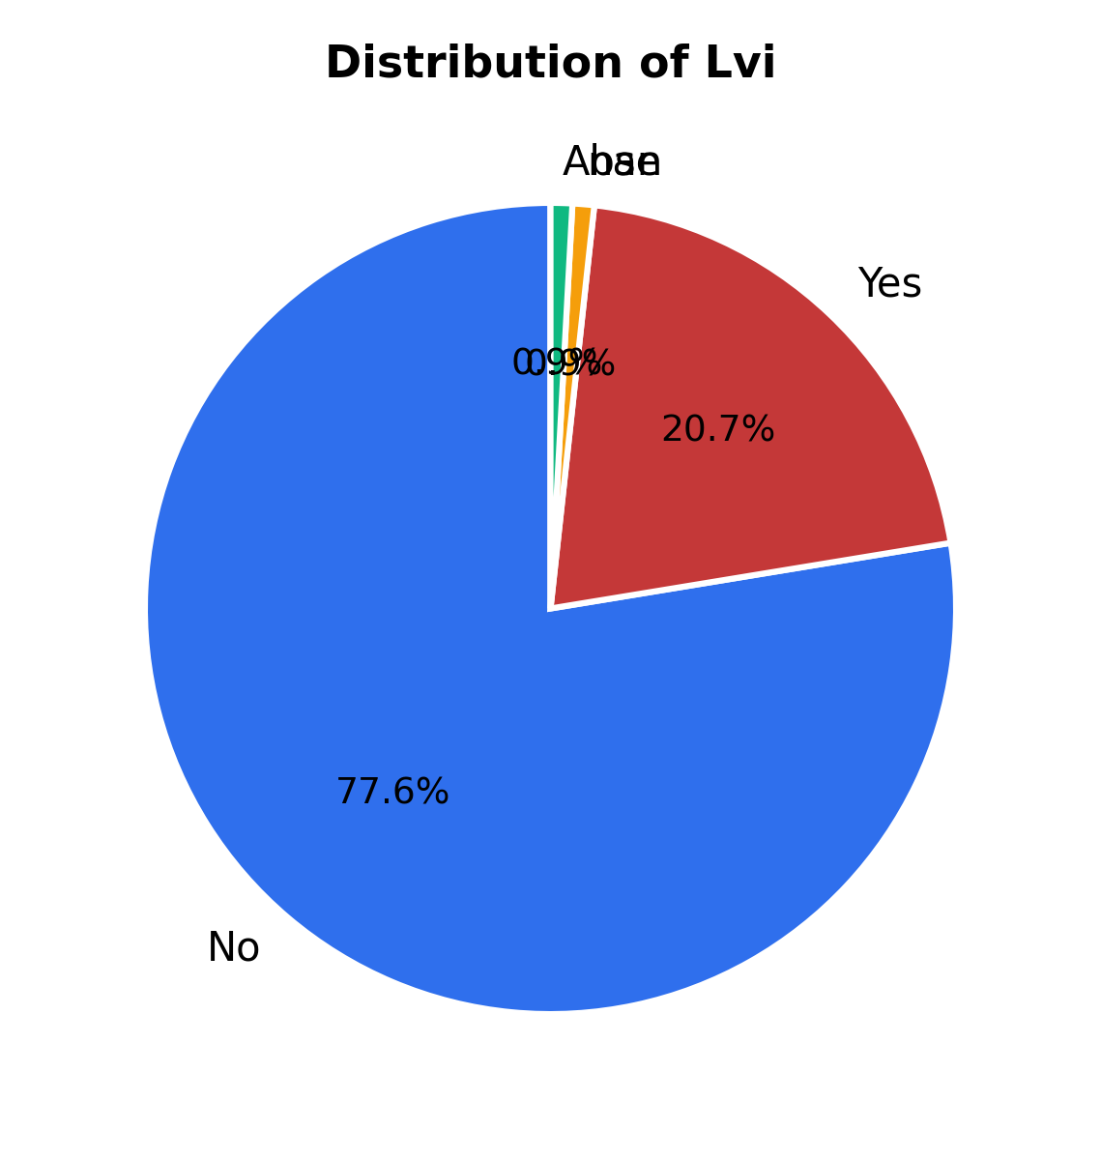

Table 30: Distribution of Lvi by Pr
LVI | No | Postive | Yes | Total
Abse | 0 (0.0%) | 0 (0.0%) | 1 (100.0%) | 1
No | 34 (37.8%) | 0 (0.0%) | 56 (62.2%) | 90
Yes | 9 (37.5%) | 1 (4.2%) | 14 (58.3%) | 24
Total | 43 (37.4%) | 1 (0.9%) | 71 (61.7%) | 115

Fig 30: Lvi Distribution Across Pr Groups
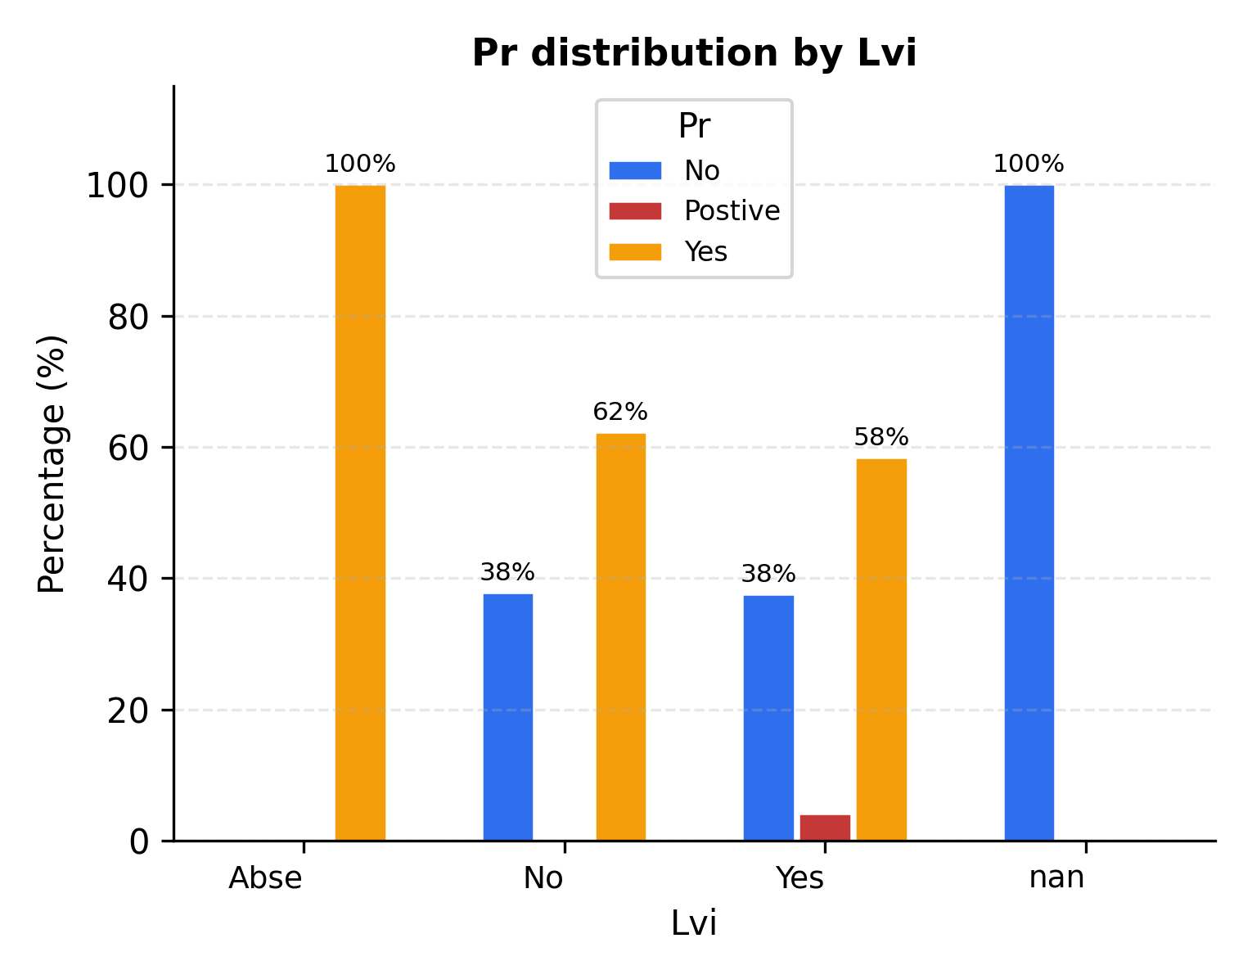

Interpretation: The association between Lvi and Pr was assessed using the chi-square test of independence (n = 115). No statistically significant association was found between Lvi and Pr (χ² = 4.455, df = 4, p = 0.348). Cramér's V was 0.139, indicating a weak degree of association between the two variables.
16. Necrosis
Table 31: Frequency Distribution of Necrosis
Necrosis | n | Percent (%)
Yes | 59 | 50.9
No | 56 | 48.3
nan | 1 | 0.9
Total | 116 | 100.0

Fig 31: Pie Chart — Distribution of Necrosis
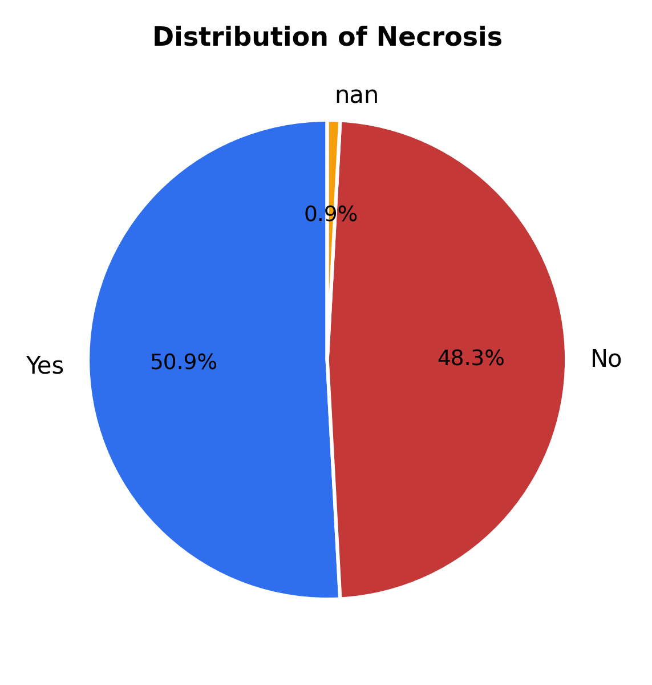

Table 32: Distribution of Necrosis by Pr
Necrosis | No | Postive | Yes | Total
No | 17 (30.4%) | 0 (0.0%) | 39 (69.6%) | 56
Yes | 26 (44.1%) | 1 (1.7%) | 32 (54.2%) | 59
Total | 43 (37.4%) | 1 (0.9%) | 71 (61.7%) | 115

Fig 32: Necrosis Distribution Across Pr Groups
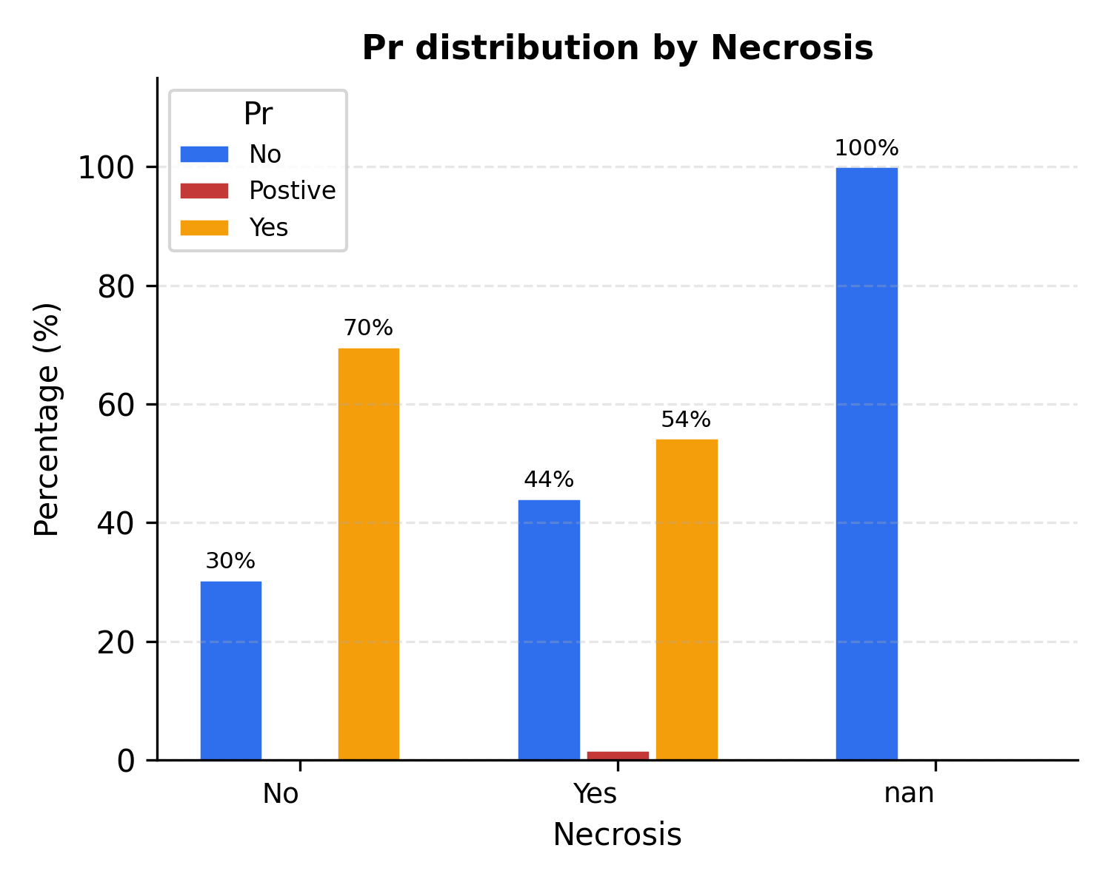

Interpretation: The association between Necrosis and Pr was assessed using the chi-square test of independence (n = 115). No statistically significant association was found between Necrosis and Pr (χ² = 3.498, df = 2, p = 0.174). Cramér's V was 0.174, indicating a weak degree of association between the two variables.
17. Upfront / Post Chemo
Table 33: Frequency Distribution of Upfront / Post Chemo
Upfront / post chemo | n | Percent (%)
No | 95 | 81.9
Yes | 20 | 17.2
nan | 1 | 0.9
Total | 116 | 100.0

Fig 33: Pie Chart — Distribution of Upfront / Post Chemo
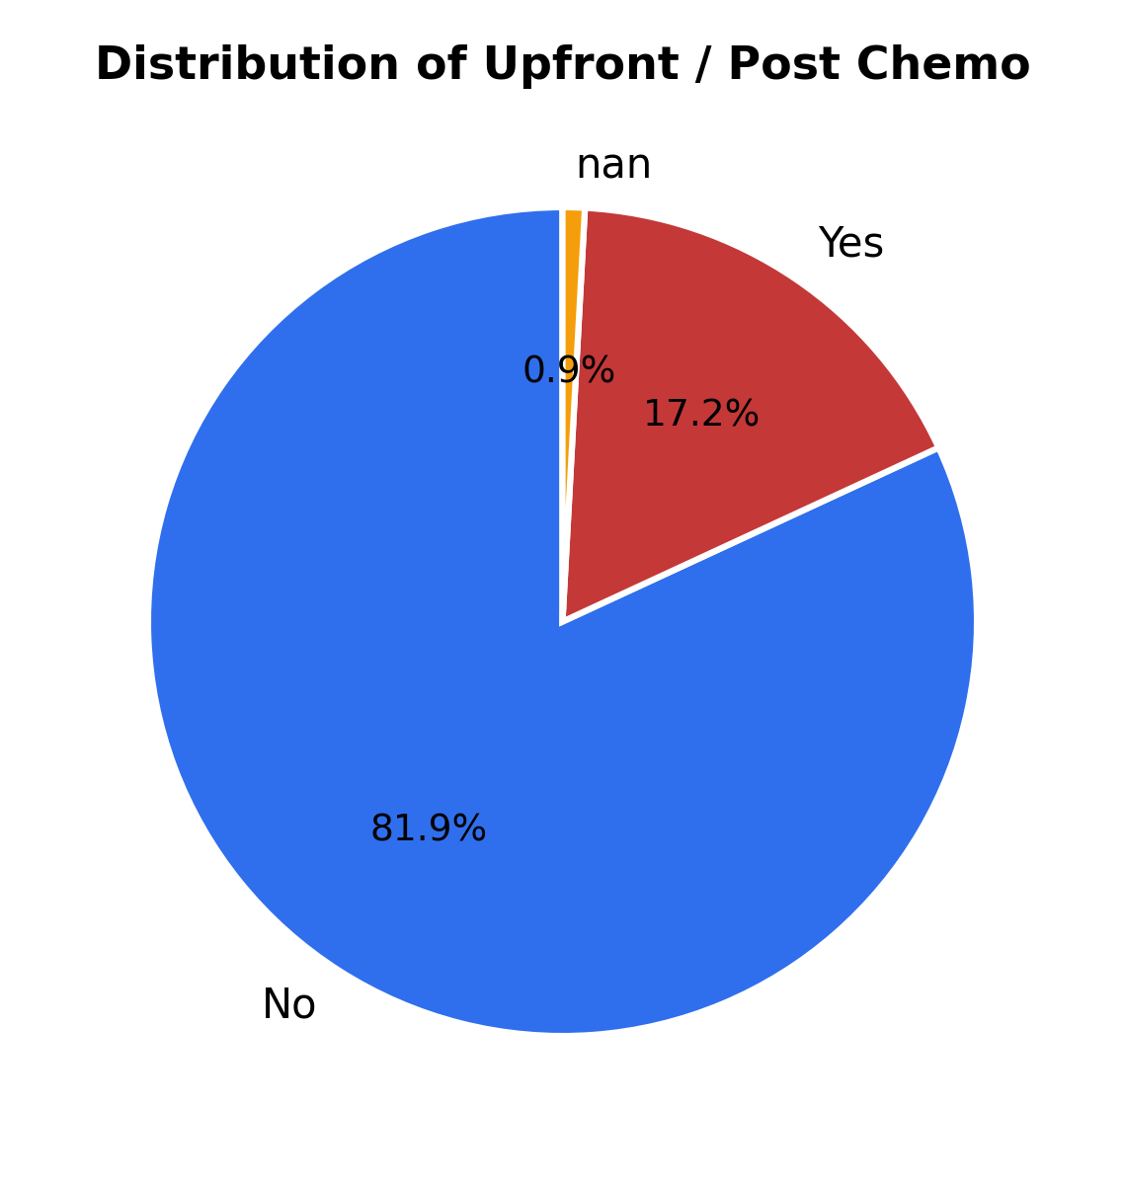

Table 34: Distribution of Upfront / Post Chemo by Pr
Upfront / post chemo | No | Postive | Yes | Total
No | 34 (35.8%) | 1 (1.1%) | 60 (63.2%) | 95
Yes | 9 (45.0%) | 0 (0.0%) | 11 (55.0%) | 20
Total | 43 (37.4%) | 1 (0.9%) | 71 (61.7%) | 115

Fig 34: Upfront / Post Chemo Distribution Across Pr Groups
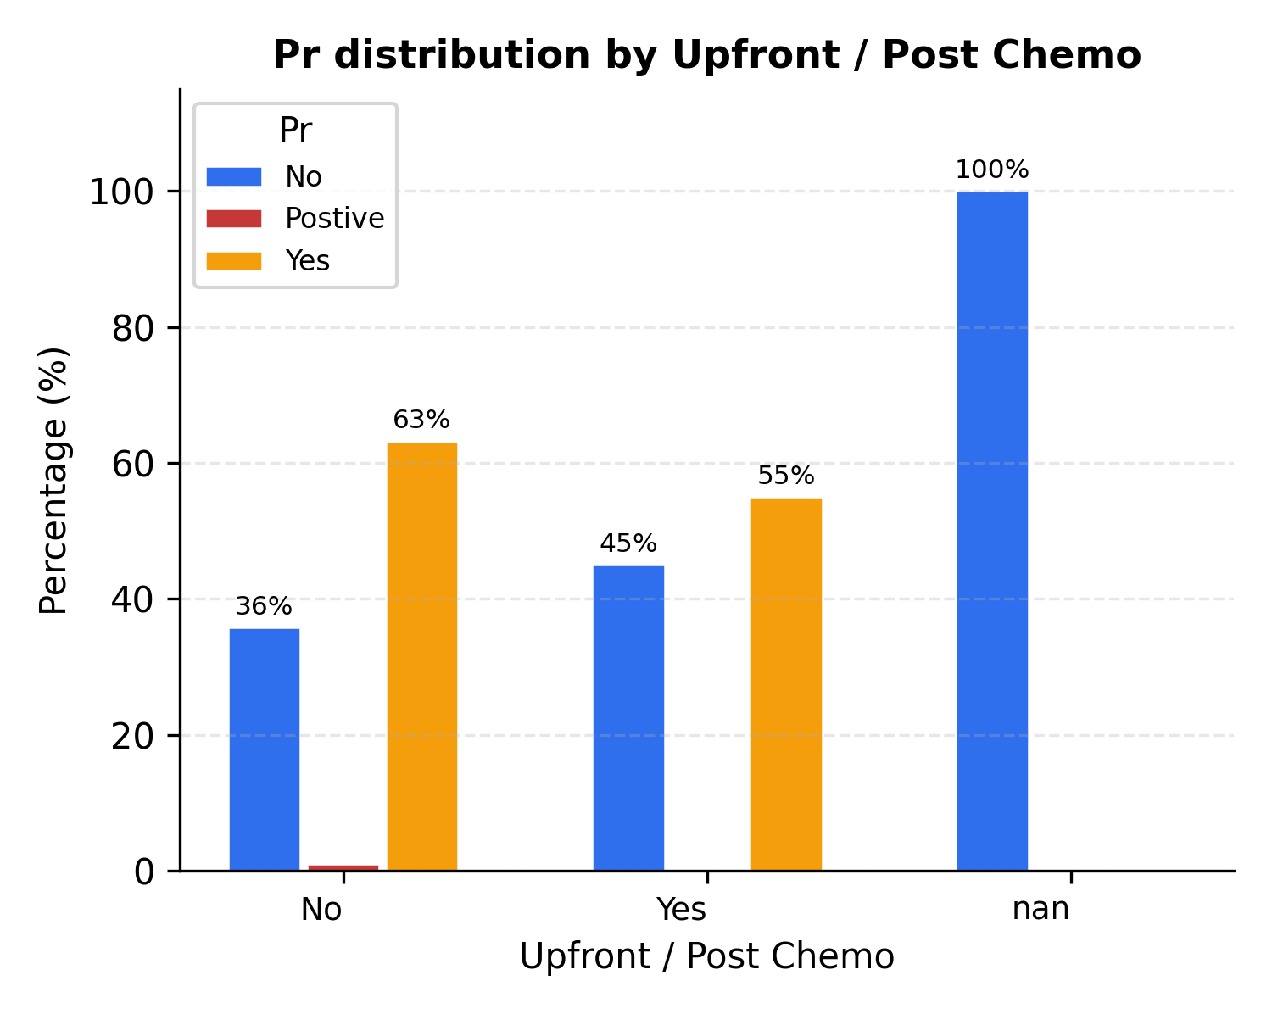

Interpretation: The association between Upfront / Post Chemo and Pr was assessed using the chi-square test of independence (n = 115). No statistically significant association was found between Upfront / Post Chemo and Pr (χ² = 0.763, df = 2, p = 0.683). Cramér's V was 0.081, indicating a negligible degree of association between the two variables.
18. Tx Infiltrating L
Table 35: Frequency Distribution of Tx Infiltrating L
Tx infiltrating L | n | Percent (%)
No | 72 | 62.1
Yes | 43 | 37.1
nan | 1 | 0.9
Total | 116 | 100.0

Fig 35: Pie Chart — Distribution of Tx Infiltrating L
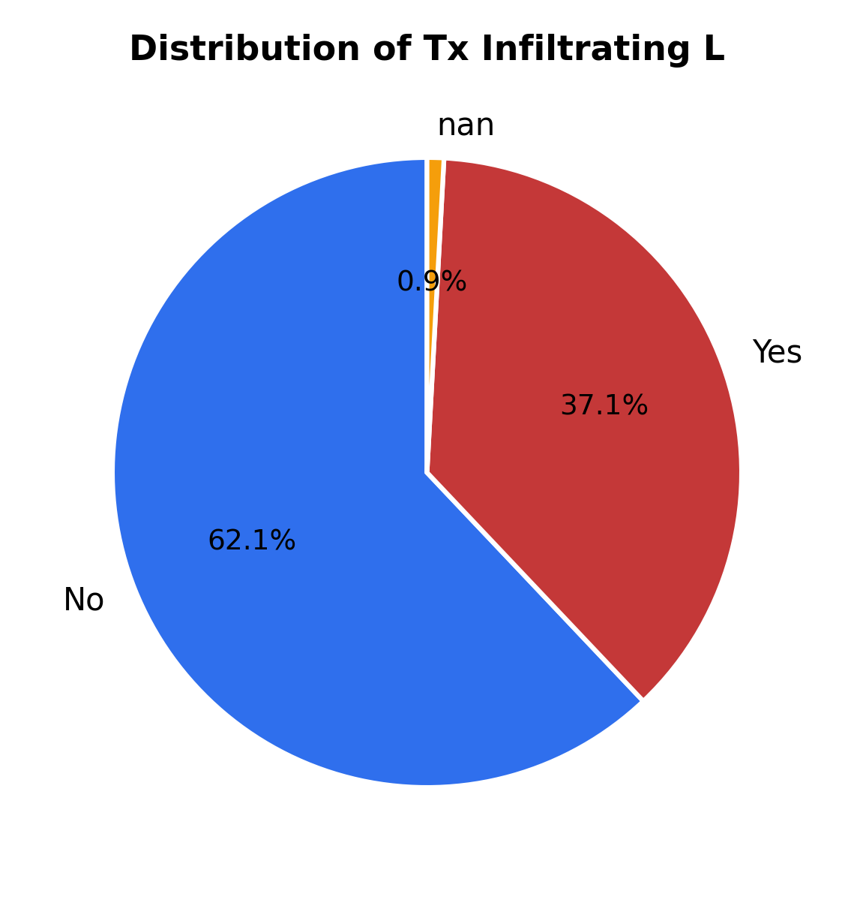

Table 36: Distribution of Tx Infiltrating L by Pr
Tx infiltrating L | No | Postive | Yes | Total
No | 23 (31.9%) | 0 (0.0%) | 49 (68.1%) | 72
Yes | 20 (46.5%) | 1 (2.3%) | 22 (51.2%) | 43
Total | 43 (37.4%) | 1 (0.9%) | 71 (61.7%) | 115

Fig 36: Tx Infiltrating L Distribution Across Pr Groups
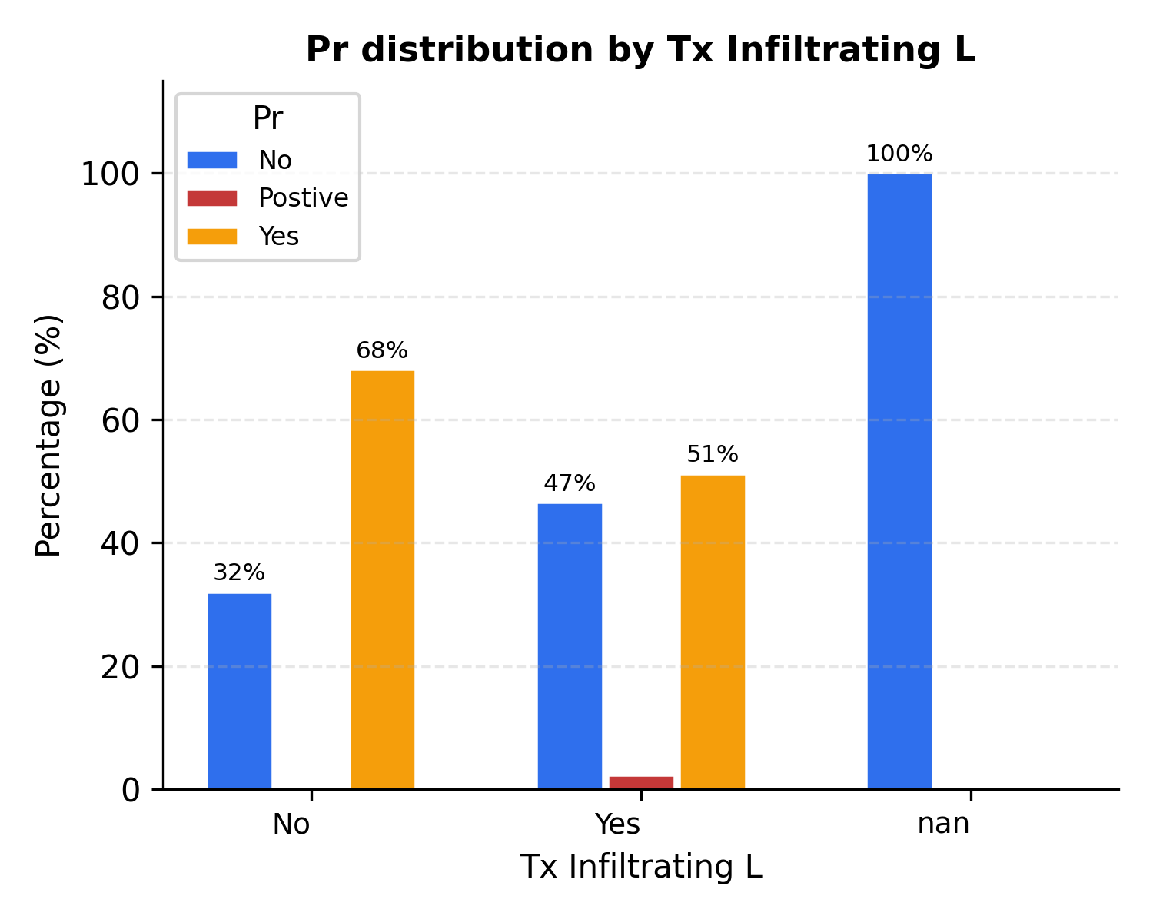

Interpretation: The association between Tx Infiltrating L and Pr was assessed using the chi-square test of independence (n = 115). No statistically significant association was found between Tx Infiltrating L and Pr (χ² = 4.447, df = 2, p = 0.108). Cramér's V was 0.197, indicating a weak degree of association between the two variables.
19. Interpretation Site
Table 37: Frequency Distribution of Interpretation Site
Interpretation - site | n | Percent (%)
Nuclear | 54 | 46.6
Cytoplasmic | 23 | 19.8
Nuclear with cytoplasmic | 14 | 12.1
No stain | 10 | 8.6
No stain | 6 | 5.2
Nuclear | 5 | 4.3
Nuclear with Cytoplasmic | 2 | 1.7
Cytoplasmic | 1 | 0.9
Nuclear with cytoplasmic | 1 | 0.9
Total | 116 | 100.0

Fig 37: Bar Chart — Distribution of Interpretation Site
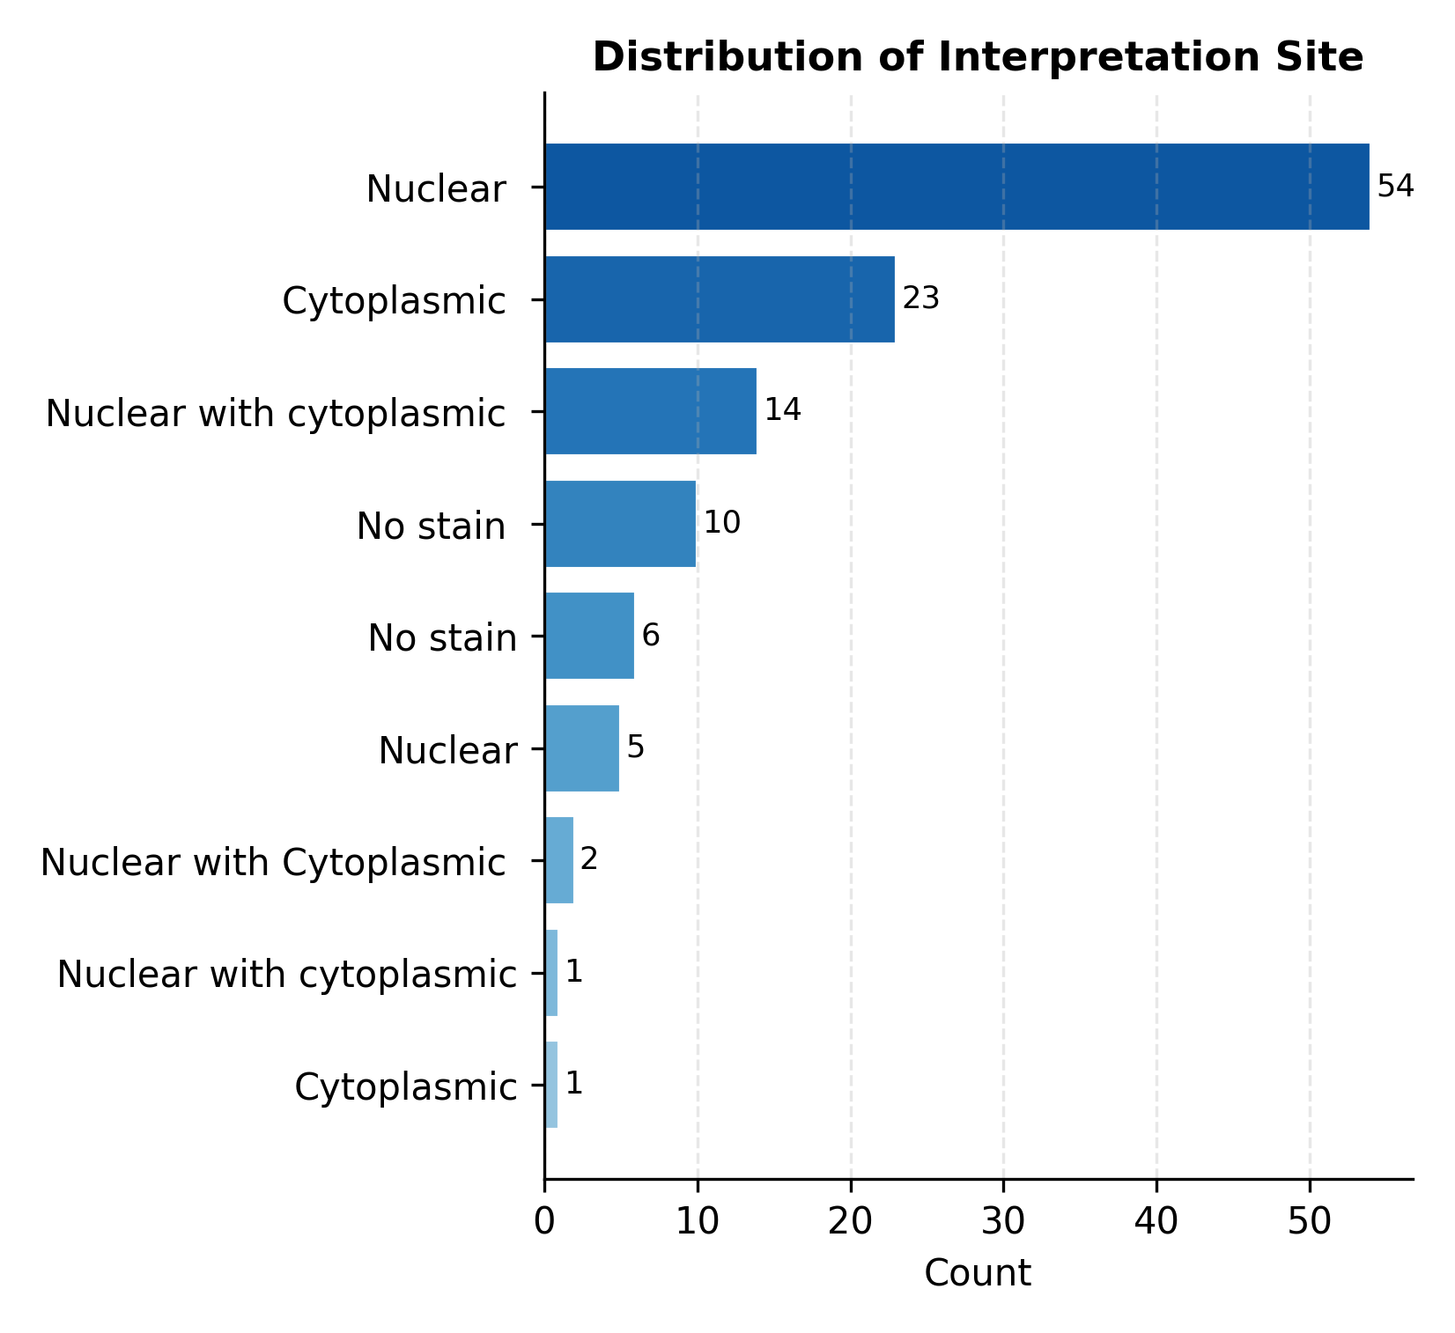

Table 38: Distribution of Interpretation Site by Pr
Interpretation - site | No | Postive | Yes | Total
Cytoplasmic | 1 (100.0%) | 0 (0.0%) | 0 (0.0%) | 1
Cytoplasmic | 16 (69.6%) | 0 (0.0%) | 7 (30.4%) | 23
No stain | 5 (83.3%) | 0 (0.0%) | 1 (16.7%) | 6
No stain | 6 (60.0%) | 0 (0.0%) | 4 (40.0%) | 10
Nuclear | 1 (20.0%) | 0 (0.0%) | 4 (80.0%) | 5
Nuclear | 13 (24.1%) | 0 (0.0%) | 41 (75.9%) | 54
Nuclear with Cytoplasmic | 1 (50.0%) | 0 (0.0%) | 1 (50.0%) | 2
Nuclear with cytoplasmic | 0 (0.0%) | 0 (0.0%) | 1 (100.0%) | 1
Nuclear with cytoplasmic | 1 (7.1%) | 1 (7.1%) | 12 (85.7%) | 14
Total | 44 (37.9%) | 1 (0.9%) | 71 (61.2%) | 116

Fig 38: Interpretation Site Distribution Across Pr Groups
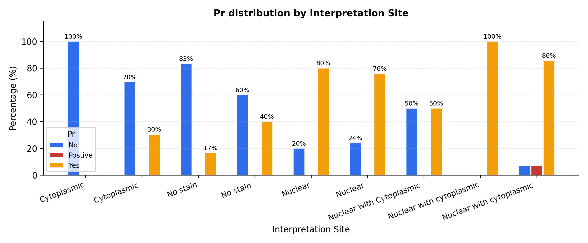

Interpretation: The association between Interpretation Site and Pr was assessed using the chi-square test of independence (n = 116). A statistically significant association was identified (χ² = 36.737, df = 16, p = 0.002). Cramér's V was 0.398, indicating a moderate degree of association between the two variables.
20. Staining Result
Table 39: Frequency Distribution of Staining Result
Staining Result | n | Percent (%)
4+2 | 28 | 24.1
0 | 16 | 13.8
3+1 | 11 | 9.5
3+2 | 11 | 9.5
5+2 | 11 | 9.5
5+1 | 11 | 9.5
4+1 | 9 | 7.8
5+3 | 7 | 6.0
1+1 | 5 | 4.3
4+3 | 3 | 2.6
2+1 | 2 | 1.7
3+3 | 1 | 0.9
2+2 | 1 | 0.9
Total | 116 | 100.0

Fig 39: Bar Chart — Distribution of Staining Result
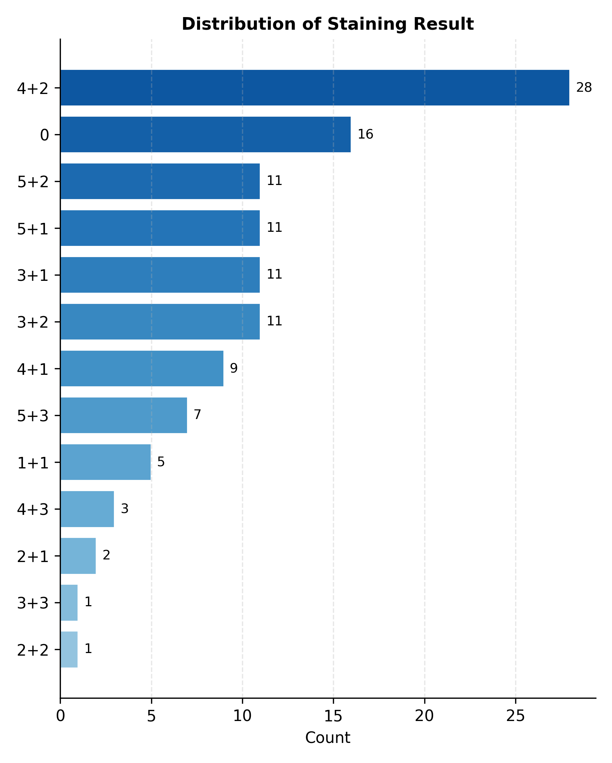

Table 40: Distribution of Staining Result by Pr
Staining Result | No | Postive | Yes | Total
0 | 11 (68.8%) | 0 (0.0%) | 5 (31.2%) | 16
1+1 | 4 (80.0%) | 0 (0.0%) | 1 (20.0%) | 5
2+1 | 1 (50.0%) | 0 (0.0%) | 1 (50.0%) | 2
2+2 | 0 (0.0%) | 0 (0.0%) | 1 (100.0%) | 1
3+1 | 4 (36.4%) | 0 (0.0%) | 7 (63.6%) | 11
3+2 | 5 (45.5%) | 0 (0.0%) | 6 (54.5%) | 11
3+3 | 1 (100.0%) | 0 (0.0%) | 0 (0.0%) | 1
4+1 | 4 (44.4%) | 0 (0.0%) | 5 (55.6%) | 9
4+2 | 10 (35.7%) | 1 (3.6%) | 17 (60.7%) | 28
4+3 | 0 (0.0%) | 0 (0.0%) | 3 (100.0%) | 3
5+1 | 1 (9.1%) | 0 (0.0%) | 10 (90.9%) | 11
5+2 | 2 (18.2%) | 0 (0.0%) | 9 (81.8%) | 11
5+3 | 1 (14.3%) | 0 (0.0%) | 6 (85.7%) | 7
Total | 44 (37.9%) | 1 (0.9%) | 71 (61.2%) | 116

Fig 40: Staining Result Distribution Across Pr Groups
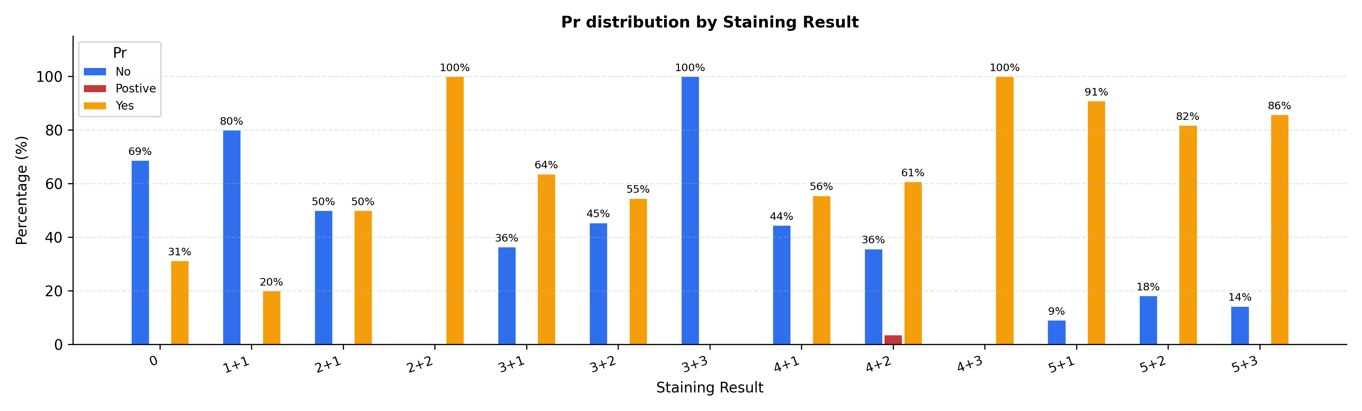

Interpretation: The association between Staining Result and Pr was assessed using the chi-square test of independence (n = 116). No statistically significant association was found between Staining Result and Pr (χ² = 25.519, df = 24, p = 0.378). Cramér's V was 0.332, indicating a moderate degree of association between the two variables.
21. Positive/ Negative
Table 41: Frequency Distribution of Positive/ Negative
Positive/ Negative | n | Percent (%)
Yes | 95 | 81.9
No | 21 | 18.1
Total | 116 | 100.0

Fig 41: Pie Chart — Distribution of Positive/ Negative
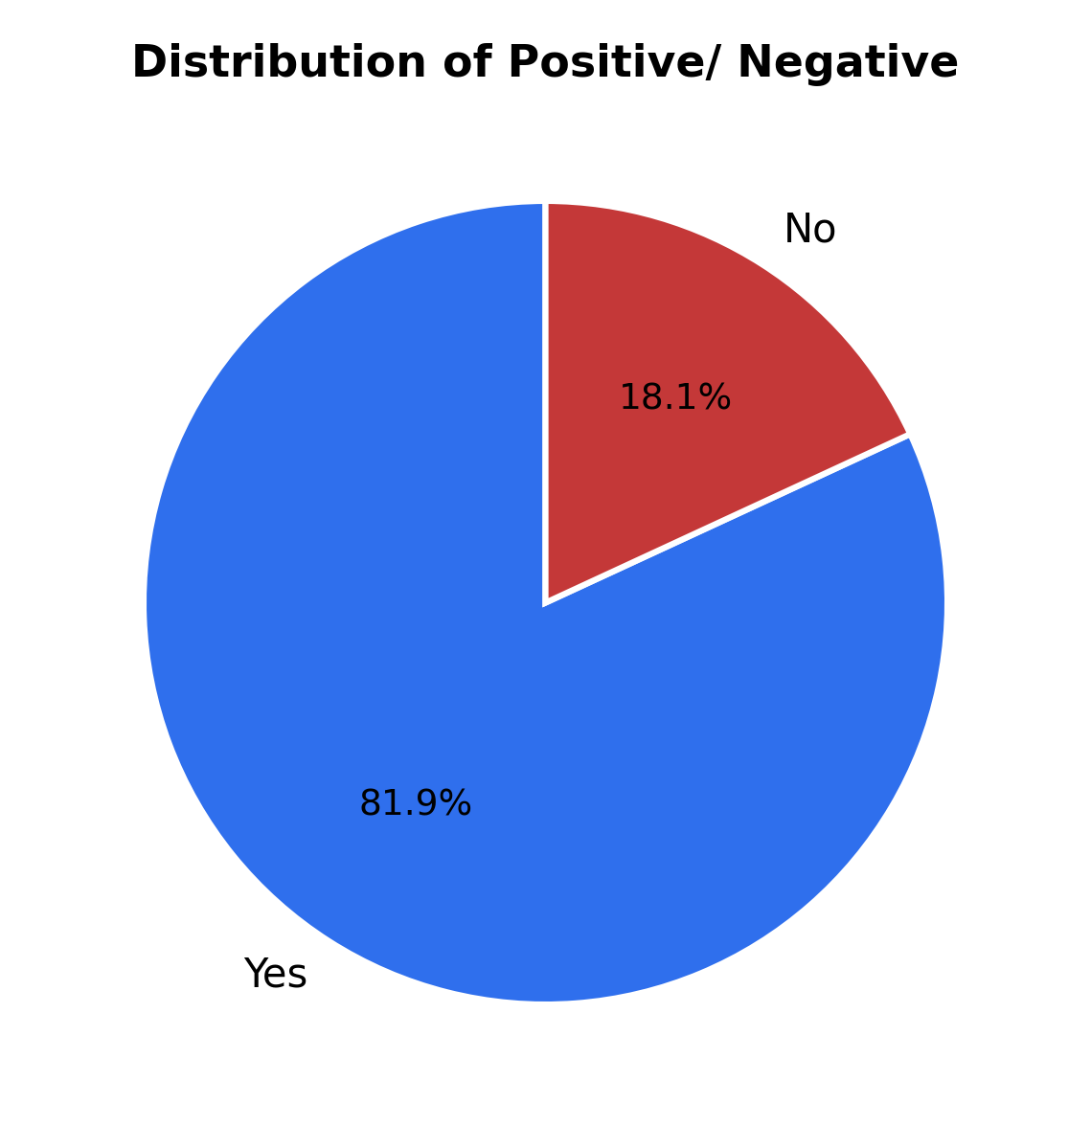

Table 42: Distribution of Positive/ Negative by Pr
Positive/ Negative | No | Postive | Yes | Total
No | 15 (71.4%) | 0 (0.0%) | 6 (28.6%) | 21
Yes | 29 (30.5%) | 1 (1.1%) | 65 (68.4%) | 95
Total | 44 (37.9%) | 1 (0.9%) | 71 (61.2%) | 116

Fig 42: Positive/ Negative Distribution Across Pr Groups
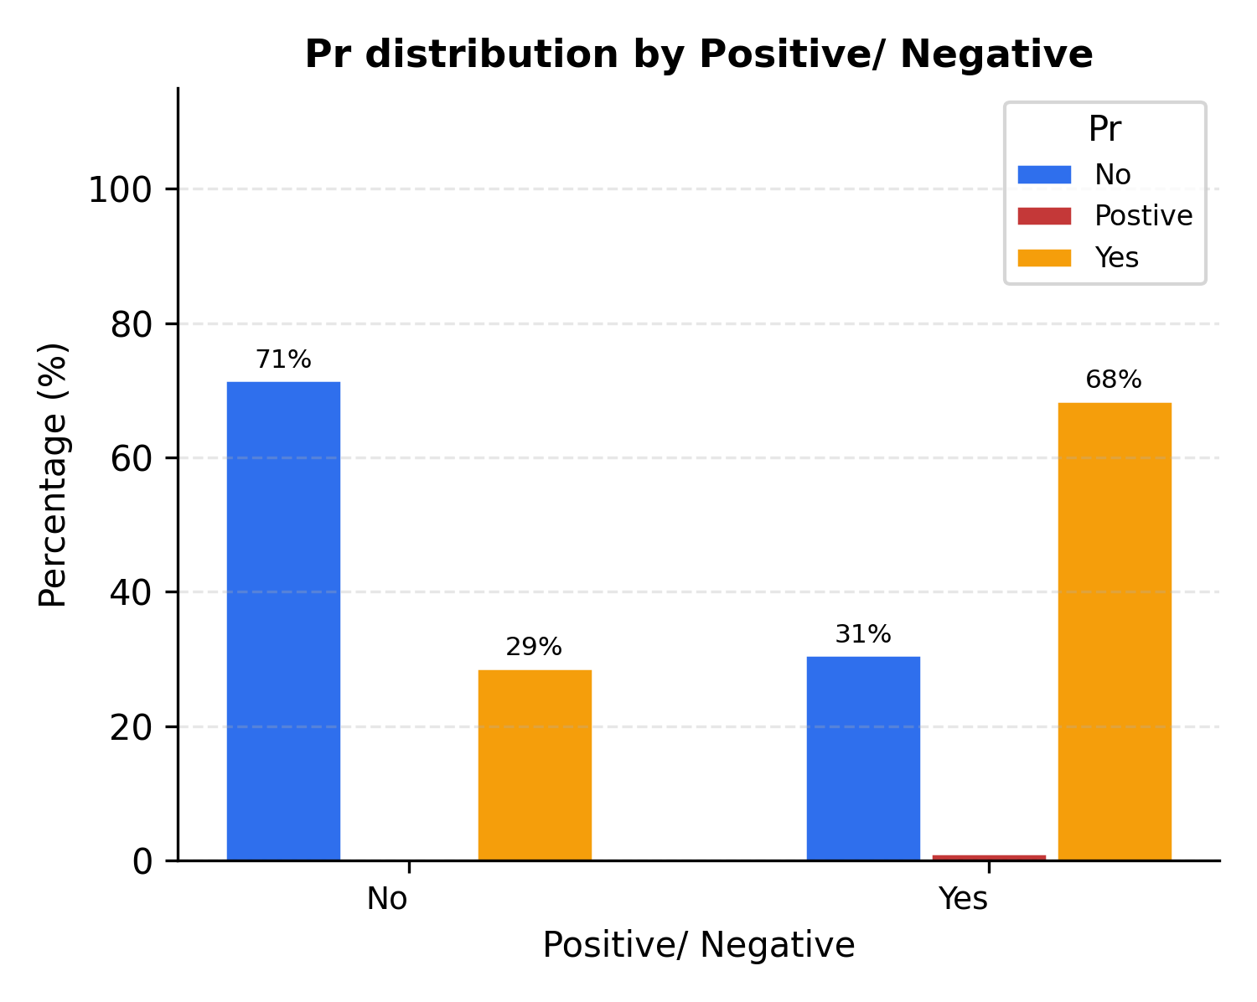

Interpretation: The association between Positive/ Negative and Pr was assessed using the chi-square test of independence (n = 116). A statistically significant association was identified (χ² = 12.269, df = 2, p = 0.002). Cramér's V was 0.325, indicating a moderate degree of association between the two variables.
22. Summary of Key Outcomes
The table below summarises the association of all predictor variables with Pr. Statistically significant findings (p < 0.05) are indicated with an asterisk (*) and shown in bold.
Table 43: Summary of Key Outcomes
Variable | Test Used | Statistic | p-value
Er | Chi-square | 141.419 | < 0.001*
Ar | Chi-square | 133.387 | < 0.001*
Molecular Subtype | Chi-square | 69.462 | < 0.001*
Histological Type | Chi-square | 30.313 | < 0.001*
Egfr | Chi-square | 22.702 | < 0.001*
Positive/ Negative | Chi-square | 12.269 | 0.002*
Interpretation Site | Chi-square | 36.737 | 0.002*
Tx Infiltrating L | Chi-square | 4.447 | 0.108
Necrosis | Chi-square | 3.498 | 0.174
Ene | Chi-square | 3.156 | 0.206
Age | Kruskal-Wallis H | 1.511 | 0.219
Ki67 | Chi-square | 7.891 | 0.246
Lvi | Chi-square | 4.455 | 0.348
Nodal Status | Chi-square | 13.157 | 0.358
Staining Result | Chi-square | 25.519 | 0.378
Laterality | Chi-square | 5.213 | 0.517
Upfront / Post Chemo | Chi-square | 0.763 | 0.683
Her2neu | Chi-square | 9.153 | 0.690
Dcis | Chi-square | 4.626 | 0.797
Tumour Size (cm) | Chi-square | 2.852 | 0.985
Pt | Chi-square | 2.525 | 0.991

Statistical Methods
Statistical analyses were conducted on the study dataset (N = 116). The association of 21 predictor variables with the outcome variable (Pr) was examined independently for each predictor. All tests were two-sided. Statistical significance was set at α = 0.05. Analyses were performed using Python (SciPy statistical library).
Test selection was guided by the measurement level of each predictor variable. For continuous predictor variables assessed against a categorical outcome, the Mann-Whitney U test (two groups) or Kruskal-Wallis H test (three or more groups) was applied, as non-parametric alternatives are robust when normality cannot be assumed. For categorical predictor variables, the chi-square test of independence was used; Fisher’s exact test was substituted when any expected cell count fell below 5.
Effect size was reported alongside each inferential test to convey the magnitude of observed associations independent of sample size. The rank-biserial correlation coefficient (rₛ) was computed for Mann-Whitney U comparisons and interpreted as negligible (< 0.10), small (0.10–0.29), medium (0.30–0.49), or large (≥0.50). Cramér’s V was reported for chi-square analyses and classified as negligible (< 0.10), weak (0.10–0.29), moderate (0.30–0.49), or strong (≥0.50), following the convention of Cohen (1988).
Table 44: Statistical Tests Applied per Variable
Variable | Type | Test Applied | Effect Size Measure
Age | Continuous | Kruskal-Wallis H | Eta-squared (η²)
Laterality | Categorical | Chi-square | Cramér’s V
Tumour Size (cm) | Categorical | Chi-square | Cramér’s V
Histological Type | Categorical | Chi-square | Cramér’s V
Pt | Categorical | Chi-square | Cramér’s V
Nodal Status | Categorical | Chi-square | Cramér’s V
Ene | Categorical | Chi-square | Cramér’s V
Er | Categorical | Chi-square | Cramér’s V
Her2neu | Categorical | Chi-square | Cramér’s V
Ar | Categorical | Chi-square | Cramér’s V
Egfr | Categorical | Chi-square | Cramér’s V
Ki67 | Categorical | Chi-square | Cramér’s V
Molecular Subtype | Categorical | Chi-square | Cramér’s V
Dcis | Categorical | Chi-square | Cramér’s V
Lvi | Categorical | Chi-square | Cramér’s V
Necrosis | Categorical | Chi-square | Cramér’s V
Upfront / Post Chemo | Categorical | Chi-square | Cramér’s V
Tx Infiltrating L | Categorical | Chi-square | Cramér’s V
Interpretation Site | Categorical | Chi-square | Cramér’s V
Staining Result | Categorical | Chi-square | Cramér’s V
Positive/ Negative | Categorical | Chi-square | Cramér’s V

Given that 21 predictor variables were tested against the same outcome, the possibility of inflated type I error due to multiple comparisons should be considered when interpreting the results. Findings with p < 0.05 should be regarded as exploratory; confirmatory analyses with appropriate correction (e.g., Bonferroni or Holm–Bonferroni) are recommended before drawing causal inferences.

