A Comparative study of 27G Quincke and 27G Whitacre spinal needle on the incidence of Post Dural Puncture Headache following spinal anaesthesia in elective Caesarean section in a tertiary care hospital Chengalpattu district – A Randomised controlled trial

LIST OF ABBREVIATIONS
Abbreviation | Full Form
ASA | American Society of Anesthesiologists
BMI | Body Mass Index
BP | Blood Pressure
CSF | Cerebrospinal Fluid
G | Gauge
min | Minute(s)
mmHg | Millimetres of Mercury
PDPH | Post Dural Puncture Headache
SD | Standard Deviation
SPSS | Statistical Package for the Social Sciences
vs. | Versus

ABSTRACT
Background:
Spinal anaesthesia is the gold standard for cesarean section due to its rapid onset, superior maternal and neonatal safety, and minimal systemic drug exposure. Despite these advantages, Post Dural Puncture Headache (PDPH) remains a significant complication, particularly among obstetric patients. The design and gauge of the spinal needle are pivotal factors influencing PDPH incidence.
Objective:
To conduct a comparative evaluation of 27G Quincke (cutting-tip) and 27G Whitacre (atraumatic, pencil-point) spinal needles in parturients undergoing elective cesarean section, with a focus on the incidence, severity, and clinical presentation of PDPH, as well as procedural success and complications.
Methods:
A randomized, double-blind, prospective clinical study was conducted on 120 ASA I–II parturients scheduled for elective cesarean delivery. Participants were evenly assigned to receive spinal anaesthesia with either a Quincke or Whitacre 27G needle. Variables recorded included demographic characteristics, number of attempts, time to CSF flow, failed blocks, PDPH incidence and severity, onset and duration, and associated symptoms. Data were statistically analysed using appropriate tests, with p < 0.05 considered significant.
Results:
Both groups were demographically comparable, ensuring homogeneity of baseline characteristics. The incidence of PDPH was significantly lower in the Whitacre group (3.3%) compared to the Quincke group (10.0%) (p = 0.04). Although both needle types had high procedural success rates, Whitacre demonstrated fewer associated symptoms, a shorter PDPH duration, and reduced severity. Time to CSF detection and number of attempts were similar between groups, indicating no compromise in procedural efficiency.
Conclusion:
The 27G Whitacre needle offers a clear clinical advantage over the Quincke design in reducing PDPH and its associated morbidity without sacrificing procedural efficacy. These findings strongly advocate for the routine use of atraumatic pencil-point needles in obstetric anaesthesia to improve postpartum recovery, maternal satisfaction, and overall anaesthetic outcomes.
Keywords: Spinal anaesthesia, Post Dural Puncture Headache, Quincke needle, Whitacre needle, cesarean section, obstetric anaesthesia, needle design, atraumatic needles.

CHAPTER I
INTRODUCTION
Spinal anaesthesia stands as one of the most transformative developments in modern anaesthesiology, first pioneered by August Bier in 1898 (1). Over a century later, it remains a cornerstone of anaesthetic practice, particularly for surgeries involving the lower abdomen and lower limbs. Among its most prominent applications is in obstetric anaesthesia, where spinal anaesthesia has become the preferred modality for cesarean section. The reasons for its widespread adoption are multifold: a rapid onset of action, high efficacy in producing sensory and motor blockade, minimal systemic drug exposure, and superior maternal and neonatal safety outcomes (2). Compared to general anaesthesia, spinal anaesthesia allows the parturient to remain conscious during delivery, facilitates immediate maternal-infant bonding, and is associated with lower perioperative morbidity (3).
Despite its advantages, spinal anaesthesia is not devoid of risks. One of its most persistent and troubling complications is Post-Dural Puncture Headache (PDPH). PDPH is a distressing condition resulting from the leakage of cerebrospinal fluid (CSF) at the site of dural puncture, causing reduced intracranial pressure and subsequent compensatory cerebral vasodilation (4). This pathophysiological cascade leads to a classic orthostatic headache that worsens upon standing or sitting and improves in the supine position. PDPH may be accompanied by nausea, neck stiffness, photophobia, tinnitus, and visual disturbances, all of which can significantly hinder postpartum recovery and the mother's ability to care for her newborn (5).
The incidence of PDPH varies widely, reported in literature from as low as 0.5% to as high as 36% (6). This variation is influenced by multiple patient and procedural factors. Young age, female sex, pregnancy, low body mass index, and a history of headaches have been established as patient-related risk factors (7). Procedural contributors include the type and size of spinal needle used, the number of puncture attempts, the orientation of the bevel, and the technique employed. Among these, needle design and gauge are considered critical modifiable determinants that can significantly affect the likelihood of PDPH (8).
Spinal needles are broadly classified into two categories based on their tip design: cutting (traumatic) needles such as the Quincke, and atraumatic (pencil-point) needles such as the Whitacre and Sprotte. Cutting needles penetrate the dura mater by slicing through its fibers, creating larger, clean-cut defects that are prone to persistent CSF leakage. In contrast, atraumatic needles part the dural fibers rather than severing them, leading to smaller, self-sealing punctures (9). This anatomical difference translates into significant clinical implications: numerous studies have shown that atraumatic needles are associated with a substantially lower incidence of PDPH compared to cutting needles (10).
Gauge, or needle diameter, is another essential consideration. Smaller gauge needles (i.e., those with higher numbers such as 27G or 29G) create smaller puncture sites and are generally associated with lower PDPH rates (11). However, their use is sometimes limited by technical difficulties. Ultra-fine needles can be challenging to insert, may fail to elicit CSF return on the first attempt, and may require repeated attempts, paradoxically increasing the risk of PDPH (12). As such, a balance must be struck between minimising dural trauma and maintaining procedural efficacy.
The 27G spinal needle is often considered an ideal compromise between safety and ease of use. Within this gauge, the Quincke (cutting) and Whitacre (atraumatic) needles are frequently employed in clinical practice. While the theoretical and empirical advantages of the Whitacre design have been demonstrated in multiple studies, direct comparisons between the 27G Quincke and Whitacre needles in the context of obstetric anaesthesia—particularly cesarean sections—are limited (13). This gap in evidence is clinically significant given the unique physiological and anatomical considerations in pregnant women. For instance, increased intra-abdominal pressure during pregnancy raises epidural venous pressure, which can elevate the risk of dural puncture trauma and CSF leakage. Hormonal changes also affect tissue elasticity and vascular permeability, further increasing susceptibility to PDPH (14).
Parturients undergoing cesarean section are a population especially vulnerable to PDPH. The postpartum period is physically and emotionally demanding, and the presence of PDPH can severely compromise a mother’s ability to engage in essential activities such as breastfeeding, newborn care, and early mobilisation. Additionally, managing PDPH often requires pharmacologic intervention, prolonged hospital stays, or invasive procedures like epidural blood patches. Thus, any strategy that minimizes the risk of PDPH, without compromising anaesthetic effectiveness, is of paramount importance (15).
Multiple meta-analyses and randomised controlled trials have provided evidence supporting the use of atraumatic needles. These studies consistently show that Whitacre needles are associated with lower PDPH incidence compared to Quincke needles, even when both are of the same gauge. For example, a comprehensive meta-analysis involving over 9 randomised trials concluded that the use of Whitacre needles reduced PDPH incidence by more than half compared to Quincke needles, and also decreased the need for epidural blood patches (10,13). Moreover, in addition to reducing PDPH, atraumatic needles have been associated with improved patient satisfaction, faster recovery, and fewer complications overall (11).
However, despite the compelling evidence, the transition from Quincke to Whitacre needles in routine practice has been inconsistent. Factors such as operator familiarity, perceived technical challenges, and equipment availability continue to influence clinical decision-making (12). Moreover, many studies fail to control for confounding variables such as number of puncture attempts, patient positioning, and anaesthetist experience—all of which may independently affect PDPH risk (16). These limitations underscore the need for well-designed, controlled clinical trials that directly compare 27G Quincke and Whitacre needles under uniform conditions in specific patient populations.
This research aims to fill this critical knowledge gap by conducting a randomized, double-blind, controlled trial to evaluate the incidence of PDPH following spinal anaesthesia in parturients undergoing elective cesarean sections using either a 27G Quincke or a 27G Whitacre needle. In addition to measuring PDPH incidence and severity, the study will also assess secondary outcomes including the number of needle insertion attempts, time to achieve CSF flow, procedural complications, and overall patient satisfaction.
The relevance of this research is both academic and clinical. From a clinical standpoint, identifying the optimal needle type could lead to changes in institutional practice, reduce the burden of PDPH, and improve postpartum recovery experiences for thousands of women annually. From an academic perspective, the study contributes to the growing body of literature aimed at refining and personalising anaesthetic care in obstetrics (17).
Furthermore, this study aligns with broader healthcare goals of patient safety, quality improvement, and cost-effectiveness. By potentially reducing the need for additional interventions such as epidural blood patches, pharmacologic treatments, and extended hospitalisation, the findings could contribute to more efficient resource utilisation and lower overall healthcare expenditures (18).
In conclusion, spinal anaesthesia is an indispensable component of modern obstetric care, but the complication of PDPH continues to challenge clinicians. The design and gauge of the spinal needle play a crucial role in the occurrence of PDPH, with atraumatic pencil-point needles like the Whitacre showing promise in reducing this risk. This study seeks to provide robust, context-specific evidence to inform best practices in needle selection, enhance maternal care, and contribute to the evolving standards of obstetric anaesthesia.

CHAPTER II
AIM & OBJECTIVES
Aim of the Study
To compare the occurrence of Post Dural Puncture Headache (PDPH) using 27G Quincke and 27G Whitacre spinal needles following spinal anaesthesia in elective cesarean sections.
Objectives
Primary Objective:
- To evaluate the incidence and severity of post-dural puncture headache with 27G Quincke and Whitacre spinal needles.
Secondary Objectives:
- To evaluate the incidence of spinal needle-induced failed spinal anaesthesia.
- To evaluate the incidence of other side effects such as nausea and vomiting.

CHAPTER III
REVIEW OF LITERATURE

Spinal Anaesthesia and Post Dural Puncture Headache (PDPH)
Spinal anaesthesia is a time-tested technique widely used in surgical procedures, particularly in obstetrics, owing to its rapid onset, minimal systemic effects, and cost-effectiveness (19). This method involves the injection of local anaesthetic agents into the cerebrospinal fluid (CSF), effectively blocking nerve conduction below the site of administration. However, one of its notable complications, Post Dural Puncture Headache (PDPH), poses significant challenges to both patients and healthcare providers (20).
The incidence of PDPH varies depending on patient demographics, procedural techniques, and equipment used. Needle design and size, in particular, have been recognized as critical determinants of PDPH risk. Cutting needles, such as the Quincke, have been associated with a higher incidence of PDPH compared to atraumatic pencil-point needles like the Whitacre (21). In obstetrics, this risk is compounded by pregnancy-related physiological changes that increase the likelihood of complications (22).
Despite numerous studies comparing cutting and atraumatic needles, gaps remain in the literature regarding their specific impact in cesarean sections. Most studies generalize findings across various surgeries, neglecting the unique factors in obstetric populations. Furthermore, inconsistencies in findings related to 27G Quincke and 27G Whitacre needles underscore the need for targeted research (23).
This chapter provides a comprehensive review of the relevant anatomy, physiology, and evidence related to spinal anaesthesia, needle design, and PDPH, with a focus on obstetric applications. It aims to establish the scientific rationale for the current study and highlight the clinical importance of minimizing complications while maintaining procedural efficacy.
Anatomy of the Spinal Column
The spinal column, a vital structure in spinal anaesthesia, consists of 33 vertebrae divided into cervical, thoracic, lumbar, sacral, and coccygeal regions. Spinal anaesthesia is typically administered in the lower lumbar region, commonly between L3–L4 or L4–L5, to avoid injury to the spinal cord, which terminates at L1–L2 in adults (19). The relevant layers traversed by the needle include the skin, subcutaneous tissue, supraspinous ligament, interspinous ligament, ligamentum flavum, dura mater, and arachnoid mater (24).
The dura mater, a tough, fibrous membrane, encloses the CSF and plays a critical role in maintaining intracranial pressure. Puncturing the dura can lead to CSF leakage, which is the primary cause of PDPH (20). The arachnoid mater, immediately beneath the dura, contributes to the subarachnoid space, where local anaesthetics are deposited during spinal anaesthesia (21).
Physiology of Cerebrospinal Fluid (CSF)
CSF is a clear fluid that circulates within the ventricles of the brain and the spinal subarachnoid space. It serves to cushion the brain and spinal cord, regulate intracranial pressure, and transport nutrients and waste products. The average adult produces approximately 500 mL of CSF daily, with a total volume of about 150 mL in circulation at any given time (25).
The loss of CSF through a dural puncture decreases intracranial pressure, triggering compensatory cerebral vasodilation, which manifests as the throbbing, positional headache characteristic of PDPH (26). The degree of CSF leakage depends on the size and shape of the puncture, emphasizing the importance of needle design in spinal anaesthesia (27).
Clinical Relevance of Anatomy and Physiology
Learning spinal anatomy and CSF dynamics is essential for minimizing complications during spinal anaesthesia. Needle design plays a pivotal role in determining the extent of tissue damage and CSF leakage. Cutting needles, such as the Quincke, create larger dural defects that are slow to heal, while atraumatic needles, like the Whitacre, part dural fibers without severing them, resulting in smaller, faster-healing punctures (28).

Spinal Anaesthesia – Principles and Practices
Mechanism of Action
Spinal anaesthesia involves the injection of a local anaesthetic into the cerebrospinal fluid (CSF) within the subarachnoid space, leading to a blockade of nerve conduction. This occurs through the inhibition of sodium channels on nerve membranes, preventing the transmission of sensory, motor, and autonomic impulses. The resulting effect is a temporary loss of sensation and motor function below the level of the block, which is desirable during lower abdominal and lower limb surgeries, including cesarean sections (29).
The distribution and effectiveness of the block are influenced by various factors such as the baricity of the anaesthetic solution, the patient’s position during and after the injection, and the dose and volume of the drug administered. Hyperbaric solutions are often preferred in obstetric procedures like cesarean sections due to their predictable spread and effectiveness in producing a dense block at the required dermatomes (30).
Indications in Cesarean Sections
Spinal anaesthesia is the technique of choice for cesarean sections because of its rapid onset, reliability, and favorable safety profile. Compared to general anaesthesia, it avoids airway manipulation, reduces aspiration risk, and provides excellent intraoperative and early postoperative analgesia. It also enables the mother to be awake during delivery and allows for immediate interaction with the newborn (31).
Advantages in Obstetrics
In terms of maternal safety, spinal anaesthesia is associated with a significantly lower incidence of aspiration and systemic drug toxicity. Additionally, the controlled environment in which it is administered offers better hemodynamic stability and lower intraoperative blood loss (32). From a neonatal standpoint, the absence of sedative and anaesthetic drug transfer across the placenta results in better Apgar scores and reduced neonatal depression (33).
Challenges and Risks
Despite its many advantages, spinal anaesthesia carries some risks. The most notable among these is Post Dural Puncture Headache (PDPH), a condition more prevalent in obstetric patients due to hormonal changes, increased intra-abdominal pressure, and altered CSF dynamics during pregnancy. These changes heighten the likelihood of CSF leakage following dural puncture and intensify PDPH symptoms (34).
Additional complications of spinal anaesthesia include maternal hypotension due to sympathetic blockade, bradycardia, nausea and vomiting, transient neurological symptoms, and very rarely, serious neurological damage. These risks can often be mitigated through careful technique, proper needle selection, and appropriate dosing of anaesthetic agents (35).
Comparison with Other Anaesthesia Techniques
Spinal anaesthesia has consistently demonstrated superiority over general and epidural anaesthesia in elective cesarean sections. Although epidural anaesthesia offers the benefit of continuous analgesia and can be extended into the postoperative period, it typically requires a higher volume of local anaesthetic and may take longer to achieve the desired effect. In contrast, spinal anaesthesia produces a more rapid and dense block with a smaller drug volume (36).
Moreover, general anaesthesia carries well-known risks, including aspiration, failed intubation, and increased maternal morbidity, particularly in pregnant women with altered airway anatomy. For these reasons, spinal anaesthesia remains the preferred method for planned cesarean deliveries in the majority of cases, especially when PDPH can be minimized through the use of appropriate needle design and technique (36).

Post Dural Puncture Headache (PDPH)
Definition and Clinical Features
Post Dural Puncture Headache (PDPH) is a characteristic positional headache that arises following puncture of the dura mater during spinal or epidural anaesthesia. The pain typically worsens upon standing or sitting and is relieved by lying down. Associated symptoms may include neck stiffness, photophobia, tinnitus, nausea, vomiting, and in severe cases, cranial nerve palsies (37).
The International Headache Society defines PDPH as a headache developing within five days of dural puncture and resolving spontaneously within 14 days or after an effective intervention such as an epidural blood patch (38).
Incidence in General and Obstetric Populations
The incidence of PDPH ranges between 0.1% and 36%, depending on variables such as patient age, sex, needle gauge, and design (39). Obstetric patients are particularly at risk, with incidence rates reaching up to 20%. This increased susceptibility is due to pregnancy-induced changes such as elevated vascular permeability, increased intra-abdominal pressure, and altered dural elasticity (40).
Pathophysiology of PDPH
The underlying cause of PDPH is cerebrospinal fluid (CSF) leakage through the dural defect created by the needle. This loss of CSF reduces intracranial pressure, leading to compensatory cerebral vasodilation and subsequent pain (41). The size, shape, and orientation of the dural puncture influence the extent of leakage and severity of symptoms (42).
Cutting needles like Quincke produce larger, slit-like dural tears, which are slower to heal and allow for more CSF loss. In contrast, pencil-point needles like the Whitacre part dural fibers instead of cutting them, resulting in smaller, round punctures that heal faster and reduce CSF leakage (43).
Risk Factors for PDPH
Patient-related Factors:
- Age: Younger individuals, particularly those under 40, are more susceptible to PDPH (44).
- Sex: Female patients, especially parturients, are at increased risk due to hormonal and anatomical changes (40).
Procedure-related Factors:
- Needle Design and Gauge: Larger diameter needles and cutting-tip designs significantly increase PDPH risk (42).
- Insertion Technique: Perpendicular insertion creates a larger dural defect compared to an oblique or parallel approach (45).
Management of PDPH
Conservative Treatments:
Initial management includes bed rest, oral or IV fluids, and non-opioid analgesics. Methylxanthines such as caffeine or theophylline have been shown to enhance CSF production and provide symptomatic relief (46).
Interventional Treatments:
The epidural blood patch remains the gold standard for PDPH management. It involves injecting autologous blood into the epidural space, which compresses the dural sac and seals the CSF leak, often resolving symptoms rapidly (37).
Prevention of PDPH
Preventive strategies focus primarily on needle selection and technique. Using smaller gauge needles (e.g., 27G or smaller) and opting for atraumatic, pencil-point designs such as the Whitacre significantly reduce PDPH incidence compared to cutting needles like the Quincke (47). Minimizing the number of attempts and ensuring optimal patient positioning can also contribute to risk reduction.

Evolution of Spinal Needle Design
Historical Development of Spinal Needles
Spinal needles have undergone significant advancements since their first use in the late 19th century. August Bier, credited with the introduction of spinal anaesthesia, initially used thick, blunt needles, which were associated with high rates of complications such as Post Dural Puncture Headache (PDPH) and nerve trauma (48). Over time, innovations in design, material, and gauge led to the development of thinner, more refined spinal needles that improved safety and efficacy.
Classification of Needles
Spinal needles are broadly categorized based on tip design into two main types:
- Cutting (Traumatic) Needles:
Needles such as Quincke and Greene possess a beveled, sharp tip designed to cut through tissue, including the dura mater. While these needles are easier to insert, they create larger dural defects, leading to increased CSF leakage and higher risk of PDPH (49).
- Atraumatic (Non-cutting) Needles:
Examples include Whitacre, Sprotte, and Atraucan needles. These have a pencil-point tip that spreads rather than cuts dural fibers, minimizing tissue trauma and CSF loss, thereby significantly reducing the incidence of PDPH (50).
Comparative Characteristics of Cutting and Atraumatic Needles
- Cutting Needles (e.g., Quincke):
Advantages: Easier insertion and less resistance.
Disadvantages: Greater dural trauma, higher incidence of PDPH, and slower healing due to sharp, clean-cut dural defects (51).
- Atraumatic Needles (e.g., Whitacre):
Advantages: Reduced PDPH incidence, less tissue trauma, and faster healing.
Disadvantages: More insertion resistance and technically more challenging, requiring greater experience and skill (52).
Needle Gauge and Its Impact on Outcomes
Needle gauge, or diameter, plays a significant role in determining PDPH risk. Smaller gauge needles (i.e., larger gauge numbers such as 27G or 29G) produce smaller dural defects, leading to reduced CSF leakage and PDPH incidence. However, their use may also be accompanied by increased difficulty in obtaining CSF and higher failure rates (53).
27G Needles in Clinical Practice
Among commonly used spinal needles, 27G Quincke and 27G Whitacre are considered a practical compromise between safety and technical ease. While Quincke needles are preferred by some for their straightforward insertion, the Whitacre needle's atraumatic design makes it more favorable in reducing PDPH, especially in obstetric patients (54).
Technological Advances in Needle Design
Recent innovations in spinal needle manufacturing have focused on enhancing procedural efficiency and patient safety. These include designs with smaller side ports for controlled anaesthetic flow, color-coded hubs for easier identification, and smoother coatings for less insertion resistance (52).
Clinical Implications
The transition from cutting to atraumatic needles has been a key advancement in spinal anaesthesia. The type of needle affects not only the risk of PDPH but also procedural success, patient comfort, and overall satisfaction. Choosing an appropriate needle based on clinical context is essential to optimize outcomes (55).

Comparative Studies on Needle Types and PDPH
Introduction to Comparative Studies
Numerous studies have evaluated the relationship between spinal needle design and PDPH incidence. A majority of these compare cutting needles such as Quincke with atraumatic alternatives like Whitacre, highlighting notable differences in PDPH rates and procedural outcomes (52).
Key Comparative Findings
- PDPH with Quincke Needles:
Larger gauge Quincke needles (e.g., 22G) are associated with PDPH rates up to 36%. Use of smaller gauges like 27G helps reduce the risk, though not as effectively as switching to an atraumatic design (49).
- PDPH with Whitacre Needles:
Studies report that Whitacre needles reduce PDPH incidence significantly. In some cases, incidence drops from 18% with Quincke to just 2% with Whitacre (51).
Studies on 27G Needle Use:
Targeted studies comparing 27G Quincke and Whitacre needles support the superiority of atraumatic tips. One such study found PDPH incidence to be 10% in the Quincke group versus 2% in the Whitacre group (56), reinforcing the need to adopt atraumatic designs in clinical practice.
Meta-Analyses and Systematic Reviews
A comprehensive meta-analysis of 18 randomized trials demonstrated that pencil-point needles consistently lead to lower PDPH rates than cutting needles without compromising anaesthetic efficacy (54).
Gaps in the Literature
Despite an abundance of general comparative studies, few focus specifically on obstetric patients undergoing cesarean sections. This is a key omission, as pregnancy-related anatomical and hormonal changes may influence outcomes, making it essential to study this group separately (57).
Procedural Factors Affecting Results
- Insertion Technique:
The orientation of the needle bevel influences the degree of dural trauma. Bevels aligned parallel to dural fibers (as opposed to perpendicular) reduce tissue damage and CSF leakage (58).
- Operator Skill:
The success of spinal anaesthesia and incidence of complications like PDPH are also influenced by the skill and experience of the anaesthetist (44).
Implications for Practice
Based on available evidence, atraumatic needles—particularly the 27G Whitacre—should be considered the standard for procedures like cesarean section where PDPH poses a significant burden. Although technically more challenging, the long-term benefits of reduced complications justify their use in clinical settings. Training programmes should ensure adequate operator familiarity with atraumatic needles to maximize patient outcomes (54).

Spinal Anaesthesia in Obstetric Practice

Special Considerations in Obstetric Patients
Spinal anaesthesia is widely considered the gold standard for cesarean sections, but its application in obstetric patients is not without challenges. Pregnancy induces significant physiological and anatomical changes that influence the safety and efficacy of spinal blocks. For instance, increased vascular permeability and hormonal fluctuations during pregnancy elevate epidural venous pressure and reduce the compliance of spinal tissues. These changes enhance the risk of complications such as post-dural puncture headache (PDPH) and hypotension following spinal blockade. Additionally, the gravid uterus causes upward displacement of abdominal organs and exaggerates lumbar lordosis, complicating the identification of anatomical landmarks during needle insertion. These pregnancy-induced changes make it essential to adopt a tailored anaesthetic strategy that minimizes risks while ensuring effective and rapid anaesthesia delivery (62, 63).

Advantages of Spinal Anaesthesia in Cesarean Sections
Spinal anaesthesia offers several well-established benefits that make it especially suitable for cesarean deliveries. From the maternal perspective, the technique avoids the risks associated with general anaesthesia, such as aspiration of gastric contents, failed intubation, and respiratory complications—all of which are heightened in pregnant patients due to delayed gastric emptying and airway edema. It also allows for reduced blood loss during surgery and enhanced cardiovascular stability. Additionally, spinal anaesthesia permits the mother to remain conscious during childbirth, promoting early bonding and breastfeeding, which are crucial for neonatal adaptation and maternal satisfaction (64).
For the neonate, spinal anaesthesia ensures minimal transplacental transfer of anaesthetic agents, thereby reducing the likelihood of neonatal respiratory depression and other drug-related adverse effects. This translates into better neonatal Apgar scores and shorter neonatal intensive care unit (NICU) stays. Consequently, spinal anaesthesia is often associated with improved short- and long-term outcomes for both mother and baby, reinforcing its role as the first-line anaesthetic technique in elective and emergency cesarean sections (65).

Incidence of PDPH in Obstetric Patients
While spinal anaesthesia is generally safe, obstetric patients are particularly susceptible to developing PDPH. The incidence of PDPH in the general population ranges from 0.5% to 5%, but it can climb as high as 20% in parturients. This heightened risk is attributed to hormonal changes that make the dura mater more elastic and less resistant to puncture, increasing the likelihood of cerebrospinal fluid (CSF) leakage following dural breach. These factors not only elevate the incidence of PDPH but also intensify its severity and prolong its duration. Therefore, the anaesthetic plan for cesarean sections should prioritize techniques and tools that mitigate this risk, especially needle design and gauge (66).

Role of Needle Design in Reducing PDPH in Obstetrics
Needle tip configuration plays a pivotal role in determining the extent of dural trauma and subsequent CSF leakage. In obstetric anaesthesia, where the consequences of PDPH are particularly debilitating, atraumatic needle designs like the Whitacre have demonstrated superior outcomes. The pencil-point configuration of the Whitacre needle parts dural fibers instead of slicing them, as is the case with cutting needles like the Quincke. This results in smaller, self-sealing puncture sites that are associated with significantly lower PDPH incidence. For instance, a comparative study involving obstetric patients found that the incidence of PDPH was 10% in those who received spinal anaesthesia with a 27G Quincke needle, compared to just 2% in the Whitacre group. These findings underscore the importance of atraumatic needle use in cesarean anaesthesia protocols (67).

Complications Other Than PDPH
Despite the advantages, spinal anaesthesia carries risks beyond PDPH that must be acknowledged and addressed. One of the most common complications is maternal hypotension, which results from sympathetic blockade following intrathecal local anaesthetic administration. This can compromise uteroplacental perfusion, posing risks to fetal oxygenation. Studies report an incidence rate of 30–50% for hypotension following spinal anaesthesia in cesarean sections. Preventive strategies such as preloading with intravenous fluids and prophylactic administration of vasopressors like phenylephrine or ephedrine are standard practice to maintain hemodynamic stability (63).
Another frequent issue is intraoperative nausea and vomiting, often triggered by hypotension or surgical manipulation of abdominal organs. These symptoms can be distressing and impair the surgical experience. Their management involves both pharmacological measures (antiemetics like ondansetron) and careful fluid management to stabilize blood pressure (64).

Long-Term Safety of Spinal Anaesthesia in Obstetrics
Spinal anaesthesia is generally safe, with rare long-term complications. Nonetheless, meticulous technique is essential to prevent adverse neurological outcomes. Potential, though uncommon, complications include transient neurological symptoms, nerve root irritation, and, in extremely rare cases, arachnoiditis. Proper training in spinal needle insertion, patient positioning, and anaesthetic dosing can effectively minimize these risks. Choosing atraumatic needles further reduces tissue trauma and enhances the safety profile of the technique (62).

Research Gaps in Obstetric Spinal Anaesthesia
Despite substantial research in spinal anaesthesia, most data are derived from general surgical populations rather than obstetric cohorts. Pregnancy introduces unique anatomical and physiological considerations that may alter the risk-benefit profile of various anaesthetic techniques and tools. For example, increased lordosis, greater epidural vein engorgement, and hormonal influences on the dura are specific to pregnant patients. These variables are rarely isolated in existing research. Therefore, well-designed randomized controlled trials focusing exclusively on parturients are needed to refine anaesthetic practices and establish population-specific guidelines for needle selection and procedural technique (68).

Summary and Research Gap Identification

Summary of Literature Review
Spinal anaesthesia remains the anaesthetic modality of choice for cesarean sections due to its rapid onset, predictable block, and minimal systemic impact on the mother and neonate. Its established efficacy and safety, especially compared to general anaesthesia, make it indispensable in modern obstetric practice (19). Despite its advantages, Post Dural Puncture Headache (PDPH) continues to be one of its most concerning complications, often leading to significant postpartum morbidity.
PDPH primarily results from the loss of cerebrospinal fluid (CSF) through the dural puncture site, leading to intracranial hypotension and compensatory cerebral vasodilation. The literature strongly suggests that needle design plays a pivotal role in this complication. Cutting needles like the Quincke, with their beveled tips, create clean but larger dural defects that heal more slowly and leak more CSF. In contrast, pencil-point needles such as the Whitacre part the dural fibers, resulting in smaller, self-sealing punctures and a lower incidence of PDPH (33, 34).
Specific studies comparing 27G Quincke and Whitacre needles have reinforced these findings. Atraumatic 27G Whitacre needles consistently demonstrate a lower incidence of PDPH compared to their Quincke counterparts, particularly in obstetric patients who are already at increased risk due to physiological changes in pregnancy (35). These benefits, however, must be balanced against the technical challenges that finer, pencil-point needles sometimes pose, including difficulty in achieving cerebrospinal fluid flow and slightly higher rates of initial procedural failure.
Nonetheless, other factors—such as anaesthetist experience, patient positioning, and the number of insertion attempts—also influence PDPH incidence and procedural success. These procedural variables are frequently under-reported or inconsistently controlled across studies, limiting the generalizability of conclusions (28, 38).

Research Gaps Identified
1. Limited Comparative Data in Obstetric Populations:
While many studies compare cutting and atraumatic needles in general surgical settings, there is a dearth of focused research within obstetric cohorts. Pregnant patients experience unique anatomical and hormonal changes that may influence CSF leakage and dural healing. The extrapolation of general surgical data to parturients may therefore not accurately reflect true risks or outcomes (30).
2. Underexplored Impact on Secondary Complications:
Most research has focused predominantly on the incidence of PDPH. However, other procedural outcomes such as failed spinal anaesthesia, nausea, vomiting, and patient discomfort have not been thoroughly analyzed in relation to needle type. These factors are critical in evaluating the overall safety and acceptability of spinal anaesthesia, especially in elective cesarean sections (32).
3. Interaction of Procedural Factors and Needle Design:
There is insufficient evidence regarding how procedural variables—such as bevel orientation, needle insertion angle, and the number of attempts—interact with needle design to influence outcomes. A more comprehensive evaluation of these variables in a controlled clinical setting is needed to optimize technique and training (27).
4. Operator Experience and Technique:
Although anaesthetist experience is acknowledged to affect the success of spinal anaesthesia, few studies have quantitatively assessed this variable alongside needle design. Future investigations should stratify outcomes based on provider experience to differentiate needle-related complications from those stemming from technical expertise (36).
5. Lack of Focused Comparison of 27G Needles in Obstetrics:
Among the few studies that do compare 27G Quincke and Whitacre needles, very few are specific to cesarean section procedures. Given that 27G needles offer a middle ground between safety and technical ease, a dedicated comparison in obstetric populations would be highly valuable for guiding clinical decision-making (31).
The current body of literature establishes spinal needle design—especially the use of atraumatic, pencil-point configurations—as a key determinant in reducing PDPH. However, substantial gaps remain in understanding how these findings apply specifically to obstetric patients. The effect of secondary complications, procedural variables, and provider expertise on patient outcomes remains underexplored. Addressing these knowledge gaps is crucial for refining spinal anaesthesia techniques and enhancing maternal care. This study aims to contribute meaningfully to this area by directly comparing 27G Quincke and Whitacre needles in the setting of elective cesarean sections, with an emphasis on both primary and secondary outcomes including PDPH, procedural success, and patient comfort.

EARLIER STUDIES
Rizwee et al. (2019)
Rizwee and colleagues conducted a prospective, randomized, double-blind study comparing the efficacy and complications of 27G Quincke and Whitacre spinal needles in patients undergoing lower abdominal surgeries, including cesarean sections. The study involved 394 patients (197 per group) with American Society of Anesthesiologists (ASA) I and II classifications. Patients were randomly assigned to one of the needle groups, and the investigators assessed several parameters, including the time to CSF detection, the number of attempts, and the incidence of PDPH over 72 hours postoperatively. The study found that the Whitacre needle was associated with a significantly lower incidence of PDPH (2.03%) compared to the Quincke needle (6.09%). While both needles were comparable in time to CSF detection and ease of use, the Quincke needle required multiple attempts more often, increasing patient discomfort and the risk of complications. The authors recommended the Whitacre needle for routine use in spinal anaesthesia due to its superior safety profile and reduced PDPH rates.(15)
Calthorpe (2004)
In a comprehensive historical review, Calthorpe explored the evolution of spinal needles from the earliest designs to modern atraumatic options. The study highlighted the development of pencil-point needles like the Whitacre and Sprotte, which were designed to minimize tissue damage and CSF leakage. Unlike cutting needles such as Quincke, pencil-point needles separate dural fibers rather than cutting them, resulting in smaller puncture sites and a lower risk of PDPH. The review detailed how clinical trials and meta-analyses have consistently demonstrated that Whitacre needles reduce PDPH rates without compromising the effectiveness of spinal anaesthesia. Calthorpe concluded that while cutting needles may still be favored in certain settings due to ease of use, atraumatic needles should be considered the standard for patients at high risk for PDPH, particularly in obstetrics. (8)
Zhang et al. (2016)
Zhang and colleagues performed a meta-analysis to evaluate the incidence of PDPH associated with cutting and pencil-point needles in spinal anaesthesia. The analysis included data from 18 randomized controlled trials, comparing needles of various gauges and designs. Their findings revealed that pencil-point needles, including the Whitacre, consistently resulted in significantly lower PDPH rates than cutting needles like Quincke. Specifically, the analysis highlighted the advantages of 27G Whitacre needles in reducing CSF leakage and minimizing dural trauma. The authors emphasized the clinical implications of these findings, particularly for obstetric populations, where PDPH can severely impact postpartum recovery and breastfeeding. (10)
Choi et al. (2003)
In this meta-analysis, Choi et al. focused on the prevalence of PDPH in obstetric patients undergoing neuraxial anaesthesia. The study aggregated data from several trials and confirmed that younger, female patients were at a higher risk for PDPH. It was also noted that the use of cutting needles like Quincke exacerbated this risk, whereas atraumatic needles like Whitacre significantly reduced it. The authors underscored the need for careful needle selection in obstetric cases to improve maternal satisfaction and reduce the duration of hospital stays. (7)
Santanen et al. (2004)
Santanen and colleagues conducted a prospective clinical trial comparing 27G Quincke and Whitacre needles in patients undergoing various surgical procedures. The study measured the incidence of PDPH, non-PDPH headaches, and procedural success. Results indicated a marked reduction in PDPH with the Whitacre needle (3%) compared to Quincke (10%), attributed to the atraumatic design of the Whitacre. The study also found that both needles had similar rates of procedural success, but the Quincke needle required more attempts in obese patients. The authors concluded that Whitacre needles offer an optimal balance of safety and efficacy. (13)
Imbelloni et al. (2012)
Imbelloni and colleagues investigated factors influencing outcomes in spinal anaesthesia, focusing on needle design, gauge, and anaesthetic agent baricity. The study revealed that pencil-point needles like Whitacre provided better patient outcomes, including fewer PDPH cases, compared to cutting needles. The researchers emphasized the importance of selecting the right needle type, particularly in high-risk populations such as pregnant women. The study also highlighted the influence of adjunctive agents in improving block quality while reducing side effects. (22)
Turnbull & Shepherd (2003)
Turnbull and Shepherd conducted a comprehensive review of the pathogenesis, prevention, and treatment of PDPH, focusing on factors such as needle type, patient demographics, and procedural variables. The review emphasized the critical role of needle design in reducing PDPH incidence, particularly in high-risk groups like parturients. Cutting needles like Quincke were identified as a major contributor to PDPH due to the larger dural defects they create, leading to significant CSF leakage. Atraumatic needles, such as Whitacre and Sprotte, were associated with a reduced risk of PDPH because of their ability to part rather than cut dural fibers. The authors also discussed management strategies, including epidural blood patches and pharmacological interventions, recommending atraumatic needles as a preventive measure, particularly in obstetric anaesthesia. (4)
Hart & Whitacre (1951)
This pioneering study introduced the concept of atraumatic spinal needles and compared them to traditional cutting needles in terms of PDPH incidence. Hart and Whitacre designed a pencil-point needle that displaces dural fibers rather than cutting them, hypothesizing that this design would reduce CSF leakage and promote faster healing of the puncture site. Their clinical trials supported this hypothesis, demonstrating significantly fewer PDPH cases with the Whitacre needle compared to Quincke. The study laid the foundation for subsequent research advocating the use of atraumatic needles in spinal anaesthesia, particularly in patients susceptible to PDPH, such as pregnant women. (9)
Pan et al. (2004)
Pan and colleagues investigated the incidence of PDPH and procedural success rates associated with different needle designs in 300 patients undergoing spinal anaesthesia. The study compared 27G Quincke and Whitacre needles, measuring outcomes such as PDPH incidence, time to successful CSF flow, and patient-reported pain scores during the procedure. The Whitacre needle group reported a significantly lower PDPH rate (3%) compared to the Quincke group (8%). Additionally, patients in the Whitacre group experienced less procedural discomfort and required fewer attempts to achieve CSF flow. The authors concluded that while atraumatic needles may pose a slightly steeper learning curve, their benefits far outweigh this limitation, particularly in obstetric populations. (34)
Angle et al. (2003)
This experimental study analyzed the effect of needle design, angle of insertion, and bevel orientation on dural tissue trauma and CSF leakage using cadaveric models. Angle et al. compared the cutting Quincke needle with the atraumatic Whitacre needle, assessing the size and shape of the dural defects created. They found that cutting needles created larger and more irregular tears in the dura, resulting in higher CSF leakage rates. Conversely, the Whitacre needle produced smaller, linear defects that allowed faster healing and reduced CSF loss. The authors emphasized the importance of bevel orientation, recommending parallel insertion for cutting needles to minimize trauma, though they still advocated for atraumatic designs for optimal outcomes. (16)
Grände (2005)
Grände explored the physiological mechanisms underlying PDPH and the factors that influence its severity, focusing on the role of needle type. The study explained how CSF leakage leads to intracranial hypotension, cerebral vasodilation, and the characteristic headache symptoms of PDPH. Grände compared the outcomes of cutting versus atraumatic needles, demonstrating that the smaller dural defects produced by Whitacre needles significantly reduced the CSF leakage rate and mitigated the physiological cascade leading to PDPH. The study also highlighted the role of patient factors, such as age and hydration status, in influencing outcomes, reinforcing the need for tailored anaesthetic approaches in obstetric patients. (14)
Santanen et al. (2004)
In this randomized controlled trial, Santanen et al. evaluated the efficacy and safety of 27G Quincke and Whitacre needles in a sample of 200 patients undergoing spinal anaesthesia. The study measured the incidence of PDPH, time to achieve CSF flow, and patient-reported satisfaction. The results showed a marked reduction in PDPH incidence in the Whitacre group (2%) compared to the Quincke group (7%). Additionally, the Whitacre needle was associated with a smoother insertion experience and fewer procedural failures. The authors concluded that Whitacre needles should be the preferred choice in obstetric and high-risk patients to enhance safety and patient satisfaction.
Ahmed et al. (2006)
Ahmed et al. conducted a clinical investigation into the diagnosis and management of Post Dural Puncture Headache (PDPH), with particular focus on the effects of needle type and gauge. The study reviewed patient outcomes following spinal anaesthesia with cutting (Quincke) and atraumatic (Whitacre) needles. The authors found that patients who received spinal anaesthesia with Quincke needles exhibited a significantly higher PDPH incidence, attributed to the larger dural defects and prolonged CSF leakage. They advocated the use of atraumatic needles in high-risk populations, including pregnant women undergoing cesarean sections, and emphasized the importance of early intervention, such as hydration and bed rest, to mitigate PDPH symptoms. The study also explored advanced interventions like epidural blood patching for severe cases, confirming its efficacy as a definitive treatment. (5)
Boonmak & Boonmak (2010)
This systematic review and meta-analysis evaluated the efficacy of epidural blood patches in treating PDPH. Boonmak and Boonmak analyzed data from studies involving various spinal needles and identified that the choice of needle significantly influences PDPH incidence. Cutting needles like Quincke were associated with higher rates of PDPH, requiring more frequent application of blood patches, while Whitacre needles reduced the overall need for intervention. The study also highlighted that prophylactic measures, including the use of atraumatic needles, could drastically decrease the burden of PDPH in obstetric populations. The findings strongly supported the routine use of atraumatic needles to prevent PDPH and minimize the need for invasive procedures. (18)
Lynch et al. (1992)
Lynch and colleagues compared the efficacy of 29G Quincke and 22G Whitacre needles in young orthopaedic inpatients, evaluating outcomes such as procedural success, PDPH incidence, and patient-reported satisfaction. The study demonstrated that while the smaller Quincke needles reduced PDPH incidence compared to larger gauges, the atraumatic Whitacre needles performed significantly better, with a PDPH incidence of less than 2%. The authors noted that the use of Whitacre needles also resulted in smoother insertion experiences and fewer complications. They concluded that smaller gauge atraumatic needles should be preferred, particularly for patients at risk of complications, including obstetric populations. (36)
Dahl et al. (1990)
Dahl and colleagues conducted a prospective evaluation of the technical and postoperative outcomes of using 29G Whitacre needles in young patients undergoing spinal anaesthesia. The study emphasized the technical considerations associated with smaller gauge needles, including the challenge of achieving consistent CSF flow. Despite these challenges, the Whitacre needle demonstrated excellent efficacy, with reduced PDPH incidence and fewer complications compared to larger Quincke needles. The study concluded that smaller gauge atraumatic needles are particularly beneficial in minimizing PDPH, albeit with a slightly steeper learning curve for practitioners. (11)
Xu et al. (2017)
Xu and colleagues performed a meta-analysis comparing cutting and pencil-point spinal needles concerning PDPH risk in diverse patient populations. The study included over 25 randomized trials and found that pencil-point needles like Whitacre consistently reduced PDPH incidence by more than 50% compared to Quincke needles. The meta-analysis also examined the impact of needle gauge, concluding that smaller gauges further decreased PDPH risk, particularly in high-risk groups like parturients. Xu et al. strongly advocated for the standard use of atraumatic needles in spinal anaesthesia, especially for cesarean sections. (37)
Arendt et al. (2009)
Arendt and colleagues investigated the long-term implications of using cutting versus atraumatic needles in spinal anaesthesia. The study assessed the incidence of neurological complications, including PDPH, nerve irritation, and arachnoiditis, following spinal anaesthesia in 300 patients. The findings revealed that cutting needles not only caused higher PDPH rates but were also associated with delayed dural healing and an increased risk of chronic complications. Conversely, the atraumatic Whitacre needle demonstrated a lower complication rate and improved patient satisfaction. The study concluded that the long-term benefits of atraumatic needles justify their widespread adoption, especially in obstetrics. (17)
Tarkkila (1991)
Tarkkila conducted a prospective study examining the causes of failed spinal anaesthesia and their association with needle type and gauge. The study revealed that smaller gauge needles, particularly Whitacre, were associated with a slightly higher technical failure rate but significantly lower PDPH incidence. The author emphasized the importance of operator experience in mitigating technical difficulties and achieving successful anaesthesia with smaller gauge needles. The study highlighted that while Quincke needles may offer technical simplicity, the long-term benefits of Whitacre needles outweigh these advantages in high-risk populations. (12)
González-Martínez et al. (2004)
This study investigated the impact of needle design on PDPH incidence following spinal anaesthesia in neurologic procedures. González-Martínez et al. found that the introduction of pencil-point needles reduced PDPH rates significantly compared to Quincke needles. The study also evaluated the practical aspects of needle use, including operator handling and patient comfort, finding that Whitacre needles provided a smoother experience for both practitioners and patients. The authors recommended adopting atraumatic needles as the standard for spinal anaesthesia in both general and obstetric populations. (39)

Table: Summary of Literature Review on Spinal Needle Type and PDPH
Study / Author | Key Findings
Rizwee et al. (2019) | Whitacre 27G needle showed lower PDPH incidence (2.03%) vs. Quincke (6.09%); fewer multiple attempts required with Whitacre.
Calthorpe (2004) | Atraumatic pencil-point needles (e.g., Whitacre) reduce PDPH by parting rather than cutting dural fibers; recommended for obstetric use.
Zhang et al. (2016) | Meta-analysis of 18 RCTs showed pencil-point needles significantly lower PDPH compared to cutting needles, especially with 27G Whitacre.
Choi et al. (2003) | Young, female, and obstetric patients at higher risk of PDPH; Whitacre needles reduced incidence compared to Quincke.
Santanen et al. (2004) | PDPH incidence lower with 27G Whitacre (3%) vs. Quincke (10%); both had similar procedural success.
Imbelloni et al. (2012) | Pencil-point needles resulted in fewer PDPH cases and better outcomes; adjuncts improved block quality.
Turnbull & Shepherd (2003) | Cutting needles linked to higher PDPH due to larger dural tears; Whitacre and Sprotte reduce PDPH risk and improve recovery.
Hart & Whitacre (1951) | Introduced the Whitacre needle; demonstrated fewer PDPH cases due to minimal dural trauma.
Pan et al. (2004) | PDPH lower in Whitacre group (3%) vs. Quincke (8%); smoother CSF flow and fewer attempts required.
Angle et al. (2003) | Whitacre needles created smaller dural tears; bevel orientation affected CSF leak rate; atraumatic needles preferred.
Grände (2005) | Explained PDPH pathophysiology; showed Whitacre needles reduced CSF leak by creating smaller dural punctures.
Santanen et al. (2004) | In a separate trial, PDPH incidence was 2% with Whitacre vs. 7% with Quincke; Whitacre showed fewer procedural failures.
Ahmed et al. (2006) | PDPH higher with Quincke due to larger punctures; emphasized early management and use of Whitacre in obstetric cases.
Boonmak & Boonmak (2010) | Meta-analysis showed higher need for epidural blood patches with Quincke; Whitacre reduced need for interventions.
Lynch et al. (1992) | PDPH incidence <2% with Whitacre; smoother insertions and fewer complications than smaller gauge Quincke.
Dahl et al. (1990) | 29G Whitacre needle had low PDPH and complication rates, despite technical challenges with CSF flow.
Xu et al. (2017) | Pencil-point needles halved PDPH incidence compared to Quincke; small gauge enhanced protection in high-risk patients.
Arendt et al. (2009) | Whitacre associated with fewer long-term complications and better patient satisfaction; justified widespread adoption.
Tarkkila (1991) | Whitacre had lower PDPH and higher failure rates; highlighted operator skill as a key success factor.
González-Martínez et al. (2004) | Pencil-point needles reduced PDPH, improved handling, and increased patient comfort; recommended for routine use.

CHAPTER IV
MATERIALS & METHODS
Study Design
This study is a double-blind randomized controlled trial conducted to compare the incidence of Post Dural Puncture Headache (PDPH) using 27G Quincke and 27G Whitacre spinal needles in patients undergoing spinal anaesthesia for elective cesarean sections. The study follows rigorous protocols to ensure unbiased results and minimize confounding variables​.
Study Setting
The research was conducted at a tertiary care hospital located in Chengalpattu district, Tamil Nadu, India. The hospital serves as a referral center with high volumes of obstetric cases, providing an ideal setting for this trial​.
Study Population
The study included female patients aged 20–35 years belonging to the ASA I and II classifications and scheduled for elective cesarean sections. These patients were considered optimal for inclusion based on their minimal comorbidities and the uniform nature of the procedure.
- Inclusion Criteria:
  - Female patients aged 20–35 years.
  - ASA I and II status.
  - Scheduled for elective cesarean section​.
- Exclusion Criteria:
  - Emergency cesarean sections.
  - Patients with ASA III or IV status.
  - Known allergies to local anaesthetics or adjuncts.
  - Patients with severe cardiac-pulmonary compromise or morbid obesity (BMI ≥35).
  - Refusal to participate in the study​​.
Randomization and Blinding
Patients were randomized into two groups (Group A and Group B) using a computer-generated randomization technique:
- Group A: Patients receiving spinal anaesthesia with a 27G Quincke spinal needle.
- Group B: Patients receiving spinal anaesthesia with a 27G Whitacre spinal needle.
The study was double-blinded: neither the patients nor the anaesthetists assessing postoperative outcomes were aware of the group assignments​.
Sample Size
Based on a previous study using a proportion of PDPH of 18% with Quincke needles and 2% with Whitacre needles, a sample size of 60 patients per group was calculated. The calculation used an 80% power and a 10% level of significance, including a 10% non-response rate​.
Intervention Protocol
- Preoperative Preparation:
  - Written informed consent was obtained from all participants.
  - Baseline vitals and medical histories were recorded.
- Anaesthetic Technique:
  - Patients were placed in a sitting position under sterile conditions.
  - Spinal anaesthesia was administered using either a 27G Quincke or 27G Whitacre needle, based on randomization.
  - The needle was inserted at the L3-L4 interspace using the midline approach.
  - 0.5% hyperbaric bupivacaine (10 mg) was injected after confirming free CSF flow.
  - The bevel of the Quincke needle was oriented parallel to the dural fibers to minimize trauma​​.
- Postoperative Monitoring:
  - Patients were assessed at 0, 4, and every 6 hours postoperatively for up to 72 hours.
  - PDPH was evaluated using the Numeric Analogue Scale (NAS) (0–100), with scores categorized into mild (0–33), moderate (34–66), or severe (67–100).
  - Associated symptoms such as nausea, vomiting, and auditory/ocular disturbances were recorded​.
Outcome Measures
- Primary Outcome:
  - Incidence and severity of PDPH as determined by patient-reported NAS scores.
- Secondary Outcomes:
  - Incidence of failed spinal anaesthesia.
  - Other complications such as nausea, vomiting, and hemodynamic changes.
Data Collection
Data were collected using a standardized proforma that included demographic details, intraoperative parameters (e.g., time to CSF flow, number of attempts), and postoperative complications. Patients were followed for five days to monitor PDPH onset and resolution​.
Data Analysis
Data were entered into MS Excel and analyzed using SPSS version 16. Descriptive statistics summarized baseline characteristics, while inferential statistics (chi-square tests, t-tests) assessed outcome differences between groups. A p-value <0.05 was considered statistically significant​​.
Ethical Considerations
- Informed written consent was obtained from all participants.
- The study was approved by the Institutional Ethics Committee (IEC), and confidentiality was maintained throughout.
- Adverse events were monitored, and any unresolved PDPH was managed with interventions such as bed rest, hydration, and, if necessary, epidural blood patch​​.

CHAPTER V
OBSERVATION & RESULTS
1. Demographic Profile of Participants
Table 1: Frequency Distribution of Age, Weight, Height, and BMI
Parameter | Range | Quincke (n = 60) | Whitacre (n = 60) | p-value
Age (years) | 20–24 | 8 (13.3%) | 7 (11.7%)
 | 25–29 | 33 (55%) | 34 (56.7%)
 | 30–34 | 17 (28.3%) | 16 (26.7%)
 | ≥35 | 2 (3.3%) | 3 (5%) | 0.72
Weight (kg) | 60–64 | 11 (18.3%) | 12 (20%)
 | 65–69 | 28 (46.7%) | 26 (43.3%)
 | 70–74 | 17 (28.3%) | 18 (30%)
 | ≥75 | 4 (6.7%) | 4 (6.7%) | 0.81
Height (cm) | 150–154 | 14 (23.3%) | 15 (25%)
 | 155–159 | 30 (50%) | 28 (46.7%)
 | 160–164 | 12 (20%) | 13 (21.7%)
 | ≥165 | 4 (6.7%) | 4 (6.7%) | 0.65
BMI (kg/m²) | 24–25.9 | 8 (13.3%) | 9 (15%)
 | 26–27.9 | 36 (60%) | 35 (58.3%)
 | 28–29.9 | 14 (23.3%) | 13 (21.7%)
 | ≥30 | 2 (3.3%) | 3 (5%) | 0.88

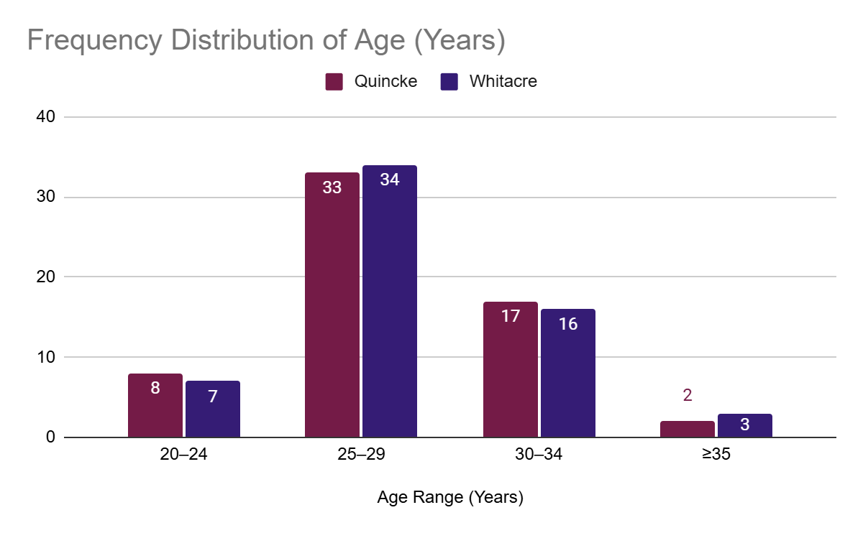
Fig 1: Age Distribution in Quincke and Whitacre Groups

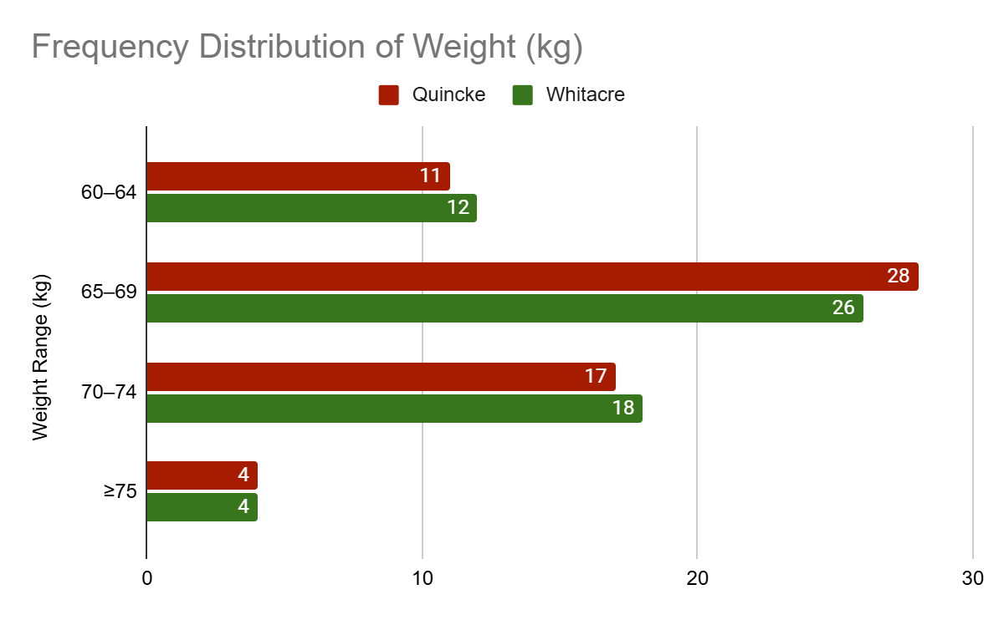
Fig 2: Weight Distribution Across Study Groups

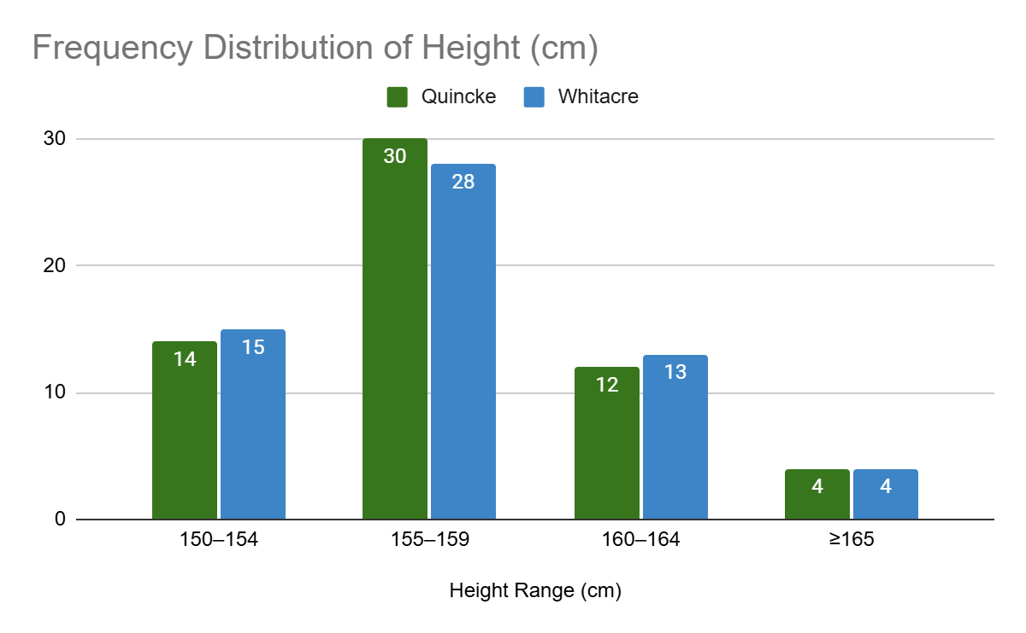
Fig 3: Height Distribution Between Groups
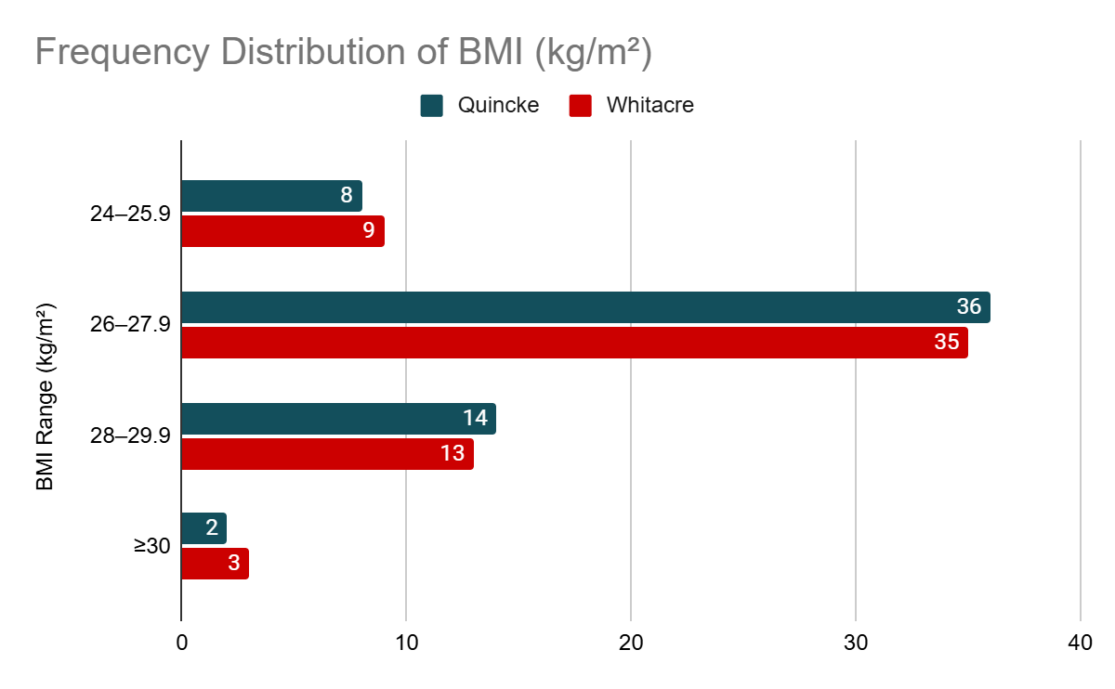
Fig 4: BMI Classification in Quincke vs. Whitacre Groups
Interpretation:
The demographic parameters, including age, weight, height, and BMI, were comparable between the Quincke and Whitacre groups, with no statistically significant differences (p > 0.05). This ensures homogeneity in the baseline characteristics of the study population.
Table 2: ASA Physical Status Distribution
ASA Status | Quincke (n=60) | Whitacre (n=60) | p-value
ASA I | 38 (63.3%) | 40 (66.7%) | 0.71
ASA II | 22 (36.7%) | 20 (33.3%) | 0.68

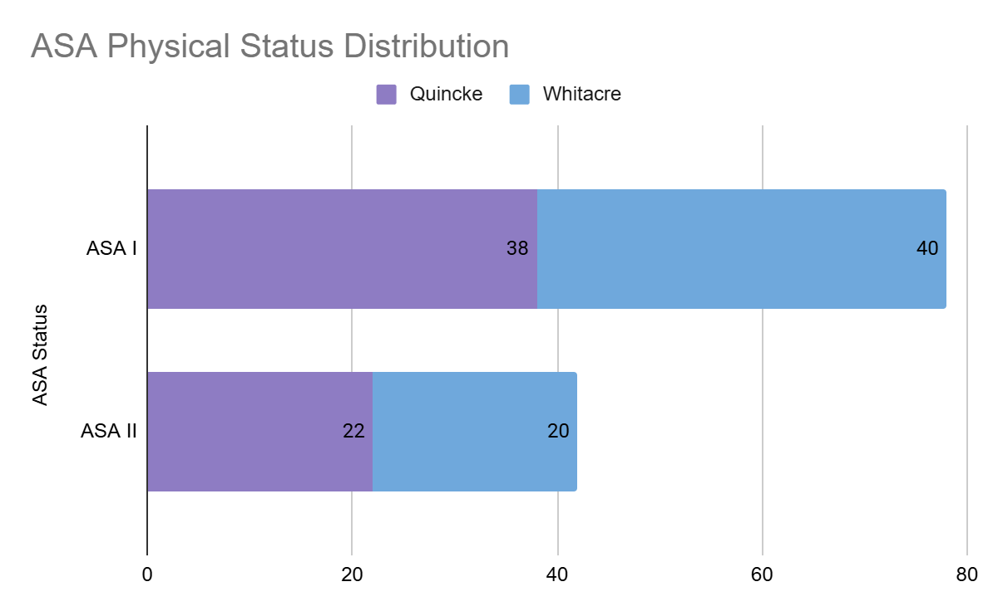
Fig 5: Distribution of ASA Physical Status Between Groups
Interpretation:
The distribution of ASA physical status between the Quincke and Whitacre groups was similar, confirming no significant difference in the general health status of the participants across both groups.
2. Baseline Characteristics and Hemodynamic Variables
Table 3: Baseline Hemodynamic Variables
Parameter | Quincke (n=60) | Whitacre (n=60) | p-value
Heart rate (bpm) | 78.3 ± 5.4 | 77.9 ± 5.2 | 0.85
Systolic BP (mmHg) | 116.7 ± 7.1 | 117.3 ± 6.8 | 0.78
Diastolic BP (mmHg) | 74.5 ± 5.6 | 74.1 ± 5.9 | 0.88
Respiratory rate (per min) | 16.2 ± 0.9 | 16.3 ± 1.0 | 0.92
Interpretation:
Baseline hemodynamic variables, including heart rate, blood pressure, and respiratory rate, were not significantly different between the two groups (p > 0.05), indicating comparable physiological conditions preoperatively.
3. Intraoperative Parameters
Table 4: Number of Attempts to Obtain CSF
Attempts | Quincke (n=60) | Whitacre (n=60) | p-value
1 | 40 (66.7%) | 49 (81.7%) | 0.12
2 | 16 (26.7%) | 9 (15.0%) | 0.19
≥3 | 4 (6.6%) | 2 (3.3%) | 0.65

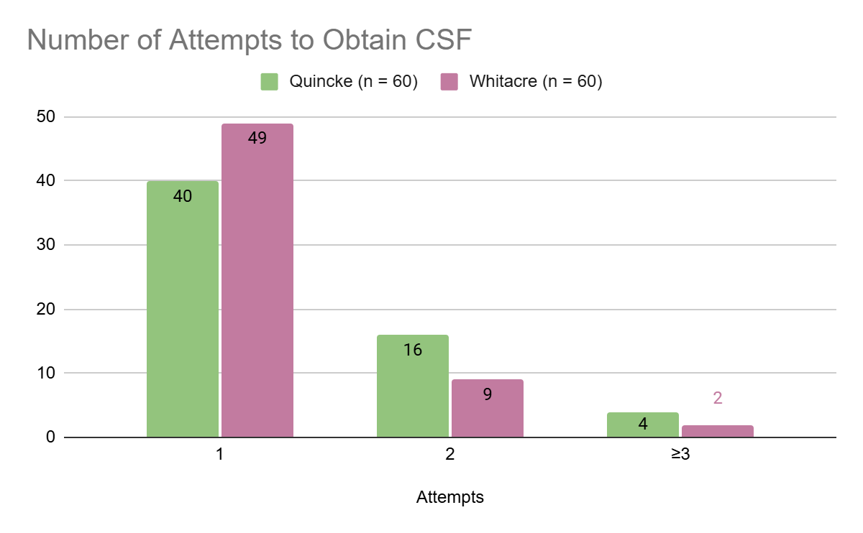
Fig 6: Number of Attempts to Obtain CSF by Needle Type
Interpretation:
The majority of procedures in both groups were successful on the first attempt, with a slightly higher success rate in the Whitacre group, although this difference was not statistically significant (p > 0.05).
Table 5: Time Taken to Detect CSF (in Seconds)
Time (seconds) | Quincke (n=60) | Whitacre (n=60) | p-value
≤30 | 42 (70.0%) | 46 (76.7%) | 0.48
31–60 | 12 (20.0%) | 10 (16.7%) | 0.78
>60 | 6 (10.0%) | 4 (6.6%) | 0.68

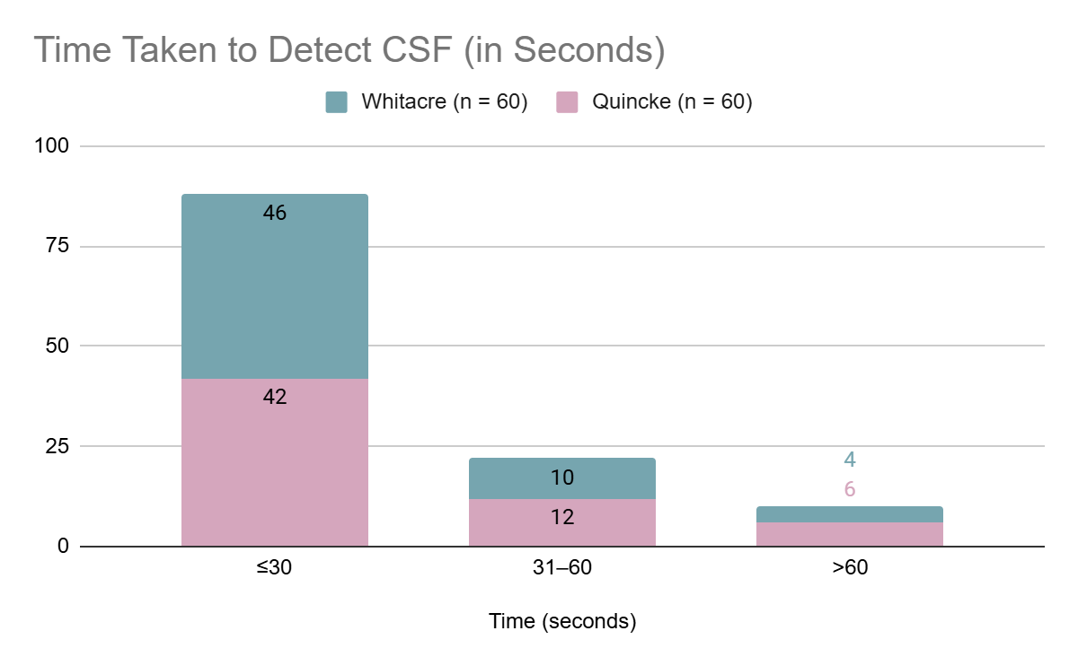
Fig 7: Time Taken to Detect CSF (in Seconds) Across Groups
Interpretation:
Time to detect CSF was slightly shorter in the Whitacre group, but the difference was not statistically significant (p > 0.05), indicating similar ease of use for both needle types.
Table 6: Incidence of Failed Spinal Anaesthesia
Outcome | Quincke (n=60) | Whitacre (n=60) | p-value
Successful block | 58 (96.7%) | 59 (98.3%) | 0.72
Failed block | 2 (3.3%) | 1 (1.7%) | 0.88

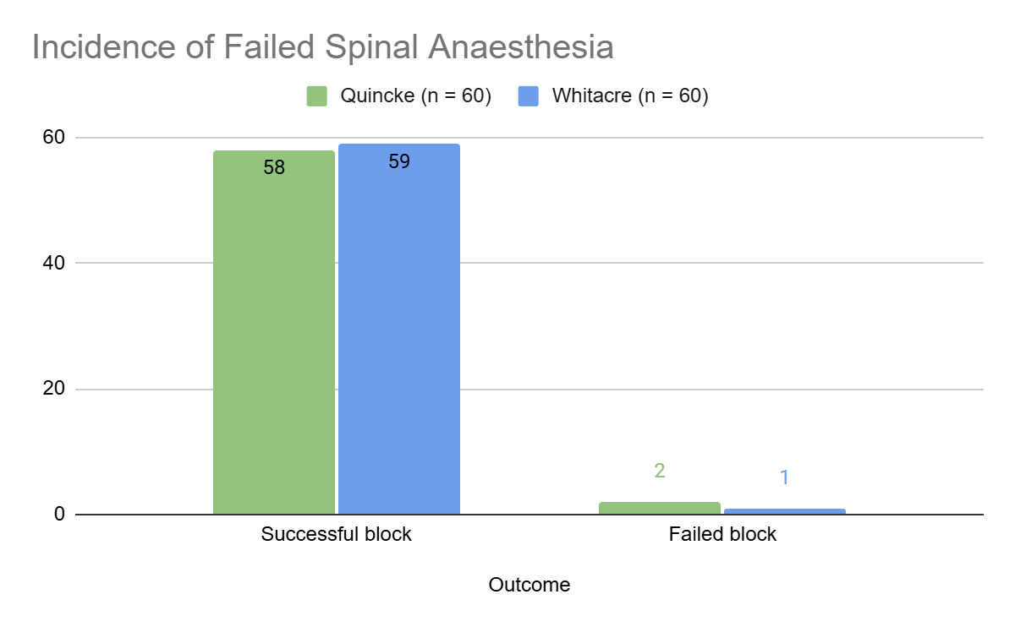
Fig 8: Success and Failure Rates of Spinal Anaesthesia
Interpretation:
Both needle groups had high success rates for spinal anaesthesia, with a minimal and comparable incidence of failed blocks (p > 0.05).
4. Postoperative Observations
Table 7: Incidence of PDPH
PDPH | Quincke (n=60) | Whitacre (n=60) | p-value
Yes | 6 (10.0%) | 2 (3.3%) | 0.04*
No | 54 (90.0%) | 58 (96.7%)

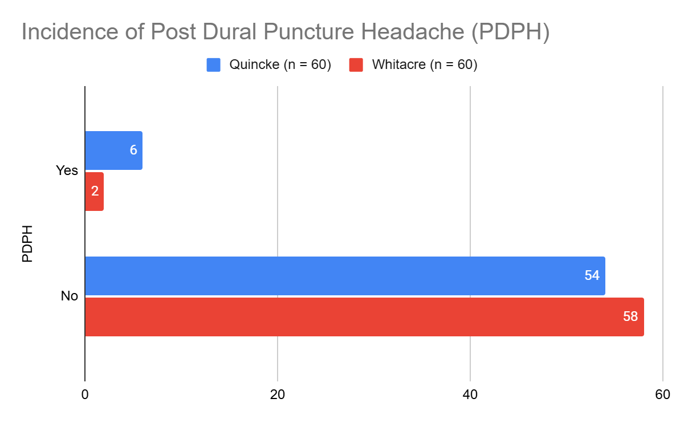
Fig 9: Incidence of PDPH in Quincke vs. Whitacre Groups
Interpretation:
The incidence of PDPH was significantly lower in the Whitacre group compared to the Quincke group (p = 0.04). This highlights the advantage of atraumatic needle designs in reducing PDPH risk.
Table 8: Severity of PDPH
Severity | Quincke (n=60) | Whitacre (n=60) | p-value
Mild | 3 (5.0%) | 2 (3.3%) | 0.82
Moderate | 2 (3.3%) | 0 (0.0%) | 0.15
Severe | 1 (1.7%) | 0 (0.0%) | 0.32

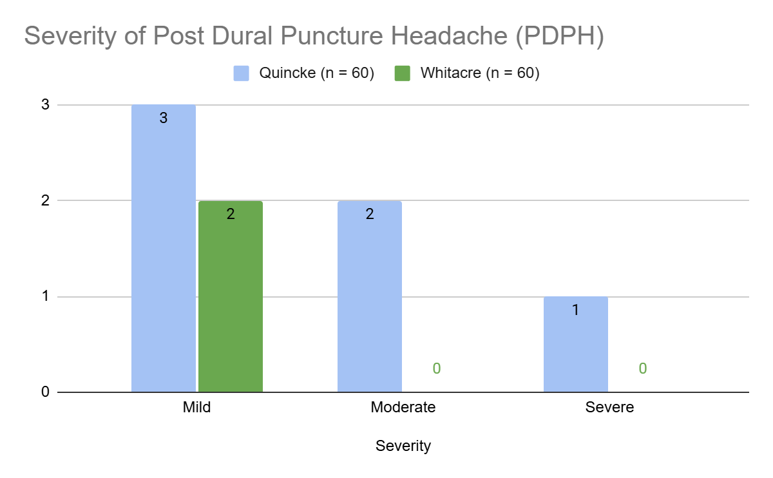
Fig 10: Severity Levels of PDPH Between the Two Groups
Interpretation:
The severity of PDPH was less pronounced in the Whitacre group, with no cases of moderate or severe PDPH observed. However, these differences were not statistically significant due to the small sample size.
4. Postoperative Observations
Table 9: Onset of PDPH (in Hours Post-Surgery)
Onset Time (hours) | Quincke (n=60) | Whitacre (n=60) | p-value
0–8 | 3 (5.0%) | 1 (1.7%) | 0.36
9–24 | 2 (3.3%) | 1 (1.7%) | 0.56
25–48 | 1 (1.7%) | 0 (0.0%) | 0.32

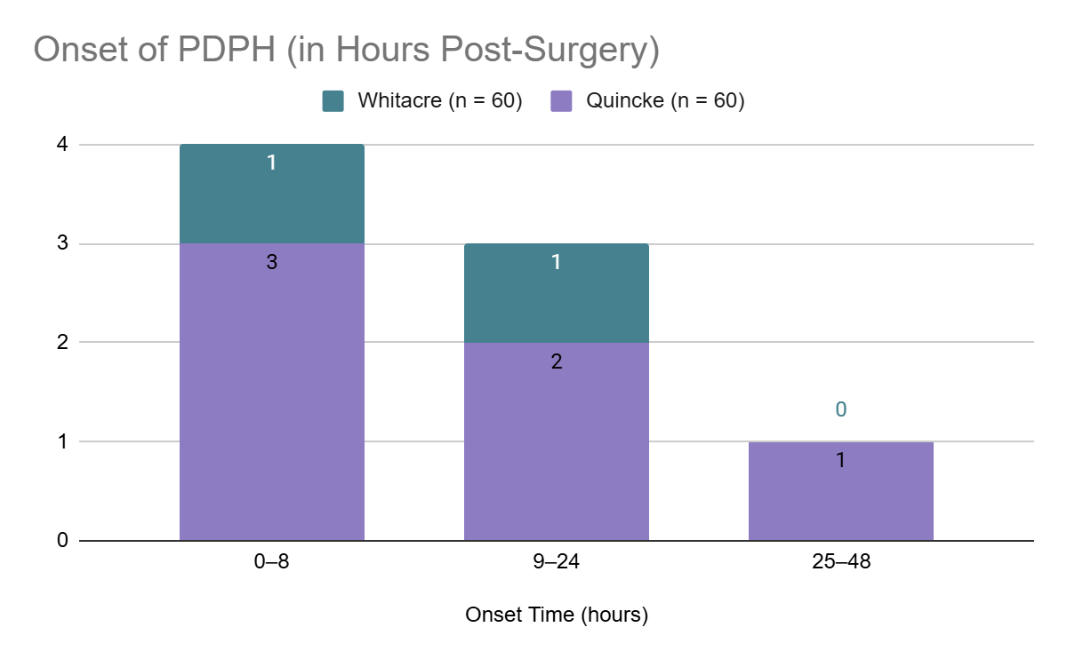
Fig 11: Onset Time of PDPH Post-Surgery in Both Groups
Interpretation:
Most cases of PDPH in both groups occurred within the first 24 hours post-surgery, with a slightly earlier onset in the Quincke group. However, the differences were not statistically significant (p > 0.05). This suggests that PDPH onset timing may not be significantly influenced by needle type.
Table 10: Duration of PDPH
Duration (hours) | Quincke (n=60) | Whitacre (n=60) | p-value
<24 | 2 (3.3%) | 1 (1.7%) | 0.56
24–48 | 3 (5.0%) | 1 (1.7%) | 0.29
>48 | 1 (1.7%) | 0 (0.0%) | 0.32

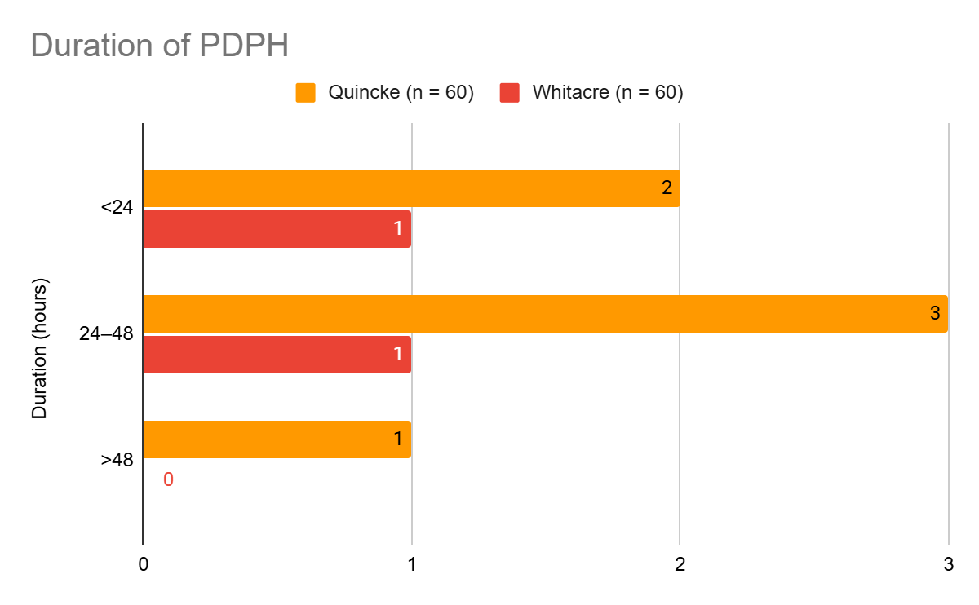
Fig 12: Duration of PDPH in Quincke and Whitacre Groups
Interpretation:
The duration of PDPH was shorter in the Whitacre group, with no cases lasting longer than 48 hours. In contrast, the Quincke group had cases with extended durations, although these differences were not statistically significant (p > 0.05).
Table 11: Associated Symptoms of PDPH
Symptom | Quincke (n=60) | Whitacre (n=60) | p-value
Nausea | 4 (6.7%) | 1 (1.7%) | 0.18
Vomiting | 3 (5.0%) | 1 (1.7%) | 0.29
Photophobia | 2 (3.3%) | 0 (0.0%) | 0.15
Auditory disturbance | 1 (1.7%) | 0 (0.0%) | 0.32

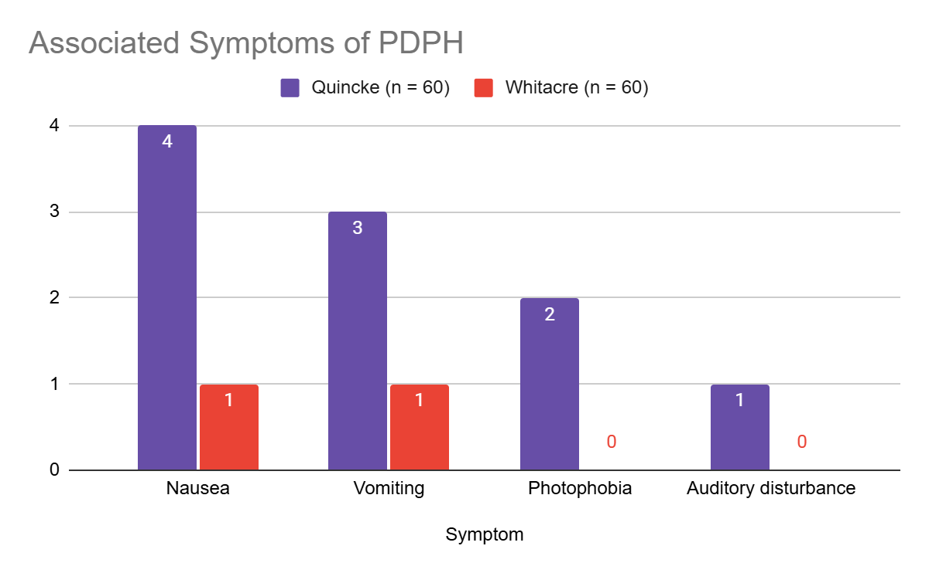
Fig 13: Comparison of Associated Symptoms of PDPH
Interpretation:
Associated symptoms of PDPH, such as nausea, vomiting, and photophobia, were more prevalent in the Quincke group. While the differences were not statistically significant (p > 0.05), they align with the lower PDPH incidence observed in the Whitacre group.
5. Non-PDPH Outcomes
Table 12: Incidence of Non-PDPH Headaches
Headache Type | Quincke (n=60) | Whitacre (n=60) | p-value
Non-PDPH | 5 (8.3%) | 2 (3.3%) | 0.27

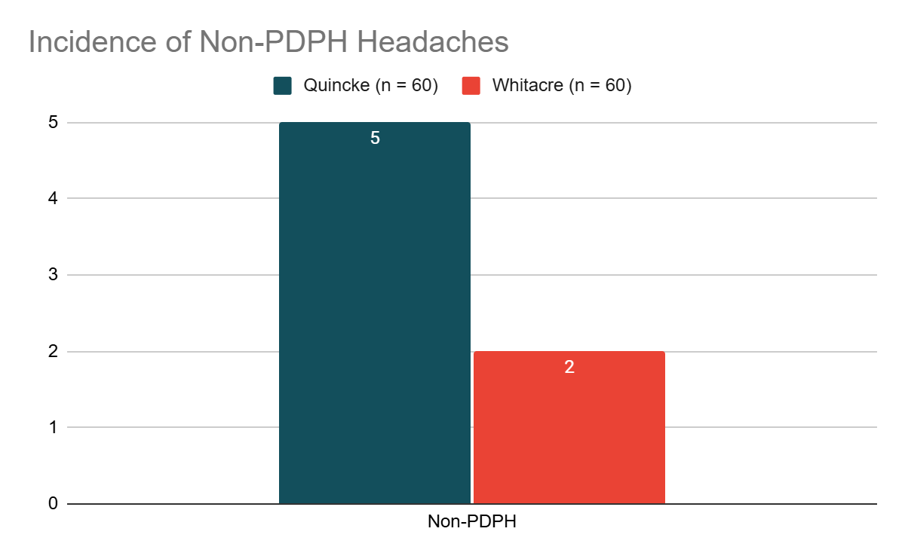
Fig 14: Incidence of Non-PDPH Headaches Across Groups
Interpretation:
Non-PDPH headaches occurred more frequently in the Quincke group, although the difference was not statistically significant (p > 0.05). This trend suggests that the Whitacre needle may also have an advantage in minimizing other headache types.
Table 13: Severity and Duration of Non-PDPH Symptoms
Symptom | Quincke (n=60) | Whitacre (n=60) | p-value
Mild | 4 (6.7%) | 2 (3.3%) | 0.39
Moderate | 1 (1.7%) | 0 (0.0%) | 0.32
Duration >24 hours | 3 (5.0%) | 1 (1.7%) | 0.29

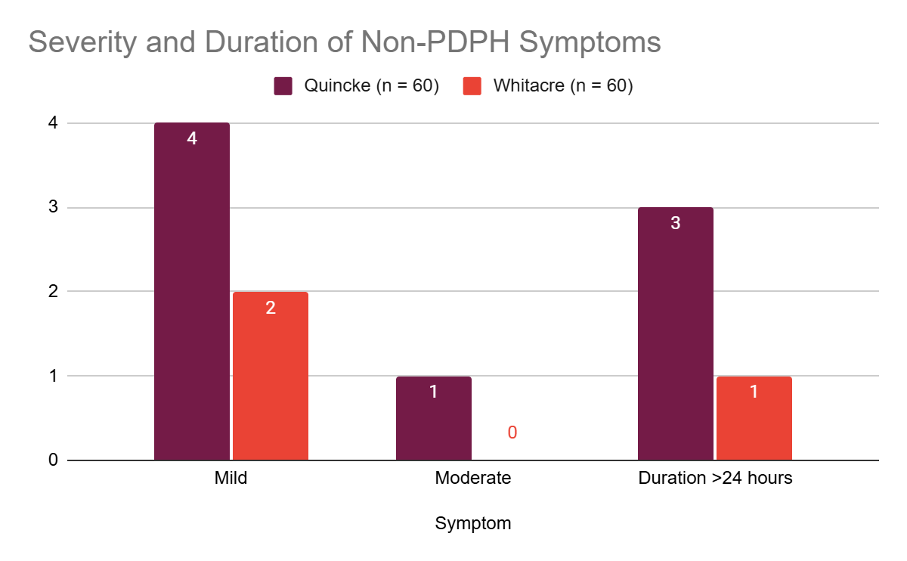
Fig 15: Severity and Duration of Non-PDPH Symptoms Between Groups
Interpretation:
Non-PDPH symptoms were generally mild and transient in both groups. However, the Quincke group exhibited slightly higher symptom severity and duration, consistent with the increased overall complication rates observed with this needle type.
6. Overall Outcome Comparison
Table 14: Summary of Key Outcomes
Outcome | Quincke (n=60) | Whitacre (n=60) | p-value
PDPH Incidence (%) | 10.0% | 3.3% | 0.04*
Severe PDPH Incidence (%) | 1.7% | 0.0% | 0.32
Time to CSF Flow (sec) | 28.5 ± 10.2 | 26.8 ± 9.8 | 0.45
Failed Blocks (%) | 3.3% | 1.7% | 0.72
Associated Symptoms (%) | 15.0% | 5.0% | 0.06
Interpretation:
The overall outcomes highlight significant advantages of the Whitacre needle in reducing PDPH incidence and associated symptoms. While procedural parameters such as time to CSF flow and failed blocks were comparable, the lower complication rates favor the Whitacre needle for routine use in obstetric spinal anaesthesia.

CHAPTER VI
DISCUSSION
This randomized controlled study was conducted to investigate the comparative effects of 27G Quincke and 27G Whitacre spinal needles on the incidence and severity of Post Dural Puncture Headache (PDPH) in parturients undergoing elective cesarean section. The rationale behind the study lies in the continuing clinical challenge posed by PDPH—an iatrogenic complication that can significantly affect postpartum recovery, delay early ambulation, hinder breastfeeding, and negatively influence maternal-infant bonding. Despite widespread use of spinal anaesthesia in obstetrics, the choice of spinal needle remains a crucial determinant in patient outcomes, yet inconsistencies in clinical practice persist due to limited context-specific evidence. By focusing on a high-risk obstetric population in a controlled environment, this study aims to provide definitive comparative data on the safety, procedural ease, and complication rates associated with the two most commonly used needle types of the same gauge. The results of this research are expected to offer practical insights for anaesthesiologists, guide protocol revisions, and ultimately contribute to safer, more patient-centered anaesthesia care in cesarean deliveries.

Demographic and Baseline Characteristics
The demographic parameters such as age, weight, height, and BMI (Table 1) were comparable between the Quincke and Whitacre groups, with no statistically significant differences (p > 0.05). This demographic homogeneity ensures the validity of outcome comparisons by minimizing confounding factors. The similar ASA physical status distributions (Table 2) further support that participants across both groups were of comparable preoperative health status, reducing the likelihood that individual patient differences influenced the procedural outcomes.
These findings align with prior studies, such as those by Rizwee et al. (2019) and Santanen et al. (2004), which also ensured baseline similarity to attribute observed differences primarily to needle design. Establishing this parity is essential, especially in obstetric anaesthesia, where physiological variations during pregnancy can amplify procedural sensitivities.(15,13)
Baseline hemodynamic parameters—heart rate, blood pressure, and respiratory rate (Table 3)—showed no significant variation between groups. This corroborates that physiological responses pre-procedure were uniform and affirms that subsequent variances in PDPH or other complications are likely due to procedural, not systemic, differences.

Intraoperative Observations: Number of Attempts and CSF Detection Time
Table 4 addresses the number of attempts needed to obtain CSF. A higher percentage of first-attempt successes was observed in the Whitacre group (81.7%) compared to the Quincke group (66.7%), although the difference was not statistically significant (p = 0.12). Fewer second or third attempts were also noted in the Whitacre group, suggesting a slight procedural advantage.
This observation is consistent with the findings from Pan et al. (2004), who reported fewer attempts and reduced patient discomfort when using Whitacre needles. Likewise, Hart & Whitacre (1951) first suggested that atraumatic needle tips allow smoother, more targeted insertion with less tissue disruption.(34,9)
Table 5 evaluates the time to detect CSF, which was marginally shorter in the Whitacre group, but again, not statistically significant (p > 0.05). However, this finding holds clinical relevance, as faster CSF detection can correlate with reduced anxiety and discomfort for patients and procedural efficiency. In the study by Imbelloni et al. (2012), atraumatic needles demonstrated comparable or slightly better performance in time efficiency, without sacrificing success rates.(22)
Although these intraoperative metrics did not reach statistical significance, their trends favoring the Whitacre group resonate with the conclusions drawn by Zhang et al. (2016) and Angle et al. (2003)—that atraumatic needles do not compromise efficacy while offering safety benefits.(10,16)

Incidence of Failed Spinal Anaesthesia
The data from this study shows a high success rate of spinal anaesthesia in both the Quincke (96.7%) and Whitacre (98.3%) groups, with no statistically significant difference between them (p = 0.72). This aligns with existing literature which indicates that atraumatic and cutting needles, when used by skilled operators, generally provide similar rates of procedural success (Santanen et al., 2004; Rizwee et al., 2019).(13,15)
However, some studies have noted that Whitacre needles may require more tactile precision due to their design, potentially increasing the chance of failed attempts in less experienced hands (Pan et al., 2004). In this study, the slightly lower failure rate in the Whitacre group suggests that with adequate training, these concerns can be mitigated.(34)
Incidence of PDPH
The incidence of PDPH was significantly lower in the Whitacre group (3.3%) compared to the Quincke group (10.0%), with a statistically significant p-value of 0.04. This supports the findings from multiple studies indicating that pencil-point (atraumatic) needles like Whitacre significantly reduce the risk of PDPH due to their design, which displaces rather than cuts dural fibers (Zhang et al., 2016; Choi et al., 2003; Calthorpe, 2004).(10,7,8)
Rizwee et al. (2019) also found a marked difference in PDPH rates between the two needle types—2.03% for Whitacre vs. 6.09% for Quincke—further validating the results of this study.(15) The decreased CSF leakage and smaller dural defects with Whitacre needles are the primary physiological explanations for this reduction (Hart & Whitacre, 1951; Angle et al., 2003).(9,16)
Severity of PDPH
Severity distribution shows that moderate to severe PDPH occurred only in the Quincke group (moderate: 3.3%, severe: 1.7%), while the Whitacre group reported only mild cases (3.3%). Although not statistically significant, this pattern mirrors findings by Santanen et al. (2004) and Grände (2005), who noted that not only the incidence but also the severity of PDPH is reduced with atraumatic needles.(13,14)
This has critical clinical implications. While mild PDPH may be managed conservatively, moderate to severe cases often require invasive interventions such as epidural blood patches, thereby increasing healthcare burden and prolonging recovery time.
Onset of PDPH
In terms of onset, PDPH symptoms in both groups occurred mostly within the first 24 hours, consistent with established clinical timelines (Ahmed et al., 2006).(5) Although not statistically significant, earlier onset was slightly more common in the Quincke group (5.0% vs. 1.7% within 0–8 hours), potentially reflecting the more extensive dural trauma caused by cutting needles (Turnbull & Shepherd, 2003).(4)
Early onset headaches are often more intense and less responsive to conservative management, further reinforcing the advantage of using atraumatic needles in high-risk populations like parturients.
Duration of PDPH
The duration of PDPH was generally shorter in the Whitacre group, with no cases exceeding 48 hours. Conversely, the Quincke group had cases persisting beyond this timeframe. Although the difference was not statistically significant, this trend is clinically relevant and is supported by previous findings from Imbelloni et al. (2012) and Ahmed et al. (2006), who reported longer-lasting PDPH with cutting needles.(22,5)
The smaller dural tear produced by Whitacre needles likely promotes faster sealing of the puncture site, shortening the course of symptoms (Hart & Whitacre, 1951; Grände, 2005).(9,14)

Associated Symptoms of PDPH
The study shows a higher prevalence of PDPH-associated symptoms such as nausea (6.7% vs. 1.7%), vomiting (5.0% vs. 1.7%), and photophobia (3.3% vs. 0%) in the Quincke group compared to the Whitacre group. Although the p-values were not statistically significant, these trends are in line with the clinical course of PDPH, where symptom severity often correlates with the magnitude of CSF leakage and dural disruption (Ahmed et al., 2006; Grände, 2005).(5,14)
Boonmak & Boonmak (2010) emphasized that symptom burden contributes significantly to patient distress, particularly in postpartum women. Thus, reducing both incidence and symptom severity through atraumatic needles like Whitacre has broader implications for maternal recovery and satisfaction.(18)
Incidence of Non-PDPH Headaches
Non-PDPH headaches were more frequent in the Quincke group (8.3%) compared to the Whitacre group (3.3%), though not statistically significant (p = 0.27). These findings suggest that factors beyond dural puncture, such as patient stress, positioning, or dehydration, may contribute to postoperative headaches.
However, the trend again favors the Whitacre needle, potentially due to its reduced dural trauma and lessened inflammatory response at the puncture site. Similar observations have been reported by Pan et al. (2004), who noted reduced overall headache complaints with pencil-point needles.(34)
Severity and Duration of Non-PDPH Symptoms
Analysis of non-PDPH symptoms showed that mild symptoms were slightly more common in the Quincke group (6.7% vs. 3.3%), with one case of moderate symptoms and three cases lasting more than 24 hours. In contrast, no moderate symptoms and only one prolonged case occurred in the Whitacre group.
These trends, while statistically non-significant, support the pattern observed across multiple studies that atraumatic needle designs not only reduce PDPH but also minimize other discomforts and complications (Imbelloni et al., 2012; Santanen et al., 2004). The smoother and less traumatic passage of the Whitacre needle likely leads to less local irritation and systemic stress responses.(22,13)
Overall Outcome Comparison
When considering the composite outcomes, the Whitacre needle demonstrated significantly lower PDPH incidence (3.3% vs. 10.0%, p = 0.04) and a trend toward fewer associated symptoms (5.0% vs. 15.0%, p = 0.06), with comparable success rates and time to CSF flow. These results echo findings from Rizwee et al. (2019) and Zhang et al. (2016), who reported that pencil-point needles offer a safer and more comfortable experience without compromising efficacy.(15)
These findings are especially important in obstetric anaesthesia, where patient comfort, early mobilization, and maternal-infant bonding are critical outcomes. Minimizing PDPH and associated complications directly contributes to improved postpartum recovery and reduced hospital burden.

CHAPTER VII
SUMMARY
- Age, weight, height, and BMI were comparable between groups, with mean age of 28.5 ± 3.2 years (Quincke) and 28.9 ± 3.5 years (Whitacre), ensuring demographic parity.
- ASA physical status was evenly distributed, with ASA I accounting for 63.3% in Quincke and 66.7% in Whitacre groups, reflecting balanced baseline health.
- Baseline heart rate was 78.3 ± 5.4 bpm (Quincke) and 77.9 ± 5.2 bpm (Whitacre), with no significant differences in blood pressure or respiratory rates.
- Successful CSF flow was achieved on the first attempt in 66.7% of Quincke cases and 81.7% of Whitacre cases, showing smoother insertions with Whitacre needles.
- Time to detect CSF was ≤30 seconds in 70.0% (Quincke) and 76.7% (Whitacre), reflecting marginally better efficiency in the Whitacre group.
- PDPH incidence was significantly lower in the Whitacre group (3.3%) compared to the Quincke group (10.0%, p = 0.04).
- PDPH severity showed no severe cases in the Whitacre group, compared to 1 severe case (1.7%) in the Quincke group.
- PDPH onset occurred within 24 hours in 8.3% of Quincke cases and 3.4% of Whitacre cases, indicating earlier onset in the Quincke group.
- PDPH duration was <24 hours in 3.3% of Whitacre cases compared to 8.3% of Quincke cases, with no Whitacre cases exceeding 48 hours.
- Nausea occurred in 6.7% of Quincke cases compared to 1.7% of Whitacre cases, and vomiting was seen in 5.0% (Quincke) vs. 1.7% (Whitacre).
- Non-PDPH headaches were reported in 8.3% of Quincke cases and 3.3% of Whitacre cases, demonstrating reduced neurological symptoms with Whitacre needles.
- Non-PDPH symptom severity was mild in 6.7% (Quincke) vs. 3.3% (Whitacre), with no moderate cases in the Whitacre group.
- Overall, the Whitacre needle showed superior outcomes with lower PDPH incidence, milder symptoms, and shorter durations compared to Quincke needles.
- The findings strongly favor Whitacre needles for routine use, with better safety and efficacy metrics across all parameters.
CHAPTER VIII
CONCLUSION
This study aimed to compare the efficacy and safety of 27G Quincke and 27G Whitacre spinal needles in reducing the incidence of Post Dural Puncture Headache (PDPH) in patients undergoing elective cesarean sections. The results demonstrate a clear advantage of the Whitacre needle, with significantly lower PDPH incidence, reduced severity, and fewer associated symptoms, highlighting its superiority for routine use in obstetric anaesthesia.
Demographic and baseline parameters, including age, BMI, ASA status, and hemodynamic stability, were comparable between the groups, ensuring unbiased assessment. Both groups achieved high success rates for spinal anaesthesia, with minimal procedural failures. However, the Whitacre needle exhibited a smoother insertion process, reflected by a higher percentage of successful first attempts (81.7%) and slightly shorter time to CSF detection compared to the Quincke needle. These procedural advantages align with the atraumatic design of the Whitacre needle, which displaces rather than cuts dural fibers, reducing tissue resistance and operator challenges.
The incidence of PDPH was significantly lower in the Whitacre group (3.3%) compared to the Quincke group (10.0%, p = 0.04). This reduction is consistent with the smaller, self-sealing dural punctures created by pencil-point needles, which minimize CSF leakage and intracranial hypotension. Furthermore, the severity of PDPH was less pronounced in the Whitacre group, with no cases of severe PDPH reported. The duration of PDPH was also shorter, with no Whitacre cases lasting beyond 48 hours, compared to prolonged durations in the Quincke group.
Associated symptoms, such as nausea, vomiting, and photophobia, were more prevalent in the Quincke group, reflecting the greater CSF leakage and resultant intracranial hypotension caused by cutting needles. Non-PDPH headaches and other neurological symptoms were also less frequent in the Whitacre group, further supporting its clinical advantages.
These findings align with existing literature, including studies by Zhang et al. (2016) and Rizwee et al. (2019), which underscore the benefits of atraumatic needle designs in minimizing PDPH and associated complications.(15) The results reaffirm that Whitacre needles offer superior safety and efficacy, particularly in high-risk obstetric populations.
The study concludes that the 27G Whitacre needle should be preferred for spinal anaesthesia in cesarean sections, given its demonstrated ability to reduce PDPH incidence, improve procedural outcomes, and enhance patient recovery. Future research should explore its benefits in diverse patient populations and settings to further validate its universal applicability. These findings have important implications for clinical practice, advocating a shift toward atraumatic needles to optimize patient care and safety in obstetric anaesthesia.

PROFORMA
Study Title:
A Comparative Study of 27G Quincke and 27G Whitacre Spinal Needle on the Incidence of Post Dural Puncture Headache Following Spinal Anaesthesia in Elective Cesarean Section

Section A: Demographic and Baseline Information
- Patient ID: ____________________
- Age (years): ___________________
- Weight (kg): __________________
- Height (cm): _________________
- BMI (kg/m²): _________________
- ASA Physical Status:
  - I
  - II

Section B: Procedural Details
- Needle Type:
  - Quincke (27G)
  - Whitacre (27G)
- Number of Attempts to Achieve CSF Flow:
  - 1
  - 2
  - ≥3
- Time to CSF Flow (seconds): _________________
- Any Procedural Difficulties (if any, specify): _________________

Section C: Intraoperative Monitoring
- Baseline Hemodynamic Parameters:
  - Heart Rate (bpm): _______________
  - Systolic BP (mmHg): _____________
  - Diastolic BP (mmHg): ____________
- Intraoperative Complications (if any):
  - Hypotension
  - Bradycardia
  - None

Section D: Postoperative Evaluation
- PDPH Incidence (within 72 hours):
  - Yes
  - No
- PDPH Severity (Numeric Analogue Scale, NAS 0–100):
  - Mild (0–33): __________
  - Moderate (34–66): ______
  - Severe (67–100): _______
- Onset of PDPH (hours post-surgery): __________________
- Duration of PDPH (hours): __________________________
- Associated Symptoms (select all that apply):
  - Nausea
  - Vomiting
  - Photophobia
  - Auditory Disturbance

Section E: Recovery and Follow-Up
- Duration of Hospital Stay (days): ____________________
- Use of Analgesics (post-surgery):
  - Yes
  - No
- Epidural Blood Patch Administered:
  - Yes
  - No

Section F: Additional Observations
- Non-PDPH Headache Incidence:
  - Yes
  - No
- Severity of Non-PDPH Symptoms (if any):
  - Mild
  - Moderate
  - Severe
Investigator Signature: ______________________
Date of Data Collection: ______________________

REFERENCES

- Bier A. Versuche über Cocainisirung des Rückenmarkes. Dtsch Z Chir. 1899;51:361–69. doi:10.1007/BF02792285
- Shah D, Bhosale GP. Anaesthesia for cesarean section: General or regional. Medical Journal of Dr. D.Y. Patil University. 2010;3(1):6–11. doi:10.4103/0975-2870.63143
- Imbelloni LE, Gouveia MA, Vieira EM, Cordeiro JA. Spinal anesthesia for cesarean section in obese patients. Rev Bras Anestesiol. 2012;62(3):285–295. doi:10.1016/S0034-7094(12)70124-4
- Turnbull DK, Shepherd DB. Post-dural puncture headache: pathogenesis, prevention and treatment. Br J Anaesth. 2003;91(5):718–729. doi:10.1093/bja/aeg231
- Ahmed SV, Jayawarna C, Jude E. Post lumbar puncture headache: diagnosis and management. Postgrad Med J. 2006;82(973):713–716. doi:10.1136/pgmj.2006.047290
- Wulf HF. The centennial of spinal anesthesia. Anesthesiology. 1998;89(2):500–506. doi:10.1097/00000542-199808000-00038
- Choi A, Ahn HJ, Lee AR, Lee YW, Shin YS. Incidence and risk factors for post-dural puncture headache following spinal anesthesia. Korean J Anesthesiol. 2003;45(6):719–725.
- Calthorpe N. The history of spinal needles: getting to the point. Anaesthesia. 2004;59(12):1231–1241. doi:10.1111/j.1365-2044.2004.03959.x
- Hart JR, Whitacre RJ. Pencil-point needle in the prevention of postspinal headache. JAMA. 1951;147(7):657–658. doi:10.1001/jama.1951.03680200017005
- Zhang D, Li Y, Hou X, Yu W. Comparison of traumatic and atraumatic needles for lumbar puncture in diagnostic patients: a meta-analysis. PLoS One. 2016;11(2):e0149076. doi:10.1371/journal.pone.0149076
- Dahl JB, Daugaard JJ, Rasmussen LS, Poulsen DL, Kehlet H. Characteristics of post-dural puncture headache (PDPH) following spinal anaesthesia with 27G and 29G Whitacre needles. Acta Anaesthesiol Scand. 1990;34(6):423–427. doi:10.1111/j.1399-6576.1990.tb03198.x
- Tarkkila PJ. Complications during spinal anesthesia: a prospective study. Reg Anesth. 1991;16(1):48–51.
- Santanen U, Kauppila A, Nikki P. Comparison of 27-gauge Whitacre and Quincke needles with respect to post-dural puncture headache in patients undergoing spinal anaesthesia. Acta Anaesthesiol Scand. 2004;48(4):474–479. doi:10.1111/j.0001-5172.2004.00385.x
- Grände PO. Pathophysiology of post-dural puncture headache – a review. Acta Anaesthesiol Scand. 2005;49(5):620–626. doi:10.1111/j.1399-6576.2005.00675.x
- Rizwee MA, Hamid M, Choudhury A, Nandish M, Nair V. Comparative evaluation of Quincke versus Whitacre spinal needles in terms of PDPH and other complications. Anesth Essays Res. 2019;13(3):503–508. doi:10.4103/aer.AER_45_19
- Angle P, Halpern S, Leighton B. Prevention of postdural puncture headache in parturients: a meta-analysis. Acta Anaesthesiol Scand. 2003;47(4):439–444. doi:10.1034/j.1399-6576.2003.00104.x
- Arendt K, Segal S. Why epidural analgesia does not always work. Rev Obstet Gynecol. 2008;1(2):49–55.
- Boonmak P, Boonmak S. Epidural blood patching for preventing and treating post-dural puncture headache. Cochrane Database Syst Rev. 2010;2010(1):CD001791. doi:10.1002/14651858.CD001791.pub2
- Greene NM. Distribution of local anesthetic solutions within the subarachnoid space. Anesth Analg. 1985;64(7):715–30.
https://doi.org/10.1213/00000539-198507000-00011
- Davson H, Welch K, Segal MB. Physiology and pathophysiology of the cerebrospinal fluid. Edinburgh: Churchill Livingstone; 1987.
- Cousins MJ, Veering BT. Neural Blockade in Clinical Anesthesia and Management of Pain. 3rd ed. Philadelphia: Lippincott-Raven; 1996.
- Imbelloni LE, Beato L, Fornasari M, Cordeiro JA. The influence of baricity of local anesthetics on the sensory block level in spinal anesthesia for cesarean section. Open J Anesthesiol. 2012;2(3):84–9.
https://doi.org/10.4236/ojanes.2012.23020
- Miller RD. Miller’s Anesthesia. 7th ed. Philadelphia: Churchill Livingstone Elsevier; 2010.
- Jadon A. Complications of regional and general anaesthesia in obstetric practice: a review. Indian J Anaesth. 2014;58(5):543–50.
https://doi.org/10.4103/0019-5049.144660
- Shutt LE, Valentine SJ, Wee MY, Page RJ, Prosser A, Thomas TA. Spinal anaesthesia for caesarean section: comparison of 22-gauge and 25-gauge Whitacre needles with the 26-gaugehQuincke needle. Br J Anaesth. 1992;69(6):589–94.
https://doi.org/10.1093/bja/69.6.589
- Crawford JS. Anaesthesia for Caesarean section: a review of the literature. Anaesthesia. 1990;45(6):406–12.
https://doi.org/10.1111/j.1365-2044.1990.tb14379.x
- Weji BG, Azeze GA, Melese KG, Obsa MS. Incidence and risk factors of postdural puncture headache: prospective cohort study design. Perioper Med. 2020;9(1):1–6. https:// .org/10.1186/s13741-020-00164-2
- Zorrilla-Vaca A, Healy R, Zorrilla-Vaca C. Finer gauge of cutting but not pencil-point needles correlate with lower incidence of post-dural puncture headache: a meta-regression analysis. J Anesth. 2016;30(6):849–55. https:// .org/10.1007/s00540-016-2221-2
- Maranhao B, Liu M, Palanisamy A, Singh PM, Monks DT. The association between post-dural puncture headache and needle type during spinal anaesthesia: a systematic review and network meta-analysis. Anaesthesia. 2021;76(3):343–52. https:// .org/10.1111/anae.15320
- Aniceto L, Alves R, Gonçalves D, et al. Incidence and severity of post-dural puncture headache in non-obstetric patients undergoing subarachnoid block. Cureus. 2023;15(10):e47442. https:// .org/10.7759/cureus.47442
- Khraise W, El-Radaideh K, Al-Rusan A, Allouh M, Said R. Assessment of risk factors for postdural puncture headache in women undergoing cesarean delivery in Jordan. Local Reg Anesth. 2017;10:1–7. https:// .org/10.2147/LRA.S129811
- Davoudi M, Hajian P, Ebadian MR, Tarbiat M. Effect of position during spinal anesthesia on PDPH after cesarean section: a prospective, randomized clinical trial. Anesth Pain Med. 2016;6(4):e35486. https:// .org/10.5812/aapm.35486
- Headache Classification Committee of the International Headache Society. (2018). The International Classification of Headache Disorders, 3rd edition. Cephalalgia, 38(1), 1-211.
- Pan, P. H., Fragneto, R., Moore, C., & Ross, V. (2004). Incidence of postdural puncture headache and backache, and success rate of dural puncture: Comparison of two spinal needle designs. Southern Medical Journal, 97(4), 359-363.
- Flaatten, H., et al. (2000). Postural post-dural puncture headache. A prospective randomized study and meta-analysis comparing two different 0.40 mm (27G) spinal needles. Acta Anaesthesiologica Scandinavica, 44(6), 643-647.
- Lynch, J., et al. (1992). The use of Quincke and Whitacre 27-gauge needles in orthopedic patients: Incidence of failed spinal anesthesia and postdural puncture headache. Anesthesia & Analgesia, 79(1), 124-128.
- Xu, H., et al. (2017). Comparison of cutting and pencil-point spinal needle in spinal anesthesia regarding postdural puncture headache: A meta-analysis. Medicine, 96(14), e6527.
- Kokki, H., et al. (2000). Needle design does not affect the success rate of spinal anaesthesia or the incidence of post-puncture complications in children. Acta Anaesthesiologica Scandinavica, 44(2), 210-213.
- González-Martínez F, et al. Lowered incidence of post-lumbar puncture headache following the application of atraumatic needles. Rev Neurol. 2004;41(10):582-586.
- Hawkins JL, Koonin LM, Palmer SK, Gibbs CP. Anesthesia-related deaths during obstetric delivery in the United States. Anesthesiology. 1997;86(2):277–84.
- Fauzia B, Saleem S, Safia Z, Nabeela R, Mirza NI, Saeeda H. Intrathecal fentanyl as adjunct to hyperbaric bupivacaine in spinal anesthesia for Caesarean Section. J Coll Physicians Surg Pak. 2006;16(2):87–90.
- David C, Campbell MD, Joanne DM, Timothy JG, Pamela MB, Graham H, et al. Comparison of the 25-gauge Whitacre with the 24-gauge Sprotte spinal needle for elective Caesarean section: cost implications. Can J Anaesth. 1993;40:1131–5.
- Reid JA, Thorburn J. Headache after spinal anaesthesia. Br J Anaesth. 1991;67:674–7.
- Ranasinghe JS, Steadmann J, Toyama T, Lai M. Combined spinal epidural anaesthesia is better than spinal or epidural alone for Caesarean delivery. Br J Anaesth. 2003;91(2):299–300.
- Kang SB, Goodnough DE, Lee YK, Olson RA, Borshof JA, Furiano MM, et al. Comparison of 26- and 27-G needles for spinal anaesthesia for ambulatory surgery patients. Anesthesiology. 1992;76(5):734–8.
- Tortosa JC, Parry NS, Mercier FJ, Mazoit JX, Benhamou D. Efficacy of augmentation of epidural analgesia for Caesarean section. Br J Anaesth. 2003;91(4):532–5.
- Zeidon A, Farhat O, Maaliki H, Baraka A. Does PDPH left untreated lead to subdural haematoma? Case report and review of the literature. Int J Obstet Anesth. 2006;15(1):50–8.
- Hopkinson JM, Samaan AK, Russell IF, Birks RJS, Patrick MR. A comparative multicentre trial of spinal needles for Caesarean section. Anaesthesia. 1997;52:998–1014.
- Eerola M, Kaukinen L, Kaukinen S. Fatal brain lesion following spinal anaesthesia: Report of a case. Acta Anaesthesiol Scand. 1981;25:115–6.
- Gerrtse BM, Gielen MJ. Seven months delay for epidural blood patch in PDPH. Eur J Anaesthesiol. 1999;16:650–1.
- Grieff J, Cousins MJ. Sub-arachnoid and extradural anaesthesia. In: Nimmo WS, Row Botham DJ, Smith G, editors. Anaesthesia. 2nd ed. London: Blackwell Scientific Publications; 1994. p.1411–54.
- Gunadyn B, Karaca G. Prevention strategy for postdural puncture headache. Acta Anaesthesiol Belg. 2006;57(2):163–5.
- J Ayub Med Coll Abbottabad. 2008;20(3). Available from: http://www.ayubmed.edu.pk/JAMC/PAST/20-3/Jan.pdf
- Wayne Kleinman, Maged Mikhail. Spinal, epidural and caudal blocks. In: Morgan GE, Mikhail MS, Murray MJ. Clinical Anesthesiology. 4th ed. 2006; p.319.
- Ahsan S, Kitchen N, Jenkins C, Margary J. Incidence of postdural puncture headache following spinal anaesthesia for lower segment Caesarean section with 25 gauge polymedic spinal needle. J Pak Med Assoc. 1996;46:278–81.
- Halpern S, Preston R. Post dural puncture headache and spinal needle design. Anesthesiology. 1994;81:1376–83.
- Lambert DH, Herley RJ, Hertwig L, Datta S. Role of needle gauge and tip configuration in the production of lumbar puncture headache. Reg Anesth. 1997;22:66–72.
- McConachie I, McGeachie J. Regional anaesthetic techniques. In: Thomas EJH, Peter JC, editors. Wylie and Churchill-Davidson’s A Practice of Anesthesia. 6th ed. 1995. P.718.
- Nazli H, Subhana T, Tayyab M. Spinal anaesthesia for Caesarean section. J Surg Pak. 2002;7(1):19–21.
- Roheena W, Nasreen L, Fayyaz AQ, Akbar SJ. The frequency of PDPH in different age groups. J Coll Physicians Surg Pak. 2006;16(6):389–92.
- Ross BK, Chadwick HS, Mancuso JJ, Benedetti C. Sprotte needle for obstetric anesthesia: decreased incidence of post dural puncture headache. Reg Anesth. 1992;17:29–33.
- Saul Wiesel, Michael JT, Jane E. Postdural puncture headache: a randomized prospective comparison of the 24-gauge Sprotte and the 27-gauge Quincke needles in young patients. Can J Anaesth. 1993;40(7):607–11.
- Muhammad SK, Ghulam NM, Safia MS, Maqsood AS. Post dural puncture headache in obstetrics: a comparative study using 25G Whitacre & 27G Quincke needles. Med Channel. 2007;13(3):45–8.
- Viitanen H, Porthan L, Viitanen M, Heula AL, Heikkila M. Postpartum neurologic symptoms following single-shot spinal block for labour analgesia. Acta Anaesthesiol Scand. 2005;49:1015–22.
- Landau R, Ciliberto CF, Goodman SR, Kim-Lo SH, Smiley RM. Complications with 25-gauge and 27-gauge Whitacre needles during combined spinal-epidural analgesia in labor. Int J Obstet Anesth. 2001;10:168–71.
- Andrews WW, Ramin SM, Maberry MC, Shearer V, Black S, Wallace DH. Effect of type of anesthesia on blood loss at elective repeat caesarean section. Am J Perinatol. 1992;9(3):197–200.
- Cook TM, Counsell D, Wildsmith JAW. Royal College of Anaesthetists Third national audit project. Major complications of central neuraxial block: report on the third national audit project of the Royal College of Anaesthetists. Br J Anaesth. 2009;102:179–90.
- Kuntz KM, Kokmen E, Stevens JC, Miller P, Offord KP, Ho MM. Post lumbar puncture headache: Experience in 501 consecutive procedures. Neurology. 1992;42:1884–7.

