Statistical Analysis Report
Study: To analyse the immunohistochemical expression patterns of ER alpha in histologically proven malignant thyroid neoplasms.
Date: 12 May 2026
Dataset: 5_6062163686229810589.xlsx
Patients: 113
Variables: 17
Generated by: MedRAS — Medical Research Acceleration System

Data Summary
Variable | Type | Missing n | Missing %
S.no | Identifier | 0 | 0.0%
Accession Number | exclude | 0 | 0.0%
Age | Scale (continuous) | 0 | 0.0%
Gender | Nominal | 0 | 0.0%
Type | exclude | 0 | 0.0%
Involved Lobe | exclude | 1 | 0.9%
Size(greatest Dimension In Cm) | exclude | 3 | 2.7%
Tnm | exclude | 2 | 1.8%
Node( Level) | exclude | 1 | 0.9%
Procedure | exclude | 7 | 6.2%
Lvi | Nominal | 1 | 0.9%
Extra Capsular Extension | Nominal | 1 | 0.9%
Co Existing Thyroid Conditions | Nominal | 80 | 70.8%
Allred Score(proportion +intensity) | Nominal | 4 | 3.5%
P/n | Nominal | 4 | 3.5%
Age Original | Scale (continuous) | 0 | 0.0%
Age Numeric | Scale (continuous) | 0 | 0.0%
Table 1a. Variable summary.

Table 1. Baseline Characteristics
Variable | Summary | No | Extra thyroid extension into esophagus | Present focal | Yes | Margins involved by tumor | Yes subcutaneous, larynx and trachea | Non
Age | Mean ± SD | 43.98 ± 12.56 (n=101) | 76.00 ± — (n=1) | 34.00 ± — (n=1) | 63.67 ± 10.88 (n=6) | 68.00 ± — (n=1) | 63.00 ± — (n=1) | 40.00 ± — (n=1)
Gender | n (count) | Female: 65; Male: 32; Female : 4 | Female: 0; Male: 1; Female : 0 | Female: 1; Male: 0; Female : 0 | Female: 3; Male: 2; Female : 1 | Female: 1; Male: 0; Female : 0 | Female: 0; Male: 1; Female : 0 | Female: 0; Male: 1; Female : 0
Lvi | n (count) | No: 74; Yes: 8; Angio yes : 6; No : 3; Angio>4 vessels: 1; Lymphatic- yes: 1 | No: 1; Yes: 0; Angio yes : 0; No : 0; Angio>4 vessels: 0; Lymphatic- yes: 0 | No: 1; Yes: 0; Angio yes : 0; No : 0; Angio>4 vessels: 0; Lymphatic- yes: 0 | No: 4; Yes: 1; Angio yes : 0; No : 0; Angio>4 vessels: 1; Lymphatic- yes: 0 | No: 0; Yes: 0; Angio yes : 0; No : 0; Angio>4 vessels: 0; Lymphatic- yes: 1 | No: 0; Yes: 0; Angio yes : 0; No : 0; Angio>4 vessels: 0; Lymphatic- yes: 0 | No: 0; Yes: 0; Angio yes : 0; No : 0; Angio>4 vessels: 0; Lymphatic- yes: 0
Co Existing Thyroid Conditions | n (count) | nan: 73; LT: 8; Lt: 4; LT : 2; Left- LT: 2; Right and isthmus- MNG( multinodular goitre) with lymphoid aggregate : 1 | nan: 1; LT: 0; Lt: 0; LT : 0; Left- LT: 0; Right and isthmus- MNG( multinodular goitre) with lymphoid aggregate : 0 | nan: 0; LT: 0; Lt: 0; LT : 0; Left- LT: 0; Right and isthmus- MNG( multinodular goitre) with lymphoid aggregate : 0 | nan: 2; LT: 1; Lt: 0; LT : 0; Left- LT: 0; Right and isthmus- MNG( multinodular goitre) with lymphoid aggregate : 0 | nan: 1; LT: 0; Lt: 0; LT : 0; Left- LT: 0; Right and isthmus- MNG( multinodular goitre) with lymphoid aggregate : 0 | nan: 1; LT: 0; Lt: 0; LT : 0; Left- LT: 0; Right and isthmus- MNG( multinodular goitre) with lymphoid aggregate : 0 | nan: 1; LT: 0; Lt: 0; LT : 0; Left- LT: 0; Right and isthmus- MNG( multinodular goitre) with lymphoid aggregate : 0
Allred Score(proportion +intensity) | n (count) | 0+0=0: 50; 2+1=3: 20; 1+1=2: 9; 4+2=6: 5; nan: 3; 3+1=4: 4 | 0+0=0: 0; 2+1=3: 0; 1+1=2: 0; 4+2=6: 1; nan: 0; 3+1=4: 0 | 0+0=0: 1; 2+1=3: 0; 1+1=2: 0; 4+2=6: 0; nan: 0; 3+1=4: 0 | 0+0=0: 2; 2+1=3: 4; 1+1=2: 0; 4+2=6: 0; nan: 0; 3+1=4: 0 | 0+0=0: 0; 2+1=3: 0; 1+1=2: 0; 4+2=6: 1; nan: 0; 3+1=4: 0 | 0+0=0: 1; 2+1=3: 0; 1+1=2: 0; 4+2=6: 0; nan: 0; 3+1=4: 0 | 0+0=0: 0; 2+1=3: 0; 1+1=2: 0; 4+2=6: 0; nan: 1; 3+1=4: 0
P/n | n (count) | N: 59; P: 39; nan: 3 | N: 0; P: 1; nan: 0 | N: 1; P: 0; nan: 0 | N: 2; P: 4; nan: 0 | N: 0; P: 1; nan: 0 | N: 1; P: 0; nan: 0 | N: 0; P: 0; nan: 1
Age Original | Mean ± SD | 43.98 ± 12.56 (n=101) | 76.00 ± — (n=1) | 34.00 ± — (n=1) | 63.67 ± 10.88 (n=6) | 68.00 ± — (n=1) | 63.00 ± — (n=1) | 40.00 ± — (n=1)
Age Numeric | Mean ± SD | 43.98 ± 12.56 (n=101) | 76.00 ± — (n=1) | 34.00 ± — (n=1) | 63.67 ± 10.88 (n=6) | 68.00 ± — (n=1) | 63.00 ± — (n=1) | 40.00 ± — (n=1)
Table 1. Baseline characteristics.
Values expressed as mean ± SD, median (IQR), or n (%) as appropriate. Independent t-test, Mann-Whitney U, chi-square, or Fisher exact used for group comparisons as appropriate. p < 0.05 considered significant.

Normality Assessment
Variable | Test | Statistic | p-value | Decision
Age | Kolmogorov-Smirnov | 0.144 | 0.016 | Non-normal
Age Original | Kolmogorov-Smirnov | 0.144 | 0.016 | Non-normal
Age Numeric | Kolmogorov-Smirnov | 0.144 | 0.016 | Non-normal
Table 2. Normality assessment results.
SW Shapiro-Wilk; KS Kolmogorov-Smirnov. p < 0.05 indicates non-normal distribution.

Primary Analysis
Test | Statistic | df | p-value | Effect size
Chi-square test of independence | — | — | 0.499 | Cramér's V = 0.296
Table 3. Chi-square test of independence — results.
CI confidence interval; Bold p-values indicate p < 0.05.
A chi-square test of independence assessed the association between Allred Score(proportion +intensity) and Extra Capsular Extension (χ²(70, N = 113) = 69.37, p = 0.499, Cramér's V = 0.30).

Figures
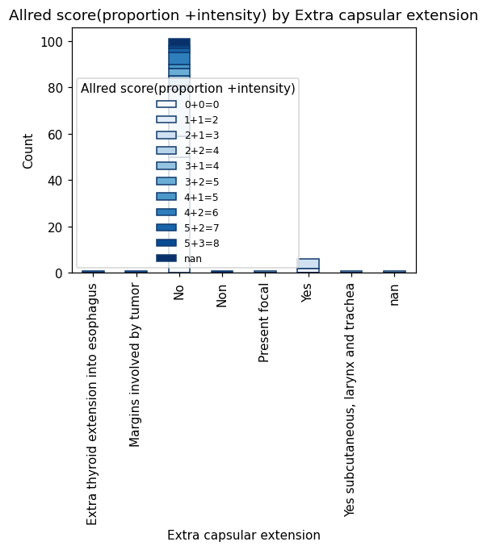
Figure 1. Stacked bar chart

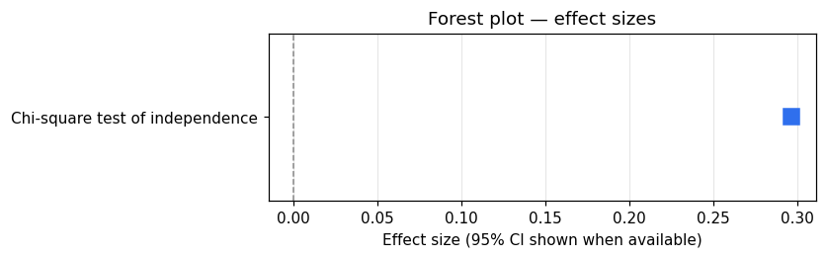
Figure 2. Forest plot


Figure 3. Forest plot of effect sizes

Results Section
Copy the text below directly into your paper's Results section.
A total of 113 participants were included in the analysis. Age, Age Original, Age Numeric were not normally distributed; non-parametric tests were used where appropriate. Allred Score(proportion +intensity) differed not significantly between Extra Capsular Extension groups (Chi-square test of independence: p = 0.499, Cramér's V = 0.296) (Table 3).

Statistical Analysis
Copy the text below directly into your paper's Methods section.
All statistical analyses were performed using Python with the scipy (v1.17.1), statsmodels (v0.14.6), pingouin (v0.6.1), lifelines (v0.30.3) libraries. A two-tailed p-value < 0.05 was considered statistically significant. Non-normally distributed variables were expressed as median with interquartile range. Categorical variables were expressed as frequencies and percentages. Statistical tests used included: Chi-square / Fisher's exact (auto-select), Chi-square test of independence.

Limitations and Notes
- High missing data rate detected (up to 71%). Results may be affected by missing data.

