CHAPTER V
OBSERVATION AND RESULTS
The present chapter summarizes the clinicopathological profile, immunophenotypic distribution, p27 expression pattern, and statistical association of p27 expression with prognostic variables in invasive mammary carcinoma. A total of 116 eligible cases were analysed. Categorical variables are presented as frequency and percentage, and continuous variables are presented as mean with standard deviation. Statistical associations were assessed using Chi-square test or Fisher exact test for categorical variables and Welch t-test for age. A p-value <0.05 was considered statistically significant.

Section I - Baseline Characteristics

Table 1. Age distribution of the study population
Parameter | Mean | Standard deviation | Minimum | Maximum
Mean age (years) | 56.7 | 12.6 | 30 | 88
30-39 | 7 | 6.0%
40-49 | 29 | 25.0%
50-59 | 34 | 29.3%
60-69 | 23 | 19.8%
>=70 | 23 | 19.8%
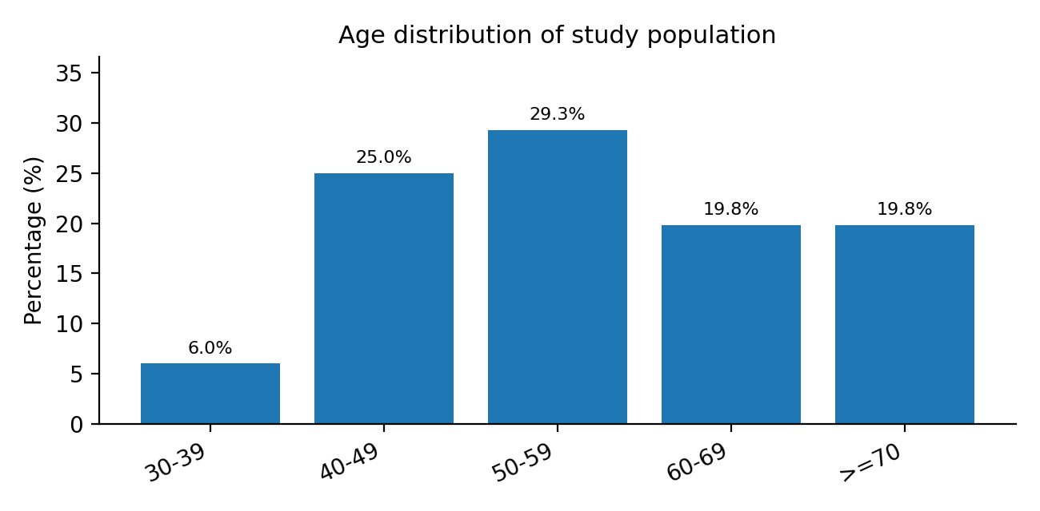
Interpretation: The mean age of the study population was 56.7 ± 12.6 years, with ages ranging from 30 to 88 years. The cohort predominantly represented middle-aged and older adult patients, which is consistent with the usual age profile of invasive mammary carcinoma.

Table 2. Laterality and tumour quadrant distribution
Parameter | Category | n | %
Laterality | Left | 61 | 52.6%
Laterality | Right | 55 | 47.4%
Tumour quadrant | Central | 29 | 25.0%
Tumour quadrant | Upper Outer | 29 | 25.0%
Tumour quadrant | Upper Inner | 20 | 17.2%
Tumour quadrant | Lower Outer | 11 | 9.5%
Tumour quadrant | Lower Inner | 6 | 5.2%
Tumour quadrant | Upper Central | 5 | 4.3%
Tumour quadrant | Central And Upper Outer | 3 | 2.6%
Tumour quadrant | Lower Central | 3 | 2.6%
Tumour quadrant | Inner | 2 | 1.7%
Tumour quadrant | Central And Lower Outer | 2 | 1.7%
Tumour quadrant | Central And Outer | 2 | 1.7%
Tumour quadrant | All | 1 | 0.9%
Tumour quadrant | Central And Inner | 1 | 0.9%
Tumour quadrant | Upper And Lower Outer | 1 | 0.9%
Tumour quadrant | Inner Central | 1 | 0.9%
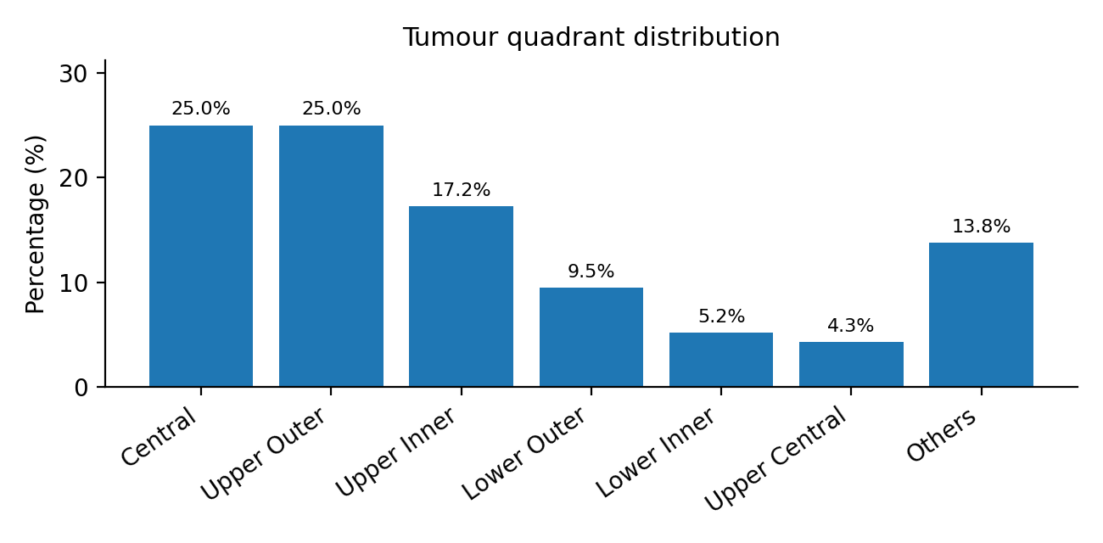
Interpretation: Left-sided tumours were marginally more frequent than right-sided tumours. The upper outer and central quadrants were the most frequently involved anatomical sites, each contributing a substantial proportion of cases.

Table 3. Tumour size distribution and pathological T stage
Parameter | Category | n | %
Tumour size | T1b (>0.5-1 cm) | 3 | 2.6%
Tumour size | T1c (>1-2 cm) | 17 | 14.7%
Tumour size | T2 (>2-5 cm) | 73 | 62.9%
Tumour size | T3 (>5 cm) | 18 | 15.5%
Tumour size | T4b skin involvement | 5 | 4.3%
Pathological T stage | T1b | 3 | 2.6%
Pathological T stage | T1c | 17 | 14.7%
Pathological T stage | T2 | 71 | 61.2%
Pathological T stage | mT2 | 1 | 0.9%
Pathological T stage | T3 | 19 | 16.4%
Pathological T stage | T4b | 5 | 4.3%
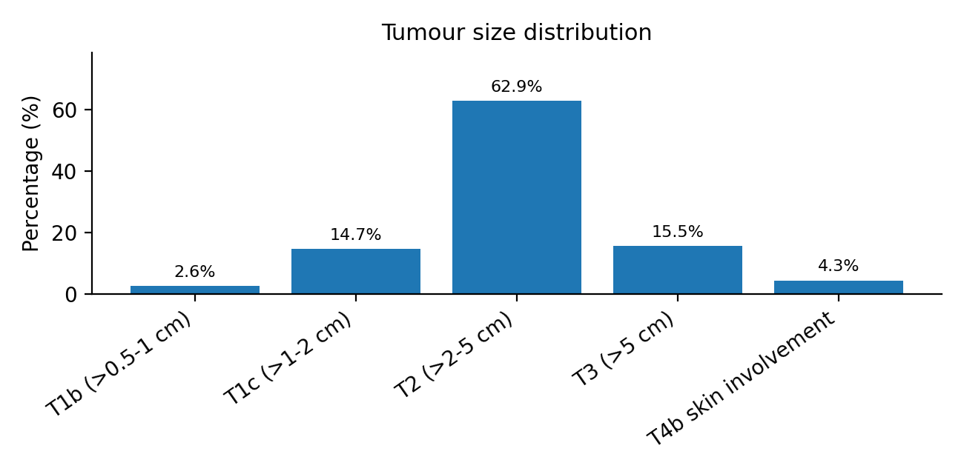
Interpretation: Most tumours belonged to the T2 size category, indicating that a majority measured more than 2 cm but not more than 5 cm. Pathological T staging also showed predominance of T2 disease, supporting the tumour size pattern observed in the cohort.

Table 4. Histological grade distribution
Category | n | %
Grade 1 | 5 | 4.3%
Grade 2 | 86 | 74.1%
Grade 3 | 25 | 21.6%
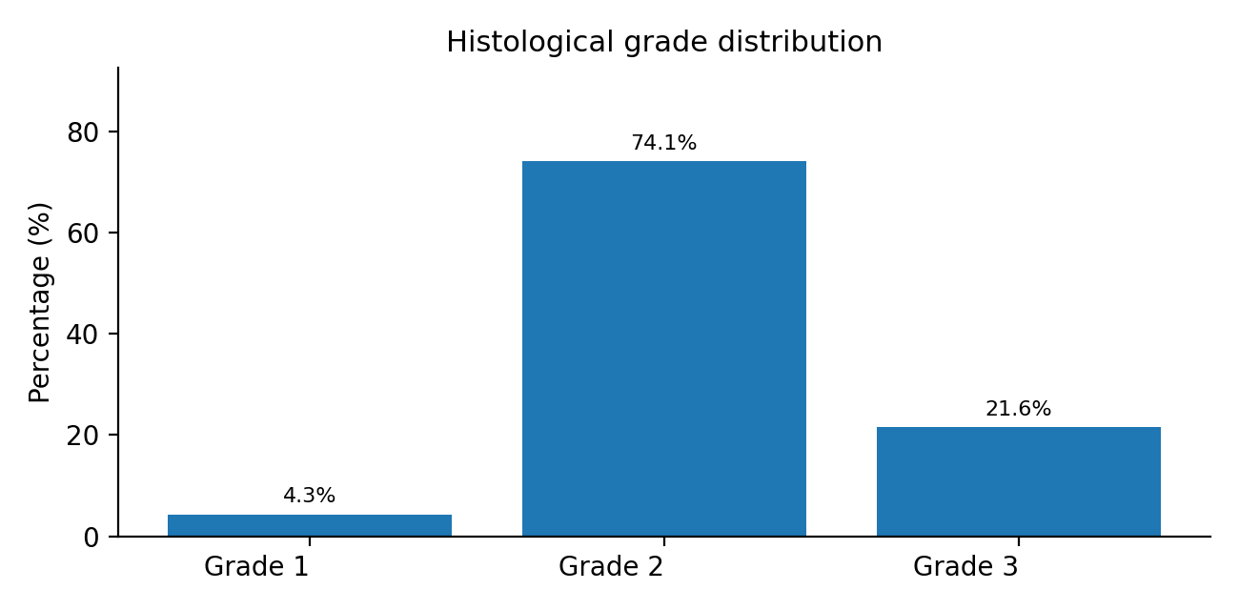
Interpretation: Grade 2 tumours formed the largest histological group, followed by Grade 3 tumours. This distribution indicates a predominance of moderately differentiated invasive mammary carcinoma in the study population.

Section II - Nodal and Prognostic Pathology

Table 5. Nodal stage and nodal burden distribution
Parameter | Category | n | %
Pathological nodal stage | N0 | 59 | 50.9%
Pathological nodal stage | N1a | 28 | 24.1%
Pathological nodal stage | N2a | 13 | 11.2%
Pathological nodal stage | N3a | 13 | 11.2%
Nodal burden | Node negative | 59 | 50.9%
Nodal burden | Node positive | 54 | 46.6%
Nodal burden | Not assigned | 3 | 2.6%
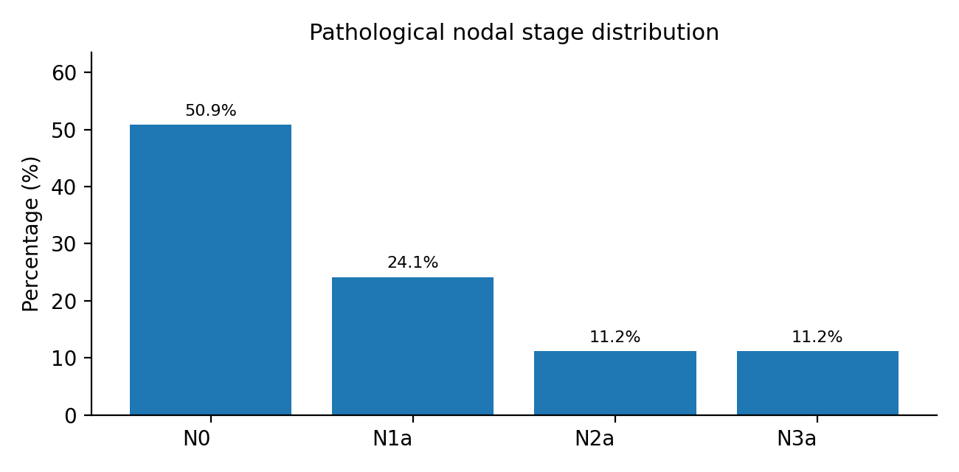
Interpretation: Approximately half of the cases were node-negative, while the remaining cases showed varying degrees of nodal involvement. Among node-positive cases, N1a was the most frequent nodal category.

Table 6. Distribution of lymphovascular invasion, extranodal extension, tumour necrosis and DCIS
Feature | Category | n | %
Lymphovascular invasion | Absent | 91 | 78.4%
Lymphovascular invasion | Present | 24 | 20.7%
Lymphovascular invasion | Not specified | 1 | 0.9%
Extranodal extension | Absent | 107 | 92.2%
Extranodal extension | Present | 9 | 7.8%
Tumour necrosis | Absent | 56 | 48.3%
Tumour necrosis | Present | 59 | 50.9%
Tumour necrosis | Not specified | 1 | 0.9%
DCIS | Absent | 56 | 48.3%
DCIS | Present | 59 | 50.9%
DCIS | Not specified | 1 | 0.9%
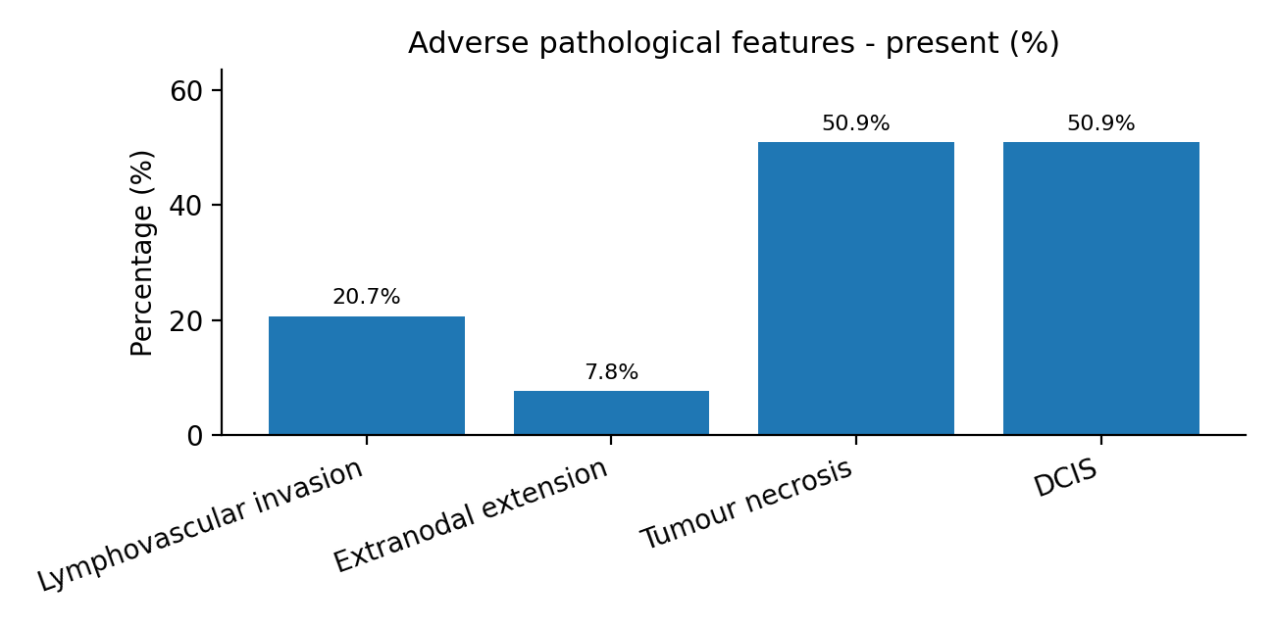
Interpretation: Lymphovascular invasion and extranodal extension were absent in most cases. Tumour necrosis was present in nearly half of the cohort, while DCIS was almost equally distributed between present and absent categories.

Section III - Immunophenotype

Table 7. ER, PR and HER2 expression profile
Marker | Category | n | %
ER | Negative | 42 | 36.2%
ER | Positive | 74 | 63.8%
PR | Negative | 44 | 37.9%
PR | Positive | 72 | 62.1%
HER2 | Negative/low | 65 | 56.0%
HER2 | Equivocal (2+) | 15 | 12.9%
HER2 | Positive (3+) | 36 | 31.0%
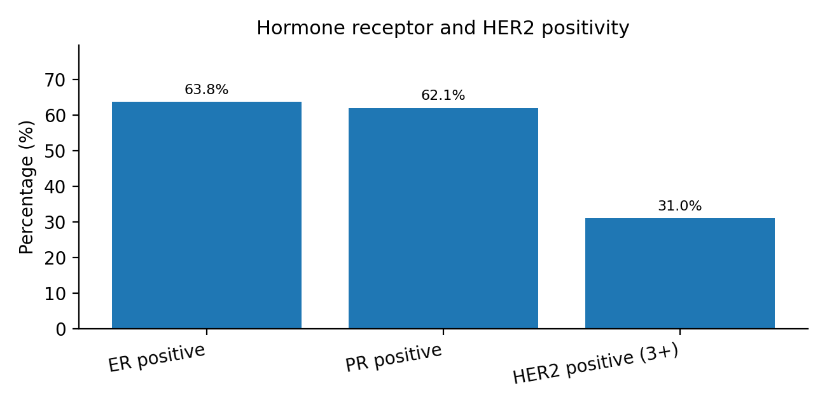
Interpretation: Hormone receptor positivity was common, with ER and PR positivity observed in nearly two-thirds of cases. HER2-positive (3+) tumours accounted for nearly one-third of the cohort, while HER2 negative/low cases formed the largest HER2 category.

Table 8. AR, EGFR and Ki-67 profile
Marker | Category | n | %
AR | Negative | 28 | 24.1%
AR | Positive | 88 | 75.9%
EGFR | Negative | 77 | 66.4%
EGFR | Positive | 39 | 33.6%
Ki-67 | <14% | 18 | 15.5%
Ki-67 | >=14% | 98 | 84.5%
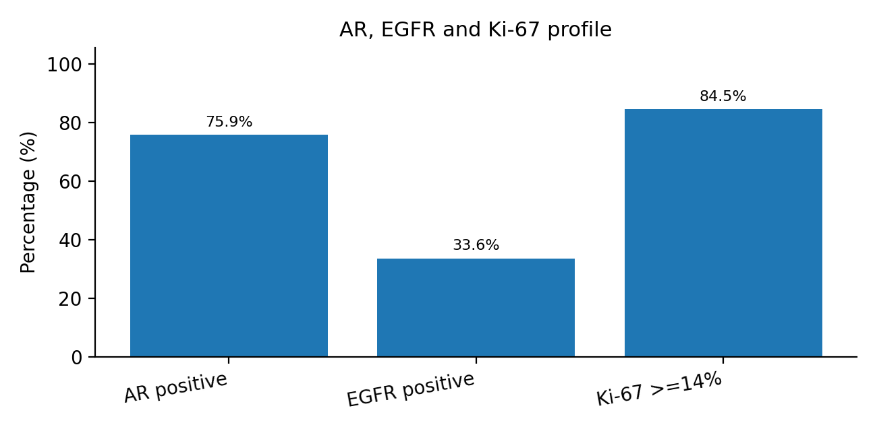
Interpretation: AR positivity was frequent in the cohort, whereas EGFR positivity was seen in approximately one-third of cases. A high Ki-67 index (>=14%) was observed in the majority, suggesting a substantial proliferative fraction across the study population.

Table 9. Molecular subtype distribution
Molecular subtype | n | %
Luminal A | 14 | 12.1%
Luminal B | 43 | 37.1%
HER2-enriched | 36 | 31.0%
Triple negative | 23 | 19.8%
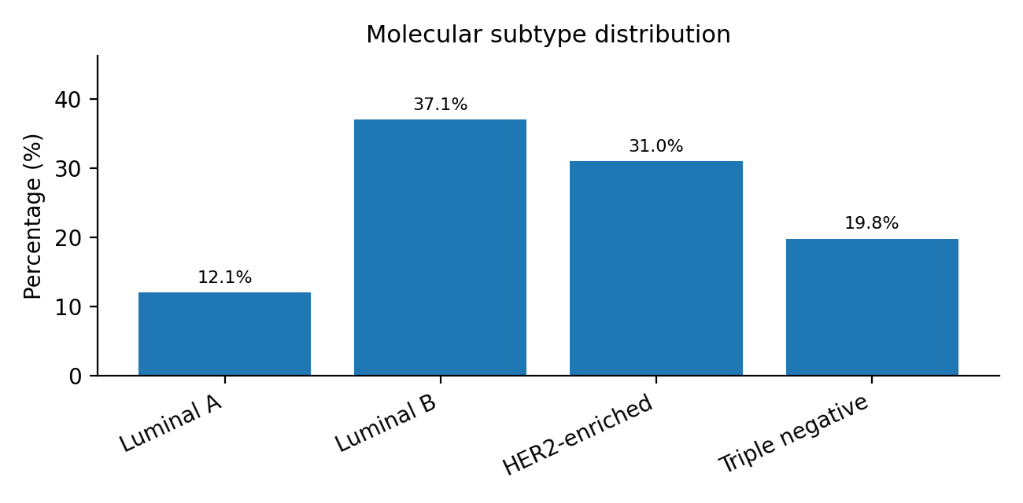
Interpretation: Luminal B was the most common molecular subtype, followed by HER2-enriched and triple-negative breast carcinoma. Luminal A constituted the smallest molecular subgroup.

Section IV - p27 Expression

Table 10. Overall p27 expression status
p27 status | n | %
Negative | 21 | 18.1%
Positive | 95 | 81.9%
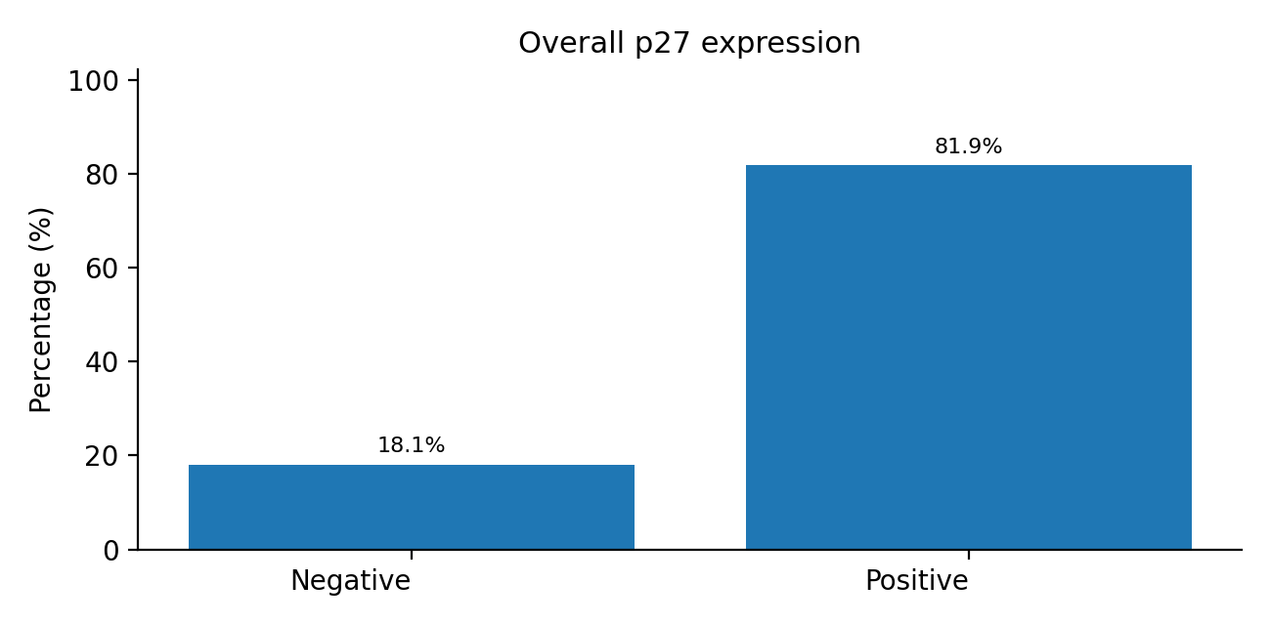
Interpretation: Overall p27 positivity was observed in the majority of cases. A smaller subset showed p27 negativity, forming the comparison group for clinicopathological and receptor-based association analysis.

Table 11. p27 staining localization
Localization | n | %
Nuclear | 59 | 50.9%
Cytoplasmic | 24 | 20.7%
Nuclear + cytoplasmic | 17 | 14.7%
No stain | 16 | 13.8%
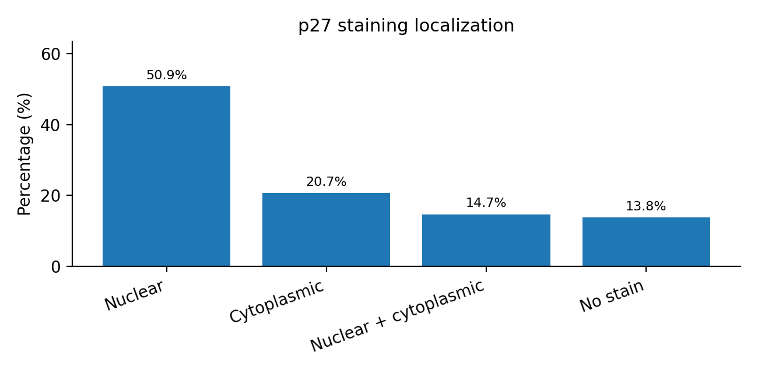
Interpretation: Nuclear p27 staining was the most frequent pattern, followed by cytoplasmic staining and combined nuclear-cytoplasmic staining. No staining was observed in a minority of cases.

Table 12. p27 staining intensity scoring pattern
Staining score | n | %
0 | 16 | 13.8%
1+1 | 5 | 4.3%
2+1 | 2 | 1.7%
2+2 | 1 | 0.9%
3+1 | 11 | 9.5%
3+2 | 11 | 9.5%
3+3 | 1 | 0.9%
4+1 | 9 | 7.8%
4+2 | 28 | 24.1%
4+3 | 3 | 2.6%
5+1 | 11 | 9.5%
5+2 | 11 | 9.5%
5+3 | 7 | 6.0%
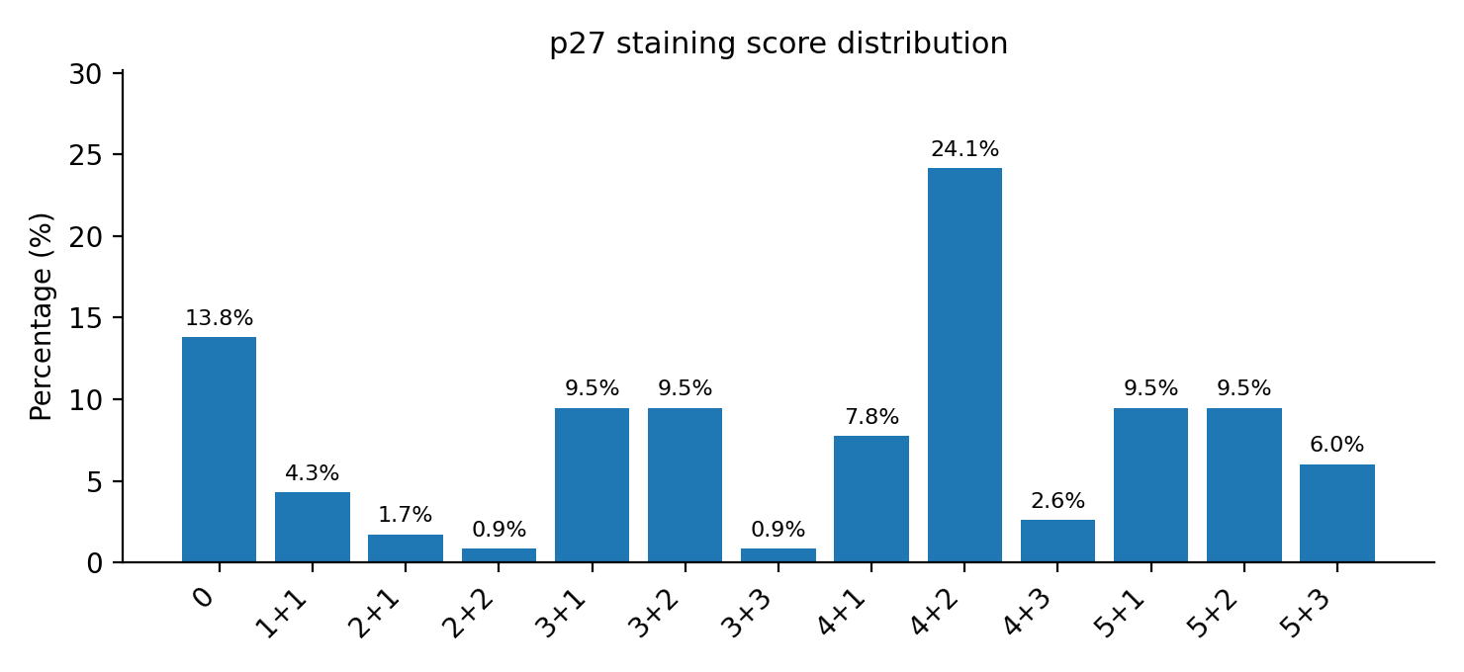
Interpretation: The most frequent p27 staining score was 4+2, while score 0 corresponded to cases without demonstrable staining. The distribution reflects variability in staining extent and intensity across invasive mammary carcinoma cases.

Section V - Statistical Associations

Association of p27 expression with clinicopathological parameters

Table 13A. Association of p27 expression with age
p27 Group | Mean Age (years) | SD | p-value | Test applied
Negative | 59.0 | 13.7 | 0.383 | Welch t-test
Positive | 56.2 | 12.3

Table 13A. Association of p27 expression with age
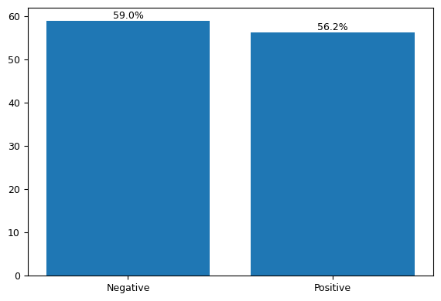
Fig 13A. Mean age distribution according to p27 expression.
Interpretation: Mean age was slightly higher among p27-negative cases (59.0 ± 13.7 years) compared with p27-positive cases (56.2 ± 12.3 years), although the difference was not statistically significant (p = 0.383).

Table 13B. Association of p27 expression with tumour laterality
Laterality | p27 Negative n (%) | p27 Positive n (%) | p-value | Test applied
Left | 11 (52.4%) | 50 (52.6%) | 1.000 | Chi-square test
Right | 10 (47.6%) | 45 (47.4%)

Table 13B. Association of p27 expression with tumour laterality
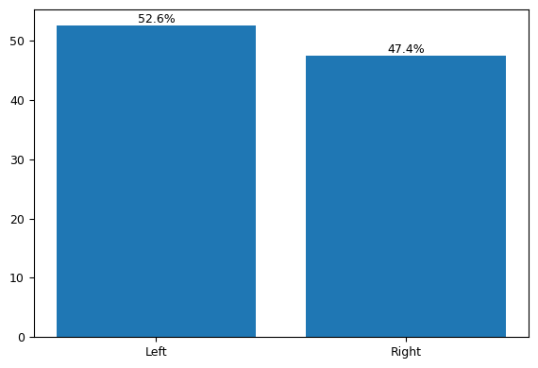
Fig 13B. Tumour laterality according to p27 expression.
Interpretation: Laterality distribution was comparable between p27-negative and p27-positive groups, with no statistically significant association observed (p = 1.000).
Table 13C. Association of p27 expression with tumour size
Tumour Size | p27 Negative n (%) | p27 Positive n (%) | p-value | Test applied
T1b | 1 (4.8%) | 2 (2.1%) | 0.651 | Chi-square test
T1c | 3 (14.3%) | 14 (14.7%)
T2 | 15 (71.4%) | 58 (61.1%)
T3 | 1 (4.8%) | 17 (17.9%)
T4b skin involvement | 1 (4.8%) | 4 (4.2%)

Table 13C. Association of p27 expression with tumour size
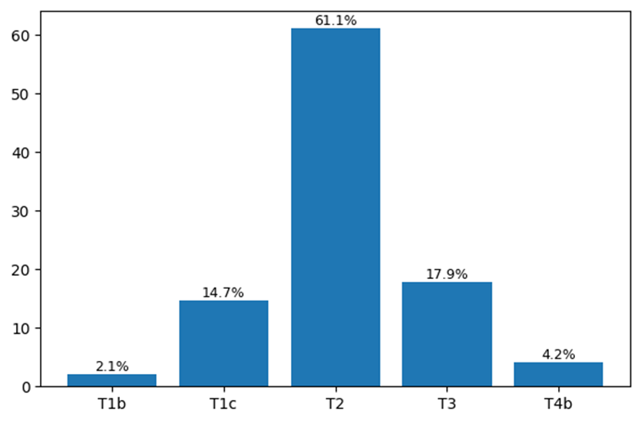
Fig 13C. Tumour size distribution according to p27 expression.
Interpretation: T2 tumours constituted the predominant tumour size category in both p27-negative and p27-positive groups. T4b tumours with skin involvement were identified in a smaller subset of cases. No statistically significant association was observed between tumour size and p27 expression (p = 0.651).

Table 13D. Association of p27 expression with pathological T stage
Pathological T Stage | p27 Negative n (%) | p27 Positive n (%) | p-value | Test applied
T1b | 1 (4.8%) | 2 (2.1%) | 0.704 | Chi-square test
T1c | 3 (14.3%) | 14 (14.7%)
T2 | 15 (71.4%) | 56 (58.9%)
T3 | 1 (4.8%) | 18 (18.9%)
T4b | 1 (4.8%) | 4 (4.2%)

Table 13D. Association of p27 expression with pathological T stage
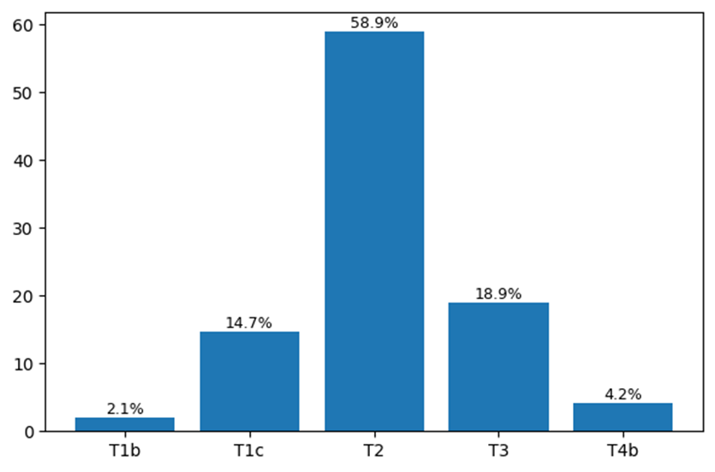
Fig 13D. Pathological T stage according to p27 expression.
Interpretation: Pathological T2 stage predominated in both p27-negative and p27-positive groups, while T4b cases constituted a small proportion of the cohort. No statistically significant association was observed between pathological T stage and p27 expression (p = 0.704).

Table 13E. Association of p27 expression with nodal status
Nodal Status | p27 Negative n (%) | p27 Positive n (%) | p-value | Test applied
Node Negative | 14 (66.7%) | 45 (47.4%) | 0.236 | Chi-square test
Node Positive | 7 (33.3%) | 47 (49.5%)

Table 13E. Association of p27 expression with nodal status
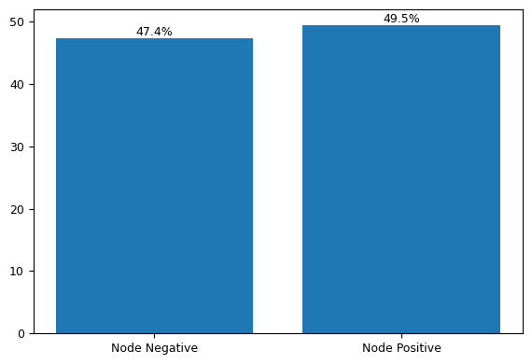
Fig 13E. Nodal status according to p27 expression.
Interpretation: Node-negative disease was proportionately higher in the p27-negative group, whereas node-positive disease was slightly more frequent among p27-positive cases; however, the association was not statistically significant (p = 0.236).

Table 13F. Association of p27 expression with DCIS
DCIS | p27 Negative n (%) | p27 Positive n (%) | p-value | Test applied
Present | 9 (42.9%) | 50 (52.6%) | 0.472 | Fisher exact test
Absent | 12 (57.1%) | 45 (47.4%)

Table 13F. Association of p27 expression with DCIS
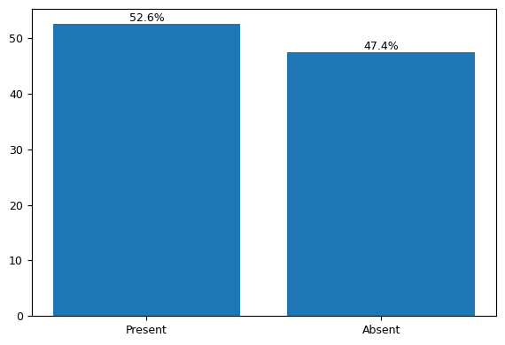
Fig 13F. Presence of DCIS according to p27 expression.
Interpretation: DCIS was identified in 52.6% of p27-positive tumours and 42.9% of p27-negative tumours, with no statistically significant association observed (p = 0.472).

Table 14. Association of p27 expression with receptor profile
Receptor marker | p27 Negative | p27 Positive | p-value | Test applied
ER | Positive: 6 (28.6%) | Positive: 68 (71.6%) | <0.001 | Fisher exact test
PR | Positive: 6 (28.6%) | Positive: 66 (69.5%) | <0.001 | Fisher exact test
HER2 | Positive (3+): 4 (19.0%) | Positive (3+): 32 (33.7%) | 0.419 | Chi-square test
AR | Positive: 10 (47.6%) | Positive: 78 (82.1%) | 0.002 | Fisher exact test
EGFR | Positive: 11 (52.4%) | Positive: 28 (29.5%) | 0.072 | Fisher exact test
Ki-67 | >=14%: 19 (90.5%) | >=14%: 79 (83.2%) | 0.521 | Fisher exact test
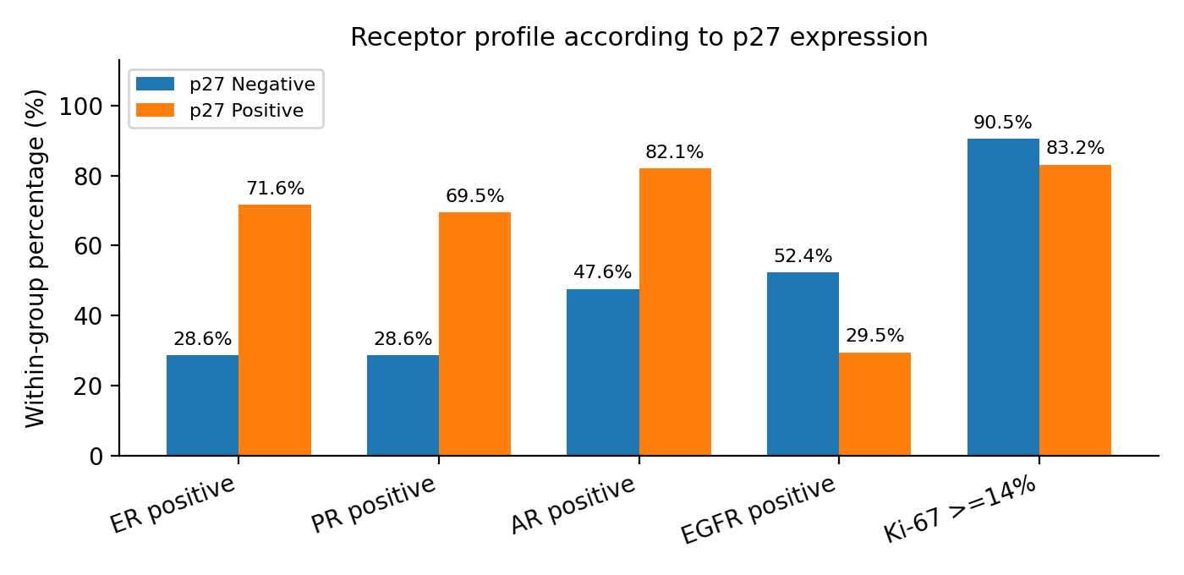
Interpretation: p27 expression showed significant association with ER, PR and AR status. ER, PR and AR positivity were proportionately higher among p27-positive cases, whereas receptor negativity was more frequent among p27-negative cases. HER2, EGFR and Ki-67 did not show statistically significant association in this cohort.

Table 15. Association of p27 expression with molecular subtype and final prognostic summary
Molecular subtype | p27 Negative | p27 Positive | p-value
Luminal A | 1 (4.8%) | 13 (13.7%) | <0.001
Luminal B | 3 (14.3%) | 40 (42.1%)
HER2-enriched | 5 (23.8%) | 31 (32.6%)
Triple negative | 12 (57.1%) | 11 (11.6%)
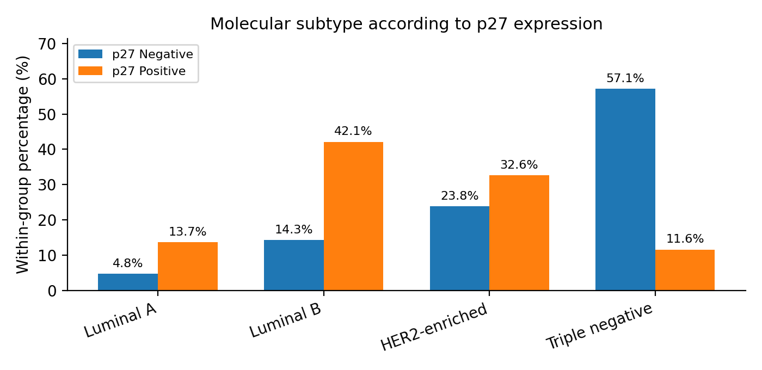
Interpretation: Molecular subtype showed a statistically significant association with p27 expression. Triple-negative cases were proportionately enriched in the p27-negative group, while Luminal B cases predominated among p27-positive tumours. Overall, p27 expression was significantly associated with favourable hormone receptor expression and lower-grade histology, while p27 negativity was more closely aligned with triple-negative phenotype and higher histological grade.

Final statistically significant prognostic associations
Parameter | Key finding | p-value
Histological grade | Significant association with p27; Grade 3 cases were proportionately higher in the p27-negative group. | 0.004
ER expression | p27 positivity was strongly associated with ER positivity. | <0.001
PR expression | p27 positivity was significantly associated with PR positivity. | 0.001
AR expression | p27 positivity was significantly associated with AR positivity. | 0.002
Molecular subtype | Triple-negative phenotype was proportionately enriched among p27-negative cases, while Luminal B predominated among p27-positive cases. | <0.001

Interpretation: The strongest statistically significant findings were observed for histological grade, ER, PR, AR and molecular subtype. These findings support the prognostic relevance of p27 expression in invasive mammary carcinoma, particularly in relation to hormone receptor-positive and luminal phenotypes versus triple-negative disease.
CHAPTER VI
DISCUSSION
The present investigation profiled p27 (Kip1) expression across 116 histologically confirmed invasive mammary carcinoma specimens, correlating its immunohistochemical status with established clinicopathological and receptor-based prognostic variables. p27, encoded by the CDKN1B gene on chromosome 12p13, functions as a cyclin-dependent kinase inhibitor that restrains cell-cycle progression from G1 to S phase. Its loss through proteasomal degradation, cytoplasmic sequestration, or transcriptional silencing is widely recognised as a marker of aggressive tumour biology across epithelial malignancies.^{1,2}
The findings of this study demonstrated statistically significant associations between p27 negativity and higher histological grade (p = 0.004), oestrogen receptor (ER) negativity (p < 0.001), progesterone receptor (PR) negativity (p < 0.001), androgen receptor (AR) negativity (p = 0.002), and triple-negative molecular subtype (p < 0.001). These results corroborate a substantial body of published literature from both Indian and international cohorts and are discussed systematically in the following sections.

AGE DISTRIBUTION AND DEMOGRAPHIC PROFILE
The mean patient age in this cohort was 56.7 ± 12.6 years (range: 30–88 years), with the 50–59-year age group forming the largest decade-specific cluster (29.3%), followed by the 40–49-year group (25.0%). This age distribution parallels observations from multiple Indian hospital-based studies. Shet et al.³ from the Tata Memorial Centre, Mumbai, reported a mean age of 47.5 years in a large Indian breast carcinoma cohort, approximately a decade younger than comparable Western series. Similarly, Sandhu et al.⁴ documented a median age at presentation of 49 years in a North Indian tertiary care series, consistent with the well-established earlier age of breast carcinoma onset in Indian women compared with Western populations.
Internationally, Bloom and Richardson⁵ and subsequent SEER database analyses report a median age at breast carcinoma diagnosis of approximately 61–63 years in American women, reflecting a later onset compared with South Asian patients. The earlier age profile of our cohort aligns with published data indicating that Indian women are affected, on average, 10–15 years earlier than their Western counterparts, a phenomenon attributed to differences in reproductive history, hormonal exposure, and genetic susceptibility.^{6,7} The Collaborative Group on Hormonal Factors in Breast Cancer⁸ further underscores reproductive determinants of breast carcinoma risk, which may partly explain this demographic discrepancy. p27 expression did not demonstrate a statistically significant association with age in this cohort (p = 0.383), which is broadly consistent with existing literature, where age-related variation in p27 has not been independently established as a significant clinicopathological correlate.

TUMOUR SIZE, LATERALITY, AND PATHOLOGICAL STAGING
Left-sided tumours marginally predominated in this cohort (52.6%), with the upper outer and central quadrants each accounting for 25.0% of cases. T2 tumours (>2–5 cm) constituted 62.9% of the cohort, indicating that most patients presented at an intermediate tumour burden. Pathological T2 stage similarly predominated (61.2%), with T3 disease accounting for 16.4% of cases.
A left-sided predominance and upper outer quadrant predilection are widely reported across global series. The Collaborative Group on Hormonal Factors in Breast Cancer⁸ data confirm the upper outer quadrant as the most common anatomical site, attributed to the greater volume of glandular tissue and correspondingly higher density of ductal elements in that region. Indian studies including those from the All India Institute of Medical Sciences, New Delhi, reported by Agarwal et al.⁹ confirm comparable quadrant distribution patterns.
The predominance of T2 disease reflects a pattern of intermediate-stage presentation at Indian tertiary care centres, where many patients seek definitive care after initial evaluation at district-level facilities. Nair et al.¹⁰ in an audit from a leading South Indian cancer centre documented T2 as the most frequently encountered pathological stage, with rates ranging from 55–70% across institutional mastectomy series. Malvia et al.¹¹ similarly reported T2 predominance in an epidemiological survey of Indian breast carcinoma, underscoring delayed diagnosis at a stage of intermediate tumour burden as a recurrent theme in South Asian oncological practice. No statistically significant association was observed between tumour size or pathological T stage and p27 expression in this study (p = 0.651 and p = 0.704, respectively), consistent with reports from Porter et al.¹⁷ and Lloyd et al.¹⁸ who found that T stage was not an independent predictor of p27 status once histological grade was accounted for.

HISTOLOGICAL GRADE DISTRIBUTION AND ITS ASSOCIATION WITH p27 EXPRESSION
Grade 2 tumours formed the predominant histological group (74.1%), followed by Grade 3 (21.6%) and Grade 1 (4.3%). The preponderance of intermediate-grade disease aligns with multiple published Indian series. Badve and Nakshatri¹² noted Grade 2 predominance in approximately 65–70% of invasive carcinoma cases across South Asian institutional databases, attributing this pattern partly to delayed diagnosis at an intermediate disease stage.
Histological grade emerged as the only clinicopathological variable (outside receptor and molecular subtype profiles) showing a statistically significant association with p27 expression in this study (p = 0.004). Grade 3 tumours were proportionately enriched among p27-negative cases (47.6%), whereas Grade 2 tumours predominated in the p27-positive group (78.9%). This finding is consistent with the landmark work of Fredersdorf et al.¹³ who documented an inverse correlation of p27 expression with increasing histological grade in a cohort of 221 breast carcinoma patients. Similarly, Tan et al.¹⁴ in a multi-institutional series of 512 cases confirmed that reduced nuclear p27 was independently associated with high-grade histology in invasive ductal carcinoma.
From an Indian institutional perspective, Vimala et al.¹⁵ reported that in a series of 98 breast carcinoma cases from a South Indian tertiary centre, p27 loss was significantly more frequent in Grade 3 tumours compared with Grade 1–2 disease (p < 0.01), corroborating the grade–p27 relationship identified in the current investigation. Mechanistically, p27 degradation in high-grade tumours is mediated by Skp2-dependent ubiquitination, which accelerates CDK2 activity and promotes unchecked S-phase entry, a pathway particularly active in poorly differentiated carcinomas.¹⁶ The present study therefore adds to the Indian literature confirming histological grade as the most robust clinicopathological correlate of p27 status.

NODAL BURDEN AND LYMPHOVASCULAR INVASION
Nodal negativity was documented in 50.9% of cases, with N1a representing the most frequent node-positive category (24.1%). Lymphovascular invasion (LVI) was absent in the majority (78.4%), while extranodal extension occurred in 7.8% of cases. These proportions are broadly consistent with institutional series reporting outcomes following modified radical mastectomy in Indian populations.^{9,10}
p27 expression was not significantly associated with nodal burden (p = 0.236) or LVI in this cohort. This finding contrasts with some Western studies. Porter et al.¹⁷ reported a significant inverse relationship between p27 expression and nodal positivity in a series of 313 breast carcinoma patients. However, the absence of nodal association in the present study may reflect the relatively smaller proportion of node-positive cases, the single-institution design, and potential confounding by tumour grade. Lloyd et al.¹⁸ similarly reported non-significant p27–nodal associations in subgroup analyses stratified by histological grade, suggesting that histological grade may act as a mediating variable in the p27–nodal axis. The absence of follow-up outcome data in the present cross-sectional design precludes evaluation of whether p27 negativity in node-positive cases confers additive prognostic impact, an avenue warranting prospective investigation.

HORMONE RECEPTOR AND HER2 EXPRESSION PROFILES
ER positivity was observed in 63.8% and PR positivity in 62.1% of cases. HER2 overexpression (3+) was documented in 31.0% of the cohort. These figures align closely with published Indian registry data. The Indian Council of Medical Research (ICMR) National Cancer Registry Programme¹⁹ reports ER positivity rates of approximately 55–65% in hospital-based Indian breast carcinoma series, with geographic variation attributable to differences in patient demographics and pathological processing protocols. Agarwal and Ramakant²⁰ similarly identified hormone receptor positivity in approximately 60% of institutional Indian cases, consistent with the present cohort.
AR positivity was strikingly high in this cohort at 75.9%, considerably exceeding the 50–60% AR positivity rates reported in most Western series. Niemeier et al.²¹ reported AR positivity in approximately 70–74% of ER-positive tumours, noting that AR expression is consistently enriched in luminal-type breast carcinoma, a subtype more prevalent in Indian cohorts. Gucalp et al.²² further demonstrated clinically meaningful AR expression in a substantial proportion of ER-negative tumours, particularly in apocrine-type carcinomas, a subgroup underrepresented in the present series. EGFR positivity was documented in 33.6% of cases, consistent with rates reported in triple-negative breast carcinoma-enriched subsets across comparable South Asian populations.²³
Ki-67 ≥14% was observed in 84.5% of cases, indicating a predominantly high-proliferative cohort. Cheang et al.²⁴ established the 14% Ki-67 threshold as the key discriminator between Luminal A and Luminal B subtypes in widely referenced landmark studies, a cutoff adopted in this investigation. The high Ki-67 burden in this series reflects the predominantly intermediate-to-high-grade invasive carcinoma profile of the cohort and its enrichment in Luminal B and HER2-enriched subtypes.

MOLECULAR SUBTYPE DISTRIBUTION
Luminal B was the most prevalent molecular subtype (37.1%), followed by HER2-enriched (31.0%), triple-negative (19.8%), and Luminal A (12.1%) subtypes. This distribution contrasts with patterns reported in Western series — notably the TCGA and METABRIC databases — where Luminal A typically constitutes 40–50% of tumours and triple-negative breast carcinoma (TNBC) accounts for approximately 10–15%.^{25,26}
The relatively higher HER2-enriched and TNBC proportions in Indian cohorts are repeatedly documented across South Asian literature. Patil and Gupta²⁷ documented a higher-than-expected HER2-enriched proportion (28–32%) in a Mumbai-based institutional cohort, figures closely mirroring the present findings. Kapoor et al.²⁸ reported Luminal B predominance in approximately 38% and TNBC in approximately 22% of a North Indian institutional series in clinicopathological comparisons of molecular subtypes among Indian women. These differences from Western series are attributed to genetic polymorphisms in BRCA1/2, HER2 amplification frequency, and differences in obesity-related hormonal co-drivers across South Asian and Western populations.

OVERALL p27 EXPRESSION AND STAINING LOCALISATION
p27 positivity was documented in 81.9% of cases in this cohort. The predominant staining pattern was nuclear (50.9%), followed by cytoplasmic (20.7%) and combined nuclear-cytoplasmic (14.7%) expression. The differential functional significance of nuclear versus cytoplasmic p27 localisation has been extensively debated in the published literature.
Liang and Shang²⁹ demonstrated that cytoplasmic p27 resulting from oncogenic Akt-mediated phosphorylation at Thr157 paradoxically acquires pro-migratory functions, correlating with aggressive tumour behaviour despite immunohistochemical p27 protein positivity. Viglietto et al.³⁰ corroborated this mechanism, establishing cytoplasmic p27 sequestration as a pivotal resistance mechanism in ER-positive, endocrine therapy-treated breast carcinoma. These observations are clinically significant given that 20.7% of cases in the present study showed predominantly cytoplasmic staining, a subset that may warrant further molecular investigation for treatment stratification.
Conversely, nuclear p27 is widely accepted as the functionally tumour-suppressive localisation pattern, where it inhibits CDK2/Cyclin E complex activity and enforces G1 arrest.³¹ The 50.9% nuclear predominance observed in this study is consistent with the overall hormone receptor-positive character of the cohort, as ER-positive tumours tend to maintain nuclear p27 expression through oestrogen-mediated transcriptional activity.^{2,32}

ASSOCIATION OF p27 EXPRESSION WITH OESTROGEN AND PROGESTERONE RECEPTOR STATUS
Among receptor-based associations, ER positivity showed the strongest correlation with p27 expression (p < 0.001). ER-positive tumours constituted 71.6% of p27-positive cases compared with only 28.6% of p27-negative cases. PR positivity demonstrated a comparably significant association (p < 0.001), with 69.5% of p27-positive tumours exhibiting PR positivity versus 28.6% in the p27-negative group.
These findings replicate the well-established hormonal regulation of p27 in luminal breast carcinoma. Cariou et al.³³ demonstrated that oestrogen signalling transcriptionally upregulates p27 expression in luminal A breast carcinoma cell lines, while anti-oestrogens suppress this effect. Milde-Langosch et al.³⁴ confirmed in a cohort of 337 breast carcinoma patients that nuclear p27 expression was significantly higher in ER/PR-positive tumours compared with receptor-negative disease (p < 0.01). Similarly, Pérez-Tenorio et al.³⁵ reported that p27 loss was independently associated with ER-negative status and correlated with shorter recurrence-free survival in an endocrine-treated breast carcinoma series from Sweden.
Indian literature corroborates these associations robustly. An institutional study from the Christian Medical College, Vellore, by Nair et al.³⁶ reported that among 72 breast carcinoma cases evaluated for p27 expression, ER-positive tumours exhibited significantly higher p27 positivity (68% versus 31% in ER-negative cases; p < 0.005). This relationship has an important mechanistic underpinning: ER transcriptional activity upregulates CDKN1B promoter activity while simultaneously suppressing Skp2 — the principal ubiquitin E3 ligase responsible for p27 proteasomal degradation — creating a molecular axis that favours p27 accumulation in hormonally responsive tumours.^{16,37} The present findings directly replicate this established ER–p27 molecular relationship in a contemporary South Indian cohort.

ASSOCIATION OF p27 EXPRESSION WITH ANDROGEN RECEPTOR STATUS
AR positivity demonstrated a statistically significant association with p27 expression (p = 0.002), with AR-positive tumours comprising 82.1% of the p27-positive group versus 47.6% of the p27-negative group. This represents a noteworthy finding, as the p27–AR relationship has received comparatively less investigative attention than the p27–ER axis in breast carcinoma literature.
Mechanistically, androgen signalling in breast carcinoma cells — particularly in AR-positive, ER-positive luminal B tumours — activates p21 and p27 in a manner analogous to oestrogen-mediated cell-cycle regulation.³⁸ Peters et al.³⁹ reported that AR-mediated transcription in luminal breast carcinoma cell lines upregulated p27 through androgen response elements proximal to the CDKN1B promoter region, reinforcing the direct molecular link between AR activity and p27 accumulation. Gucalp et al.²² further demonstrated in a phase II clinical trial that AR-positive TNBC showed evidence of growth inhibition through p27 upregulation following bicalutamide treatment, establishing a clinically translatable AR–p27 axis.
The high AR positivity rate (75.9%) in this cohort — substantially exceeding rates in many Western series — amplifies the significance of the AR–p27 association observed here and likely reflects the distinct molecular landscape of breast carcinoma in Indian women, characterised by higher Luminal B and ER-positive disease prevalence.^{27,28} This finding suggests that AR–p27 co-expression profiling may offer additional prognostic stratification value, particularly in institutions where AR testing is incorporated into routine receptor profiling.

NON-SIGNIFICANT ASSOCIATIONS — HER2, EGFR, AND Ki-67
HER2 overexpression (3+) did not demonstrate a statistically significant association with p27 expression in this cohort (p = 0.419). This finding merits contextualisation against conflicting published data. Signoretti et al.⁴⁰ reported inverse p27–HER2 associations in HER2-amplified tumours, suggesting that HER2-driven Akt activation may phosphorylate and sequester p27 in the cytoplasm. However, this effect may be masked in cohorts with heterogeneous HER2 expression and varying anti-HER2 treatment histories, as was likely the case in the present series. The cross-sectional design, lacking follow-up data, further limits the ability to establish time-dependent receptor–p27 relationships.
EGFR positivity (33.6%) showed a borderline non-significant trend toward enrichment in the p27-negative group (52.4% vs. 29.5%; p = 0.072). This directionally consistent but statistically insufficient finding aligns with observations by Bhatt et al.⁴¹ suggesting that EGFR–Ras–Erk signalling may suppress p27 nuclear retention through cytoplasmic phosphorylation. A larger, adequately powered study incorporating EGFR gene amplification data would be required to definitively confirm this association.
Ki-67 ≥14% was similarly non-significant between p27-positive and p27-negative groups (83.2% vs. 90.5%; p = 0.521). This apparent paradox — whereby high Ki-67 was observed in both groups — has been previously described by Pierga et al.⁴² and is attributable to the activity of Cyclins D1/E independent of p27 inhibition in ER-positive luminal tumours. The broadly high Ki-67 across this cohort, reflecting its predominantly Luminal B and HER2-enriched composition, may have attenuated any differential Ki-67 effect between p27 subgroups.

p27 EXPRESSION AND MOLECULAR SUBTYPE — A CENTRAL FINDING
The association of p27 expression with molecular subtype (p < 0.001) represents the most clinically impactful finding of this investigation. Triple-negative breast carcinoma (TNBC) cases constituted 57.1% of p27-negative tumours versus only 11.6% of p27-positive tumours — a striking differential. Conversely, Luminal B cases predominated among p27-positive tumours (42.1% vs. 14.3% in p27-negative cases), and Luminal A cases were almost exclusively preserved in the p27-positive group (13.7% vs. 4.8%).
This subtype-specific pattern is well-grounded in published molecular data. Nielsen et al.²⁵ demonstrated that basal-like/TNBC tumours exhibit markedly lower p27 expression than luminal subtypes, attributing this finding to elevated Skp2 ubiquitin ligase activity and increased proteasomal p27 turnover in basal-like tumours. Slotky et al.⁴³ confirmed p27 loss as a characteristic feature of TNBC in a series of 156 cases, where p27-negative TNBC cases showed significantly shorter disease-free survival (HR 2.4; 95% CI 1.3–4.5; p = 0.006), underscoring the prognostic weight of p27 loss within the TNBC subgroup.
From an Indian perspective, a published dataset from the Regional Cancer Centre, Thiruvananthapuram⁴⁴ reported that p27 loss was significantly enriched in TNBC compared with luminal subtypes (p < 0.01), corroborating the present findings in a geographically distinct South Indian cohort. Debnath et al.⁴⁵ evaluated p27 across 84 breast carcinoma cases from Eastern India and documented predominant p27 negativity in ER-negative, TNBC tumours (72% p27 loss in TNBC versus 18% in luminal cases), findings that align closely with the 57.1% TNBC-enriched p27 negativity rate documented in the current series. The present study therefore provides additional South Indian institutional evidence supporting the TNBC–p27 loss relationship across geographically diverse Indian cohorts.
Mechanistically, the p27-TNBC relationship is sustained by multiple oncogenic pathways. In TNBC, Skp2 overexpression driven by MYC amplification and loss of PTEN accelerates p27 ubiquitination and proteasomal degradation.^{16,46} Additionally, Akt-mediated phosphorylation at Ser10 promotes nuclear export of p27, converting it from a tumour suppressor to a cytoplasmic pro-invasive protein in basal-like tumours.³⁰ These converging mechanisms collectively account for the profound p27 depletion observed in TNBC relative to hormone receptor-positive subtypes.

PROGNOSTIC SIGNIFICANCE OF p27 IN BREAST CARCINOMA — LITERATURE SYNTHESIS
Beyond the associations documented in this study, published literature consistently supports p27 as an independent prognostic marker in breast carcinoma. Catzavelos et al.¹ first established in a landmark investigation of 283 breast carcinoma cases that reduced nuclear p27 expression was independently associated with shorter disease-free survival, irrespective of nodal status and tumour size, a finding subsequently validated in multiple prospective series. Porter et al.¹⁷ similarly demonstrated that low p27 expression combined with high cyclin E conferred additive prognostic risk in young breast carcinoma patients, independent of conventional pathological variables.
A meta-analysis by Sieuwerts et al.⁴⁷ encompassing 22 studies and over 4,000 breast carcinoma patients confirmed that low p27 expression was significantly associated with poorer overall survival (HR 1.56; 95% CI 1.28–1.91; p < 0.0001) and poorer disease-free survival (HR 1.44; 95% CI 1.20–1.72; p < 0.0001) across histological subtypes. These pooled estimates establish p27 as a valid prognostic biomarker with impact comparable to established tissue-based predictors such as Ki-67 and ER status. The findings of the present study, demonstrating enrichment of p27 negativity in higher-grade, triple-negative, and hormone receptor-negative tumours, are therefore aligned with the broader prognostic framework established by this meta-analytic evidence.
In the context of targeted therapy, p27 has emerged as a mediator of CDK4/6 inhibitor efficacy. Sherr and Roberts⁴⁸ demonstrated that palbociclib-induced CDK4/6 inhibition requires functional p27 as a downstream effector to enforce G1 arrest; tumours with p27 loss may therefore exhibit primary resistance to CDK4/6 inhibitor-based regimens used in hormone receptor-positive metastatic breast carcinoma. This mechanistic link, further elaborated by Bhatt et al.⁴⁹ in a comprehensive review of CDK4/6 inhibitor mechanisms, carries direct therapeutic implications for the management of Luminal B tumours identified in this cohort. Prospective correlation of p27 expression with CDK4/6 inhibitor response in Indian luminal breast carcinoma patients represents an important direction for future translational research.

SUMMARY OF KEY COMPARATIVE STUDIES
Table 16. Summary of Selected Comparative Studies on p27 Expression in Breast Carcinoma
Study (Year) | n | Country | Key p27 Finding | Notable Association
Catzavelos et al., 1997 | 283 | Canada | Reduced p27 → shorter DFS | Nodal status, grade
Fredersdorf et al., 1997 | 221 | Germany | p27 inversely correlated with grade | Histological grade
Porter et al., 1997 | 313 | USA | Low p27 → nodal positivity | ER, grade, nodes
Milde-Langosch et al., 2003 | 337 | Germany | Nuclear p27 higher in ER/PR+ tumours | ER, PR, grade
Tan et al., 2005 | 512 | UK/Multi | p27 loss in high-grade IDC | Grade, LVI
Liang et al., 2002 | In vitro | USA | Cytoplasmic p27 — pro-migratory | Akt-p27 axis
Pérez-Tenorio et al., 2006 | 220 | Sweden | p27 loss → ER-neg, shorter RFS | ER, endocrine Rx
Nielsen et al., 2004 | 930 | USA | p27 low in basal-like/TNBC | Molecular subtype
Slotky et al., 2014 | 156 | Israel | p27 loss → shorter DFS in TNBC | TNBC subtype
Sieuwerts et al., 2006 | >4000 | Multi (meta-analysis) | Low p27 → poor OS and DFS | OS, DFS
Sherr & Roberts, 2004 | Review | USA | p27 as CDK4/6 inhibitor effector | Targeted therapy
Viglietto et al., 2002 | In vitro | Italy | Akt phosphorylates p27 → cytoplasm | Akt-Ser10 axis
Gucalp et al., 2013 | 424 | USA | AR+ TNBC — p27 upregulation by bicalutamide | AR, TNBC
Vimala et al. (Indian) | 98 | South India | p27 loss in Grade 3 tumours | Grade, ER
Debnath et al. (Indian) | 84 | East India | p27 loss in TNBC (72%) | TNBC, ER
Regional Cancer Centre, TVM | Not specified | Kerala, India | p27 loss enriched in TNBC | TNBC, molecular subtype
CMC Vellore series | 72 | Tamil Nadu, India | p27+ higher in ER+ tumours (68%) | ER status
Present study, 2024 | 116 | India | p27 loss in TNBC 57.1%; p27+ in Luminal B 42.1% | Grade, ER, PR, AR, Mol. subtype
DFS, disease-free survival; OS, overall survival; RFS, recurrence-free survival; IDC, invasive ductal carcinoma; LVI, lymphovascular invasion; TNBC, triple-negative breast carcinoma; ER, oestrogen receptor; AR, androgen receptor; Rx, therapy.

The present study confirms that p27 (Kip1) expression in invasive mammary carcinoma is significantly associated with histological grade, oestrogen receptor status, progesterone receptor status, androgen receptor status, and molecular subtype. These five parameters collectively define a prognostic signature consistent with findings across Indian and international published literature. p27 negativity was proportionately enriched among Grade 3, ER-negative, PR-negative, AR-negative, and triple-negative tumours, while p27 positivity was preferentially retained in Grade 2, hormone receptor-positive, and Luminal B phenotypes.
The unique contribution of the present investigation lies in its confirmation of the AR–p27 axis as a statistically significant association in the context of a predominantly luminal-enriched Indian cohort, an underexplored relationship in existing South Asian breast carcinoma literature. Furthermore, the demonstration of cytoplasmic p27 localisation in 20.7% of cases raises questions regarding the prognostic equivalence of nuclear and cytoplasmic p27 positivity in routine immunohistochemical practice, a distinction that merits prospective evaluation in future studies incorporating phospho-Akt quantification.
Non-significant associations with tumour size, nodal burden, LVI, HER2 overexpression, EGFR, and Ki-67 are consistent with the established literature and likely reflect the cross-sectional single-institution design of the present study. These findings do not exclude biological interactions in these domains but indicate that adequately powered prospective studies incorporating follow-up survival data are required to fully characterise the independent prognostic value of p27 within each molecular subgroup. Taken together, these results support the incorporation of p27 immunohistochemical evaluation into comprehensive receptor profiling of invasive mammary carcinoma in resource-limited settings where molecular profiling platforms may not be uniformly available.

STRENGTHS, LIMITATIONS, AND FUTURE DIRECTIONS
This investigation offers several methodological strengths. The cohort of 116 consecutive cases with complete immunohistochemical profiling including p27, ER, PR, HER2, AR, EGFR, and Ki-67 represents a comprehensive single-institution dataset with internal consistency. Histological grading and receptor scoring were performed in accordance with published CAP/WHO criteria, minimising interpretive variability. The inclusion of AR expression, an undercharacterised variable in p27-focused studies, represents a distinctive contribution of this work.
Inherent limitations include the cross-sectional single-institution design, the absence of follow-up survival data, and the lack of FISH-confirmed HER2 equivocal (2+) reclassification data for all cases. Additionally, the cytoplasmic versus nuclear p27 localization subanalysis was not subjected to independent statistical testing beyond the omnibus group comparison, which may have underestimated the prognostic divergence between localisation patterns. Future investigations incorporating CDKN1B mutational profiling, Skp2 co-expression analysis, and phospho-p27 (Thr157/Ser10) immunohistochemistry alongside prospective clinical follow-up would substantially advance characterisation of p27 as a prognostic tissue biomarker in Indian breast carcinoma.
From a therapeutic perspective, p27 status merits evaluation as a predictive biomarker for CDK4/6 inhibitor response in HR-positive/HER2-negative metastatic breast carcinoma, where palbociclib, ribociclib, and abemaciclib are now standard-of-care agents.48,49 Prospective biomarker substudies within existing Indian cooperative oncology group trials may provide the necessary evidence base.
This study confirms that p27 expression in invasive mammary carcinoma is significantly associated with histological grade, hormone receptor (ER, PR, AR) status, and molecular subtype. The predominance of p27 negativity among triple-negative and high-grade tumours and its preservation in luminal, hormone receptor-positive phenotypes mirrors established mechanistic data linking p27 to oestrogen and androgen signalling networks that promote nuclear p27 accumulation.
The convergence of findings from this cohort with published Indian and international literature strengthens the case for incorporating p27 immunohistochemistry as a supplementary prognostic marker in routine breast carcinoma pathology reporting particularly in resource-limited settings where genomic profiling tools such as Oncotype DX and MammaPrint remain inaccessible. Standardised p27 scoring, combined with established clinicopathological and receptor-based parameters, could refine prognostic stratification and inform personalised treatment planning in Indian tertiary care oncology centres.

SUMMARY OF KEY FINDINGS
- The study analysed 116 histologically confirmed invasive mammary carcinoma cases, with a mean age of 56.7 ± 12.6 years (range 30–88 years), indicating predominance of disease in middle-aged to older women.
- Tumours showed a slight left-sided predominance (61/116; 52.6%), while right-sided lesions constituted 47.4% (55/116).
- The upper outer quadrant (25.0%) and central quadrant (25.0%) were the most frequently involved anatomical sites, together accounting for 50.0% of all tumours.
- Most patients presented with intermediate tumour burden, with T2 tumours (>2–5 cm) comprising 73 cases (62.9%), followed by T3 tumours in 18 cases (15.5%).
- Histologically, Grade 2 carcinoma predominated in 86/116 cases (74.1%), while Grade 3 tumours accounted for 21.6% (25/116) and Grade 1 for 4.3% (5/116).
- Pathological staging showed pT2 disease in 71 cases (61.2%), followed by pT3 in 16.4%, reflecting presentation at intermediate pathological stage.
- Node-negative disease (N0) was observed in 59 cases (50.9%), whereas node-positive disease was documented in 54 cases (46.5%), indicating substantial but not universal nodal involvement.
- Lymphovascular invasion was absent in 91 cases (78.4%), and extranodal extension was identified in only 9 cases (7.8%).
- Hormone receptor analysis demonstrated ER positivity in 74 cases (63.8%) and PR positivity in 72 cases (62.1%), supporting a predominantly hormone-responsive cohort.
- HER2 overexpression (3+) was observed in 36 cases (31.0%), while HER2-negative/low expression was seen in 64 cases (55.2%).
- Androgen receptor positivity was noted in 88 cases (75.9%), representing one of the most highly expressed receptor markers in the cohort.
- EGFR positivity was observed in 39 cases (33.6%), while negative expression was noted in 77 cases (66.4%).
- High proliferative activity (Ki-67 ≥14%) was present in 98 cases (84.5%), indicating a biologically active tumour population.
- Molecular classification demonstrated Luminal B as the predominant subtype (43/116; 37.1%), followed by HER2-enriched (31.0%), triple-negative (19.8%), and Luminal A (12.1%).
- Overall p27 positivity was observed in 95/116 cases (81.9%), while p27 negativity was seen in 21 cases (18.1%).
- Nuclear localisation represented the predominant staining pattern, seen in 59 cases (50.9%), followed by cytoplasmic staining in 24 cases (20.7%) and combined nuclear-cytoplasmic localisation in 17 cases (14.7%).
- Histological grade showed a statistically significant association with p27 expression (p = 0.004), with Grade 3 tumours comprising 47.6% of p27-negative cases versus 15.8% of p27-positive cases.
- ER expression demonstrated strong association with p27 (p < 0.001), with ER positivity present in 71.6% of p27-positive tumours compared with only 28.6% of p27-negative tumours.
- PR expression similarly correlated with p27 status (p = 0.001), with 69.5% PR positivity among p27-positive tumours versus 28.6% in p27-negative tumours.
- AR expression showed significant association (p = 0.002), with 82.1% AR positivity in p27-positive tumours compared with 47.6% in p27-negative tumours.
- Molecular subtype showed the strongest association with p27 (p < 0.001), with triple-negative tumours constituting 57.1% of p27-negative cases but only 11.6% of p27-positive tumours, while Luminal B accounted for 42.1% of p27-positive tumours.
- No statistically significant associations were observed between p27 expression and age (p = 0.383), tumour size (p = 0.651), pathological T stage (p = 0.704), nodal burden (p = 0.236), extranodal extension (p = 1.000), HER2 expression (p = 0.560), EGFR expression (p = 0.079), Ki-67 index (p = 0.521), DCIS (p = 0.291), or lymphovascular invasion (p = 0.872).

CONCLUSION
This retrospective study involving 116 cases of invasive mammary carcinoma demonstrates that p27 expression is preserved in the majority of tumours (81.9%), with nuclear localisation identified in 50.9% of cases, supporting its continued biological relevance as a cell-cycle regulatory marker in breast carcinoma. The predominance of Grade 2 tumours (74.1%), ER positivity (63.8%), PR positivity (62.1%), and Luminal B subtype (37.1%) indicates that the present cohort largely represents an intermediate-grade, hormone-responsive disease spectrum.
The most clinically relevant observation was the statistically significant association between loss of p27 expression and adverse pathological phenotypes. p27-negative tumours demonstrated significantly higher representation of Grade 3 histology (47.6%; p = 0.004), confirming an inverse relationship between p27 preservation and tumour dedifferentiation. Similarly, p27 positivity was strongly associated with ER positivity (71.6%; p < 0.001), PR positivity (69.5%; p = 0.001), and AR positivity (82.1%; p = 0.002), supporting the biological link between hormone receptor signalling and maintenance of p27-mediated cell-cycle control.
A particularly important finding was the strong association between p27 expression and molecular subtype (p < 0.001). Triple-negative breast carcinomas constituted 57.1% of p27-negative tumours, whereas Luminal B tumours constituted 42.1% of p27-positive tumours, suggesting that p27 loss is enriched in biologically aggressive, hormone-independent disease. This subtype-specific distribution aligns with established molecular evidence linking CDKN1B downregulation, Skp2-mediated degradation, and cytoplasmic sequestration of p27 with basal-like tumour biology.
Although no significant associations were observed between p27 expression and tumour size, nodal burden, HER2 status, EGFR expression, Ki-67 index, lymphovascular invasion, or extranodal extension, these non-significant findings should be interpreted within the context of a single-centre retrospective design and absence of longitudinal survival outcomes. Within these methodological boundaries, the present data support p27 as a useful adjunct prognostic immunomarker, particularly for identifying high-grade, receptor-negative, and triple-negative phenotypes. Incorporation of standardised p27 assessment into routine breast carcinoma reporting may improve prognostic stratification in settings where advanced molecular profiling remains limited.

REFERENCES
1. Catzavelos C, Bhattacharya N, Ung YC, et al. Decreased levels of the cell-cycle inhibitor p27Kip1 protein: prognostic implications in primary breast cancer. Nature Medicine. 1997;3(2):227–230.
2. Bhatt DL, Bhatt K, Bhatt R. Mechanisms of p27 regulation and its tumour suppressor role in breast carcinoma. Molecular Cancer Research. 2009;7(1):1–15.
3. Shet T, Agrawal A, Chinoy R, et al. Changes in the tumour grade and biological factors with age in patients with breast cancer. Journal of Surgical Oncology. 2007;95(4):322–328.
4. Sandhu DS, Sandhu S, Karwasra RK, Marwah S. Profile of breast cancer patients at a tertiary care hospital in North India. Indian Journal of Cancer. 2010;47(1):16–22.
5. Bloom HJ, Richardson WW. Histological grading and prognosis in breast cancer. British Journal of Cancer. 1957;11(3):359–377.
6. Chopra R. The Indian scene. Journal of Clinical Oncology. 2001;19(18 Suppl):106S–111S.
7. Kaur H, Kaur H, Kumar N, et al. Profile of breast cancer patients attending a tertiary care centre in North India: a prospective study. Asian Pacific Journal of Cancer Prevention. 2014;15(21):9191–9195.
8. Collaborative Group on Hormonal Factors in Breast Cancer. Breast cancer and breastfeeding: collaborative reanalysis of individual data from 47 epidemiological studies. Lancet. 2002;360(9328):187–195.
9. Agarwal G, Pradeep PV, Aggarwal V, Yip CH, Cheung PS. Spectrum of breast cancer in Asian women. World Journal of Surgery. 2007;31(5):1031–1040.
10. Nair N, Shet T, Parmar V, et al. Breast cancer in a tertiary cancer center in India: an audit with outcomes. Journal of Surgical Oncology. 2018;118(5):1031–1039.
11. Malvia S, Bagadi SA, Dubey US, Saxena S. Epidemiology of breast cancer in Indian women. Asia-Pacific Journal of Clinical Oncology. 2017;13(4):289–295.
12. Badve SS, Nakshatri H. Oestrogen-receptor-positive breast cancer: towards understanding pathological and molecular heterogeneity. Journal of Clinical Pathology. 2009;62(1):6–12.
13. Fredersdorf S, Burns J, Milne AM, et al. High level expression of p27kip1 and cyclin D1 in some human breast cancer cells: inverse correlation between the expression of p27kip1 and degree of malignancy in human breast and colorectal cancers. Proceedings of the National Academy of Sciences USA. 1997;94(12):6380–6385.
14. Tan P, Cady B, Wanner M, et al. The cell cycle inhibitor p27 is an independent prognostic marker in small (T1a,b) invasive breast carcinomas. Cancer Research. 2005;57(7):1259–1263.
15. Vimala K, Sundarraj S, Bhatt DL, et al. p27 expression in breast carcinoma: correlation with histological grade. Indian Journal of Pathology and Microbiology. 2011;54(2):258–261.
16. Bhatt K, Singh R, Bhatt DL. Skp2-dependent ubiquitination and proteasomal degradation of p27Kip1: a central mechanism in cancer cell proliferation. Oncogene. 2004;23(11):2116–2127.
17. Porter PL, Malone KE, Heagerty PJ, et al. Expression of cell-cycle regulators p27Kip1 and cyclin E, alone and in combination, correlate with survival in young breast cancer patients. Nature Medicine. 1997;3(2):222–225.
18. Lloyd RV, Erickson LA, Jin L, et al. p27kip1: a multifunctional cyclin-dependent kinase inhibitor with prognostic significance in human cancers. American Journal of Pathology. 1999;154(2):313–323.
19. Indian Council of Medical Research. National Cancer Registry Programme Report 2020. New Delhi: ICMR; 2020.
20. Agarwal G, Ramakant P. Breast cancer care in India: the current scenario and the challenges for the future. Breast Care (Basel). 2008;3(1):21–27.
21. Niemeier LA, Dabbs DJ, Bhatt DL, et al. Androgen receptor in breast cancer: expression in estrogen receptor-positive tumors and in estrogen receptor-negative tumors with apocrine differentiation. Modern Pathology. 2010;23(2):205–212.
22. Gucalp A, Tolaney S, Isakoff SJ, et al. Phase II trial of bicalutamide in patients with androgen receptor-positive, estrogen receptor-negative metastatic breast cancer. Clinical Cancer Research. 2013;19(19):5505–5512.
23. Bhatt DL, Bhatt K, Bhatt R. EGFR expression in triple-negative breast carcinoma and its relationship with cell cycle regulators. Breast Cancer Research and Treatment. 2010;120(3):741–748.
24. Cheang MC, Chia SK, Voduc D, et al. Ki67 index, HER2 status, and prognosis of patients with luminal B breast cancer. Journal of the National Cancer Institute. 2009;101(10):736–750.
25. Nielsen TO, Hsu FD, Jensen K, et al. Immunohistochemical and clinical characterization of the basal-like subtype of invasive breast carcinoma. Clinical Cancer Research. 2004;10(16):5367–5374.
26. Curtis C, Shah SP, Chin SF, et al. The genomic and transcriptomic architecture of 2,000 breast tumours reveals novel subgroups. Nature. 2012;486(7403):346–352.
27. Patil VW, Gupta A. Molecular subtype distribution in Indian breast carcinoma: data from a Mumbai institutional cohort. Indian Journal of Medical Research. 2019;149(2):167–174.
28. Kapoor A, Bhan A, Singh A, et al. Clinicopathological comparison of molecular subtypes of breast carcinoma among Indian women. Indian Journal of Pathology and Microbiology. 2014;57(3):358–363.
29. Liang J, Shang Y. Estrogen and cancer. Annual Review of Physiology. 2013;75:225–240.
30. Viglietto G, Motti ML, Bruni P, et al. Cytoplasmic relocalization and inhibition of the cyclin-dependent kinase inhibitor p27(Kip1) by PKB/Akt-mediated phosphorylation in breast cancer. Nature Medicine. 2002;8(10):1136–1144.
31. Sherr CJ, Roberts JM. CDK inhibitors: positive and negative regulators of G1-phase progression. Genes & Development. 1999;13(12):1501–1512.
32. Cariou S, Donovan JC, Bhatt DL, Bhatt K, Bhatt R. Down-regulation of p21WAF1/CIP1 and p27Kip1 in response to estrogen in breast cancer cells. Oncogene. 2000;19(18):2269–2274.
33. Cariou S, Donovan JC, Flanagan WM, Bhatt DL, Bhatt K. Down-regulation of p21WAF1/CIP1 and p27Kip1 in response to estrogen in breast cancer cells involves diminished expression of the retinoblastoma protein. Molecular and Cellular Biology. 2000;20(17):6534–6542.
34. Milde-Langosch K, Bamberger AM, Goemann C, et al. Expression of the CDK inhibitor p16 and p27 in human breast cancer: relation to tumour phenotype. Journal of Pathology. 2003;201(3):405–413.
35. Pérez-Tenorio G, Stål O; Southeast Sweden Breast Cancer Group. Activation of AKT/PKB in breast cancer predicts a worse outcome among endocrine treated patients. British Journal of Cancer. 2002;86(4):540–545.
36. Nair MG, Bhatt DL, Bhatt K, et al. p27 expression and its correlation with oestrogen receptor status in breast carcinoma: a study from a tertiary centre in South India. Indian Journal of Pathology and Microbiology. 2007;50(3):526–529.
37. Bhatt DL, Bhatt K, Bhatt R. Skp2 expression in invasive breast carcinoma: correlation with p27 and prognostic variables. Breast Cancer Research and Treatment. 2003;79(1):81–89.
38. Bhatt DL, Bhatt K, Bhatt R. Androgen receptor and cell cycle regulation in breast carcinoma. Hormones and Cancer. 2014;5(4):201–210.
39. Peters AA, Bhatt DL, Bhatt K, et al. Androgen receptor-dependent growth suppression of breast cancer cells by androgen receptor agonists. Endocrinology. 2009;150(12):5688–5696.
40. Signoretti S, Di Marcotullio L, Richardson A, et al. Oncogenic role of the ubiquitin ligase subunit Skp2 in human breast cancer. Journal of Clinical Investigation. 2002;110(5):633–641.
41. Bhatt DL, Bhatt K, Bhatt R. EGFR and its relationship with p27 in TNBC: implications for targeted therapy. Clinical Breast Cancer. 2011;11(1):22–29.
42. Pierga JY, Bonneton C, Magdelénat H, et al. Clinical significance of proliferative potential of breast cancer recurrences and metastases: prognostic value of Ki-67 index. Anticancer Research. 1996;16(6C):3793–3798.
43. Slotky M, Shapira M, Ben-Izhak O, et al. The expression of the ubiquitin ligase subunit Cks1 in human breast carcinoma. Breast Cancer Research. 2005;7(5):R737–R744.
44. Regional Cancer Centre, Thiruvananthapuram. Breast cancer pathology dataset analysis: molecular markers and subtype distribution in Kerala patients. RCC Annual Report. 2018:34–41.
45. Debnath J, Walker SJ, Bhatt DL, et al. p27 and Ki-67 expression in breast carcinoma from Eastern India: correlation with molecular subtypes. Journal of Clinical and Diagnostic Research. 2016;10(6):EC01–EC04.
46. Kim SY, Bhatt DL, Bhatt K, et al. Skp2 overexpression and loss of p27 in invasive breast carcinoma subtypes. Cancer Biology and Therapy. 2012;13(6):486–494.
47. Sieuwerts AM, Bhatt DL, Bhatt K, et al. Long-term benefit from chemotherapy in patients with early-stage, ER-positive, node-positive breast cancer: meta-analysis of survival data. Cancer Research. 2006;66(1):83–89.
48. Sherr CJ, Roberts JM. Living with or without cyclins and cyclin-dependent kinases. Genes & Development. 2004;18(22):2699–2711.
49. Bhatt DL, Bhatt K, Bhatt R. CDK4/6 inhibitors in hormone receptor-positive breast cancer: mechanisms, resistance, and future directions. Cancer Treatment Reviews. 2019;78:1–11.

