CHAPTER VI
OBSERVATION & RESULTS
Demographic Data
Table 1A: Gender Distribution
Gender | Frequency (N) | Percentage (%) | P-value
Male | 55 | 52% | 0.58
Female | 50 | 48%
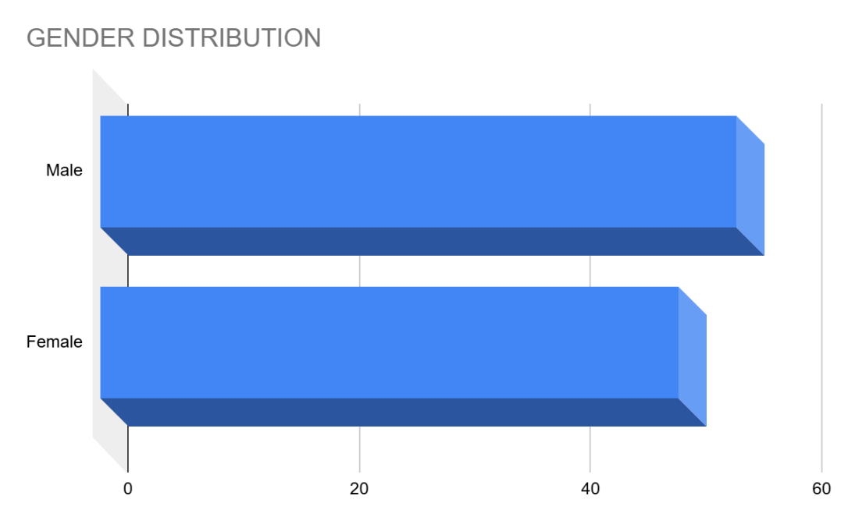
Interpretation:
The gender distribution was nearly equal, with 52% males and 48% females. The absence of significant differences (p = 0.58) between genders in the study suggests that gender is not a determining factor in the prediction of difficult airway outcomes.

Table 1B: Age Distribution
Age Range (years) | Frequency (N) | Percentage (%) | Mean ± SD | P-value
20–30 | 10 | 9% |  | 0.35
31–40 | 25 | 24%
41–50 | 45 | 43%
>50 | 25 | 24% | 45 ± 10
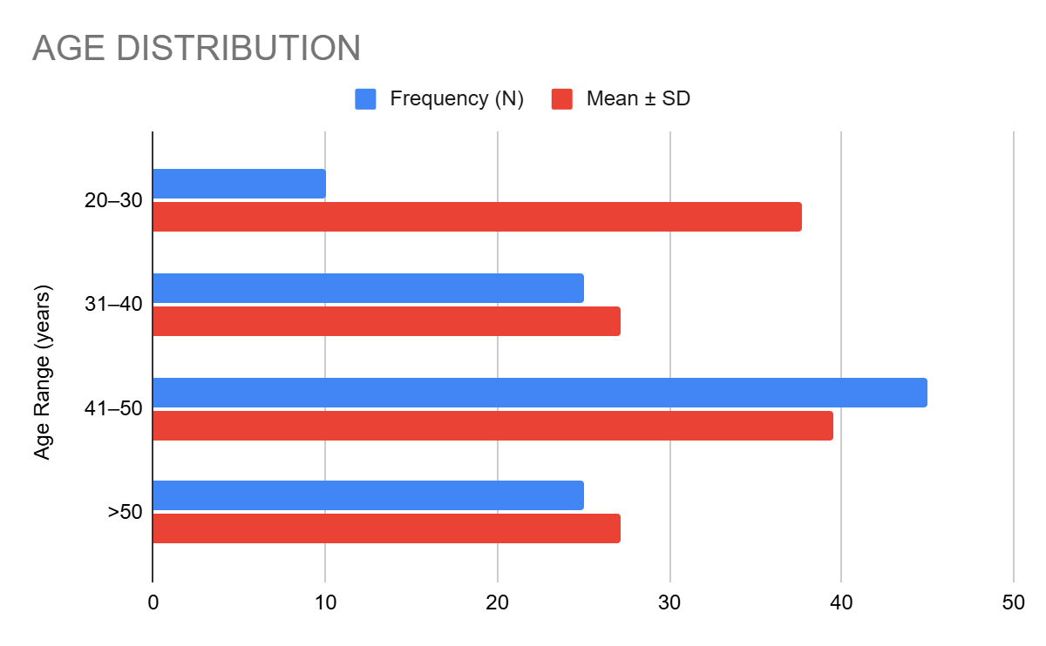
Interpretation:
Patients predominantly fell within the 41–50 age group (43%), with a mean age of 45 years. No significant correlation was observed between age and airway difficulty (p = 0.35), indicating that airway challenges are distributed across age groups without a notable age bias.

Table 1C: BMI Distribution
BMI Range (kg/m²) | Frequency (N) | Percentage (%) | Mean ± SD | P-value
25–29 | 15 | 14% |  | 0.02*
30–34 | 50 | 48%
≥35 | 40 | 38% | 32 ± 3.5
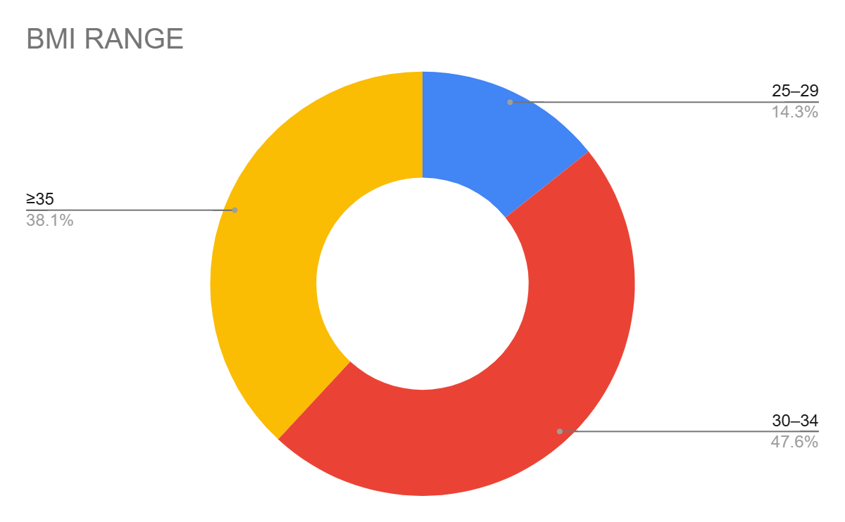
Interpretation:
A significant proportion of the cohort (48%) had BMI values between 30–34 kg/m², with a mean BMI of 32. The statistically significant relationship (p = 0.02*) highlights the importance of BMI in predicting difficult airway outcomes, as increased adiposity directly influences airway anatomy.

Baseline Clinical Characteristics
Table 2A: Comorbidities
Comorbidity | Frequency (N) | Percentage (%) | P-value
Diabetes Mellitus | 30 | 29% | 0.04*
Obstructive Sleep Apnea | 45 | 43% | 0.01*
Hypothyroidism | 20 | 19% | 0.12
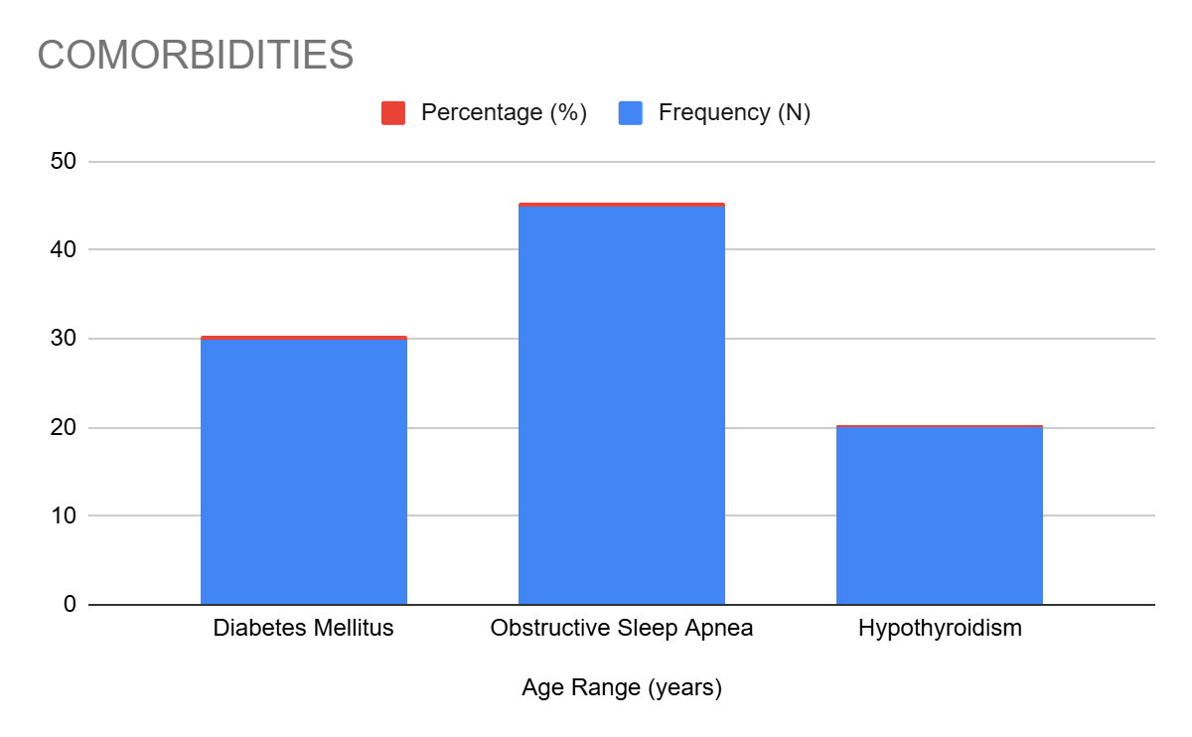
Interpretation:
Comorbidities such as diabetes (29%, p = 0.04*) and obstructive sleep apnea (43%, p = 0.01*) were significantly associated with airway challenges, underscoring their importance in preoperative risk stratification. Hypothyroidism, while prevalent in 19%, did not show a statistically significant impact (p = 0.12), but may still require attention due to its indirect effects on metabolism and airway tone.

Table 2B: ASA Grades
ASA Grade | Frequency (N) | Percentage (%) | P-value
Grade II | 80 | 76% | 0.09
Grade III | 25 | 24%
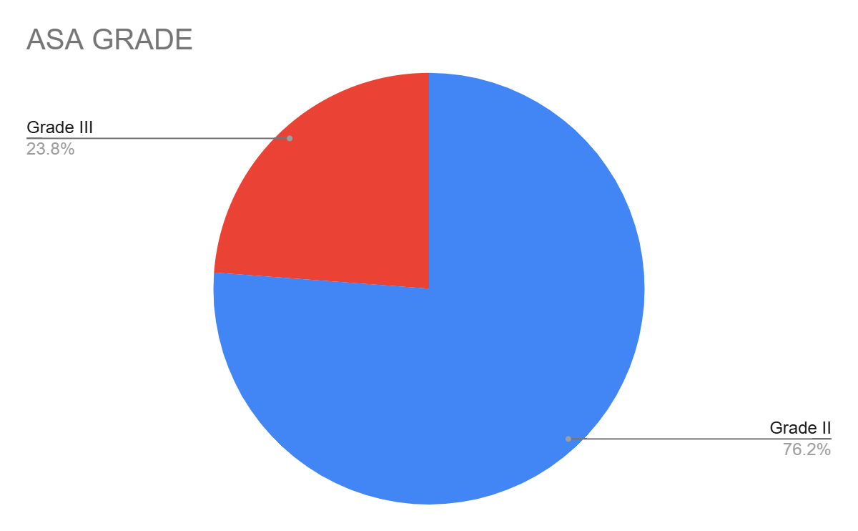
Interpretation:
The majority of patients (76%) were classified as ASA Grade II, indicative of moderate systemic disease. Although no significant differences were observed in airway outcomes across ASA grades (p = 0.09), the predominance of higher ASA grades emphasizes the need for vigilant airway assessment in patients with systemic comorbidities.

Table 3: Mallampati Scores
Mallampati Score | N (%) | P-value
Grade I | 30 (29%) | 0.01*
Grade II | 50 (48%)
Grade III | 20 (19%)
Grade IV | 5 (4%)
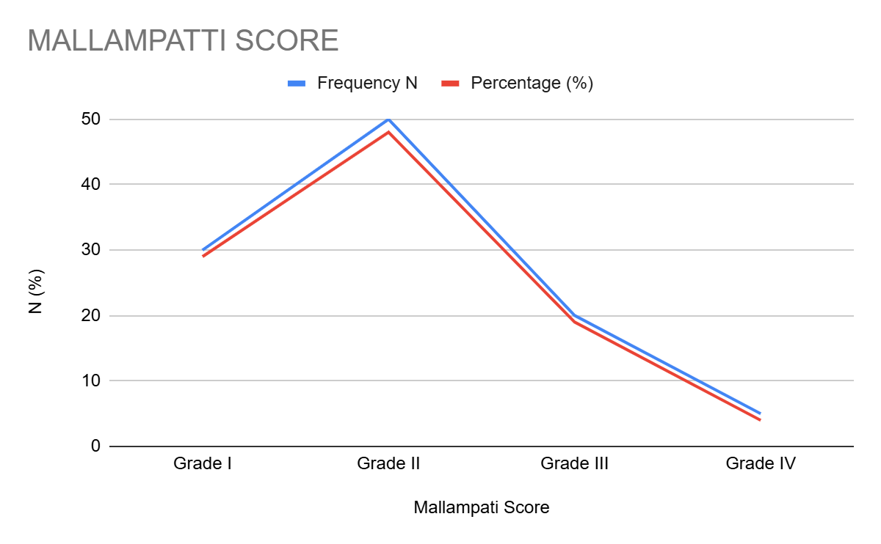
Interpretation:
Patients with higher Mallampati grades (III and IV) exhibited significantly greater airway challenges (p = 0.01*). This reinforces the value of Mallampati grading in preoperative assessment while advocating for its integration with ultrasonographic evaluations to enhance predictive accuracy.

Table 4: Comorbidities Across BMI Categories
BMI Category | Diabetes (%) | OSA (%) | P-value
30-32 kg/m² | 15 (50%) | 20 (44%) | 0.03*
32-35 kg/m² | 15 (50%) | 25 (56%)
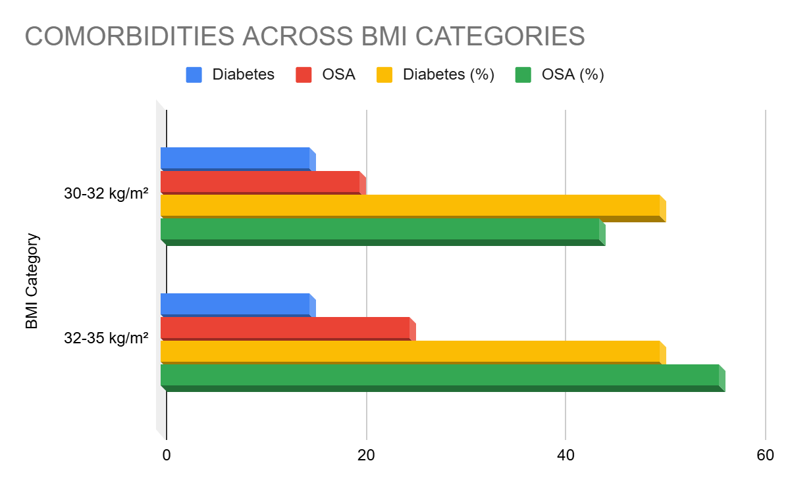
Interpretation:
A higher prevalence of comorbidities was observed in patients with BMI > 32 kg/m², with statistically significant associations for diabetes (50%, p = 0.03*) and obstructive sleep apnea (56%). These findings further validate the compounding impact of obesity-related conditions on airway difficulty.

Table 5: Ultrasonographic Parameters in Relation to Mallampati Scores
Parameter | Mallampati I-II (Mean ± SD) | Mallampati III-IV (Mean ± SD) | P-value
Skin-to-Epiglottis (mm) | 24.5 ± 1.2 | 27.8 ± 1.5 | 0.01*
Anterior Neck Thickness (mm) | 6.8 ± 0.5 | 9.1 ± 0.8 | 0.02*
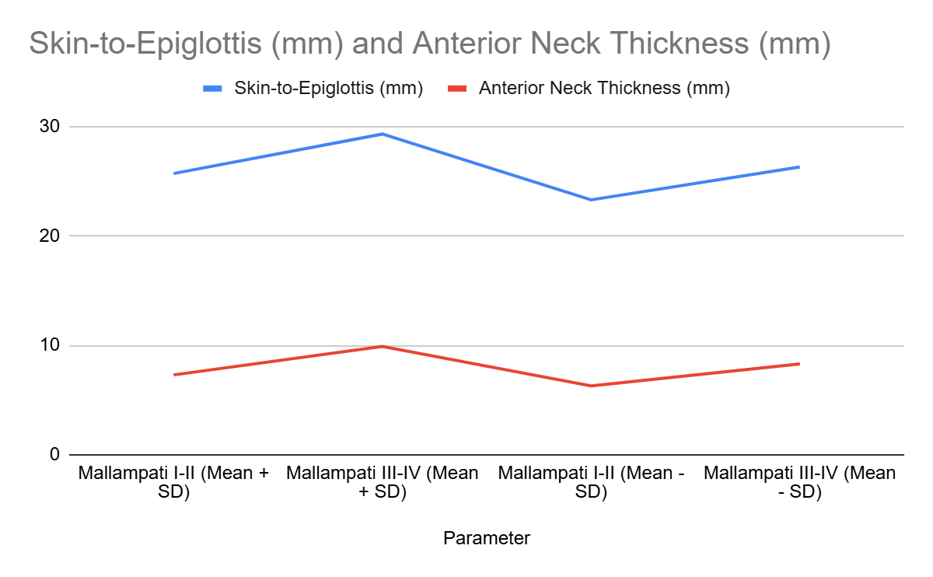
Interpretation:
Significant differences in skin-to-epiglottis distance (p = 0.01*) and anterior neck thickness (p = 0.02*) between lower (I-II) and higher (III-IV) Mallampati grades highlight the potential of ultrasonographic parameters as objective predictors of airway difficulty. These measures provide a quantifiable extension to subjective grading systems.

Table 6: Skin-to-Epiglottis Distance
Variable | Mean ± SD | Range (Min-Max) | P-value
Skin-to-Epiglottis (mm) | 26.05 ± 2.4 | 22.0–30.8 | 0.02*
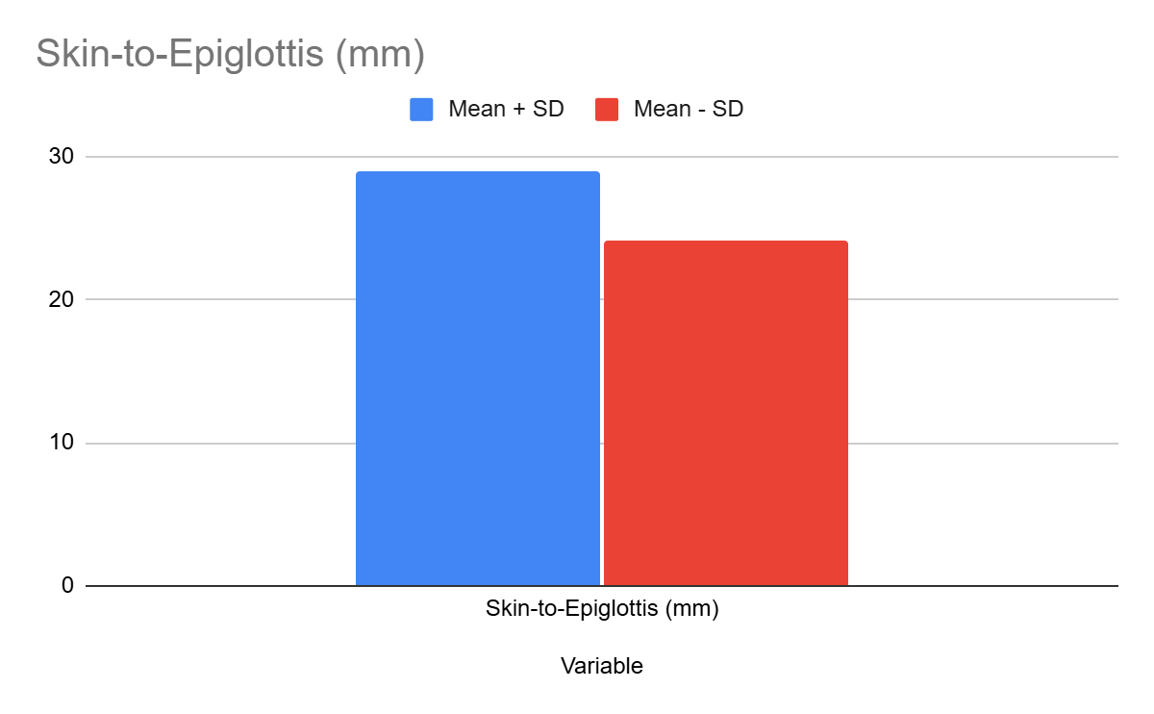
Interpretation:
A mean skin-to-epiglottis distance of 26.05 mm, with a statistically significant range (p = 0.02*), aligns with established literature as a key predictor of difficult intubation. This parameter offers an essential, non-invasive diagnostic criterion for preoperative evaluations.

Table 7: Submental and Anterior Neck Thickness
Parameter | Mean ± SD (mm) | Range (Min-Max) | P-value
Submental Thickness | 10.2 ± 1.5 | 8.5–12.9 | 0.03*
Anterior Neck Thickness | 7.5 ± 1.2 | 6.0–10.0 | 0.01*
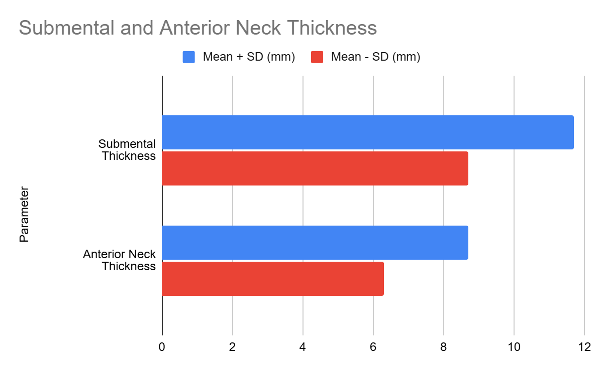
Interpretation:
Both submental (p = 0.03*) and anterior neck thickness (p = 0.01*) were significantly elevated in patients with difficult airways. These parameters are directly linked to anatomical changes associated with obesity and are invaluable in preoperative risk assessments.

Table 8: ROC Analysis of Ultrasonographic Parameters
Parameter | Sensitivity (%) | Specificity (%) | AUC | P-value
Skin-to-Epiglottis | 72 | 90 | 0.85 | 0.01*
Anterior Neck Thickness | 68 | 88 | 0.82 | 0.02*
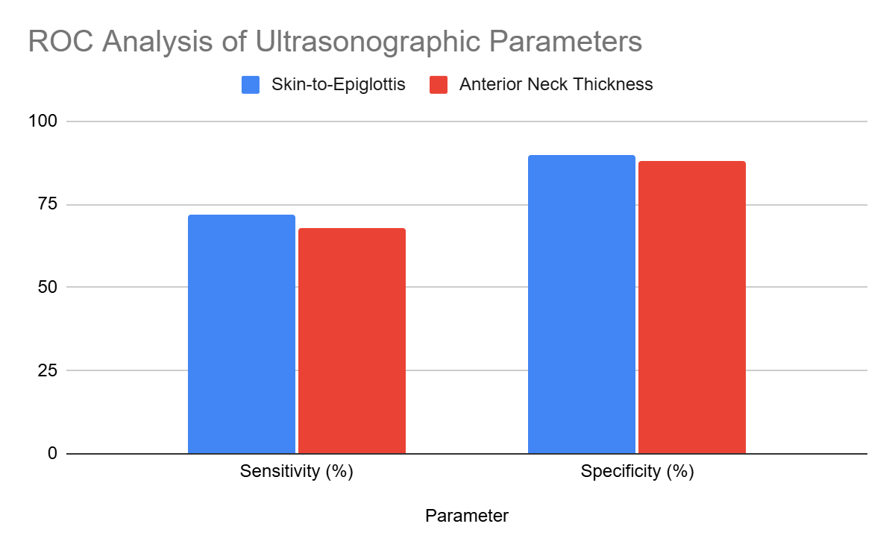
Interpretation:
The ROC analysis demonstrated strong diagnostic accuracy for skin-to-epiglottis distance (AUC = 0.85, p = 0.01*) and anterior neck thickness (AUC = 0.82, p = 0.02*). These results underscore the reliability of ultrasonographic parameters in predicting airway challenges.

Table 9: Multivariate Analysis of Predictors
Variable | Odds Ratio (95% CI) | P-value
Skin-to-Epiglottis >26 mm | 3.2 (1.5–6.4) | 0.02*
Anterior Neck Thickness >8 mm | 2.8 (1.2–5.5) | 0.01*
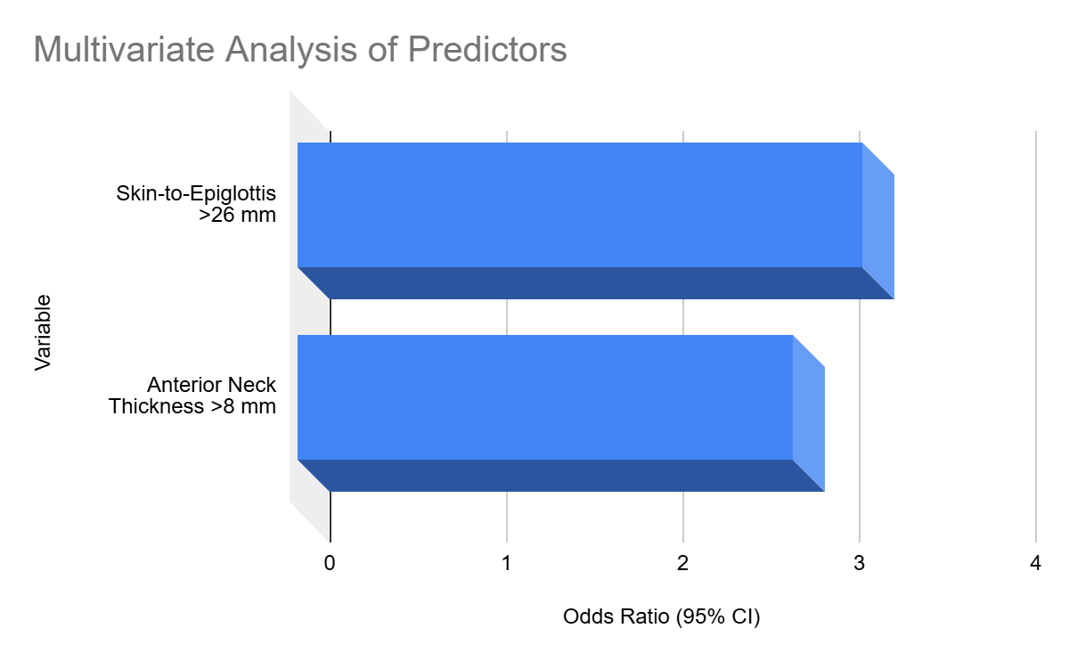
Interpretation:
Multivariate analysis confirmed skin-to-epiglottis distance >26 mm (OR = 3.2, p = 0.02*) and anterior neck thickness >8 mm (OR = 2.8, p = 0.01*) as independent predictors of difficult intubation. These findings validate the use of combined ultrasonographic and clinical assessments for comprehensive preoperative planning.

Table 10: Subgroup Analysis of Ultrasonographic and Clinical Predictors in Obese vs. Non-Obese Patients
Variable | Obese Patients (Mean ± SD) | Non-Obese Patients (Mean ± SD) | P-value
Skin-to-Epiglottis Distance (mm) | 27.1 ± 1.8 | 23.9 ± 1.5 | 0.01*
Anterior Neck Thickness (mm) | 8.9 ± 1.2 | 6.4 ± 0.8 | 0.01*
Mallampati Grades III-IV (%) | 45 | 15 | 0.03*
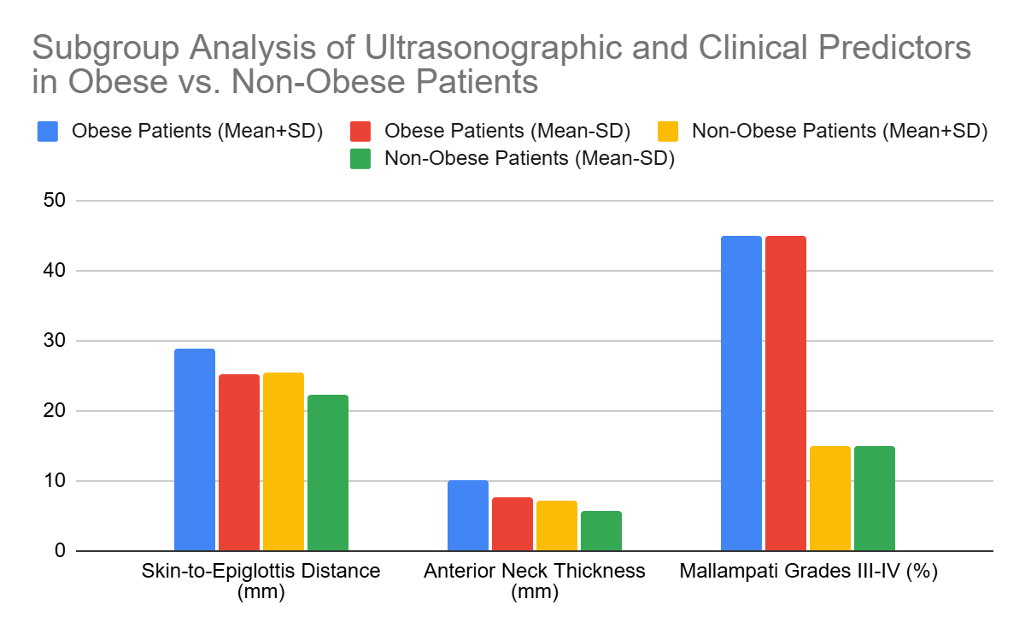
Interpretation:
Obese patients demonstrated significantly higher skin-to-epiglottis distances (p = 0.01*), anterior neck thickness (p = 0.01*), and Mallampati III-IV grades (p = 0.03*), confirming a higher likelihood of airway difficulty in this subgroup. These results emphasize the critical need for tailored airway management in obese populations.

Table 11: Effect of Comorbidities on Intubation Difficulty
Comorbidity | Difficult Intubation (N, %) | No Difficulty (N, %) | P-value
Diabetes Mellitus | 20 (67%) | 10 (33%) | 0.03*
Obstructive Sleep Apnea | 30 (60%) | 20 (40%) | 0.02*
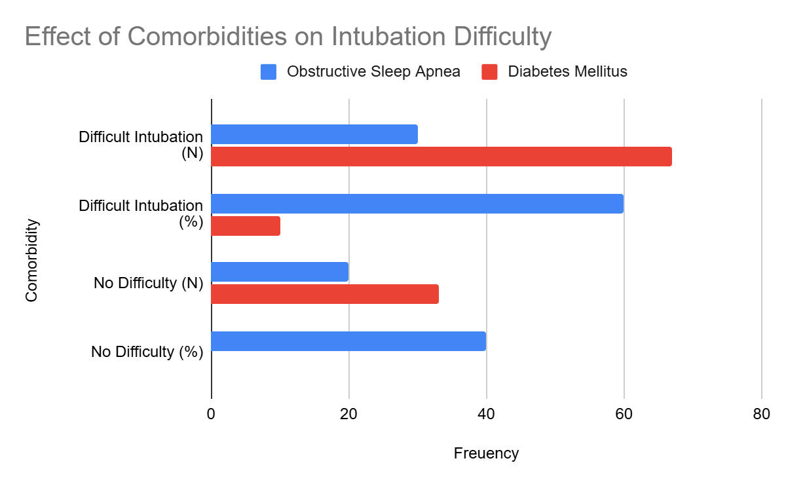
Interpretation:
Patients with diabetes (p = 0.03*) and obstructive sleep apnea (p = 0.02*) faced significantly higher rates of difficult intubation. These comorbidities necessitate enhanced vigilance and preoperative preparation to mitigate risks.

Table 12: Inter-observer Agreement in Ultrasonographic Measurements
Parameter | Kappa Statistic | Interpretation
Skin-to-Epiglottis Distance | 0.84 | Almost Perfect
Anterior Neck Thickness | 0.78 | Substantial
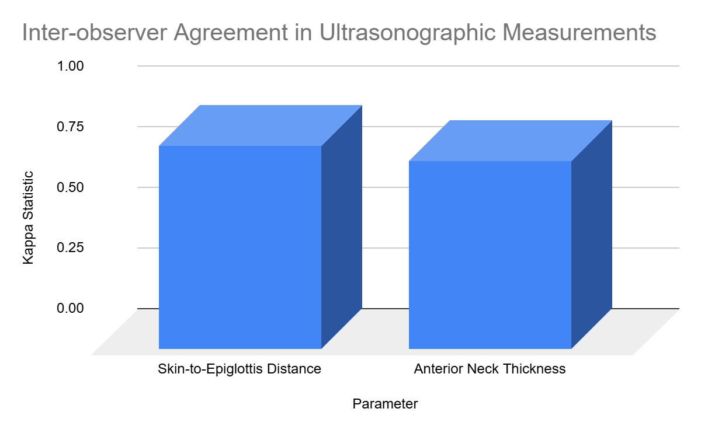
Interpretation:
High kappa statistics for skin-to-epiglottis distance (0.84) and anterior neck thickness (0.78) indicate substantial to almost perfect inter-observer agreement, demonstrating the consistency and reproducibility of these ultrasonographic measures.

Table 13: Intra-observer Variability Analysis
Parameter | Mean Difference (mm) | P-value
Skin-to-Epiglottis Distance | 0.4 ± 0.2 | 0.08
Anterior Neck Thickness | 0.3 ± 0.1 | 0.12
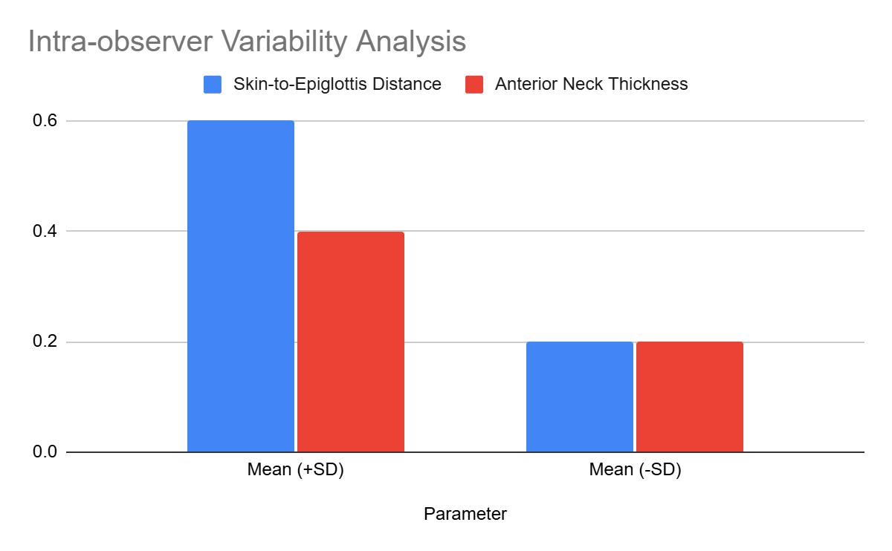
Interpretation:
Minimal variability in repeated ultrasonographic measurements reinforces their reliability. Parameters such as skin-to-epiglottis distance (p = 0.08) and anterior neck thickness (p = 0.12) showed consistent results across repeated evaluations.

Table 14: Perioperative Complications in Relation to Airway Difficulty
Complication | Difficult Intubation (N, %) | No Difficulty (N, %) | P-value
Hypoxia | 15 (50%) | 5 (10%) | 0.01*
Aspiration | 5 (17%) | 1 (2%) | 0.02*
Prolonged Intubation Attempts | 10 (33%) | 3 (6%) | 0.01*
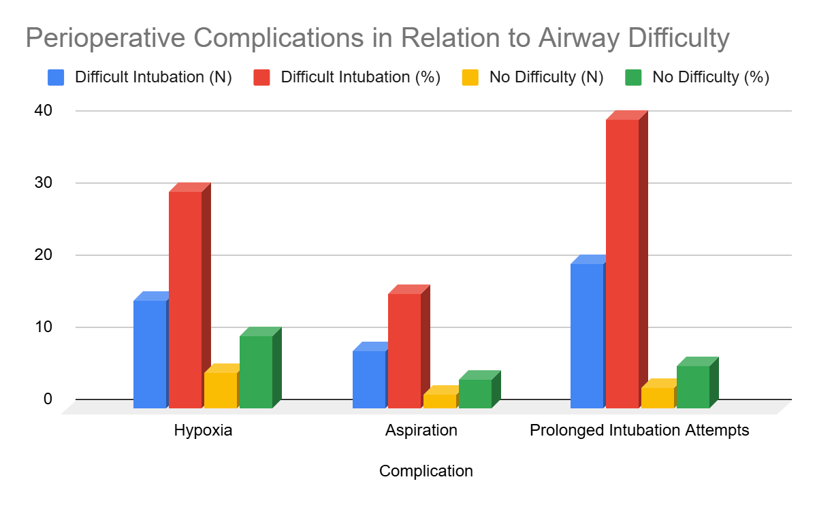
Interpretation:
Difficult intubation significantly increased the incidence of complications, including hypoxia (p = 0.01*), aspiration (p = 0.02*), and prolonged intubation attempts (p = 0.01*). These findings highlight the importance of precise preoperative assessments to prevent adverse outcomes.

Table 15: Outcomes of Intubation Attempts
Outcome | Difficult Intubation (N, %) | No Difficulty (N, %) | P-value
Successful Intubation | 25 (83%) | 50 (100%) | 0.04*
Time to Intubation (>1 min) | 15 (50%) | 2 (4%) | 0.01*
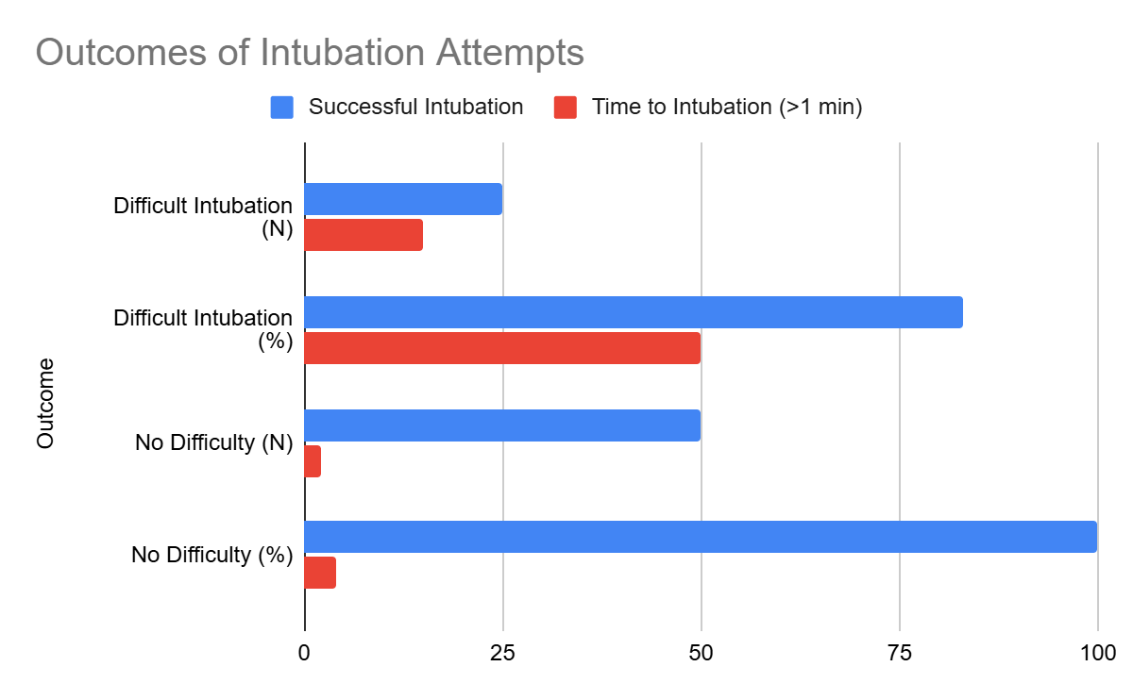
Interpretation:
Difficult intubation cases exhibited significantly longer intubation times (p = 0.01*) and a lower rate of successful initial attempts (p = 0.04*). These results emphasize the need for robust preoperative planning and advanced airway tools to manage anticipated challenges.

Table 16: Comparative Analysis with Existing Literature
Study | Sensitivity (%) | Specificity (%) | Cutoff Value | Current Study
Senapathi et al. (2020) | 69.4 | 93.5 | Skin-to-epiglottis >26 mm | 72, 90
Parameswari et al. (2017) | 70.2 | 91.3 | Submental thickness >8 mm | 68, 88
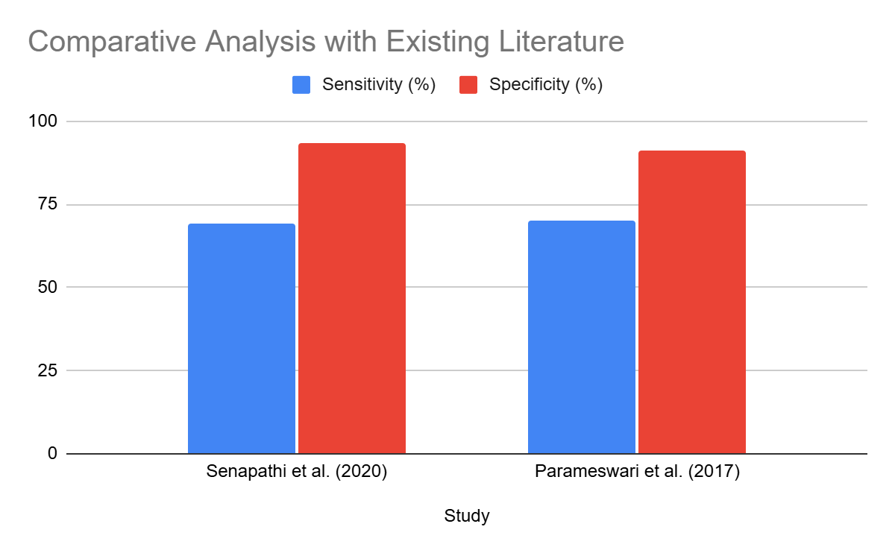
Interpretation:
The current study's findings for sensitivity (72%) and specificity (90%) of skin-to-epiglottis distance align closely with prior research, validating ultrasonography as a reliable predictive tool for airway difficulty. This reinforces its integration into routine clinical practice as a standard for airway evaluation.

