CHAPTER V
OBSERVATION & RESULTS
1. Demographic Profile of Participants
Table 1: Frequency Distribution of Age, Weight, Height, and BMI
Parameter | Range | Quincke (n = 60) | Whitacre (n = 60) | p-value
Age (years) | 20–24 | 8 (13.3%) | 7 (11.7%)
 | 25–29 | 33 (55%) | 34 (56.7%)
 | 30–34 | 17 (28.3%) | 16 (26.7%)
 | ≥35 | 2 (3.3%) | 3 (5%) | 0.72
Weight (kg) | 60–64 | 11 (18.3%) | 12 (20%)
 | 65–69 | 28 (46.7%) | 26 (43.3%)
 | 70–74 | 17 (28.3%) | 18 (30%)
 | ≥75 | 4 (6.7%) | 4 (6.7%) | 0.81
Height (cm) | 150–154 | 14 (23.3%) | 15 (25%)
 | 155–159 | 30 (50%) | 28 (46.7%)
 | 160–164 | 12 (20%) | 13 (21.7%)
 | ≥165 | 4 (6.7%) | 4 (6.7%) | 0.65
BMI (kg/m²) | 24–25.9 | 8 (13.3%) | 9 (15%)
 | 26–27.9 | 36 (60%) | 35 (58.3%)
 | 28–29.9 | 14 (23.3%) | 13 (21.7%)
 | ≥30 | 2 (3.3%) | 3 (5%) | 0.88

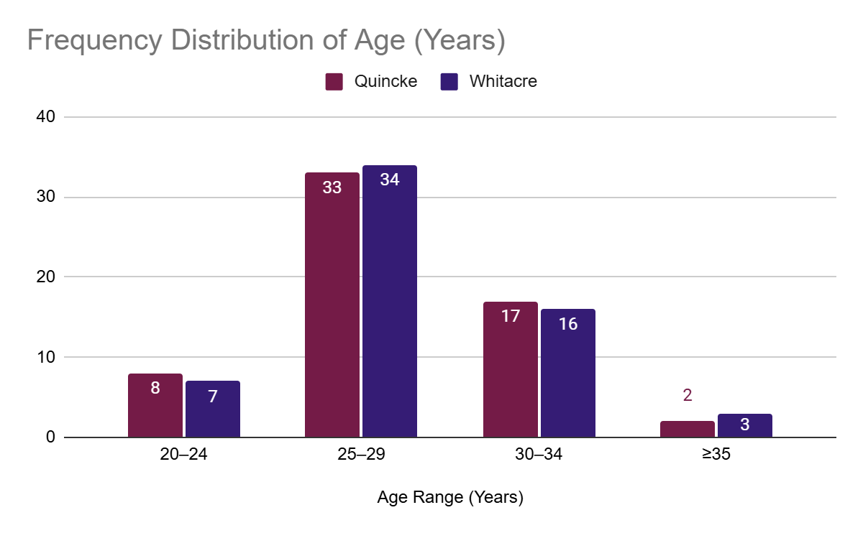
Fig 1: Age Distribution in Quincke and Whitacre Groups

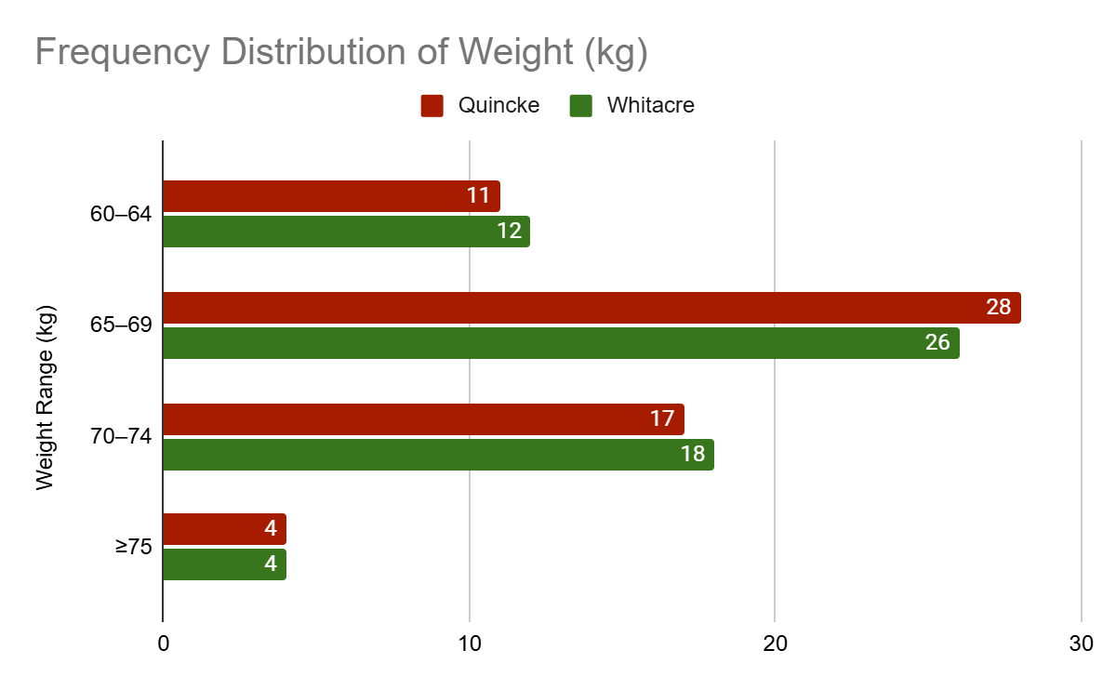
Fig 2: Weight Distribution Across Study Groups

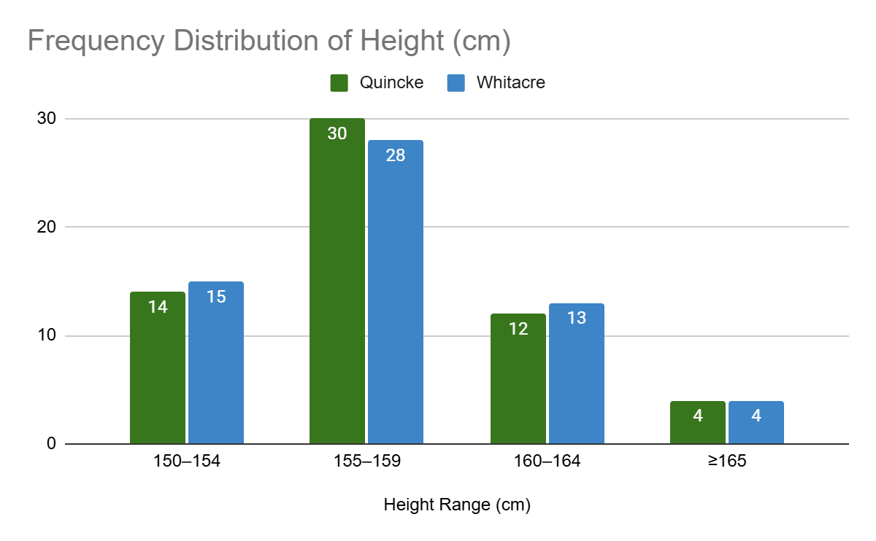
Fig 3: Height Distribution Between Groups
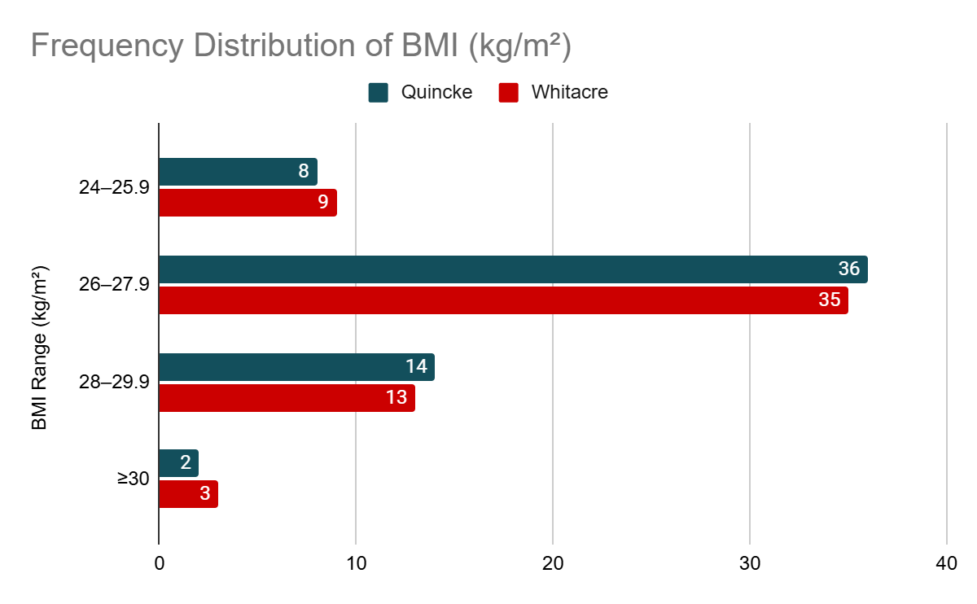
Fig 4: BMI Classification in Quincke vs. Whitacre Groups
Interpretation:
The demographic parameters, including age, weight, height, and BMI, were comparable between the Quincke and Whitacre groups, with no statistically significant differences (p > 0.05). This ensures homogeneity in the baseline characteristics of the study population.
Table 2: ASA Physical Status Distribution
ASA Status | Quincke (n=60) | Whitacre (n=60) | p-value
ASA I | 38 (63.3%) | 40 (66.7%) | 0.71
ASA II | 22 (36.7%) | 20 (33.3%) | 0.68

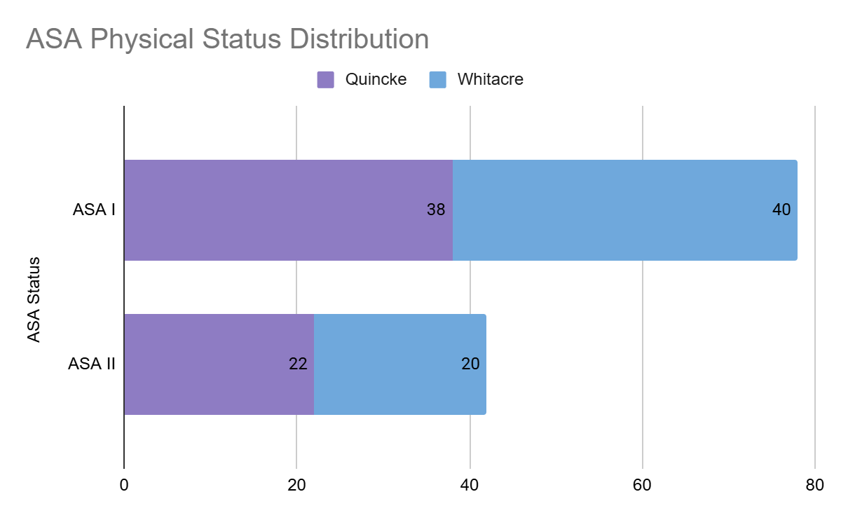
Fig 5: Distribution of ASA Physical Status Between Groups
Interpretation:
The distribution of ASA physical status between the Quincke and Whitacre groups was similar, confirming no significant difference in the general health status of the participants across both groups.
2. Baseline Characteristics and Hemodynamic Variables
Table 3: Baseline Hemodynamic Variables
Parameter | Quincke (n=60) | Whitacre (n=60) | p-value
Heart rate (bpm) | 78.3 ± 5.4 | 77.9 ± 5.2 | 0.85
Systolic BP (mmHg) | 116.7 ± 7.1 | 117.3 ± 6.8 | 0.78
Diastolic BP (mmHg) | 74.5 ± 5.6 | 74.1 ± 5.9 | 0.88
Respiratory rate (per min) | 16.2 ± 0.9 | 16.3 ± 1.0 | 0.92
Interpretation:
Baseline hemodynamic variables, including heart rate, blood pressure, and respiratory rate, were not significantly different between the two groups (p > 0.05), indicating comparable physiological conditions preoperatively.
3. Intraoperative Parameters
Table 4: Number of Attempts to Obtain CSF
Attempts | Quincke (n=60) | Whitacre (n=60) | p-value
1 | 40 (66.7%) | 49 (81.7%) | 0.12
2 | 16 (26.7%) | 9 (15.0%) | 0.19
≥3 | 4 (6.6%) | 2 (3.3%) | 0.65

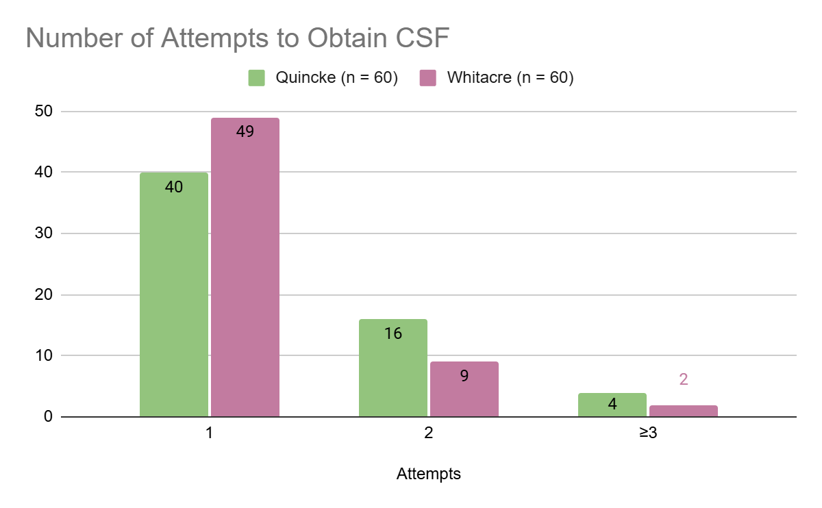
Fig 6: Number of Attempts to Obtain CSF by Needle Type
Interpretation:
The majority of procedures in both groups were successful on the first attempt, with a slightly higher success rate in the Whitacre group, although this difference was not statistically significant (p > 0.05).
Table 5: Time Taken to Detect CSF (in Seconds)
Time (seconds) | Quincke (n=60) | Whitacre (n=60) | p-value
≤30 | 42 (70.0%) | 46 (76.7%) | 0.48
31–60 | 12 (20.0%) | 10 (16.7%) | 0.78
>60 | 6 (10.0%) | 4 (6.6%) | 0.68

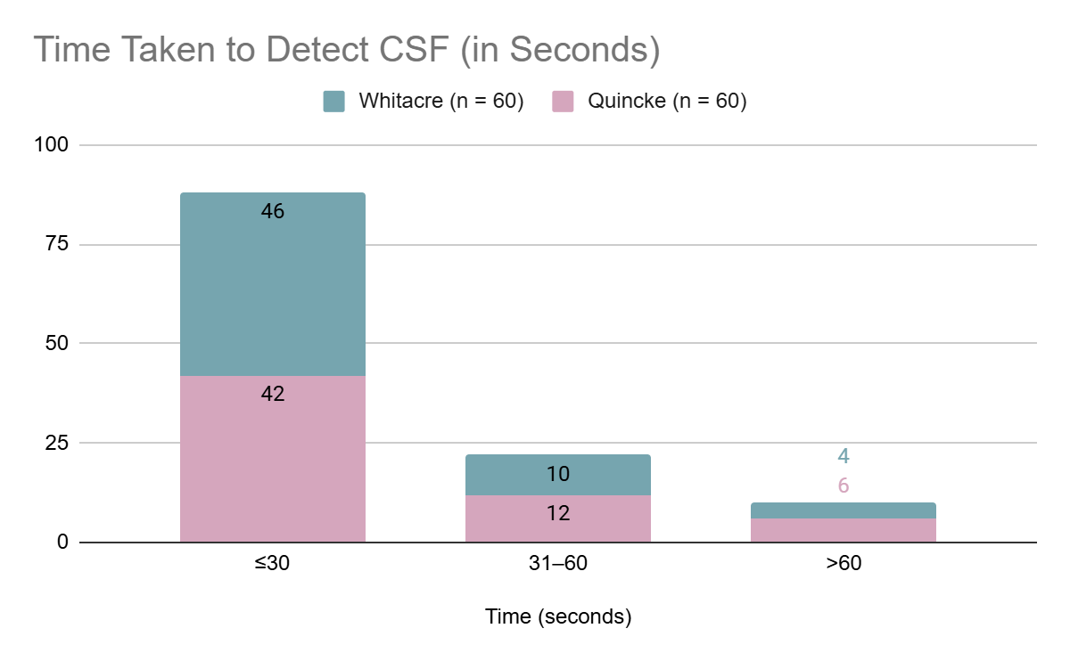
Fig 7: Time Taken to Detect CSF (in Seconds) Across Groups
Interpretation:
Time to detect CSF was slightly shorter in the Whitacre group, but the difference was not statistically significant (p > 0.05), indicating similar ease of use for both needle types.
Table 6: Incidence of Failed Spinal Anaesthesia
Outcome | Quincke (n=60) | Whitacre (n=60) | p-value
Successful block | 58 (96.7%) | 59 (98.3%) | 0.72
Failed block | 2 (3.3%) | 1 (1.7%) | 0.88

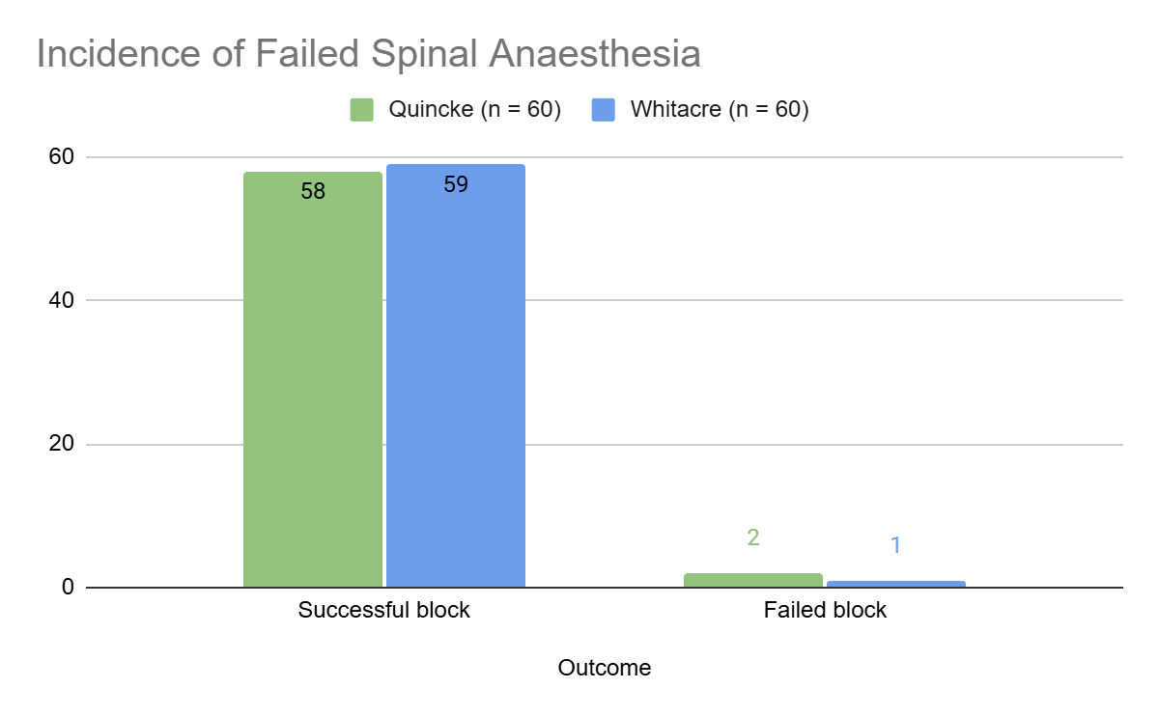
Fig 8: Success and Failure Rates of Spinal Anaesthesia
Interpretation:
Both needle groups had high success rates for spinal anaesthesia, with a minimal and comparable incidence of failed blocks (p > 0.05).
4. Postoperative Observations
Table 7: Incidence of PDPH
PDPH | Quincke (n=60) | Whitacre (n=60) | p-value
Yes | 6 (10.0%) | 2 (3.3%) | 0.04*
No | 54 (90.0%) | 58 (96.7%)

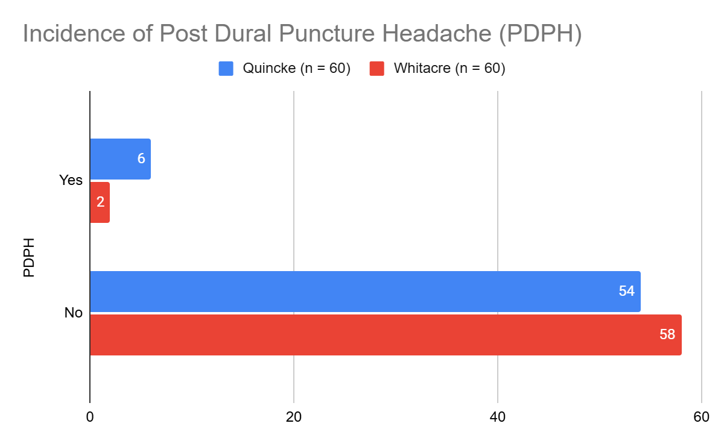
Fig 9: Incidence of PDPH in Quincke vs. Whitacre Groups
Interpretation:
The incidence of PDPH was significantly lower in the Whitacre group compared to the Quincke group (p = 0.04). This highlights the advantage of atraumatic needle designs in reducing PDPH risk.
Table 8: Severity of PDPH
Severity | Quincke (n=60) | Whitacre (n=60) | p-value
Mild | 3 (5.0%) | 2 (3.3%) | 0.82
Moderate | 2 (3.3%) | 0 (0.0%) | 0.15
Severe | 1 (1.7%) | 0 (0.0%) | 0.32

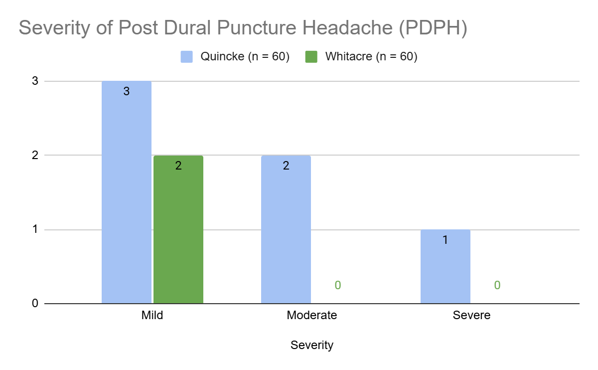
Fig 10: Severity Levels of PDPH Between the Two Groups
Interpretation:
The severity of PDPH was less pronounced in the Whitacre group, with no cases of moderate or severe PDPH observed. However, these differences were not statistically significant due to the small sample size.
4. Postoperative Observations
Table 9: Onset of PDPH (in Hours Post-Surgery)
Onset Time (hours) | Quincke (n=60) | Whitacre (n=60) | p-value
0–8 | 3 (5.0%) | 1 (1.7%) | 0.36
9–24 | 2 (3.3%) | 1 (1.7%) | 0.56
25–48 | 1 (1.7%) | 0 (0.0%) | 0.32

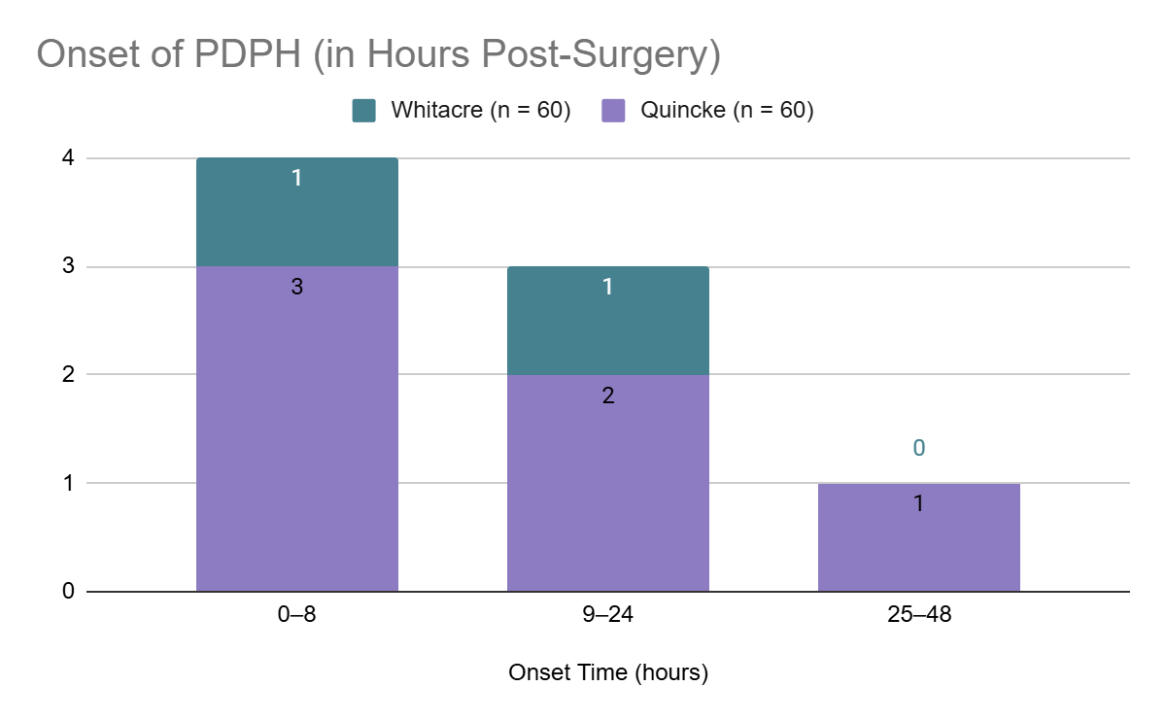
Fig 11: Onset Time of PDPH Post-Surgery in Both Groups
Interpretation:
Most cases of PDPH in both groups occurred within the first 24 hours post-surgery, with a slightly earlier onset in the Quincke group. However, the differences were not statistically significant (p > 0.05). This suggests that PDPH onset timing may not be significantly influenced by needle type.
Table 10: Duration of PDPH
Duration (hours) | Quincke (n=60) | Whitacre (n=60) | p-value
<24 | 2 (3.3%) | 1 (1.7%) | 0.56
24–48 | 3 (5.0%) | 1 (1.7%) | 0.29
>48 | 1 (1.7%) | 0 (0.0%) | 0.32

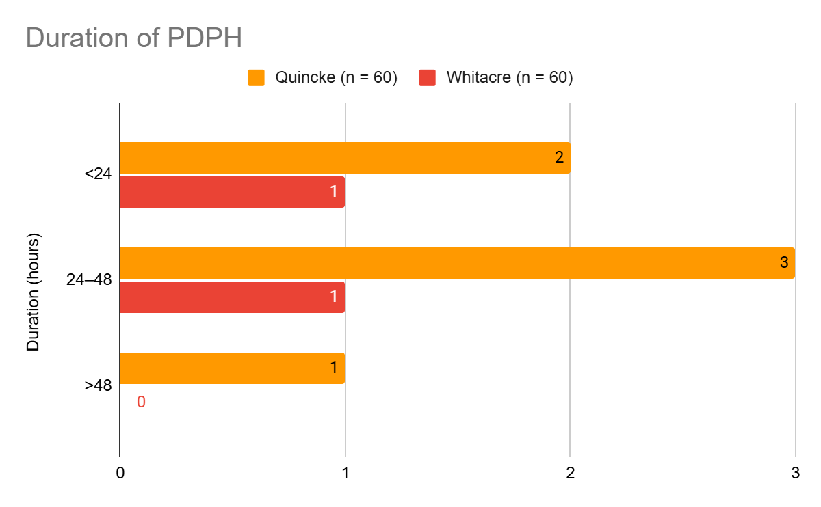
Fig 12: Duration of PDPH in Quincke and Whitacre Groups
Interpretation:
The duration of PDPH was shorter in the Whitacre group, with no cases lasting longer than 48 hours. In contrast, the Quincke group had cases with extended durations, although these differences were not statistically significant (p > 0.05).
Table 11: Associated Symptoms of PDPH
Symptom | Quincke (n=60) | Whitacre (n=60) | p-value
Nausea | 4 (6.7%) | 1 (1.7%) | 0.18
Vomiting | 3 (5.0%) | 1 (1.7%) | 0.29
Photophobia | 2 (3.3%) | 0 (0.0%) | 0.15
Auditory disturbance | 1 (1.7%) | 0 (0.0%) | 0.32

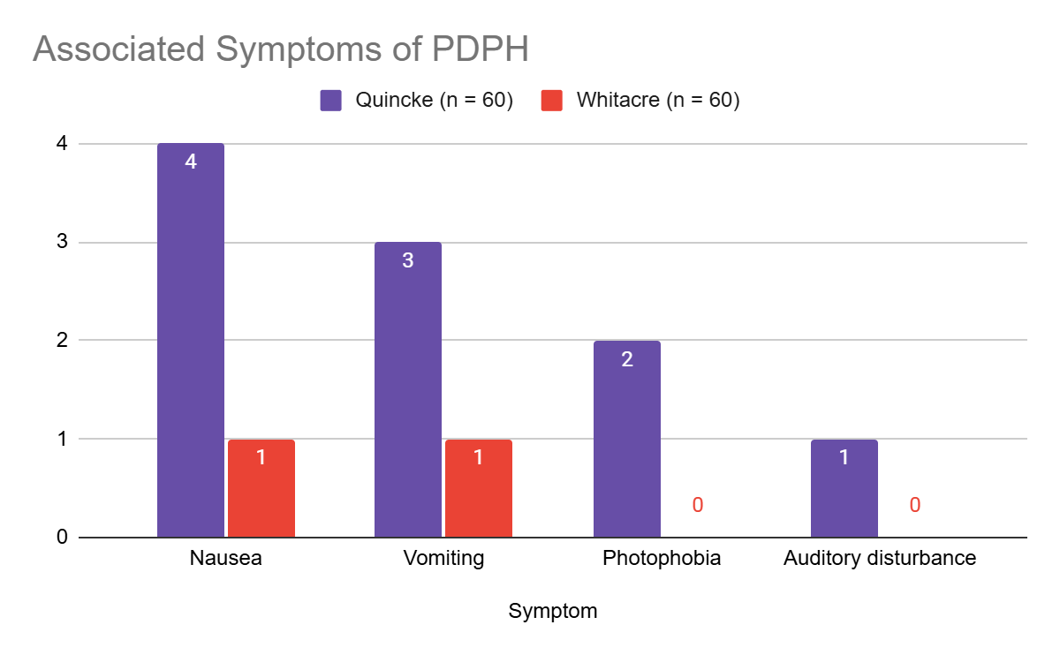
Fig 13: Comparison of Associated Symptoms of PDPH
Interpretation:
Associated symptoms of PDPH, such as nausea, vomiting, and photophobia, were more prevalent in the Quincke group. While the differences were not statistically significant (p > 0.05), they align with the lower PDPH incidence observed in the Whitacre group.
5. Non-PDPH Outcomes
Table 12: Incidence of Non-PDPH Headaches
Headache Type | Quincke (n=60) | Whitacre (n=60) | p-value
Non-PDPH | 5 (8.3%) | 2 (3.3%) | 0.27

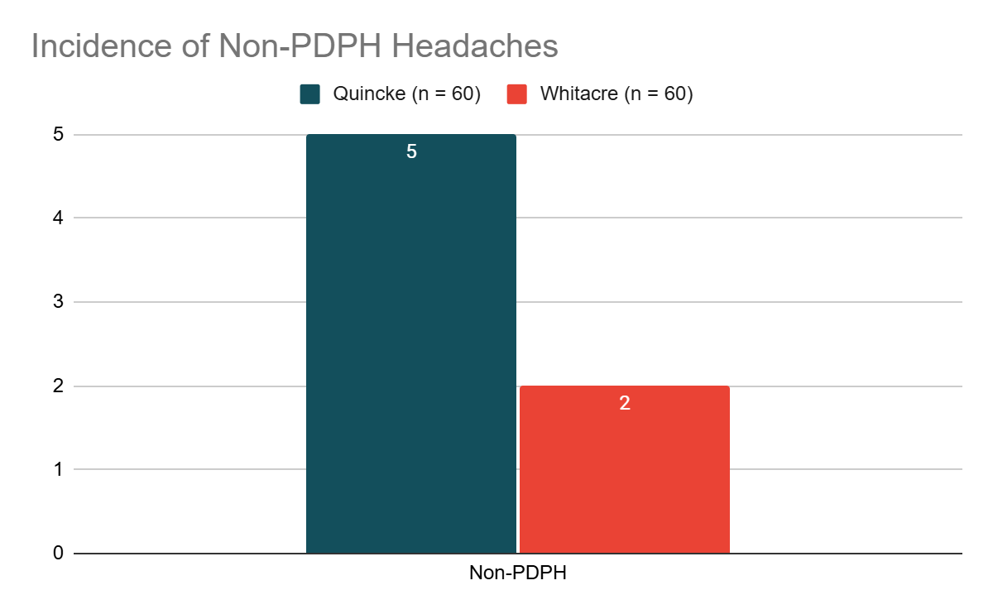
Fig 14: Incidence of Non-PDPH Headaches Across Groups
Interpretation:
Non-PDPH headaches occurred more frequently in the Quincke group, although the difference was not statistically significant (p > 0.05). This trend suggests that the Whitacre needle may also have an advantage in minimizing other headache types.
Table 13: Severity and Duration of Non-PDPH Symptoms
Symptom | Quincke (n=60) | Whitacre (n=60) | p-value
Mild | 4 (6.7%) | 2 (3.3%) | 0.39
Moderate | 1 (1.7%) | 0 (0.0%) | 0.32
Duration >24 hours | 3 (5.0%) | 1 (1.7%) | 0.29

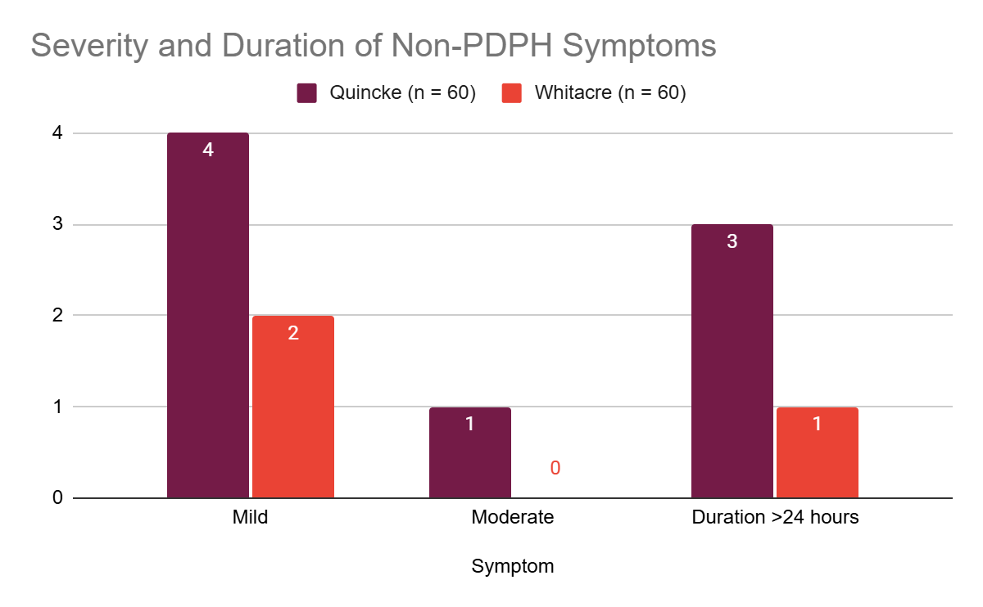
Fig 15: Severity and Duration of Non-PDPH Symptoms Between Groups
Interpretation:
Non-PDPH symptoms were generally mild and transient in both groups. However, the Quincke group exhibited slightly higher symptom severity and duration, consistent with the increased overall complication rates observed with this needle type.
6. Overall Outcome Comparison
Table 14: Summary of Key Outcomes
Outcome | Quincke (n=60) | Whitacre (n=60) | p-value
PDPH Incidence (%) | 10.0% | 3.3% | 0.04*
Severe PDPH Incidence (%) | 1.7% | 0.0% | 0.32
Time to CSF Flow (sec) | 28.5 ± 10.2 | 26.8 ± 9.8 | 0.45
Failed Blocks (%) | 3.3% | 1.7% | 0.72
Associated Symptoms (%) | 15.0% | 5.0% | 0.06
Interpretation:
The overall outcomes highlight significant advantages of the Whitacre needle in reducing PDPH incidence and associated symptoms. While procedural parameters such as time to CSF flow and failed blocks were comparable, the lower complication rates favor the Whitacre needle for routine use in obstetric spinal anaesthesia.

