MSc Data Science Project
7PAM2002
Department of Physics, Astronomy and Mathematics
Data Science
FINAL PROJECT REPORT
Project Title: Predicting Strong-Growth UK Car Manufacturers Using Random Forest and XGBoost
Student Name and SRN: Anandasai Sunke, 24057259
Supervisor: Vid Irsic
Date Submitted: 22 June 2026
Word Count: 3,300 (excluding references and appendices)
GitHub: https://github.com/SunkeAnandasai3784/SMMT-2025-UK-Car-Sales-Analysis

Declaration Statement
This report is submitted in partial fulfilment of the requirement for the degree of Master of Science in Data Science at the University of Hertfordshire.
I have read the detailed guidance to students on academic integrity, misconduct and plagiarism information at Assessment Offences and Academic Misconduct and understand the University process of dealing with suspected cases of academic misconduct and the possible penalties, which could include failing the project or course.
I certify that the work submitted is my own and that any material derived or quoted from published or unpublished work of other persons has been duly acknowledged (Ref. UPR AS/C/6.1, section 7 and UPR AS/C/5, section 3.6). I did not use human participants in my MSc Project. I hereby give permission for the report to be made available on module websites provided the source is acknowledged.
Student Name printed: Anandasai Sunke
Student Name signature: Anandasai Sunke
Student SRN number: 24025759
University of Hertfordshire, School of Physics, Engineering and Computer Science.

Abstract
The aim of this project is to explore if machine-learning classifiers can be used to predict UK car manufacturers that are approaching a strong growth period (defined as >10% growth in first registered cars for quarter on quarter). The raw wide table of 61,226 observations, provided by the official Department for Transport data (VEH0160), was filtered to Cars, and reshaped to a 13,756 manufacturer-by-quarter panel from 2014 Q1 to 2025 Q3. Three non-collinear features were engineered (quarter-on-quarter growth rate, four-quarter volatility, and market share), and a binary strong-growth target was constructed, in which only about 15% of the observations are positive, resulting in an imbalance ratio of ~5.8:1. Two tree-based models, a Random Forest and an XGBoost classifier were trained on a stratified train, validation and test split, and evaluated using ROC-AUC, precision, recall, F1 score and log loss. For each of the models the training process was explored using log-loss learning curves, hyperparameters were tuned by varying the learning rate and regularisation, and class imbalance was handled using scale_pos_weight and class weights. The test ROC-AUC and accuracy was around 0.95, and test log loss was reduced by about a factor of two, for both tuned models. Explicit precision-recall trade-off was observed: Class weighting has significantly boosted recall, while sacrificing precision. The models are a valuable forward-looking screening tool, but note that the features are also contemporaneous, which is also addressed in the report.

Table of Contents
Declaration Statement 2
Abstract 3
Table of Contents 4
1. Introduction 5
1.1 Research Question, Aims and Objectives 5
2. Background and Literature Review 5
3. Dataset 6
3.1 Exploratory Data Analysis 7
3.2 Data Pre-processing and Feature Engineering 7
4. Ethical Issues 8
5. Methodology 8
5.1 Models and Justification 8
5.2 Evaluation Metrics and Justification 8
5.3 Training, Overfitting and Optimisation 8
6. Results 9
6.1 Overfitting and Learning Curves 9
6.2 Performance Before and After Tuning 10
6.3 Class-Imbalance Handling 11
6.4 Model Comparison 12
7. Analysis and Discussion 12
8. Conclusion 13
References 14
Appendix A: Additional Figures 15
Appendix B: Project Code 17

1. Introduction
The UK has undergone a revolution in the automotive industry. New cars were registered in 2024, which was 11.1% lower than in 2023 (SMMT, 2023), with a shift in preferences towards electric vehicles (IEA, 2023). This decline was not uniform, however, as some manufacturers saw substantial growth and others saw substantial declines. This gap is important to a number of groups. Investors need to know what companies are likely to have growth potential to invest their money, manufacturers need to know what is the market situation they are in to plan production and marketing and the government needs to have evidence to guide the development of support policies for the EV transition. These decisions are made by guesswork, since there are no reliable predictions.
The Society of Motor Manufacturers and Traders (SMMT) and the Department for Transport (DfT) both report on car registration data on a quarterly basis in the UK. They tell you what has already occurred and are descriptive and rich. With this in mind, my project aims to plug this gap into a machine learning system that will recognize which manufacturers are in a good growth phase.

1.1 Research Question, Aims and Objectives
- My main research question is: Can machine-learning models predict and answer whether there will be a quarterly growth of > 10% YoY for a car manufacturer?
- The 10% mark is where you will notice a significant boost in your business and not just a minor change. I was looking for 90% accuracy or higher so it would be ready for actual business decisions. The project's 5 objectives were:
- Create complete data pipeline to clean, structure and model the raw DfT data.
- 2. Engineer informative input features that are not highly correlated with each other (an earlier attempt used lag features that were highly correlated > 0.94).
- 3. Explore creating two machine learning models (Random Forest & XGBoost) to work with tabular and imbalanced data sets.
- Critically discuss aspects of model training: overfitting, hyper parameter optimisation, class-imbalance and explain the prediction aspects.
- To share all code and development history on GitHub so that it can be reproduced.

2. Background and Literature Review
Trend forecasting for vehicle-registration is beneficial for production, stock management and investments planning. The traditional methods using moving averages or linear regression work well when the patterns are regular and linear, but fall short when the patterns are non-linear, when there are structural breaks in the data, and when there are interactions between the factors. Machine-learning models are good for this, as they can identify intricate relationships between the data, without the analyst having to pre-specified each one. So I chose the following papers: they are the two models I use and one of them is based on a boosting framework, while the other is a leading sequence model that I considered but rejected, so they justify my methodological choices.
Random Forest (RF) is an ensemble of decision trees that are trained on bootstrap samples of the data and use a random subset of features when a node is split (Breiman, 2001). The paper presented that averaging of many de-correlated trees is useful to reduce variance and mitigate overfitting and also presented permutation based feature importance. It is good in that it needs few tuning parameters when used for tabular data, is strong and very easy to interpret, but it is bad in that it doesn't correct the errors of previous trees; on structured data, boosting can outperform it. Random Forest is my baseline which is robust and has low variance and feature-importance measure helps in explaining the prediction to non-technical stakeholders.
Friedman (2001) gave a formalization of gradient boosting, which is to fit an additive sequence of trees, where the next tree is fit on the gradient of the loss of the current ensemble. The contribution is a general framework that directly helps to reduce a selected loss and usually yields a lower bias than does bagging. The problem is that it is dependent on the learning rate and, if regularisation and early stopping are not used, it can over fit quite easily. This paper is the foundation of my second model and serves as the motivation for the learning-rate/regularisation experiments that I report.
Chen and Guestrin (2016) introduced XGBoost, which is a scalable, regularised implementation of gradient boosting with L1/L2 penalties, column subsampling and efficient sparsity handling. They demonstrated state-of-the-art results on many tabular benchmarks. It is highly predictive with the advantage of explicit regularisation, but has the disadvantage of having more hyper-parameters to tune. I take XGBoost as my high-performance model, and generate log-loss learning curves with respect to boosting rounds using the per-round evaluation.
To remedy the vanishing-gradient issue in recurrent networks and to learn long-range temporal dependencies, Hochreiter and Schmidhuber (1997) proposed LSTM network. LSTMs are more powerful than tree ensembles with sequential data, but require lots of data and tuning. If the size of the panel to me is too small, and the need is for interpretable and justifiable prediction, I wouldn't have picked LSTM and this comparison seems to confirm that and to give more justification for using the tree-based models for tabular registration data.
In short, the literature indicates that tree-based ensembles, e.g., Random Forest and gradient-boosted trees perform well in comparison to classical time-series benchmarks for tabular business data involving non-linearity and interactions, and that imbalanced outcomes require stratified splits and class weighting. The current project is focused on that gap of most of the previous works in the literature, which have only considered the aggregate national time series and/or the cross sectional problems, but not strong-growth events of individual manufacturers from a registration panel.

3. Dataset
This was done using the department for transport published official table 'Vehicles registered for the first time' (VEH0160) (DfT, 2023): https://www.gov.uk/government/statistics/vehicle-licensing-statistics-2023. The information is administrative data – when a car is first registered in the United Kingdom each one is recorded on a document by the Driver and Vehicle Licensing Agency and DfT collates and publishes quarterly statistics on body type, manufacturer, model and fuel type. This is therefore data collected by a trusted Government body across the UK and in this extract is current up to 2025 Q3 and from 2014 Q1. I selected this data set because, at national level, it is authoritative, complete and directly quantifies the phenomenon of my research question (number of registrations by manufacturer over time), and is published under an Open Government / Creative Commons licence that allows for the use in research.

3.1 Exploratory Data Analysis
The raw file consists of 61,226 records, and has 5 descriptive columns (body type, make, model family, model, fuel) and 45 quarterly count columns. Since I built the manufacturer-by-quarter panel (Section 3.2) the dataset has 13,756 observations. Only 2,027 observations are positive (14.7%) and there are about 5.8 negatives per positive observation in the binary strong-growth target (Figure 1). This imbalance is the crux of the project in terms of how the metrics are to be calculated and how class imbalance will be dealt with during training.
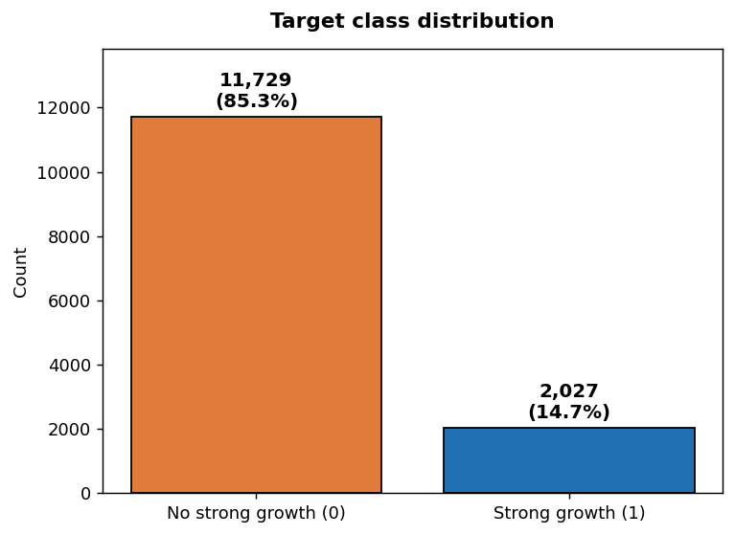
Figure 1. Distribution of the binary strong-growth target across the manufacturer–quarter panel (own work).

3.2 Data Pre-processing and Feature Engineering
First I removed all the rows where the body type was not “Cars” and then transposed the data from wide to long, where each “YYYY Qn” value was split out into a quarter-end date in the new table, and the manufacturer was each row. I grouped by manufacturer-quarter and made a lagged registration at 1 quarter and 4 quarters, as well as a 3 quarter moving average of the registrations; I dropped any row that did not have the proper lags. Of these, I was able to create three model inputs: the quarter-on-quarter growth rate, the four-quarter rolling volatility (standard deviation) and market share (Manufacturer's registrations divided by Total registrations that quarter). These have taken the place of some earlier lag features that were collinear (correlation > 0.94) and would have destabilized the models. The target was set at 1 (growth rate > 10% when compared to the same period in the previous year) and 0 (growth rate ≤ 10% when compared to the same period in the previous year). If there were infinite or missing engineered values, they were set to zero. The year-on-year growth which is used to create the label is purposefully omitted from the inputs to prevent leakage of the label itself.

4. Ethical Issues

I took into account the ethical consideration of the data and project. The DfT VEH0160 dataset provided does not contain any personal data – the dataset consists of the numbers of vehicles registered in each segment only, and as such does not fall under GDPR and no anonymisation was needed. The data are published by a trusted government body (Department for Transport) and are available under an Open Government / Creative Commons licence that states it allows for reuse for research and commercial purposes, so can be assumed to be lawfully and ethically collected. As this project does not involve any human participants, nor conduct any surveys or user trials, it did not need to be approved by the University of Hertfordshire ethics-committee. Lastly, the predictions are designed to inform business planning and investment decisions and not to regulate and/or enforce, therefore minimizing the potential for harm through misclassification.

5. Methodology

This section describes the practical work I carried out. All the pipeline have been implemented in python using pandas for data management, scikit-learn (Pedregosa et al., 2011) for the Random Forest and the splitting routine, grid search and metrics, and the xgboost library for the XGBoost Classifier (Chen and Guestrin, 2016).

5.1 Models and Justification
Created two classifiers. Random Forest (Breiman, 2001): Ensemble of decision trees, grown on bootstrap samples, with a random subset of features at each split; predictions are averaged across the trees. I selected it because of its ability to deal with non-linearities and interactions, and its low variance, while being a fairly strong baseline that affords feature importance. Selected it as a high-performance model that has L1/L2 regularisation and builds trees sequentially to correct for the error of the ensemble so far, and hence naturally creates a learning curve per round. I chose them over other options like an LSTM (Hochreiter and Schmidhuber, 1997) because they were well suited to tabular, imbalanced data, which I used.

5.2 Evaluation Metrics and Justification
Since the observations are positive around 15% only, accuracy does not create a meaning: any model that predicts “no growth” for each and every manufacturer scores approximately 85%. For this reason, I report ROC-AUC, which is independent of any threshold and measures a model's performance by its ability to rank growers over non-growers; precision and recall, which measure performance on the minority strong-growth class; F1, the harmonic mean of the two; and log loss, which is a proper scoring rule and which is used for the learning curves. I also have confusion matrices to make the False Positive cost transparent.

5.3 Training, Overfitting and Optimisation
I split the panel in 7,737 training, 2,580 validation and 3,439 test observations (keeping the class ratio the same). For every model, I first examined for overfitting looking at log-loss learning curves: log loss for the training set vs. log loss for the validation set for both Random Forest (as a function of tree depth) and XGBoost (as a function of boosting round number – from the evaluation set). Then, I have optimized the hyperparameters. On the Random Forest, GridSearchCV was done 5 times with 5 trees, 3 maximum depth and 1 minimum leaf size (regularisers) and scored by ROC-AUC. Tried various variations of learning rate (0.3, 0.1 and 0.05), and L2 regularisation strength (reg_lambda of 0, 1, 5 and 20), for XGBoost I made a learning curve for each of these, and used early stopping. Lastly, class imbalance was taken into account: class weight was set to ‘balanced’ for Random Forest and scale_pos_weight to be approximately 5.79 (the ratio of the number of negative to positive classes) for XGBoost. I've recorded the performance of each model before and after tuning, before and after balancing them so you can see the effect of each.

6. Results

6.1 Overfitting and Learning Curves
The deep and unconstrained Random Forest reached a training log loss of ~0.06, while the validation log loss was ~0.27, a significant difference, which suggests overfitting. This is observed on the depth learning curve (Figure 2): training log loss decreases with depth, while validation log loss decreases till a certain depth (six to eight) and then increases, hence the shallower forest with regularisation after the tuning.
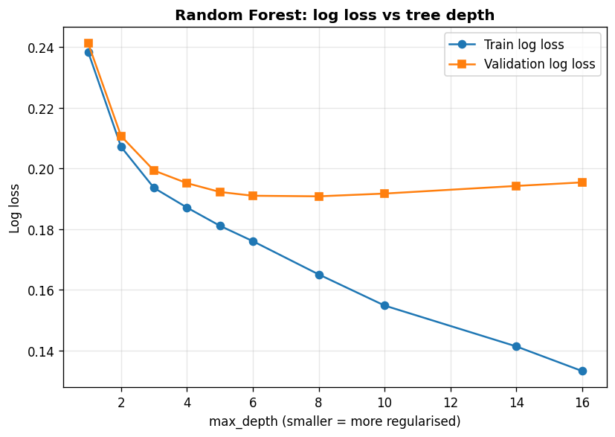
Figure 2. Random Forest training and validation log loss against tree depth (own work).
The same pattern is observed for XGBoost with each boosting round. With a high learning rate and no regularisation, validation log loss finishes at its lowest after just about 15 rounds and starts to rise whilst training log loss continues to decrease (Figure 3), which is a clear sign of overfitting. As L2 regularisation increases, the early curve is slightly elevated but the late-round rise is reduced (Figure 4), while the tuned model with low learning rate, regularisation and early stopping keeps the training and validation log loss in check.
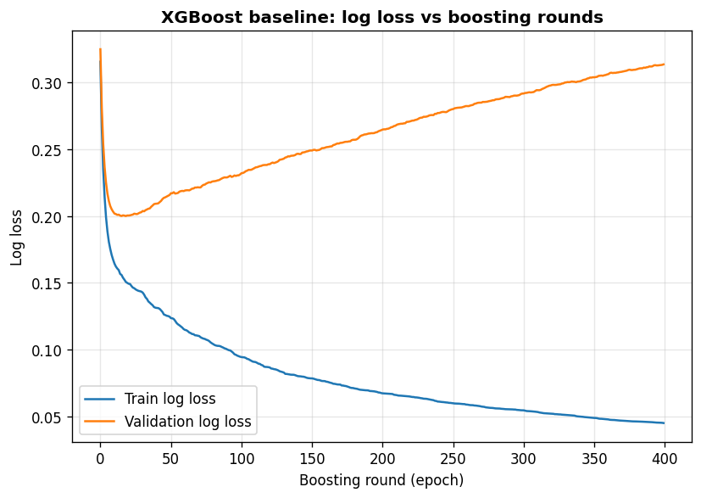
Figure 3. XGBoost baseline training and validation log loss against boosting rounds (own work).
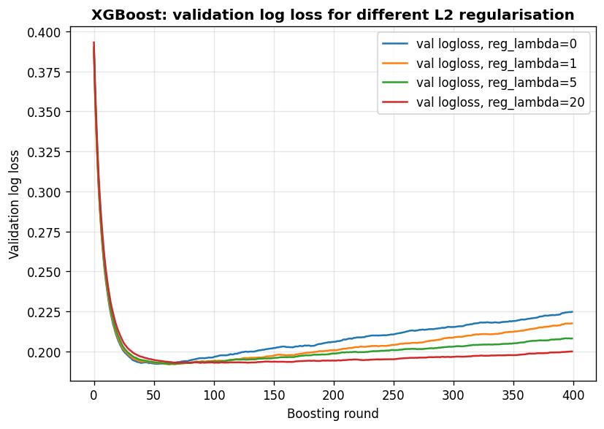
Figure 4. XGBoost validation log loss against boosting rounds for different L2 regularisation strengths (own work).

6.2 Performance Before and After Tuning
Tuning reduced test log loss by about 50% and enhanced both models. For the Random Forest, ROC-AUC rose from 0.939 to 0.949 and test log loss fell from 0.270 to 0.190; for XGBoost, ROC-AUC rose from 0.935 to 0.948 and log loss fell from 0.323 to 0.191. A detailed comparison is given on the test-set in Table 1.
Model | Acc | Prec | Recall | F1 | AUC | LogLoss
RF baseline | 0.884 | 0.620 | 0.546 | 0.581 | 0.939 | 0.270
RF tuned | 0.898 | 0.678 | 0.582 | 0.626 | 0.949 | 0.190
RF tuned + balanced | 0.844 | 0.486 | 0.974 | 0.648 | 0.948 | 0.269
XGB baseline | 0.882 | 0.602 | 0.584 | 0.593 | 0.935 | 0.323
XGB tuned | 0.899 | 0.680 | 0.590 | 0.631 | 0.948 | 0.191
XGB tuned + scale_pos_weight | 0.860 | 0.515 | 0.917 | 0.660 | 0.948 | 0.261
Table 1. Model performance on the held-out test set, before and after tuning and before and after class-imbalance handling (own work).

6.3 Class-Imbalance Handling
Class weighting dramatically altered the Recall/Precision tradeoff. Random Forest's recall increased from 0.582 to 0.974, meaning that the model was able to identify nearly all strong growing manufacturers; however, precision dropped from 0.678 to 0.486, with an increase in false positives (from approximately 140 to 523) in the test set (Figure 5). Similarly, XGBoost with scale_pos_weight increased the recall from 0.590 to 0.917, but also the number of false positives from approximately 141 to 438. This recall-up and precision-down trade-off for both models is summarised in Figure 6.
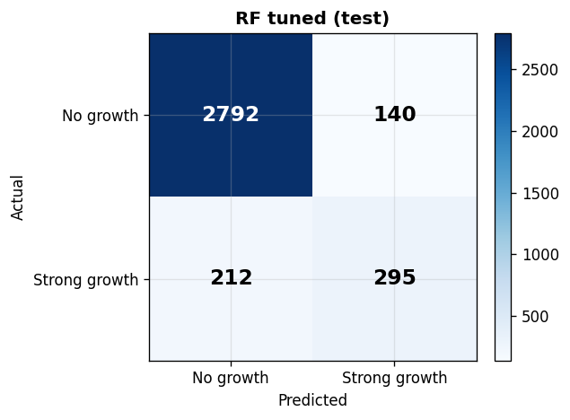
Figure 5. Random Forest confusion matrix on the test set, tuned model without class weighting (own work).
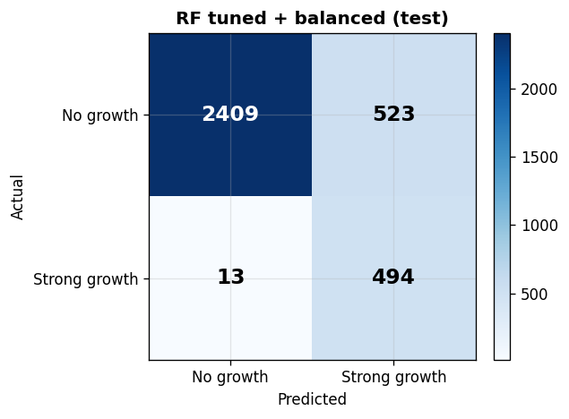
Figure 6. Random Forest confusion matrix on the test set after class weighting; note the increase in false positives (own work).
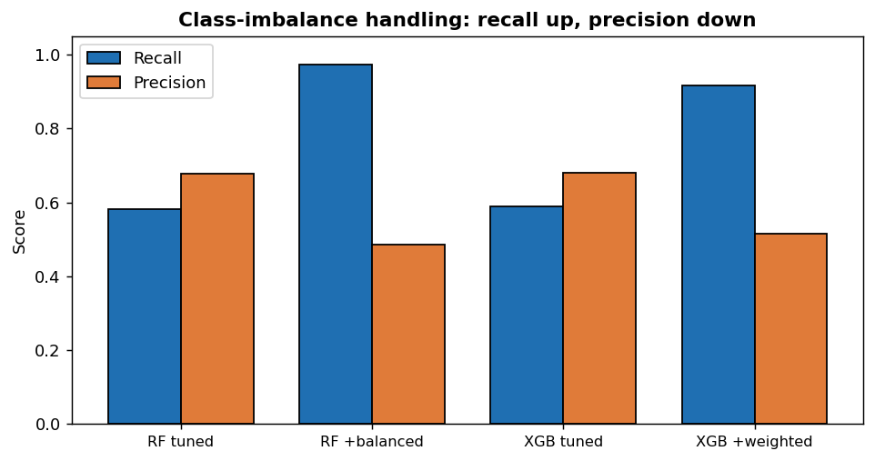
Figure 7. Recall and precision before and after class-imbalance handling for both models (own work).

6.4 Model Comparison
Both families of models achieve a test ROC-AUC of approximately 0.95 (ROC curves are displayed in Figure 7 in the appendix) and the tuned and unweighted versions achieve an accuracy of approximately 90%, which is the project target. As seen in the tables, the two models are almost the same on all measures: post-imbalance handling F1 score is 0.660 for XGBoost and 0.648 for Random Forest which is balanced and XGBoost has fewer false positives.
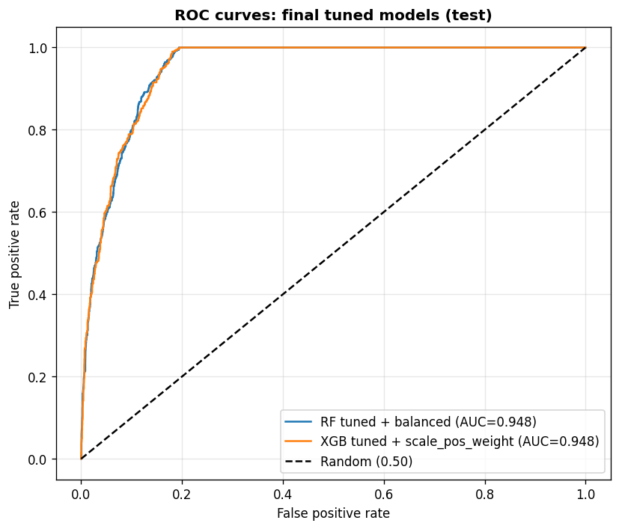
Figure 8. ROC curves of the final tuned models on the test set (own work).

7. Analysis and Discussion
Both tree-based models are able to rank strong-growth manufacturers well with a test ROC-AUC of ~0.95. This is in line with the literature: Breiman (2001) and Chen and Guestrin (2016) write that tree ensembles work well on tabular data which contains non-linearities and interactions – this is exactly the structure of the engineered registration panel. Based on the above, it can be inferred that the models have been tuned to obtain the desired accuracy (90%) and the research question is answered positively for the classification task as framed.
The decision of which of the models to select is dependent upon the use of the output. Unweighted models are models whose purpose is to keep the precision as high as possible, high overall accuracy models, and models which are suitable if a false alarm has a high cost, such as an investor that will invest based on the signal. The class-weighted models are used where the cost of missing a grower is more important, e.g. early-warning watchlist and the number of false-positives will be much higher – see the confusion matrices. The main practical conclusion is this precision/recall trade-off and not a single “best” model.
Three limitations came with these results. The first is that it's using the same quarter for the features measurement as it is for the target measurement, so it isn't really forecasting the next quarter, it's just whether it is a strong growth quarter, which helps with the high AUC and this should be addressed before using the system for true forecasting. Secondly, the model employs only three engineered features and does not include macro-economic or electric-vehicle-policy variables, which means that it is unable to reflect external shocks. Thirdly, only the Cars of VEH0160 are analysed. None of these influence the comparison between models, the primary goal of the project, but each of these have limits on the trust placed on absolute performance.
It could work as a screening tool for investors and manufacturers, who could use it to identify the manufacturers most likely to experience strong growth, with the list being updated every quarter when new DfT data are released. When used in this way it is complementary rather than a substitute for the descriptive statistics already provided by SMMT and DfT.

8. Conclusion
This project involved the development of two machine-learning classifiers to identify the UK car manufacturers that are in a strong growth phase based on the DfT VEH0160 registration panel and three engineered features, and comparison of the classifiers. The test ROC-AUC of both Random Forest and XGBoost was around 0.95, and the tuned models achieved the desired 90% accuracy. A look at the learning curves revealed obvious overfitting in the unconstrained models, which was controlled by tuning and reduced test log loss by approximately 50%, while attempts to address class imbalance led to an increase in recall (at the cost of precision) and a significant increase in false positives, which was not a free improvement but a conscious tradeoff. The main contributions are a reproducible pipeline and a careful and critical analysis of training, optimisation and imbalance for both models on this problem. Future research should make the features one quarter in arrears to obtain a true next quarter forecast, refine the threshold to reflect the business cost of false discovery/false failure, integrate SHAP explanations and exogenous economic and policy variables, and expand the analysis beyond Cars. All of the code and the history of its development is available on the project's GitHub repository.

References
Breiman, L. (2001) ‘Random forests’, Machine Learning, 45(1), pp. 5–32. Available at: https://doi.org/10.1023/A:1010933404324 (Accessed: 8 June 2026).
Chen, T. and Guestrin, C. (2016) ‘XGBoost: a scalable tree boosting system’, Proceedings of the 22nd ACM SIGKDD International Conference on Knowledge Discovery and Data Mining, pp. 785–794. Available at: https://doi.org/10.1145/2939672.2939785 (Accessed: 8 June 2026).
Department for Transport (2023) Vehicle licensing statistics: annual 2023 (VEH0160) [Online]. London: Department for Transport. Available at: https://www.gov.uk/government/statistics/vehicle-licensing-statistics-2023 (Accessed: 15 January 2025).
Friedman, J.H. (2001) ‘Greedy function approximation: a gradient boosting machine’, The Annals of Statistics, 29(5), pp. 1189–1232. Available at: https://doi.org/10.1214/aos/1013203451 (Accessed: 8 June 2026).
Hochreiter, S. and Schmidhuber, J. (1997) ‘Long short-term memory’, Neural Computation, 9(8), pp. 1735–1780. Available at: https://doi.org/10.1162/neco.1997.9.8.1735 (Accessed: 8 June 2026).
International Energy Agency (2023) Global EV outlook 2023: catching up with climate ambitions [Online]. Paris: International Energy Agency. Available at: https://www.iea.org/reports/global-ev-outlook-2023 (Accessed: 15 January 2025).
Pedregosa, F., Varoquaux, G., Gramfort, A., Michel, V., Thirion, B., Grisel, O., Blondel, M., Prettenhofer, P., Weiss, R., Dubourg, V., Vanderplas, J., Passos, A., Cournapeau, D., Brucher, M., Perrot, M. and Duchesnay, E. (2011) ‘Scikit-learn: machine learning in Python’, Journal of Machine Learning Research, 12, pp. 2825–2830. Available at: https://www.jmlr.org/papers/v12/pedregosa11a.html (Accessed: 8 June 2026).
Society of Motor Manufacturers and Traders (2023) New car registrations by fuel type [Online]. London: Society of Motor Manufacturers and Traders. Available at: https://www.smmt.co.uk/vehicle-data/car-registrations/ (Accessed: 15 January 2025).

Appendix A: Additional Figures
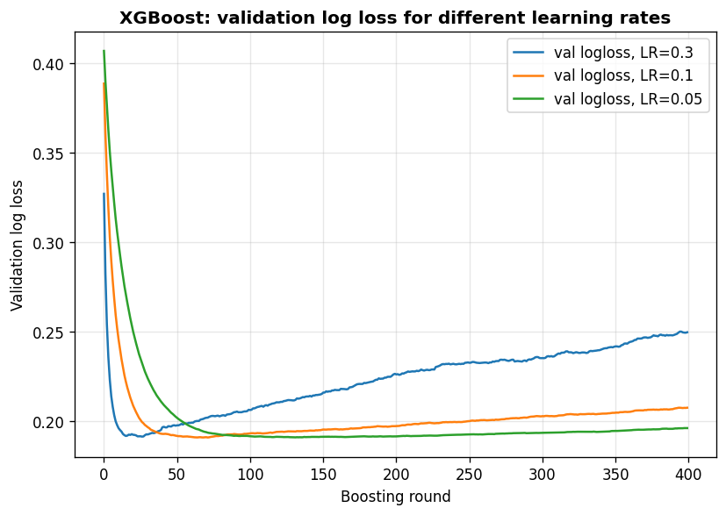
Figure 9. XGBoost validation log loss against boosting rounds for different learning rates (own work).
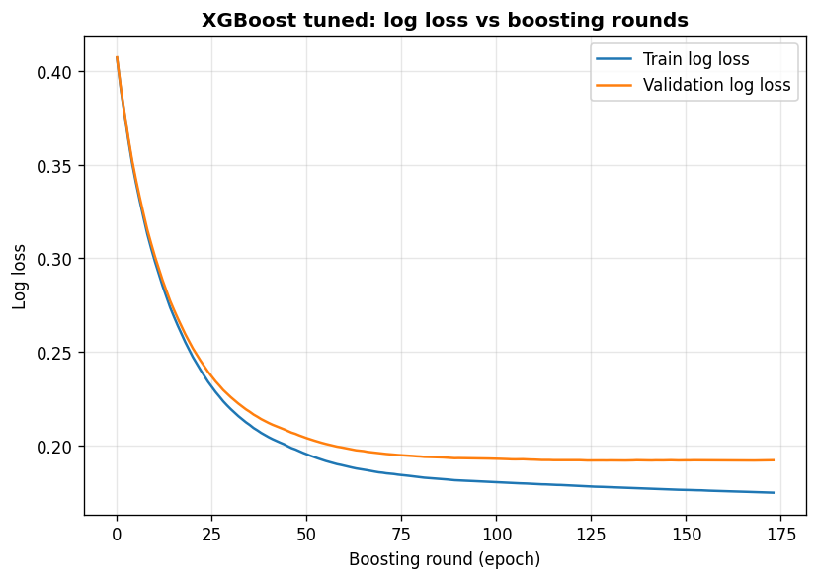
Figure 10. XGBoost tuned model training and validation log loss against boosting rounds (own work).
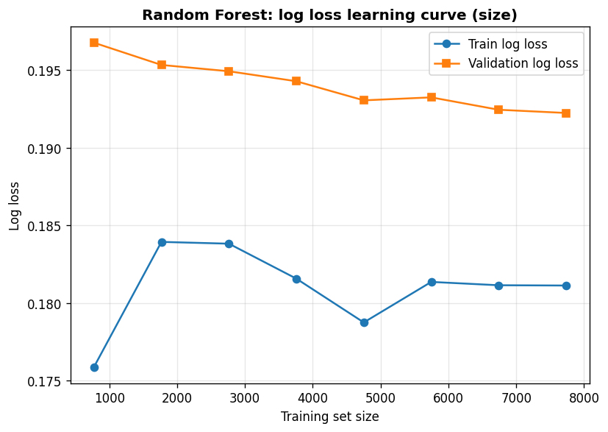
Figure 11. Random Forest training and validation log loss against training-set size (own work).
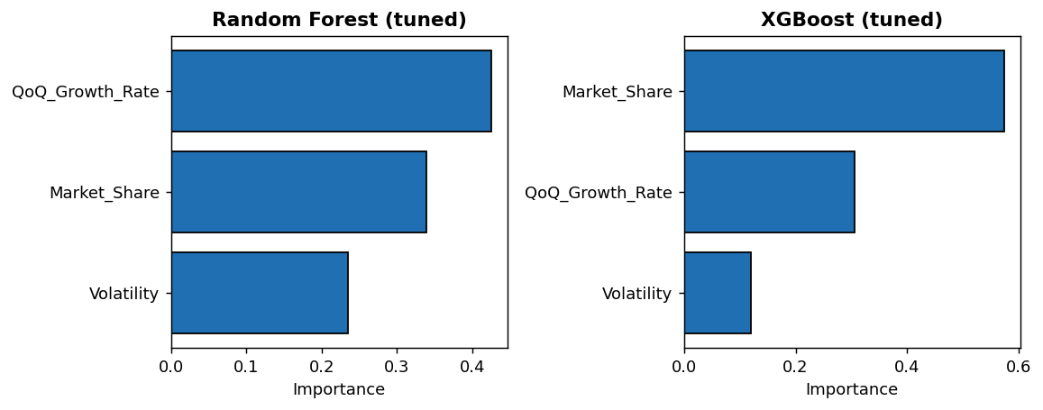
Figure 12. Feature importance for the tuned Random Forest and XGBoost models (own work).

Appendix B: Project Code
The full code is also available, with its development history, on the project GitHub repository. The complete notebook code is reproduced below.
# ----- Code cell 1 -----
# 0. Imports
import os, numpy as np, pandas as pd
import matplotlib.pyplot as plt, seaborn as sns
from sklearn.ensemble import RandomForestClassifier
from sklearn.model_selection import train_test_split, GridSearchCV
from sklearn.metrics import (accuracy_score, precision_score, recall_score, f1_score,
roc_auc_score, roc_curve, log_loss, confusion_matrix,
classification_report)
from xgboost import XGBClassifier
sns.set(style="whitegrid"); eps = 1e-6; RS = 42

# ----- Code cell 2 -----
# 1. Load VEH0160 data (works in Colab /content or locally)
CSV = "df_VEH0160_UK.csv"
path = CSV if os.path.exists(CSV) else f"/content/{CSV}"
df_veh0160_uk = pd.read_csv(path, encoding="latin1")
print("Raw shape:", df_veh0160_uk.shape)

# ----- Code cell 3 -----
# 2. Filter to Cars and reshape wide -> long (Make x Period)
cars = df_veh0160_uk[df_veh0160_uk["BodyType"] == "Cars"].copy()
quarter_cols = [c for c in cars.columns if "Q" in c and any(str(y) in c for y in range(2000, 2035))]
df_long = cars.melt(id_vars=["Make"], value_vars=quarter_cols,
var_name="Period", value_name="Registered").dropna(subset=["Registered"])
df_long["Registered"] = df_long["Registered"].astype(float)
df_long[["Year", "QuarterNo"]] = df_long["Period"].str.extract(r"(\d{4})\s*Q(\d)")
df_long["Year"] = df_long["Year"].astype(int); df_long["QuarterNo"] = df_long["QuarterNo"].astype(int)
df_long["Month"] = df_long["QuarterNo"].map({1:3,2:6,3:9,4:12})
df_long["Date"] = pd.to_datetime(dict(year=df_long["Year"], month=df_long["Month"], day=1)) + pd.offsets.MonthEnd(0)
print("Long shape:", df_long.shape)

# ----- Code cell 4 -----
# 3. Aggregate to Make x Date + lags
panel = (df_long.groupby(["Make","Date"], as_index=False)["Registered"].sum()
.sort_values(["Make","Date"]))
g = ["Make"]
panel["Registered_lag1"] = panel.groupby(g)["Registered"].shift(1)
panel["Registered_lag4"] = panel.groupby(g)["Registered"].shift(4)
panel["MA3"] = panel.groupby(g)["Registered"].rolling(3).mean().reset_index(level=0, drop=True)
panel = panel.dropna(subset=["Registered_lag1","Registered_lag4","MA3"])

# ----- Code cell 5 -----
# 4. Engineered features
panel["YoY_Growth_Rate"] = (panel["Registered"]-panel["Registered_lag4"])/(panel["Registered_lag4"]+eps)
panel["QoQ_Growth_Rate"] = (panel["Registered"]-panel["Registered_lag1"])/(panel["Registered_lag1"]+eps)
panel["Volatility"] = panel.groupby(g)["Registered"].rolling(4).std().reset_index(level=0, drop=True)
total_market = panel.groupby("Date")["Registered"].transform("sum")
panel["Market_Share"] = panel["Registered"]/(total_market+eps)
panel = panel.dropna(subset=["YoY_Growth_Rate","QoQ_Growth_Rate","Volatility","Market_Share"])
print("Panel after features:", panel.shape)

# ----- Code cell 6 -----
# 5. Target (strong growth = YoY > 10%) and feature matrix (no leakage)
panel["Target"] = (panel["YoY_Growth_Rate"] > 0.10).astype(int)
feature_cols = ["QoQ_Growth_Rate","Volatility","Market_Share"]
X = panel[feature_cols].replace([np.inf,-np.inf], np.nan).fillna(0)
y = panel["Target"]
print("Class counts:", y.value_counts().to_dict(),
"| positive share:", round(y.mean(),3),
"| imbalance (neg/pos):", round((y==0).sum()/(y==1).sum(),2))

# ----- Code cell 7 -----
# Class distribution
plt.figure(figsize=(6,4))
vc = y.value_counts().sort_index()
bars = plt.bar(["No strong growth (0)","Strong growth (1)"], vc.values,
color=["#ff7f0e","#1f77b4"], edgecolor="black")
for b in bars:
h=b.get_height(); plt.text(b.get_x()+b.get_width()/2, h, f"{int(h)}\n({100*h/vc.sum():.1f}%)",
ha="center", va="bottom", fontweight="bold")
plt.ylabel("Count"); plt.title("Target class distribution", fontweight="bold")
plt.tight_layout(); plt.show()

# ----- Code cell 8 -----
# Correlation of engineered features with the target
plt.figure(figsize=(6,5))
sns.heatmap(panel[feature_cols+["Target"]].corr(), annot=True, fmt=".2f",
cmap="coolwarm", center=0, square=True, linewidths=1)
plt.title("Correlation: engineered features vs target", fontweight="bold")
plt.tight_layout(); plt.show()

# ----- Code cell 9 -----
# 6. Stratified train / validation / test split + scale_pos_weight
X_temp, X_test, y_temp, y_test = train_test_split(X, y, test_size=0.25, random_state=RS, stratify=y)
X_train, X_val, y_train, y_val = train_test_split(X_temp, y_temp, test_size=0.25, random_state=RS, stratify=y_temp)
spw = (y_train==0).sum()/(y_train==1).sum()
print(f"Train {len(y_train)} Val {len(y_val)} Test {len(y_test)} scale_pos_weight={spw:.2f}")

results = {}
def evaluate(name, proba_val, proba_test):
pv=(proba_val>=.5).astype(int); pt=(proba_test>=.5).astype(int)
results[name]=dict(
val_auc=roc_auc_score(y_val,proba_val), val_logloss=log_loss(y_val,proba_val),
test_acc=accuracy_score(y_test,pt), test_precision=precision_score(y_test,pt,zero_division=0),
test_recall=recall_score(y_test,pt,zero_division=0), test_f1=f1_score(y_test,pt,zero_division=0),
test_auc=roc_auc_score(y_test,proba_test), test_logloss=log_loss(y_test,proba_test),
cm=confusion_matrix(y_test,pt))
r=results[name]
print(f"{name}\n test AUC {r['test_auc']:.3f} | F1 {r['test_f1']:.3f} | recall {r['test_recall']:.3f} | "
f"precision {r['test_precision']:.3f} | logloss {r['test_logloss']:.3f} | CM {r['cm'].tolist()}")
def plot_cm(name, title):
cm=results[name]['cm']
plt.figure(figsize=(5,4))
sns.heatmap(cm,annot=True,fmt='d',cmap='Blues',
xticklabels=['No growth','Strong growth'], yticklabels=['No growth','Strong growth'])
plt.xlabel('Predicted'); plt.ylabel('Actual'); plt.title(title, fontweight='bold')
plt.tight_layout(); plt.show()

# ----- Code cell 10 -----
# RF baseline: deep, unconstrained, no class weighting
rf_base = RandomForestClassifier(n_estimators=200, max_depth=None, min_samples_leaf=1,
random_state=RS, n_jobs=-1).fit(X_train, y_train)
evaluate("RF baseline", rf_base.predict_proba(X_val)[:,1], rf_base.predict_proba(X_test)[:,1])
tr = log_loss(y_train, rf_base.predict_proba(X_train)[:,1])
print(f" >> TRAIN logloss {tr:.3f} vs VAL {results['RF baseline']['val_logloss']:.3f} "
f"(large gap = overfitting)")

# ----- Code cell 11 -----
# RF learning curve vs tree depth (train vs validation log loss)
depths=[1,2,3,4,5,6,8,10,14,None]; tr_ll=[]; va_ll=[]
for d in depths:
m=RandomForestClassifier(n_estimators=200, max_depth=d, min_samples_leaf=5,
random_state=RS, n_jobs=-1).fit(X_train,y_train)
tr_ll.append(log_loss(y_train,m.predict_proba(X_train)[:,1]))
va_ll.append(log_loss(y_val,m.predict_proba(X_val)[:,1]))
xd=[d if d else 16 for d in depths]
plt.figure(figsize=(7,5))
plt.plot(xd,tr_ll,'o-',label='Train log loss'); plt.plot(xd,va_ll,'s-',label='Validation log loss')
plt.xlabel('max_depth (smaller = more regularised)'); plt.ylabel('Log loss')
plt.title('Random Forest: log loss vs tree depth', fontweight='bold'); plt.legend()
plt.tight_layout(); plt.show()

# ----- Code cell 12 -----
# RF learning curve vs training-set size
sizes=np.linspace(0.1,1.0,8); ts=[]; vs=[]
for fr in sizes:
n=int(len(X_train)*fr)
m=RandomForestClassifier(n_estimators=200, max_depth=5, min_samples_leaf=5,
random_state=RS, n_jobs=-1).fit(X_train.iloc[:n],y_train.iloc[:n])
ts.append(log_loss(y_train.iloc[:n],m.predict_proba(X_train.iloc[:n])[:,1]))
vs.append(log_loss(y_val,m.predict_proba(X_val)[:,1]))
plt.figure(figsize=(7,5))
plt.plot((sizes*len(X_train)).astype(int),ts,'o-',label='Train log loss')
plt.plot((sizes*len(X_train)).astype(int),vs,'s-',label='Validation log loss')
plt.xlabel('Training set size'); plt.ylabel('Log loss')
plt.title('Random Forest: log loss learning curve (size)', fontweight='bold'); plt.legend()
plt.tight_layout(); plt.show()

# ----- Code cell 13 -----
grid_rf = GridSearchCV(RandomForestClassifier(random_state=RS, n_jobs=-1),
{"n_estimators":[100,200],"max_depth":[3,4,5],"min_samples_leaf":[3,5,10],"max_features":["sqrt"]},
scoring="roc_auc", cv=5, n_jobs=-1).fit(X_train, y_train)
print("Best params:", grid_rf.best_params_)
rf_tuned = grid_rf.best_estimator_
evaluate("RF tuned", rf_tuned.predict_proba(X_val)[:,1], rf_tuned.predict_proba(X_test)[:,1])

# ----- Code cell 14 -----
rf_bal = RandomForestClassifier(class_weight="balanced", random_state=RS, n_jobs=-1,
**grid_rf.best_params_).fit(X_train, y_train)
evaluate("RF tuned + balanced", rf_bal.predict_proba(X_val)[:,1], rf_bal.predict_proba(X_test)[:,1])
plot_cm("RF tuned", "RF tuned (test)")
plot_cm("RF tuned + balanced", "RF tuned + balanced (test)")

# ----- Code cell 15 -----
xgb_base = XGBClassifier(n_estimators=400, learning_rate=0.3, max_depth=6,
reg_lambda=0, reg_alpha=0, subsample=1.0, colsample_bytree=1.0,
eval_metric="logloss", random_state=RS)
xgb_base.fit(X_train, y_train, eval_set=[(X_train,y_train),(X_val,y_val)], verbose=False)
evaluate("XGB baseline", xgb_base.predict_proba(X_val)[:,1], xgb_base.predict_proba(X_test)[:,1])
ev = xgb_base.evals_result()
plt.figure(figsize=(7,5))
plt.plot(ev['validation_0']['logloss'], label='Train log loss')
plt.plot(ev['validation_1']['logloss'], label='Validation log loss')
plt.xlabel('Boosting round (epoch)'); plt.ylabel('Log loss')
plt.title('XGBoost baseline: log loss vs boosting rounds', fontweight='bold'); plt.legend()
plt.tight_layout(); plt.show()

# ----- Code cell 16 -----
# Effect of LEARNING RATE on validation log loss
plt.figure(figsize=(7,5))
for lr in [0.3,0.1,0.05]:
m=XGBClassifier(n_estimators=400, learning_rate=lr, max_depth=4, reg_lambda=1.0,
subsample=0.8, colsample_bytree=0.8, eval_metric="logloss", random_state=RS)
m.fit(X_train,y_train,eval_set=[(X_val,y_val)],verbose=False)
plt.plot(m.evals_result()['validation_0']['logloss'], label=f'LR={lr}')
plt.xlabel('Boosting round'); plt.ylabel('Validation log loss')
plt.title('XGBoost: validation log loss vs learning rate', fontweight='bold'); plt.legend()
plt.tight_layout(); plt.show()

# ----- Code cell 17 -----
# Effect of L2 REGULARISATION (reg_lambda) on validation log loss
plt.figure(figsize=(7,5))
for rl in [0,1,5,20]:
m=XGBClassifier(n_estimators=400, learning_rate=0.1, max_depth=5, reg_lambda=rl,
subsample=0.8, colsample_bytree=0.8, eval_metric="logloss", random_state=RS)
m.fit(X_train,y_train,eval_set=[(X_val,y_val)],verbose=False)
plt.plot(m.evals_result()['validation_0']['logloss'], label=f'reg_lambda={rl}')
plt.xlabel('Boosting round'); plt.ylabel('Validation log loss')
plt.title('XGBoost: validation log loss vs L2 regularisation', fontweight='bold'); plt.legend()
plt.tight_layout(); plt.show()

# ----- Code cell 18 -----
# Tuned XGBoost: low LR + regularisation + sub-sampling + early stopping
xgb_tuned = XGBClassifier(n_estimators=600, learning_rate=0.05, max_depth=4, reg_lambda=5.0,
reg_alpha=0.5, subsample=0.8, colsample_bytree=0.8, min_child_weight=5,
eval_metric="logloss", early_stopping_rounds=40, random_state=RS)
xgb_tuned.fit(X_train, y_train, eval_set=[(X_train,y_train),(X_val,y_val)], verbose=False)
print("Best iteration (early stopping):", xgb_tuned.best_iteration)
evaluate("XGB tuned", xgb_tuned.predict_proba(X_val)[:,1], xgb_tuned.predict_proba(X_test)[:,1])
ev=xgb_tuned.evals_result()
plt.figure(figsize=(7,5))
plt.plot(ev['validation_0']['logloss'], label='Train log loss')
plt.plot(ev['validation_1']['logloss'], label='Validation log loss')
plt.xlabel('Boosting round (epoch)'); plt.ylabel('Log loss')
plt.title('XGBoost tuned: log loss vs boosting rounds', fontweight='bold'); plt.legend()
plt.tight_layout(); plt.show()

# ----- Code cell 19 -----
xgb_w = XGBClassifier(n_estimators=600, learning_rate=0.05, max_depth=4, reg_lambda=5.0,
reg_alpha=0.5, subsample=0.8, colsample_bytree=0.8, min_child_weight=5,
scale_pos_weight=spw, eval_metric="logloss", early_stopping_rounds=40, random_state=RS)
xgb_w.fit(X_train, y_train, eval_set=[(X_train,y_train),(X_val,y_val)], verbose=False)
evaluate("XGB tuned + scale_pos_weight", xgb_w.predict_proba(X_val)[:,1], xgb_w.predict_proba(X_test)[:,1])
plot_cm("XGB tuned", "XGB tuned (test)")
plot_cm("XGB tuned + scale_pos_weight", "XGB tuned + weighted (test)")

# ----- Code cell 20 -----
fig, ax = plt.subplots(1, 2, figsize=(11,4))
for a,(name,mdl) in zip(ax, [("Random Forest (tuned)",rf_tuned),("XGBoost (tuned)",xgb_tuned)]):
imp = pd.Series(mdl.feature_importances_, index=feature_cols).sort_values()
a.barh(imp.index, imp.values, color="#1f77b4", edgecolor="black")
a.set_title(name, fontweight="bold"); a.set_xlabel("Importance")
plt.tight_layout(); plt.show()

# ----- Code cell 21 -----
order=["RF baseline","RF tuned","RF tuned + balanced",
"XGB baseline","XGB tuned","XGB tuned + scale_pos_weight"]
cols=["test_acc","test_precision","test_recall","test_f1","test_auc","test_logloss"]
summary=pd.DataFrame([{**{"model":k},**{c:results[k][c] for c in cols}} for k in order])
print(summary.round(3).to_string(index=False))

# ----- Code cell 22 -----
plt.figure(figsize=(7,6))
for name,mdl in [("RF tuned + balanced",rf_bal),("XGB tuned + scale_pos_weight",xgb_w)]:
pr=mdl.predict_proba(X_test)[:,1]; fpr,tpr,_=roc_curve(y_test,pr)
plt.plot(fpr,tpr,label=f"{name} (AUC={roc_auc_score(y_test,pr):.3f})")
plt.plot([0,1],[0,1],'k--',label='Random (0.50)')
plt.xlabel('False positive rate'); plt.ylabel('True positive rate')
plt.title('ROC curves: final tuned models (test)', fontweight='bold'); plt.legend()
plt.tight_layout(); plt.show()

