Exercise 4.1

CREATE TABLE students (

student_ID int not null auto_increment,

student_name varchar(20) not null,

admission_year int not null,

major varchar(20) not null,

individual_no int not null,

phone_no int not null,

address varchar(100) not null,

total_credit int not null default 0,

avg_credit double not null default 0.0,

is_attending tinyint(1) not null default 1,

primary key(student_ID)

) ENGINE=InnoDB DEFAULT CHARSET=utf8;

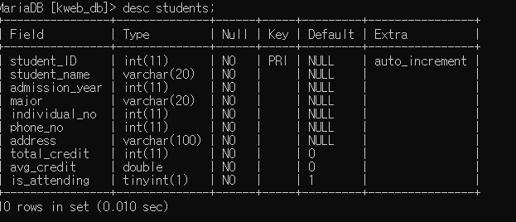

Exercise 4.2

CREATE TABLE users (

user_id int not null auto_increment,

user_name varchar(20) not null,

password varchar(20) not null,

profile_imgurl varchar(100) not null,

profile_msg varchar(100) not null,

is_left tinyint(1) not null default 0,

date_joined datetime not null,

primary key (user_id)

) ENGINE=InnoDB DEFAULT CHARSET=utf8;

CREATE TABLE channels (

channel_id int not null auto_increment,

channel_name varchar(50) not null,

host int not null,

channel_url varchar(100) not null,

capacity int not null,

is_left tinyint(1) not null default 0,

date_created datetime not null,

primary key(channel_id),

foreign key(host) references users(user_id) on delete cascade

) ENGINE=InnoDB DEFAULT CHARSET=utf8;

CREATE TABLE chats (

chat_id int not null auto_increment,

message varchar(100) not null,

writer int not null,

channel int not null,

date_created datetime not null,

primary key(chat_id),

foreign key(writer) references users(user_id) on delete cascade,

foreign key(channel) references channels(channel_id) on delete cascade

) ENGINE=InnoDB DEFAULT CHARSET=utf8;

CREATE TABLE blocks (

block_id int not null auto_increment,

blocked_by int not null,

blocked_user int not null,

date_created datetime not null,

primary key(block_id),

foreign key(blocked_by) references users(user_id) on delete cascade,

foreign key(blocked_user) references users(user_id) on delete cascade

) ENGINE=InnoDB DEFAULT CHARSET=utf8;

CREATE TABLE follows (

follow_id int not null auto_increment,

follower int not null,

following int not null,

date_created datetime not null,

primary key(follow_id),

foreign key(follower) references users(user_id) on delete cascade,

foreign key(following) references users(user_id) on delete cascade

) ENGINE=InnoDB DEFAULT CHARSET=utf8;

