1. (1)Most machine learning methods work well because of human-designed representations and input features. ML become just optimizing weights to best make a final prediction.

Deep learning is a machine learning subfield of learning representations of data. It is exceptional effective at learning patterns. DL algorithms attempt to learn representation by using a hierarchy of multiple layers.

ML separates feature extraction and classification, while DL connects them.

(2)

1)Manually designed features are often over-specified, incomplete and take a long time to design and validate.

2)Learning Features are easy to adapt, fast to learn.

3)Deep learning provides a very flexible,(almost) universal, learnable framework for representing world, visual and linguistic information.

4)Can learn both unsupervised and supervised.

5)Effective end-to-end joint system learning.

6)Utilize large amounts of training data.

2．(a)

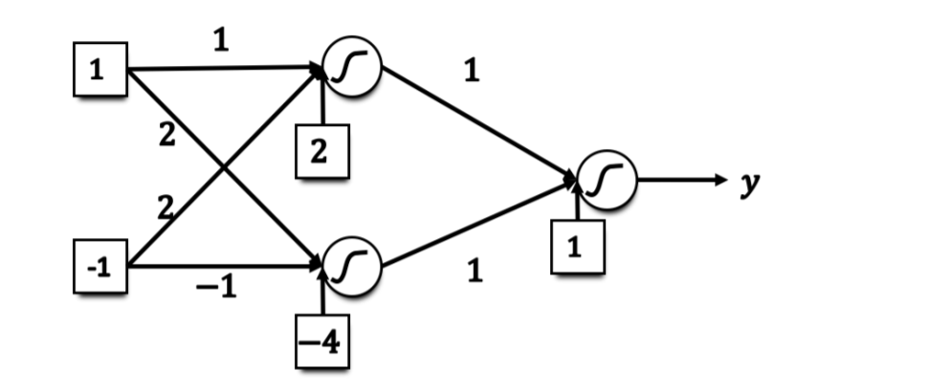(b) **0.73**

**0.88**

**0.27**

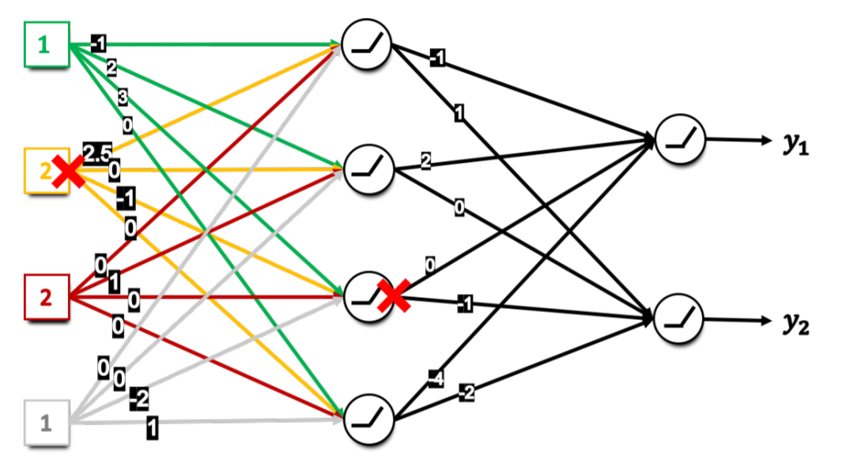3．（a） **0**

**4**

**4**

**0**

**1**

(b)

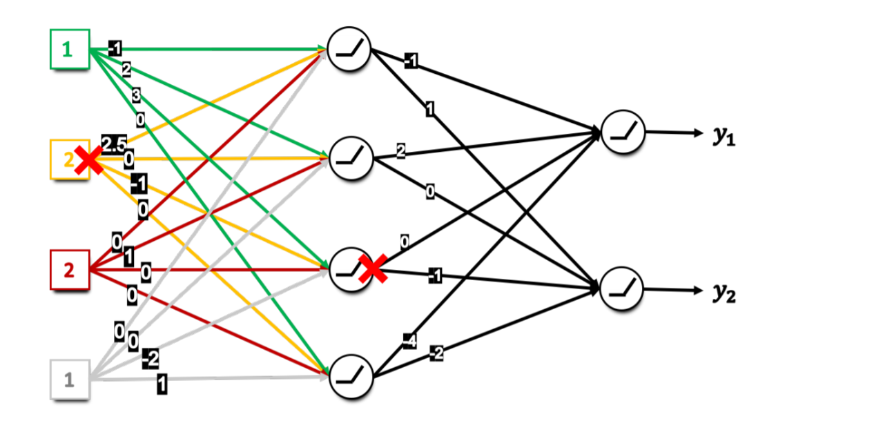

**3**

**0**

**3**

**0**

**1.125**

**0.75**

4．（a）

（b）the decision boundary is :