Apps Script Document Hub
Draft skill for building Google Sheets document hubs
Skill name | apps-script-document-hub
Description | Build, extend and maintain Google Apps Script web apps that turn a Google Sheet of documents or links into a searchable "virtual library" hub - shelves and cards, filters, Insights charts, role-based access (viewer, editor, admin, owner) with approval requests, audit log, soft-delete archive, per-team workstream tabs, shared documents, and autofill from pasted Google links. Use this skill whenever the user wants a web app, dashboard, portal, library or hub on top of Google Sheets or Apps Script, mentions workstream tabs, a document hub or document central, Governance or Log tabs, access requests, or asks to change, fix, optimize, rename, test, package or deploy one of these apps (for example Document Hub or Gabby-Sunlong Document Central), asks to see a demo, prototype or screenshots of one, or wants a README or guide for building one, even if they never say "Apps Script".
Built from | The Document Hub and Gabby-Sunlong Document Central build sessions (Hub version 2.5.0)
Files in the skill | SKILL.md, six reference files, scripts, and an interactive demo with screenshots. This document contains the written files; the demo and scripts are inside the .skill file.

How to use this document
- To create the skill: give this document to Claude and ask it to build a skill from it using the skill-creator. Part 1 becomes SKILL.md and each appendix becomes a file in the references folder.
- To reuse the prompts: Appendix A holds the prompt templates in build order. Replace the words in [brackets] and send them.
- To see the hub before building it: the pictures below are taken from the interactive demo. Open assets/demo/demo.html from the .skill file in Chrome to click through it.
- To brief a new teammate: Part 1 and Appendix B (decisions already made) explain how the Hub was built and how you like to work.

Contents
- Part 1. Skill instructions (SKILL.md)
- Appendix A. Prompt templates
- Appendix B. Decisions already made
- Appendix C. Architecture of the Hub
- Appendix D. Testing and delivery
- Appendix E. Lessons learned
- Appendix F. The interactive prototype

What the hub looks like
These pictures come from the bundled demo: the real hub running on sample data. Nothing in it is saved to Google.
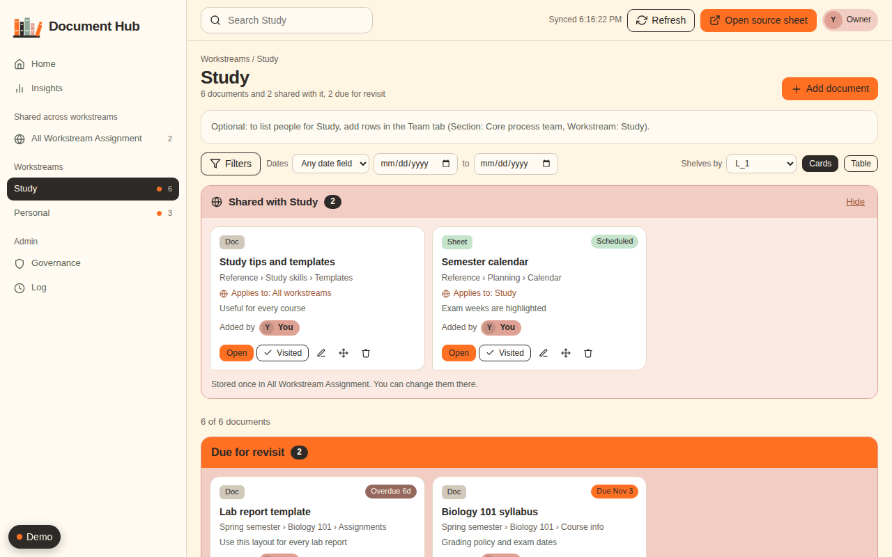
A topic page: shared documents, documents due for revisit, then shelves of cards
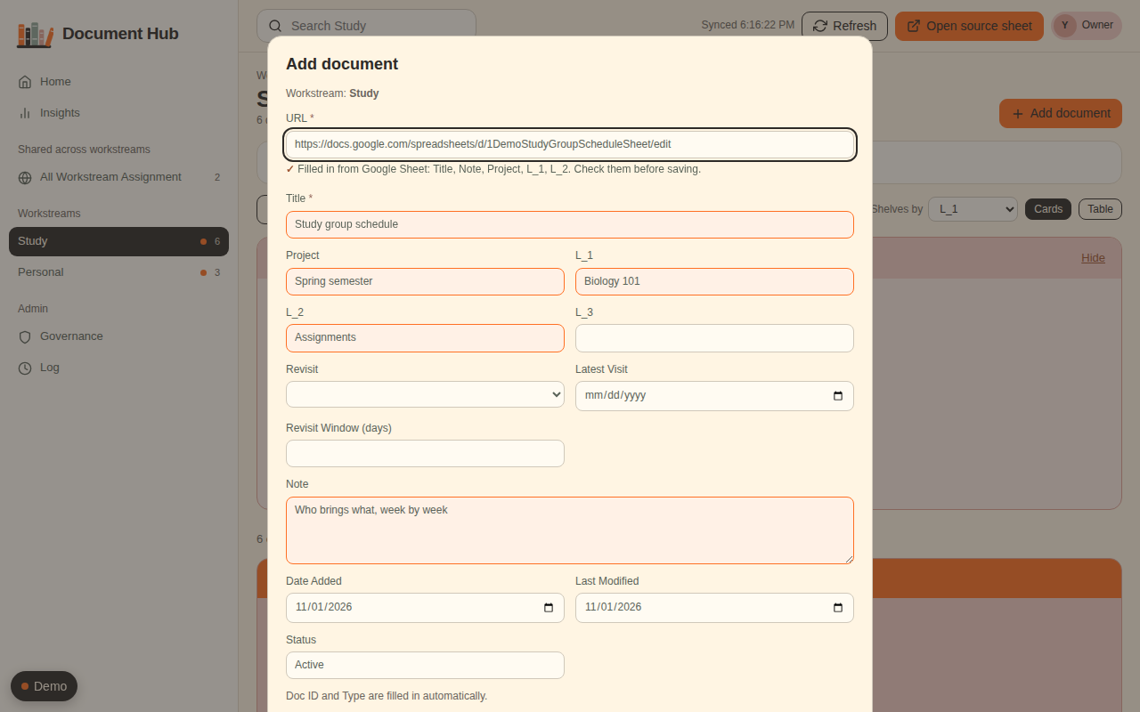
Add document: paste a Google link and the title and details fill in
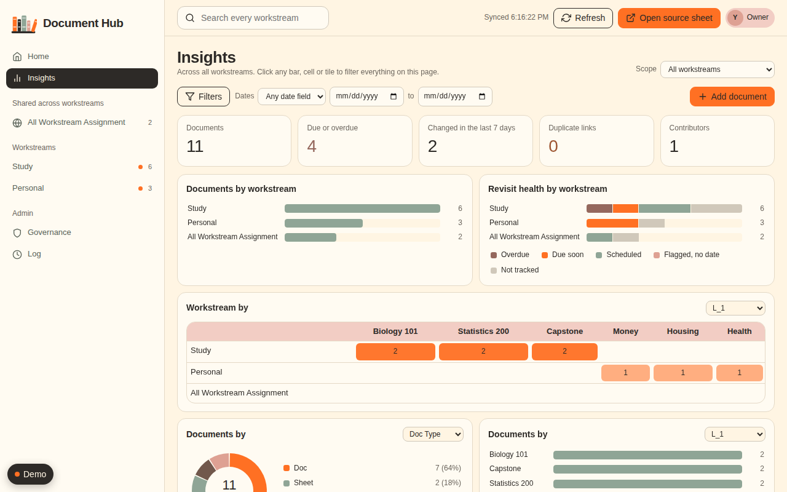
Insights: totals and charts that filter each other when you click

Part 1. Skill instructions
Saved in the skill as SKILL.md
This skill captures a workflow that was refined over many rounds with one user: a Google Sheet holds documents and links, and an Apps Script web app presents them like a library, with live two-way sync to the sheet. Two apps were built this way (a personal one and a broader "Hub" with eight workstream tabs), reaching version 2.5.0 of the Hub.
Read the reference files when you reach the step that needs them:
- references/prompt-templates.md - the reusable prompts, in build order, and how to turn a user's request into one.
- references/defaults.md - decisions the user has already made. Propose these as defaults instead of re-asking.
- references/architecture.md - sheet layout, roles, caching, sync, files and menu items.
- references/testing-and-delivery.md - how to test without the live app, version, package and give deploy steps.
- references/lessons.md - bugs and traps found along the way. Skim before building any UI, lookup or permission feature, or before publishing a package.
- references/prototype.md - the interactive demo and the simulated Google environment bundled in assets/ and scripts/. Read it before showing, testing or documenting the app.

How this user works (follow these)
- Design before code for anything new. Propose two to four layouts as mockups and a numbered list of questions, then wait for approval. Each question gets a recommended default so the user can answer by number ("1. Layout: B+A").
- They invite questions. Requests often end with "if you have questions, please ask me". Ask only what changes the build, batch the questions, and do not ask what references/defaults.md already answers.
- Screenshots with a coloured box mark the exact spot. Look at the boxed area first, and believe the screenshot over assumptions about the code. Many requests are bug reports in disguise ("the flag is still there", "the name is wrong").
- A "how" or "why" question is a question. Answer it. Do not build until they ask for a change.
- When two apps share a project, agree a keyword ("GS", "Hub", "Both") and use it back so every instruction is unambiguous.
- Plain language. The user is a program leader, not a developer. Explain a term in one clause the first time, and give deploy steps as numbered clicks.
- Be honest about testing. Say what was tested in a simulated environment and a headless browser, and that the live deployment was not tested.

Workflow

1. Intake
Fill the brief from references/prompt-templates.md (template 1). If the user gives a source sheet link, read it. Identify: who uses it and when, brand colours and logo, roles, whether data must stay editable in the sheet, and whether more than one team or workstream needs its own tab.

2. Design proposal (new apps and big features)
Show the working prototype first: assets/demo/demo.html is the real hub running on sample data (open it, or attach the pictures in assets/demo/screenshots/). For a new app, change the sample data in scripts/demo_runtime.js to the user's own subject, rebuild with scripts/build_demo.js, and let them react to it. Otherwise show mockups of the main screens (library, Insights, Governance, Log) with the brand palette. Summarise requirements back, list assumptions, and ask the numbered questions. Do not write app code until the user answers. For a big feature on an existing app (for example the shared documents area), propose the design with one visual and three or four questions, then build on their answers.

3. Build
Use the architecture in references/architecture.md. Keep to these principles, each of which came from a real problem:
- The sheet stays the source of truth. Anything done in the app writes to the sheet, and anything typed in the sheet shows in the app within about 30 seconds.
- Every feature that reads data on the user's behalf must check what that user is allowed to see. The app runs as its owner, so it can see more than its users.
- Keep reads cheap: one shared cache for everyone, invalidated by a change token. Measure before optimizing and after.
- Make writes feel instant (optimistic updates with rollback) and make failures visible.
- Store a thing once. When users want the same card in many places, build a shared area with assignments, not copies.
- Never guess data you cannot verify (categories from folder names, titles from unreadable pages). Offer what is certain and leave the rest to the user.

4. Verify
Follow references/testing-and-delivery.md: server tests in the bundled simulated Apps Script environment (scripts/fake_google.js), browser tests (scripts/test_demo.py for the demo journey), a performance benchmark at a few thousand rows, and a visual check of screenshots at desktop and phone width. Fix what the tests find before reporting.

5. Deliver
Bump the version, update the in-sheet spec log (requirements, change log, prompts), refresh the README, zip the folder, and present the zip. If the interface changed, rebuild the demo and retake the screenshots (references/prototype.md) so guides never show an old look. Before publishing anything, scan it for private IDs, emails, company names and logos (references/lessons.md). Then reply with: what changed in the user's words, what they must do to deploy (numbered), and anything you changed in their live sheet. Keep the reply short; the zip carries the detail.

6. Change requests
Typical rounds are small and specific. For each: restate the problem in one line if the screenshot is ambiguous, make the change, run all suites, bump a minor version for features and a patch for fixes. If a request reveals a wrong assumption (for example folder names that do not match categories), say so plainly and explain the safer behaviour you built.

Output conventions
- Package name: the app's folder name (document-hub.zip). For a guide: README.md, an images folder, docs/demo.html for GitHub Pages, and a starter spreadsheet. Files: Code.gs, Setup.gs, Spec.gs, Index.html, appsscript.json, README.md.
- Deploy steps always end with: Deploy > Manage deployments > pencil > New version > Deploy, execute as the owner, access within the owner's domain.
- When the user's sheet needs changes (new tab, new rows in HOME), make them directly and report exactly what was changed.

Appendix A. Prompt templates
Saved in the skill as references/prompt-templates.md
These are the user's real requests, generalised. Words in [brackets] are filled in per project. Use them two ways: to help a new user write a good brief, and to recognise which stage an incoming request belongs to.
Contents: 12 Guide for newcomers, 13 Visuals and a prototype, 1 Brief, 2 Answers to expect, 3 Polish, 4 Optimization, 5 New product from an existing app, 6 Multi-workstream design, 7 Rule and content fixes, 8 Shared documents, 9 Filters, 10 Views, 11 Autofill from a link, Question-asking pattern.

1. The brief (first message)
TASK: Build a Google Apps Script web app that organizes and displays [documents] from [source sheet URL] in the right categories, headers and contexts, like a virtual library.
CONTEXT: [Who stores what here, who uses it, and when - e.g. "a one-stop shop to grasp and go during a hectic project rollout"].
DESIGN: Act as an innovative UI/UX designer. Propose rich layouts for my confirmation before you generate code. Follow [brand palette, rules and logo].
FEATURES:
1. Filters (category, date, date range), search box, data refresh, clear filters.
2. Intuitive graphs (donut, bar, line) for concepts, quantity and category.
3. Add, edit, delete from the dashboard or the source file, in real time both ways.
4. A button that opens the source sheet.
5. A Governance tab: user groups (viewer, editor, owner), Google sign-in, access requests routed to the owner for approval.
6. A Log tab for the audit trail.
Remember every prompt and response in this project. Summarize requirements and layout for my approval before building. Ask me questions if you need clarification.

2. Answers to expect (so you can pre-propose them)
Layout choice (often a blend: "B+A"). Add the fields the app needs and edit the source sheet directly. Date Added is stamped once and never changes; Last Modified is stamped on every change. Doc Type is detected from the URL. The owner is emailed and approves in the app only, and sets the access type at approval. Deleting moves the row to an Archive tab. Sheet edits are allowed only for editors and owners. The requirements live in a Project_spec tab that the app keeps up to date. The log is visible to owners only. No real legacy data, so ship with sample or empty data. Insights charts respond to each other, with a records table under them. Adding or removing columns in the sheet must show in the app.

3. Polish prompts
- "The headers blend into the background and cards. How do I make them stand out as visual blocks?" / "Where do I change the shelf title colour to [hex]?"
- "Reorder the high-priority bands to the top in this order: [list]. Apply the existing order rules to the rest."
- "Highlight the name of the person who added each card."
- "Troubleshoot the Log tab [screenshot]. Show the latest 10 entries and let me step further back by a day, a week, a month or a date range."
- "How can I know why this is flagged?" / "I added the next revisit but the flag is still there [screenshot]."
- "Also track duplicated records when the URL is the same."

4. Optimization
"Optimize the code for faster run time, lower latency and higher user satisfaction." Always measure first (sheet reads and CPU per request at a few thousand rows), then change, then show before and after.

5. A new product from an existing app
"Copy the solution into a new project called [name] for a broader audience. Use [new source sheet] and the attached logo, and follow the original setup requirements. If you have questions, ask me." Follow with: "Two apps live in this project. What keyword should I use to refer to each?", "Rename them to [A] and [B]", "Check it points to the correct source file [URL]", "The displayed name is wrong in one app."

6. Multi-workstream design
"I want [N] action tabs for these user groups: [list, with screenshot]. I created one sheet tab per group with identical headers. Sync each tab's records to its sheet tab. I made a HOME tab for the README. Act as a professional UI/UX designer and propose an industry-standard design. Update Insights, and maintain Governance and Log. Ask me questions." Expect answers on: navigation (left sidebar), permissions (per-workstream roles; owner and admin do everything), visibility (everyone sees everything), duplicates across workstreams (one home workstream plus a Move action), what to prefill (leave Team names blank, draft the README into HOME, start empty), and whether Insights should become workstream-aware.

7. Rule and content fixes
"Apply the duplicate rule within each workstream only [screenshots]. Make the title a bit bigger. Fill the Team tab from this org chart [screenshot]; tell me if anything is unclear. Redesign the HOME tab to an industry standard."

8. Shared documents
"Some cards apply to all workstreams. Adding the same card to each one is inefficient. How should we improve this?" Then answer the design questions: some documents apply to only a few workstreams; the area is named [name]; admins and owners, plus editors who are granted it, can create, read, update and delete shared documents.

9. Filters
"The filter options should be dropdown lists with multiple selections."

10. Views
"The Cards and Table toggle should affect one workstream only; it currently changes all of them [screenshots]. The Shared-with band does not follow when I switch to Table."

11. Autofill from a link
"When adding a document, can users paste only the URL and have the app fill the title and details?" Answers: links are mostly Google; if the user cannot open the file, fill nothing; fill categories automatically (then adjust: folder names rarely match categories, so use folder memory).

12. A guide for newcomers
"Write a README that guides new users step by step to build a document hub themselves from these files. The audience is students or individuals with a personal Google account. Keep it simple and doable for beginners: start with creating the Google Sheet and its content, then the Apps Script setup. Include a flow chart or visuals first. Remove any private or company names. Split the checklist so each box is one action. Ask me if you have questions." Expect follow-ups such as: reframe "Before you start" for the audience, fix pictures that do not load on GitHub, remove a product name from the guide, the skill and the sample file name.

13. Visuals and a prototype
"In the README, the instructions and the skill, include visuals or prototypes of the Document Hub so people can play around on GitHub and see whether it matches their expectation." Answer with screenshots in the README, a one-file interactive demo that GitHub Pages can host, and the demo plus its builder inside the skill.

Question-asking pattern that works
Number every question, say what you recommend, and keep each answerable in a few words. Close with: "If you have questions or clarification, please ask me." The user replies "Answer: 1. ... 2. ..." and often adds new requirements inside the answers; reread them.

Appendix B. Decisions already made
Saved in the skill as references/defaults.md

Identity and access
- The app runs as the owner and is open to users within the owner's domain. Execute as: owner. Access: anyone within the domain.
- Roles: viewer (reads everything), editor (adds, edits, visits, moves and deletes only in the workstreams listed for them), admin (all workstreams, manages access), owner (everything, and grants admin and owner).
- New people request access with Google sign-in. The owner is emailed and approves in the app, choosing the role. Optional auto-viewer setting for a broad audience.
- Editors may also type in their workstream tab in the sheet. An edit by someone without rights is reverted (single-cell edits) and logged as BLOCKED.
- The audit log is visible to owners and admins. Show the latest 10 with a way to step back.

Data
- One header row per workstream tab (row 3), identical columns in every tab: Title, URL, Project, L_1, L_2, L_3, Revisit, Latest Visit, Revisit Window (days), Next Visit, Weekday, Note, Doc ID, Doc Type, Date Added, Last Modified, Modified By, Status, Added By.
- Date Added is stamped once. Last Modified is stamped on change. Doc Type comes from the URL. Doc ID is unique across all tabs.
- Deleting moves the row to an Archive tab with who, when and why; an admin can restore it.
- The duplicate rule (same link) applies within one workstream only. The same link in two workstreams is allowed.
- A document lives in one home workstream; Move changes it and keeps its Doc ID, Date Added and Added By.
- Documents that apply to everyone or a few workstreams live once in a shared area tab, with an Assigned To column ("All" or names separated by semicolons).
- Start with sample or empty data when real data is unavailable. Keep cleanup flags visible for the user to fix.

Look and behaviour
- Left sidebar: Home, Insights, shared area, one entry per workstream, Governance, Log. Brand palette from the user's guidelines; use their logo.
- Library: shelves by a chosen category, a "Due for revisit" strip, Cards or Table (remembered per page), search scoped to the page, filters as multi-select dropdowns with counts.
- Insights cross-filter: choosing a slice filters every chart and the records table.
- Priority shelf order is configurable (SHELF_ORDER). Show who added each card.
- Home page shows a program Team panel from a Team tab; HOME tab is a styled page with Title, Heading, Text, Bullet, Note, Link, Spacer, Accent styles.
- Add form: link first, then title, with autofill from Google links.

Process
- Version every change (patch for fixes, minor for features). Keep a spec log in the sheet (requirements, change log, prompts).
- Zip the folder and present it. Give numbered deploy steps. Say exactly what was changed in the live sheet.

Personal edition (students and individuals)
- Personal Google account, one user, "access": "MYSELF", Execute as: Me. Teams need Google Workspace (DOMAIN plus "access": "DOMAIN").
- A starter spreadsheet (two tabs, header row 3, one sample row) is uploaded in step 1, so nobody types headers.
- Code ships with placeholders (SS_ID, DOMAIN, OWNER_SEED); the user changes three values and one manifest setting.
- Neutral branding: a bookshelf icon, the warm palette, no company names, an empty Team tab, no confidentiality line.
- The guide starts with the sheet, then Apps Script, then setup, then deploy; it opens with pictures, a flow chart and a demo to try.

Appendix C. Architecture of the Hub
Saved in the skill as references/architecture.md
Contents: Files, Sheet tabs, Data model, Roles, Sync and caching, Performance targets, Config keys, Menu, Features by area.

Files (one Apps Script project bound to the source sheet)
Code.gs (server: data, rights, writes, lookups), Setup.gs (menu, setup, fresh start, formatting, triggers, system tabs), Spec.gs (requirements, change log and prompts written into the Project_Spec tab), Index.html (the whole client: HTML, CSS, JS), appsscript.json (scopes, web app settings), README.md. The client is one file because HtmlService serves one template; keep it organised in labelled sections.

Sheet tabs
- Workstream tabs (one per team): identical headers in the header row, plus the shared area tab (same headers plus Assigned To).
- HOME (styled README page), Team (program org chart), Access (people and roles), Access_Requests, Audit_Log, Archive, Config (key, value, notes), Project_Spec.
- Hidden system tabs: _Shadow (copy of each document used to detect changes and who changed what), _Folders (learned Drive folder to category mapping).
- A tab is a workstream if it has Title and URL headers and is not a system tab. Order of tabs is the order in the app unless Config WORKSTREAMS lists names.

Data model
Columns are found by header name, not position, so users can add, rename or move columns in the sheet. Roles detected by name: title, url, note, id, type, added, modified, modified by, added by, status, revisit, latest visit, window, next visit, project, L_1, L_2, L_3. A virtual Workstream column comes from the tab name at runtime. Categorical columns (few distinct values) become filters; Assigned To, Title, URL, Note, IDs and Weekday never do.
Next Visit and Weekday are formulas from Config templates (NEXT_VISIT_FORMULA, WEEKDAY_FORMULA). Revisit status is derived: Overdue, Due soon, Scheduled, Flagged without a date, Not tracked.

Roles and rights
Viewer, Editor (list of workstreams, or * for all), Admin, Owner. The shared area counts as a workstream for editing rights. Every write goes through one guard that checks the user's rights for the target workstream; Move checks both ends; merging copies needs rights on every workstream involved. Sheet edits by people without rights are reverted when single-cell and always logged.

Shared documents ("All Workstream Assignment")
One tab holds documents that apply to all or some workstreams. Assigned To is All/blank or a semicolon list of workstream names, validated and normalised on save. Each workstream page shows a "Shared with this workstream" band (cards or table, following the page's view). Counts are never double counted. Governance offers Merge into shared (same link kept in several workstreams) and Move to shared (documents marked with Config SHARED_HINT). Type off in Config SHARED_TAB to disable.

Sync and caching
- One shared dataset cache for all viewers; the key combines the date, the code version and a change token that is bumped on every write or sheet edit. First viewer after a change rebuilds (one open, a handful of reads); the rest are served from cache.
- Polling every POLL_SECONDS (30), cache-only, slowing when idle (after about 3 minutes and again after 15) and checking at once on return. Refreshes are diff-aware so scroll position is kept.
- Writes: lock, re-read the row, check a row hash to detect someone else's edit, write, update the shadow copy, bump the token, return the fresh row. Optimistic UI for Visited, Delete and Move rolls back with an error if the server refuses.

Performance (3,000 documents, reference numbers)
First viewer after a change: about 300 to 400 ms CPU, 1 open, 9 reads (8 workstreams plus shared). Cache hit: about 15 ms, 0 reads. Poll: 0 reads. Create about 13 reads, edit about 4, delete about 2.

Config keys
APP_TITLE, PROGRAM_NAME, POLL_SECONDS, HEADER_ROW, HIDDEN_COLUMNS, GROUP_A, GROUP_B, SHELF_BY, PAGE_SIZE, SOON_DAYS, SHELF_ORDER, AUTO_VIEWER, WORKSTREAMS, NEXT_VISIT_FORMULA, WEEKDAY_FORMULA, SHARED_TAB, SHARED_HINT. A blank value means "use the default"; to switch a feature off use an explicit off.

Menu (in the sheet)
Run setup, Fresh start (clears data and rebuilds), Sync project spec, Refresh workstream list, Restyle HOME page. Setup is idempotent and creates missing tabs (including the shared area).

Features by area
Library: shelves, due strip, cards and table (per page), filters (multi-select dropdowns with counts and search), dates, search. Insights: workstream-aware, cross-filtering charts, heatmap, weekly activity, records table. Governance: access matrix per workstream, requests, connection card, archive, data quality (duplicates, merge, shared suggestions). Log: latest 10 with stepping back. Add form: link first with Google link autofill (title, note, categories) behind a privacy check.

Link autofill rules
Parse Drive file or folder IDs from Docs, Sheets, Slides, Forms, Drawings, Drive file and folder links. Read details with the Drive advanced service if enabled, otherwise DriveApp. Return details only if the sharing list shows the requester could open the file (named, whole domain, anyone, owner). Same refusal text for private, hidden and missing files. Cache raw Drive details for 5 minutes, decide access per person each time, limit to 30 lookups a minute. Categories come from learned folder memory, then folder names that equal an existing value (leading numbers ignored), then the workstream's usual Project. Never copy folder names in as new categories.

Personal edition and the demo
The personal edition is the same code with placeholders, a neutral logo, an empty Team tab and "access": "MYSELF". scripts/build_demo.js turns any package folder into a one-file interactive demo (references/prototype.md).

Appendix D. Testing and delivery
Saved in the skill as references/testing-and-delivery.md
Contents: Why simulate, Server tests, Browser tests, Benchmark, Visual check, Versioning and packaging, Deploy steps, Reply format.

Why simulate
Apps Script cannot be run locally and the live deployment belongs to the user. Test everything in a simulator, then say clearly that live testing is theirs. A simulator is bundled in the skill: scripts/fake_google.js (see references/prototype.md). It is not part of the app zip.

Server tests (Node `vm`)
Concatenate Code.gs, Setup.gs and Spec.gs into one context with fakes for: SpreadsheetApp (multiple tabs; getRange, getValues, setValues, appendRow, deleteRow, insertSheet, hideSheet, copyTo, setFrozenRows, formats as no-ops), CacheService (get, put, remove), LockService, PropertiesService, Session (switchable active user), ScriptApp (triggers), HtmlService, MailApp, DriveApp, and optionally the Drive advanced service with controllable files and sharing lists. Counters for reads and writes make performance assertions possible. Options on the factory (for example "no shared tab", "Drive off") let one test change the world.
Test groups to keep: setup and fresh start; dataset shape per role; create, edit, visit, move, delete and restore; conflicts (stale row hash); duplicates per workstream; Revisit status; rights for every role on every action; sheet-edit reverts and BLOCKED logs; access requests and approval mail; cache behaviour per user; Governance data; shared area (assignment rules, rights, move in and out, merge); link lookup (parsing, privacy per sharing type, rate limit, fallback, learning).
Use throws() helpers and assert on messages for rights and validation. Keep each test independent by building a fresh environment.

Browser tests (Playwright, headless Chromium)
Generate payloads from the server code (so client and server agree), then load Index.html with its boot tag replaced by the payload and google.script.run replaced by a Proxy that supports withSuccessHandler and withFailureHandler, a small latency, and a record of calls and last arguments (window.__calls, window.__last). Let tests set per-call delays and failures (window.__delays, window.__fail).
Keep separate suites: core behaviour per role; optimistic UI and polling; each new feature. Give new features their own fixtures instead of changing old fixtures, so old suites stay meaningful. Do not change the exact text another suite patches in the mock.
Always include: keyboard operation, phone width (390 px) with no sideways scroll, no JavaScript errors, and role variants (owner, admin, editor, viewer, shared-area editor).

Benchmark
Create about 3,000 documents and report CPU time and sheet calls for: first load after a change, cache hit, poll, create, edit, delete. Compare with the previous version.

Visual check
Take screenshots at desktop and phone width of every changed screen and look at them. Several real bugs (a wrapped required star, an always-visible picker, a popover below the fold) were only visible this way.

Versioning and packaging
Patch for fixes, minor for features, major for architecture changes. Update SPEC_VERSION, SPEC_DATE, requirements, change log and prompts in Spec.gs, the README header and any instructions. Zip the folder to <app-folder>.zip, unzip into a temporary folder and diff against the source to prove the zip matches, then present it.

Deploy steps (say these every time)
- Replace the changed files in the Apps Script project (usually Code.gs, Setup.gs, Spec.gs, Index.html; replace appsscript.json only if told).
- Check SS_ID on line 7 of Code.gs is the app's own sheet.
- In the sheet menu run Sync project spec (and Run setup if told).
- Deploy > Manage deployments > pencil > New version > Deploy. Execute as: me. Access: anyone within the domain.
- Check Governance > Connection shows the right sheet ending, version and tab count.

Reply format
Lead with what changed in the user's terms (a short list per request), then limits or decisions they should know (privacy, what was learned from real files), then deploy steps, then any change made to their live sheet. Keep it under about 250 words plus the steps. Present the zip with the file tool; never describe its position on the page.

Appendix E. Lessons learned
Saved in the skill as references/lessons.md
Contents: Server and data, Privacy and permissions, UI, Publishing a package or guide, Process.

Server and data
- User-supplied text written with setValues becomes a formula if it starts with =, +, - or @. Prefix an apostrophe for anything stored in system tabs.
- Automatic revert of a bad sheet edit only works for a single changed cell; multi-cell pastes can only be logged.
- A blank Config value means "use the default", so it cannot switch a feature off. Add an explicit off value and document it.
- Find columns by header name so users can add and reorder columns; never rely on position.
- Cache keys must include the code version, otherwise a new deployment serves stale data. Cache raw facts, never per-person decisions.
- Drive titles often carry trailing or double spaces; tidy them. Drive folder names are often numbered ("03. Kick Off") and do not match the user's own categories.
- Sharing lists are only visible to people who can share the file. Group shares cannot be resolved without extra scopes; treat them as "not verified".
- Prefer built-in services with an optional advanced service, so a missing API setting never breaks the app. Catch errors and fall back.
- Real organisations can have more than one email domain (a company renamed itself and both domains appear in sharing lists). Check real data before hard-coding domain rules.
- Keep the duplicate rule per workstream; the same link in two workstreams is legitimate, and the answer to "the same card in every workstream" is a shared area, not copies that drift apart.

Privacy and permissions
- The web app executes as its owner, so any feature that reads Drive or other data on behalf of a user can leak things the user could not see. Require the requester's own access, use one refusal message for every "no" (private, hidden, missing), limit chains of folders to those the requester can open, and rate-limit lookups.
- Gate lookups by the same edit rights as the write they support (only people who can add in that workstream).

UI
- A required-field asterisk dropped to its own line because the label was a flex column and the star was a separate flex item. Wrap the label text and star in one span.
- Patching HTML by string replacement once produced two style attributes, so a hidden picker was always visible. Build attributes inside the function that renders them.
- Re-rendering destroys focus and scroll. Restore list scroll, put focus back on the same checkbox, move focus into a popover on open, return it to the button on Escape, and scroll popovers into view on phones.
- UI state shared across pages leaks (the Cards or Table toggle changed every workstream). Key such state by page, remember it in browser storage inside try/catch, and fall back to memory when storage is blocked.
- Long pill lists for filters take over the screen. Use multi-select dropdowns with counts, a search box for long lists and a per-list Clear.
- Optimistic updates need a rollback path and a visible error; test the refusal and the network-failure cases.
- Counts must reconcile: items shown in a shared band are not added to each workstream's count.
- When a new band or panel appears (shared band), check each existing view mode (cards, table) and each role (viewer, editor, shared-area editor).

Publishing a package or guide
- A package made for yourself carries private things. Ours carried the real sheet ID and work email in Code.gs, a seeded corporate org chart in the Team tab, an "internal use only" line on the Home page, the company logo and colour names, and a company-specific link rule. Replace them with clear placeholders (PASTE_YOUR_SHEET_ID_HERE, you@gmail.com), an empty Team tab and a neutral logo, then scan every file (grep -i for the company, product, person and sheet-ID fragments) before sharing.
- Build and look at the demo first. It showed in seconds what a brand-new user would see after setup, including the corporate Team tab and the "Program structure" heading that would have confused a student.
- Personal Google accounts: when a web app runs as its owner, Session.getActiveUser().getEmail() is blank for other visitors unless they share the owner's Workspace domain (Google's documentation says so). A personal-account hub therefore works for its owner only. Use manifest "access": "MYSELF" and say plainly that teams need Workspace. "Anyone within domain" does not exist for personal accounts.
- Check platform facts against the vendor's documentation (manifest values, what an API returns) instead of memory, and say what could not be tested.
- A README's pictures only show when their files are in the repository at the same relative path, and an .html file only runs when served (GitHub Pages). Say both in the guide, with the click path.
- Checklists work best with one action per box, grouped by step.

Process
- Verify assumptions against real data before building (read the user's files, sharing lists and folder names with read-only calls). Two planned behaviours changed after doing so.
- Correct yourself plainly when an earlier statement turns out wrong (for example a claimed new permission that was already granted).
- Keep fixtures stable for old suites and add new fixtures for new features.
- Make changes to the user's live sheet only when they are part of the request, verify them by reading back, and report them.
- Test files kept in temporary folders disappear between sessions. Do not promise they persist.

Appendix F. The interactive prototype
Saved in the skill as references/prototype.md
Contents: What it is, When to use it, How it works, Rebuild and test, Change the sample data, Publish it on GitHub, What it is not.

What it is
assets/demo/demo.html is one file. It contains the app's real interface (Index.html) and the app's real server code (Code.gs, Setup.gs, Spec.gs) running against a pretend spreadsheet in the browser. People can click everything: browse topics, filter, add a document, paste a link and watch the title fill in, view Insights and Governance, and switch between Owner, Editor and Viewer with the Demo button. Nothing is saved to Google. Changes stay for as long as the browser tab is open.
assets/demo/screenshots/ holds ready-made pictures of eight screens: home, library, table, filters, add with a pasted link, insights, governance and phone.

When to use it
- Design proposal (workflow step 2): show it before writing more code, so the user can say "like this" or "not like that". Attach two or three screenshots when you cannot open a browser for them.
- Guides and READMEs: use the screenshots as a gallery and link the demo, so readers see the finished result before they start (see the README in the starter kit for a model).
- Checking your own work: the journey test opens the demo and clicks through the main paths.
- Teaching: the Owner, Editor and Viewer switch shows exactly what each role can and cannot do.

How it works
- scripts/fake_google.js simulates the Google services the server code calls: a spreadsheet with tabs, ranges, formulas (stored, not calculated), cache, locks, script properties, the signed-in user, Drive file details for the paste-a-link feature, and mail. Unknown formatting calls are harmless no-ops. It works in Node and in the browser.
- scripts/demo_runtime.js builds the demo workbook: it creates the starter tabs, runs the real setupAll(), adds sample documents through the real saveDoc(), grants access to an editor and a viewer, writes the HOME page, and spreads "Date Added" over eight weeks so Insights has a shape. It replaces SS_ID, DOMAIN and OWNER_SEED in the code text, exactly as a new user would.
- scripts/build_demo.js <package-folder> <output.html> assembles the single file and adds the demo panel. It exposes the app's boot function to the panel (demo build only) so switching role does not need a reload.
- The panel keeps your changes in sessionStorage (inside try/catch, so it still works if storage is blocked) and offers sample links to copy: one in a folder the hub has learned, one in a folder whose name matches a category, and one private file that is refused.

Rebuild and test
node scripts/build_demo.js <package-folder> assets/demo/demo.html
python scripts/test_demo.py # needs playwright and chromium
python scripts/make_screenshots.py # refreshes assets/demo/screenshots
Run the three steps whenever the interface changes. Because the real server code runs, the same environment also serves as a test harness: load the three .gs files with FakeGoogle.loadServer(files, g.globals, replacements), call setupAll(), getStartup(), saveDoc(...), lookupLink(...) and assert on the results, switching person with g.setUser(email). Pass a drive map to createGoogle to control file sharing for link lookups.

Change the sample data
Edit DOCS, HOME, HEADERS and the DRIVE map in scripts/demo_runtime.js, then rebuild. Keep the demo fictional and neutral (a student's topics work well). Never put a real sheet ID, email address, company name or logo in the demo: it is meant to be published.

Publish it on GitHub
GitHub shows .html files as text, so the demo needs GitHub Pages: put it in a docs folder, then Settings > Pages > Deploy from a branch > main > /docs. The link is https://USER.github.io/REPO/demo.html. Screenshots in a README only show if the images folder is uploaded next to README.md.

What it is not
- It is not Google. Formulas such as Next Visit are stored but not calculated by the simulator (the interface calculates what it shows). Sheet triggers, protections, email, sharing and permissions are simulated or ignored.
- It does not prove the app works in someone's Workspace. Say so, and keep telling the user to test with real accounts.
- Fonts load from Google Fonts; offline, the page falls back to a plain font.

