**Ex No: 3**

**IMPLEMENTATION OF MINIMAX algorithm**

NAME: Sunmathi.S

Roll no: 241801283

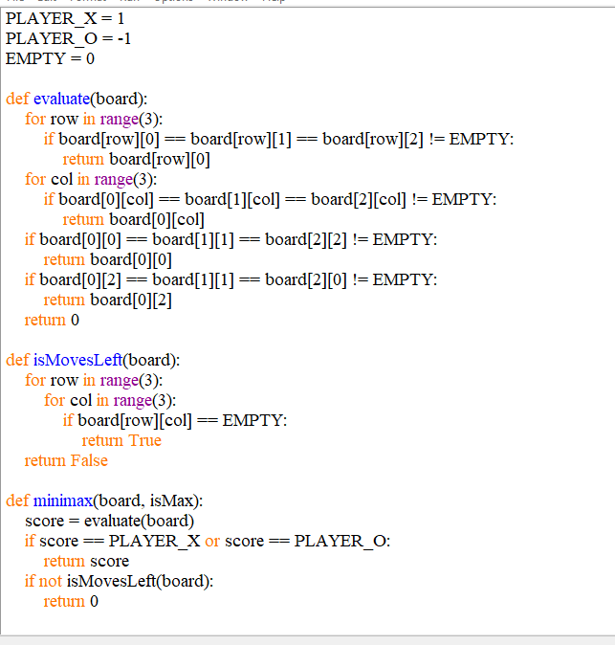

NAME:Sunmathi.S

Roll no:241801283

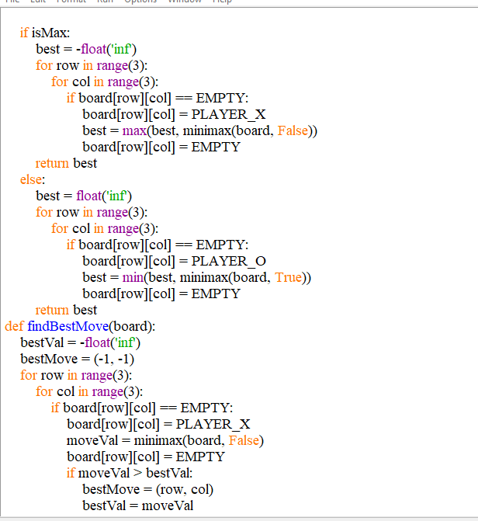

NAME: Sunmathi.S

Roll no: 241801283

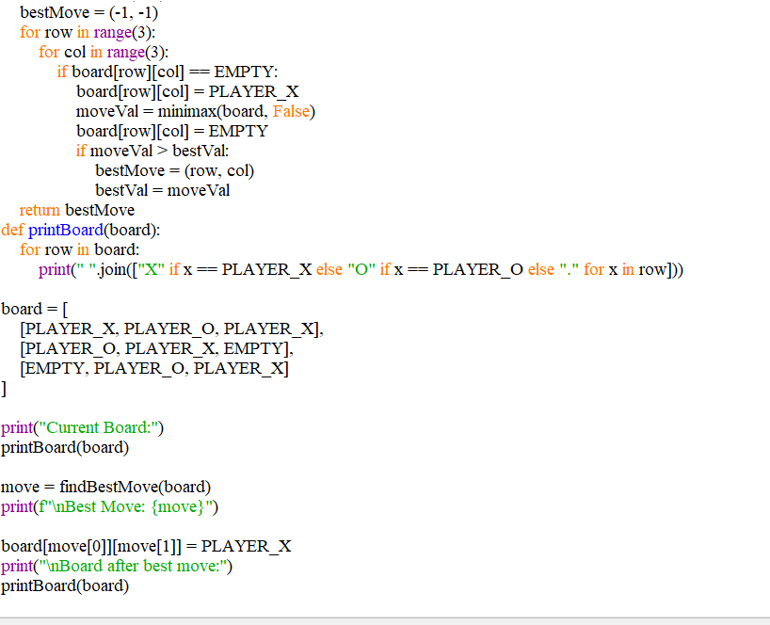

NAME: Sunmathi.S

Roll no: 241801283

**OUTPUT:**

