Name: Sunmathi S

Roll No: 241801283

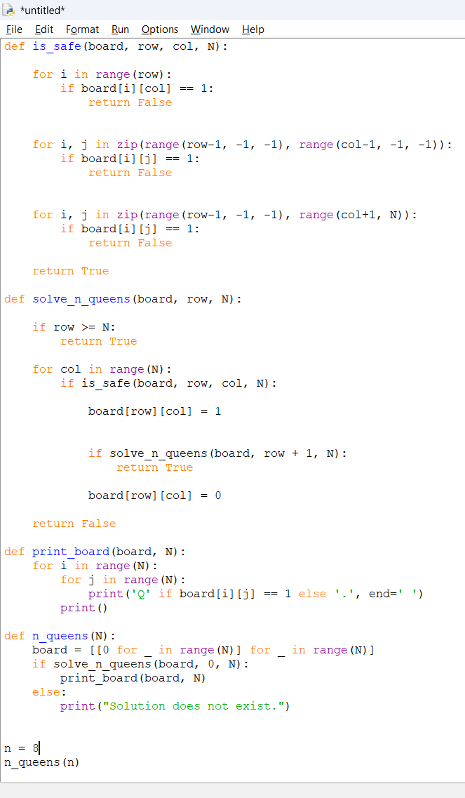

Name: Sunmathi

Roll No: 241801283

