**NAME: SUNMATHI.S**

**ROLL NO: 241801283**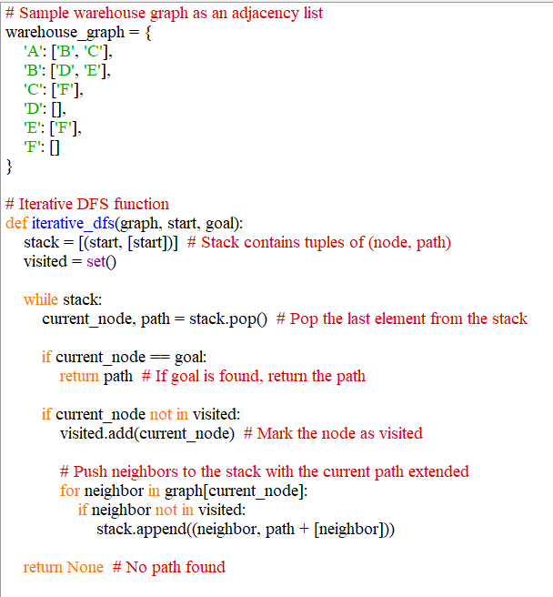

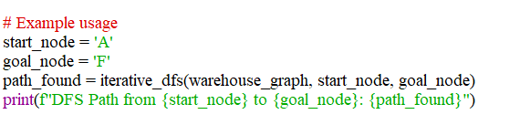

NAME: SUNMATHI.S

ROLL NO: 241801283

OUTPUT:

