INDIA CENSUS 2011
DISTRICT ANALYTICS &
LITERACY ESTIMATION
Data Analytics + Machine Learning Project
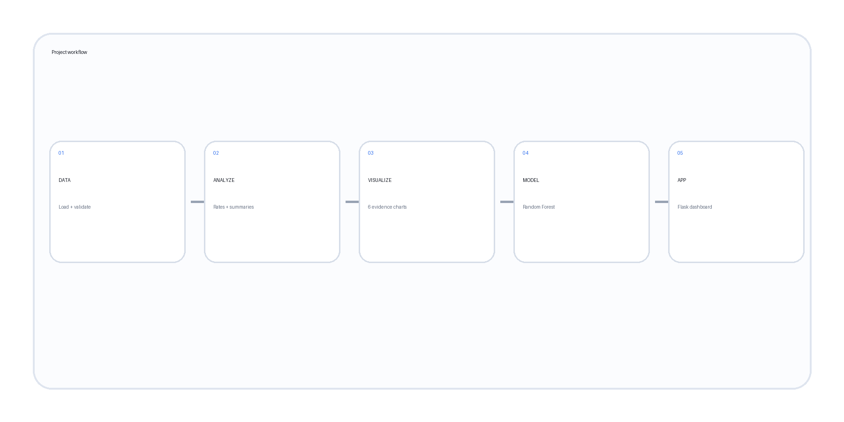
AICTE | IBM SkillsBuild Data Analytics with AI Internship 2026
Final Project Report
Author: Sunnam Mehta
Program: B.Tech Computer Science and Engineering (AI/ML)
Institution: VIT Bhopal University

1. Executive Summary
India Census 2011 — District Analytics & Literacy Estimation is an end-to-end data analytics and machine-learning project built on district-level Indian Census 2011 data. The project cleans and validates the data, creates comparable demographic and household percentages, explores geographic variation through visualizations, and fits a Random Forest regression model to estimate district literacy rate.
The project is packaged as a single Jupyter Notebook containing the data-analysis workflow, model code, Flask REST backend and embedded HTML/CSS/JavaScript frontend. The notebook's current executed results report R² 0.666, MAE 4.86 percentage points and RMSE 6.26 percentage points on the held-out test split.

2. Problem Statement
The objective is to turn Census 2011 district data into a clear analytical system that answers practical questions about population scale, literacy, demographic composition and household infrastructure, while also demonstrating whether selected district-level indicators can support an estimated literacy-rate model.

3. Objectives
- Understand the structure and quality of the district-level Census dataset.
- Compare population, literacy, sex ratio and household infrastructure across states and districts.
- Create clear visual evidence for major geographic patterns.
- Develop a reproducible Random Forest regression model for district literacy rate.
- Expose the analysis through an interactive Flask web application.

4. Dataset Description
The project uses the Kaggle "India Census 2011" dataset published by Dan Ofer, specifically the file "india-districts-census-2011.csv".
Kaggle source: https://www.kaggle.com/danofer/india-census
Specific file page: https://www.kaggle.com/datasets/danofer/india-census?select=india-districts-census-2011.csv
The executed notebook loaded 640 rows and 118 columns, covering 634 unique district names and 35 state/UT labels. The district data contains demographic, literacy, workforce, household and infrastructure-related measures.

5. Data Quality and Preparation
Check | Executed result
Rows loaded | 640
Columns loaded | 118
Unique districts | 634
State/UT labels | 35
Duplicate rows | 0
Missing values in key fields | 0
Cleaned working shape | 640 × 118
Key population and household measures were converted to numeric form. The analysis then created rate-based variables so that districts and states could be compared on a common scale.

6. Derived Metrics
Metric | Formula / meaning
Literacy rate | Literate / Population × 100
Female share | Female / Population × 100
Workers share | Workers / Population × 100
Urban share | Urban households / Households × 100
Electricity % | Households with electric lighting / Households × 100
Internet % | Households with internet / Households × 100
Computer % | Households with computer / Households × 100
LPG/PNG % | LPG/PNG households / Households × 100
Television % | Households with television / Households × 100
Telephone/mobile % | Telephone/mobile households / Households × 100
Vehicle % | Car and motorcycle household ownership percentages
Sex ratio | Female / Male × 1,000

7. Exploratory Data Analysis
Six visual elements from the executed notebook are included below: five geographic comparisons and one machine-learning feature-importance chart.
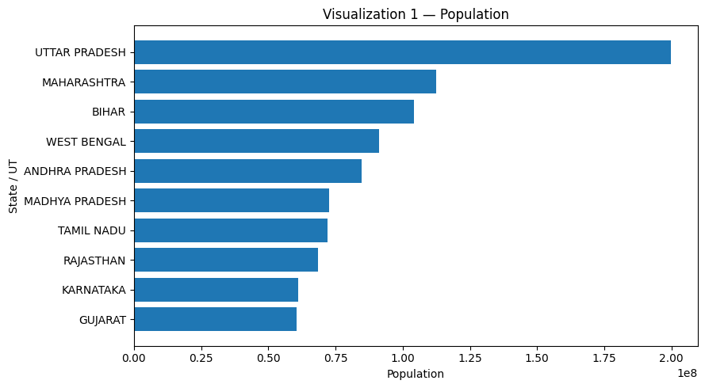
Figure 1. Top 10 state/UT aggregates by population.
Uttar Pradesh is the largest population aggregate among the states shown, followed by Maharashtra and Bihar.
This is a descriptive observation; it does not establish why the observed differences occur.
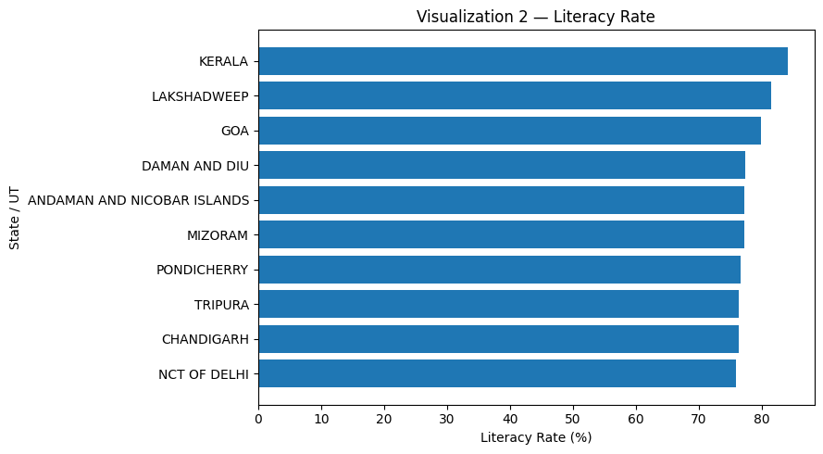
Figure 2. Highest displayed state/UT literacy rates.
Kerala is highest among the displayed group, followed by Lakshadweep and Goa.
This is a descriptive observation; it does not establish why the observed differences occur.
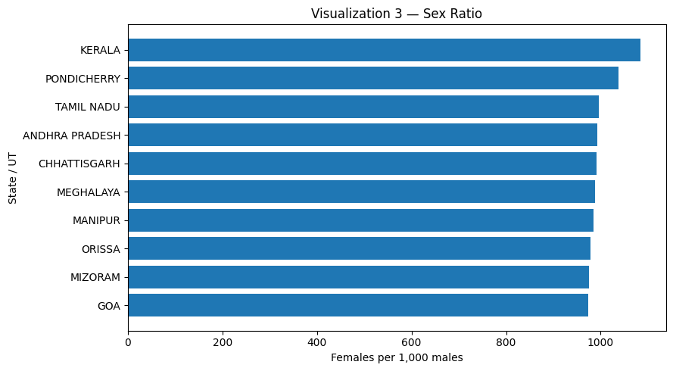
Figure 3. Highest displayed state/UT sex ratios.
Kerala has the highest displayed sex ratio, with other southern and northeastern states also prominent in the selected group.
This is a descriptive observation; it does not establish why the observed differences occur.
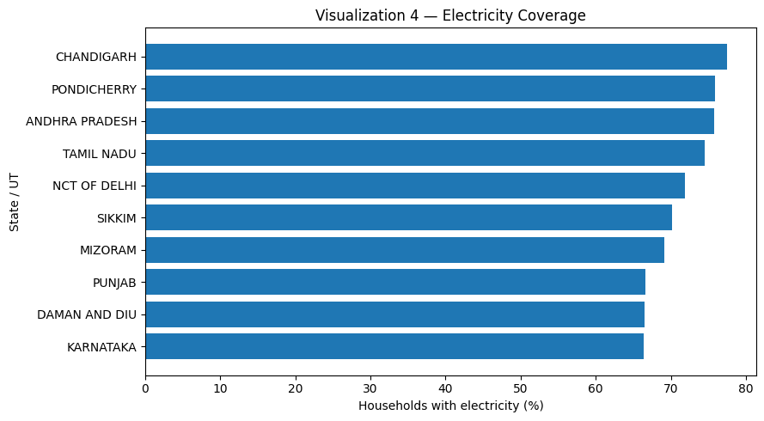
Figure 4. Highest displayed household electricity coverage.
Chandigarh has the highest displayed electricity-coverage value, followed by Pondicherry and Andhra Pradesh.
This is a descriptive observation; it does not establish why the observed differences occur.
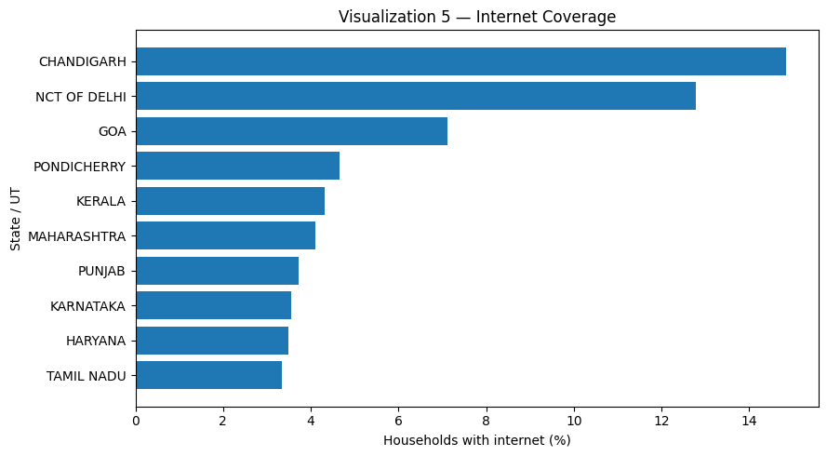
Figure 5. Highest displayed household internet coverage.
Chandigarh has the highest displayed internet-coverage value, followed by NCT of Delhi and Goa.
This is a descriptive observation; it does not establish why the observed differences occur.

8. Key Findings
- Population is concentrated: the largest state aggregates are substantially larger than the rest of the displayed group.
- Literacy varies geographically: the displayed state/UT literacy rates show a wide spread, with Kerala at the top of the selected group.
- Demographic composition varies: sex ratios differ materially among states/UTs.
- Basic infrastructure varies: electricity coverage is not uniform across state aggregates.
- Digital access is uneven: internet coverage differs sharply across the displayed state/UTs.

9. Analytical Hypotheses
1. Districts with higher household electricity and digital-access coverage may also show higher literacy rates.
2. Districts with a larger urban-household share may display different literacy patterns from more rural districts.
3. Differences in workforce composition may be associated with differences in literacy rate.
These hypotheses are possible explanations for observed associations. The dataset and model do not establish causation.

10. Recommendations
1. Use rates and percentages in addition to raw counts when comparing districts or states of different sizes.
2. Use district-level drill-downs when a state average could hide internal variation.
3. Use infrastructure and digital-access measures as additional analytical dimensions alongside literacy.
4. Treat model estimates as analytical support and validate them on newer and larger data before operational use.

11. Machine-Learning Methodology
A Random Forest Regressor is used to estimate district literacy rate. The target is calculated as Literate / Population × 100. The model is trained on eleven derived demographic and household features.
- female_share
- workers_share
- urban_share
- electricity_pct
- internet_pct
- computer_pct
- lpg_pct
- television_pct
- telephone_pct
- car_pct
- motorcycle_pct
The data is split into training and testing subsets using an 80/20 train-test split with random_state=42. The model configuration in the notebook is n_estimators=250, max_depth=8, min_samples_leaf=3 and random_state=42.

12. Model Evaluation
Metric | Result
R² | 0.666
Mean Absolute Error | 4.86 percentage points
Root Mean Squared Error | 6.26 percentage points
An R² of 0.666 means that, for this particular train/test split, the model explains about two-thirds of the variation in the held-out literacy-rate values under the chosen feature set. MAE and RMSE express prediction error in literacy-rate percentage points. These results are dataset- and split-specific and should not be treated as a general national prediction.

13. Feature Importance
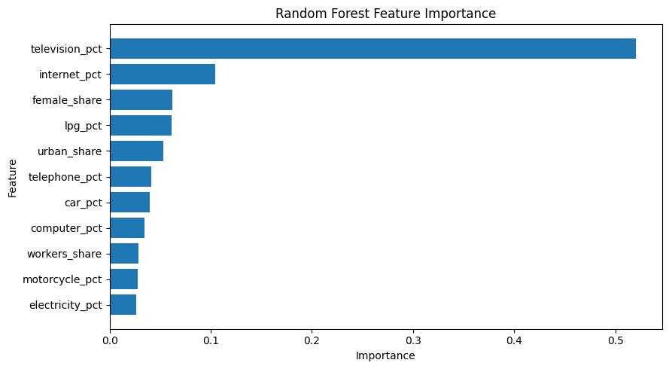
Figure 6. Random Forest feature importance.
In the executed model, television_pct has the largest feature importance, followed by internet_pct and female_share. Feature importance indicates how the fitted model uses the inputs; it is not evidence that any individual feature causes literacy outcomes.

14. Web Application
The same notebook contains a single-file Flask application. The backend exposes JSON endpoints, while the frontend is embedded directly in the notebook using HTML, CSS and JavaScript. Chart.js is loaded from a public CDN for browser-side charts.
Application component | Implementation
Backend | Flask
Data layer | Pandas + NumPy
Model | Scikit-learn Random Forest Regressor
Frontend | HTML + CSS + JavaScript
Interactive charts | Chart.js
District filtering | Flask API + browser-side JavaScript
Prediction API | POST /api/predict

15. API Endpoints
Endpoint | Purpose
/api/summary | Returns project KPIs.
/api/states | Returns state-level population and derived metrics.
/api/districts | Returns district records with optional state filtering.
/api/insights | Returns five analytical insight cards.
/api/model | Returns model metrics and feature importance.
/api/predict | Returns an estimated literacy rate from submitted feature values.
/ | Serves the interactive dashboard.

16. How to Run
1. Install the Python packages from requirements.txt.
2. Open the Jupyter Notebook in Jupyter or Google Colab.
3. Run the cells from top to bottom.
4. The notebook downloads the dataset to data/india-districts-census-2011.csv when the file is not present.
5. Run the final application cell to start Flask on port 5000.
6. Open http://127.0.0.1:5000 in a local Jupyter environment; Google Colab port forwarding is attempted when the helper is available.

17. Limitations and Responsible Use
- The underlying Census data describes 2011 conditions and should not be interpreted as a current 2026 measure.
- The analysis is based on district-level aggregate data rather than individual records.
- The literacy-rate target is derived from Census count fields.
- The model is a baseline trained and evaluated on one train/test split.
- Feature importance is model-specific and does not establish causality.
- Interactive predictions should not be used as a stand-alone basis for consequential decisions about individuals.

18. Conclusion
The project provides a complete analytical pipeline from Census 2011 data to an interactive software product. It combines data validation, feature engineering, descriptive visualization, structured analytical findings, machine learning and a browser-based dashboard. The result is a reproducible educational system for exploring geographic variation and demonstrating literacy-rate estimation from demographic and household indicators.

19. Deliverables
- Sunnam_Mehta_India_Census_2011_Insight.ipynb — complete notebook with embedded visualizations, analysis, model, backend and frontend.
- requirements.txt — Python dependencies.
- README.md — project setup and dataset documentation.
- India_Census_2011_ProjectReport.docx — this report.

