

1. This is the bar graph about the number of the selling product in sunflower in december.

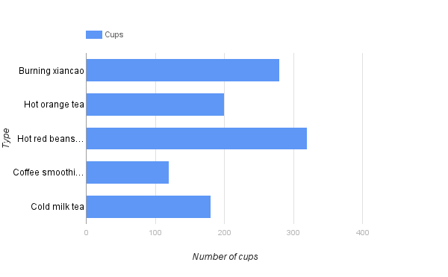

1. This is the bar graph about the value of the rainfall in the Feitsui reservior.

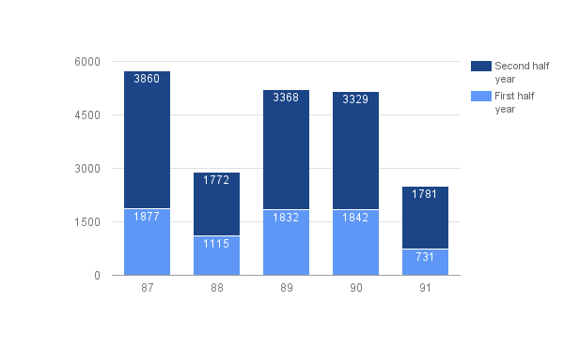

1. This is the bar graph about the national average life expectency in each country.

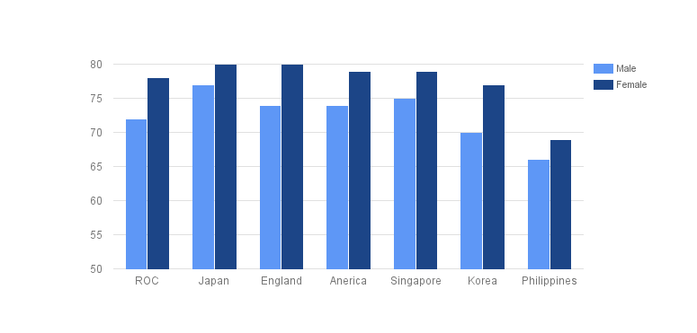

1. The following shows the distribution of the income that the peter got from the work this month.

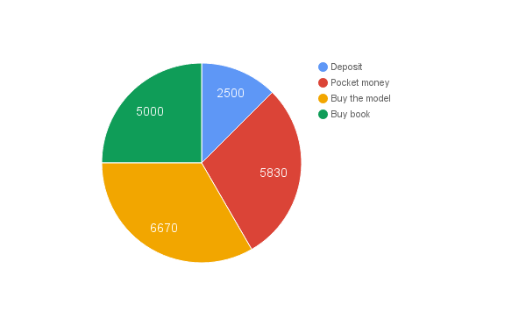

1. The following shows the line chart about the varies of the peter’s weight.

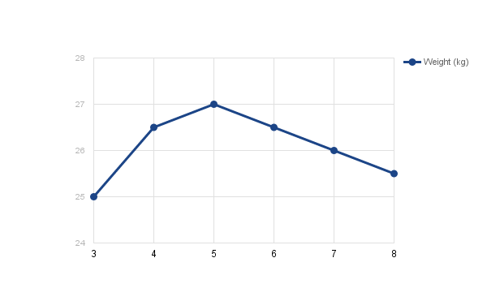

1. The following shows the value of each type of tourist amusement area in taiwan.

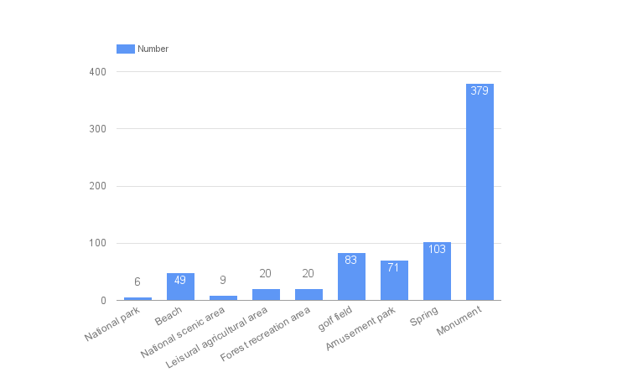

1. This is the statistic which deal with year 85 to 90. The number is the average amount of the garbage each person produce.

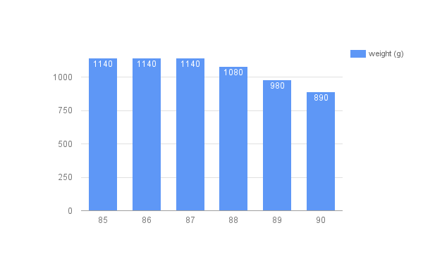

1. This is the result of the book loading number statistic in specific semester in happy school.

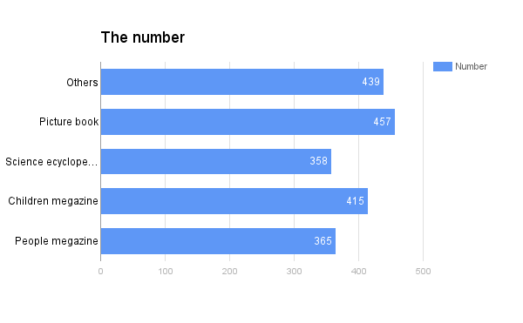

1. This is the number of the computer people have in 7 main city. The statistic unit is every 1,000 people.

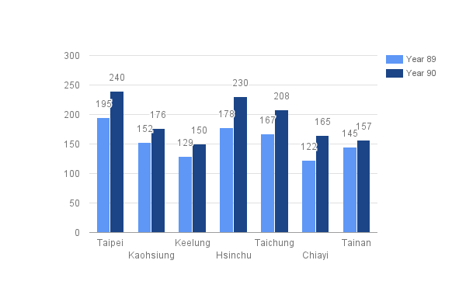

1. This is the line chart about the water usage of Mary’s house in last year.

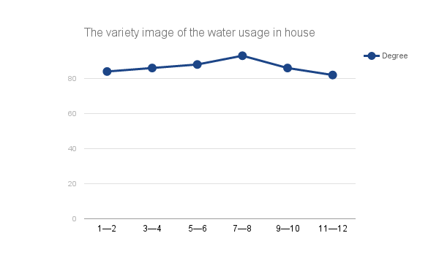

1. This is the bar chart about the number distribution of the 9th councilor in taipei city council.

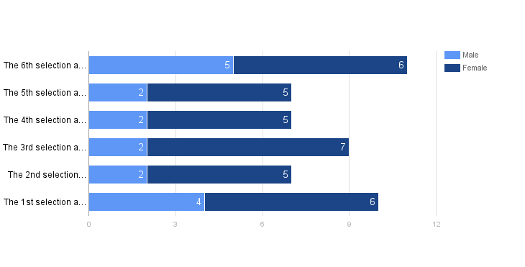

1. This is the variaty line chart of A-fa’s height.

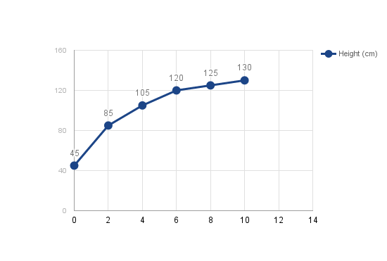

1. The following is the Profit-market statistic which about part of the selling value in last year.

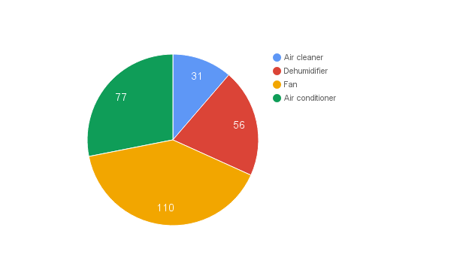

1. The following is the grade distribution line chart about math and scientist in the first mid-term exam.

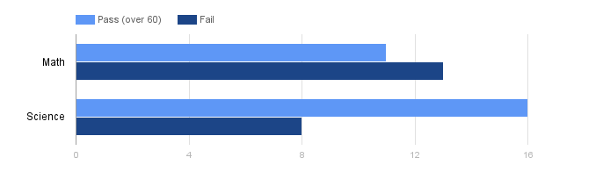

1. The following is the bar chart of people distrubution of the aborigional in four cities.

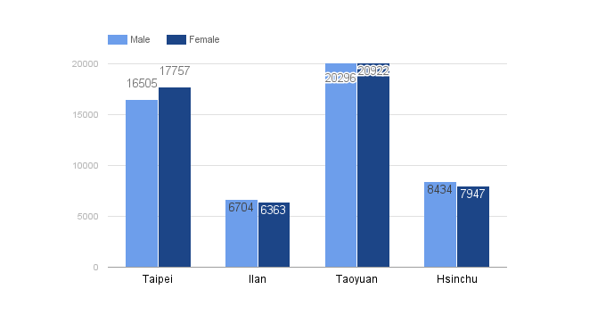

1. This is selling bar chart about the four kinds of product in Da-Da groceries store.

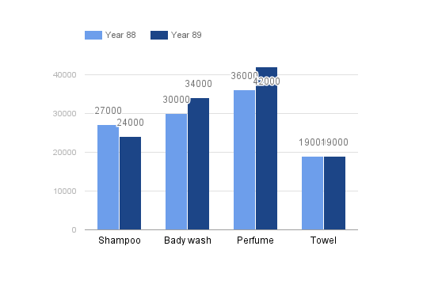

.

.

(1) The small period in the horizential represent ( ) cups.

(2) Which one got the best selling? Hot orange tea, buring xiancao or cold milk tea.

(3) Which type of drink got the best selling? Hot drinks or cold drinks?

(1) The most amount of the rainfall is in ( ) year, and it total has ( ) mm.

(2) From the graph above, Is rainfall of first half year more or less than the second half year?

( )