The box plot (a.k.a. box and whisker diagram) is a standardized way of displaying the distribution of data based on the five number summary: minimum, first quartile, median, third quartile, and maximum. In the simplest box plot the central rectangle spans the first quartile to the third quartile (the interquartile range or IQR). A segment inside the rectangle shows the median and "whiskers" above and below the box show the locations of the minimum and maximum.

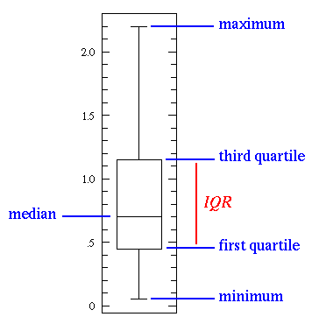

This simplest possible box plot displays the full range of variation (from min to max), the likely range of variation (the IQR), and a typical value (the median). Not uncommonly real datasets will display surprisingly high maximums or surprisingly low minimums called outliers. John Tukey has provided a precise definition for two types of outliers:

