2501report_ShenHongshan
Shen Hongshan
2025-11-20

Predicting Mental Health Treatment Needs Based on Workplace Factors and Demographic Characteristics

Author: Shen Hongshan (3036290936)

Data source: Kaggle Mental Health in Tech Survey

1. Introduction

1.1 Background
Mental health issues in workplace environments represent a significant public health concern with substantial economic and social consequences. Early identification of individuals who need mental health support can facilitate timely intervention, reduce workplace productivity loss, and improve overall well-being. This project addresses the critical need for data-driven approaches to mental health screening in professional settings, particularly in high-pressure sectors like technology.
This project, analyzes the OSMI Mental Health in Tech Survey dataset from Kaggle to model how workplace conditions and demographic factors are associated with issue. The dataset contains survey responses to workplace, demographic and mental health questions, providing rich information for data-driven analysis of this spublic health issue.

1.2 Data science question
The analysis focuses on two primary research questions:
- What are the most significant demographics and workplace features associated with employees seeking mental health treatment?
- Based on these associations, what targeted interventions can employers prioritize?

1.3 Methodological Challenges
Challenges are anticipated in this analysis, including handling class imbalance in the target variable, managing missing survey data, and addressing potential response bias.The subjective nature of self-reported mental health data may introduce measurement noise, requiring careful data cleaning and validation approaches.

2. Data Loading & Cleaning

2.1 Data loading
library(tidyverse)
library(readr)
library(dplyr)
library(ggplot2)
library(knitr)
library(caret)
library(broom)
library(car) # for VIF
library(pROC)
library(patchwork)
# Read the dataset (make sure 'survey.csv' is in the same folder)
survey_data <- read_csv("survey.csv")
# Overview: dimensions and column names
cat("Dataset dimensions:", dim(survey_data), "\n")
## Dataset dimensions: 1259 27
cat("Column names:\n")
## Column names:
names(survey_data)
## [1] "Timestamp" "Age"
## [3] "Gender" "Country"
## [5] "state" "self_employed"
## [7] "family_history" "treatment"
## [9] "work_interfere" "no_employees"
## [11] "remote_work" "tech_company"
## [13] "benefits" "care_options"
## [15] "wellness_program" "seek_help"
## [17] "anonymity" "leave"
## [19] "mental_health_consequence" "phys_health_consequence"
## [21] "coworkers" "supervisor"
## [23] "mental_health_interview" "phys_health_interview"
## [25] "mental_vs_physical" "obs_consequence"
## [27] "comments"

2.2 Handle Missing Values, drop Irrelevant biased sampled variables
- Check the number of missing value for each variable, delete those with too many NAs: comments, state
- delete irrelevant variable for analysis: Timestamp
- delete biased sampled variable: Country (60% from USA, most countries which have only 1 respondents)
# Missing value summary
data.frame(Missing_data=sort(colSums(is.na(survey_data)),decreasing=TRUE))
## Missing_data
## comments 1096
## state 515
## work_interfere 264
## self_employed 18
## Timestamp 0
## Age 0
## Gender 0
## Country 0
## family_history 0
## treatment 0
## no_employees 0
## remote_work 0
## tech_company 0
## benefits 0
## care_options 0
## wellness_program 0
## seek_help 0
## anonymity 0
## leave 0
## mental_health_consequence 0
## phys_health_consequence 0
## coworkers 0
## supervisor 0
## mental_health_interview 0
## phys_health_interview 0
## mental_vs_physical 0
## obs_consequence 0
# Drop columns with too many NAs or irrelevant for analysis (comments, Timestamp, state)
survey_clean0 <- survey_data |>
select(-Timestamp, -Country, -comments, -state)
cat("Columns left after removal:", names(survey_clean0))
## Columns left after removal: Age Gender self_employed family_history treatment work_interfere no_employees remote_work tech_company benefits care_options wellness_program seek_help anonymity leave mental_health_consequence phys_health_consequence coworkers supervisor mental_health_interview phys_health_interview mental_vs_physical obs_consequence

2.3 Standardize Variables
- Convert Gender variable into standard level: Male/ Female/ Transgender/Non-binary/Others
- Remove unrealistic Age input, only maintain age within 18~100 years old
- sort the levels for better visualization latter: work_interfere(4 level), leave(5 level), no_employees(6 level)
survey_clean0 <- survey_clean0 |>
mutate(
# Gender standardization
Gender = case_when(
str_detect(tolower(Gender), "^m|^male|^man|^maile|^make|^mal$|^male-ish|^guy") ~ "Male",
str_detect(tolower(Gender), "^f|^female|^woman|^femaile|^femake|^fem") ~ "Female",
TRUE ~ "Transgender/Non-binary/Others"
),
# Convert character columns to factors
across(where(is.character), as.factor)
)
# Handle age outliers
survey_clean0 <- survey_clean0 |>
mutate(
Age = case_when(
Age < 18 ~ NA, # Remove unrealistic ages
Age > 100 ~ NA,
TRUE ~ Age
)
) |>
filter(!is.na(Age)) # Remove rows with invalid ages
#sort the levels of variables
survey_clean0$work_interfere <-
factor(survey_clean0$work_interfere,levels = c("Never", "Rarely", "Sometimes", "Often"))
survey_clean0$leave <-
factor(survey_clean0$leave,levels = c("Very difficult","Somewhat difficult","Somewhat easy","Very easy","Don't know"))
survey_clean0$no_employees <-
factor(survey_clean0$no_employees,levels = c("1-5", "6-25", "26-100", "100-500", "500-1000", "More than 1000"))

2.3 Combine variables with similar meaning
- The variables “benefits,” “care_options,” “wellness_program,” and “seek_help” each measure a different facet of employers’ support for mental health. So, they can be consolidated into a single variable, “mental_care,” with a binary (Yes/No) level.
survey_clean <- survey_clean0|>
mutate(mental_care=if_any(c(benefits, care_options, wellness_program, seek_help), ~ . == "Yes"))
survey_clean<- survey_clean|>
select(-benefits, -care_options, -wellness_program, -seek_help)

3. Exploratory Data Analysis & Visualization

3.1 Target Variable Check
- The target variable “treatment” indicates whether an employee is currently seeking treatment for a mental health condition.
- 49.48% report No and 50.52% report Yes, which underscoring the significance of mental health conditions in the workplace.
#Distribution of treatment status
as.data.frame(table(survey_clean$treatment))
## Var1 Freq
## 1 No 619
## 2 Yes 632
#Proportion table
as.data.frame(prop.table(table(survey_clean$treatment)))
## Var1 Freq
## 1 No 0.4948042
## 2 Yes 0.5051958

3.2 Demographic Overview
- sample is skewed to male by Gender, thus it is important to notice the potential bias caused by this during analysis
demographic_summary <- survey_clean %>%
summarise(
n = n(),
avg_age = mean(Age, na.rm = TRUE),
male_pct = round(mean(Gender == "Male")*100,1),
female_pct = round(mean(Gender == "Female")*100,1),
treatment_rate = round(mean(treatment == "Yes")*100,1)
)
#Sample Demographic Summary
demographic_summary
## # A tibble: 1 × 5
## n avg_age male_pct female_pct treatment_rate
## <int> <dbl> <dbl> <dbl> <dbl>
## 1 1251 32.1 78.7 19.8 50.5

3.3 Key Visualizations
- Treatment rate by Age, Gender, family_history, work_interference, mental_care, tech_company
# prepare Age-treatment information for visualization
Age_summary<-survey_clean|>
group_by(Age)|>
summarise(
n_total = n(),
n_treatment = sum(treatment == "Yes", na.rm = TRUE),
prop_treatment = n_treatment / n_total,
.groups = "drop"
)|>
filter(n_total>=5)
#
Age_visualization<-ggplot(Age_summary , aes(x = Age, y = prop_treatment, size = n_total)) +
geom_point(alpha = 0.6) +
geom_smooth(alpha = 0.2)+
theme_minimal()+
theme(legend.position = "none")
Age_visualization
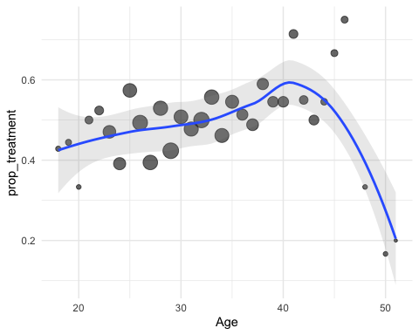
# proportion of answers for different features
feature_prop <- function(data, var, var_name) {
# Use tidy evaluation with {{var}}
percentage_data <- data |>
count({{var}}) |>
mutate(Percentage = n / sum(n))
# Create plot
ggplot(percentage_data, aes(x = {{var}}, y = Percentage, fill = {{var}})) +
geom_bar(stat = "identity") +
scale_y_continuous(labels = scales::percent_format(),
limits = c(0, max(percentage_data$Percentage) * 1.15)) +
labs(title = paste(var_name, "of Survey Respondents"),
x = var_name, y = "Percentage") +
theme_minimal() +
theme(legend.position = "none")
}
# Treatment rate by feature (function) - FIXED to use tidy evaluation
treatment_prop <- function(data, feature, feature_name) {
ggplot(data, aes(x = {{feature}}, fill = treatment)) +
geom_bar(position = "fill") +
labs(y = "Proportion", x = feature_name) +
scale_y_continuous(labels = scales::percent) +
theme_minimal()
}
#plots for each feature
feature_prop(survey_clean, Gender, "Gender")+
treatment_prop(survey_clean, Gender, "Gender")
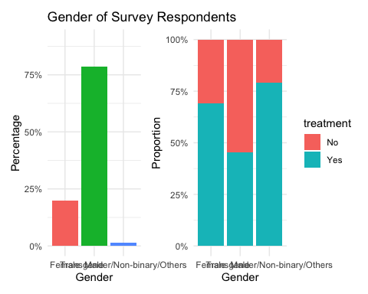
feature_prop(survey_clean, family_history, "Family History")+
treatment_prop(survey_clean, family_history, "Family History")
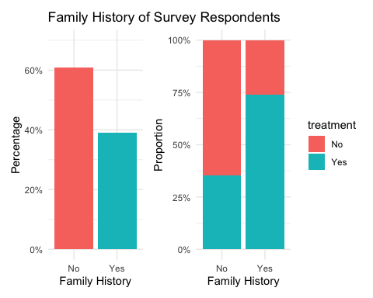
feature_prop(survey_clean, work_interfere, "Work Interference")+
treatment_prop(survey_clean, work_interfere, "Work Interference")
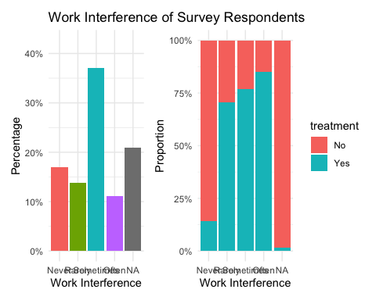
feature_prop(survey_clean, tech_company, "Tech Company")+
treatment_prop(survey_clean, tech_company, "Tech Company")
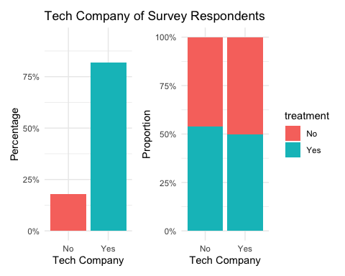
feature_prop(survey_clean, remote_work, "remote_work")+
treatment_prop(survey_clean, remote_work, "remote_work")
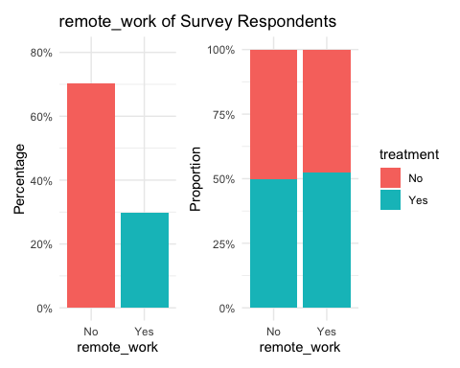
feature_prop(survey_clean, self_employed, "self_employed")+
treatment_prop(survey_clean, self_employed, "self_employed")
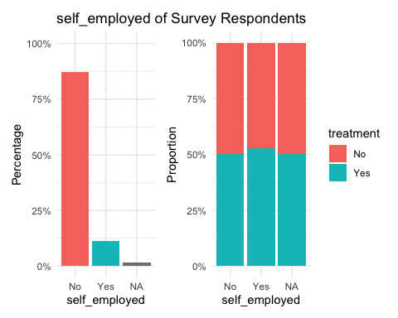
#company resourses
feature_prop(survey_clean, mental_care, "Mental Health Care")+
treatment_prop(survey_clean, mental_care, "Mental Health Care")
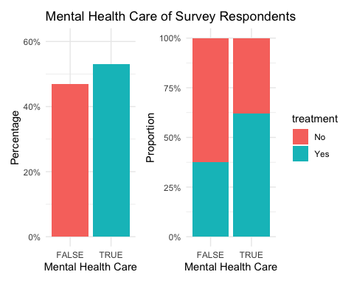
feature_prop(survey_clean, anonymity, "anonymity for mental health information")+
treatment_prop(survey_clean, anonymity, "anonymity for mental health information")
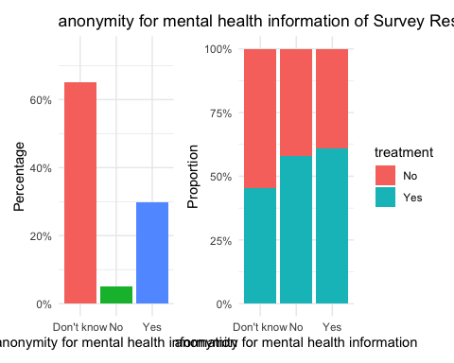
feature_prop(survey_clean, leave, "availability for taking medical leave for mental treatment")+
treatment_prop(survey_clean, leave, "availability for taking medical leave for mental treatment")
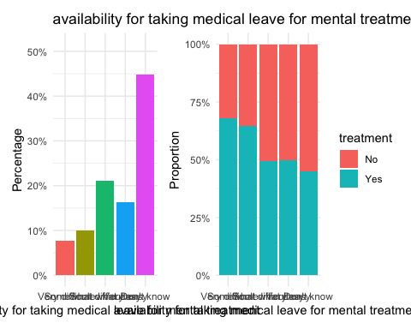
feature_prop(survey_clean, coworkers,"feel free to discuss mental issue with coworkers")+
treatment_prop(survey_clean,coworkers,"feel free to discuss mental issue with coworkers")
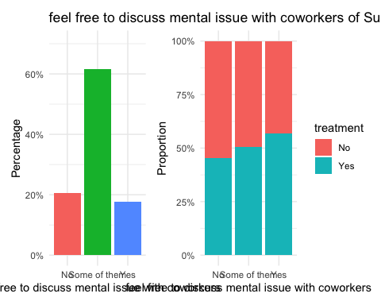

3.4 Insights
- Age: Treatment needs show a continuous increase from age 18, peaking at around 40 years old, followed by a significant decline in later years. This pattern may reflect several factors: increased mental health awareness and openness to treatment in middle adulthood, workplace stressors reaching their peak during career-building years, or potentially changing attitudes toward mental health across generations.
- Gender: Females show approximately 20% higher treatment rates compared to males, while non-binary and gender-diverse individuals demonstrate over 80% need for mental treatment.
- family_history: Those who have a family history of mental illness are around 35% more likely to get treatment rather than without a family history. This aligns with clinical understanding, as family history is a well-established risk factor for many mental health disorders.
- Work_interfere: Respondents who report that mental health concerns “often” interfere with their work show the highest treatment rates, while those reporting “never” experiencing work interference show the lowest. This suggests that work interference serves as a significant motivator for seeking treatment, highlighting the importance of workplace mental health interventions.
- tech_company/ self_employed: The little difference in treatment rates between tech company employees, non-tech employees, and self-employed individuals suggests that industry type and employment structure have limited influence on treatment-seeking behavior.
- Mental healthcare/ anonymity/ leave: Companies that provide comprehensive mental health care programs—including confidential counseling services, robust privacy protections for mental health information, and clear mental health leave policies—show significantly higher treatment rates among employees. This supports the implementation of workplace mental health programs and policies are effective strategy for increasing treatment engagement.

4. Modelling & Statistical Analysis

4.1 Prepare Data for Modelling
# Create binary target variable
survey_model <- survey_clean %>%
mutate(
treatment_binary = ifelse(treatment == "Yes", 1, 0)
)
# Select key predictors as per project proposal
predictors <- c(
"Age", "Gender", "family_history",
"work_interfere", "no_employees", "remote_work", "tech_company",
"mental_care",
"anonymity", "leave",
"mental_health_consequence", "phys_health_consequence",
"coworkers", "supervisor", "mental_health_interview",
"mental_vs_physical", "obs_consequence"
)
model_data <- survey_model |>
select(all_of(c("treatment_binary", predictors))) |>
na.omit() ##删除数据缺失行
head(model_data)
## # A tibble: 6 × 18
## treatment_binary Age Gender family_history work_interfere no_employees
## <dbl> <dbl> <fct> <fct> <fct> <fct>
## 1 1 37 Female No Often 6-25
## 2 0 44 Male No Rarely More than 1000
## 3 0 32 Male No Rarely 6-25
## 4 1 31 Male Yes Often 26-100
## 5 0 31 Male No Never 100-500
## 6 0 33 Male Yes Sometimes 6-25
## # ℹ 12 more variables: remote_work <fct>, tech_company <fct>,
## # mental_care <lgl>, anonymity <fct>, leave <fct>,
## # mental_health_consequence <fct>, phys_health_consequence <fct>,
## # coworkers <fct>, supervisor <fct>, mental_health_interview <fct>,
## # mental_vs_physical <fct>, obs_consequence <fct>

4.2 Split Data: Train/Test
set.seed(42)
train_idx <- createDataPartition(model_data$treatment_binary, p=0.7, list=FALSE)
train_data <- model_data[train_idx, ]
test_data <- model_data[-train_idx, ]
cat("Training set size:", nrow(train_data), "\n")
## Training set size: 693
cat("Test set size:", nrow(test_data), "\n")
## Test set size: 296

4.3 Logistic Regression Model
target variable & feature variable are both discrete, most of them with only 2~3 levels. So, we can not use linear regression, but logistic regression to explore what are the significant features associated with our target value “treatment”
logit_model <- glm(treatment_binary ~ ., data=train_data, family="binomial")
cat("Model summary (logistic regression):\n")
## Model summary (logistic regression):
summary(logit_model)
##
## Call:
## glm(formula = treatment_binary ~ ., family = "binomial", data = train_data)
##
## Coefficients:
## Estimate Std. Error z value Pr(>|z|)
## (Intercept) -3.05835 0.89832 -3.405 0.000663 ***
## Age 0.03011 0.01450 2.077 0.037837 *
## GenderMale -0.79747 0.28035 -2.845 0.004448 **
## GenderTransgender/Non-binary/Others 0.19497 0.91680 0.213 0.831584
## family_historyYes 1.08318 0.21276 5.091 3.56e-07 ***
## work_interfereRarely 2.11481 0.32405 6.526 6.75e-11 ***
## work_interfereSometimes 2.68910 0.29640 9.072 < 2e-16 ***
## work_interfereOften 2.88780 0.38183 7.563 3.94e-14 ***
## no_employees6-25 0.36963 0.35319 1.047 0.295310
## no_employees26-100 0.65790 0.36357 1.810 0.070367 .
## no_employees100-500 0.70573 0.43058 1.639 0.101205
## no_employees500-1000 0.85216 0.60058 1.419 0.155930
## no_employeesMore than 1000 0.26291 0.37641 0.698 0.484892
## remote_workYes 0.01822 0.23748 0.077 0.938838
## tech_companyYes -0.06577 0.28103 -0.234 0.814958
## mental_careTRUE 0.57800 0.22927 2.521 0.011699 *
## anonymityNo -0.01578 0.45670 -0.035 0.972441
## anonymityYes 0.47029 0.26063 1.804 0.071163 .
## leaveSomewhat difficult -0.27922 0.47677 -0.586 0.558115
## leaveSomewhat easy -0.72958 0.44131 -1.653 0.098288 .
## leaveVery easy -0.32236 0.48513 -0.664 0.506384
## leaveDon't know -0.51625 0.41638 -1.240 0.215023
## mental_health_consequenceNo -0.25477 0.28531 -0.893 0.371878
## mental_health_consequenceYes -0.11745 0.30379 -0.387 0.699050
## phys_health_consequenceNo 0.17988 0.27915 0.644 0.519329
## phys_health_consequenceYes -0.61063 0.48552 -1.258 0.208507
## coworkersSome of them 0.44016 0.28520 1.543 0.122747
## coworkersYes 1.09031 0.42254 2.580 0.009870 **
## supervisorSome of them -0.25823 0.29497 -0.875 0.381345
## supervisorYes -0.32457 0.33779 -0.961 0.336621
## mental_health_interviewNo 0.31513 0.31713 0.994 0.320365
## mental_health_interviewYes 0.16143 0.72359 0.223 0.823457
## mental_vs_physicalNo -0.04933 0.26430 -0.187 0.851929
## mental_vs_physicalYes 0.04360 0.29458 0.148 0.882340
## obs_consequenceYes 0.23140 0.30289 0.764 0.444886
## ---
## Signif. codes: 0 '***' 0.001 '**' 0.01 '*' 0.05 '.' 0.1 ' ' 1
##
## (Dispersion parameter for binomial family taken to be 1)
##
## Null deviance: 903.92 on 692 degrees of freedom
## Residual deviance: 622.27 on 658 degrees of freedom
## AIC: 692.27
##
## Number of Fisher Scoring iterations: 5

Predictors sorted by p-value (significance)
significant_predictors <- broom::tidy(logit_model) |>
arrange(p.value)
significant_predictors
## # A tibble: 35 × 5
## term estimate std.error statistic p.value
## <chr> <dbl> <dbl> <dbl> <dbl>
## 1 work_interfereSometimes 2.69 0.296 9.07 1.16e-19
## 2 work_interfereOften 2.89 0.382 7.56 3.94e-14
## 3 work_interfereRarely 2.11 0.324 6.53 6.75e-11
## 4 family_historyYes 1.08 0.213 5.09 3.56e- 7
## 5 (Intercept) -3.06 0.898 -3.40 6.63e- 4
## 6 GenderMale -0.797 0.280 -2.84 4.45e- 3
## 7 coworkersYes 1.09 0.423 2.58 9.87e- 3
## 8 mental_careTRUE 0.578 0.229 2.52 1.17e- 2
## 9 Age 0.0301 0.0145 2.08 3.78e- 2
## 10 no_employees26-100 0.658 0.364 1.81 7.04e- 2
## # ℹ 25 more rows

Feature Importance Plot
feature_importance <- broom::tidy(logit_model) %>%
filter(term != "(Intercept)") %>%
mutate(odds_ratio=exp(estimate),
direction=ifelse(estimate>0,"Increased","Decreased")) %>%
arrange(desc(abs(estimate)))
top_features <- feature_importance %>% head(15)
ggplot(top_features, aes(x=reorder(term, estimate), y=estimate, fill=direction)) +
geom_col() +
coord_flip() +
labs(title="Top 15 Most Important Predictors of Mental Health Treatment Need",
x="Predictor", y="Estimate (log-odds)", fill="Direction") +
theme_minimal()
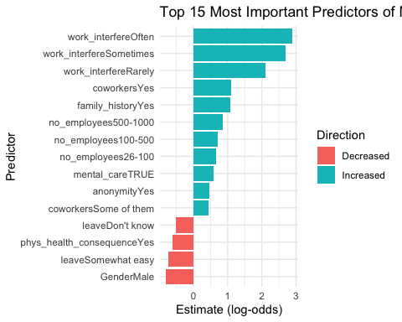

4.4 Insights
- Work interference is the single strongest signal: respondents saying their mental health often interferes with work are far more likely to be in treatment. This supports screening based on self‑reported work interference.
- Family history and coworker openness are also meaningful predictors. Family history increases risk, and feeling free to discuss with coworkers is positively associated with being in treatment, reflecting greater willingness to seek help or workplaces where issues are more openly discussed.
- Company provisions (mental_care TRUE, anonymity TRUE) are positively associated with treatment.This can mean:
  - access to care increases uptake
  - companies experiencing higher demand put programs in place (reverse causality)
  - confounding by unmeasured factors.
- Male gender is associated with lower odds of being in treatment. That likely reflects differing help‑seeking behavior, not necessarily lower need.

5. Model Evaluation

ROC Curve
- ROC plots sensitivity (true positive rate) vs 1 − specificity (false positive rate) over thresholds. The curve is well above the diagonal: model discriminates much better than random.
- AUC = 0.8476716 indicates good ranking/discrimination: the model usually gives higher predicted probabilities to respondents who are actually in treatment than to those who are not.
test_data$predicted_prob <- predict(logit_model, newdata=test_data, type="response")
test_data$predicted_class <- ifelse(test_data$predicted_prob > 0.5, 1, 0)
test_conf <- confusionMatrix(as.factor(test_data$predicted_class), as.factor(test_data$treatment_binary))
print(test_conf)
## Confusion Matrix and Statistics
##
## Reference
## Prediction 0 1
## 0 69 15
## 1 44 168
##
## Accuracy : 0.8007
## 95% CI : (0.7506, 0.8447)
## No Information Rate : 0.6182
## P-Value [Acc > NIR] : 1.045e-11
##
## Kappa : 0.5559
##
## Mcnemar's Test P-Value : 0.0002671
##
## Sensitivity : 0.6106
## Specificity : 0.9180
## Pos Pred Value : 0.8214
## Neg Pred Value : 0.7925
## Prevalence : 0.3818
## Detection Rate : 0.2331
## Detection Prevalence : 0.2838
## Balanced Accuracy : 0.7643
##
## 'Positive' Class : 0
##
roc_curve <- roc(test_data$treatment_binary, test_data$predicted_prob)
cat("AUC on test:", auc(roc_curve), "\n")
## AUC on test: 0.8476716
plot(roc_curve, main="ROC Curve for Mental Health Treatment Prediction", col="blue", lwd=3)
abline(a=0, b=1, col="grey", lty=2)
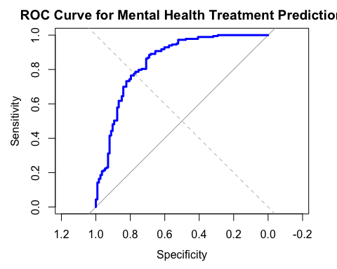

Prediction (training set)
- Strength of model:
High Specificity (91.91%): Excellent at identifying people who truly need treatment
Good Overall Accuracy (80.23%): Beats baseline by 16 percentage points
Balanced Precision: Similar precision for both classes (~80%)
Statistical Significance: Results are not due to chance
- Concerns
Low Sensitivity (59.27%): Poor at identifying people who don’t need treatment
Imbalanced Performance: Much better at detecting treatment needs than non-needs
Potential Over-intervention: 40.73% of “No treatment” people are incorrectly flagged
train_data$predicted_prob <- predict(logit_model, type="response")
train_data$predicted_class <- ifelse(train_data$predicted_prob > 0.5, 1, 0)
train_conf <- confusionMatrix(as.factor(train_data$predicted_class), as.factor(train_data$treatment_binary))
print(train_conf)
## Confusion Matrix and Statistics
##
## Reference
## Prediction 0 1
## 0 147 36
## 1 101 409
##
## Accuracy : 0.8023
## 95% CI : (0.7707, 0.8313)
## No Information Rate : 0.6421
## P-Value [Acc > NIR] : < 2.2e-16
##
## Kappa : 0.5434
##
## Mcnemar's Test P-Value : 4.554e-08
##
## Sensitivity : 0.5927
## Specificity : 0.9191
## Pos Pred Value : 0.8033
## Neg Pred Value : 0.8020
## Prevalence : 0.3579
## Detection Rate : 0.2121
## Detection Prevalence : 0.2641
## Balanced Accuracy : 0.7559
##
## 'Positive' Class : 0
##
# vusualize confusion data
conf_matrix_data <- as.data.frame(as.table(train_conf$table))
names(conf_matrix_data) <- c("Predicted", "Actual", "Freq")
# calculate relevant statistics
conf_matrix_data <- conf_matrix_data %>%
group_by(Actual) %>%
mutate(
Percentage = Freq / sum(Freq) * 100,
Label = paste0(Freq, "\n(", round(Percentage, 1), "%)")
)
# plot heatmap ofr confusion matrix
ggplot(conf_matrix_data, aes(x = Actual, y = Predicted, fill = Freq)) +
geom_tile(color = "white", alpha = 0.8) +
geom_text(aes(label = Label), color = "black", size = 5) +
scale_fill_gradient(low = "#F8F9FA", high = "blue", name = "frequency") +
labs(
title = "heatmap ofr confusion matrix",
subtitle = paste("Accuracy:", round(train_conf$overall["Accuracy"]*100, 1), "%"),
x = "Actural class",
y = "Predicted class",
caption = paste("sensitivity:", round(train_conf$byClass["Sensitivity"]*100, 1), "% |",
"Specificity:", round(train_conf$byClass["Specificity"]*100, 1), "%")
) +
theme_minimal()
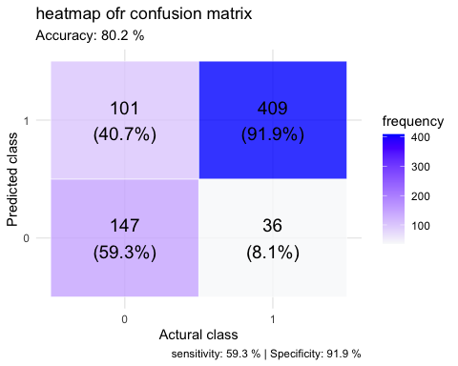

6. Answering data science questions

6.1. How to identify potential mental issue, In other words, what features are most predictive of needing mental health treatment?
- We identified that family history, work interference, and workplace support systems are among the strongest predictors of mental health treatment need. (detailed analysis seen in section 3.4 & 4.4)

6.2 What could employers do to reduce mental issue’s risks?
- A logistic regression model giving the most predictive factors can reasonably identify potnetial employees at higher risk.
- Companies should focus on improving support policies for employees showing risk factors.
  - easier access to applying for medical leave due to mental issue
  - protect workers anonymity regarding mental health issue, and creating a non-judgmental environment
- Increasing mental health care benefits, easy-access mental care treatment resources.
  - interesting to notice the different approach that may apply to different Gender (see visualization below!)
    - women are more sensitive to mental care benefit (money): providing more money on mental health care have a greater positive effect on seeking treatment for women(nearly 30% more) compared to men(around 10% more).
    - on the other hand, men are more sensitive to giving health care access: providing more money on mental health care have a greater positive effect on seeking treatment for men(around 15% increase) compared to women(lower than 5% increase).
    - giving direct mental care options at work place, is the most effective way to encourage employees seeking treatment, for both men and women.
# 1. Interaction Effects Visualization - benefit * Gender
gender_care_data <- survey_clean0 |>
filter(Gender!="Transgender/Non-binary/Others")|>
mutate(
treatment_binary = ifelse(treatment == "Yes", 1, 0)
)|>
group_by(Gender, benefits) |>
summarise(
treatment_rate = mean(treatment_binary),
n = n(),
.groups = 'drop'
)
ggplot(gender_care_data, aes(x = Gender, y = treatment_rate, fill = benefits)) +
geom_bar(stat = "identity", position = "dodge") +
geom_text(aes(label = paste0(round(treatment_rate*100, 1), "%")),
position = position_dodge(width = 0.9), vjust = -0.5) +
labs(
title = "Interaction Effect: Gender × mental health benefits",
x = "Gender",
y = "Treatment Rate",
fill = "Company Provides\nMental Health Benefits"
) +
theme_minimal() +
scale_y_continuous(labels = scales::percent) +
scale_fill_brewer(palette = "Set2")
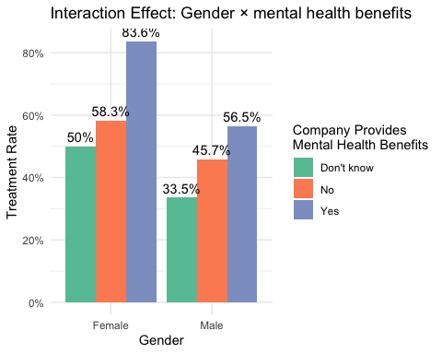
# 2. Interaction Effects Visualization - seek_help * Gender
gender_care_data <- survey_clean0 |>
filter(Gender!="Transgender/Non-binary/Others")|>
mutate(
treatment_binary = ifelse(treatment == "Yes", 1, 0)
)|>
group_by(Gender, seek_help) |>
summarise(
treatment_rate = mean(treatment_binary),
n = n(),
.groups = 'drop'
)
ggplot(gender_care_data, aes(x = Gender, y = treatment_rate, fill = seek_help)) +
geom_bar(stat = "identity", position = "dodge") +
geom_text(aes(label = paste0(round(treatment_rate*100, 1), "%")),
position = position_dodge(width = 0.9), vjust = -0.5) +
labs(
title = "Interaction Effect: Gender × Access to help",
x = "Gender",
y = "Treatment Rate",
fill = "Company Provides\nAccess to help"
) +
theme_minimal() +
scale_y_continuous(labels = scales::percent) +
scale_fill_brewer(palette = "Set2")
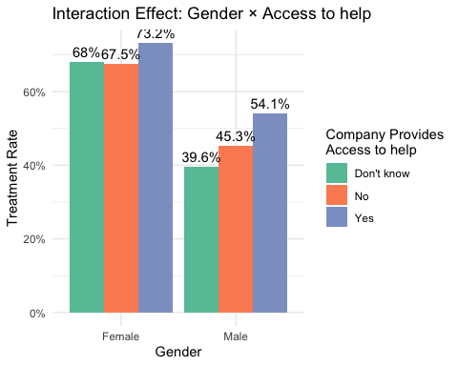
# 3. Interaction Effects Visualization - care_options * Gender
gender_care_data <- survey_clean0 |>
filter(Gender!="Transgender/Non-binary/Others")|>
mutate(
treatment_binary = ifelse(treatment == "Yes", 1, 0)
)|>
group_by(Gender, care_options) |>
summarise(
treatment_rate = mean(treatment_binary),
n = n(),
.groups = 'drop'
)
ggplot(gender_care_data, aes(x = Gender, y = treatment_rate, fill = care_options)) +
geom_bar(stat = "identity", position = "dodge") +
geom_text(aes(label = paste0(round(treatment_rate*100, 1), "%")),
position = position_dodge(width = 0.9), vjust = -0.5) +
labs(
title = "Interaction Effect: Gender × mental care options",
x = "Gender",
y = "Treatment Rate",
fill = "Company Provides\nMental care options"
) +
theme_minimal() +
scale_y_continuous(labels = scales::percent) +
scale_fill_brewer(palette = "Set2")
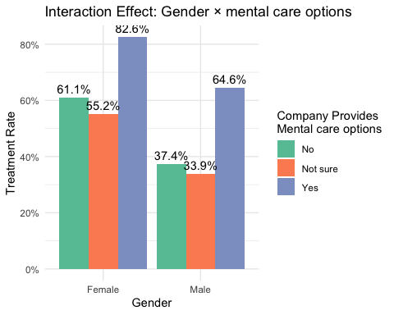

7. Limitation & possible improvement
- Most significant limitation: Subjective survey responses, possible response bias.
  - target variable “treatment” indicates whether respondents are currently receiving mental health treatment. It may demonstrate the actual need for mental treatment (real mental issue posed). However, due to subjective survey response “willingness to get treatment” also affected whether or not they are receiving treatment. This self-report bias means some individuals with mental health conditions may not seek or report treatment, while others receiving treatment may do so preventively rather than for diagnosed conditions.
- one-to-one association between one feature and target variable”treatment” is investigated, but the interactions between different features and how their combinations is associated with need for treatment is not considered. this is an aspect of future investigation.
  - an example is given below to explore the relationship between two factors “work_interfere” & “family_history”
  - Heatmap indicating the correlation between features are provided below
- assessing the association between demographic&workplace features and treatment is enough to identify individuals at risk, but from employers prospect, if they want to address mental issue for employees more effectively, analyzing the causual relationship should be considered.
  - This can be solved by using more advanced ML (random forest, boosting), longitudinal data, and testing interventions…

example demonstration:
- simple correlation to interaction
# 1. Interaction Effects Visualization - work_interfere * family_history
interaction_data <- train_data %>%
group_by(work_interfere, family_history) %>%
summarise(
treatment_rate = mean(treatment_binary),
n = n(),
.groups = 'drop'
) %>%
filter(!is.na(work_interfere))
ggplot(interaction_data, aes(x = work_interfere, y = treatment_rate,
color = family_history, group = family_history)) +
geom_line(size = 1.5) +
geom_point(size = 3) +
geom_text(aes(label = paste0(round(treatment_rate*100, 1), "%")),
vjust = -0.8, size = 3) +
labs(
title = "Interaction Effect: Work Interference × Family History",
subtitle = "Family history significantly amplifies the impact of work interference on treatment needs",
x = "Frequency of Work Interference",
y = "Treatment Rate",
color = "Family History of\nMental Health"
) +
theme_minimal() +
scale_y_continuous(labels = scales::percent) +
scale_color_manual(values = c("No" = "red", "Yes" = "blue"))
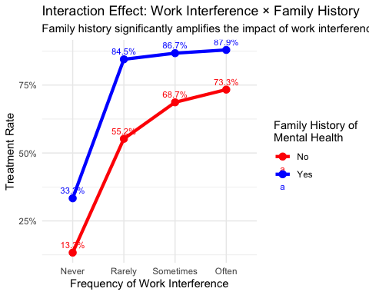
- There is a powerful interaction between work interference and family history:
  - For employees without family history, even frequent work interference leads to only 60% treatment rate.
  - But for those with family history, the same level of work interference drives treatment rates above 90%.
- This tells us screening should prioritize employees who report both family history AND work interference.
- correlation heatmap
if(!requireNamespace("corrplot", quietly=TRUE)) install.packages("corrplot")
if(!requireNamespace("reshape2", quietly=TRUE)) install.packages("reshape2")
if(!requireNamespace("Hmisc", quietly=TRUE)) install.packages("Hmisc")
library(corrplot); library(reshape2); library(Hmisc)
corr_df <- model_data
corr_num <- corr_df |>
mutate(across(everything(), ~ if(is.factor(.)) as.numeric(as.factor(.)) else .))
corr_mat <- cor(corr_num, use = "pairwise.complete.obs", method = "spearman")
corr_mat[upper.tri(corr_mat, diag = TRUE)] <- NA
melted <- reshape2::melt(corr_mat, na.rm = TRUE)
ggplot(melted, aes(x = Var2, y = Var1, fill = value)) +
geom_tile(color = "white") +
scale_fill_gradient2(low = "blue", mid = "white", high = "red", midpoint = 0, limits = c(-0.5,0.6)) +
theme_minimal() +
theme(axis.text.x = element_text(angle = 45, hjust = 1)) +
labs(x = "", y = "", fill = "Spearman\nrho",
title = "Spearman Correlation Heatmap (factors -> numeric)")
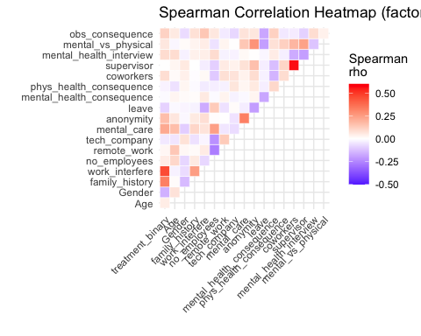
- notice the correlation between supervisor (feel free to discuss mental issue with direct supervisor) & coworkers (feel free to discuss mental issue with coworkers) is quite high
  - is there any potential causation ? any insightful management approach for employers?
  - Supervisors may serve as tone-setters for team culture. When supervisors openly discuss mental health and demonstrate empathy, they model vulnerable communication, giving employees ‘permission’ to have similar conversations with peers. This aligns with social learning theory, where employees observe and mimic leader behaviors.
  - A supportive peer culture might normalize mental health discussions, making it safer for employees to approach supervisors. This creates a virtuous cycle where peer support builds confidence for upward communication.

8. Conclusion
This study utilized the OSMI Mental Health in Tech Survey to investigate the relationship between workplace factors, demographic characteristics, and mental health treatment-seeking behavior. My analysis revealed that work interference and family history of mental illness are the strongest predictors of treatment need, with employees reporting frequent work interference and those with family history showing substantially higher treatment rates. Additionally, company’s support systems—including mental health benefits, confidential resources, and supportive workplace cultures—significantly correlate with treatment engagement. The logistic regression model demonstrated good predictive capability with an AUC of 0.85 and overall accuracy of 80%, though it exhibited higher specificity than sensitivity, indicating better performance at identifying treatment needs than non-needs.
From a practical perspective, these findings suggest employers should implement targeted screening for employees experiencing work interference, particularly those with family mental health history, and develop gender-sensitive interventions given the pronounced differences in treatment-seeking patterns. The strong correlation between supervisor and coworker support highlights the importance of creating psychologically safe environments at multiple organizational levels. While these associative findings provide valuable insights for identifying at-risk individuals, establishing causal relationships would further enhance employers’ ability to design effective interventions. Future research employing longitudinal designs and causal inference methods could build upon these findings to develop more targeted workplace mental health strategies that promote employee well-being and organizational resilience.

reference:
OSMI Mental Health in Tech Survey Kaggle Dataset - Introduction to Statistical Learning

