topic
Predicting Mental Health Treatment Needs Based on Workplace Factors and Demographic Characteristics
data source
https://www.kaggle.com/datasets/osmi/mental-health-in-tech-survey/data
target variable: treatment
influential variables: demographic characters, workplace factors
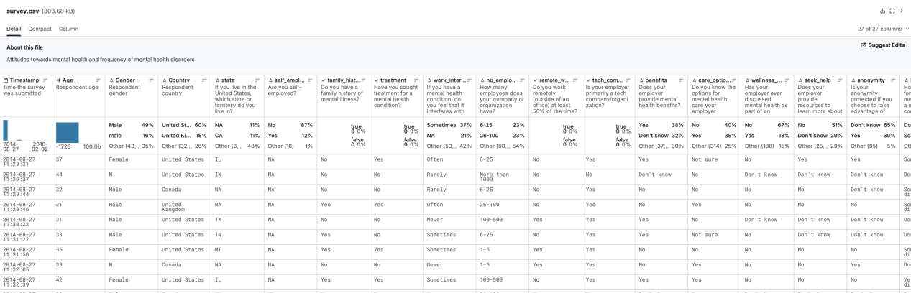
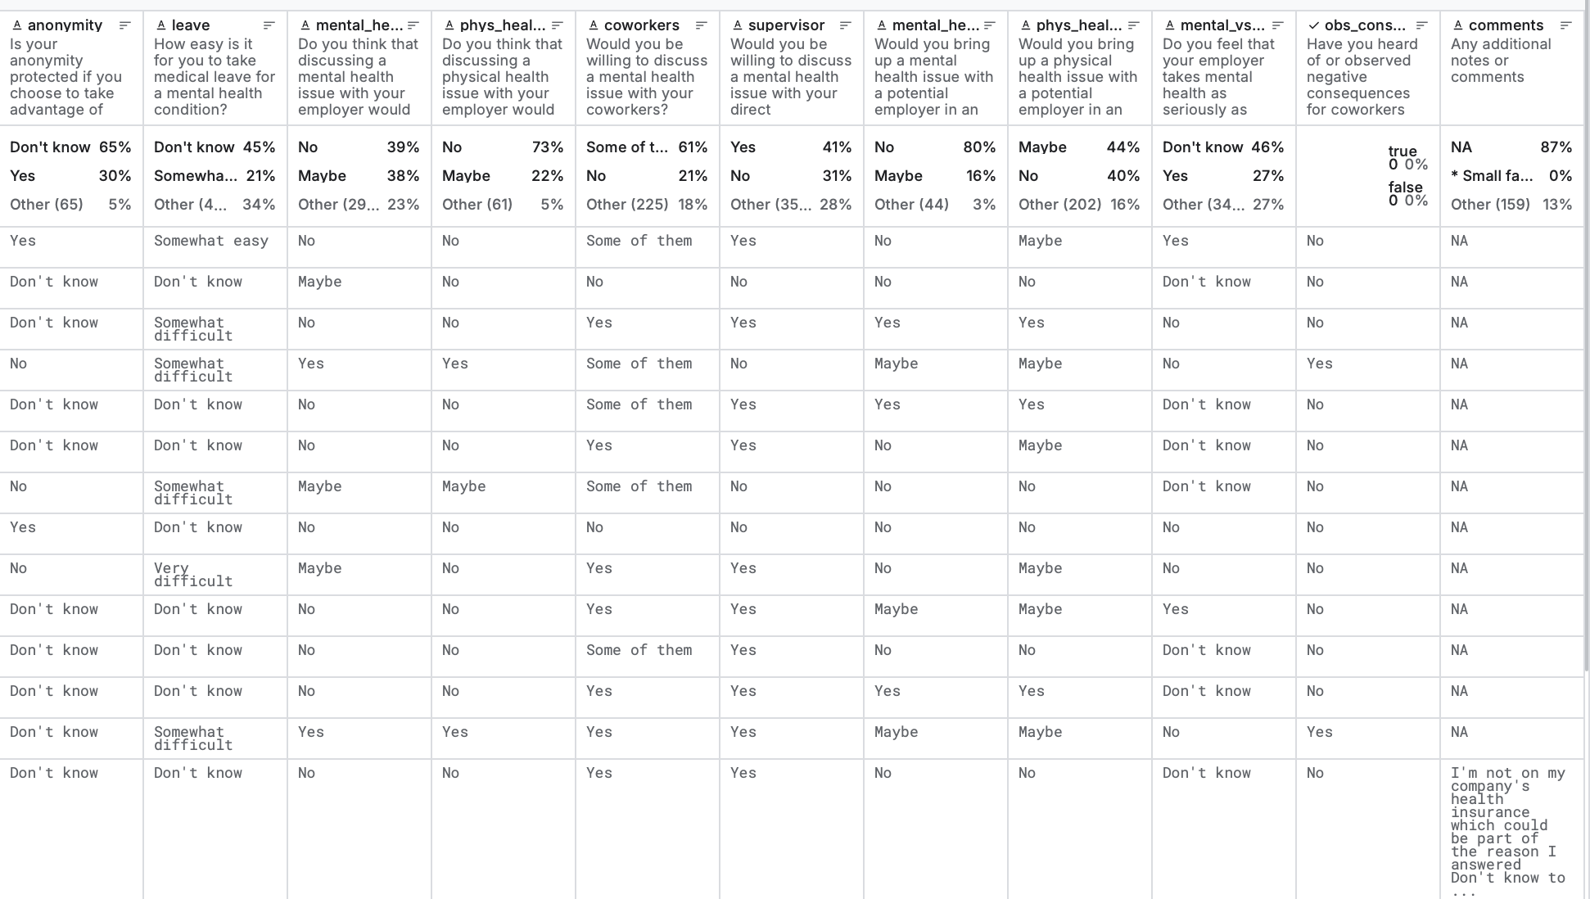
data science questions you want to answer with the data
1) Which workplace factors and demographic characteristics are most predictive of needing mental health treatment?
2) how to build a machine learning model to identify individuals who would benefit from mental health intervention based on their survey responses?

proposal
- Importance of the question
Mental health issues in workplace environments are a significant public health concern with economic and social consequences. Early identification of individuals who need mental health support can facilitate timely intervention, reduce workplace productivity loss, and improve overall well-being. This project addresses the need for data-driven approaches to mental health screening in professional settings.
- Challenges/difficulties
Several challenges are anticipated, including handling class imbalance in the target variable, handling missing survey data, and addressing potential response bias. The subjective nature of self-reported mental health data may introduce noise.
- Existing work
Previous research has established correlations between workplace stress and mental health outcomes. Open-source projects on Kaggle demonstrate the successful application of multiple machine learning algorithms to similar mental health prediction tasks. Existing literature shows that factors like work interference, family history, and employer support significantly impact mental health treatment needs.
- Methodology
1. Data loading and exploration using tidyverse
2. Data cleaning: remove irrelevant columns, handle missing values and outliers.
3. Standardising variables and data type conversion
4. Data analysis and visualisation using ggplot2: uncover patterns, relationships, and potential biases in the data. This will include examining the bivariate relationships between workplace factors and the outcome variable (treatment).
5. Statistical modelling using logistic regression: Identify key predictors using logistic regression to quantify relationships between predictors and treatment-seeking behaviour. We will complement this with subgroup analyses to examine how these relationships vary by gender, country, and company size
6. Conclusion: Interpret the model results and visualisations to conclude, answering the key questions and discussing implications.

