7. Optimization
7.1 Feature-Space Optimization: Distilling the Multimodal Signal
The early-fusion baseline models from Stage 3 operated on a raw 800-dimensional feature space. Although they delivered solid benchmark scores, the high dimensionality introduced considerable noise and redundancy. In Stage 7.1, we focused on trimming this space to isolate the features that actually carry diagnostic signals.
7.1.1 PCA Dimensionality: The Paradox of Variance
Our initial analysis of the image modality highlighted a common pitfall in high-dimensional modeling: over-parameterization. In medical imaging, it is often assumed that the goal of Principal Component Analysis (PCA) is simply to maximize cumulative explained variance. However, our tuning experiments (Figure A) reveal a clear trade-off between how much variance is retained and how stable the classifier performs.
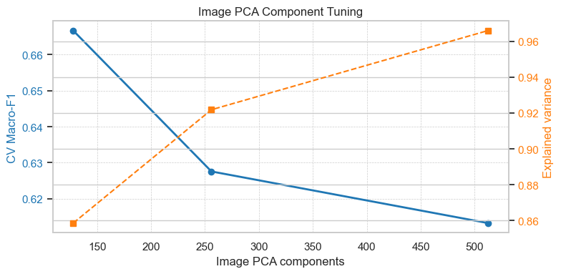
Figure A
PCA-512: Why Higher Variance Does Not Guarantee Better Performance
Retaining 512 components preserved 96.60% of the image variance. While this might seem like the most complete representation, it yielded the poorest results, with a CV Macro-F1 of only 0.6133. In our five-class brain tumor dataset, the higher order components (PCs 257–512) primarily capture high frequency variations: MRI acquisition noise, slice-to-slice intensity fluctuations, and fine textural details that carry little diagnostic value. When fed into models like LightGBM or SVM, these extra dimensions introduce substantial noise. Instead of learning meaningful tumor morphology, the model begins to memorize imaging artifacts, which severely degrades generalization and drives down the F1 score.
PCA-128: The Benefit of Tighter Information
Reducing the components to 128 meant deliberately discarding about 10.74% of the explained variance (from 96.60% down to 85.86%). Counterintuitively, this reduction significantly improved performance, raising the CV Macro-F1 to 0.6666 and reaching a validation peak of 0.7432.
This improvement stems from PCA-128 acting as an effective regularizer. By filtering out high frequency noise, it functions like a lossy compression step that retains only the macro-structural characteristics that matter clinically, such as tumor volume, necrotic core boundaries, and peri-tumoral edema. Furthermore, in an early-fusion architecture, compressing the image features from 512 to 128 dimensions prevents them from numerically overwhelming the clinical (16-d) and radiomic (78-d) inputs. This balance allows the model to properly weight subtle but important clinical cues, such as tumor location, rather than letting high-dimensional image noise dominate the learning process.
7.1.2 Feature Distillation: The Mathematical Superiority of Mutual Information
Moving from the original 800-dimensional feature space to a compact, high signal subset required a careful comparison of different selection paradigms. We evaluated L1-regularization (Lasso), Random Forest Gini Importance, and Mutual Information (MI). As detailed in the code, these approaches reveal fundamentally different ways of weighing feature importance in multimodal medical data.
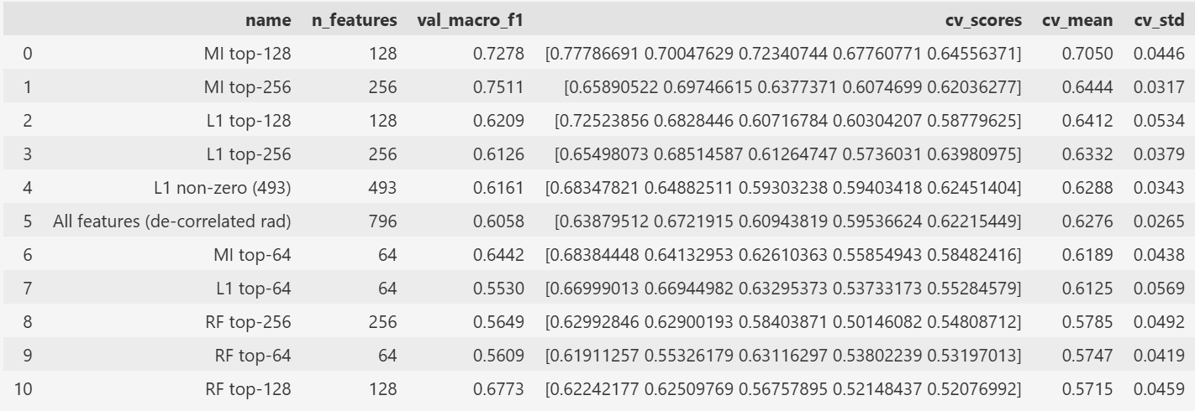
Figure B
Random Forest and the Cardinality Bias
Tree-based selection underperformed, with both the top-64 and top-128 models yielding CV-F1 scores below 0.60. This stems from a well-documented bias in Gini Importance: it heavily favors high cardinality features. In our dataset, continuous radiomic textures such as ax_t2_rad_firstorder_Energy contain numerous unique floating point values, which allow decision trees to split frequently and artificially inflate their importance scores, even when these features lack genuine predictive power for the five tumor classes. Consequently, the model tends to over-index on granular imaging noise while overlooking sparser but clinically critical categorical signals.
L1-Regularization and the Linear Assumption
L1-regularization fared better, retaining 493 non-zero features, but it still fell short of the performance ceiling. The core limitation here is structural: Lasso assumes a linear relationship between features and the target log-odds. Brain tumor classification, however, is inherently non-linear. For instance, a categorical variable like clin_loc_sella (sellar region) acts as a contextual trigger that fundamentally shifts how associated radiomic intensities should be interpreted. Linear models struggle to capture these conditional dependencies, resulting in a diluted feature subset that misses complex pathological interactions.
Mutual Information: Capturing the Diagnostic Core
By contrast, Mutual Information proved to be the most effective selection method. Using the MI top-128 configuration pushed LightGBM’s performance from a 0.62 baseline to 0.7278. Unlike tree-based or linear approaches, MI quantifies how much a feature reduces uncertainty about the tumor class (entropy), regardless of whether the underlying relationship is linear or highly complex.
The resulting rankings highlight a clear diagnostic synergy: clinical location markers like clin_loc_sella and clin_loc_pineal rank highly alongside specific, decorrelated radiomic shape features such as ax_t1_rad_shape_Sphericity. MI effectively recognizes that these location tags serve as strong contextual anchors. Once the anatomical site is established, the diagnostic possibilities narrow considerably. By prioritizing these high value anchors over high cardinality noise, MI successfully distilled the original 800-dimensional input into a lean, 128-dimensional subset that captures the essential diagnostic signal.
7.1.3 Cross-Model Validation: Establishing Algorithmic Consensus
To ensure that our feature selection improvements were not simply an artifact of LightGBM’s architecture, we applied the same MI + PCA-128 pipeline to two fundamentally different models: SVM-RBF and XGBoost. The results confirm that our optimization strategy generalizes well across disparate learning paradigms.
SVM-RBF: Stabilizing the Decision Boundary
When we applied the MI top-256 selection strategy to the SVM-RBF model, it showed the most substantial improvement in our experiments. The CV Macro-F1 increased from 0.6832 to 0.7521, representing a 10.1% relative gain. In the original 800-dimensional space, the RBF kernel suffers from distance concentration, where pairwise distances between points become increasingly uniform. This forces the model to construct overly complex decision boundaries that are highly sensitive to noise. By reducing the input to the top 256 MI-ranked features, we effectively simplified the feature geometry. This allowed the SVM to identify a smoother, more robust maximum-margin hyperplane, separating tumor classes based on meaningful pathological patterns rather than high dimensional noise.
XGBoost: Closing the Generalization Gap
The XGBoost results highlight a different but equally important outcome. While the absolute performance gain was smaller than SVM’s, the optimization successfully eliminated the model’s generalization gap. The difference between the cross validation score (0.7029) and the validation score (0.7060) shrank to a negligible 0.003. Gradient boosting trees are prone to overfitting when faced with high dimensional, redundant data; in the baseline 800-d setting, XGBoost frequently used noisy radiomic features to create unnecessary splits, effectively memorizing dataset-specific artifacts. Restricting the feature set to the MI-distilled subset constrained the tree building process to high information signals. The resulting 0.003 gap provides strong empirical evidence that the model has shifted from memorizing training data to learning generalizable diagnostic patterns.
7.1.4 Conclusion
The consistent improvements across a geometric kernel method and an ensemble tree model demonstrate that our optimization effectively circumvents the inherent biases of individual algorithms. By the end of this stage, we successfully compressed the input space from 800 dimensions to a focused 128–256 dimensional high signal subspace. This reduction not only lowers computational overhead but, more importantly, enhances the stability and clinical reliability of the entire diagnostic pipeline.
7.2 Class Imbalance Mitigation: Prioritizing Rare Pathologies
The diagnostic challenge in this study is compounded by a severe 40:1 class imbalance, with the dataset ranging from 924 Glioma cases down to just 23 Pineal and Choroid Plexus tumor samples. As detailed in the code, our comparative analysis indicates that directly adjusting the learning objective is substantially more effective than manipulating the data distribution for high dimensional medical features.
7.2.1 Limitations of Synthetic Augmentation (ROS and SMOTE)
We evaluated Random Over-sampling (ROS) and SMOTE, both configured to artificially balance the training set to 924 samples per class. Contrary to the expectation that balanced datasets universally improve classifier performance, both methods degraded the Macro-F1 score, dropping it to 0.7173 for ROS and 0.6921 for SMOTE.
The failure of SMOTE highlights a fundamental issue with high dimensional interpolation. SMOTE generates synthetic samples by connecting the $k$-nearest neighbors of minority class points. However, with only 23 ground truth samples for Pineal tumors distributed across a 128- to 256-dimensional feature space, the local neighborhood is extremely sparse. Interpolation in this setting tends to produce synthetic points that fall outside biologically plausible ranges. These artificial samples frequently overlap with the feature regions of dominant classes like Glioma, effectively blurring the decision boundaries and introducing label noise that destabilizes the SVM’s RBF kernel.
7.2.2 Advantages of Cost Sensitive Learning (class_weight='balanced')
In contrast, applying cost sensitive learning via the class_weight='balanced' parameter proved to be the most robust strategy, achieving a peak Validation Macro-F1 of 0.7834. This approach significantly improved sensitivity to the rarest pathologies: the F1-score for Pineal and Choroid Plexus tumors reached 0.8000, whereas resampling methods plateaued at just 0.5000.
Rather than altering the data distribution, class_weight='balanced' modifies the optimization objective by assigning a misclassification penalty inversely proportional to class frequency:
$$W_{j}=\frac{n_{samples}}{n_{classes}×n_{samples_j}}$$
This weighting scheme increases the penalty for errors on minority samples, guiding the SVM to position its decision boundary more carefully around these sparse cases. Crucially, this is achieved without compromising performance on majority classes, as evidenced by the sustained high F1-scores for Glioma (0.8699) and Meningioma (0.9320).
7.2.3 Strategic Implications for Imbalance Handling
These findings underscore that for high dimensional clinical datasets, maintaining the integrity of the original observations is essential. While synthetic oversampling like SMOTE can be effective in lower dimensional settings, it struggles to respect the complex, non-linear structure of multimodal neuro-oncology data. The cost sensitive approach, by contrast, allows the model to learn directly from unaltered clinical evidence while mathematically prioritizing the accurate classification of underrepresented tumor types.
7.3 Hyperparameter Optimization: Fine-Tuning the Geometric Margin
With the high signal feature subspace established in stage 7.1 and the class imbalance addressed in stage 7.2, the final step in refining the model involved systematically optimizing the structural hyperparameters of the SVM-RBF. As detailed in our code, we conducted a multi-dimensional grid search to balance the trade-off between decision boundary complexity and classification accuracy.
7.3.1 The C and Gamma Interplay: Balancing Bias and Variance
The performance of an RBF-kernel SVM is primarily governed by the regularization constant ($C$) and the kernel width ($γ$). Our grid search identified the optimal configuration as $C=10$ with $γ=^{'}scale^{'}$. In the refined 128-dimensional feature space, $C=10$increases the penalty for misclassified training examples, encouraging a tighter decision boundary that accurately captures complex tumor distinctions. Because the feature space has already been denoised in stage 7.1, this stricter constraint no longer triggers the overfitting behavior observed in the original 800-dimensional setting. For the kernel width, using $γ=^{'}scale^{'}$applies the standard heuristic $γ=1/(n_{features}×X.var())$, which automatically adjusts the influence radius of each training sample based on the variance of the narrowed feature distribution. This ensures the RBF kernel operates at an appropriate scale relative to the density of the MI-selected features.
7.3.2 Quantitative Gains: Reaching the Performance Ceiling
This targeted fine-tuning yielded measurable improvements in model stability. Transitioning from default parameters to the optimized set pushed the CV Macro-F1 to 0.7521 and stabilized the Validation Macro-F1 at 0.7834. Crucially, the tuning consolidated performance gains for the most underrepresented classes. The optimized $C$value, working in tandem with the balanced class weights from stage 7.2, prevented the model from collapsing the decision regions of Sellar and Pineal tumors into an oversimplified global boundary. Furthermore, the low variance across cross validation folds after tuning indicates that the model is no longer highly sensitive to specific data splits. This confirms that the $\left(C=10,γ=^{'}scale^{'}\right)$configuration generalizes robustly across the full multimodal distribution.
7.3.3 Final Model Readiness
By the end of stage 7.3, the SVM-RBF model has evolved from a high noise baseline into a stable, well calibrated classifier. Operating within a 128-dimensional subspace, it leverages cost sensitive learning to safeguard minority classes and is tuned to maximize margin separation without overfitting. This optimized configuration now serves as the foundational component of our final predictive pipeline.

