短趋势策略：基于三 K 线短趋势突破开仓的止盈点设置优化
- 假设：
给定开仓：3根连续k线，这三根 k的最低价与最高价都呈现上升趋势（前后连续的三根最高价大于最高价 最低价大于最低价），开盘价与收盘价也是越来越高。
给定止损点为第一根k线的最低价点，止盈点应该怎么设，让夏普比率、胜率跟盈亏比相对来说最优，收益期望最大。
参照中证500 ic2606，只有一手（因为买卖一手都很贵） 无法按比率止盈

核心指标：夏普比率（Sharpe Ratio）是衡量策略风险调整后收益的核心指标，公式为：
夏普比率=​$\frac{策略年化超额收益}{策略年化波动率（回撤标准差）}$
分子：策略收益减去无风险收益（比如国债利率），代表策略的 “净赚能力”。
分母：策略收益的标准差，反映收益的波动幅度（回撤大小、盈亏的稳定性）。

- 思考方案：
E：入场价，S：止损点，R：单笔风险（E-S）
1：纯粹的固定止盈，缺乏流动性与弹性，比如说以入场价减第一根k线的最低价为一个风险区间，可以设置2r或者3r的止盈点，盈亏比是占优但没有流动性，难以跟随市场趋势
2：移动止损，不设置止盈价格，尽可能吃更多利润，我先按照固定止盈来设置，以第一根k线的最低价为止损点，那么开始后一旦价格突破E+1R，先把止损调为E，这样子哪怕止损都是不亏不赚，降低回撤方差。然后触发移动追踪止损机制：止损S设为当前止损价与从入场至今最高价减去风险系数乘atr中的价高者（S = max(S, HighestCloseSinceEntry - k*ATR14)）k取2~3左右
第二种移动追踪机制：保本止损价和最近2-3根k线最低价中的价高者
按时间来平？入场后8-15根k未到一个止盈点 直接平，假如说入场T天内未达到入场价+0.8R，退场，达到了继续用移动止损以获取更大收益

每手亏损：止损差点*合约乘数
名义价值：入场价*合约乘数
开手数（基础手数定下限，上限取三者中最小）：1.风险预算风控：账户资金*风险点
- 名义杠杆风控：账户资金*杠杆/名义价值
- 保证金：账户资金*保证金率
- 优化流程：
难点：如何识别与过滤假突破，大部分的亏损都来自入场后震荡然后趋势不明显，或者说未经历拉高入场后直接跌破止损点带来的。
- 先采取固定止损后触发移动止损
- 对比时间止盈，先止损后止盈，时间止盈放在止损判断后
- 将移动止损与时间止盈结合在一起，得到较不错的效果
- 考虑加杠杆，跟同期指数相比
- 将三重风控（风险预算，名义杠杆，保证金）加上去，更符合现实交易
- 以下为中证500 日线 从2020-1-2到今日的数据：
k_atr: 2.0
trades: 56
realized_pnl: 303202.825316192
final_equity: 1303202.8253161917
exposure: 0.44005449591280654
win_rate: 0.39285714285714285
avg_R: 0.19576108125827213
max_dd: -0.2744986531787995
sharpe_full: 0.3852506950396267
sharpe_active: 0.5807708716203229
expectancy_trade: 5414.336166360565
expectancy_R: 0.19576108125827213
avg_win: 55272.591884675065
avg_loss: -26846.888121960576
profit_factor: 1.332169975002203
payoff_ratio: 2.0588081431852228
expectancy_per_day: 206.54143413909537
expectancy_per_hold_day: 469.3542187557152

Last trades:
entry_date exit_date entry exit pnl R_mult reason
2020-05-07 2020-05-22 5454.2515 5372.102768 -16429.746384 -0.324984 stop
2020-06-18 2020-07-06 5738.0314 6118.421536 76078.027192 2.580878 stop
2020-07-07 2020-07-15 6368.3135 6663.338440 59004.988088 0.578776 stop
2020-07-22 2020-07-24 6554.1681 6307.793411 -49274.937812 -0.876072 stop
2020-08-19 2020-08-26 6782.5931 6506.026600 -55313.300000 -1.000000 stop
2020-09-16 2020-09-25 6379.5178 6241.124012 -27678.757552 -0.815378 stop
2020-10-13 2020-10-20 6538.8354 6335.600791 -40646.921707 -0.529512 stop
2020-11-24 2020-11-26 6472.7468 6293.555300 -35838.300000 -1.000000 stop
2021-01-05 2021-01-15 6470.2503 6362.080496 -21633.960764 -0.384048 stop
2021-02-18 2021-02-26 6657.3065 6456.981684 -40064.963286 -0.453657 stop
2021-03-30 2021-04-12 6239.4695 6239.469500 0.000000 0.000000 stop
2021-04-20 2021-05-11 6419.7312 6456.037600 7261.280000 0.174490 timeout
2021-05-27 2021-06-16 6629.2373 6629.237300 0.000000 0.000000 stop
2021-06-22 2021-07-02 6723.2981 6682.906433 -8078.333328 -0.239008 stop
2021-07-14 2021-07-26 6953.8224 6861.351447 -18494.190649 -0.342438 stop
2021-08-02 2021-08-17 6756.8132 6910.491886 30735.737170 0.692573 stop
2021-08-25 2021-09-17 7092.1469 7437.949290 69160.477966 1.387959 stop
2021-10-18 2021-12-20 7027.1401 7236.723066 41916.593290 1.499150 stop
2021-12-24 2022-01-05 7335.9996 7218.611684 -23477.583180 -0.809422 stop
2022-01-19 2022-01-20 7144.4768 7052.634800 -18368.400000 -1.000000 stop
2022-05-06 2022-07-11 5560.9758 6295.597103 146924.260507 3.318563 stop
2022-07-21 2022-08-02 6400.0661 6200.520300 -39909.160000 -1.000000 stop
2022-08-09 2022-08-24 6314.1043 6320.827341 1344.608140 0.028731 stop
2022-09-07 2022-09-15 6269.9911 6149.608718 -24076.476436 -0.790614 stop
2022-10-17 2022-10-25 5952.3801 5817.361668 -27003.686364 -0.377059 stop
2022-11-03 2022-11-28 5944.5114 6049.882244 21074.168898 0.524347 stop
2022-12-28 2023-02-16 5869.4556 6270.228251 80154.530211 2.925679 stop
2023-03-02 2023-03-07 6398.2563 6288.299400 -21991.380000 -1.000000 stop
2023-03-24 2023-04-21 6312.4308 6353.551168 8224.073584 0.291329 stop
2023-05-04 2023-05-12 6223.2261 6121.457960 -20353.628008 -0.782660 stop
2023-06-14 2023-06-21 6046.4375 6046.437500 0.000000 0.000000 stop
2023-07-04 2023-07-20 6042.7217 5936.641322 -21216.075556 -0.895621 stop
2023-10-31 2023-11-16 5547.3243 5609.360700 12407.280000 0.295648 timeout
2023-11-16 2023-11-23 5647.0613 5565.091400 -16393.980000 -1.000000 stop
2024-01-02 2024-01-05 5431.4784 5275.192483 -31257.183322 -0.797286 stop
2024-01-26 2024-01-30 5055.2878 4810.178957 -49021.768533 -0.748636 stop
2024-02-19 2024-03-06 5225.1379 5350.101600 24992.740000 0.152426 timeout
2024-04-02 2024-04-16 5395.4811 5196.230783 -39850.063439 -0.833681 stop
2024-04-30 2024-05-21 5471.1676 5478.913100 1549.100000 0.032093 timeout
2024-09-26 2024-09-30 4725.9960 5458.396960 146480.191940 3.015659 stop
2024-10-08 2024-10-09 6417.8142 5756.066290 -132349.582051 -0.389615 stop
2024-10-09 2024-10-25 6013.7015 5809.687900 -40802.720000 -0.205620 timeout
2024-11-07 2024-11-15 6061.7349 6061.734900 0.000000 0.000000 stop
2025-02-11 2025-02-27 5890.3732 6028.985600 27722.480000 0.473001 timeout
2025-03-07 2025-03-21 6029.3813 5962.777329 -13320.794161 -0.358244 stop
2025-05-07 2025-05-23 5805.6560 5653.043600 -30522.480000 -0.651022 timeout
2025-06-06 2025-06-19 5768.3989 5686.033300 -16473.119958 -0.715594 stop
2025-06-26 2025-07-14 5868.2924 6020.858500 30513.220000 0.598272 timeout
2025-07-22 2025-07-31 6166.6164 6229.448083 12566.336623 0.409133 stop
2025-08-07 2025-09-03 6356.3322 6900.343768 108802.313633 3.224531 stop
2025-09-15 2025-10-13 7170.4123 7289.102783 23738.096620 0.395624 stop
2025-10-28 2025-11-03 7344.4539 7215.231882 -25844.403656 -0.401112 stop
2025-11-27 2025-12-16 6970.7329 6970.732900 0.000000 0.000000 stop
2025-12-23 2026-01-21 7257.9076 8340.113300 216441.140000 6.624343 eod

===== Summary =====
k_atr: 2.5
trades: 54
realized_pnl: 341089.25479553035
final_equity: 1341089.2547955306
exposure: 0.4598092643051771
win_rate: 0.3888888888888889
avg_R: 0.19698208764574243
max_dd: -0.2895725466262952
sharpe_full: 0.3959281298210482
sharpe_active: 0.5838994673714065
expectancy_trade: 6316.46768139871
expectancy_R: 0.19698208764574243
avg_win: 58561.49726997411
avg_loss: -26930.36932951291
profit_factor: 1.3838060257413458
payoff_ratio: 2.174552326164972
expectancy_per_day: 232.3496286073095
expectancy_per_hold_day: 505.3174145118968

Last trades:
entry_date exit_date entry exit pnl R_mult reason
2020-02-07 2020-02-28 5287.2690 5565.314385 55609.077002 0.504486 stop
2020-04-09 2020-04-27 5301.2663 5265.724800 -7108.300000 -0.164413 timeout
2020-05-07 2020-05-22 5454.2515 5328.159485 -25218.402980 -0.498825 stop
2020-06-18 2020-07-15 5738.0314 6604.293676 173252.455110 5.877431 stop
2020-07-22 2020-07-24 6554.1681 6272.941600 -56245.300000 -1.000000 stop
2020-08-19 2020-08-26 6782.5931 6506.026600 -55313.300000 -1.000000 stop
2020-09-16 2020-09-25 6379.5178 6209.788100 -33945.940000 -1.000000 stop
2020-10-13 2020-10-22 6538.8354 6282.183570 -51330.365999 -0.668687 stop
2020-11-24 2020-11-26 6472.7468 6293.555300 -35838.300000 -1.000000 stop
2021-01-05 2021-01-21 6470.2503 6622.495900 30449.120000 0.540535 timeout
2021-02-18 2021-02-26 6657.3065 6395.356579 -52389.984107 -0.593213 stop
2021-03-30 2021-04-12 6239.4695 6239.469500 0.000000 0.000000 stop
2021-04-20 2021-05-11 6419.7312 6456.037600 7261.280000 0.174490 timeout
2021-05-27 2021-06-16 6629.2373 6629.237300 0.000000 0.000000 stop
2021-06-22 2021-07-06 6723.2981 6646.503992 -15358.821660 -0.454411 stop
2021-07-14 2021-07-26 6953.8224 6820.052258 -26754.028311 -0.495378 stop
2021-08-02 2021-08-20 6756.8132 6864.314257 21500.211462 0.484467 stop
2021-08-25 2021-09-17 7092.1469 7385.249587 58620.537457 1.176436 stop
2021-10-18 2021-12-20 7027.1401 7200.654483 34702.876613 1.241151 stop
2021-12-24 2022-01-06 7335.9996 7190.972800 -29005.360000 -1.000000 stop
2022-01-19 2022-01-20 7144.4768 7052.634800 -18368.400000 -1.000000 stop
2022-05-06 2022-07-12 5560.9758 6238.713603 135547.560634 3.061599 stop
2022-07-21 2022-08-02 6400.0661 6200.520300 -39909.160000 -1.000000 stop
2022-08-09 2022-08-25 6314.1043 6277.658001 -7289.259825 -0.155751 stop
2022-09-07 2022-09-15 6269.9911 6117.726600 -30452.900000 -1.000000 stop
2022-10-17 2022-10-28 5952.3801 5762.783660 -37919.287954 -0.529476 stop
2022-11-03 2022-11-28 5944.5114 6003.256856 11749.091123 0.292330 stop
2022-12-28 2023-02-17 5869.4556 6238.481664 73805.212764 2.693926 stop
2023-03-02 2023-03-07 6398.2563 6288.299400 -21991.380000 -1.000000 stop
2023-03-24 2023-04-21 6312.4308 6325.822360 2678.311980 0.094876 stop
2023-05-04 2023-05-12 6223.2261 6093.197600 -26005.700000 -1.000000 stop
2023-06-14 2023-06-21 6046.4375 6046.437500 0.000000 0.000000 stop
2023-07-04 2023-07-20 6042.7217 5924.278300 -23688.680000 -1.000000 stop
2023-10-31 2023-11-16 5547.3243 5609.360700 12407.280000 0.295648 timeout
2023-11-16 2023-11-23 5647.0613 5565.091400 -16393.980000 -1.000000 stop
2024-01-02 2024-01-08 5431.4784 5241.626754 -37970.329152 -0.968520 stop
2024-01-26 2024-01-31 5055.2878 4755.950397 -59867.480667 -0.914266 stop
2024-02-19 2024-03-06 5225.1379 5350.101600 24992.740000 0.152426 timeout
2024-04-02 2024-04-22 5395.4811 5267.581100 -25580.000000 -0.535145 timeout
2024-04-30 2024-05-21 5471.1676 5478.913100 1549.100000 0.032093 timeout
2024-09-26 2024-10-09 4725.9960 5704.523225 195705.444931 4.029083 stop
2024-10-09 2024-10-25 6013.7015 5809.687900 -40802.720000 -0.205620 timeout
2024-11-07 2024-11-15 6061.7349 6061.734900 0.000000 0.000000 stop
2025-02-11 2025-02-27 5890.3732 6028.985600 27722.480000 0.473001 timeout
2025-03-07 2025-03-24 6029.3813 5920.146211 -21847.017701 -0.587544 stop
2025-05-07 2025-05-23 5805.6560 5653.043600 -30522.480000 -0.651022 timeout
2025-06-06 2025-06-20 5768.3989 5656.128050 -22454.169947 -0.975411 stop
2025-06-26 2025-07-14 5868.2924 6020.858500 30513.220000 0.598272 timeout
2025-07-22 2025-08-01 6166.6164 6197.776929 6232.105779 0.202904 stop
2025-08-07 2025-09-03 6356.3322 6847.857660 98305.092041 2.913429 stop
2025-09-15 2025-10-13 7170.4123 7224.147829 10747.105775 0.179113 stop
2025-10-28 2025-11-05 7344.4539 7148.798202 -39131.139570 -0.607326 stop
2025-11-27 2025-12-16 6970.7329 6970.732900 0.000000 0.000000 stop
2025-12-23 2026-01-21 7257.9076 8340.113300 216441.140000 6.624343 eod

===== Summary =====
k_atr: 3.0
trades: 48
realized_pnl: 527689.2913881452
final_equity: 1527689.2913881443
exposure: 0.4938692098092643
win_rate: 0.4166666666666667
avg_R: 0.32216752652020914
max_dd: -0.2993961033945963
sharpe_full: 0.5630475909334268
sharpe_active: 0.8014398274500427
expectancy_trade: 10993.52690391969
expectancy_R: 0.32216752652020914
avg_win: 61831.26706392712
avg_loss: -25319.14463894276
profit_factor: 1.7443397630431219
payoff_ratio: 2.4420756682603706
expectancy_per_day: 359.4613701554122
expectancy_per_hold_day: 727.8472984664071

Last trades:
entry_date exit_date entry exit pnl R_mult reason
2020-02-07 2020-02-28 5287.2690 5498.832882 42312.776402 0.383862 stop
2020-04-09 2020-04-27 5301.2663 5265.724800 -7108.300000 -0.164413 timeout
2020-05-07 2020-05-25 5454.2515 5316.603600 -27529.580000 -0.544540 timeout
2020-06-18 2020-07-16 5738.0314 6545.248911 161443.502132 5.476823 stop
2020-07-22 2020-07-24 6554.1681 6272.941600 -56245.300000 -1.000000 stop
2020-08-19 2020-08-26 6782.5931 6506.026600 -55313.300000 -1.000000 stop
2020-09-16 2020-09-25 6379.5178 6209.788100 -33945.940000 -1.000000 stop
2020-10-13 2020-10-23 6538.8354 6228.340544 -62098.971199 -0.808971 stop
2020-11-24 2020-11-26 6472.7468 6293.555300 -35838.300000 -1.000000 stop
2021-01-05 2021-01-21 6470.2503 6622.495900 30449.120000 0.540535 timeout
2021-02-18 2021-03-05 6657.3065 6333.731475 -64715.004929 -0.732770 stop
2021-03-30 2021-04-12 6239.4695 6239.469500 0.000000 0.000000 stop
2021-04-20 2021-05-11 6419.7312 6456.037600 7261.280000 0.174490 timeout
2021-05-27 2021-06-16 6629.2373 6629.237300 0.000000 0.000000 stop
2021-06-22 2021-07-08 6723.2981 6748.654000 5071.180000 0.150038 timeout
2021-07-14 2021-07-26 6953.8224 6778.753070 -35013.865973 -0.648317 stop
2021-08-02 2021-09-17 6756.8132 7332.549885 115147.336949 2.594632 stop
2021-10-18 2022-01-06 7027.1401 7169.811326 28534.245229 1.020529 stop
2022-01-19 2022-01-20 7144.4768 7052.634800 -18368.400000 -1.000000 stop
2022-05-06 2022-08-02 5560.9758 6229.805236 133765.887189 3.021356 stop
2022-08-09 2022-08-25 6314.1043 6234.488661 -15923.127790 -0.340233 stop
2022-09-07 2022-09-15 6269.9911 6117.726600 -30452.900000 -1.000000 stop
2022-10-17 2022-11-02 5952.3801 5997.803800 9084.740000 0.126852 timeout
2022-11-03 2022-12-19 5944.5114 6028.970608 16891.841696 0.420287 stop
2022-12-28 2023-03-10 5869.4556 6206.735077 67455.895316 2.462173 stop
2023-03-24 2023-04-21 6312.4308 6312.430800 0.000000 0.000000 stop
2023-05-04 2023-05-12 6223.2261 6093.197600 -26005.700000 -1.000000 stop
2023-06-14 2023-06-21 6046.4375 6046.437500 0.000000 0.000000 stop
2023-07-04 2023-07-20 6042.7217 5924.278300 -23688.680000 -1.000000 stop
2023-10-31 2023-11-16 5547.3243 5609.360700 12407.280000 0.295648 timeout
2023-11-16 2023-11-23 5647.0613 5565.091400 -16393.980000 -1.000000 stop
2024-01-02 2024-01-08 5431.4784 5235.455900 -39204.500000 -1.000000 stop
2024-01-26 2024-01-31 5055.2878 4727.880600 -65481.440000 -1.000000 stop
2024-02-19 2024-03-06 5225.1379 5350.101600 24992.740000 0.152426 timeout
2024-04-02 2024-04-22 5395.4811 5267.581100 -25580.000000 -0.535145 timeout
2024-04-30 2024-05-21 5471.1676 5478.913100 1549.100000 0.032093 timeout
2024-09-26 2024-10-10 4725.9960 5614.311530 177663.105917 3.657636 stop
2024-11-07 2024-11-15 6061.7349 6061.734900 0.000000 0.000000 stop
2025-02-11 2025-02-27 5890.3732 6028.985600 27722.480000 0.473001 timeout
2025-03-07 2025-03-25 6029.3813 5946.951000 -16486.060000 -0.443369 timeout
2025-05-07 2025-05-23 5805.6560 5653.043600 -30522.480000 -0.651022 timeout
2025-06-06 2025-06-20 5768.3989 5653.297800 -23020.220000 -1.000000 stop
2025-06-26 2025-07-14 5868.2924 6020.858500 30513.220000 0.598272 timeout
2025-07-22 2025-09-04 6166.6164 6795.371552 125751.030449 4.094183 stop
2025-09-15 2025-10-13 7170.4123 7170.412300 0.000000 0.000000 stop
2025-10-28 2025-11-13 7344.4539 7355.291100 2167.440000 0.033639 timeout
2025-11-27 2025-12-16 6970.7329 6970.732900 0.000000 0.000000 stop
2025-12-23 2026-01-21 7257.9076 8340.113300 216441.140000 6.624343 eod
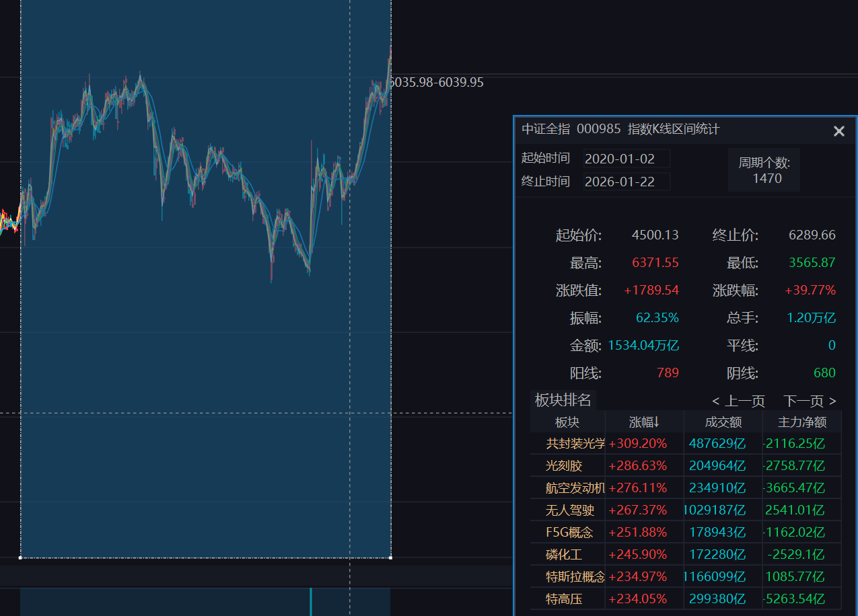
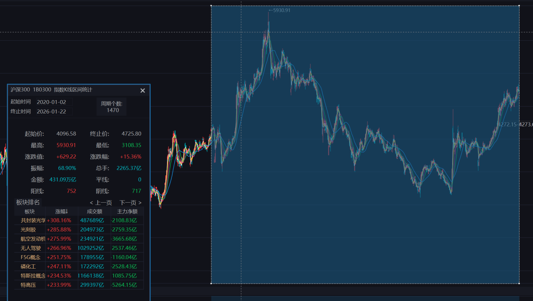

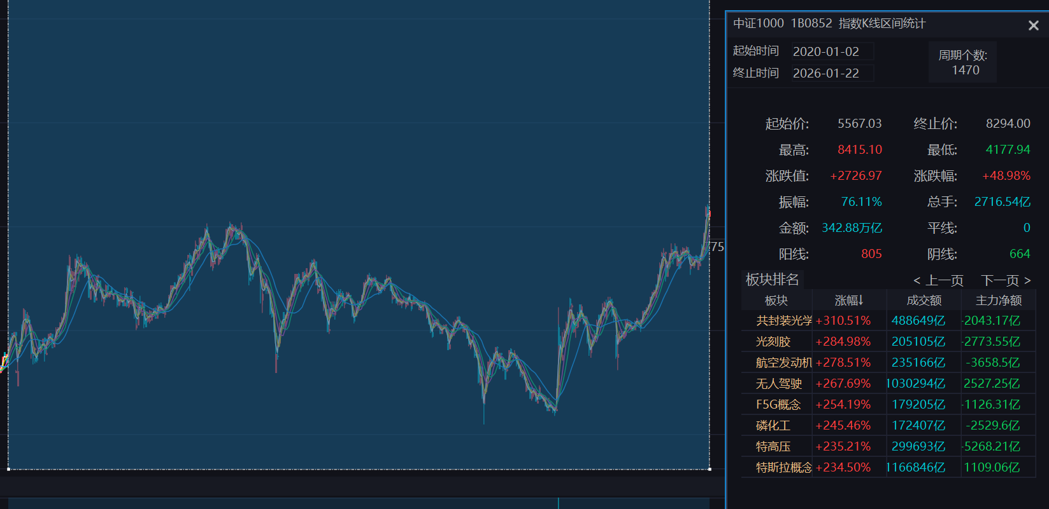
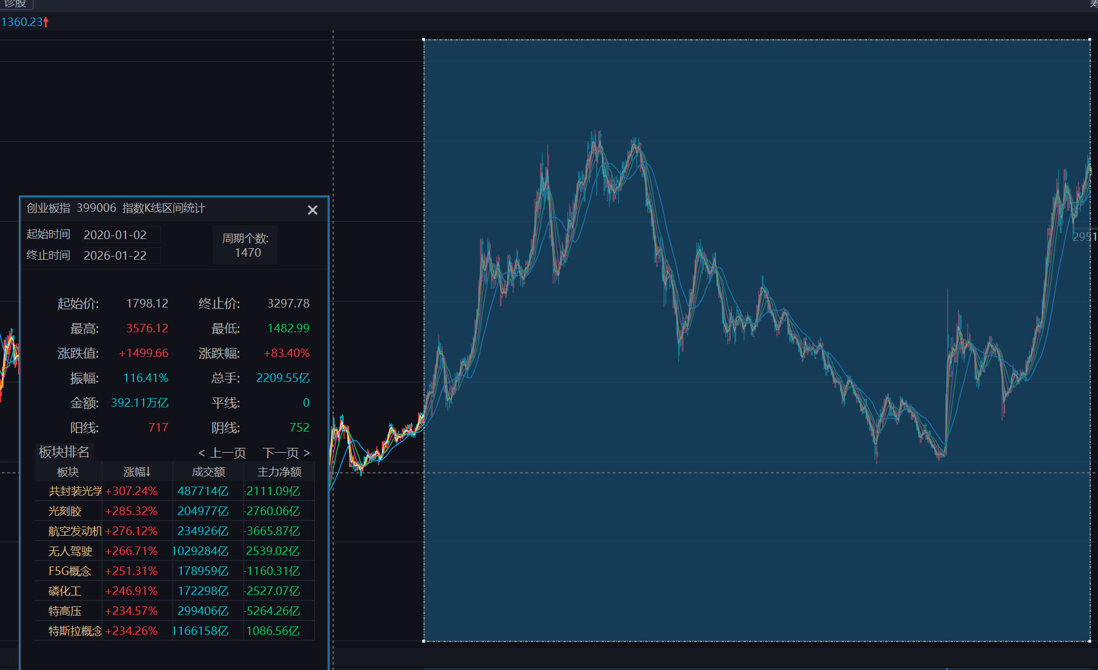
Using data file: C:\Users\24106\Desktop\中证500.xlsx
Data range: 2020-01-02 -> 2026-01-21, rows=1468
signals: 128

===== 风控参数配置 =====
基础手数 (BASE_LOTS): 0
单笔最大风险比例 (RISK_PCT): 0.50%
最大名义杠杆 (MAX_LEVERAGE): 1 倍
初始保证金率 (MARGIN_RATE): 15.00%
最大手数上限 (MAX_LOTS_CAP): 5

===== 回测结果汇总 =====
k_atr: 3.000
trades: 0.000
realized_pnl: 0.00
final_equity: 1000000.00
exposure: 0.0000
win_rate: 0.0000
avg_R: 0.000
max_dd: 0.0000
sharpe_full: 0.000
sharpe_active: 0.000
expectancy_trade: 0.00
expectancy_R: 0.000
avg_win: 0.00
avg_loss: 0.00
profit_factor: 0.000
payoff_ratio: 0.000
expectancy_per_day: 0.00
expectancy_per_hold_day: 0.00

%runfile 'C:/Users/24106/Desktop/实习program汇总/untitled0.py' --wdir
Using data file: C:\Users\24106\Desktop\中证500.xlsx
Data range: 2020-01-02 -> 2026-01-21, rows=1468
signals: 128

===== 风控参数配置 =====
基础手数 (BASE_LOTS): 0
单笔最大风险比例 (RISK_PCT): 0.50%
最大名义杠杆 (MAX_LEVERAGE): 1.5 倍
初始保证金率 (MARGIN_RATE): 15.00%
最大手数上限 (MAX_LOTS_CAP): 5

===== 回测结果汇总 =====
k_atr: 3.000
trades: 0.000
realized_pnl: 0.00
final_equity: 1000000.00
exposure: 0.0000
win_rate: 0.0000
avg_R: 0.000
max_dd: 0.0000
sharpe_full: 0.000
sharpe_active: 0.000
expectancy_trade: 0.00
expectancy_R: 0.000
avg_win: 0.00
avg_loss: 0.00
profit_factor: 0.000
payoff_ratio: 0.000
expectancy_per_day: 0.00
expectancy_per_hold_day: 0.00

%runfile 'C:/Users/24106/Desktop/实习program汇总/untitled0.py' --wdir
Using data file: C:\Users\24106\Desktop\中证500.xlsx
Data range: 2020-01-02 -> 2026-01-21, rows=1468
signals: 128

===== 风控参数配置 =====
基础手数 (BASE_LOTS): 0
单笔最大风险比例 (RISK_PCT): 1.00%
最大名义杠杆 (MAX_LEVERAGE): 1.5 倍
初始保证金率 (MARGIN_RATE): 12.00%
最大手数上限 (MAX_LOTS_CAP): 10

===== 回测结果汇总 =====
k_atr: 3.000
trades: 0.000
realized_pnl: 0.00
final_equity: 1000000.00
exposure: 0.0000
win_rate: 0.0000
avg_R: 0.000
max_dd: 0.0000
sharpe_full: 0.000
sharpe_active: 0.000
expectancy_trade: 0.00
expectancy_R: 0.000
avg_win: 0.00
avg_loss: 0.00
profit_factor: 0.000
payoff_ratio: 0.000
expectancy_per_day: 0.00
expectancy_per_hold_day: 0.00

%runfile 'C:/Users/24106/Desktop/实习program汇总/untitled0.py' --wdir
Using data file: C:\Users\24106\Desktop\中证500.xlsx
Data range: 2020-01-02 -> 2026-01-21, rows=1468
signals: 128

===== 风控参数配置 =====
基础手数 (BASE_LOTS): 0
单笔最大风险比例 (RISK_PCT): 2.00%
最大名义杠杆 (MAX_LEVERAGE): 1.5 倍
初始保证金率 (MARGIN_RATE): 12.00%
最大手数上限 (MAX_LOTS_CAP): 10

===== 回测结果汇总 =====
k_atr: 3.000
trades: 8.000
realized_pnl: 126980.65
final_equity: 1126980.65
exposure: 0.0763
win_rate: 0.2500
avg_R: 0.904
max_dd: -0.1013
sharpe_full: 0.471
sharpe_active: 1.713
expectancy_trade: 15872.58
expectancy_R: 0.904
avg_win: 103492.49
avg_loss: -13334.06
profit_factor: 2.587
payoff_ratio: 7.762
expectancy_per_day: 86.50
expectancy_per_hold_day: 1133.76

===== 最近交易记录 =====
entry_date exit_date entry exit pnl R_mult reason
2022-01-19 2022-01-20 7144.4768 7052.634800 -18368.400000 -1.000000 stop
2023-01-10 2023-03-10 6044.6410 6206.735077 32418.815316 1.714349 stop
2023-03-27 2023-03-29 6304.4792 6242.157000 -12464.440000 -1.000000 stop
2023-06-14 2023-06-21 6046.4375 6046.437500 0.000000 0.000000 stop
2023-07-12 2023-07-20 6030.6447 5936.227200 -18883.500000 -1.000000 stop
2023-11-16 2023-11-23 5647.0613 5565.091400 -16393.980000 -1.000000 stop
2025-05-22 2025-05-23 5739.1909 5669.720800 -13894.020000 -1.000000 stop
2025-07-02 2025-09-04 5922.5407 6795.371552 174566.170449 10.520699 stop

%runfile 'C:/Users/24106/Desktop/实习program汇总/untitled0.py' --wdir
Using data file: C:\Users\24106\Desktop\中证500.xlsx
Data range: 2020-01-02 -> 2026-01-21, rows=1468
signals: 128

===== 风控参数配置 =====
基础手数 (BASE_LOTS): 0
单笔最大风险比例 (RISK_PCT): 2.00%
最大名义杠杆 (MAX_LEVERAGE): 1.5 倍
初始保证金率 (MARGIN_RATE): 13.00%
最大手数上限 (MAX_LOTS_CAP): 10

===== 回测结果汇总 =====
k_atr: 3.000
trades: 8.000
realized_pnl: 126980.65
final_equity: 1126980.65
exposure: 0.0763
win_rate: 0.2500
avg_R: 0.904
max_dd: -0.1013
sharpe_full: 0.471
sharpe_active: 1.713
expectancy_trade: 15872.58
expectancy_R: 0.904
avg_win: 103492.49
avg_loss: -13334.06
profit_factor: 2.587
payoff_ratio: 7.762
expectancy_per_day: 86.50
expectancy_per_hold_day: 1133.76

===== 最近交易记录 =====
entry_date exit_date entry exit pnl R_mult reason
2022-01-19 2022-01-20 7144.4768 7052.634800 -18368.400000 -1.000000 stop
2023-01-10 2023-03-10 6044.6410 6206.735077 32418.815316 1.714349 stop
2023-03-27 2023-03-29 6304.4792 6242.157000 -12464.440000 -1.000000 stop
2023-06-14 2023-06-21 6046.4375 6046.437500 0.000000 0.000000 stop
2023-07-12 2023-07-20 6030.6447 5936.227200 -18883.500000 -1.000000 stop
2023-11-16 2023-11-23 5647.0613 5565.091400 -16393.980000 -1.000000 stop
2025-05-22 2025-05-23 5739.1909 5669.720800 -13894.020000 -1.000000 stop
2025-07-02 2025-09-04 5922.5407 6795.371552 174566.170449 10.520699 stop

%runfile 'C:/Users/24106/Desktop/实习program汇总/untitled0.py' --wdir
Using data file: C:\Users\24106\Desktop\中证500.xlsx
Data range: 2020-01-02 -> 2026-01-21, rows=1468
signals: 128

===== 风控参数配置 =====
基础手数 (BASE_LOTS): 0
单笔最大风险比例 (RISK_PCT): 2.00%
最大名义杠杆 (MAX_LEVERAGE): 2 倍
初始保证金率 (MARGIN_RATE): 13.00%
最大手数上限 (MAX_LOTS_CAP): 10

===== 回测结果汇总 =====
k_atr: 3.000
trades: 8.000
realized_pnl: 126980.65
final_equity: 1126980.65
exposure: 0.0763
win_rate: 0.2500
avg_R: 0.904
max_dd: -0.1013
sharpe_full: 0.471
sharpe_active: 1.713
expectancy_trade: 15872.58
expectancy_R: 0.904
avg_win: 103492.49
avg_loss: -13334.06
profit_factor: 2.587
payoff_ratio: 7.762
expectancy_per_day: 86.50
expectancy_per_hold_day: 1133.76

===== 最近交易记录 =====
entry_date exit_date entry exit pnl R_mult reason
2022-01-19 2022-01-20 7144.4768 7052.634800 -18368.400000 -1.000000 stop
2023-01-10 2023-03-10 6044.6410 6206.735077 32418.815316 1.714349 stop
2023-03-27 2023-03-29 6304.4792 6242.157000 -12464.440000 -1.000000 stop
2023-06-14 2023-06-21 6046.4375 6046.437500 0.000000 0.000000 stop
2023-07-12 2023-07-20 6030.6447 5936.227200 -18883.500000 -1.000000 stop
2023-11-16 2023-11-23 5647.0613 5565.091400 -16393.980000 -1.000000 stop
2025-05-22 2025-05-23 5739.1909 5669.720800 -13894.020000 -1.000000 stop
2025-07-02 2025-09-04 5922.5407 6795.371552 174566.170449 10.520699 stop

%runfile 'C:/Users/24106/Desktop/实习program汇总/untitled0.py' --wdir
Using data file: C:\Users\24106\Desktop\中证500.xlsx
Data range: 2020-01-02 -> 2026-01-21, rows=1468
signals: 128

===== 风控参数配置 =====
基础手数 (BASE_LOTS): 1
单笔最大风险比例 (RISK_PCT): 2.00%
最大名义杠杆 (MAX_LEVERAGE): 2 倍
初始保证金率 (MARGIN_RATE): 12.00%
最大手数上限 (MAX_LOTS_CAP): 20

===== 回测结果汇总 =====
k_atr: 3.000
trades: 48.000
realized_pnl: 527689.29
final_equity: 1527689.29
exposure: 0.4939
win_rate: 0.4167
avg_R: 0.322
max_dd: -0.2994
sharpe_full: 0.563
sharpe_active: 0.801
expectancy_trade: 10993.53
expectancy_R: 0.322
avg_win: 61831.27
avg_loss: -25319.14
profit_factor: 1.744
payoff_ratio: 2.442
expectancy_per_day: 359.46
expectancy_per_hold_day: 727.85

===== 最近交易记录 =====
entry_date exit_date entry exit pnl R_mult reason
2025-02-11 2025-02-27 5890.3732 6028.985600 27722.480000 0.473001 timeout
2025-03-07 2025-03-25 6029.3813 5946.951000 -16486.060000 -0.443369 timeout
2025-05-07 2025-05-23 5805.6560 5653.043600 -30522.480000 -0.651022 timeout
2025-06-06 2025-06-20 5768.3989 5653.297800 -23020.220000 -1.000000 stop
2025-06-26 2025-07-14 5868.2924 6020.858500 30513.220000 0.598272 timeout
2025-07-22 2025-09-04 6166.6164 6795.371552 125751.030449 4.094183 stop
2025-09-15 2025-10-13 7170.4123 7170.412300 0.000000 0.000000 stop
2025-10-28 2025-11-13 7344.4539 7355.291100 2167.440000 0.033639 timeout
2025-11-27 2025-12-16 6970.7329 6970.732900 0.000000 0.000000 stop
2025-12-23 2026-01-21 7257.9076 8340.113300 216441.140000 6.624343 eod

%runfile 'C:/Users/24106/Desktop/实习program汇总/untitled0.py' --wdir
Using data file: C:\Users\24106\Desktop\中证500.xlsx
Data range: 2020-01-02 -> 2026-01-21, rows=1468
signals: 128

===== 风控参数配置 =====
基础手数 (BASE_LOTS): 1
单笔最大风险比例 (RISK_PCT): 3.00%
最大名义杠杆 (MAX_LEVERAGE): 2 倍
初始保证金率 (MARGIN_RATE): 12.00%
最大手数上限 (MAX_LOTS_CAP): 20

===== 回测结果汇总 =====
k_atr: 3.000
trades: 48.000
realized_pnl: 511295.31
final_equity: 1511295.31
exposure: 0.4939
win_rate: 0.4167
avg_R: 0.322
max_dd: -0.2994
sharpe_full: 0.547
sharpe_active: 0.779
expectancy_trade: 10651.99
expectancy_R: 0.322
avg_win: 61831.27
avg_loss: -25904.64
profit_factor: 1.705
payoff_ratio: 2.387
expectancy_per_day: 348.29
expectancy_per_hold_day: 705.23

===== 最近交易记录 =====
entry_date exit_date entry exit pnl R_mult reason
2025-02-11 2025-02-27 5890.3732 6028.985600 27722.480000 0.473001 timeout
2025-03-07 2025-03-25 6029.3813 5946.951000 -16486.060000 -0.443369 timeout
2025-05-07 2025-05-23 5805.6560 5653.043600 -30522.480000 -0.651022 timeout
2025-06-06 2025-06-20 5768.3989 5653.297800 -23020.220000 -1.000000 stop
2025-06-26 2025-07-14 5868.2924 6020.858500 30513.220000 0.598272 timeout
2025-07-22 2025-09-04 6166.6164 6795.371552 125751.030449 4.094183 stop
2025-09-15 2025-10-13 7170.4123 7170.412300 0.000000 0.000000 stop
2025-10-28 2025-11-13 7344.4539 7355.291100 2167.440000 0.033639 timeout
2025-11-27 2025-12-16 6970.7329 6970.732900 0.000000 0.000000 stop
2025-12-23 2026-01-21 7257.9076 8340.113300 216441.140000 6.624343 eod

%runfile 'C:/Users/24106/Desktop/实习program汇总/untitled0.py' --wdir
Using data file: C:\Users\24106\Desktop\中证500.xlsx
Data range: 2020-01-02 -> 2026-01-21, rows=1468
signals: 128

===== 风控参数配置 =====
基础手数 (BASE_LOTS): 1
单笔最大风险比例 (RISK_PCT): 3.00%
最大名义杠杆 (MAX_LEVERAGE): 3 倍
初始保证金率 (MARGIN_RATE): 12.00%
最大手数上限 (MAX_LOTS_CAP): 20

===== 回测结果汇总 =====
k_atr: 3.000
trades: 48.000
realized_pnl: 511295.31
final_equity: 1511295.31
exposure: 0.4939
win_rate: 0.4167
avg_R: 0.322
max_dd: -0.2994
sharpe_full: 0.547
sharpe_active: 0.779
expectancy_trade: 10651.99
expectancy_R: 0.322
avg_win: 61831.27
avg_loss: -25904.64
profit_factor: 1.705
payoff_ratio: 2.387
expectancy_per_day: 348.29
expectancy_per_hold_day: 705.23

===== 最近交易记录 =====
entry_date exit_date entry exit pnl R_mult reason
2025-02-11 2025-02-27 5890.3732 6028.985600 27722.480000 0.473001 timeout
2025-03-07 2025-03-25 6029.3813 5946.951000 -16486.060000 -0.443369 timeout
2025-05-07 2025-05-23 5805.6560 5653.043600 -30522.480000 -0.651022 timeout
2025-06-06 2025-06-20 5768.3989 5653.297800 -23020.220000 -1.000000 stop
2025-06-26 2025-07-14 5868.2924 6020.858500 30513.220000 0.598272 timeout
2025-07-22 2025-09-04 6166.6164 6795.371552 125751.030449 4.094183 stop
2025-09-15 2025-10-13 7170.4123 7170.412300 0.000000 0.000000 stop
2025-10-28 2025-11-13 7344.4539 7355.291100 2167.440000 0.033639 timeout
2025-11-27 2025-12-16 6970.7329 6970.732900 0.000000 0.000000 stop
2025-12-23 2026-01-21 7257.9076 8340.113300 216441.140000 6.624343 eod

%runfile 'C:/Users/24106/Desktop/实习program汇总/untitled0.py' --wdir
Using data file: C:\Users\24106\Desktop\中证500.xlsx
Data range: 2020-01-02 -> 2026-01-21, rows=1468
signals: 128

===== 风控参数配置 =====
基础手数 (BASE_LOTS): 1
单笔最大风险比例 (RISK_PCT): 3.00%
最大名义杠杆 (MAX_LEVERAGE): 3 倍
初始保证金率 (MARGIN_RATE): 10.00%
最大手数上限 (MAX_LOTS_CAP): 20

===== 回测结果汇总 =====
k_atr: 3.000
trades: 48.000
realized_pnl: 511295.31
final_equity: 1511295.31
exposure: 0.4939
win_rate: 0.4167
avg_R: 0.322
max_dd: -0.2994
sharpe_full: 0.547
sharpe_active: 0.779
expectancy_trade: 10651.99
expectancy_R: 0.322
avg_win: 61831.27
avg_loss: -25904.64
profit_factor: 1.705
payoff_ratio: 2.387
expectancy_per_day: 348.29
expectancy_per_hold_day: 705.23

===== 最近交易记录 =====
entry_date exit_date entry exit pnl R_mult reason
2025-02-11 2025-02-27 5890.3732 6028.985600 27722.480000 0.473001 timeout
2025-03-07 2025-03-25 6029.3813 5946.951000 -16486.060000 -0.443369 timeout
2025-05-07 2025-05-23 5805.6560 5653.043600 -30522.480000 -0.651022 timeout
2025-06-06 2025-06-20 5768.3989 5653.297800 -23020.220000 -1.000000 stop
2025-06-26 2025-07-14 5868.2924 6020.858500 30513.220000 0.598272 timeout
2025-07-22 2025-09-04 6166.6164 6795.371552 125751.030449 4.094183 stop
2025-09-15 2025-10-13 7170.4123 7170.412300 0.000000 0.000000 stop
2025-10-28 2025-11-13 7344.4539 7355.291100 2167.440000 0.033639 timeout
2025-11-27 2025-12-16 6970.7329 6970.732900 0.000000 0.000000 stop
2025-12-23 2026-01-21 7257.9076 8340.113300 216441.140000 6.624343 eod

