短趋势策略：基于三 K 线短趋势突破开仓的止盈点设置优化
- 假设：
给定开仓：3根连续k线，这三根 k的最低价与最高价都呈现上升趋势（前后连续的三根最高价大于最高价 最低价大于最低价），开盘价与收盘价也是越来越高。
给定止损点为第一根k线的最低价点，止盈点应该怎么设，让夏普比率、胜率跟盈亏比相对来说最优，收益期望最大。
参照中证500 ic2606，只有一手（因为买卖一手都很贵） 无法按比率止盈

核心指标：
- 夏普比率（Sharpe Ratio）是衡量策略风险调整后收益的核心指标，公式为：夏普比率=​$\frac{策略年化超额收益}{策略年化波动率（回撤标准差）}$。分子：策略收益减去无风险收益（比如国债利率），代表策略的 “净赚能力”。分母：策略收益的标准差，反映收益的波动幅度（回撤大小、盈亏的稳定性）。
- Exposure（持仓比率），持仓计为1，否则为0，将所有持仓天数/总天数得出的比率
- profit_factor与payoff_ratio，前者是总盈利/总亏损的绝对值，后者是平均盈利/平均亏损
- Expectancy：期望，胜率*盈利+（1-胜率）*亏损
- R：（出-进）/（进-止损）
- 最大回撤（max_dd）：（收益-峰值）/峰值
- sharpe_full与sharpe_active：前者是全时段计算夏普比率，包含没有持仓的日期收益率（把这些没有持仓时候的收益率算作0，总体标准差也为0），计算为：收益均值/策略风险波动*sqrt（252）；后者为持仓日期时的夏普比率，只取持仓日期时候的均值。

- 思考方案：
E：入场价，S：止损点，R：单笔风险（E-S）
1：纯粹的固定止盈，缺乏流动性与弹性，比如说以入场价减第一根k线的最低价为一个风险区间，可以设置2r或者3r的止盈点，盈亏比是占优但没有流动性，难以跟随市场趋势
2：移动止损，不设置止盈价格，尽可能吃更多利润，我先按照固定止盈来设置，以第一根k线的最低价为止损点，那么开始后一旦价格突破E+1R，先把止损调为E，这样子哪怕止损都是不亏不赚，降低回撤方差。然后触发移动追踪止损机制：止损S设为当前止损价与从入场至今最高价减去风险系数乘atr中的价高者（S = max(S, HighestCloseSinceEntry - k*ATR14)）k取2~3左右
第二种移动追踪机制：保本止损价和最近2-3根k线最低价中的价高者
3：按时间来平？入场后8-15根k未到一个止盈点 直接平，假如说入场T天内未达到入场价+0.8R，退场，达到了继续用移动止损以获取更大收益

每手亏损：止损差点*合约乘数
名义价值：入场价*合约乘数
开手数（基础手数定下限，上限取三者中最小）：1.风险预算风控：账户资金*风险点
- 名义杠杆风控：账户资金*杠杆/名义价值
- 保证金：账户资金*保证金率
- 优化流程：
难点：如何识别与过滤假突破，大部分的亏损都来自入场后震荡然后趋势不明显，或者说未经历拉高入场后直接跌破止损点带来的。
- 先采取固定止损后触发移动止损
- 对比时间止盈，先止损后止盈，时间止盈放在止损判断后
- 将移动止损与时间止盈结合在一起，得到较不错的效果
- 考虑加杠杆，跟同期指数相比
- 将三重风控（风险预算，名义杠杆，保证金）加上去，更符合现实交易
- 考虑大小周期结合，日线仍是三根k判断，用30分钟线加上三个指标判断：三根30min k线持续走高（同日线走高趋势判断一致）且第一个k没有立马走低到止损点；进的时候以第四根k开盘为入场价，入场后6根k线内收盘价大于等于（入场价-k*atr30min）的根数（用概率处理），假如说概率没达标，那就用第六根k线的收盘价止损；最后一层指标是进场瞬间计算：m30_stop = entry - k * ATR30；止损取：stop = max(日线止损, m30_stop)
- 做空做多合起来，做空是做多的镜像，一起看策略收益。
- 以下为中证500 日线 从2020-1-2到今日的数据：
k_atr: 2.0
trades: 56
realized_pnl: 303202.825316192
final_equity: 1303202.8253161917
exposure: 0.44005449591280654
win_rate: 0.39285714285714285
avg_R: 0.19576108125827213
max_dd: -0.2744986531787995
sharpe_full: 0.3852506950396267
sharpe_active: 0.5807708716203229
expectancy_trade: 5414.336166360565
expectancy_R: 0.19576108125827213
avg_win: 55272.591884675065
avg_loss: -26846.888121960576
profit_factor: 1.332169975002203
payoff_ratio: 2.0588081431852228
expectancy_per_day: 206.54143413909537
expectancy_per_hold_day: 469.3542187557152

Last trades:
entry_date exit_date entry exit pnl R_mult reason
2020-05-07 2020-05-22 5454.2515 5372.102768 -16429.746384 -0.324984 stop
2020-06-18 2020-07-06 5738.0314 6118.421536 76078.027192 2.580878 stop
2020-07-07 2020-07-15 6368.3135 6663.338440 59004.988088 0.578776 stop
2020-07-22 2020-07-24 6554.1681 6307.793411 -49274.937812 -0.876072 stop
2020-08-19 2020-08-26 6782.5931 6506.026600 -55313.300000 -1.000000 stop
2020-09-16 2020-09-25 6379.5178 6241.124012 -27678.757552 -0.815378 stop
2020-10-13 2020-10-20 6538.8354 6335.600791 -40646.921707 -0.529512 stop
2020-11-24 2020-11-26 6472.7468 6293.555300 -35838.300000 -1.000000 stop
2021-01-05 2021-01-15 6470.2503 6362.080496 -21633.960764 -0.384048 stop
2021-02-18 2021-02-26 6657.3065 6456.981684 -40064.963286 -0.453657 stop
2021-03-30 2021-04-12 6239.4695 6239.469500 0.000000 0.000000 stop
2021-04-20 2021-05-11 6419.7312 6456.037600 7261.280000 0.174490 timeout
2021-05-27 2021-06-16 6629.2373 6629.237300 0.000000 0.000000 stop
2021-06-22 2021-07-02 6723.2981 6682.906433 -8078.333328 -0.239008 stop
2021-07-14 2021-07-26 6953.8224 6861.351447 -18494.190649 -0.342438 stop
2021-08-02 2021-08-17 6756.8132 6910.491886 30735.737170 0.692573 stop
2021-08-25 2021-09-17 7092.1469 7437.949290 69160.477966 1.387959 stop
2021-10-18 2021-12-20 7027.1401 7236.723066 41916.593290 1.499150 stop
2021-12-24 2022-01-05 7335.9996 7218.611684 -23477.583180 -0.809422 stop
2022-01-19 2022-01-20 7144.4768 7052.634800 -18368.400000 -1.000000 stop
2022-05-06 2022-07-11 5560.9758 6295.597103 146924.260507 3.318563 stop
2022-07-21 2022-08-02 6400.0661 6200.520300 -39909.160000 -1.000000 stop
2022-08-09 2022-08-24 6314.1043 6320.827341 1344.608140 0.028731 stop
2022-09-07 2022-09-15 6269.9911 6149.608718 -24076.476436 -0.790614 stop
2022-10-17 2022-10-25 5952.3801 5817.361668 -27003.686364 -0.377059 stop
2022-11-03 2022-11-28 5944.5114 6049.882244 21074.168898 0.524347 stop
2022-12-28 2023-02-16 5869.4556 6270.228251 80154.530211 2.925679 stop
2023-03-02 2023-03-07 6398.2563 6288.299400 -21991.380000 -1.000000 stop
2023-03-24 2023-04-21 6312.4308 6353.551168 8224.073584 0.291329 stop
2023-05-04 2023-05-12 6223.2261 6121.457960 -20353.628008 -0.782660 stop
2023-06-14 2023-06-21 6046.4375 6046.437500 0.000000 0.000000 stop
2023-07-04 2023-07-20 6042.7217 5936.641322 -21216.075556 -0.895621 stop
2023-10-31 2023-11-16 5547.3243 5609.360700 12407.280000 0.295648 timeout
2023-11-16 2023-11-23 5647.0613 5565.091400 -16393.980000 -1.000000 stop
2024-01-02 2024-01-05 5431.4784 5275.192483 -31257.183322 -0.797286 stop
2024-01-26 2024-01-30 5055.2878 4810.178957 -49021.768533 -0.748636 stop
2024-02-19 2024-03-06 5225.1379 5350.101600 24992.740000 0.152426 timeout
2024-04-02 2024-04-16 5395.4811 5196.230783 -39850.063439 -0.833681 stop
2024-04-30 2024-05-21 5471.1676 5478.913100 1549.100000 0.032093 timeout
2024-09-26 2024-09-30 4725.9960 5458.396960 146480.191940 3.015659 stop
2024-10-08 2024-10-09 6417.8142 5756.066290 -132349.582051 -0.389615 stop
2024-10-09 2024-10-25 6013.7015 5809.687900 -40802.720000 -0.205620 timeout
2024-11-07 2024-11-15 6061.7349 6061.734900 0.000000 0.000000 stop
2025-02-11 2025-02-27 5890.3732 6028.985600 27722.480000 0.473001 timeout
2025-03-07 2025-03-21 6029.3813 5962.777329 -13320.794161 -0.358244 stop
2025-05-07 2025-05-23 5805.6560 5653.043600 -30522.480000 -0.651022 timeout
2025-06-06 2025-06-19 5768.3989 5686.033300 -16473.119958 -0.715594 stop
2025-06-26 2025-07-14 5868.2924 6020.858500 30513.220000 0.598272 timeout
2025-07-22 2025-07-31 6166.6164 6229.448083 12566.336623 0.409133 stop
2025-08-07 2025-09-03 6356.3322 6900.343768 108802.313633 3.224531 stop
2025-09-15 2025-10-13 7170.4123 7289.102783 23738.096620 0.395624 stop
2025-10-28 2025-11-03 7344.4539 7215.231882 -25844.403656 -0.401112 stop
2025-11-27 2025-12-16 6970.7329 6970.732900 0.000000 0.000000 stop
2025-12-23 2026-01-21 7257.9076 8340.113300 216441.140000 6.624343 eod

===== Summary =====
k_atr: 2.5
trades: 54
realized_pnl: 341089.25479553035
final_equity: 1341089.2547955306
exposure: 0.4598092643051771
win_rate: 0.3888888888888889
avg_R: 0.19698208764574243
max_dd: -0.2895725466262952
sharpe_full: 0.3959281298210482
sharpe_active: 0.5838994673714065
expectancy_trade: 6316.46768139871
expectancy_R: 0.19698208764574243
avg_win: 58561.49726997411
avg_loss: -26930.36932951291
profit_factor: 1.3838060257413458
payoff_ratio: 2.174552326164972
expectancy_per_day: 232.3496286073095
expectancy_per_hold_day: 505.3174145118968

Last trades:
entry_date exit_date entry exit pnl R_mult reason
2020-02-07 2020-02-28 5287.2690 5565.314385 55609.077002 0.504486 stop
2020-04-09 2020-04-27 5301.2663 5265.724800 -7108.300000 -0.164413 timeout
2020-05-07 2020-05-22 5454.2515 5328.159485 -25218.402980 -0.498825 stop
2020-06-18 2020-07-15 5738.0314 6604.293676 173252.455110 5.877431 stop
2020-07-22 2020-07-24 6554.1681 6272.941600 -56245.300000 -1.000000 stop
2020-08-19 2020-08-26 6782.5931 6506.026600 -55313.300000 -1.000000 stop
2020-09-16 2020-09-25 6379.5178 6209.788100 -33945.940000 -1.000000 stop
2020-10-13 2020-10-22 6538.8354 6282.183570 -51330.365999 -0.668687 stop
2020-11-24 2020-11-26 6472.7468 6293.555300 -35838.300000 -1.000000 stop
2021-01-05 2021-01-21 6470.2503 6622.495900 30449.120000 0.540535 timeout
2021-02-18 2021-02-26 6657.3065 6395.356579 -52389.984107 -0.593213 stop
2021-03-30 2021-04-12 6239.4695 6239.469500 0.000000 0.000000 stop
2021-04-20 2021-05-11 6419.7312 6456.037600 7261.280000 0.174490 timeout
2021-05-27 2021-06-16 6629.2373 6629.237300 0.000000 0.000000 stop
2021-06-22 2021-07-06 6723.2981 6646.503992 -15358.821660 -0.454411 stop
2021-07-14 2021-07-26 6953.8224 6820.052258 -26754.028311 -0.495378 stop
2021-08-02 2021-08-20 6756.8132 6864.314257 21500.211462 0.484467 stop
2021-08-25 2021-09-17 7092.1469 7385.249587 58620.537457 1.176436 stop
2021-10-18 2021-12-20 7027.1401 7200.654483 34702.876613 1.241151 stop
2021-12-24 2022-01-06 7335.9996 7190.972800 -29005.360000 -1.000000 stop
2022-01-19 2022-01-20 7144.4768 7052.634800 -18368.400000 -1.000000 stop
2022-05-06 2022-07-12 5560.9758 6238.713603 135547.560634 3.061599 stop
2022-07-21 2022-08-02 6400.0661 6200.520300 -39909.160000 -1.000000 stop
2022-08-09 2022-08-25 6314.1043 6277.658001 -7289.259825 -0.155751 stop
2022-09-07 2022-09-15 6269.9911 6117.726600 -30452.900000 -1.000000 stop
2022-10-17 2022-10-28 5952.3801 5762.783660 -37919.287954 -0.529476 stop
2022-11-03 2022-11-28 5944.5114 6003.256856 11749.091123 0.292330 stop
2022-12-28 2023-02-17 5869.4556 6238.481664 73805.212764 2.693926 stop
2023-03-02 2023-03-07 6398.2563 6288.299400 -21991.380000 -1.000000 stop
2023-03-24 2023-04-21 6312.4308 6325.822360 2678.311980 0.094876 stop
2023-05-04 2023-05-12 6223.2261 6093.197600 -26005.700000 -1.000000 stop
2023-06-14 2023-06-21 6046.4375 6046.437500 0.000000 0.000000 stop
2023-07-04 2023-07-20 6042.7217 5924.278300 -23688.680000 -1.000000 stop
2023-10-31 2023-11-16 5547.3243 5609.360700 12407.280000 0.295648 timeout
2023-11-16 2023-11-23 5647.0613 5565.091400 -16393.980000 -1.000000 stop
2024-01-02 2024-01-08 5431.4784 5241.626754 -37970.329152 -0.968520 stop
2024-01-26 2024-01-31 5055.2878 4755.950397 -59867.480667 -0.914266 stop
2024-02-19 2024-03-06 5225.1379 5350.101600 24992.740000 0.152426 timeout
2024-04-02 2024-04-22 5395.4811 5267.581100 -25580.000000 -0.535145 timeout
2024-04-30 2024-05-21 5471.1676 5478.913100 1549.100000 0.032093 timeout
2024-09-26 2024-10-09 4725.9960 5704.523225 195705.444931 4.029083 stop
2024-10-09 2024-10-25 6013.7015 5809.687900 -40802.720000 -0.205620 timeout
2024-11-07 2024-11-15 6061.7349 6061.734900 0.000000 0.000000 stop
2025-02-11 2025-02-27 5890.3732 6028.985600 27722.480000 0.473001 timeout
2025-03-07 2025-03-24 6029.3813 5920.146211 -21847.017701 -0.587544 stop
2025-05-07 2025-05-23 5805.6560 5653.043600 -30522.480000 -0.651022 timeout
2025-06-06 2025-06-20 5768.3989 5656.128050 -22454.169947 -0.975411 stop
2025-06-26 2025-07-14 5868.2924 6020.858500 30513.220000 0.598272 timeout
2025-07-22 2025-08-01 6166.6164 6197.776929 6232.105779 0.202904 stop
2025-08-07 2025-09-03 6356.3322 6847.857660 98305.092041 2.913429 stop
2025-09-15 2025-10-13 7170.4123 7224.147829 10747.105775 0.179113 stop
2025-10-28 2025-11-05 7344.4539 7148.798202 -39131.139570 -0.607326 stop
2025-11-27 2025-12-16 6970.7329 6970.732900 0.000000 0.000000 stop
2025-12-23 2026-01-21 7257.9076 8340.113300 216441.140000 6.624343 eod

===== Summary =====
k_atr: 3.0
trades: 48
realized_pnl: 527689.2913881452
final_equity: 1527689.2913881443
exposure: 0.4938692098092643
win_rate: 0.4166666666666667
avg_R: 0.32216752652020914
max_dd: -0.2993961033945963
sharpe_full: 0.5630475909334268
sharpe_active: 0.8014398274500427
expectancy_trade: 10993.52690391969
expectancy_R: 0.32216752652020914
avg_win: 61831.26706392712
avg_loss: -25319.14463894276
profit_factor: 1.7443397630431219
payoff_ratio: 2.4420756682603706
expectancy_per_day: 359.4613701554122
expectancy_per_hold_day: 727.8472984664071

Last trades:
entry_date exit_date entry exit pnl R_mult reason
2020-02-07 2020-02-28 5287.2690 5498.832882 42312.776402 0.383862 stop
2020-04-09 2020-04-27 5301.2663 5265.724800 -7108.300000 -0.164413 timeout
2020-05-07 2020-05-25 5454.2515 5316.603600 -27529.580000 -0.544540 timeout
2020-06-18 2020-07-16 5738.0314 6545.248911 161443.502132 5.476823 stop
2020-07-22 2020-07-24 6554.1681 6272.941600 -56245.300000 -1.000000 stop
2020-08-19 2020-08-26 6782.5931 6506.026600 -55313.300000 -1.000000 stop
2020-09-16 2020-09-25 6379.5178 6209.788100 -33945.940000 -1.000000 stop
2020-10-13 2020-10-23 6538.8354 6228.340544 -62098.971199 -0.808971 stop
2020-11-24 2020-11-26 6472.7468 6293.555300 -35838.300000 -1.000000 stop
2021-01-05 2021-01-21 6470.2503 6622.495900 30449.120000 0.540535 timeout
2021-02-18 2021-03-05 6657.3065 6333.731475 -64715.004929 -0.732770 stop
2021-03-30 2021-04-12 6239.4695 6239.469500 0.000000 0.000000 stop
2021-04-20 2021-05-11 6419.7312 6456.037600 7261.280000 0.174490 timeout
2021-05-27 2021-06-16 6629.2373 6629.237300 0.000000 0.000000 stop
2021-06-22 2021-07-08 6723.2981 6748.654000 5071.180000 0.150038 timeout
2021-07-14 2021-07-26 6953.8224 6778.753070 -35013.865973 -0.648317 stop
2021-08-02 2021-09-17 6756.8132 7332.549885 115147.336949 2.594632 stop
2021-10-18 2022-01-06 7027.1401 7169.811326 28534.245229 1.020529 stop
2022-01-19 2022-01-20 7144.4768 7052.634800 -18368.400000 -1.000000 stop
2022-05-06 2022-08-02 5560.9758 6229.805236 133765.887189 3.021356 stop
2022-08-09 2022-08-25 6314.1043 6234.488661 -15923.127790 -0.340233 stop
2022-09-07 2022-09-15 6269.9911 6117.726600 -30452.900000 -1.000000 stop
2022-10-17 2022-11-02 5952.3801 5997.803800 9084.740000 0.126852 timeout
2022-11-03 2022-12-19 5944.5114 6028.970608 16891.841696 0.420287 stop
2022-12-28 2023-03-10 5869.4556 6206.735077 67455.895316 2.462173 stop
2023-03-24 2023-04-21 6312.4308 6312.430800 0.000000 0.000000 stop
2023-05-04 2023-05-12 6223.2261 6093.197600 -26005.700000 -1.000000 stop
2023-06-14 2023-06-21 6046.4375 6046.437500 0.000000 0.000000 stop
2023-07-04 2023-07-20 6042.7217 5924.278300 -23688.680000 -1.000000 stop
2023-10-31 2023-11-16 5547.3243 5609.360700 12407.280000 0.295648 timeout
2023-11-16 2023-11-23 5647.0613 5565.091400 -16393.980000 -1.000000 stop
2024-01-02 2024-01-08 5431.4784 5235.455900 -39204.500000 -1.000000 stop
2024-01-26 2024-01-31 5055.2878 4727.880600 -65481.440000 -1.000000 stop
2024-02-19 2024-03-06 5225.1379 5350.101600 24992.740000 0.152426 timeout
2024-04-02 2024-04-22 5395.4811 5267.581100 -25580.000000 -0.535145 timeout
2024-04-30 2024-05-21 5471.1676 5478.913100 1549.100000 0.032093 timeout
2024-09-26 2024-10-10 4725.9960 5614.311530 177663.105917 3.657636 stop
2024-11-07 2024-11-15 6061.7349 6061.734900 0.000000 0.000000 stop
2025-02-11 2025-02-27 5890.3732 6028.985600 27722.480000 0.473001 timeout
2025-03-07 2025-03-25 6029.3813 5946.951000 -16486.060000 -0.443369 timeout
2025-05-07 2025-05-23 5805.6560 5653.043600 -30522.480000 -0.651022 timeout
2025-06-06 2025-06-20 5768.3989 5653.297800 -23020.220000 -1.000000 stop
2025-06-26 2025-07-14 5868.2924 6020.858500 30513.220000 0.598272 timeout
2025-07-22 2025-09-04 6166.6164 6795.371552 125751.030449 4.094183 stop
2025-09-15 2025-10-13 7170.4123 7170.412300 0.000000 0.000000 stop
2025-10-28 2025-11-13 7344.4539 7355.291100 2167.440000 0.033639 timeout
2025-11-27 2025-12-16 6970.7329 6970.732900 0.000000 0.000000 stop
2025-12-23 2026-01-21 7257.9076 8340.113300 216441.140000 6.624343 eod
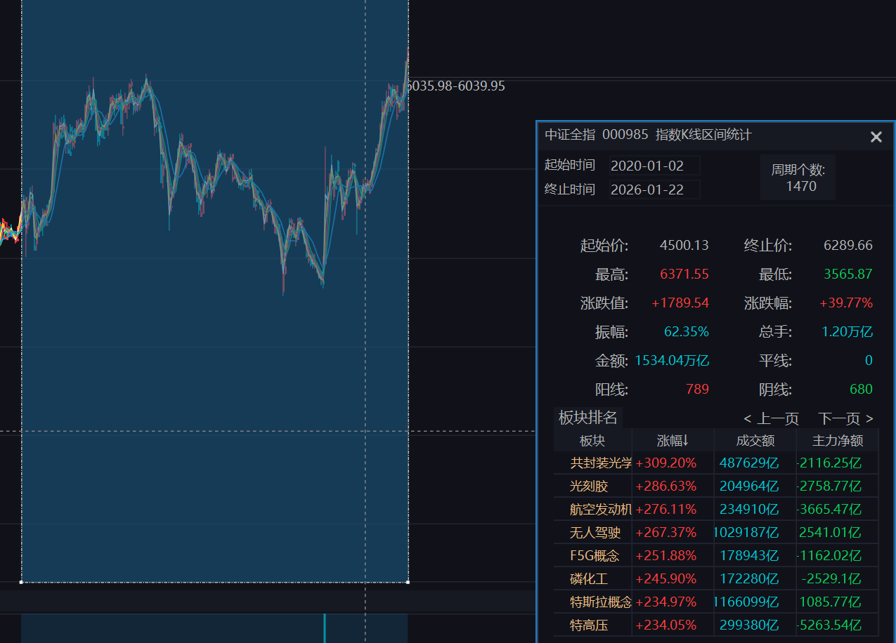
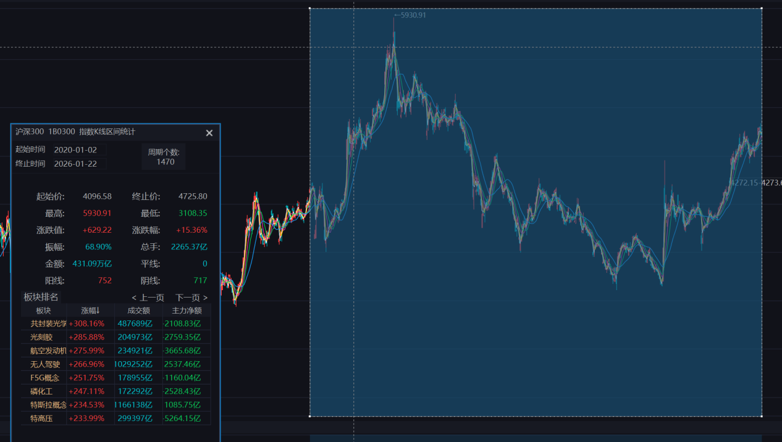

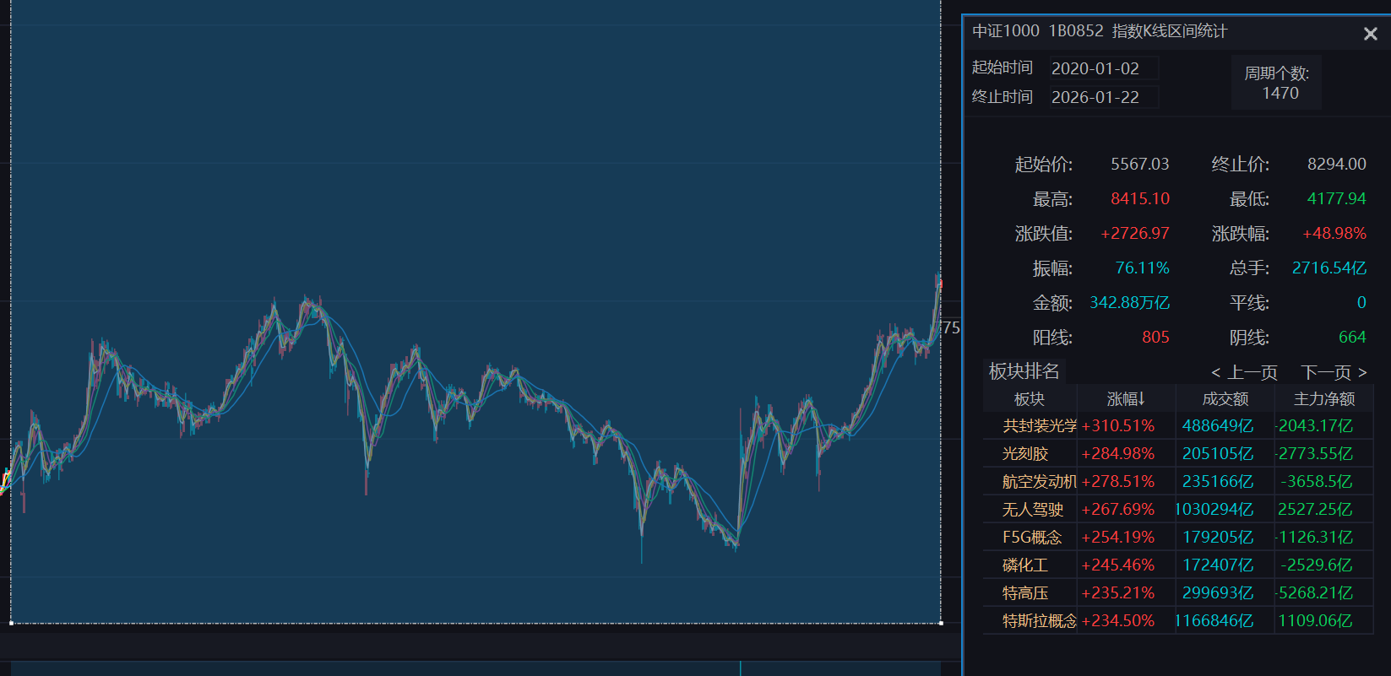
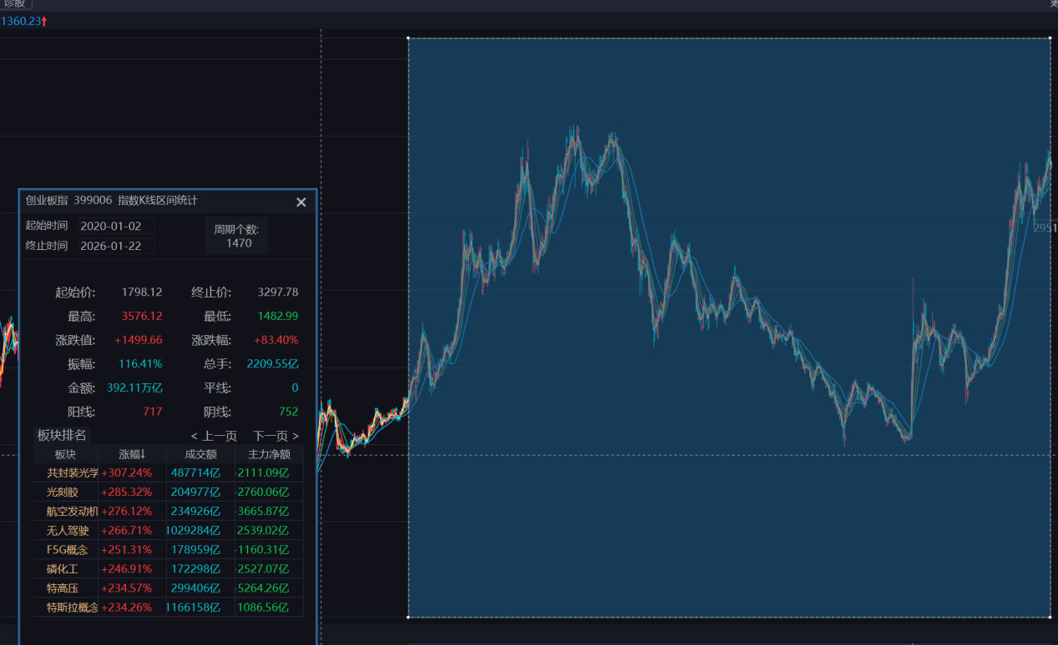
加了三重风险：
Using data file: C:\Users\24106\Desktop\中证500.xlsx
Data range: 2020-01-02 -> 2026-01-21, rows=1468
signals: 128

===== 风控参数配置 =====
基础手数 (BASE_LOTS): 0
单笔最大风险比例 (RISK_PCT): 0.50%
最大名义杠杆 (MAX_LEVERAGE): 1 倍
初始保证金率 (MARGIN_RATE): 15.00%
最大手数上限 (MAX_LOTS_CAP): 5

===== 回测结果汇总 =====
k_atr: 3.000
trades: 0.000
realized_pnl: 0.00
final_equity: 1000000.00
exposure: 0.0000
win_rate: 0.0000
avg_R: 0.000
max_dd: 0.0000
sharpe_full: 0.000
sharpe_active: 0.000
expectancy_trade: 0.00
expectancy_R: 0.000
avg_win: 0.00
avg_loss: 0.00
profit_factor: 0.000
payoff_ratio: 0.000
expectancy_per_day: 0.00
expectancy_per_hold_day: 0.00

%runfile 'C:/Users/24106/Desktop/实习program汇总/untitled0.py' --wdir
Using data file: C:\Users\24106\Desktop\中证500.xlsx
Data range: 2020-01-02 -> 2026-01-21, rows=1468
signals: 128

===== 风控参数配置 =====
基础手数 (BASE_LOTS): 0
单笔最大风险比例 (RISK_PCT): 0.50%
最大名义杠杆 (MAX_LEVERAGE): 1.5 倍
初始保证金率 (MARGIN_RATE): 15.00%
最大手数上限 (MAX_LOTS_CAP): 5

===== 回测结果汇总 =====
k_atr: 3.000
trades: 0.000
realized_pnl: 0.00
final_equity: 1000000.00
exposure: 0.0000
win_rate: 0.0000
avg_R: 0.000
max_dd: 0.0000
sharpe_full: 0.000
sharpe_active: 0.000
expectancy_trade: 0.00
expectancy_R: 0.000
avg_win: 0.00
avg_loss: 0.00
profit_factor: 0.000
payoff_ratio: 0.000
expectancy_per_day: 0.00
expectancy_per_hold_day: 0.00

%runfile 'C:/Users/24106/Desktop/实习program汇总/untitled0.py' --wdir
Using data file: C:\Users\24106\Desktop\中证500.xlsx
Data range: 2020-01-02 -> 2026-01-21, rows=1468
signals: 128

===== 风控参数配置 =====
基础手数 (BASE_LOTS): 0
单笔最大风险比例 (RISK_PCT): 1.00%
最大名义杠杆 (MAX_LEVERAGE): 1.5 倍
初始保证金率 (MARGIN_RATE): 12.00%
最大手数上限 (MAX_LOTS_CAP): 10

===== 回测结果汇总 =====
k_atr: 3.000
trades: 0.000
realized_pnl: 0.00
final_equity: 1000000.00
exposure: 0.0000
win_rate: 0.0000
avg_R: 0.000
max_dd: 0.0000
sharpe_full: 0.000
sharpe_active: 0.000
expectancy_trade: 0.00
expectancy_R: 0.000
avg_win: 0.00
avg_loss: 0.00
profit_factor: 0.000
payoff_ratio: 0.000
expectancy_per_day: 0.00
expectancy_per_hold_day: 0.00

%runfile 'C:/Users/24106/Desktop/实习program汇总/untitled0.py' --wdir
Using data file: C:\Users\24106\Desktop\中证500.xlsx
Data range: 2020-01-02 -> 2026-01-21, rows=1468
signals: 128

===== 风控参数配置 =====
基础手数 (BASE_LOTS): 0
单笔最大风险比例 (RISK_PCT): 2.00%
最大名义杠杆 (MAX_LEVERAGE): 1.5 倍
初始保证金率 (MARGIN_RATE): 12.00%
最大手数上限 (MAX_LOTS_CAP): 10

===== 回测结果汇总 =====
k_atr: 3.000
trades: 8.000
realized_pnl: 126980.65
final_equity: 1126980.65
exposure: 0.0763
win_rate: 0.2500
avg_R: 0.904
max_dd: -0.1013
sharpe_full: 0.471
sharpe_active: 1.713
expectancy_trade: 15872.58
expectancy_R: 0.904
avg_win: 103492.49
avg_loss: -13334.06
profit_factor: 2.587
payoff_ratio: 7.762
expectancy_per_day: 86.50
expectancy_per_hold_day: 1133.76

===== 最近交易记录 =====
entry_date exit_date entry exit pnl R_mult reason
2022-01-19 2022-01-20 7144.4768 7052.634800 -18368.400000 -1.000000 stop
2023-01-10 2023-03-10 6044.6410 6206.735077 32418.815316 1.714349 stop
2023-03-27 2023-03-29 6304.4792 6242.157000 -12464.440000 -1.000000 stop
2023-06-14 2023-06-21 6046.4375 6046.437500 0.000000 0.000000 stop
2023-07-12 2023-07-20 6030.6447 5936.227200 -18883.500000 -1.000000 stop
2023-11-16 2023-11-23 5647.0613 5565.091400 -16393.980000 -1.000000 stop
2025-05-22 2025-05-23 5739.1909 5669.720800 -13894.020000 -1.000000 stop
2025-07-02 2025-09-04 5922.5407 6795.371552 174566.170449 10.520699 stop

%runfile 'C:/Users/24106/Desktop/实习program汇总/untitled0.py' --wdir
Using data file: C:\Users\24106\Desktop\中证500.xlsx
Data range: 2020-01-02 -> 2026-01-21, rows=1468
signals: 128

===== 风控参数配置 =====
基础手数 (BASE_LOTS): 0
单笔最大风险比例 (RISK_PCT): 2.00%
最大名义杠杆 (MAX_LEVERAGE): 1.5 倍
初始保证金率 (MARGIN_RATE): 13.00%
最大手数上限 (MAX_LOTS_CAP): 10

===== 回测结果汇总 =====
k_atr: 3.000
trades: 8.000
realized_pnl: 126980.65
final_equity: 1126980.65
exposure: 0.0763
win_rate: 0.2500
avg_R: 0.904
max_dd: -0.1013
sharpe_full: 0.471
sharpe_active: 1.713
expectancy_trade: 15872.58
expectancy_R: 0.904
avg_win: 103492.49
avg_loss: -13334.06
profit_factor: 2.587
payoff_ratio: 7.762
expectancy_per_day: 86.50
expectancy_per_hold_day: 1133.76

===== 最近交易记录 =====
entry_date exit_date entry exit pnl R_mult reason
2022-01-19 2022-01-20 7144.4768 7052.634800 -18368.400000 -1.000000 stop
2023-01-10 2023-03-10 6044.6410 6206.735077 32418.815316 1.714349 stop
2023-03-27 2023-03-29 6304.4792 6242.157000 -12464.440000 -1.000000 stop
2023-06-14 2023-06-21 6046.4375 6046.437500 0.000000 0.000000 stop
2023-07-12 2023-07-20 6030.6447 5936.227200 -18883.500000 -1.000000 stop
2023-11-16 2023-11-23 5647.0613 5565.091400 -16393.980000 -1.000000 stop
2025-05-22 2025-05-23 5739.1909 5669.720800 -13894.020000 -1.000000 stop
2025-07-02 2025-09-04 5922.5407 6795.371552 174566.170449 10.520699 stop

%runfile 'C:/Users/24106/Desktop/实习program汇总/untitled0.py' --wdir
Using data file: C:\Users\24106\Desktop\中证500.xlsx
Data range: 2020-01-02 -> 2026-01-21, rows=1468
signals: 128

===== 风控参数配置 =====
基础手数 (BASE_LOTS): 0
单笔最大风险比例 (RISK_PCT): 2.00%
最大名义杠杆 (MAX_LEVERAGE): 2 倍
初始保证金率 (MARGIN_RATE): 13.00%
最大手数上限 (MAX_LOTS_CAP): 10

===== 回测结果汇总 =====
k_atr: 3.000
trades: 8.000
realized_pnl: 126980.65
final_equity: 1126980.65
exposure: 0.0763
win_rate: 0.2500
avg_R: 0.904
max_dd: -0.1013
sharpe_full: 0.471
sharpe_active: 1.713
expectancy_trade: 15872.58
expectancy_R: 0.904
avg_win: 103492.49
avg_loss: -13334.06
profit_factor: 2.587
payoff_ratio: 7.762
expectancy_per_day: 86.50
expectancy_per_hold_day: 1133.76

===== 最近交易记录 =====
entry_date exit_date entry exit pnl R_mult reason
2022-01-19 2022-01-20 7144.4768 7052.634800 -18368.400000 -1.000000 stop
2023-01-10 2023-03-10 6044.6410 6206.735077 32418.815316 1.714349 stop
2023-03-27 2023-03-29 6304.4792 6242.157000 -12464.440000 -1.000000 stop
2023-06-14 2023-06-21 6046.4375 6046.437500 0.000000 0.000000 stop
2023-07-12 2023-07-20 6030.6447 5936.227200 -18883.500000 -1.000000 stop
2023-11-16 2023-11-23 5647.0613 5565.091400 -16393.980000 -1.000000 stop
2025-05-22 2025-05-23 5739.1909 5669.720800 -13894.020000 -1.000000 stop
2025-07-02 2025-09-04 5922.5407 6795.371552 174566.170449 10.520699 stop

%runfile 'C:/Users/24106/Desktop/实习program汇总/untitled0.py' --wdir
Using data file: C:\Users\24106\Desktop\中证500.xlsx
Data range: 2020-01-02 -> 2026-01-21, rows=1468
signals: 128

===== 风控参数配置 =====
基础手数 (BASE_LOTS): 1
单笔最大风险比例 (RISK_PCT): 2.00%
最大名义杠杆 (MAX_LEVERAGE): 2 倍
初始保证金率 (MARGIN_RATE): 12.00%
最大手数上限 (MAX_LOTS_CAP): 20

===== 回测结果汇总 =====
k_atr: 3.000
trades: 48.000
realized_pnl: 527689.29
final_equity: 1527689.29
exposure: 0.4939
win_rate: 0.4167
avg_R: 0.322
max_dd: -0.2994
sharpe_full: 0.563
sharpe_active: 0.801
expectancy_trade: 10993.53
expectancy_R: 0.322
avg_win: 61831.27
avg_loss: -25319.14
profit_factor: 1.744
payoff_ratio: 2.442
expectancy_per_day: 359.46
expectancy_per_hold_day: 727.85

===== 最近交易记录 =====
entry_date exit_date entry exit pnl R_mult reason
2025-02-11 2025-02-27 5890.3732 6028.985600 27722.480000 0.473001 timeout
2025-03-07 2025-03-25 6029.3813 5946.951000 -16486.060000 -0.443369 timeout
2025-05-07 2025-05-23 5805.6560 5653.043600 -30522.480000 -0.651022 timeout
2025-06-06 2025-06-20 5768.3989 5653.297800 -23020.220000 -1.000000 stop
2025-06-26 2025-07-14 5868.2924 6020.858500 30513.220000 0.598272 timeout
2025-07-22 2025-09-04 6166.6164 6795.371552 125751.030449 4.094183 stop
2025-09-15 2025-10-13 7170.4123 7170.412300 0.000000 0.000000 stop
2025-10-28 2025-11-13 7344.4539 7355.291100 2167.440000 0.033639 timeout
2025-11-27 2025-12-16 6970.7329 6970.732900 0.000000 0.000000 stop
2025-12-23 2026-01-21 7257.9076 8340.113300 216441.140000 6.624343 eod

%runfile 'C:/Users/24106/Desktop/实习program汇总/untitled0.py' --wdir
Using data file: C:\Users\24106\Desktop\中证500.xlsx
Data range: 2020-01-02 -> 2026-01-21, rows=1468
signals: 128

===== 风控参数配置 =====
基础手数 (BASE_LOTS): 1
单笔最大风险比例 (RISK_PCT): 3.00%
最大名义杠杆 (MAX_LEVERAGE): 2 倍
初始保证金率 (MARGIN_RATE): 12.00%
最大手数上限 (MAX_LOTS_CAP): 20

===== 回测结果汇总 =====
k_atr: 3.000
trades: 48.000
realized_pnl: 511295.31
final_equity: 1511295.31
exposure: 0.4939
win_rate: 0.4167
avg_R: 0.322
max_dd: -0.2994
sharpe_full: 0.547
sharpe_active: 0.779
expectancy_trade: 10651.99
expectancy_R: 0.322
avg_win: 61831.27
avg_loss: -25904.64
profit_factor: 1.705
payoff_ratio: 2.387
expectancy_per_day: 348.29
expectancy_per_hold_day: 705.23

===== 最近交易记录 =====
entry_date exit_date entry exit pnl R_mult reason
2025-02-11 2025-02-27 5890.3732 6028.985600 27722.480000 0.473001 timeout
2025-03-07 2025-03-25 6029.3813 5946.951000 -16486.060000 -0.443369 timeout
2025-05-07 2025-05-23 5805.6560 5653.043600 -30522.480000 -0.651022 timeout
2025-06-06 2025-06-20 5768.3989 5653.297800 -23020.220000 -1.000000 stop
2025-06-26 2025-07-14 5868.2924 6020.858500 30513.220000 0.598272 timeout
2025-07-22 2025-09-04 6166.6164 6795.371552 125751.030449 4.094183 stop
2025-09-15 2025-10-13 7170.4123 7170.412300 0.000000 0.000000 stop
2025-10-28 2025-11-13 7344.4539 7355.291100 2167.440000 0.033639 timeout
2025-11-27 2025-12-16 6970.7329 6970.732900 0.000000 0.000000 stop
2025-12-23 2026-01-21 7257.9076 8340.113300 216441.140000 6.624343 eod

%runfile 'C:/Users/24106/Desktop/实习program汇总/untitled0.py' --wdir
Using data file: C:\Users\24106\Desktop\中证500.xlsx
Data range: 2020-01-02 -> 2026-01-21, rows=1468
signals: 128

===== 风控参数配置 =====
基础手数 (BASE_LOTS): 1
单笔最大风险比例 (RISK_PCT): 3.00%
最大名义杠杆 (MAX_LEVERAGE): 3 倍
初始保证金率 (MARGIN_RATE): 12.00%
最大手数上限 (MAX_LOTS_CAP): 20

===== 回测结果汇总 =====
k_atr: 3.000
trades: 48.000
realized_pnl: 511295.31
final_equity: 1511295.31
exposure: 0.4939
win_rate: 0.4167
avg_R: 0.322
max_dd: -0.2994
sharpe_full: 0.547
sharpe_active: 0.779
expectancy_trade: 10651.99
expectancy_R: 0.322
avg_win: 61831.27
avg_loss: -25904.64
profit_factor: 1.705
payoff_ratio: 2.387
expectancy_per_day: 348.29
expectancy_per_hold_day: 705.23

===== 最近交易记录 =====
entry_date exit_date entry exit pnl R_mult reason
2025-02-11 2025-02-27 5890.3732 6028.985600 27722.480000 0.473001 timeout
2025-03-07 2025-03-25 6029.3813 5946.951000 -16486.060000 -0.443369 timeout
2025-05-07 2025-05-23 5805.6560 5653.043600 -30522.480000 -0.651022 timeout
2025-06-06 2025-06-20 5768.3989 5653.297800 -23020.220000 -1.000000 stop
2025-06-26 2025-07-14 5868.2924 6020.858500 30513.220000 0.598272 timeout
2025-07-22 2025-09-04 6166.6164 6795.371552 125751.030449 4.094183 stop
2025-09-15 2025-10-13 7170.4123 7170.412300 0.000000 0.000000 stop
2025-10-28 2025-11-13 7344.4539 7355.291100 2167.440000 0.033639 timeout
2025-11-27 2025-12-16 6970.7329 6970.732900 0.000000 0.000000 stop
2025-12-23 2026-01-21 7257.9076 8340.113300 216441.140000 6.624343 eod

%runfile 'C:/Users/24106/Desktop/实习program汇总/untitled0.py' --wdir
Using data file: C:\Users\24106\Desktop\中证500.xlsx
Data range: 2020-01-02 -> 2026-01-21, rows=1468
signals: 128

===== 风控参数配置 =====
基础手数 (BASE_LOTS): 1
单笔最大风险比例 (RISK_PCT): 3.00%
最大名义杠杆 (MAX_LEVERAGE): 3 倍
初始保证金率 (MARGIN_RATE): 10.00%
最大手数上限 (MAX_LOTS_CAP): 20

===== 回测结果汇总 =====
k_atr: 3.000
trades: 48.000
realized_pnl: 511295.31
final_equity: 1511295.31
exposure: 0.4939
win_rate: 0.4167
avg_R: 0.322
max_dd: -0.2994
sharpe_full: 0.547
sharpe_active: 0.779
expectancy_trade: 10651.99
expectancy_R: 0.322
avg_win: 61831.27
avg_loss: -25904.64
profit_factor: 1.705
payoff_ratio: 2.387
expectancy_per_day: 348.29
expectancy_per_hold_day: 705.23

===== 最近交易记录 =====
entry_date exit_date entry exit pnl R_mult reason
2025-02-11 2025-02-27 5890.3732 6028.985600 27722.480000 0.473001 timeout
2025-03-07 2025-03-25 6029.3813 5946.951000 -16486.060000 -0.443369 timeout
2025-05-07 2025-05-23 5805.6560 5653.043600 -30522.480000 -0.651022 timeout
2025-06-06 2025-06-20 5768.3989 5653.297800 -23020.220000 -1.000000 stop
2025-06-26 2025-07-14 5868.2924 6020.858500 30513.220000 0.598272 timeout
2025-07-22 2025-09-04 6166.6164 6795.371552 125751.030449 4.094183 stop
2025-09-15 2025-10-13 7170.4123 7170.412300 0.000000 0.000000 stop
2025-10-28 2025-11-13 7344.4539 7355.291100 2167.440000 0.033639 timeout
2025-11-27 2025-12-16 6970.7329 6970.732900 0.000000 0.000000 stop
2025-12-23 2026-01-21 7257.9076 8340.113300 216441.140000 6.624343 eod
加上大小周期与没有大小周期的对比：
中证500无大小周期 仅日线过滤：
Data range: 2023-01-30 -> 2026-01-21, rows=726
signals: 58

===== Summary =====
k_atr: 3.0
trades: 25
realized_pnl: 311795.89636577934
final_equity: 1311795.8963657795
exposure: 0.4022038567493113
win_rate: 0.36
avg_R: 0.25326832212128736
max_dd: -0.21661573999999975
sharpe_full: 0.6379553968829963
sharpe_active: 1.0064415554884583
expectancy_trade: 12471.835854631172
expectancy_R: 0.25326832212128736
avg_win: 68800.83737397545
avg_loss: -19213.227499999983
profit_factor: 2.014261842413578
payoff_ratio: 3.5809099420685833
expectancy_per_day: 429.4709316333049
expectancy_per_hold_day: 1067.7941656362307

Last trades:
entry_date exit_date entry exit pnl R_mult reason
2023-02-03 2023-02-09 6354.7135 6259.527500 -19037.200000 -1.000000 stop
2023-03-02 2023-03-07 6398.2563 6288.299400 -21991.380000 -1.000000 stop
2023-03-24 2023-04-21 6312.4308 6312.430800 0.000000 0.000000 stop
2023-05-04 2023-05-12 6223.2261 6093.197600 -26005.700000 -1.000000 stop
2023-06-14 2023-06-21 6046.4375 6046.437500 0.000000 0.000000 stop
2023-07-04 2023-07-20 6042.7217 5924.278300 -23688.680000 -1.000000 stop
2023-10-31 2023-11-16 5547.3243 5609.360700 12407.280000 0.295648 timeout
2023-11-16 2023-11-23 5647.0613 5565.091400 -16393.980000 -1.000000 stop
2024-01-02 2024-01-08 5431.4784 5235.455900 -39204.500000 -1.000000 stop
2024-01-26 2024-01-31 5055.2878 4727.880600 -65481.440000 -1.000000 stop
2024-02-19 2024-03-06 5225.1379 5350.101600 24992.740000 0.152426 timeout
2024-04-02 2024-04-22 5395.4811 5267.581100 -25580.000000 -0.535145 timeout
2024-04-30 2024-05-21 5471.1676 5478.913100 1549.100000 0.032093 timeout
2024-09-26 2024-10-10 4725.9960 5614.311530 177663.105917 3.657636 stop
2024-11-07 2024-11-15 6061.7349 6061.734900 0.000000 0.000000 stop
2025-02-11 2025-02-27 5890.3732 6028.985600 27722.480000 0.473001 timeout
2025-03-07 2025-03-25 6029.3813 5946.951000 -16486.060000 -0.443369 timeout
2025-05-07 2025-05-23 5805.6560 5653.043600 -30522.480000 -0.651022 timeout
2025-06-06 2025-06-20 5768.3989 5653.297800 -23020.220000 -1.000000 stop
2025-06-26 2025-07-14 5868.2924 6020.858500 30513.220000 0.598272 timeout
2025-07-22 2025-09-04 6166.6164 6795.371552 125751.030449 4.094183 stop
2025-09-15 2025-10-13 7170.4123 7170.412300 0.000000 0.000000 stop
2025-10-28 2025-11-13 7344.4539 7355.291100 2167.440000 0.033639 timeout
2025-11-27 2025-12-16 6970.7329 6970.732900 0.000000 0.000000 stop
2025-12-23 2026-01-21 7257.9076 8340.113300 216441.140000 6.624343 eod

中证500有大小周期：
===== Summary =====
trades: 8
realized_pnl: 408989.4029405941
final_equity: 1408989.402940594
exposure: 0.052452316076294275
win_rate: 0.375
avg_R: 0.9595182086998495
max_dd: -0.11044365229427665
sharpe_full: 0.7824533756358923
sharpe_active: 3.4927441463096796
expectancy_trade: 51123.67536757427
expectancy_R: 0.9595182086998495
avg_win: 156861.89878859298
avg_loss: -12319.258685036948
profit_factor: 7.6398378895534576
payoff_ratio: 12.733063149255765

Last trades:
entry_date entry_ts exit_date entry exit pnl R_mult reason
2023-02-03 2023-02-03 15:00:00 2023-02-06 6348.2865 6289.999664 -11657.367119 -0.656686 m30_stop
2023-03-27 2023-03-27 15:00:00 2023-03-29 6313.8268 6267.977174 -9169.925119 -0.639734 m30_stop
2023-06-15 2023-06-15 11:30:00 2023-06-21 6071.6923 6031.728334 -7992.793206 -0.473372 m30_stop
2023-07-04 2023-07-04 13:30:00 2023-07-05 6058.6387 6016.376218 -8452.496472 -0.314546 m30_stop
2024-09-26 2024-09-26 14:30:00 2024-10-10 4876.2355 5614.311530 147615.205917 1.877552 m30_stop
2024-11-07 2024-11-07 14:00:00 2024-11-15 6161.4992 6039.880642 -24323.711509 -0.372940 m30_stop
2025-07-22 2025-07-22 14:00:00 2025-09-04 6206.8003 6795.371552 117714.250449 3.037682 m30_stop
2025-12-24 2025-12-24 13:30:00 2026-01-21 7313.8321 8340.113300 205256.240000 5.218190 eod
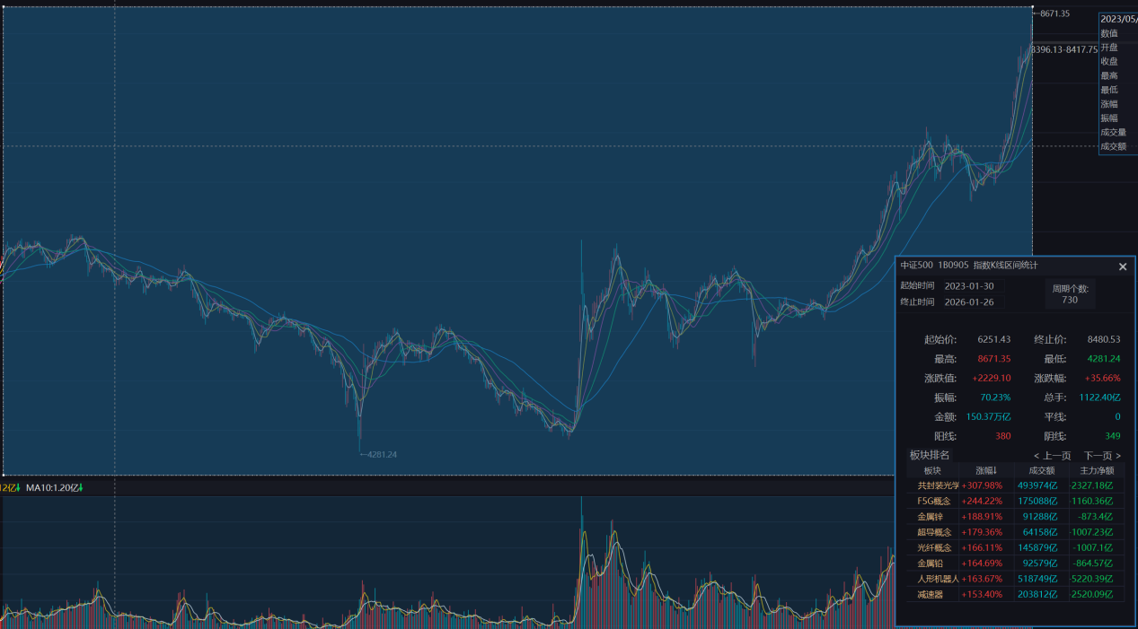
沪深300仅日线：
===== Summary =====
trades: 24
realized_pnl: 53331.3780837443
final_equity: 1053331.3780837443
exposure: 0.42857142857142855
win_rate: 0.375
avg_R: -0.06099061550642698
max_dd: -0.11444017550944287
sharpe_full: 0.24481508539658406
sharpe_active: 0.3737634151785866
expectancy_trade: 2222.140753489346
expectancy_R: -0.06099061550642698
avg_win: 26479.193615836804
avg_loss: -12332.090963919129
profit_factor: 1.288306761277168
payoff_ratio: 2.1471779354619467

Last trades:
entry_date entry_ts exit_date entry exit pnl R_mult reason
2023-04-04 None 2023-04-21 4089.29 4046.037517 -8650.496556 -0.410404 daily_stop
2023-05-05 None 2023-05-12 4031.09 3942.820000 -17654.000000 -1.000000 daily_stop
2023-06-13 None 2023-06-26 3838.13 3838.130000 0.000000 0.000000 daily_stop
2023-07-05 None 2023-07-21 3895.19 3813.550000 -16328.000000 -1.000000 daily_stop
2023-10-31 None 2023-11-16 3581.68 3572.360000 -1864.000000 -0.089935 timeout
2024-01-02 None 2024-01-08 3426.27 3309.670000 -23320.000000 -1.000000 daily_stop
2024-01-26 None 2024-02-02 3326.65 3188.130000 -27704.000000 -1.000000 daily_stop
2024-02-08 None 2024-04-12 3351.41 3483.410833 26400.166604 0.550256 daily_stop
2024-04-30 None 2024-05-21 3619.26 3676.160000 11380.000000 0.498860 timeout
2024-05-21 None 2024-05-24 3682.29 3626.330000 -11192.000000 -1.000000 daily_stop
2024-07-15 None 2024-07-23 3462.61 3462.610000 0.000000 0.000000 daily_stop
2024-08-20 None 2024-08-28 3361.64 3297.970000 -12734.000000 -1.000000 daily_stop
2024-09-25 None 2024-10-10 3403.70 3932.128305 105685.660964 2.292730 daily_stop
2024-11-06 None 2024-11-22 4051.29 3886.449938 -32968.012314 -0.962120 daily_stop
2024-12-26 None 2025-01-02 3981.73 3928.150000 -10716.000000 -1.000000 daily_stop
2025-03-07 None 2025-03-31 3944.91 3881.035722 -12774.855589 -0.716240 daily_stop
2025-04-11 None 2025-04-29 3730.31 3775.080000 8954.000000 0.305722 timeout
2025-05-08 None 2025-05-28 3820.55 3835.805897 3051.179441 0.294572 daily_stop
2025-06-06 None 2025-06-23 3878.10 3832.720000 -9076.000000 -1.000000 daily_stop
2025-06-26 None 2025-08-01 3953.16 4044.641819 18296.363849 0.725585 daily_stop
2025-08-07 None 2025-09-04 4120.28 4352.196858 46383.371684 2.816576 daily_stop
2025-10-28 None 2025-11-13 4697.73 4702.070000 868.000000 0.027813 timeout
2025-11-27 None 2025-12-16 4520.01 4520.010000 0.000000 0.000000 daily_stop
2025-12-23 None 2026-01-23 4616.03 4702.500000 17294.000000 1.202810 eod
沪深300大小周期：
===== Summary =====
trades: 11
realized_pnl: 124788.69178969982
final_equity: 1124788.6917897
exposure: 0.024628616106333073
win_rate: 0.45454545454545453
avg_R: 0.3111605651547183
max_dd: -0.07592448860977465
sharpe_full: 0.23731517905926391
sharpe_active: 1.5187739820799422
expectancy_trade: 11344.426526336343
expectancy_R: 0.3111605651547183
avg_win: 31154.539851472015
avg_loss: -5164.001244610047
profit_factor: 5.027519420137909
payoff_ratio: 6.033023304165491

Last trades:
entry_date entry_ts exit_date entry exit pnl R_mult reason
2023-06-13 2023-06-13 14:00:00 2023-06-26 3849.1730 3849.173000 0.000000 0.000000 m30_stop
2024-02-21 2024-02-21 11:30:00 2024-04-12 3460.6977 3483.410833 4542.626609 0.183588 m30_stop
2024-07-18 2024-07-18 14:00:00 2024-07-23 3514.4979 3483.480106 -6203.558866 -0.577528 m30_stop
2024-09-26 2024-09-26 14:30:00 2024-10-10 3503.2056 3932.128305 85784.540964 1.405449 m30_stop
2024-12-26 2024-12-26 13:30:00 2024-12-31 3987.6036 3955.500342 -6420.651579 -0.539972 m30_stop
2025-04-11 2025-04-11 14:30:00 2025-04-29 3752.3643 3775.080000 4543.140000 0.134816 timeout
2025-05-14 2025-05-14 14:00:00 2025-05-16 3929.1613 3898.387164 -6154.827267 -0.332222 m30_stop
2025-07-04 2025-07-04 14:00:00 2025-07-04 4008.4160 3979.092052 -5864.789642 -0.350363 m30_stop_entryday
2025-07-22 2025-07-22 14:00:00 2025-07-31 4115.6867 4083.985799 -6340.180114 -0.286583 m30_stop
2025-08-07 2025-08-07 14:00:00 2025-09-04 4115.9668 4352.196858 47246.011684 3.027550 m30_stop
2025-12-23 2025-12-23 11:30:00 2026-01-23 4634.2181 4702.500000 13656.380000 0.758030 eod
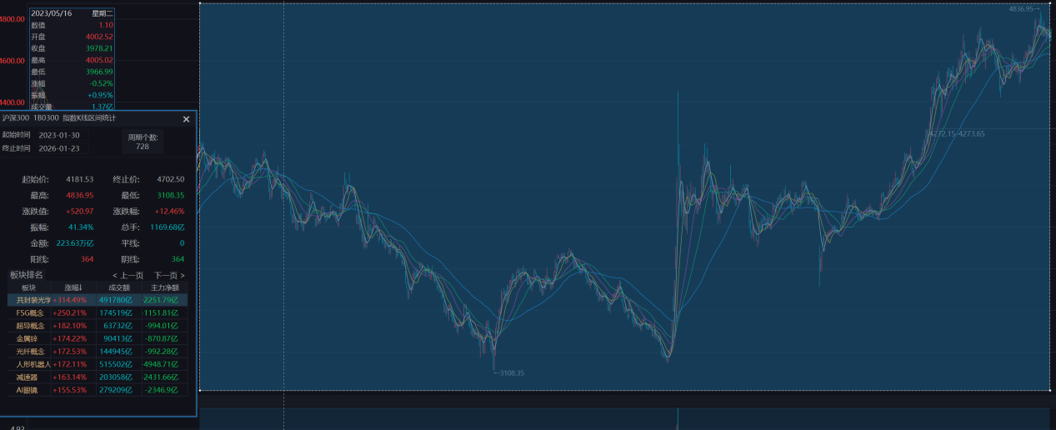
中证1000日线：
===== Summary =====
trades: 27
realized_pnl: 90410.4459554963
final_equity: 1090410.4459554965
exposure: 0.42032967032967034
win_rate: 0.2962962962962963
avg_R: 0.1052921026322635
max_dd: -0.3462904937266654
sharpe_full: 0.2439463944386963
sharpe_active: 0.3760723970230203
expectancy_trade: 3348.535035388748
expectancy_R: 0.1052921026322635
avg_win: 84195.26917217215
avg_loss: -30692.195127467417
profit_factor: 1.1550376082326874
payoff_ratio: 2.7432143195526324

Last trades:
entry_date entry_ts exit_date entry exit pnl R_mult reason
2023-02-03 None 2023-02-16 6922.79 6922.790000 0.000000 0.000000 daily_stop
2023-04-04 None 2023-04-21 6960.91 6842.197498 -23742.500309 -0.567405 daily_stop
2023-05-04 None 2023-05-12 6701.49 6573.880000 -25522.000000 -1.000000 daily_stop
2023-06-06 None 2023-06-07 6625.09 6515.020000 -22014.000000 -1.000000 daily_stop
2023-06-14 None 2023-06-21 6556.03 6556.030000 0.000000 0.000000 daily_stop
2023-07-04 None 2023-07-19 6610.66 6462.070000 -29718.000000 -1.000000 daily_stop
2023-09-13 None 2023-09-14 6169.53 6062.900000 -21326.000000 -1.000000 daily_stop
2023-10-31 None 2023-12-05 6003.37 6032.494904 5824.980811 0.104252 daily_stop
2024-01-02 None 2024-01-08 5891.17 5636.940000 -50846.000000 -1.000000 daily_stop
2024-01-26 None 2024-01-31 5303.96 4939.520000 -72888.000000 -1.000000 daily_stop
2024-02-19 None 2024-03-06 5062.68 5381.460000 63756.000000 0.366536 timeout
2024-03-13 None 2024-03-27 5501.59 5292.818248 -41754.350469 -0.955740 daily_stop
2024-04-02 None 2024-04-15 5556.52 5262.220000 -58860.000000 -1.000000 daily_stop
2024-04-29 None 2024-05-24 5422.41 5358.115717 -12858.856644 -0.289862 daily_stop
2024-09-02 None 2024-09-10 4627.18 4437.520000 -37932.000000 -1.000000 daily_stop
2024-09-26 None 2024-10-10 4675.94 5631.785045 191169.009056 4.156752 daily_stop
2024-10-29 None 2024-11-18 6106.19 6106.190000 0.000000 0.000000 daily_stop
2024-11-22 None 2024-11-25 6240.09 5945.460000 -58926.000000 -1.000000 daily_stop
2025-02-11 None 2025-03-24 6209.52 6278.473079 13790.615803 0.193814 daily_stop
2025-04-03 None 2025-04-07 6208.29 6143.650000 -12928.000000 -1.000000 daily_stop
2025-05-07 None 2025-05-23 6171.61 5989.680000 -36386.000000 -0.542136 timeout
2025-06-06 None 2025-06-20 6164.41 6008.540000 -31174.000000 -1.000000 daily_stop
2025-06-26 None 2025-07-14 6272.44 6462.310000 37974.000000 0.618913 timeout
2025-07-21 None 2025-09-04 6557.25 7174.297739 123409.547708 4.986647 daily_stop
2025-10-10 None 2025-10-13 7608.29 7376.910000 -46276.000000 -1.000000 daily_stop
2025-10-28 None 2025-11-13 7462.91 7590.580000 25534.000000 0.471995 timeout
2025-12-23 None 2026-01-23 7410.22 8470.740000 212104.000000 6.299121 eod
中证1000大小周期：
===== Summary =====
trades: 10
realized_pnl: 319321.3568850093
final_equity: 1319321.3568850094
exposure: 0.0209147771696638
win_rate: 0.5
avg_R: 0.5566753981739316
max_dd: -0.10206040143344124
sharpe_full: 0.2986896102503307
sharpe_active: 2.082472624104274
expectancy_trade: 31932.135688500923
expectancy_R: 0.5566753981739316
avg_win: 77066.25451329825
avg_loss: -13201.983136296403
profit_factor: 5.837475606329089
payoff_ratio: 5.837475606329089

Last trades:
entry_date entry_ts exit_date entry exit pnl R_mult reason
2023-02-03 2023-02-03 15:00:00 2023-02-06 6929.4252 6862.146606 -13455.718894 -0.394538 m30_stop
2023-06-15 2023-06-15 11:30:00 2023-06-21 6601.4647 6556.239331 -9045.073874 -0.357217 m30_stop
2023-07-04 2023-07-04 13:30:00 2023-07-05 6637.3861 6585.237369 -10429.746151 -0.297455 m30_stop
2024-02-27 2024-02-27 11:30:00 2024-02-28 5294.0309 5199.955483 -18815.083497 -0.412556 m30_stop
2024-03-13 2024-03-13 14:00:00 2024-03-14 5545.1384 5473.816934 -14264.293266 -0.272231 m30_stop
2024-04-29 2024-04-29 11:30:00 2024-05-20 5513.5549 5596.780000 16645.020000 0.265933 timeout
2024-09-26 2024-09-26 14:30:00 2024-10-10 4805.3724 5631.785045 165282.529056 2.299536 m30_stop
2025-02-11 2025-02-11 13:30:00 2025-03-24 6199.5854 6278.473079 15777.535803 0.228108 m30_stop
2025-07-21 2025-07-21 14:30:00 2025-09-04 6598.8821 7174.297739 115083.127708 3.479521 m30_stop
2026-01-09 2026-01-09 15:00:00 2026-01-23 8108.0247 8470.740000 72543.060000 1.027654 eod
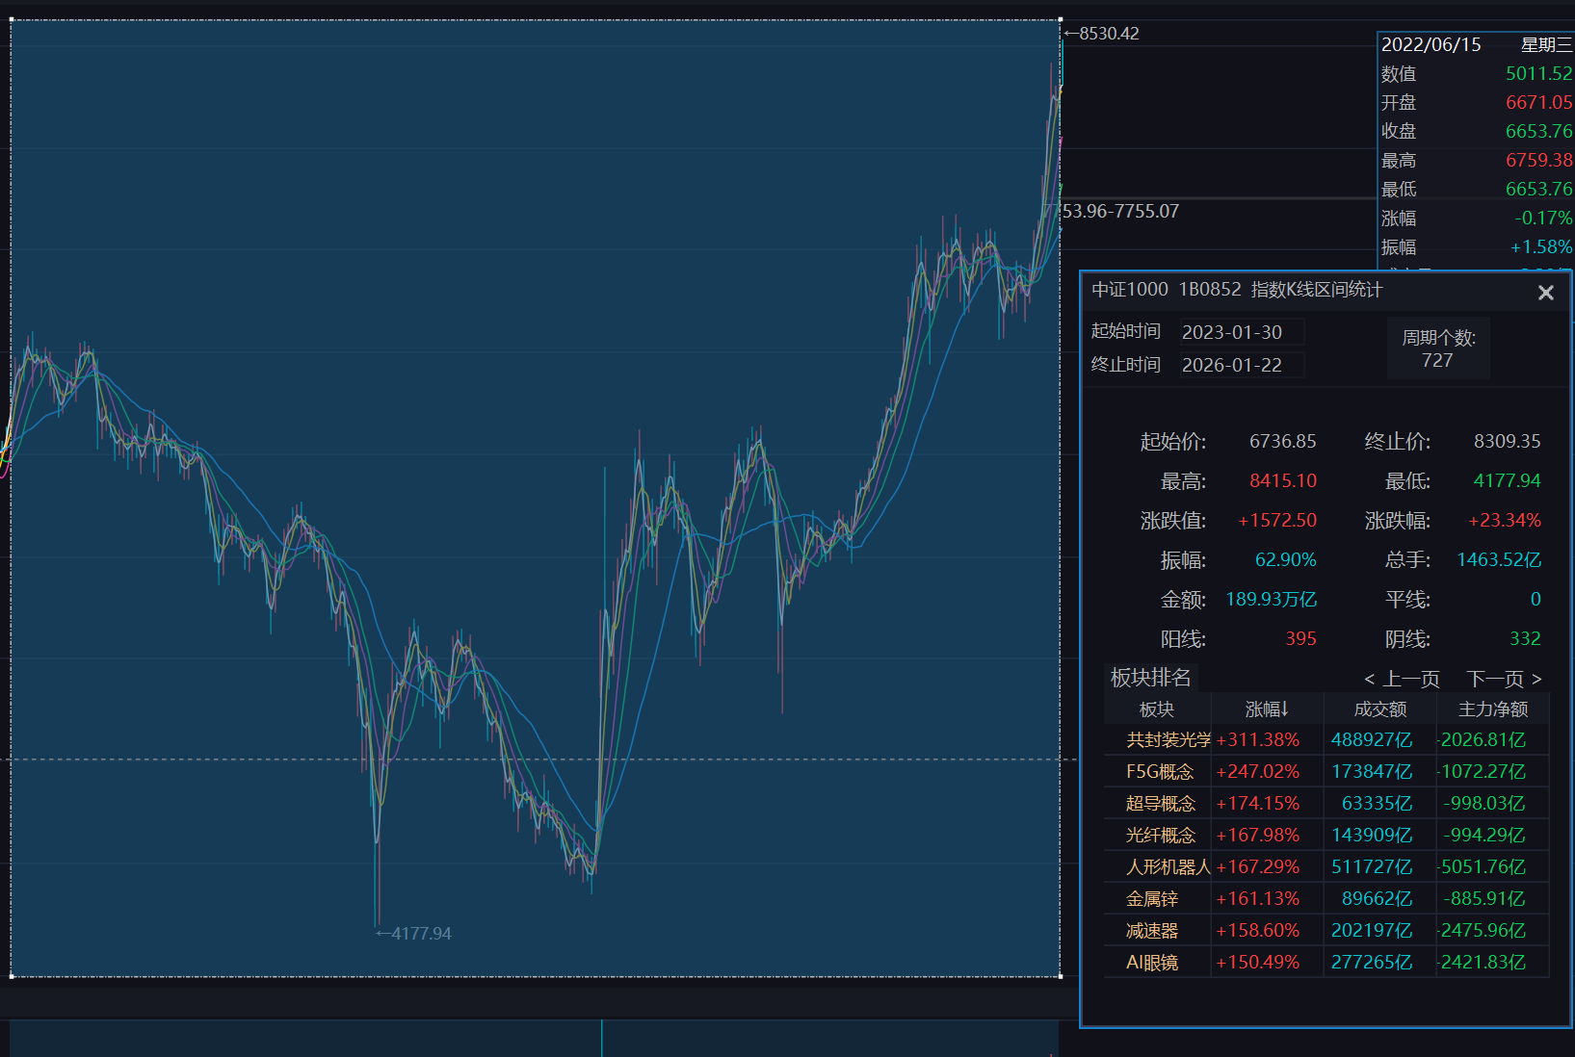

那现在我们要是做空呢，把做多跟做空合在一起，收益会不会更厉害：
- 先考虑单做空的：逻辑一样，但是镜像过来：日线三根k开高低收均下降，止损点为第一根k的最高价，突破E-1R时候重设止损点为E，止损S设为当前止损价与从入场至今最低价加风险系数乘atr中的价低者（S = min(S, LowestCloseSinceEntry + k*ATR14)）k取2~3左右，最后是时间止盈，假如说入场后12根k没有到E-0.8R就退出。分钟线规则一样，三个指标判断：三根30min k线持续走低（同日线走低趋势判断一致）且第一个k没有立马走高到止损点；进的时候以第四根k开盘为入场价，入场后6根k线内收盘价小于等于（入场价+k*atr30min）的根数（用概率处理），假如说概率没达标，那就用第六根k线的收盘价止损；最后一层指标是进场瞬间计算：m30_stop = entry + k * ATR30；止损取：stop = min(日线止损, m30_stop)
然后将做空做多一起之后，得到的收益相比来说较大。
- 最后做多做空结合，收益得到提高

