High-Level Design (HLD)
AI-Assisted Government & Legal Notice Explainer
(Working name: "Yojana Mitra — Notice Explainer")
Document Type | High-Level Design (HLD)
Related Documents | BRS v1.0, SRS v1.0
Version | 1.0 (Draft)
Status | Draft for review

1. Introduction

1.1 Purpose
This High-Level Design (HLD) document describes the system architecture, major components, data flow, technology stack, and deployment approach for the AI-Assisted Government & Legal Notice Explainer. It sits between the SRS (what the system must do) and any subsequent low-level design (exact class/module internals), describing how the system is structured to meet those requirements.

1.2 Scope
This document covers the overall architecture, module responsibilities and their interactions, the data model at a component level, external interfaces, deployment topology, and cross-cutting design concerns (reliability, security, scalability). It does not specify internal class structures, database schemas at the column level, or detailed algorithms — those belong in a Low-Level Design (LLD).

1.3 Design Goals
- Keep each processing stage independently retryable and independently replaceable.
- Make the escalation safety check deterministic and auditable, not solely dependent on AI model behavior.
- Operate within free-tier limits of third-party APIs for the initial release.
- Support extension to additional document types and languages without redesigning the pipeline.

2. Architecture Overview
The system uses an asynchronous, staged-pipeline architecture. A client request is authenticated and rate-limited at the API gateway, then handed to an async job queue that decouples request handling from processing latency. A document processing pipeline runs a fixed sequence of stages, after which the response is delivered to the client. Escalated or low-confidence cases are additionally routed to a human review queue, and every stage writes to an append-only audit log.
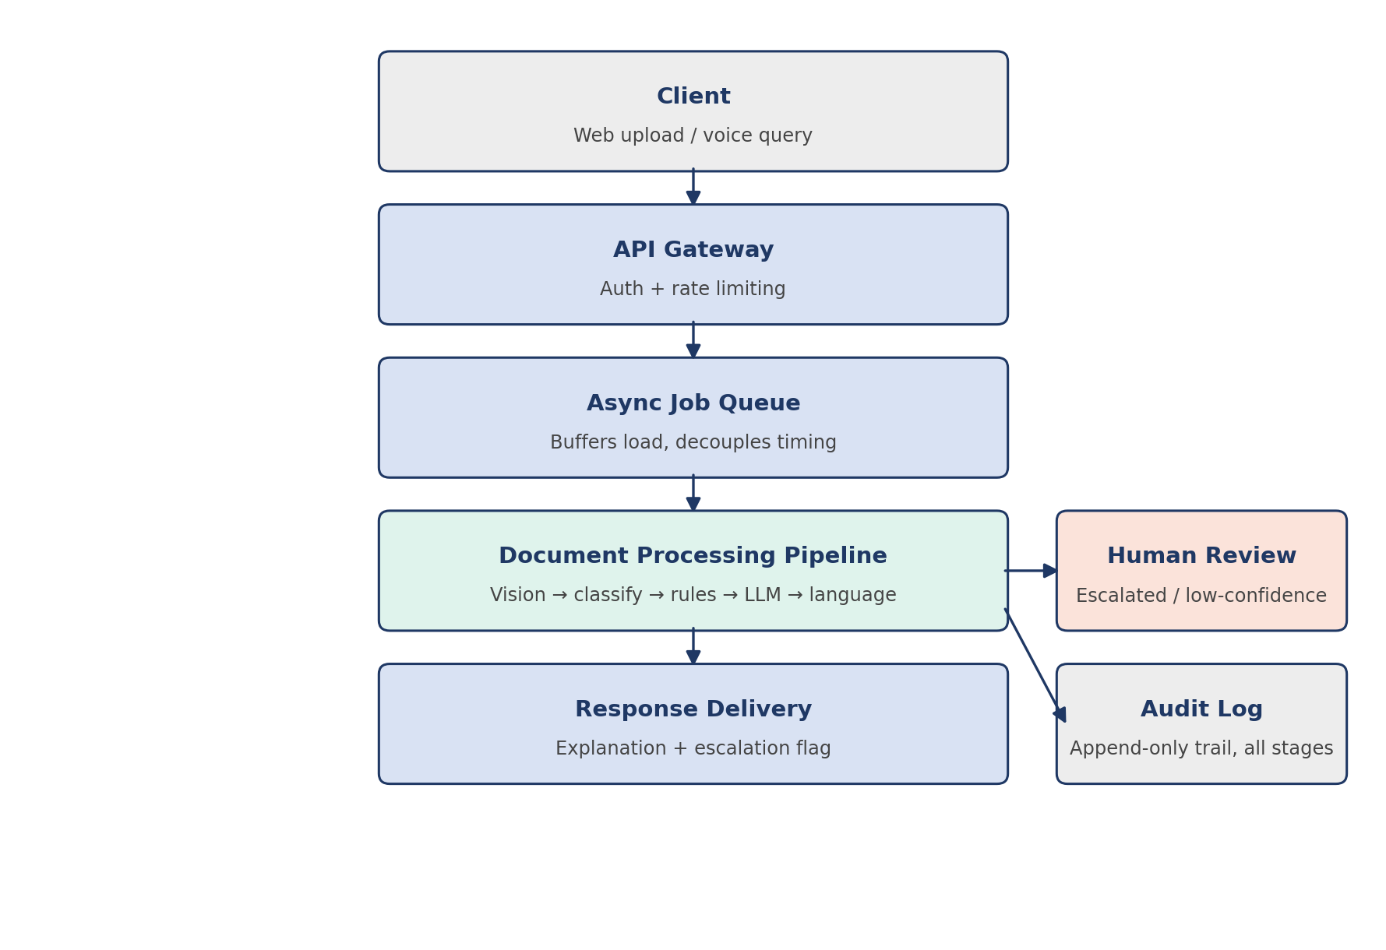
Figure 1: High-level component and data-flow diagram. Blue = request-path infrastructure, teal = core AI processing, coral = human escalation path, gray = client/storage.

2.1 Architectural Style
- Asynchronous, queue-based processing to absorb variable third-party API latency.
- Staged pipeline with independently retryable steps, rather than a single monolithic handler.
- Deterministic rule engine as a first-class component, separate from AI-driven reasoning, for the safety-critical escalation decision.
- Provider abstraction for AI services so the vision/reasoning model and the language/voice service can each be swapped independently.

3. Component Design

3.1 Client Application
- Responsibility: image capture/upload, language selection, voice input, and displaying the explanation/escalation result.
- Key design decision: minimal-typing interface, large touch targets, voice as a first-class input, given the target user base's literacy profile.

3.2 API Gateway
- Responsibility: authentication, request validation, rate limiting, and routing to the job queue.
- Key design decision: stateless; all session/job state lives downstream, so the gateway can scale horizontally without shared memory.

3.3 Async Job Queue
- Responsibility: buffers incoming jobs so pipeline processing time never blocks the client-facing request.
- Key design decision: each job carries a unique job ID used consistently across every downstream stage and the audit log, enabling full traceability of a single request.

3.4 Document Processing Pipeline
Composed of five ordered sub-stages, each implemented as an independently retryable unit:
Stage | Responsibility
Text extraction | Reads text out of the document image using a vision-capable model; returns extracted text plus a confidence score.
Document classification | Determines which supported document type the text represents, or flags it unsupported.
Field extraction | Pulls structured fields (deadline, amount, issuing authority, cited section) from the classified text.
Escalation rule engine | Deterministic keyword/pattern evaluation against raw text and, separately, against the generated explanation; sets the escalation flag.
Explanation generation | Produces the plain-language, target-language explanation and appends the mandatory disclaimer.
Design note: the escalation rule engine deliberately sits as its own step, evaluated independently before and after explanation generation, rather than being folded into the LLM prompt for explanation generation. This keeps the safety-critical decision testable in isolation and immune to prompt-level drift.

3.5 Human Review Queue
- Responsibility: presents escalated or low-confidence cases with full context (image, extracted text, tentative output) for manual resolution before release to the user, where the operating workflow requires pre-release review.
- Key design decision: reviewer decisions and resolution times are captured to monitor escalation-rule quality over time.

3.6 Audit Log Store
- Responsibility: append-only record of every stage's input/output metadata, model/prompt version, and final decision, keyed by job ID.
- Key design decision: stores structured fields and a document hash rather than the raw image, to minimize retained personal data while preserving traceability.

4. Data Flow
1. Client uploads a document image and selects a target language.
2. API gateway authenticates the request and enqueues a job with a unique job ID.
3. Text extraction stage reads the image and returns extracted text with a confidence score.
4. Classification stage determines the document type.
5. Field extraction stage pulls structured fields relevant to that document type.
6. Escalation rule engine evaluates the raw extracted text against configured risk patterns.
7. Explanation generation stage produces the plain-language response in the target language, appending the disclaimer.
8. Escalation rule engine re-evaluates the generated explanation text as a second, independent check.
9. If escalated or low-confidence, the case is routed to the human review queue before release; otherwise the response is delivered directly to the client.
10. Every stage's execution is written to the audit log, keyed by job ID.

5. Technology Stack
Layer | Technology | Notes
Client | React + Tailwind CSS | Deployed as a static site (e.g. Vercel/Netlify free tier).
API layer | Python (FastAPI) or Node.js (Express) | Choose based on team familiarity; both support async job dispatch equally well.
Job queue | Managed queue (e.g. cloud pub/sub) or Redis-backed queue | Redis is simplest for a small-scale initial deployment.
Vision + reasoning | Vision-capable LLM API (free tier) | Used for text extraction, classification, field extraction, and explanation generation.
Language / voice | Indian-language translation, ASR, TTS API (e.g. Bhashini) | Used for target-language explanation delivery and optional voice input/output.
Object storage | Cloud object storage (free tier) | Transient storage for uploaded images; deleted post-processing.
Audit / structured data store | Relational database (e.g. Postgres) or lightweight document store | Append-only audit table; structured field storage.
Rule engine config | Versioned YAML/JSON configuration | Loaded by the escalation stage; editable without a full redeploy.

6. Deployment Architecture
- Initial release: single-region deployment on free-tier cloud compute, with the client as a static site and the API/pipeline as containerized services.
- Job queue and audit store are provisioned as managed services where free-tier options exist, to avoid operating stateful infrastructure directly during the initial release.
- Configuration (API keys, rule engine config, supported document type list) is externalized from application code via environment variables and a versioned config file.

7. Cross-Cutting Design Concerns

7.1 Reliability
- Each pipeline stage is retried independently on transient failure (e.g. third-party API timeout) without reprocessing already-completed stages.

7.2 Security and Privacy
- All communication over HTTPS; document images encrypted at rest during the transient processing window and deleted immediately afterward by default.

7.3 Scalability
- The async queue and independently scalable pipeline stages allow horizontal scaling of the processing layer without changes to the API gateway or client.

7.4 Extensibility
- New document types are added by extending the classification stage's supported list and the field extraction prompts, without changing pipeline control flow.
- New languages are added by extending the translation/voice service configuration, without changing the reasoning or escalation logic.

7.5 Observability
- Per-stage latency and error rate, escalation rate over time, and periodic re-evaluation of the reasoning model's output quality against a fixed eval set are tracked as core operational metrics.

8. Assumptions and Constraints
- Third-party AI and language APIs are accessed via their published free tiers for the initial release and are subject to those tiers' rate limits.
- The system does not verify document authenticity; it processes and explains whatever is uploaded, assuming genuineness.
- Detailed internal module logic (prompt templates, exact rule pattern lists, database schema) is deferred to the Low-Level Design document.

Appendix A: Related Documents
- Business Requirements Specification (BRS) v1.0 — business objectives, scope, and success criteria.
- Software Requirements Specification (SRS) v1.0 — detailed functional and non-functional requirements, and the data entity list this design implements.

