Custom VPC Creation in AWS Steps :

- Go to AWS Management Console
- VPC -> Create VPC
- Resource to create : VPC only/ VPC and more (AWS creates default resources -> Public and Private Subnets)
- Name the VPC
- Set the IPv4 CIDR Block as per requirement
- IPv6 CIDR Block : No IPv6 CIDR block/ Amazon-provided IPv6 CIDR block
- Tenancy : default / dedicated
- Set number of availability zones - 2
- Set number of public subnets - 2
- Set number of private subnets - 2
- Customize subnet CIDR Blocks (2 public and 2 private)
- Select DNS Options : Enable DNS Hostname | Enable DNS Resolution
- Additional tags option
- Create VPC / Preview Code

OUTPUT :
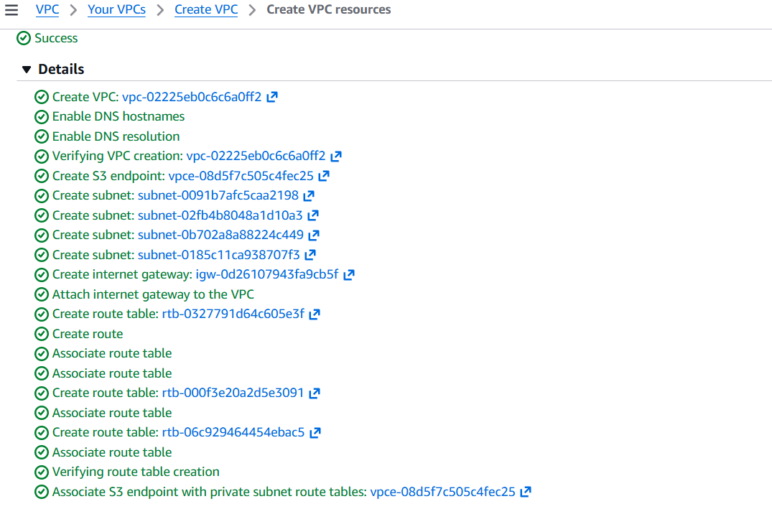

- Have Created the EC2 Instance int the same VPC, Public Subnet-1

Deploying Python Application on this EC2 Instance:
- python3 -m http.server 8000

Allowing port 8000 from Security Group to the respected Instance.
- Change Security Group Inbound Rule to allow port 8000

Blocking port 8000 using NACL to the perticular subnet.
- Select Targeted NACL from VPC
- Edit Inbound Rules
- Remove default rule of allowing all traffic
- Add new rule
- Give the number to rule e.g. 100, 200, custom TCP, port range - 8000, Deny the traffic : Now traffic on port 8000 can not enter the subnet.
- Now Allow all traffic (rule number 100) -> traffic on port 8000 is also allowed.
- Now Add one more rule (rule number 200) blocking port 8000 -> still traffic on 8000 is allowed. As the the lowest rule number comes first i.e. 100.
- Now swap the rule number of two added rules. Now traffic on port 8000 is not allowed because now the rule of blocking the traffic on 8000 is on top with lowest rule number.
- We can also allow or deny specific IP ranges using these rules.

NOTE:
Inbound vs Outbound Traffic
- Outbound traffic:
When the EC2 instance itself goes out to the internet to get something.
Example: EC2 downloading updates, software, or calling an external API.
- Inbound traffic:
When someone on the internet tries to come into the EC2 instance without the EC2 asking first.
Example: Trying to SSH or access a private EC2 directly from the internet.
Key clarification
- Private subnet:
  - EC2 can go to the internet (outbound)
  - Internet cannot come to the EC2 by itself (inbound)

