Homework#01: Image Enhancement in the Spatial Domain

Due Date: 2022/11/04

1. Implement the histogram equalization technique and perform histogram equalization on the Lena image.

Original Lena： Processed Lena：

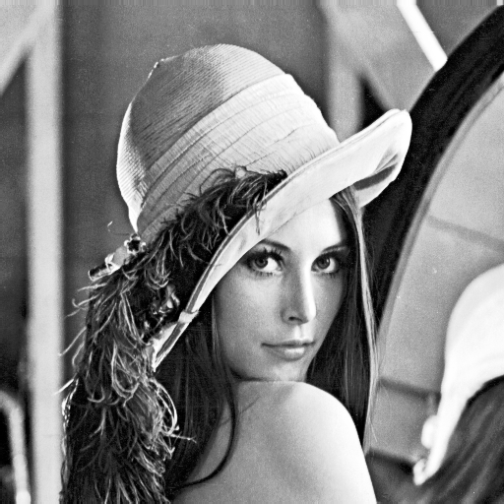

1. Write a computer program for computing the histograms of the original Lena image and the processed Lena image.

The histograms of the original Lena：

Histogram values：h1.txt

The histograms of the processed Lena：

Histogram values：h2.txt