**How to run the project.**

* I use pods to install the third part library, so please check this link if you have not used pods before.

<https://guides.cocoapods.org/using/using-cocoapods.html>

* Click the ColourMemory.xcworkspace and open the project in Xcode, now you can run the app in emulator.

**App Structure**

**The main interface is :**

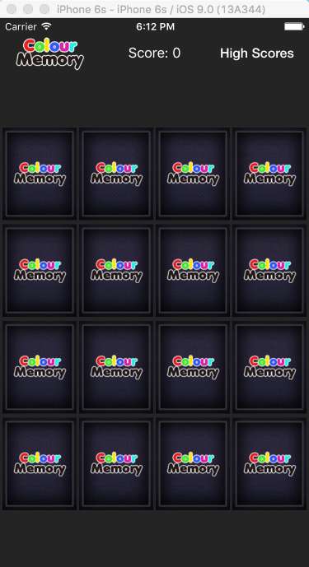

**All the play rules are strictly follow the requirement. I also add sound effect when flipping the card, guess correct or wrong.**

**After game over, there will be the dialog showing user the ranking and score. The database is network-based. So the ranking will have a loading time.**

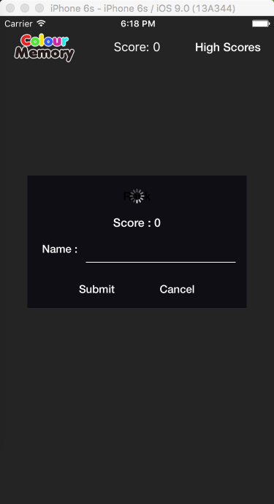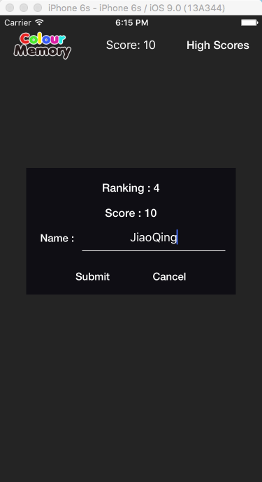

**F**

**The high score table will show the top 20 highest score. Since it is network-based the score is logged on a remote server. I use Heroku server service. So there is no need to setup a server system. I write two simple Restful server APIs using Ruby, so there is great space to improve the network efficiency.**

