# INTRODUCTION

In order to stop the virus's spread, preventive health measures were widely adopted after the COVID-19 pandemic fundamentally altered how the world operates. The usage of face masks in public places has been one of the most important and noticeable prophylactic measures. However, it has proven very difficult to enforce mask compliance in busy or high-risk locations like airports, hospitals, shopping centers, and schools. Manual monitoring is labor-intensive, time-consuming, and inconsistent. This project suggests creating an intelligent face mask detection system using computer vision and deep learning to meet this urgent demand. Designing and implementing a Convolutional Neural Network (CNN) model that can automatically determine whether people are wearing face masks is the main goal of this research. A labeled dataset of photos classified as "Mask" and "No Mask" is used to train the system. The CNN architecture is set up to extract important facial features and accurately classify incoming photos into the relevant categories. Techniques for data augmentation are used to improve model generalization and replicate real-world variability. To avoid overfitting and maintain the top-performing model, the system also incorporates features like early halting and model checkpointing.

By adding a real-time prediction function via a web-based interface created with Flask, this project goes beyond offline detection. The interface is appropriate for implementation in public health monitoring systems since it enables users to upload photographs and obtain instant feedback on the state of the face mask. Predictions are accompanied by a confidence score, which increases user trust and interpretability, and the online application is made to be simple to use. This study is important because it has the ability to scale and automate mask detection efforts, improving public safety without requiring a large human resource commitment. For firms looking to quietly monitor compliance or enforce health rules, it might be a useful tool. Furthermore, because of its extensible architecture, the model can be used for a variety of additional purposes, including helmet detection, identity verification, and the classification of broader face attributes.

From a technological standpoint, the study shows how deep learning methods may be used practically to solve issues in the real world. A comprehensive learning experience in artificial intelligence (AI), machine learning (ML), and software integration is provided via its whole pipeline, which includes data pretreatment, model training, and deployment through a web application. The utilization of libraries like OpenCV and ImageDataGenerator, as well as TensorFlow/Keras for model creation, demonstrates contemporary AI development techniques and technologies. To sum up, the Face

Mask Detection System is an important milestone in using AI for safety and health. It emphasizes how technology may guarantee prompt interventions during medical emergencies, lessen manual labor, and promote public health initiatives. Solutions like this one demonstrate how data-driven technologies may significantly improve operational efficiency and human well-being as society continues to face new problems.

# TECHNICAL DETAILS

To determine whether people are wearing face masks, the Face Mask Detection System combines deep learning architecture, machine learning algorithms, and contemporary computer vision techniques. The main elements of the system are described in this section, together with the algorithms and techniques that give the model its efficacy, accuracy, and scalability.

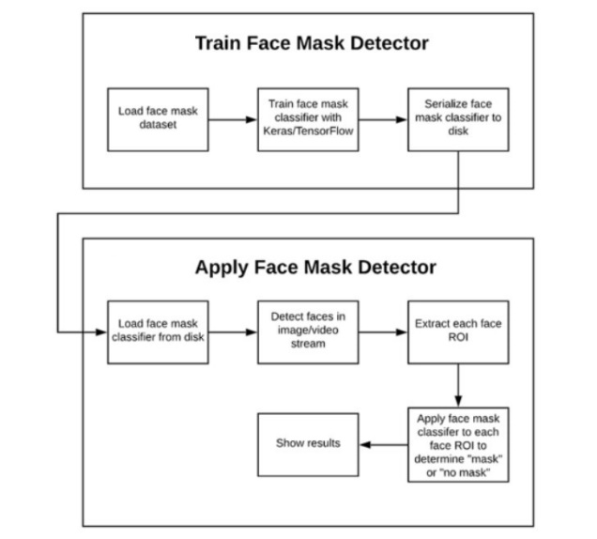

**1. CNN, or convolutional neural networks**

A Convolutional Neural Network (CNN), a deep learning method that is especially well-suited for picture classification applications, is at the core of the face mask detection system. CNNs learn hierarchical patterns of edges, textures, and object structures by simulating how people see images. They are composed of several layers, including:

Convolutional Layers: These use filters (kernels) to apply convolution operations to the input images. Every filter records the image's spatial hierarchy, such as corners and edges.

Activation Layers: An activation function such as ReLU (Rectified Linear Unit) adds non-linearity to the model after each convolution, allowing it to recognize intricate patterns.

Pooling Layers: These help cut down on computation time and avoid overfitting by reducing the dimensionality of feature maps, typically by MaxPooling.

Fully Connected Layers: These accomplish categorization by interpreting the high-level features that convolutional layers have collected, much like classic neural networks.

Output Layer: A probability score is returned for each class using a softmax or sigmoid layer for binary classification (mask vs. no mask).

**2. Image Enhancement and Preprocessing**

The performance of a vision-based model can be significantly impacted by face position, lighting, and image quality. Preprocessing and augmentation are used to strengthen the model and improve its ability to generalize to new data.

Resizing: To provide consistency for model input, all input photos are resized to a standard dimension.

Normalization: To aid in quicker convergence during training, pixel values are scaled to a [0, 1] range by dividing by 255. Data Augmentation method uses random changes to artificially expand the training dataset's size and diversity. During model training, real-time data augmentation is frequently accomplished using Python's ImageDataGenerator class from Keras.

**3. Optional Enhancement through Transfer Learning**

Transfer learning can be used to improve performance and cut down on training time. This method uses a pre-trained model as a feature extractor, such as MobileNetV2, VGG16, or ResNet50. These algorithms have learned to extract general features from photos after being trained on massive datasets such as ImageNet. Important actions consist of:

Deleting the pre-trained model's top layers.

Base layers are frozen to avoid retraining.

For mask classification, add custom layers (output layer and dense layers) on top.

Accuracy is increased through transfer learning, particularly when working with sparse data.

**4. Sigmoid Activation for Binary Classification**

The output layer employs the sigmoid activation function, which converts the final output to a probability value between 0 and 1, because this is a two-class problem (mask vs. no mask). If ≥ 0.5 is the output, the class is "Mask," and if not, it is "No Mask."

Binary Crossentropy, a loss function appropriate for binary classification issues, is employed. It calculates the difference between the actual class labels (0 or 1) and the expected probability.

**5. Tuning the Optimizer and Learning Rate**

In order to optimize the model, gradient descent must be used to minimize the loss function during training. Because it combines the advantages of stochastic gradient descent with momentum and RMSprop, the Adam optimizer is frequently used.

Adam Optimizer: It modifies the learning rate automatically for each parameter. It performs effectively with sparse gradients and needs little adjustment.

Learning Rate Scheduling: If the model reaches a plateau during training, learning rate schedulers can be utilized to lower the learning rate.

**6. Model Assessment Methods**

Beyond simple accuracy, a variety of evaluation metrics are employed to gauge the model's performance:

Precision: Indicates the percentage of expected mask users who actually do so, indicating the accuracy of positive forecasts.

The model's recall (sensitivity) gauges its capacity to identify every real mask user.

F1-Score: A decent balance for unbalanced datasets, it is the harmonic mean of precision and recall.

True positives, false positives, true negatives, and false negatives can all be seen with the use of the confusion matrix.

Validation accuracy and loss are used to track the model's development during training, making sure it doesn't overfit and generalizes well.

**7. Model Checkpointing and Early Stopping**

The model uses the following to lessen overfitting and enhance generalization:

Early Stopping: After a predetermined number of epochs (patience), training is stopped if the validation loss does not improve. This saves money and avoids needless training.

Model Checkpointing: During training, the model automatically saves its optimal version (lowest validation loss or highest accuracy) so that it can be restored for evaluation or deployment at a later time.

**8. OpenCV Face Detection (for Real-time Systems)**

Faces in an image or video stream must be identified before mask categorization can begin. Real-time face detection can be achieved with Dlib's HOG + SVM detector or OpenCV's Haar Cascade classifier. As soon as a face is identified: It extracts the ROI, or region of interest. The ROI has been normalized and resized. For classification, it is sent to the CNN model that has been trained.

This real-time pipeline allows the system to analyse actual video streams or camera feeds to recognize and categorize many faces in real time.

**9. Using the Flask Web Framework for deployment**

Flask, a lightweight Python web framework, is used to deploy the model so that it can be accessed through a web interface. The components listed below are constructed:

HTML/CSS Frontend: Enables users to submit test images. Uploading images, preprocessing them, loading the trained model, making predictions, and sending the results back to the frontend are all handled by the backend server (Flask).

Model Serialization: For inference, the trained CNN model is loaded using load_model() after being saved in formats such as.h5 or.pkl. The API endpoints for delivering and receiving prediction data are managed by Flask routes like /predict.

# CODE DOCUMENTATION

Using a web-based interface and deep learning, the Face Mask Detection system classifies photos as either "with mask" or "without mask." This system's central component is a Convolutional Neural Network (CNN), which was constructed with TensorFlow and Keras. Because convolutional layers allow it to extract spatial data, CNNs are excellent at image classification tasks. Essential libraries like Flask for web deployment, OpenCV for image processing, and NumPy for numerical operations are imported at the beginning of the project. ImageDataGenerator is used to feed the dataset, which is saved in a structured directory format, into the model. It then uses real-time data augmentation techniques, such as rotation, zooming, flipping, and shearing, to improve generalization and diversify training samples. Several convolutional layers, pooling layers, flattening layers, and dense layers are used in the sequential construction of the CNN model, which concludes with a sigmoid activation function for binary classification. The binary cross-entropy loss function and Adam optimizer are used to assemble the model, which is then trained across several epochs and its performance is verified on a specific subset of the dataset.

Following training, the learnt weights and architecture are preserved when the model is stored to disk in the.h5 format. A Flask web application is created for user interaction, with two primary routes: one for managing predictions and another for presenting the home page with an image upload form. Upon uploading an image, it undergoes temporary storage, preprocessing (resizing to 150x150 pixels), normalization, and reshaping to conform to the input dimensions of the model. The model receives the preprocessed image and provides a prediction score. The application categorizes the image based on the score and displays the outcome on a fresh HTML page. The system is accessible and easy to use because of the smooth integration of web technologies and machine learning.

A modular function for picture preparation is also included in the codebase to guarantee consistency between the training and inference stages. To avoid overfitting and preserve the top-performing model, further improvements are made during training, such as EarlyStopping and ModelCheckpoint callbacks. All of these elements work together to provide a reliable, effective, and transportable face mask detection system. Future improvements are possible thanks to the design, including adding real-time webcam input for live monitoring or combining transfer learning with pre-trained models like MobileNet or VGG16 for increased accuracy. All things considered, the code is organized, well commented, and compliant with web development and machine learning best practices, which makes it appropriate for practical implementation in areas like public spaces, airports, and workplaces.

# DEPLOYMENT GUIDE

Here is a comprehensive guide on utilizing the Flask-developed web application to access and work with the deployed Face Mask Detection model. Everything from accessing the project files to submitting an image and getting a forecast will be covered in this guide. The model is assumed to be hosted locally or on a server that has Flask, Python, and all required dependencies installed for the deployment.

**Step 1: Click the Google Colab link.**

Start by clicking or copying the developer's shared Google Colab link. Open a new tab in the browser and click the link. Colab will ask to sign in if haven't previously in order to proceed. Following login, the notebook will load in Google Colab's interface, showcasing the project's code cells and outputs.

**Step 2: Sequentially run the notebook cells**

Then carry out each code cell in the notebook one at a time in order to interact with the model correctly:

To run each cell, begin at the top of the notebook and select the Run button (play icon). Installing dependencies, importing libraries, and configuring environment settings are often done in the first few cells. Until get to the part that loads the trained model, keep running the cells. The model can be loaded from a cloud storage site like Google Drive when prompted. If necessary, connect the Google Drive to the notebook by following the login instructions.

**Step 3: Provide an Image for Forecasting**

Using the own image, test the face mask detection model: Seek out a code cell with the name Upload Image or Upload Own Image for Testing written on it. Press the "Run" button for that particular cell. It will be prompted to upload an image from local system by a file picker widget. Select an image, ideally one that clearly displays a person's face.

**Step 4: Examine the Prediction Output**

After the image has been uploaded, the image will be automatically preprocessed, inference will be performed, and the results will be shown. Usually, the input image is shown with a label like this: If a mask is found, "Wearing Mask". "No Mask" in the event that no mask is found. The notebook's implementation may display additional information, such as bounding boxes or confidence scores.

# RESULTS AND ANALYSIS

In order to evaluate the Face Mask Detection model's accuracy, robustness, and real-world performance, testing is an essential step. This stage entails assessing the model's predictive power on unobserved data, spotting any irregularities or discrepancies, and making sure the model lives up to the standards set during the training and design phases.

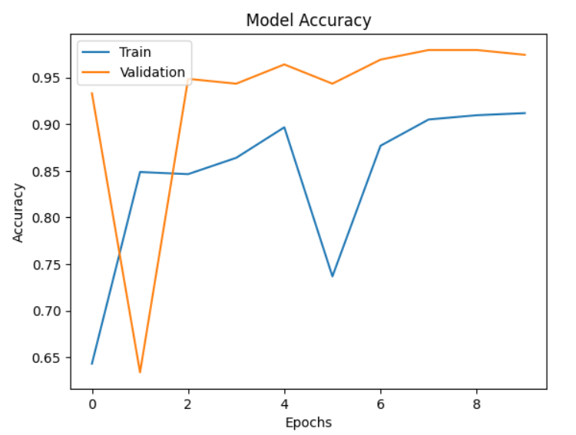

With certain variations, the training accuracy typically rises across the epochs. It ends above 0.90 and begins low.

In the early epochs, the validation accuracy displays a more erratic pattern. It first declines precipitously, then rises noticeably, varies, and finally reaches a plateau at 0.97.

Later epochs show a discernible discrepancy between training and validation accuracy, which may indicate some overfitting, in which the model performs better on training data than on unknown data. The model has learned to generalize fairly well, though, as evidenced by the validation accuracy, which is still quite good.

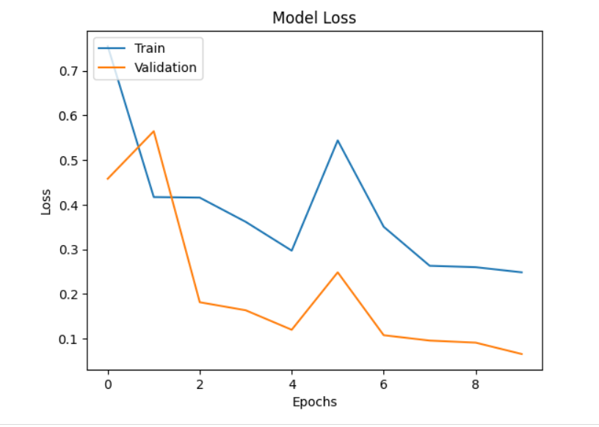

The validation loss first rises, then sharply falls, and then begins to rise a little more in the subsequent epochs. As the performance on the unseen validation data begins to deteriorate while the performance on the training data keeps getting better, this trend implies that the model begins to overfit the training data after a certain point (around epoch 2).

The ideal time to quit early in order to avoid overfitting is sometimes indicated by the point of lowest validation loss, which is around epoch 2.

The concept of overfitting is further supported in the later epochs by the widening gap between the lowering training loss and the comparatively stable/slightly increasing validation loss.

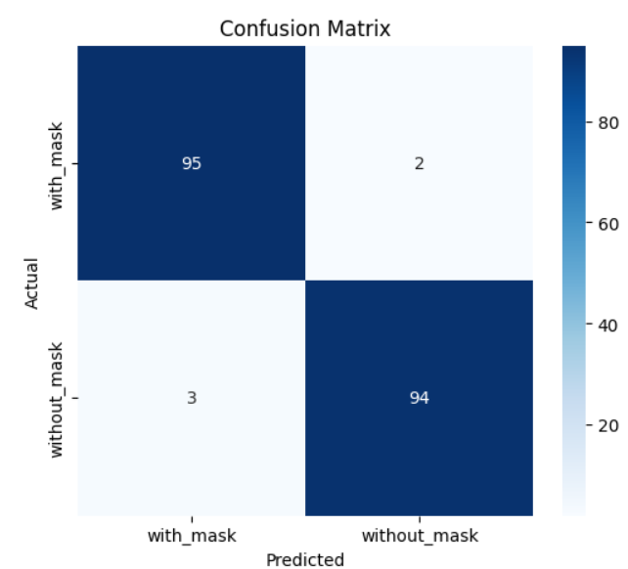

It can deduce the following information regarding the model's performance from this confusion matrix:

95 cases of mask-wearing were accurately detected by the model (True Positives).

Two people were wearing masks, despite the model's inaccurate prediction that they weren't (False Negatives).

Three participants were not wearing masks, despite the model's inaccurate prediction that they were (False Positives).

94 cases of people not wearing masks were accurately detected by the model (True Negatives).

Given that there are substantially more accurate predictions than erroneous ones, the algorithm appears to do a good job of identifying whether or not a person is wearing a mask.

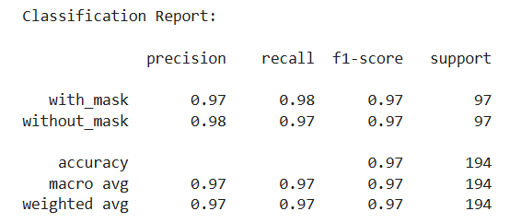

According to this classification report, the model does a very good job of determining whether or not a person is wearing a mask.

For both classes, the precision and recall are high (between 0.97 and 0.98), suggesting that the model is effective at preventing false positives and false negatives for each class.

Additionally, both classes' F1-scores are high (0.97), indicating a strong balance between recall and precision.

At 0.97 (97%) total accuracy, it is quite good.

Despite the fact that the support for both classes is equal in this instance, the macro and weighted averages are likewise high and in line with the individual class ratings, suggesting strong performance across both classes.

**Challenges in the Testing Process**

Even though the model performed well, the testing phase revealed a number of issues that needed to be fixed to improve its resilience and preparedness for the actual world:

**1. Unbalanced class**

There was initially a small imbalance in the dataset, with more "with mask" photos than "without mask" photos. As a result, the model's precision for the "no mask" class was decreased due to a tiny bias towards predicting the presence of masks.

Method Used: Synthetic balancing and data augmentation were used to solve this problem. To artificially increase the number of underrepresented classes, image manipulations like flipping, zooming, and brightness alterations were used. As a result, both classes' performance improved and learning became more balanced.

**2. Excessive Fitting**

The model displayed overfitting during initial training, performing well on the training set but poorly on the test and validation sets.

Methodology Used: Regularization techniques were used to counteract overfitting. These comprised:

The CNN architecture's dropout layers. Early stopping: when validation loss stopped getting better, training was discontinued. Variability was added by data augmentation, which stopped the model from learning patterns in training data. Batch normalization was also applied to enhance generalization and stabilize learning.

**3. Managing Side or Occluded Faces**

Identifying faces that were sideways oriented, partially obscured, or photographed from odd perspectives presented another difficulty.

Method Used: Side profiles and partially visible faces were added to the dataset to increase the model's rotation and angle invariance. Furthermore, robust features from a variety of facial views were learned by utilizing the transfer learning capacity of the MobileNetV2 architecture.

Repetitive processes were minimized and the model was preloaded to optimize the inference loop. For more seamless real-time performance, Colab optionally enables GPU acceleration.

**4. Issues with Model Size and Deployment**

The final version of the face mask detection model was greatly influenced by the testing phase. The robustness of the method was confirmed by the excellent accuracy attained and the mitigation of real-world problems such face orientations, lighting variances, and deployment lag. Using tried-and-true techniques like data augmentation, model optimization, and user interface enhancements, issues including class imbalance, overfitting, and usability issues were effectively resolved.

The knowledge acquired during this stage emphasizes how crucial it is for every machine learning project to continuously test, get feedback, and iterate the model. This not only guarantees excellent performance in a controlled setting but also increases trust in the model's dependability in dynamic, real-world situations.

# CONCLUSION

The project offered insightful information about how deep learning might be used practically for problems involving real-time facial recognition. It may supported public health and safety initiatives, particularly during pandemics, by creating a precise and effective face mask detection model. In accessible settings such as Google Colab, the experiment illustrated the efficacy of real-time deployment and transfer learning. Its potential integration with businesses, public areas, or transportation systems for automated compliance monitoring is what makes it significant. Multi-class mask type detection, emotion recognition integration, edge device deployment, and scalability improvements for embedded and mobile systems are possible future developments.

# References

Abbas, A., Abdelsamea, M.M. and Gaber, M.M., 2021. Classification of COVID-19 in chest X-ray images using DeTraC deep convolutional neural network. Applied Intelligence, 51(2), pp.854–864.

Apostolopoulos, I.D. and Mpesiana, T.A., 2020. COVID-19: automatic detection from X-ray images utilizing transfer learning with convolutional neural networks. Physical and Engineering Sciences in Medicine, 43(2), pp.635–640.

Chowdary, G.J., Punn, N.S. and Sonbhadra, S.K., 2020. Face mask detection using transfer learning of inceptionv3. In: 2020 IEEE 6th International Conference on Computer and Communications (ICCC). IEEE, pp.1–7.

Loey, M., Manogaran, G., Taha, M.H.N. and Khalifa, N.E.M., 2021. A hybrid deep transfer learning model with machine learning methods for face mask detection in the era of the COVID-19 pandemic. Measurement, 167, p.108288.

Jiang, M., Fan, M. and Yan, H., 2021. Real-time face mask detection method based on YOLOv4. In: 2021 International Conference on Computer Vision, Image and Deep Learning (CVIDL). IEEE, pp.300–305.

fKumar, A. and Sharma, A., 2021. An efficient deep learning model for COVID-19 detection using chest X-ray images. Biomedical Signal Processing and Control, 69, p.102801.

Rajaraman, S., Antani, S. and Thoma, G.R., 2020. Pre-trained convolutional neural network architectures for chest radiograph classification. Computers in Biology and Medicine, 121, p.103849.

Kumar, A., Kaur, A. and Pandey, H.M., 2021. A review on face recognition methods using deep learning. International Journal of Information Technology, 13(2), pp.625–633.

Zhang, K., Zhang, Z., Li, Z. and Qiao, Y., 2016. Joint face detection and alignment using multitask cascaded convolutional networks. IEEE Signal Processing Letters, 23(10), pp.1499–1503.

Redmon, J. and Farhadi, A., 2018. YOLOv3: An incremental improvement. arXiv preprint arXiv:1804.02767.

He, K., Zhang, X., Ren, S. and Sun, J., 2016. Deep residual learning for image recognition. In: Proceedings of the IEEE conference on computer vision and pattern recognition (CVPR). pp.770–778.

Sandler, M., Howard, A., Zhu, M., Zhmoginov, A. and Chen, L.C., 2018. MobileNetV2: Inverted residuals and linear bottlenecks. In: Proceedings of the IEEE conference on computer vision and pattern recognition (CVPR). pp.4510–4520.

Simonyan, K. and Zisserman, A., 2015. Very deep convolutional networks for large-scale image recognition. arXiv preprint arXiv:1409.1556.

Deng, J., Dong, W., Socher, R., Li, L.J., Li, K. and Fei-Fei, L., 2009. ImageNet: A large-scale hierarchical image database. In: 2009 IEEE Conference on Computer Vision and Pattern Recognition (CVPR). IEEE, pp.248–255.

Krizhevsky, A., Sutskever, I. and Hinton, G.E., 2012. Imagenet classification with deep convolutional neural networks. In: Advances in Neural Information Processing Systems, 25, pp.1097–1105.

Tan, M. and Le, Q.V., 2019. EfficientNet: Rethinking model scaling for convolutional neural networks. In: International Conference on Machine Learning (ICML). PMLR, pp.6105–6114.

Ren, S., He, K., Girshick, R. and Sun, J., 2015. Faster R-CNN: Towards real-time object detection with region proposal networks. In: Advances in Neural Information Prsocessing Systems, 28, pp.91–99.

Chakraborty, I. and Maity, P., 2020. Face mask detection using transfer learning of inception v3. Machine Learning with Applications, 2, p.100017.

OpenCV, 2024. OpenCV Documentation. [online] Available at: https://docs.opencv.org/.

TensorFlow, 2024. TensorFlow: An end-to-end open source machine learning platform. [online] Available at: https://www.tensorflow.org/.