Edge AI Framework for Brain Tumor Segmentation and Classification Using
Fine-Tuned Deep Learning Models with Quantized Deployment on
NVIDIA Jetson Platforms
Abstract
MRI brain tumor segmentation aids in diagnosis, surgical pre-planning, targeting radiotherapy, and monitoring treatment; however, the most accurate models often require workstation-grade GPUs. This paper describes a deployment-ready workflow to move from a standard U-Net baseline to an AttentionDRUNet, and finally to a MobileNetV2-UNet optimized for edge inference. The developed method includes 2.5D slice stacking, normalizing each slice using local Z-scores, reflexively padding to form 2.5D stacks of slices, using Hybrid Focal-Dice loss, using TensorRT FP16 inference with a Jetson Nano deployment. The selected parameters of lambda = 0.7 and gamma = 2.0 achieved a Dice of 0.8558 with a recall of 0.8815. The AttentionDRUNet achieved a Dice of 87.37% on BraTS 2021 using TTA, and maintained a Dice of 83.08%, a recall of 82.79%, a latency of 53.56 ms, a frame rate of 18.6 FPS, and a power consumption of 5.08 W during Jetson Nano inference. The proposed MobileNetV2-UNet reduced the complexity to 1.167 GFLOPs, generated a 5.2 MB TensorRT engine, and achieved 134.5 FPS. The zero-shot BraTS 2019 audit demonstrated performance of 80.15% Dice and 88.26% recall, affirming the deployment concept of this paper.

Keywords: Brain tumor segmentation; MRI; U-Net; AttentionDRUNet; MobileNetV2; TensorRT; Jetson Nano; edge AI; 2.5D spatial stacking; Hybrid Focal-Dice loss

1. Introduction
It is critical to determine the exact size of a brain tumor, as treatment options largely depend on where it has grown and developed in the brain. MRI is used for assessing abnormalities in the brain, as it provides an excellent view of soft tissue. However, by manually examining images, it can take a long time to find and identify a tumor, and then the diagnosis is reliant on the expertise of radiologists, meaning that this method of diagnosis could be difficult to implement in areas with limited access to specialists; therefore, a computer model could provide quick and reliable methods of creating a mask of the tumor to assist in the process of triaging patients, planning for their treatment, and following up with them afterward on their progress.
Deep learning has significantly advanced the field of medical image segmentation, especially since dense semantic predictions became feasible in combination with fully convolutional networks and encoder/decoder networks like U-Net for use with biomedical segmentation. For instance, large models typically require more time for processing data, require more memory, and utilize more power, particularly when moving from the laboratory setting to embedded device environments. This research addresses brain-tumor segmentation by treating it as a problem of both modeling and deployment. The initial work focused on a U-Net baseline, followed by the development of an Attention-Enhanced DRU-Net to maximize feature extraction and to improve the sensitivity of the classification boundary between tumor and normal tissues, then finally, a Hybrid MobileNetV2 U-Net configuration to reduce the computational cost on the edge devices. Ultimately, this research asks whether we can maintain an adequate level of spatial accuracy while maintaining low latency, minimal memory usage, and low power consumption, and how this is applied to the specific brain-tumor segmentation problem at hand. This research makes the following contributions: a 2.5D spatially-stacked pipeline for maintaining local inter-slice context; a robust preprocessing solution through use of z-score normalization and reflectional-padding; the employment of a hybrid focal-dice loss function that is properly tuned to balance class imbalance; a TensorRT FP16 deployment process for the NVIDIA Jetson Nano; and through comparative analyses, validation of the impacts of segmentation accuracy across multiple configurations, specifically, 2D, 2.5D, 3D, Attention-Enhanced DRU-Net, and MobileNetV2 U-Net.

2. Related Work
U-Net represents a collection of universal foundational models utilized for the segmentation of biomedicine, utilizing semantic abstraction and localizing within an image by utilizing skip connections. The difficulty in segmenting tumors using a conventional U-Net exists when an irregular tumor morphology, with weak boundary definition, occupies only a small amount of the image. The issues described above are especially prevalent in the case of glioma segmentation, whereby the tumors and their appearance (i.e. with respect to the surrounding edema and gross total resection of mass effect) varies significantly between patients and acquisition protocols. Attention mechanisms suppress irrelevant activations of the background during image segmentation by providing an increased emphasis to spatial regions that contain clinically significant foreground information. Residual connections facilitate the flow of gradients in the network and promote the training of deeper networks. Dilated convolutions increase the receptive field of the image without reducing the feature map resolution, allowing for a greater contextual body of anatomy to be observed. Squeeze-and-Excitation blocks adaptively re-calibrate the contribution of each channel [5, 6, 11]. In this study, when selecting an architecture for this task, performance of a model was not just evaluated qualitatively (segmentation performance) but also quantitatively (how feasible the model would be to train and deploy on limited computational resources). Full 3D segmentation networks would be ideal for acquiring volumetric data from MRI scans because they analyze the relationship between adjacent slices in three dimensions. However, segmentation networks such as 3D U-Net, V-Net, or multi-scale 3D CNNs generally require significantly more GPU memory, have longer training times, and have bigger inference costs [7-9]. Therefore, it can be challenging to apply them in environments where hardware availability is at a premium. In contrast, a pure 2D model has opposite characteristics. It is faster, has less memory overhead, and is easier to train but processes each slice of an MRI independently of each other. In segmentation of tumor regions, this independence could be a drawback since tumor borders are generally contiguous across depth (depth axis) in an MRI scan, and ignoring continuity may well result in misprediction of borders. For this reason, the proposed strategy using a 2.5D is a balanced solution. Instead of using one slice as input to the network, the network uses three slices (preceding, following, current) as input channels. This allows the network to receive local depth context, while employing an efficient approach using 2D convolutional processes.
Similar deployment-oriented logic is used in the lightweight phase of the pipeline as well. MobileNetV2 was chosen because the depth-wise separable convolutions and inverted residual bottlenecks reduce not only compute but also memory requirements and model size. However, with respect to medical segmentation, a smaller model is only worthwhile if it can still capture clinically relevant regions. Thus, the lightweight model will be assessed not only based on speed or size but also on its Dice score and recall, since these two measurements are a better indicator of how accurately tumor regions are being represented [4].
Previous studies on glioma based on MRI indicated that there is a shift from the usage of conventional machine-learning techniques toward employing deep-learning for the interpretation of brain tumors. Techniques based on features like SVMs, KNNs, and ensembles have been employed for tumor classification and brain tumor classification, which is reliant on the quality of dataset and carefully constructed features [16,19]. Deep learning has presented a new approach to this field as it allows for automatic understanding of the features of the image. Numerous systems have been generated that aim to provide visualization of the data through augmented-reality applications that incorporate color coding [18]. Nonetheless, all these works are focused on the issue of detection of tumors, classification, or visualization, and thus do not address other vital aspects, while the present study takes the direction of implementation and tumor segmentation [20].
Therefore, the pipeline in this paper was guided by three primary requirements. The model must be able to follow atypical tumor borders along with retaining sufficient spatial context. Evaluating the model should use an overlap and sensitivity metric rather than simpler evaluations focused on accuracy, as most MRI image pixels will be in healthy background tissues. Finally, the model should be applicable in more resource constrained environments such as hit or mobile diagnostic units, rural hospitals, or bedside clinical support.

3. Materials and Methods
The two types of images used in this study were from the imaging modality called Fluid, Attenuated Inversion Recovery (FLAIR), since FLAIR images can give the most comprehensive view of the whole tumor and allow for assessment of the edema. The goal of the segmentation was to create a binary prediction of the location of the whole tumor by assigning pixels to either the tumor foreground or the non-tumor background [1, 2].
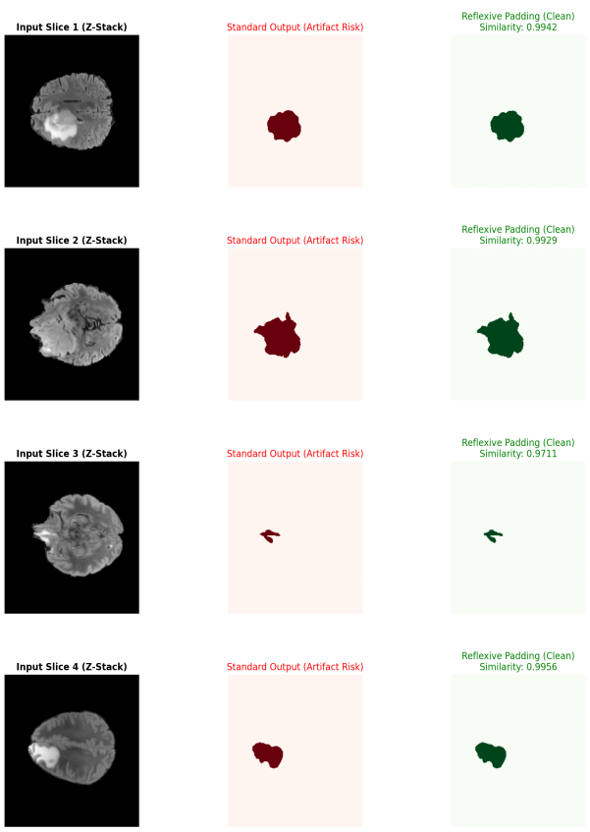
Figure 1: Dataset and segmentation-mask examples.
To keep the depth context local to the target slice, z, the model takes each slice (z-1, z, z+1) and stacks them together. The slices making up the z boundary are padded reflexively with respect to the boundary slice. To minimize intensity differences between scanners, local Z-score normalization, x_hat = (x - mu)/(sigma + epsilon), used in the model to reduce how much variation in in in intensity is caused by the scanner itself.
The model consists of three standard U-Net architectures: U-net, AttentionDRUNet, and MobileNetV2+U-net.
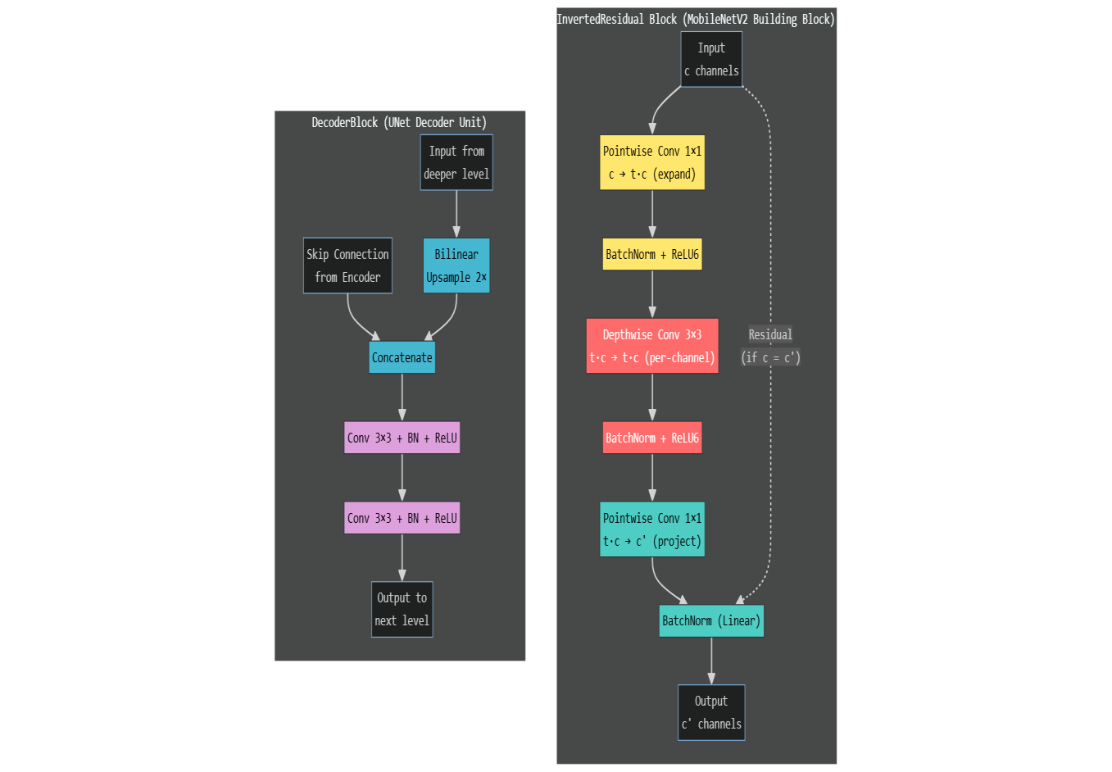
Figure 2: MobileNetV2-UNet decoder and inverted residual block.

In addition, the addition of MobileNetV2 provides some difference in the use of inverted residual blocks, which allows for expansion of channel size, depth-wise convolution on the expanded size, followed by projection of the expanded channels back into a smaller representation. The use of MobileNetV2 allows for preservation of semantic feature information and provides significant reduction in complexity of the computation required.
The design of the 2.5D feature outputs is a trade-off; the use of spatial features from slices that neighbour one another helps maintain anatomical continuity, however, due to the need for practical constraints with long-term embedded deployments, only 2D convolutions can be used.

4. Training, Optimization, and Algorithms
In MRI-based tumor segmentation, one of the main difficulties is the imbalance between healthy tissue and tumor regions. Most pixels in a slice belong to the background, while tumor pixels form only a small area. Because of this, a standard cross-entropy loss can make the model focus too much on predicting the background correctly, even if it misses important tumor regions. To reduce this problem, the source report used a Hybrid Focal-Dice loss. The Dice component helps the model improve region overlaps between the predicted mask and the ground-truth tumor mask, while the focal component gives more weight to difficult pixels, especially foreground and boundary areas. This makes the training objective more suitable for detecting small and irregular tumor regions.
DiceLoss = 1 − (2Σpᵢgᵢ + ε) / (Σpᵢ + Σgᵢ + ε) (1)
FocalLoss = −α(1 − p_{t})^{γ} log(p_{t}) (2)
To choose the final loss settings, a grid search was carried out using nine different combinations of lambda and gamma. This was tested on a 5% subset of the data, which included 3,265 MRI slices. Among the tested settings, the best result was obtained with lambda = 0.7 and gamma = 2.0 as indicated in table 1.In brain-tumor segmentation, recall is especially important because missing tumor tissue can be more clinically harmful than slightly over-segmenting the region.
Table 1: Hybrid Focal-Dice grid-search results on 3,265 slices
lambda | gamma | Dice | Precision | Recall
0.3 | 1.5 | 0.7567 | 0.9618 | 0.6499
0.3 | 2.0 | 0.7952 | 0.9585 | 0.7171
0.3 | 2.5 | 0.8387 | 0.8091 | 0.8971
0.5 | 1.5 | 0.8458 | 0.9114 | 0.8105
0.5 | 2.0 | 0.8519 | 0.8891 | 0.8427
0.5 | 2.5 | 0.8102 | 0.9212 | 0.7646
0.7 | 1.5 | 0.7475 | 0.9560 | 0.6563
0.7 | 2.0 | 0.8558 | 0.8496 | 0.8815
0.7 | 2.5 | 0.8311 | 0.8688 | 0.8223

Table 2: Dimensionality and deployment comparison
Model | Architecture | Dice | Deployment cost
2D baseline | Standard U-Net | 79.2% | 28.4 ms; 35.2 FPS; Not reported
2.5D proposed | AttentionDRUNet | 83.08% | 53.56 ms; 18.6 FPS; 58.56 G
3D benchmark | 3D U-Net | 84.1% | 128.71 ms; 7.7 FPS; 438.93 G

Table 2 that summaries the key parameters for optimizing the model which yields the best Dice coefficient scores. Since tumor segmentation is always clinically asymmetric, not finding all the tumor pixels is generally more detrimental than having a few extra pixels on one or both sides of the tumor boundary. Table 4 helps explain some of the design imperfections of a completely 3D U-Net versus a 2.5D system like the AttentionDRUNet. The RAM caching in the above-mentioned section allowed caching in RAM reducing the amount of repeated small file loading to save time during the process of grid searching; and reducing memory consumption by approximately 40% via mixed-precision training while maintaining the same precision.

IoU = TP / (TP + FP + FN) (3)
Precision = TP / (TP + FP), Recall = TP / (TP + FN) (4)
Test-time augmentation was used as a low-cost stability step rather than as a replacement for model improvement. The source report averaged predictions from the original image and flipped versions, then thresholded the averaged probability map.

P_{TTA} = (P(x) + P_{h} + P_{v}) / 3 (5)

M(i,j) = 1 if P_{TTA}(i,j) ≥ τ (6)

4.1 Edge-Optimized Inference Pipeline
Algorithm 1: 2.5D Edge-Optimized Inference Pipeline
Input: Raw MRI volume V and serialized TensorRT FP16 engine E.
Output: Reconstructed binary tumor volume M.
1. Load the MRI volume and iterate through each target slice z.
2. Normalize each slice: x_hat_z = (x_z - mu_z) / (sigma_z + epsilon).
3. Form the 2.5D tensor X_z = [S_{z-1}, S_z, S_{z+1}].
4. Apply boundary padding: S_{-1}=S_0 and S_N=S_{N-1}.
5. Transfer the stacked tensor to pre-allocated GPU buffers asynchronously.
6. Compute logits y_z = E(X_z) using non-blocking TensorRT inference.
7. Convert logits to probability: P_z = sigmoid(y_z) = 1 / (1 + exp(-y_z)).
8. Threshold the mask: M_z(i,j)=1 if P_z(i,j) >= tau, else 0; tau=0.5.
9. Reconstruct the volume M = {M_1, M_2, ..., M_N}.

4.2 TensorRT Compilation and Precision Calibration
Algorithm 2: TensorRT Compilation and Precision Calibration
Input: Trained PyTorch segmentation model and Jetson Nano target device.
Output: Serialized FP16 TensorRT engine for low-latency inference.
1. Export the trained model to ONNX for framework-independent optimization.
2. Initialize the TensorRT builder with explicit batch configuration.
3. Enable graph-level optimization, layer fusion, and kernel auto-tuning.
4. Enable FP16 casting: W_16=cast(W_32), A_16=cast(A_32).
5. Constrain workspace memory: workspace <= 512 MiB.
6. Build E = TensorRT(ONNX, FP16, workspace) and record time/memory.
7. Verify fidelity: Delta Dice = |Dice_FP32 - Dice_FP16| <= delta.
8. Serialize E and report latency L_ms, FPS = 1000 / L_ms, power, Dice, and recall.

5. Edge Deployment Pipeline
The deployment step was performed using an NVIDIA Jetson Nano, an energy-efficient edge device that has only 4 GB of memory. Thus, it served as a good test platform to assess the capability of the model pipeline to work within practical hardware limitations. The trained PyTorch model was exported to the ONNX format and further converted to TensorRT for execution on the target hardware. In the course of this process, optimization measures, including explicit batching, layer fusion, kernel auto-tuning, and FP16 precision, were performed in order to minimize the runtime overhead of the model. For the AttentionDRUNet model, the TensorRT engine utilized a maximum of 1941 MiB of memory during the generation stage and required around 374.81 seconds to build the engine. In the course of inference, each MRI slice was normalized and merged with its neighbors to form a three-channel 2.5D input tensor. The data exchange between the host and device memories was done asynchronously, whereas inference itself was performed by the TensorRT FP16 engine via asynchronous CUDA calls. The output logits were transformed using the sigmoid function to get the probability maps, which were further thresholded to obtain the binary tumor masks.
For deployments on the NVIDIA Jetson Nano, the conversion process to TensorRT FP16 is essential, as it significantly reduces computational demands while preserving sufficient segmentation fidelity for real-time inference. Furthermore, the employment of layer fusion and kernel auto-tuning minimizes runtime execution overheads, while disciplined workspace management prevents engine-related overflows within the device’s limited memory constraints.

6. Results
The study established the AttentionDRUNet as the most proficient model when it comes to scanning performance in the high-capacity configuration. The Dice score was equal to 87.37% and the IoU was equal to 80.12%. This shows that the Dice score improved by approximately 85.58% to the value of 87.37% as indicated in the report. It was concluded that test-time augmentation allowed for the augmentation of the stability of predictions at the edges of the tumor and the reduction of false-positive prediction. The test run on the device NVIDIA Jetson Nano revealed that the model proves to be stable and able to be run on edge devices. The FP16 model TensorRT conversion of the AttentionDRUNet produced the following results: recall of the model was equal to 82.79% and its Dice score was 83.08% corresponding to the latency of inferences of 53.56 ms and throughput of 18.6 FPS (which consumes only 5.08 W). The MobileNet V2 UNet presented good results in terms of energy consumption with the required GFLOPs reducing from 58.56 GFLOPs to 1.167 GFLOPs which is a 50.1× reduction achieved with just 2.6 million trainable parameters. It also proved to have some of the smallest tensor RT engines in the field of 5.2 MB with the throughput value of 134.5 FPS and latency of 8.6 ms.
Table 3: Workstation and Jetson Nano AttentionDRUNet audit
Metric | Workstation | Jetson Nano
Dice Similarity Coefficient | 87.37% with TTA | 83.08%
Recall / sensitivity | approximately 90% | 82.79%
Inference latency | 12.47 ms | 53.56 ms
Average power draw | Not applicable | 5.08 W
Accuracy per watt | Not applicable | 16.37 %/W
Model parameters | 33.00 M | 33.00 M
Table 4: MobileNetV2-UNet edge-optimized profile
Metric | MobileNetV2-UNet result
Dice Similarity Coefficient | 0.8986
Computational complexity | 1.167 GFLOPs
Inference speed | 134.5 FPS
Inference latency | 8.6 ms
TensorRT engine size | 5.2 MB
Trainable parameters | 2.6 M

6.1 Clinical interpretation of audit results
The last audit discusses the practical significance of test-time augmentation. Predictions derived from both original inputs and their horizontal- and vertical-flipped inputs were averaged which enabled a decrease in isolated false positives and an enhancement in smoothness of boundaries. The internal validation score therefore increased from a plateau value of about 85.58% Dice to the final 87.37% Dice evident from the original data.

7. Qualitative Segmentation Analysis
The qualitative evaluations are relevant as numerical evaluations do not always illustrate how the model performs around local tumor boundaries. Dice and IoU may measure segmentation quality overall but also may be hiding small inaccuracies in shape, borders, or areas that were not classified. Therefore, examples presented here demonstrate input MRI slice, true mask, predicted mask, and overlay visualization. All these outputs should confirm a model is actually learning the true tumor area instead of high results just by guessing the major healthy background.
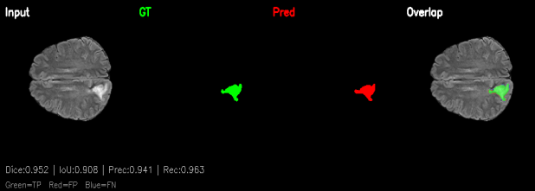
Figure 3: Representative segmentation output 1under the 2.5D input strategy.
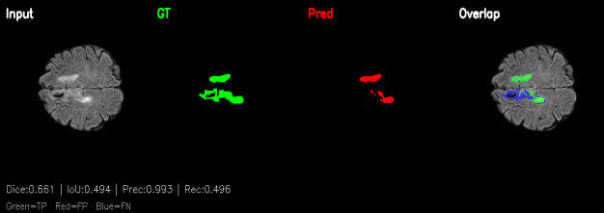
Figure 4: Boundary-level alignment between the prediction and the ground truth is demonstrated in representative segmentation output 2.

Discussion
The results suggest that the main trade-off involved is not merely between high aggression and low correctness. The study demonstrates the importance of finding a middle ground between segmentation quality, depth context, cost of computing resources, and feasibility of hardware. While a complete 3D model allows for capturing more volumetric data, its requirements for latency and memory make it not suitable for real-time deployment. A pure 2D model is fast, but does not have continuity that connects slices. In this situation, a 2.5D design is the most suitable compromise as this approach retains some anatomical information without putting extra pressure on computation.
While the final model tuned for edge computing is smaller, the AttentionDRUNet stage is still significant. Its use facilitated the creation of a good performance object and allowed to compare different architecture solutions, such as large receptive fields, use of skip connections with attention gating, and approach with recalibrated channels. Thus, MobileNetV2-UNet applied the mentioned findings in the development of a lightweight deployment-ready model by minimizing FLOPs, size of the model, and complexity of implementation.
The principal limitation is that the sources at hand do not provide institutional metadata or potential clinical trials. That is why the paper can support an academic trial, and for clinical practice, the following are needed: ethical approval, validation at multiple sites, comparison against radiologists, calibration analysis, and reporting of failures.

Conclusion
This study demonstrates that brain-tumor segmentation can be adapted more effectively for clinical environments with limited computational resources when model accuracy and deployment requirements are addressed together. Some of the concepts used in the approach are 2.5D slice stacking, structured preprocessing, the Hybrid Focal-Dice loss function, attention-assisted feature extraction, FP16 inference with the help of TensorRT and the usage of the MobileNetV2 architecture. The suggested framework can be seen as an option of utilizing the abilities of segmentation by means of the balance between memory and processing speeds and could further lead to advancements in medical imaging systems for distant hospitals lacking financing.
Further studies might include investigation of the framework's capabilities for multi-class segmentation of tumor sub-regions. Another area that deserves investigation is the usage of INT8 quantization to find out whether it is possible to increase the effectiveness in terms of speed and memory without any quality loss in the process of segmentation. In addition, confidence scores or uncertainty estimates should be incorporated to support safer interpretation and more informed clinical decision-making.

References
1. Menze, B. H., et al.: The Multimodal Brain Tumor Image Segmentation Benchmark (BRATS). IEEE Transactions on Medical Imaging, 34(10), 1993-2024, 2015. DOI: 10.1109/TMI.2014.2377694.
2. Baid, U., et al.: The RSNA-ASNR-MICCAI BraTS 2021 Benchmark on Brain Tumor Segmentation and Radiogenomic Classification. arXiv:2107.02314, 2021. DOI: 10.48550/arXiv.2107.02314.
3. Ronneberger, O., Fischer, P., Brox, T.: U-Net: Convolutional Networks for Biomedical Image Segmentation. MICCAI, 234-241, 2015. DOI: 10.1007/978-3-319-24574-4_28.
4. Sandler, M., Howard, A., Zhu, M., Zhmoginov, A., Chen, L.-C.: MobileNetV2: Inverted Residuals and Linear Bottlenecks. CVPR, 4510-4520, 2018. DOI: 10.1109/CVPR.2018.00474.
5. Hu, J., Shen, L., Sun, G.: Squeeze-and-Excitation Networks. CVPR, 7132-7141, 2018. DOI: 10.1109/CVPR.2018.00745.
6. Oktay, O., et al.: Attention U-Net: Learning Where to Look for the Pancreas. arXiv:1804.03999, 2018. DOI: 10.48550/arXiv.1804.03999.
7. Cicek, O., Abdulkadir, A., Lienkamp, S. S., Brox, T., Ronneberger, O.: 3D U-Net: Learning Dense Volumetric Segmentation from Sparse Annotation. MICCAI, 424-432, 2016. DOI: 10.1007/978-3-319-46723-8_49.
8. Milletari, F., Navab, N., Ahmadi, S.-A.: V-Net: Fully Convolutional Neural Networks for Volumetric Medical Image Segmentation. 3DV, 565-571, 2016. DOI: 10.1109/3DV.2016.79.
9. Kamnitsas, K., et al.: Efficient Multi-Scale 3D CNN with Fully Connected CRF for Accurate Brain Lesion Segmentation. Medical Image Analysis, 36, 61-78, 2017. DOI: 10.1016/j.media.2016.10.004.
10. Isensee, F., Jaeger, P. F., Kohl, S. A. A., Petersen, J., Maier-Hein, K. H.: nnU-Net: A Self-Configuring Method for Deep Learning-Based Biomedical Image Segmentation. Nature Methods, 18, 203-211, 2021. DOI: 10.1038/s41592-020-01008-z.
11. He, K., Zhang, X., Ren, S., Sun, J.: Deep Residual Learning for Image Recognition. CVPR, 770-778, 2016. DOI: 10.1109/CVPR.2016.90.
12. Lin, T.-Y., Goyal, P., Girshick, R., He, K., Dollar, P.: Focal Loss for Dense Object Detection. ICCV, 2980-2988, 2017. DOI: 10.1109/ICCV.2017.324.
13. Litjens, G., et al.: A Survey on Deep Learning in Medical Image Analysis. Medical Image Analysis, 42, 60-88, 2017. DOI: 10.1016/j.media.2017.07.005.
14. Long, J., Shelhamer, E., Darrell, T.: Fully Convolutional Networks for Semantic Segmentation. CVPR, 3431-3440, 2015. DOI: 10.1109/CVPR.2015.7298965.
15. Bakas, S., et al.: Identifying the Best Machine Learning Algorithms for Brain Tumor Segmentation, Progression Assessment, and Overall Survival Prediction in the BRATS Challenge. Nature Communications, 10, 2019. DOI: 10.1038.
16.Dheeraj and H. Prasantha, “Study of Machine Learning vs Deep Learning Algorithms for Detection of Tumor in Human Brain”, Int. J. Comp. Sci. Eng., vol. 8, no. 1, pp. 57–63, Jan. 2020.doi:10.26438/ijcse/v8i1.5763
17. Dheeraj D, Prasantha H S, "DR-UNET: A Hybrid Model for Classification of Glioma using Transfer Learning on MR Images," International Journal of Engineering Trends and Technology (IJETT), vol. 69, no. 10, pp. 146-150, 2021.
18. Dheeraj, D., and H. S. Prasantha. “An Augmented Reality Application for Localization and Classification of Glioma in Human Brain Using Color-Coding”. International Journal of Health Sciences, vol. 6, no. S3, May 2022, pp. 4327-39, doi:10.53730/iijhs. vnS3.6860.
19. Dheeraj, D., and H. S. Prasantha,” Analysis Of Performance of Ensemble Based Machine Learning Algorithms for Classification of Glioma Using MR Images”Turkish Journal of Computer and Mathematics Education (TURCOMAT), 12(12), 4101–4118.
20. C. Manasa, D. Dheeraj, and V. S. Deepthi, “Unmasking Manipulations: Recent Advances in Image Tampering Detection,” in 2024 International Conference on IoT, Communication and Automation Technology (ICICAT), IEEE, 2024, pp. 52–57.

