**Problem 2: Matrix Multiplication**

**Write a program that:**

**• Accepts two matrices A (m x p) and B (p x n).**

**• Computes the matrix multiplication C = A × B.**

**• Print the resultant matrix C.**

**Verify matrix dimensions for multiplication validity (columns of A = rows of B).**

**Problem 3: Transpose of a Matrix**

**Create a program to:**

**• Accept a matrix A (m x n).**

**• Find its transpose AT (n x m).**

**• Display both the original and the transposed matrices.**

**Problem 4: Determinant of a 2x2 Matrix**

**Write a program to compute the determinant of a 2x2 matrix:**

**Determinant=a11a22−a12a21Determinant=a11a22−a12a21**

**Problem 5: Saddle Point of a Matrix**

**Find and print all saddle points in a matrix. A saddle point is the minimum element in its row but**

**the maximum in its column.**

#include <stdio.h>

//This file contains Assgiment 2 question 2

int main(){

int row1,col1;

printf("Enter the number of rows for B:");

scanf("%d", &row1);

printf("Enter the number of columns For B:");

scanf("%d", &col1);

int array[row1][col1];

printf("-------------------------------------\n");

printf("2D Array:\n");

for(int i=0;i<row1;i++){

for(int j=0;j<col1;j++){

printf("Enter element at [%d][%d]: ", i, j);

scanf("%d", &array[i][j]);

}

}

printf("-------------------------------------\n");

int row2,col2;

printf("Enter the number of rows:");

scanf("%d", &row2);

printf("Enter the number of columns:");

scanf("%d", &col2);

int B[row2][col2];

printf("-------------------------------------\n");

printf("2D Array:\n");

for(int i=0;i<row2;i++){

for(int j=0;j<col2;j++){

printf("Enter element at [%d][%d]: ", i, j);

scanf("%d", &B[i][j]);

}

}

printf("-------------------------------------\n");

printf("2D Array A:\n");

for(int i=0;i<row1;i++){

for(int j=0;j<col1;j++){

printf("\t %d ", array[i][j]);

}

printf("\n");

}

printf("2D Array B:\n");

for(int i=0;i<row2;i++){

for(int j=0;j<col2;j++){

printf("\t %d ", B[i][j]);

}

printf("\n");

}

printf("-------------------------------------\n");

printf("addition of A and B:\n");

if(row1 == row2 && col1 == col2){

int c[row1][col1];

for (int i = 0; i < row1; i++)

{

for (int j=0;j<col1;j++){

c[i][j]=array[i][j]+B[i][j];

printf("\t %d ", c[i][j]);

}

printf("\n");

}

}

printf("-------------------------------------\n");

printf("Multiplication of A and B:\n");

if(col1 == row2 ){

int c[row1][col1];

for (int i = 0; i < row1; i++)

{

for (int j=0;j<col1;j++){

c[i][j]=array[i][j]*B[i][j];

printf("\t %d ", c[i][j]);

}

printf("\n");

}

}

printf("-------------------------------------\n");

printf("Transpose of result:\n");

int c[row1][col1];

for(int i=0;i<col1;i++){

for(int j=0;j<row1;j++){

c[i][j]=array[i][j]*B[i][j];

printf("\t %d ", c[j][i]);

}

printf("\n");

}

printf("-------------------------------------\n");

printf("DETERMINATof 2*2 MATRIX:\n");

int result=0;

if(row1==2 && col1==2){

result=(array[0][0]*array[1][1])-(array[0][1]*array[1][0]);

printf("\t %d ", result);

}

else{

printf("DETERMINANT is not possible for this matrix\n");

return 0;

}

printf("-------------------------------------\n");

return 0;

}

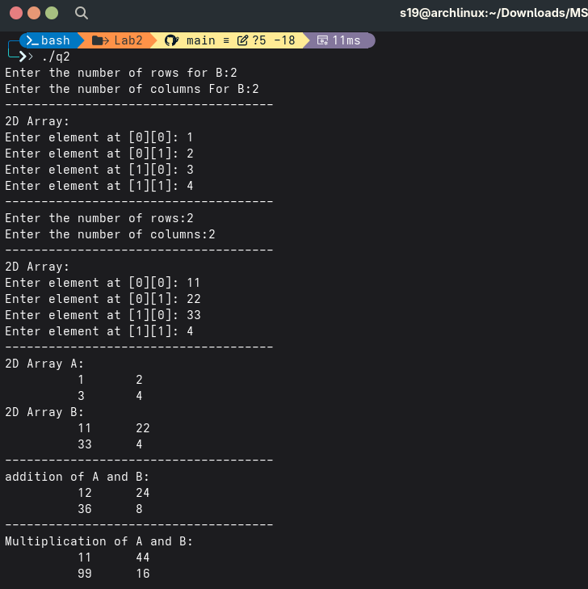

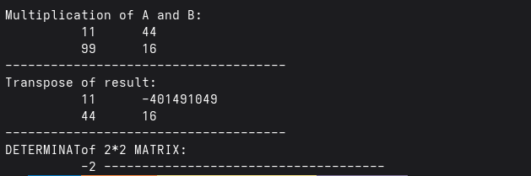

**WAP to solve the following 2D Array in C/C++**

**1) Create a Null Matrix of 3X3**

**2) Create an Identity Matrix of 4X4**

**3) Check that a matrix is Square or Not**

**4) Check that a matrix is Identity Matrix or Not.**

**5) Write a program to implement a 2D Array by defining its elements and display the**

**elements of the 2D Array.**

**6) Write a program to implement a 2D Array by taking inputs from user and display the**

**elements of the 2D Array.**

#include <stdio.h>

#define COL 3

#define ROW 3

//This file contains Assgiment 2 question 1

int main(){

int array[ROW][COL]={

{1,2,3},{4,5,6},{7,8,9}

};

for(int i=0;i<ROW;i++){

for(int j=0;j<COL;j++){

printf("\t %d ",array[i][j]);

}

printf("\n");

}

printf("\n2D Array in Column-Major Order (Simulated):\n");

for(int j=0;j<COL;j++){

for(int i=0;i<ROW;i++){

printf("\t %d ",array[i][j]);

}

printf("\n");

}

printf("\n2D NULL MATRIX:\n");

for(int i=0;i<ROW;i++){

for(int j=0;j<COL;j++){

array[i][j] = 0; // Initialize to zero

printf("\t %d ",array[i][j]);

}

printf("\n");

}

printf("\n2D IDENTITY MATRIX:\n");

for(int i=0;i<ROW;i++){

for(int j=0;j<COL;j++){

if(i==j){

array[i][j]=1;

}else{

array[i][j]=0;

}

printf("\t %d ",array[i][j]);

}

printf("\n");

}

printf("\n2D check square MATRIX:\n");

if(ROW == COL){

printf("The martix is square");

}

else{

printf("The matrix is not square");

}

return 0;

}

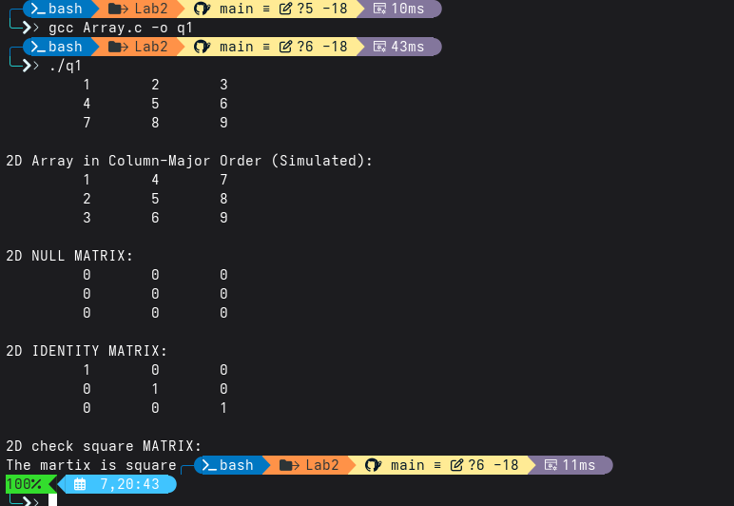

**Part B: 3D Arrays**

**Problem 6: Traversal of a 3D Array**

**Declare and initialize a 3D array of size 2×3×4. Write a program to:**

**• Display all elements of the array.**

**• Print the elements layer by layer.**

**Problem 7: Search in a 3D Array**

**Write a program that:**

**• Accepts a 3D array of size 3×3×3 from the user.**

**• Searches for a specific element entered by the user.**

**• Displays its position(s) (layer, row, column) if found.**

**Problem 8: Sum of All Elements in a 3D Array**

**Accept a 3D array of size 2×2×2 from the user. Write a program to calculate and print the sum of**

**all elements.**

#include<stdio.h>

//This file contains Assgiment 2 question 3

int main(){

int array[2][3][4]={

{{1,2,3,4},{5,6,7,8},{9,10,11,12}},

{{13,14,15,16},{17,18,19,20},{21,22,23,24}}

};

for(int i=0;i<2;i++){

for(int j=0;j<3;j++){

for(int k=0;k<4;k++){

printf("%2d \n",array[i][j][k]);

}

}

}

printf("\n\nDisplaying elements layer by layer:\n");

for (int i = 0; i < 2; i++) {

printf("Layer %d:\n", i + 1);

for (int j = 0; j < 3; j++) {

for (int k = 0; k < 4; k++) {

printf("%2d ", array[i][j][k]);

}

printf("\n");

}

printf("\n");

}

return 0;

}

