ORIGINAL SOURCE URL: https://dainely.com/en/education/pickleball-injury-prevention
PAGE CATEGORY: MEDICAL EDUCATION SERVICE
Pickleball Injury Prevention: 10 Smart Ways to Play Safer After 50
Play Smart. Move Ready. Keep Playing.

Hero Image (Alt: Pickleball Injury Prevention)
Direct Image CDN URL: https://media.dainely.com/dainely-media/optimized/education/W3YURv5Vqaaq97pgPUmQNcEDpzbKgEzhviYNmlsl.webp
Pickleball is a fun, social way to stay active as you age—but the quick stops, starts, lunges, reaches, and directional changes place genuine physical demands on your body.
A few simple habits, from warming up and building strength and balance to choosing appropriate footwear and managing your playing load, can help you reduce preventable risks and stay ready for the game you enjoy.
Key Figures & Medical Guidelines
5–10 MINUTES | 2 DAYS | BALANCE
Dynamic Warm-Up  A short, progressive warm-up can help you transition from rest into the multidirectional movements used during pickleball. | Strength Training  Adults 65+ are advised to include muscle-strengthening activities on at least 2 days each week as part of their overall physical activity routine. | Practice Regularly  For adults 65+, the CDC recommends including balance activities as part of weekly physical activity. Balance, strength, and aerobic activity form an important combination for maintaining physical function.

Embedded Video Demonstration
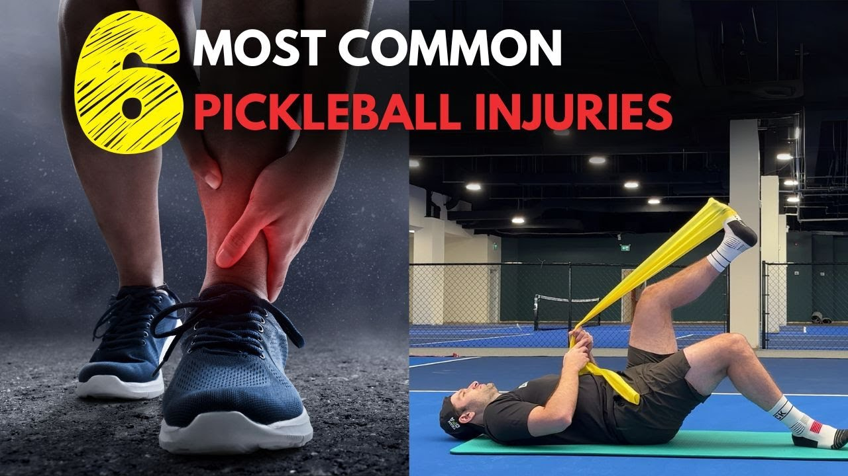
Video Thumbnail: Pickleball Injury Prevention Demonstration
Watch Video on YouTube: https://www.youtube.com/watch?v=sNCBUGDUgfk
Embed / Iframe Link: https://www.youtube.com/embed/sNCBUGDUgfk
Why Pickleball Injuries Happen—and What You Can Control
Pickleball is accessible to many adults, but it is still a sport that involves acceleration, deceleration, reaching, lunging, rotation, and rapid changes in direction.
A 2026 systematic review of 15 studies examining lower-extremity injuries in adult pickleball players found that sprains, strains, and fractures were among the most commonly reported injuries. Falls were the leading injury mechanism, followed by forward running or lunging and foot or ankle inversion. Age 50 and older was a consistent risk factor across the studies reviewed.
That doesn't mean pickleball is unsafe—or that you should stop playing.
It means there are several things you can do to become better prepared for the way the game actually moves your body.
1. Rapid Direction Changes
The Pickleball frequently requires you to move sideways, forward, backward, and diagonally. A sudden change of direction can challenge your feet, ankles, knees, hips, balance, and ability to control your body.
What You Can Do
Practice controlled lateral movement, weight shifting, step-and-hold exercises, and lower-body strengthening away from the court. Start with movements you can control rather than trying to immediately match the speed of experienced players.

2. Falls and Loss of Balance
Falls are the leading injury mechanism identified in the latest pickleball-specific systematic review. A player may lose balance while lunging, reaching, changing direction, stepping backward, or trying to recover quickly.
What You Can Do
Integrate balance work into your regular training routine:
- Supported single-leg standing
- Controlled weight shifts
- Step-and-hold exercises
- Heel-to-toe walking
💡 Keep a sturdy support nearby when practicing challenging balance exercises.

3. Doing Too Much Too Soon
Pickleball is enjoyable, which can make it easy to increase your playing time quickly. But your enthusiasm can increase faster than your body's ability to adapt. Going from occasional play to multiple long sessions in a short period can place a very different demand on your muscles, tendons, joints, and overall recovery capacity.
What You Can Do
Gradually increase your playing frequency, duration, and intensity—especially after a long break. If you change one part of your routine, consider keeping the other variables relatively stable while your body adapts.

4. Starting Cold
Going directly from sitting in a car or at home to rapid court movement gives your body little time to transition into activity.
What You Can Do
Give yourself approximately 5–10 minutes to gradually increase your movement before your first game. Start easy and progressively introduce the movements you'll use on the court.

5. Insufficient Strength and Conditioning
Pickleball involves repeated pushing, stopping, bending, stepping, reaching, and recovering. Your body doesn't need to be exceptionally strong—but it benefits from having an adequate physical foundation for those demands.
What You Can Do
Complement pickleball with regular strength training. Useful movements include:
- Sit-to-stands
- Step-ups
- Calf raises
- Supported hip hinges
- Resistance-band rows
- Controlled lateral steps
For adults 65+, the CDC recommends muscle-strengthening activity on at least 2 days each week as part of a broader physical activity routine.

6. Limited Balance and Body Control
Balance is more than standing on one foot. During pickleball, you need to control your body while your weight shifts, your feet reposition, and your upper body reaches toward the ball.
What You Can Do
Practice balance when you're not playing. Start with simple supported exercises and gradually make them more challenging as your control improves.

7. Inappropriate Footwear
Pickleball includes substantial side-to-side movement. Footwear designed primarily for straight-line running may not provide the same type of support or stability you want for court movement. USA Pickleball recommends comfortable court shoes and specifically notes the importance of footwear suited to pickleball's lateral movement.
What You Can Do
Choose court shoes that:
- Fit comfortably
- Provide appropriate traction
- Are suitable for your playing surface
- Are in good condition
- Allow your toes adequate room without your foot sliding inside the shoe

8. Court Hazards and Poor Court Awareness
Good physical preparation cannot compensate for a wet surface, debris, equipment left near the court, or an unexpected collision.
What You Can Do
Before playing:
- Check the court surface
- Look for moisture or debris
- Make sure loose equipment is out of the playing area
- Know where your partner and opponents are
- Be aware of neighboring courts
- Avoid moving backward without knowing what's behind you
USA Pickleball identifies court awareness as an important part of pickleball safety.

9. Playing Through Fatigue
Your movement can change when you're tired. Steps may become less precise. Reaction time may feel slower. You may reach farther instead of repositioning your feet. That's when a movement that normally feels easy can become harder to control.
What You Can Do
Pay attention to how you're moving, not just how much longer you can keep playing. Taking a break is part of smart training—not a sign that you're giving up.

10. Ignoring a New or Worsening Problem
There is a difference between normal effort and a symptom that is getting worse. Trying to play through significant pain, swelling, instability, dizziness, or another concerning symptom isn't a good strategy.
What You Can Do
Stop and assess what's happening. If symptoms persist, worsen, or interfere with normal activities, seek appropriate professional guidance before returning to play.

Comprehensive Injury Prevention Strategies
1. Warm Up for the Movements You're About to Make
A good pickleball warm-up doesn't need to be complicated. Start with easy movement and gradually progress toward the movements you'll use on the court.
A simple 5–10 minute progression:
- 1–2 minutes: Easy walking or marching
- 1–2 minutes: Shoulder circles, arm swings, and gentle trunk movements
- 1–2 minutes: Hip circles, leg swings, and mini squats
- 1–2 minutes: Controlled side steps and weight shifts
- 1–2 minutes: Gradually faster pickleball-specific movements
The goal is to ramp up—not wear yourself out.
For the complete routine, see our Pickleball Warm-Up Exercises guide.
Direct Link: Pickleball Warm-Up Exercises Routine

2. Build the Physical Qualities Pickleball Demands
Playing pickleball is valuable, but you don't have to expect the sport itself to train every physical quality. Think about what the game asks you to do:
- Strength: Push, stop, bend, and recover.
- Balance: Control your body while your weight shifts.
- Mobility: Reach comfortable positions.
- Coordination: Combine those movements smoothly.
- Endurance: Continue moving as the game progresses.
Training these qualities outside the court can complement your time playing.

3. Injury Prevention Isn't About Avoiding Movement
It can be tempting to think that staying safe means avoiding bending, lunging, rotation, or fast movement. That's not the goal.
Your body benefits from being exposed to movement and physical challenge in an appropriate, progressive way. Instead of avoiding every challenging movement, work toward being able to perform the movements you need comfortably, progressively, and with control.

4. Don't Confuse Flexibility With Readiness
Being flexible doesn't automatically mean you're ready to play. Before pickleball, your body needs to transition from rest into movement. That's why dynamic movement is generally a better fit at the beginning of a session than spending a long time holding static stretches.
Save longer, comfortable flexibility work for after play or a separate mobility session.
For more information, see our Pickleball Stretches guide.
Direct Link: Pickleball Stretches Guide

5. Increase Your Playing Load Gradually
One of the easiest ways to overdo pickleball is to increase several variables at the same time. For example: You normally play once a week, then you suddenly play four days in one week with several games each day. Your motivation may be ready; your body may not be.
Instead, when possible, change one variable at a time:
- Frequency
- Duration
- Number of games
- Intensity
- Competitive level
Then give your body time to adapt.

6. Court Awareness Is Part of Injury Prevention
Good movement isn't only about what your body can do. It's also about understanding what's happening around you.
Before and during play:
- Know where your partner is.
- Know where your opponent is.
- Be aware of neighboring courts.
- Avoid stepping backward without looking.
- Don't chase a ball into an unsafe area.
- Keep bags, bottles, and other objects away from the playing area.
Court awareness is specifically emphasized by USA Pickleball as part of playing safely.

7. Choose the Right Shoes for the Court
Pickleball involves frequent lateral movement, quick stops, and changes of direction. A properly fitting court shoe is generally a better choice for pickleball than footwear designed primarily for straight-line running.
USA Pickleball recommends comfortable court shoes and notes that running shoes may not provide the support needed for pickleball's side-to-side action. Before playing, check that your shoes:
- Fit securely without excessive pressure.
- Provide appropriate traction.
- Match your indoor or outdoor playing surface.
- Are not excessively worn.

8. Hydration and the Playing Environment Matter
Injury prevention isn't only about muscles and movement. Heat, sun exposure, dehydration, and fatigue can affect how you feel and perform on the court.
When playing outdoors:
- Drink fluids regularly.
- Take breaks in hot conditions.
- Consider the temperature and humidity.
- Use sun protection.
- Don't ignore dizziness, unusual weakness, or feeling faint.
USA Pickleball's health and safety guidance also highlights hydration, sun protection, and appropriate breaks as part of playing safely.

9. What If You Fall?
Falls can happen even when you prepare carefully. If you fall and experience significant pain, swelling, inability to bear weight, deformity, or another concerning symptom, stop playing and seek appropriate medical evaluation.
If you hit your head, do not simply assume you're fine because you feel able to continue. Symptoms such as headache, dizziness, confusion, nausea, balance problems, visual changes, or unusual difficulty concentrating warrant appropriate medical evaluation. When in doubt after a significant fall or head impact, err on the side of getting checked rather than returning immediately to play.

10. When Should You Take a Break?
A rest day isn't a failure. It's part of training. Consider taking additional recovery time when:
- You feel unusually fatigued.
- Your movement feels noticeably different.
- You develop new or persistent pain.
- You have significant muscle or joint soreness.
- You're recovering from an injury.
- You've substantially increased your playing volume.
- You're not feeling recovered before the next session.
The objective isn't to play as many games as possible. The objective is to keep playing for the long term.

11. Pickleball Should Fit Into a Bigger Active-Lifestyle Plan
For adults 65+, the CDC recommends a combination of aerobic activity, muscle-strengthening activity, and balance activities each week. That doesn't mean you need to spend hours in a gym.
Walking, gardening, resistance-band exercises, strength training, mobility work, and pickleball can all contribute to an active lifestyle. Think of pickleball as one enjoyable part of the bigger picture.

12. What About Adults 50–64?
The phrase 'older adults' is generally used in federal physical-activity guidance for adults 65+, but Dainely's active audience extends well into the 50s and 60s.
Adults ages 18–64 are advised to get at least 150 minutes of moderate-intensity aerobic activity each week and muscle-strengthening activity on at least 2 days. Adults 65+ have the additional recommendation to include balance activities.
So whether you're 52, 62, or 72, the principle is the same: Build a body that is prepared for the activities you enjoy.

A Simple Pickleball Safety Checklist
Before you step onto the court, ask yourself:
- BODY: Am I reasonably recovered and ready to play?
- WARM-UP: Have I gradually warmed up?
- SHOES: Am I wearing appropriate court footwear?
- COURT: Is the playing surface clear and suitable?
- AWARENESS: Do I know where my partner, opponents, and nearby players are?
- PACE: Am I playing at an intensity appropriate for my current fitness?
- RECOVERY: Have I given myself enough recovery between sessions?
If the answer to one of these is 'no,' that's useful information. Make the adjustment before you play.
The Goal Isn't to Eliminate All Risk
No sport is completely risk-free. And injury prevention isn't about trying to control every variable.
You can't control every bounce of the ball. You can't predict every movement another player will make. You can't eliminate every possibility of falling or getting hurt.
What you can control is how prepared you are:
- You can warm up.
- You can build strength.
- You can practice balance.
- You can choose appropriate footwear.
- You can pay attention to the court.
- You can manage your playing load.
- You can respect fatigue.
- And you can respond appropriately when something doesn't feel right.
That's smart preparation—not fear of movement.
Keep Playing—Smarter
Pickleball has become popular for good reason: It's active. It's social. It's challenging. And it's fun.
The latest research also reinforces that pickleball can be a meaningful form of physical activity for older adults, while highlighting the importance of understanding the movement demands and injury patterns associated with the sport.
You don't have to choose between enjoying the game and being smart about safety. You can do both.
Warm up. Build strength. Practice balance. Wear appropriate shoes. Know your court. Manage your workload. Respect fatigue. Give yourself time to recover. Then get back out there.
Play Smart. Move Ready. Keep Playing.
Dainely: Support for Active Movement
Dainely Belt — Support for Active Movement
The Dainely Belt is designed for active adults who want comfortable support while moving through everyday activities, recreation, pickleball, golf, walking, travel, and more.
It is designed to complement an active lifestyle—not replace exercise, conditioning, or professional care.
Keep moving. Keep playing. Keep doing what you love.
View Product Link: https://dainely.com/en/products/dainely-belt
Daily Support & Recovery System — A Practical Movement Routine
The Daily Support & Recovery System combines the Dainely Belt and Extender with practical movement and recovery resources designed around active adults.
The included resources focus on:
- Rotational stability
- Pre-activity movement preparation
- Post-activity recovery
It is designed to make movement preparation and recovery easier to incorporate into an active lifestyle.
View Product Link: https://dainely.com/en/products/daily-support-recovery-system
Ergo Cushion — Comfort Between Games
Whether you're sitting between games, working at home, traveling, or relaxing after a day on the court, the Ergo Cushion is designed to provide comfortable everyday sitting support.
View Product Link: https://dainely.com/en/products/ergocushion
Neck Cloud — Comfort for Recovery
After an active day, comfortable rest is part of the bigger picture. The Neck Cloud is designed for comfortable support and relaxation while resting at home.
View Product Link: https://dainely.com/en/products/neck-cloud
Medical Disclaimer
This article is provided for general educational and wellness purposes only. It is not intended to diagnose, treat, cure, or prevent any disease, medical condition, or injury.
No exercise, warm-up, product, footwear choice, or safety strategy can guarantee that an injury will not occur.
Exercise selection, playing frequency, and intensity should be appropriate for your individual fitness level and abilities.
Stop playing or exercising if you experience sharp or worsening pain, significant swelling, instability, dizziness, chest discomfort, unusual shortness of breath, numbness, tingling, or other concerning symptoms.
If you fall, sustain an injury, hit your head, or develop symptoms that concern you, seek appropriate medical evaluation rather than attempting to play through them.
If you have a medical condition, significant mobility or balance limitations, a previous injury, or have been inactive for an extended period, consult an appropriate healthcare professional before beginning or substantially changing an exercise or pickleball routine.
A physical therapist or other qualified healthcare professional can help tailor exercises, movement strategies, and activity levels to your individual needs.
Final Takeaway
Pickleball injury prevention isn't about playing less. It's about being better prepared to play.
- Warm up before you start.
- Build strength and balance away from the court.
- Wear appropriate footwear.
- Pay attention to the playing surface.
- Know what's happening around you.
- Increase your playing load gradually.
- Respect fatigue.
- And give your body time to recover.
Because the goal isn't simply to get through today's game. It's to keep enjoying the game for years to come.
Play Smart. Move Ready. Keep Playing.

