Date: 13th February 2024

T1. Make a simple web page that contains an h2 with the word “Hello” a text input box, and a button. When the user types a word or phrase into the input box and presses the button, replace the old h2 with the word entered. Using animation, make the word spin.

⇒ <!DOCTYPE html>

<html lang="en">

<head>

<meta charset="UTF-8">

<meta name="viewport" content="width=device-width, initial-scale=1.0">

<title>Word Spinner</title>

<style>

body {

font-family: Arial, sans-serif;

text-align: center;

}

#word {

font-size: 24px;

margin-top: 50px;

transition: transform 0.5s ease-in-out;

}

#word.spinning {

animation: spin 1s infinite linear;

}

@keyframes spin {

from { transform: rotate(0deg); }

to { transform: rotate(360deg); }

}

</style>

</head>

<body>

<h2 id="word">Hello</h2>

<input type="text" id="textInput">

<button onclick="replaceWord()">Replace</button>

<script>

function replaceWord() {

const inputText = document.getElementById("textInput").value;

const wordElement = document.getElementById("word");

wordElement.textContent = inputText;

wordElement.classList.add("spinning");

setTimeout(() => {

wordElement.classList.remove("spinning");

}, 1000);

}

</script>

</body>

</html>

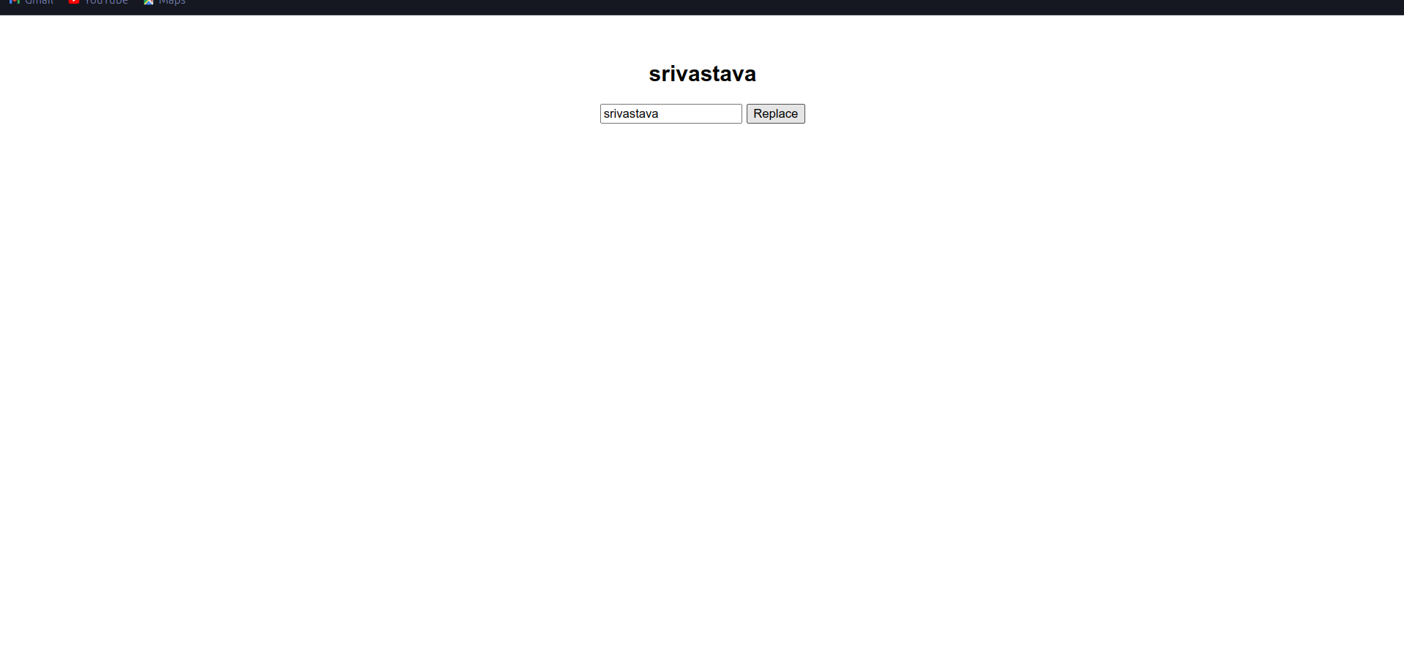

T2. Make a simple web page that contains a button and a paragraph with the id of count Whenever this button is pressed increment the count by 1 and update the paragraph text. Also update the font size so that as the number gets larger, so does the font.

⇒ <!DOCTYPE html>

<html lang="en">

<head>

<meta charset="UTF-8">

<meta name="viewport" content="width=device-width, initial-scale=1.0">

<title>Count Button</title>

<style>

#count {

font-size: 16px;

text-align: center;

}

</style>

</head>

<body>

<p id="count">0</p>

<button onclick="incrementCount()">Increment</button>

<script>

var count = 0;

function incrementCount() {

count++;

document.getElementById("count").textContent = count;

document.getElementById("count").style.fontSize = (16 + count) + "px";

}

</script>

</body>

</html>



T3. Repeat the previous exercise but make a list of numbers. In this case you will not be able to simply update the innerHTML of the paragraph, you will need to use the document.createElement() and document.appendChild() functions to add a new list item.

⇒ <!DOCTYPE html>

<html lang="en">

<head>

<meta charset="UTF-8">

<meta name="viewport" content="width=device-width, initial-scale=1.0">

<title>Counter with List</title>

<style>

body {

font-family: Arial, sans-serif;

text-align: center;

}

#countList {

list-style: none;

padding: 0;

}

#countList li {

font-size: 16px;

transition: font-size 0.3s ease-in-out;

}

</style>

</head>

<body>

<button onclick="incrementCount()">Increment Count</button>

<ul id="countList">

</ul>

<script>

let count = 0;

const countList = document.getElementById("countList");

function incrementCount() {

count++;

updateCountList();

}

function updateCountList() {

const listItem = document.createElement("li");

listItem.textContent = count;

listItem.style.fontSize = 16 + count \* 2 + "px";

countList.appendChild(listItem);

}

</script>

</body>

</html>

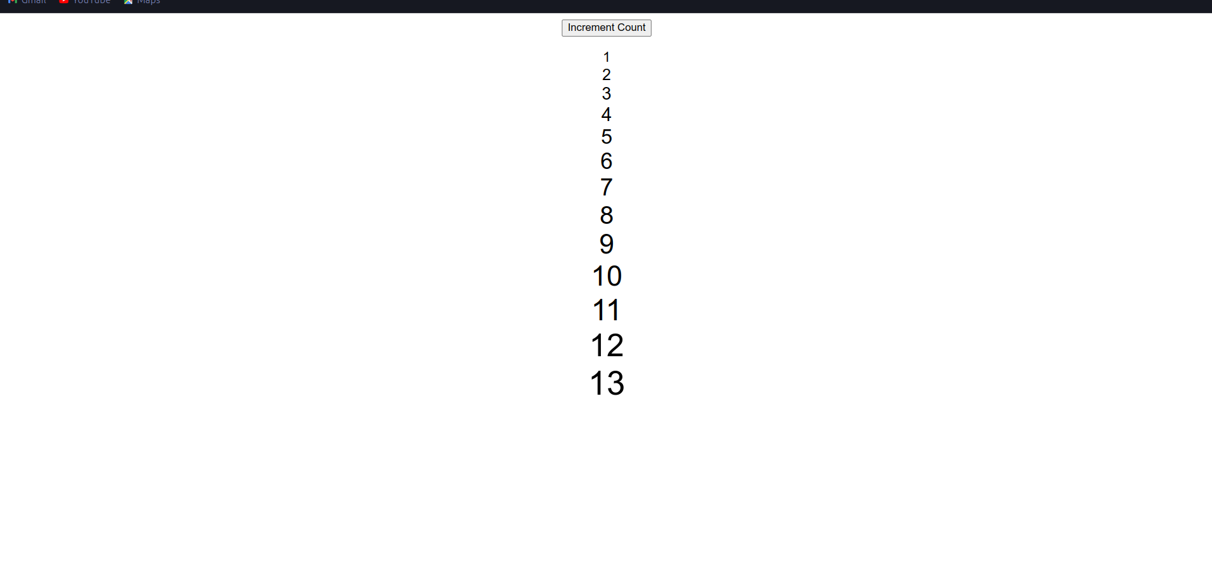

T4. Given the following html. Every time the button is pressed you should add a row to the table, where the new row of the table contains the sum of the previous two rows. You should make use of the lastChild, previousSibling, and innerText attributes in this exercise.

⇒ <!DOCTYPE html>

<html lang="en">

<head>

<meta charset="UTF-8">

<meta name="viewport" content="width=device-width, initial-scale=1.0">

<title>Table with Dynamic Rows</title>

<style>

body {

font-family: Arial, sans-serif;

text-align: center;

margin: 20px;

}

button {

padding: 10px;

font-size: 16px;

}

table {

border-collapse: collapse;

margin-top: 20px;

width: 100%;

}

th, td {

border: 1px solid #ddd;

padding: 8px;

text-align: center;

}

th {

background-color: #f2f2f2;

}

</style>

</head>

<body>

<button onclick="addRow()">Add Row</button>

<table id="myTable">

<tr>

<th>Value 1</th>

<th>Value 2</th>

</tr>

<tr>

<td>1</td>

<td>1</td>

</tr>

<tr>

<td>1</td>

<td>2</td>

</tr>

</table>

<script>

function addRow() {

var table = document.getElementById('myTable');

var rows = table.getElementsByTagName('tr');

var newRow = document.createElement('tr');

if (rows.length >= 2) {

var lastRow = rows[rows.length - 1];

var prevRow = rows[rows.length - 2];

for (var i = 0; i < lastRow.children.length; i++) {

var lastCellValue = parseInt(lastRow.children[i].innerText);

var prevCellValue = parseInt(prevRow.children[i].innerText);

var newCell = document.createElement('td');

newCell.innerText = lastCellValue + prevCellValue;

newRow.appendChild(newCell);

}

} else {

var newCell = document.createElement('td');

newCell.innerText = '1';

newRow.appendChild(newCell);

newCell = document.createElement('td');

newCell.innerText = '1';

newRow.appendChild(newCell);

}

table.appendChild(newRow);

}

</script>

</body>

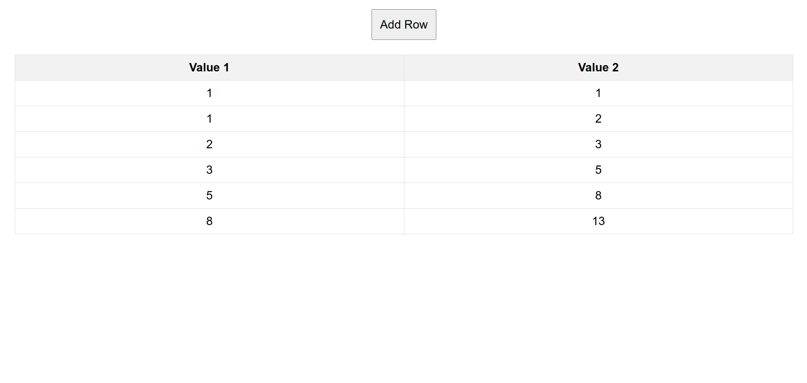

T5. Create an html page with two text input boxes and four buttons. The buttons should be labeled +, -, \*, and /. When one of these buttons is pressed you should get the value from both text input boxes and add, subtract, multiply, or divide the numbers entered in the text input boxes. The result should be displayed below the buttons. Note In order to do math on the values you read from the text input boxes you will need to use Number.parseInt on the value. for example suppose you get a reference to input box 1 using myIn1 = document.querySelector("#in1id"); then the statement value1 = Number.parseInt(myIn1.value) converts the string from the text input box to an integer. In fact most of the time Javascript will do the conversion for you automatically except for addition.

⇒ <!DOCTYPE html>

<html lang="en">

<head>

<meta charset="UTF-8">

<meta name="viewport" content="width=device-width, initial-scale=1.0">

<title>Calculator</title>

</head>

<body>

<input type="text" id="input1">

<input type="text" id="input2">

<br>

<button onclick="calculate('+')">+</button>

<button onclick="calculate('-')">-</button>

<button onclick="calculate('')"></button>

<button onclick="calculate('/')">/</button>

<div id="result"></div>

<script>

function calculate(operator) {

const input1 = Number.parseInt(document.getElementById("input1").value);

const input2 = Number.parseInt(document.getElementById("input2").value);

let result;

switch(operator) {

case '+':

result = input1 + input2;

break;

case '-':

result = input1 - input2;

break;

case '\*':

result = input1 \* input2;

break;

case '/':

if(input2 !== 0) {

result = input1 / input2;

} else {

result = "Cannot divide by zero";

}

break;

default:

result = "Invalid operator";

}

document.getElementById("result").innerText = "Result: " + result;

}

</script>

</body>

</html>

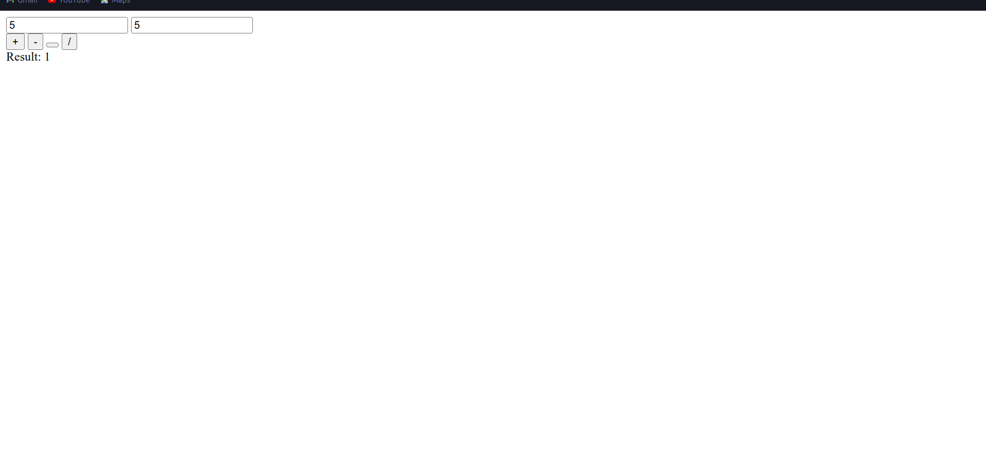

T6. Starting with the code given, create a page that looks like the following image: The rest of the page must be created using javascript. You must use document.createElement and the appendChild functions.

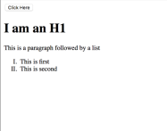

<html>

<body>

<button onclick="makePage();">Click Here</button>

</body>

</html>

⇒ <!DOCTYPE html>

<html lang="en">

<head>

<meta charset="UTF-8">

<meta name="viewport" content="width=device-width, initial-scale=1.0">

<title>Document</title>

</head>

<body>

<button class="btn">Click me!</button>

<div class="body"></div>

<script>

let onclick = ()=>{

body = document.querySelector(".body");

let heading = document.createElement("h1")

heading.textContent ="I am H1";

body.appendChild(heading);

let para = document.createElement("p");

para.textContent = "I am para";

body.appendChild(para)

let ul = document.createElement('ul');

let li1 = document.createElement("li");

li1.textContent = 'one';

let li2 = document.createElement("li");

li2.textContent = 'two';

ul.appendChild(li1);

ul.appendChild(li2);

body.appendChild(ul);

}

document.querySelector(".btn").addEventListener("click",onclick);

</script>

</body>

</html>

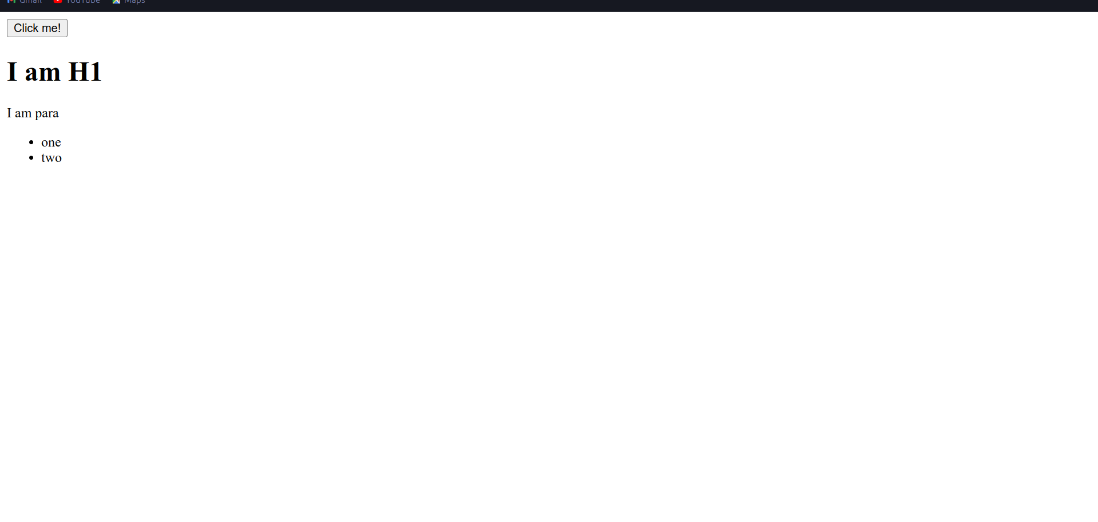

T7. Create a Tip Calculator as a single page web application (SPA). Design an interface that allows you to enter the amount of the tip. The percentage you would like to tip, and the number of people to split the tip with. Do not use 3 text input elements! Calculate and dynamically display the tip.

⇒ <!DOCTYPE html>

<html lang="en">

<head>

<meta charset="UTF-8">

<meta name="viewport" content="width=device-width, initial-scale=1.0">

<title>Tip Calculator</title>

<style>

body {

font-family: Arial, sans-serif;

text-align: center;

}

.container {

max-width: 400px;

margin: 0 auto;

padding: 20px;

border: 1px solid #ccc;

border-radius: 5px;

background-color: #f9f9f9;

}

label {

display: block;

margin-bottom: 10px;

}

input[type="number"] {

width: 100%;

padding: 8px;

margin-bottom: 10px;

border: 1px solid #ccc;

border-radius: 5px;

}

button {

padding: 10px 20px;

font-size: 16px;

background-color: #007bff;

color: #fff;

border: none;

border-radius: 5px;

cursor: pointer;

}

#tipAmount {

margin-top: 20px;

font-size: 20px;

}

</style>

</head>

<body>

<div class="container">

<label for="billAmount">Bill Amount ($)</label>

<input type="number" id="billAmount" min="0" step="0.01">

<label for="tipPercentage">Tip Percentage (%)</label>

<input type="number" id="tipPercentage" min="0" max="100" step="1">

<label for="splitNumber">Number of People to Split</label>

<input type="number" id="splitNumber" min="1" step="1">

<button onclick="calculateTip()">Calculate Tip</button>

<div id="tipAmount"></div>

</div>

<script>

function calculateTip() {

const billAmount = parseFloat(document.getElementById("billAmount").value);

const tipPercentage = parseFloat(document.getElementById("tipPercentage").value);

const splitNumber = parseInt(document.getElementById("splitNumber").value);

if (isNaN(billAmount) || isNaN(tipPercentage) || isNaN(splitNumber) || billAmount <= 0 || tipPercentage < 0 || splitNumber <= 0) {

document.getElementById("tipAmount").textContent = "Please enter valid input";

return;

}

const tipAmount = (billAmount \* tipPercentage) / 100;

const totalAmount = billAmount + tipAmount;

const tipPerPerson = tipAmount / splitNumber;

document.getElementById("tipAmount").textContent = Tip Amount: $${tipAmount.toFixed(2)} (Total: $${totalAmount.toFixed(2)});

if (splitNumber > 1) {

document.getElementById("tipAmount").textContent += ` (Each: $${tipPerPerson.toFixed(2)})`;

}

}

</script>

</body>

</html>