Date: 30th January 2024

T1. Add a CSS rule and appropriate html to style every other line of the unordered list with a light blue background color. Specify the background color using the rgb method. ● Eswatini

● Ecuador

● Tanzania

● Spain

● Slovakia

● Iraq

⇒ 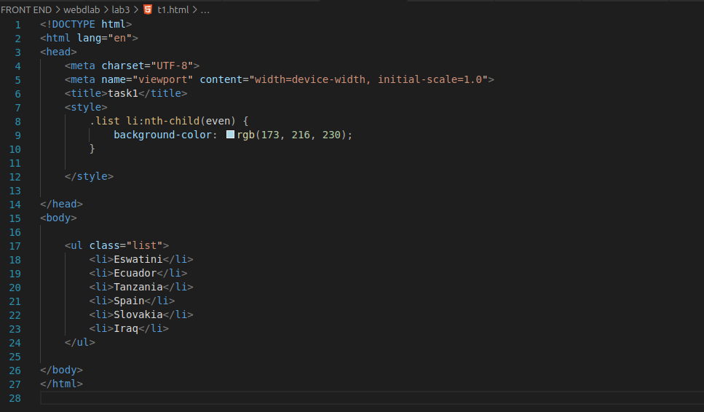

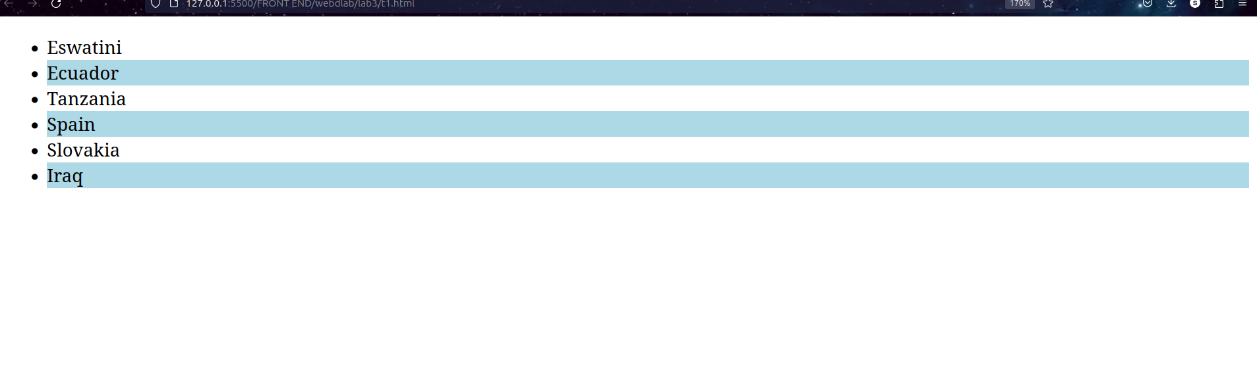

T2. Given the table in the question style the table so that the odd rows have a light gray background. In addition add a header row to the table and style that row so it has white text and a black background color. Change the font so that they are all 14 point sans serif of some kind.

| Albania | Tirana | Albanian |
| --- | --- | --- |
| Papua New Guinea | Port Moresby | English |
| Latvia | Riga | Latvian |
| France | Paris | French |

⇒ 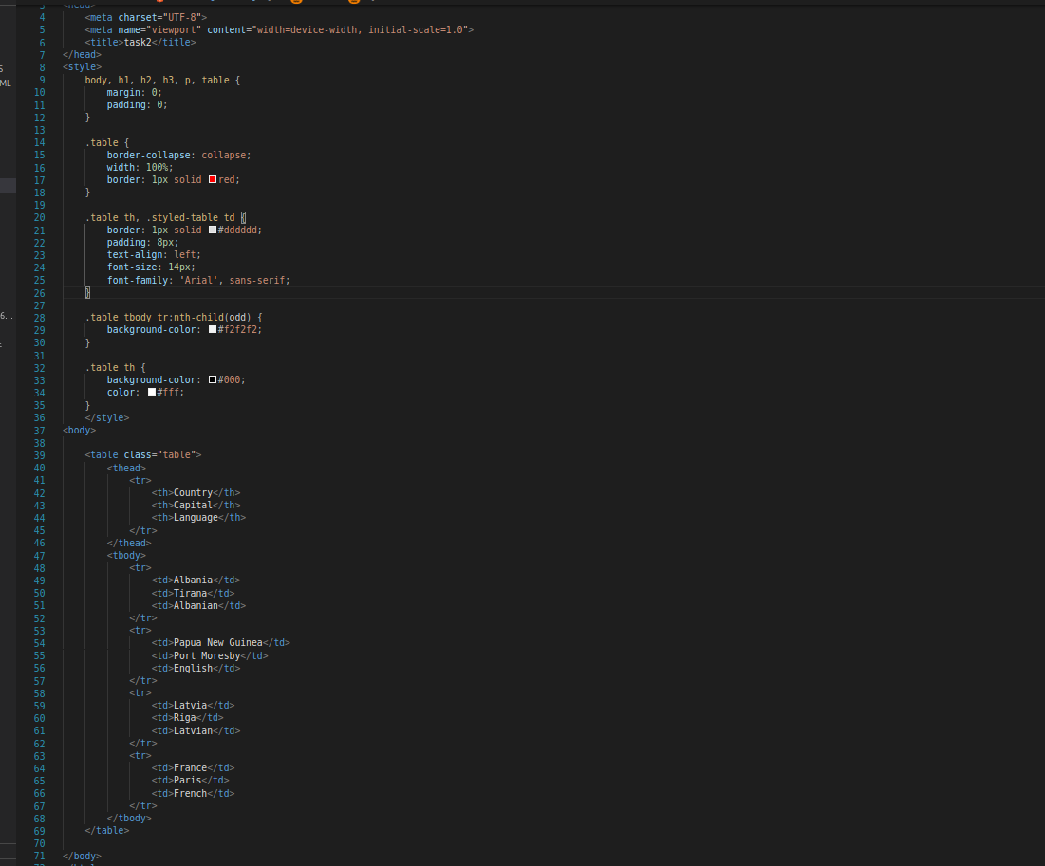

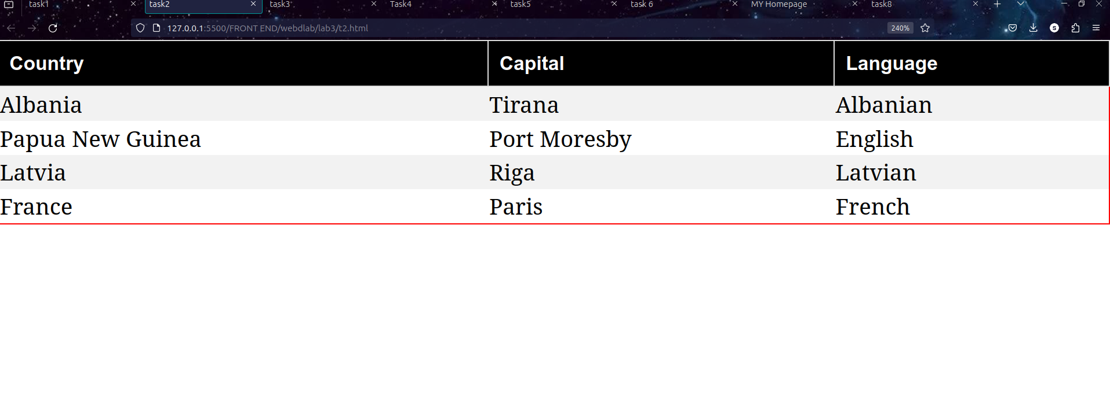

T3. Suppose you are working on a recipe website. Recipes have a title, a list of ingredients, and an instructions section. Make a webpage that shows the recipe for grilled cheese sandwiches with bacon and tomato. The ingredients should be displayed as an unordered list, with no bullets. Meat ingredients should have a light red background color, vegetables should have a light green background, and dairy products should have a light yellow. The title should be in a sans serif font of your choice, and the instructions should have a heading “Instructions” and the font for the instructions should be italic.

⇒

<!DOCTYPE html>

<html lang="en">

<head>

<meta charset="UTF-8">

<meta name="viewport" content="width=device-width, initial-scale=1.0">

<title>task3</title>

<style>

body {

font-family: 'Arial', sans-serif;

}

h1 {

font-family: 'Helvetica', sans-serif;

}

ul {

list-style: none;

padding: 0;

}

li {

margin-bottom: 8px;

padding: 8px;

font-style: italic;

}

.Bacon {

background-color: #ff9999;

}

.Tomato_slices {

background-color: #99ff99;

}

.dairy {

background-color: #ffff99;

}

</style>

</head>

<body>

<h1>Grilled Cheese Sandwich with Bacon and Tomato</h1>

<h2>Ingredients</h2>

<ul>

<li class="Bacon">Bacon</li>

<li class="dairy">Cheese</li>

<li class="Tomato_slices">Tomato slices</li>

<li class="dairy">Butter</li>

<li class="dairy">Bread slices</li>

</ul>

<h2>Instructions</h2>

<p>Step-1. Heat a non-stick pan over medium heat. Place bacon slices in the pan and cook until crispy. Remove bacon and set aside.</p>

<p>Step-2. Butter one side of each bread slice. On the unbuttered side of half the slices, place a layer of cheese, followed by bacon slices and tomato slices. Top with another bread slice, buttered side facing out.</p>

<p>Step-3. Place the sandwiches in the pan and cook until the bread is golden brown and the cheese is melted. Flip the sandwiches and cook the other side.</p>

<p>Step-4. Serve hot and enjoy your delicious grilled cheese sandwich with bacon and tomato!</p>

</body>

</html>

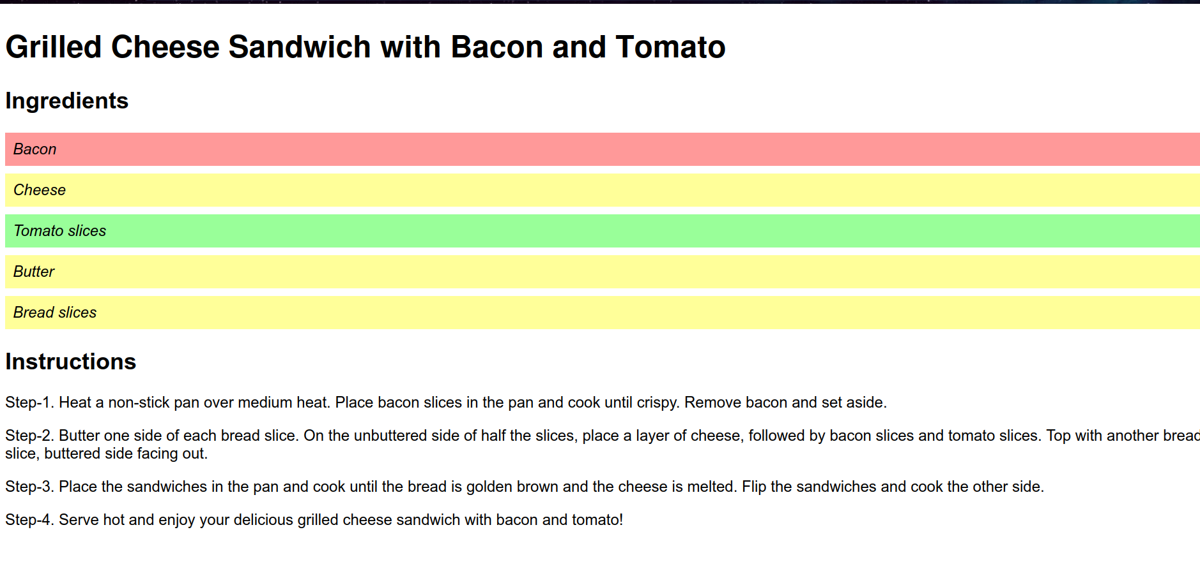

T4. Using CSS and HTML Make a webpage that has two columns. Each column should use half of the width of the page. The left half should have a light gray background and the right half should have a light green background. The left half should have a list of the 5 best selling books in Amazon’s kindle store, and the right should have a list of your five favorite celebrities or athletes.

⇒ <!DOCTYPE html>

<html lang="en">

<head>

<meta charset="UTF-8">

<meta name="viewport" content="width=device-width, initial-scale=1.0">

<title>Task4</title>

<style>

body {

margin: 0;

padding: 0;

font-family: 'Arial', sans-serif;

}

.container {

display: flex;

width: 100%;

}

.column {

flex: 1;

padding: 20px;

}

._left-column {

background-color: #f0f0f0;

}

._right-column {

background-color: #b3ffb3;

}

ul {

list-style: none;

padding: 0;

margin: 0;

}

li {

margin-bottom: 10px;

}

</style>

</head>

<body>

<div class="container">

<div class="column_left-column">

<h2>Best Selling Books on Amazon Kindle</h2>

<ul>

<li>Book 1</li>

<li>Book 2</li>

<li>Book 3</li>

<li>Book 4</li>

<li>Book 5</li>

</ul>

</div>

<div class="column_right-column">

<h2>My Favorite Celebrities/Athletes</h2>

<ul>

<li>Celebrity/Athlete 1</li>

<li>Celebrity/Athlete 2</li>

<li>Celebrity/Athlete 3</li>

<li>Celebrity/Athlete 4</li>

<li>Celebrity/Athlete 5</li>

</ul>

</div>

</div>

</body>

</html>

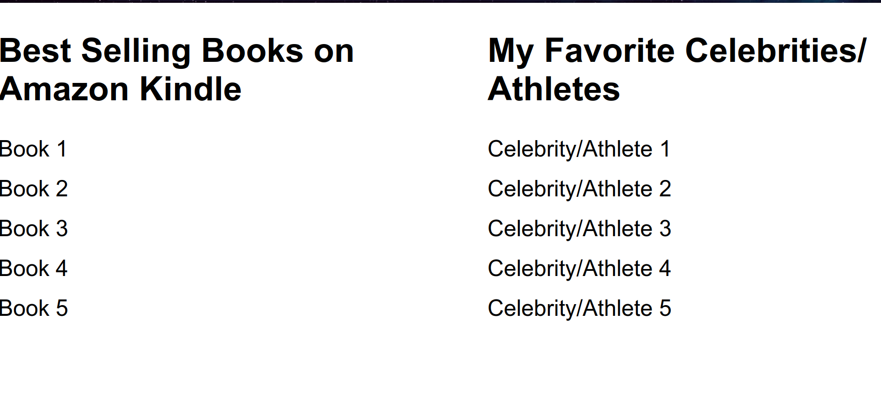

T5. Using the nav element, make a navbar for at the top of a sample webpage. Add at least three links to the navbar using an unordered list that is displayed as inline rather than block. Make the navbar have a light blue background color, but change the background of the title to a darker blue when the mouse hovers over it.

⇒ <!DOCTYPE html>

<html lang="en">

<head>

<meta charset="UTF-8">

<meta name="viewport" content="width=device-width, initial-scale=1.0">

<title>task5</title>

<style>

body {

margin: 0;

padding: 0;

font-family: 'Arial', sans-serif;

}

nav {

background-color: #add8e6;

padding: 10px;

}

nav ul {

list-style: none;

margin: 0;

padding: 0;

text-align: center;

}

nav li {

display: inline;

margin-right: 20px;

}

nav a {

text-decoration: none;

color: #333;

font-weight: bold;

}

nav h1:hover {

background-color: #0077cc;

transition: background-color 0.3s ease;

}

</style>

</head>

<body>

<nav>

<h1>My portfolio</h1>

<ul>

<li><a href="#">Home</a></li>

<li><a href="#">About</a></li>

<li><a href="#">Contact</a></li>

</ul>

</nav>

</body>

</html>

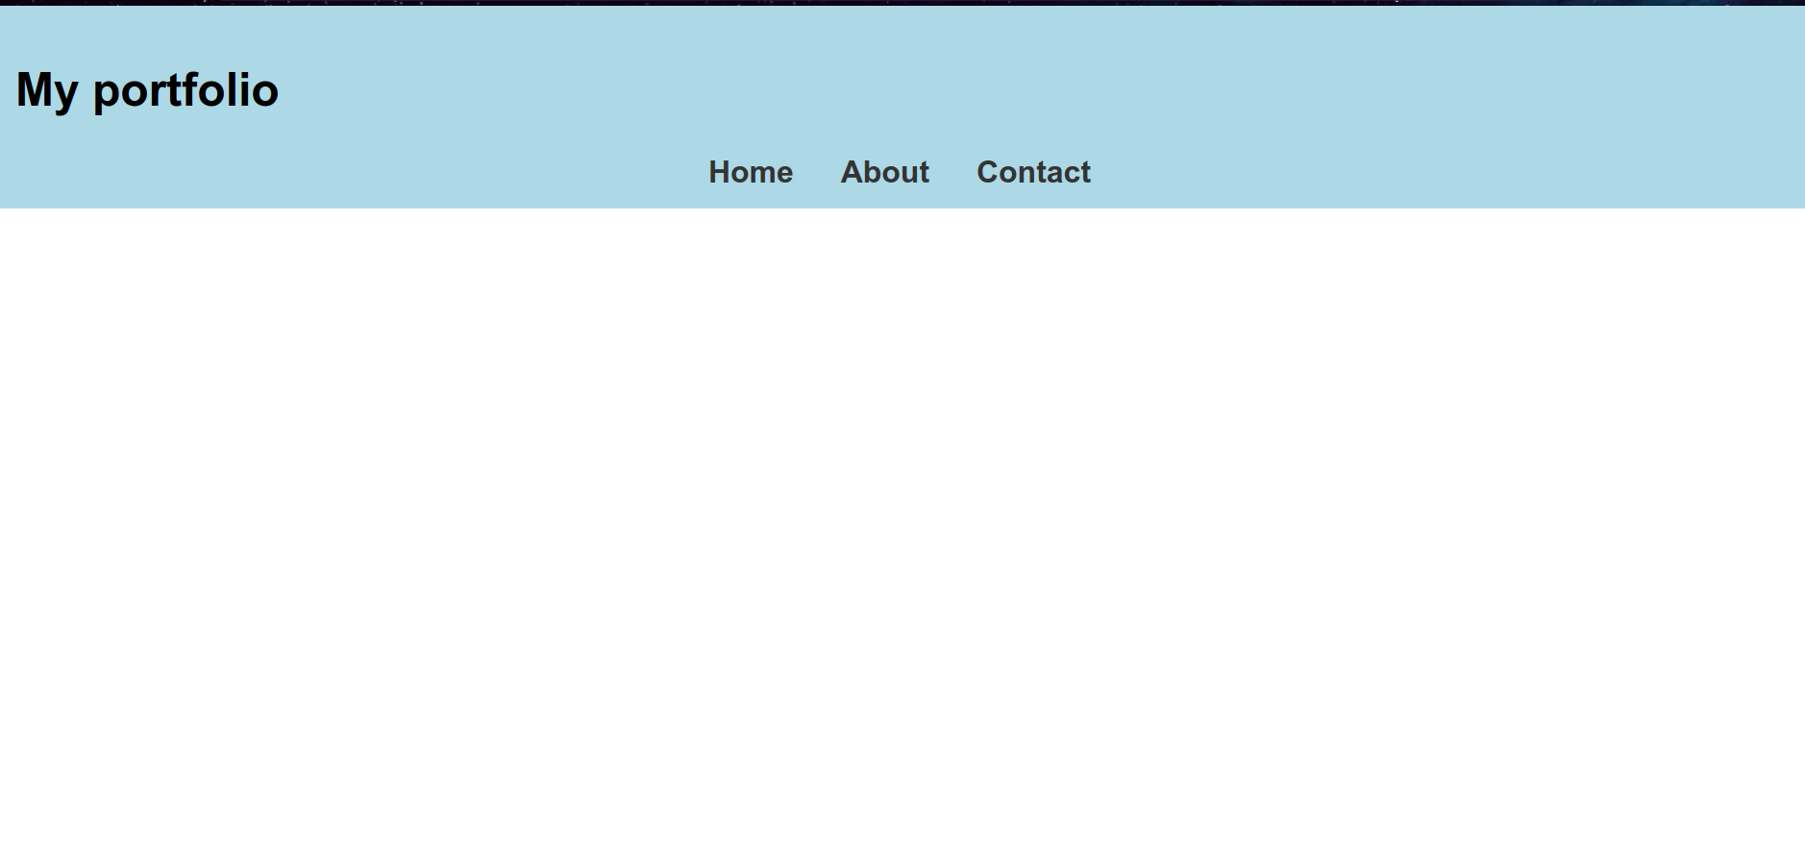

T6. Using the image of the playing card, use transformations and animations to make the playing card spin around endlessly.

⇒ <!DOCTYPE html>

<html lang="en">

<head>

<meta charset="UTF-8">

<meta name="viewport" content="width=device-width, initial-scale=1.0">

<title>task 6</title>

<style>

@keyframes spin {

0% { transform: rotate(0deg); }

100% { transform: rotate(360deg); }

}

.playing-card {

width: 150px;

height: 200px;

margin: 50px auto;

border: 1px solid #ccc;

animation: spin 5s linear infinite;

}

</style>

</head>

<body>

<img class="playing-card" src="https://www.shutterstock.com/image-photo/five-hearts-isolated-on-gray-260nw-2169913703.jpg" alt="Playing Card">

</body>

</html>



T7. Develop a homepage for yourself, published on github pages, that employs a two column layout with a fixed navbar (always on screen), and a footer. The navbar should link to at least two additional pages used to describe your hobbies or favorite teams. The CSS for this website should be contained in its own CSS file, and all three pages should use this CSS file.

⇒ index=

<!DOCTYPE html>

<html lang="en">

<head>

<meta charset="UTF-8">

<meta name="viewport" content="width=device-width, initial-scale=1.0">

<link rel="stylesheet" href="style.css">

<title>MY Homepage</title>

</head>

<body>

<header>

<nav>

<ul>

<li><a href="index.html">Home</a></li>

<li><a href="hobbies.html">Hobbies</a></li>

<li><a href="teams.html">Favorite Teams</a></li>

</ul>

</nav>

</header>

<div class="container">

<section class="main-content">

<h1>Welcome to My Homepage</h1>

<p>Lorem ipsum dolor sit amet consectetur adipisicing elit. Debitis a distinctio amet magni repellendus rerum nihil nemo recusandae provident minima blanditiis officiis fugiat, commodi voluptatem non, esse, cum nobis nisi quasi quis. Eum, dolorum. Rerum eius in impedit placeat iste fugiat, repellat pariatur iure exercitationem? Rerum perspiciatis suscipit sunt placeat?

</p>

</section>

<aside class="sidebar">

<h2>About Me</h2>

<p>My name is sunny,i am from bihar.i am currently pursuing my integrated dual degree in computer science and artificial intelligence from rajiv gandhi institute of petroleum technology.i am very much intrested in the field of computer science. </p>

</aside>

</div>

<footer>

<p>&copy; 2024 sunny gupta. All rights reserved.</p>

</footer>

</body>

</html>

Hobbies 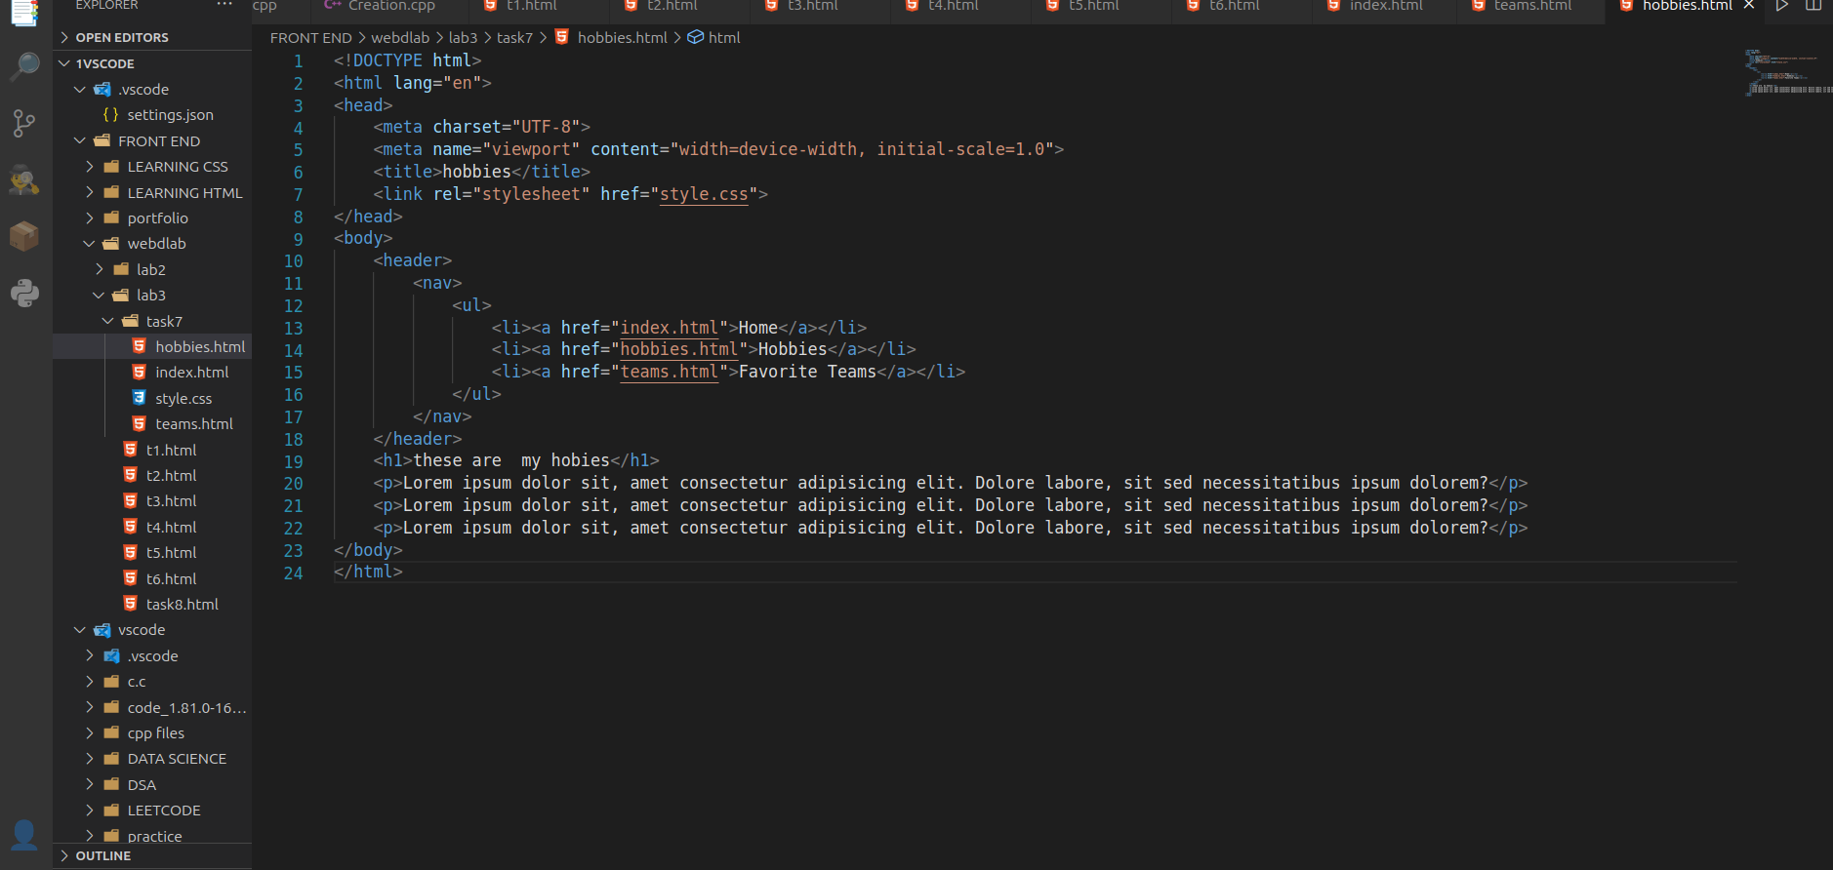

Teams 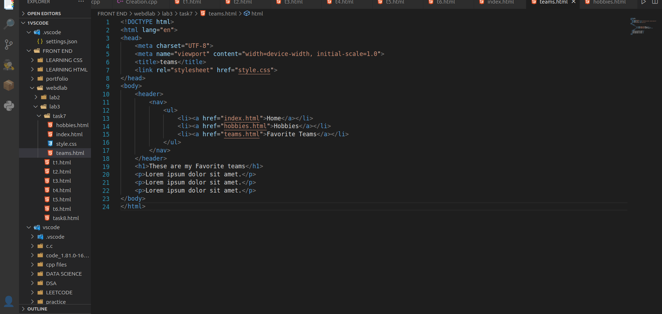

Css file: 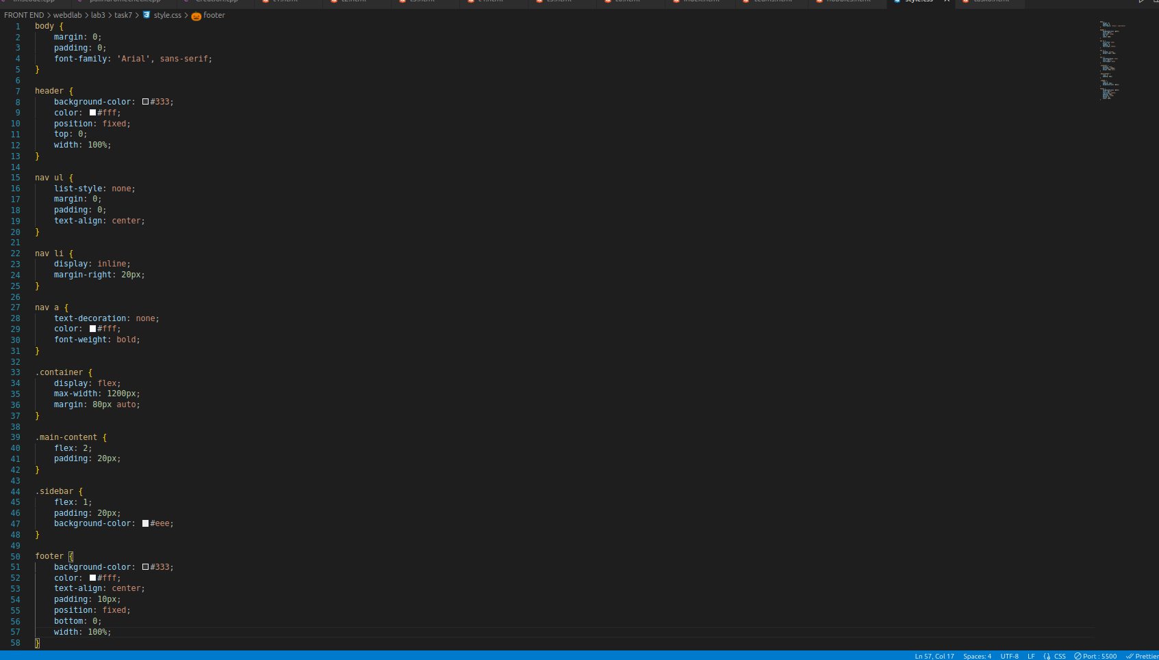

Output: 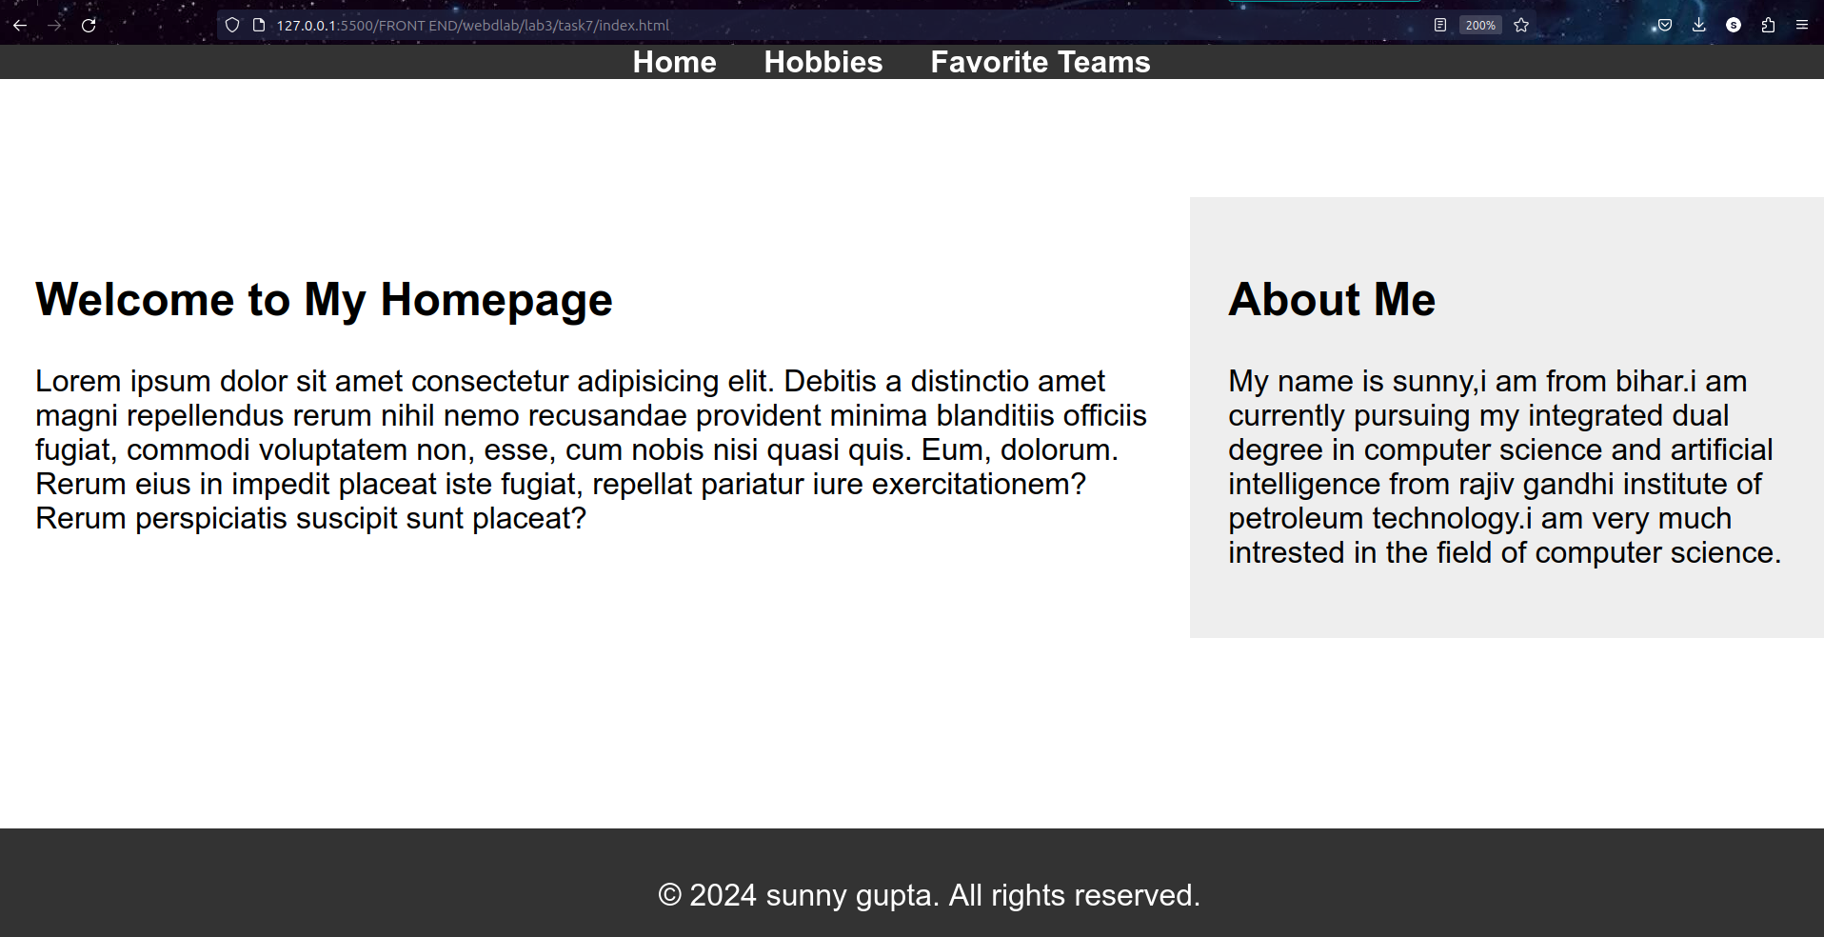

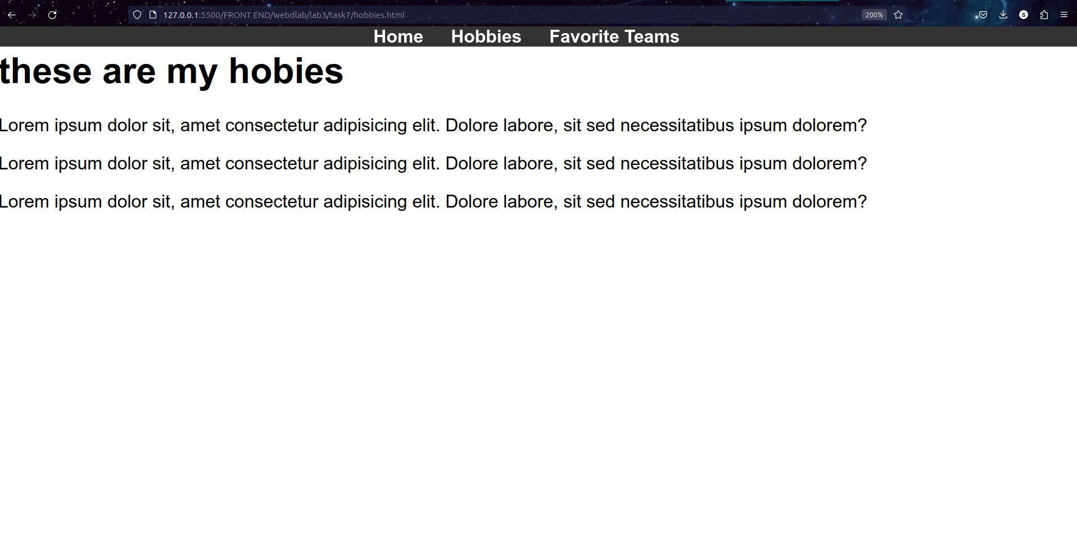

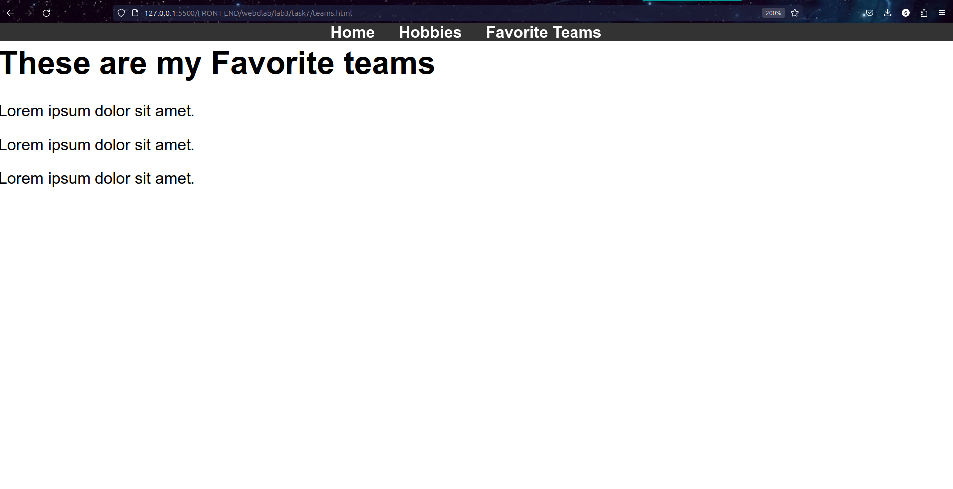

T8. Modify the final version of the menu project so that the menu is a horizontal menu with the first level of submenus dropping down below the selected item.

⇒<!DOCTYPE html>

<html lang="en">

<head>

<meta charset="UTF-8">

<meta name="viewport" content="width=device-width, initial-scale=1.0">

<title>task8</title>

<style>

body {

font-family: 'Arial', sans-serif;

margin: 0;

padding: 0;

}

header {

background-color: #333;

color: #fff;

padding: 10px;

text-align: center;

}

nav {

background-color: #444;

}

ul {

list-style: none;

padding: 0;

margin: 0;

display: flex;

}

li {

position: relative;

}

a {

display: block;

padding: 15px;

text-decoration: none;

color: #fff;

transition: background-color 0.3s ease;

}

a:hover {

background-color: #555;

}

ul.submenu {

display: none;

position: absolute;

top: 100%;

left: 0;

background-color: #555;

}

li:hover > ul.submenu {

display: block;

}

ul.submenu li {

display: block;

white-space: nowrap;

}

</style>

</head>

<body>

<header>

<h1>Horizontal Dropdown Menu</h1>

</header>

<nav>

<ul>

<li><a href="#">Home</a></li>

<li>

<a href="#">Categories</a>

<ul class="submenu">

<li><a href="#">Category 1</a></li>

<li><a href="#">Category 2</a></li>

<li><a href="#">Category 3</a></li>

</ul>

</li>

<li>

<a href="#">Products</a>

<ul class="submenu">

<li><a href="#">Product 1</a></li>

<li><a href="#">Product 2</a></li>

<li><a href="#">Product 3</a></li>

</ul>

</li>

<li><a href="#">Contact</a></li>

</ul>

</nav>

</body>

</html>

⇒