**Goal 3**: To compare the gender with the job role of the employees based on their monthly income. The graph is visualized using tableau with tree map.

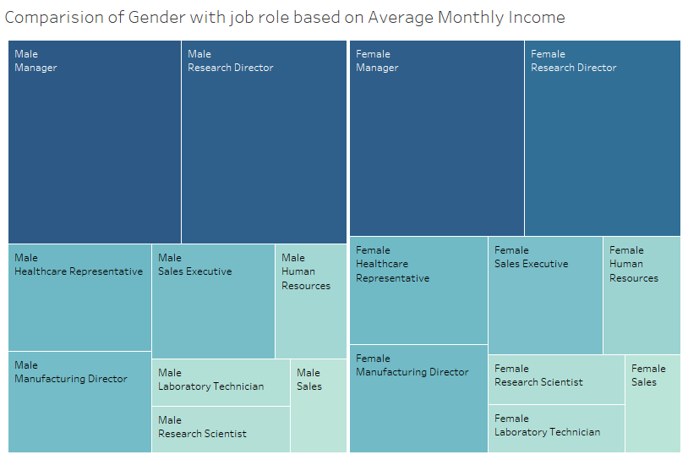

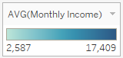

The graph is divided into 2 portions. The first half represents the highest to lowest average monthly income of males based on the job role. Similarly, the second half signifies the same for female gender. When we consider the graph, we can observe that,

* The manager role has the most monthly income for both the genders.
* Comparison between male and female, males have more average income than females.
* In the overall graph, female employees have more average monthly income than male employees in the job roles such as Sales representative, Laboratory technician, Research Scientist, Manufacturing Director and human resources. On the other hand, male employees have greater average monthly income in Manager, Research Director, and Healthcare representative and Sales Executive roles.