**44-599: Introduction to Data Visualization**

**Individual Tool Presentation**

**Objective:** The main objective of this worksheet is to generate **Parallel Coordinate Plot Graph using RAW tool.**

**Worksheet for drawing Parallel Coordinate Plot Graph (desktop version) tool**

1. Dataset



1. Data Source: [https://www.google.com/#q=cars.xls](https://www.google.com/)
2. Open [http://rawgraphs.io](http://rawgraphs.io/)/
3. Click on **Use it now!**. Then a new window opens where we need to import the data.
4. Click on **Upload a File.** The drag and drop or select your data in the excel sheet.

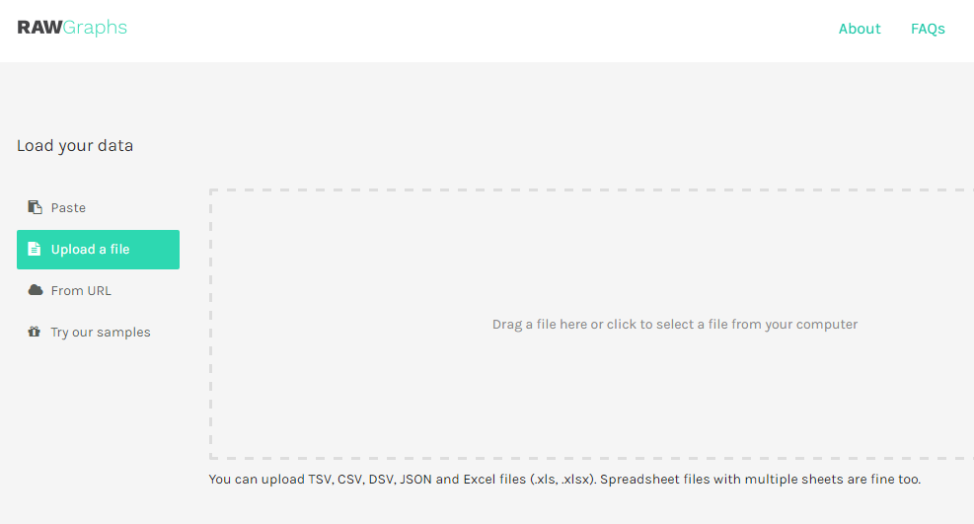

1. After selecting the data, we will have something like this.

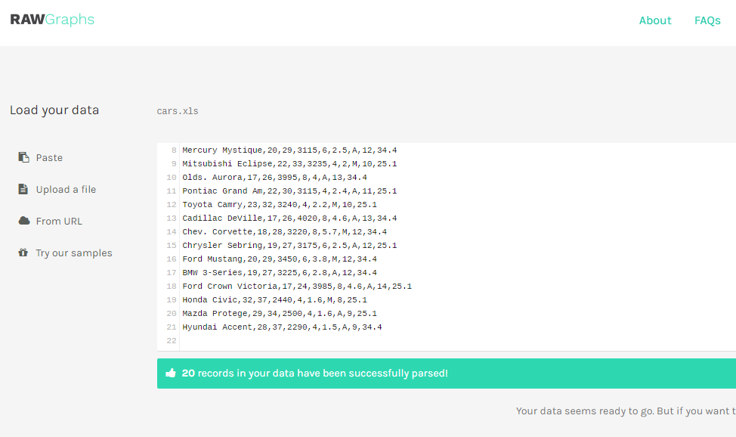

1. Then Select the required chart.

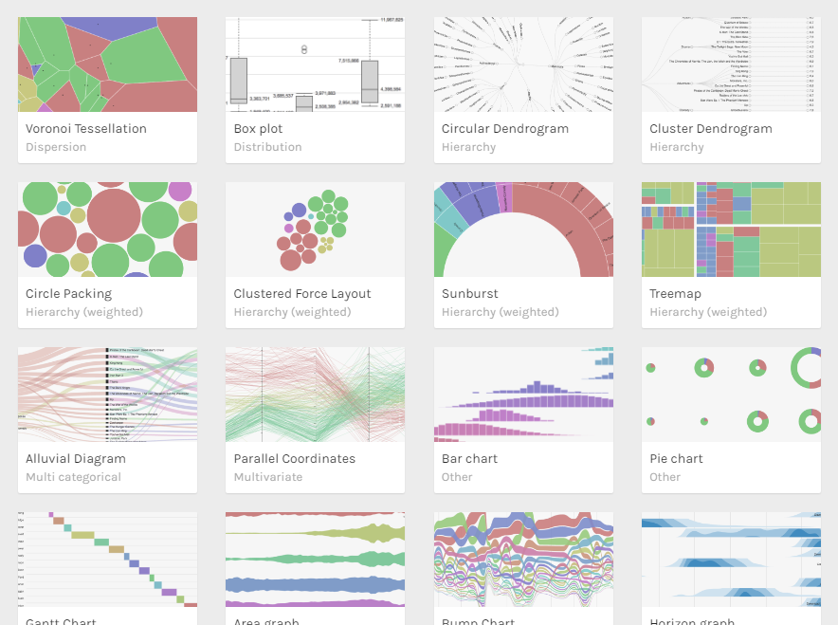

1. After selecting the chart, map the dimensions according to your required fields.

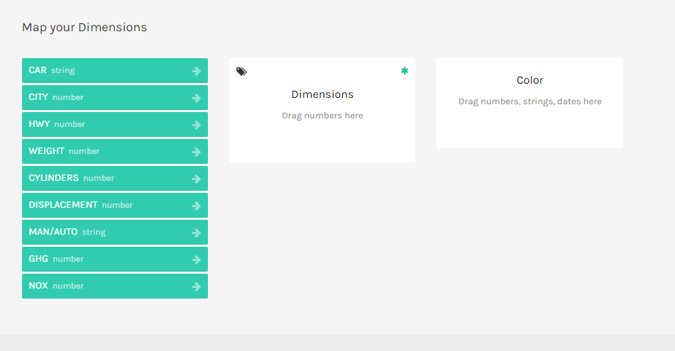

1. After mapping the dimensions, we get the parallel coordinate graph which will look like this.

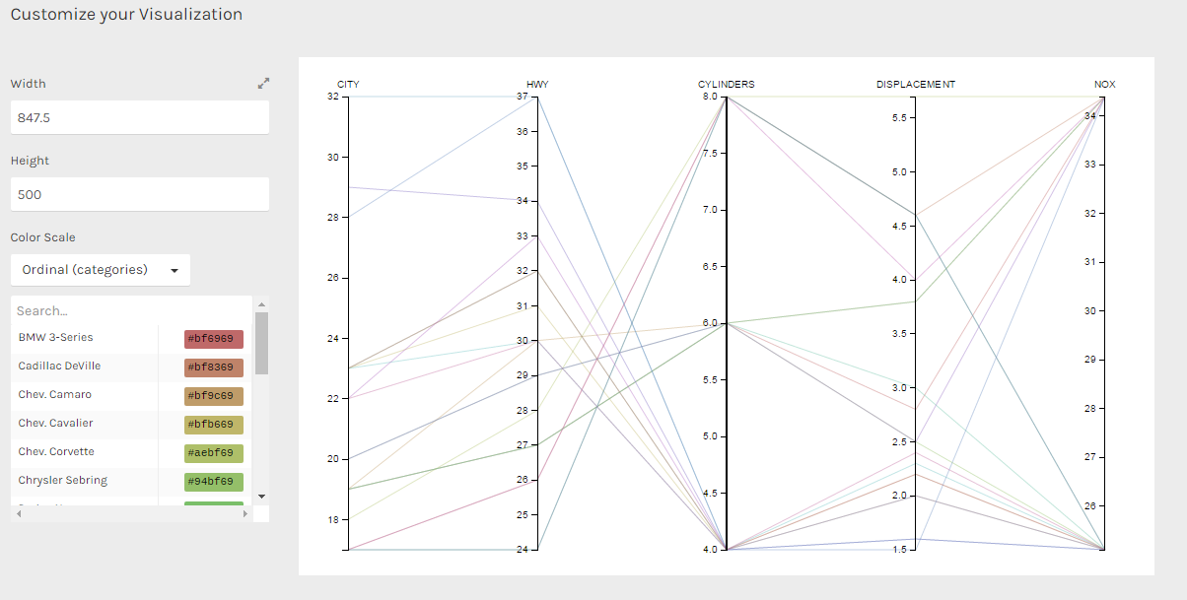

**GitHub Link:** [**https://github.com/Sunny3003/DV-presentation**](https://github.com/Sunny3003/DV-presentation)