Bachelor MKI

„Mobile Computing“,

WS 2018/2019

Prof. Dr. Natividad Martínez Madrid

- Seminar report -

Spill – Split the Bill

Sonja Czernotzky

[Sonja.czernotzky@student.reutlingen-university.de](mailto:Sonja.czernotzky@student.reutlingen-university.de)

Hanna Schulze

[Hanna_Frederike.Schulze@student.reutlingen-university.de](mailto:Hanna_Frederike.Schulze@student.reutlingen-university.de)

Jannik Renner

[Jannik.Renner@student.reutlingen-university.de](mailto:Jannik.Renner@student.reutlingen-university.de)

Oliver Wagner

[Oliver.Wagner@student.reutlingen-university.de](mailto:Oliver.Wagner@student.reutlingen-university.de)

Tim Herold

[Tim.Herold@student.reutlingen-university.de](mailto:Tim.Herold@student.reutlingen-university.de)

Arjun Grewal

[arjun.grewal@student.reutlingen-university.de](mailto:arjun.grewal@student.reutlingen-university.de)

Kenneth Alegria

[Kenneth.Alegria@student.reutlingen-university.de](mailto:Kenneth.Alegria@student.reutlingen-university.de)

**Abstract:** SPILL (SPlit the bILL) is an app for people who love to travel, doing activities, or just go out at the evening in groups and may have had difficulties in splitting bills along their journey. SPILL will help those people and nobody has to calculate who owes somebody money and how much. In this Report, we’ll show you our goals for the app and the requirements to it. We will include mockups and decisions about our design and how it finally got there. In addition, there are activity and sequence diagrams for understanding how the app works.

**Table of contents**

1 Idea 2

2 Motivation 2

3 Mockups 2

4 Design 4

4.1 Variances to the Mockups 5

5 Database 5

6 API 5

7 Declaration on oath 6

# Idea

Our idea is to make it easier for groups to split their Bills when they go traveling or do some activities together. Every Person has to login to the App with a Google-Account. With our App you can create trips for groups. Multiple activities within trips can be created. The App records total costs for whole trips as well as separate costs for each activity for each person. People can be assigned to separate activities individually, so the activities cost will not automatically splitted to everyone in the group rather only by the people who are assigned to the activities. Also, can People take the charge from others (for example there is a couple with in the group and one of them is paying for both). The person who created a trip for a group is the administrator. He’s the only one who can invite or delete people to/from the group. Every user can add his or her individual positions to an activity/trip. Motivation

# Motivation

All of us made the experience to create an Excel sheet or a list after a trip with a group of friends to get an overview of the costs that came up and who has to pay what which person, so everyone payed at the end “the same”. Mostly to create that list you need to look through the bills collected while being on the trip and at the end you don’t even have every bill and have to run after others to get all those bills together. The app will take care of balancing for everybody.

# Mockups

We planned the following process:

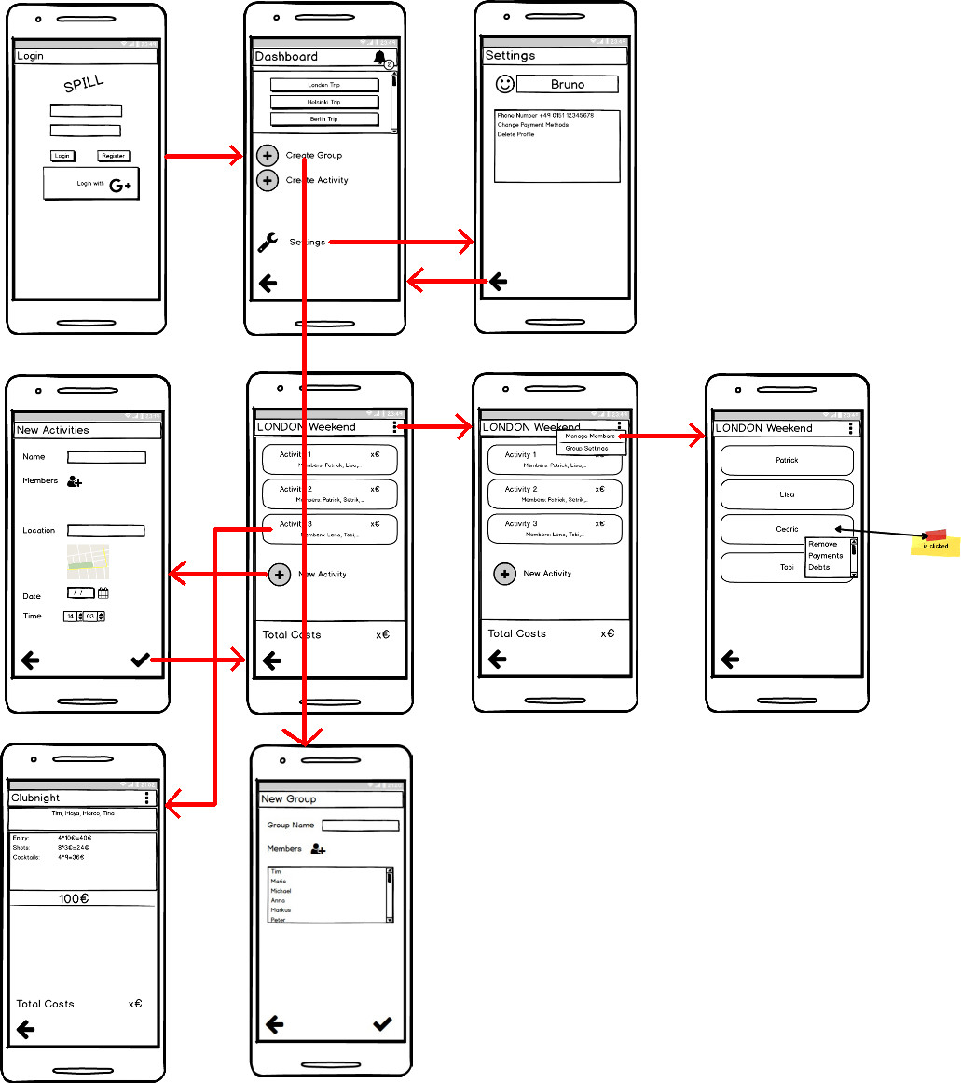

In Words:

1. The User can log in his account or create a new one (via Google should be possible, too).
2. Once He/She is logged in, the user can see his/her groups, in which they participate. This is shown in the dashboard. The user can navigate to the settings where he can change app settings, user settings regarding the user profile and the account. Also, the notifications are visible here. The user can click on a bell button and navigate to his/her notification page.
3. By clicking on the ‘+’ button, the new group page is opened, and a new group can be created.
4. If the user clicks on a group name, the group page is opened. Here are all activities of the group listed, which the user created or participated in.

By clicking on the menu button, the user can add and remove group members and see the group settings.

1. By clicking on an activity, the details of this activity open. Here the user can see his balance and who he/she owes money to.
2. By clicking the ‘+’ button, a new item can be added. The App provides the group members to choose from.

# Design

We chose a simple design. Not too colourful but not the standard colours and design.

The headers are in the Google font ‘Pacifico Regular’, to add some dynamics to the content.

The login and registering pages show our logo, the dollar coin, broken in half – split in two. I added a night sky background with twinkling stars for more eye comfort and made the buttons a darker yellow.

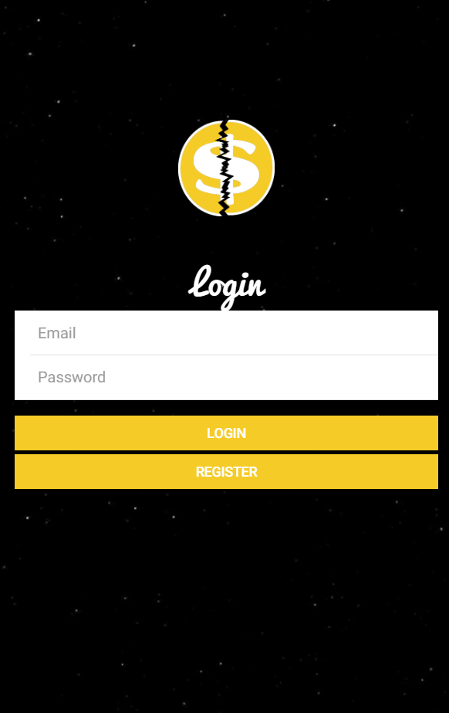

The following pages have a white background, to contrast to the login and registering page. The headers still have the same font, but a deep purple background. The buttons are in the same colour which adds another contrast.

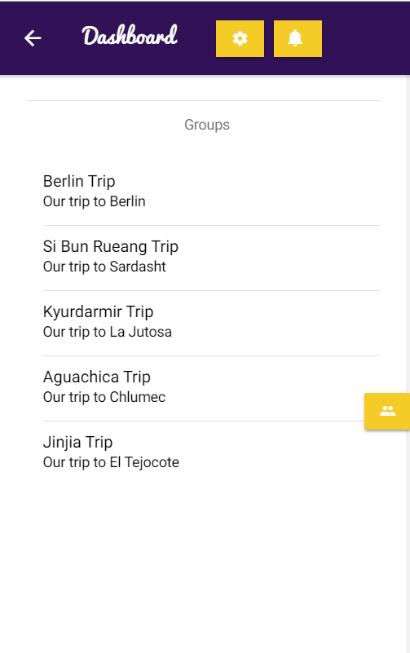

## Variances to the Mockups

1. We didn’t integrate the Google login
2. Dashboard
   1. Navigation bar hold buttons for settings and notifications
   2. New Group button is floating on the right side
3. Group page
   1. Menu button holds buttons for adding/deleting members and edit the group’s name and description and creating a new activity
4. New Activity
   1. We didn’t integrate google maps for the place
5. Activity page
   1. Menu button holds buttons for adding/deleting members, editing the activity and adding a new item
6. Activity details (new)
   1. Shows balance of current user
   2. Shows all of his created items and the ones he/she participated in
   3. Ability to click an item and edit it or make an attempt to pay

# Connection to the Database

# Database

# API

# Declaration on oath

I hereby declare that I have written the present work on my own, that I have not used any external help other that declared and that all helping material and sources used for the work have been properly named and referenced.

I am aware that an untruthful declaration will be considered as a deceit.

______________ ___________ ________________________

Place, Date Signature

(First and last name)

______________ ___________ ________________________

Place, Date Signature

(First and last name)

______________ ___________ ________________________

Place, Date Signature

(First and last name)

______________ ___________ ________________________

Place, Date Signature

(First and last name)

______________ ___________ ________________________

Place, Date Signature

(First and last name)

______________ ___________ ________________________

Place, Date Signature

(First and last name)

______________ ___________ ________________________

Place, Date Signature

(First and last name)