
Blog Entry for $PiLL

Hello to the new readers of my blog! I am Alex, I love to travel and go on festivals. In this post, I’d love to tell you something about an app, that will be really helpful on your trip, when money is a big topic (it always is, I guess?).
Have you ever wondered, if there is an easy way to split costs on a trip? When I go to a festival with my friends, someone buys the beer, someone pays for gas and other ones bring snacks and other food. In our case it is mostly even. We guessed, until we calculated all the costs once. All of us were in depth for Paul, who paid the gas. To us, that seemed unfair. We needed a solution!

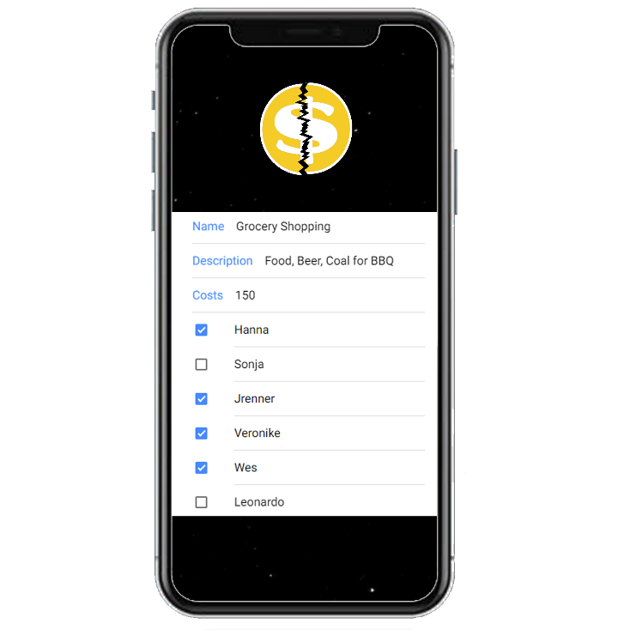
That’s were the students of the university in Reutlingen did an amazing job. They developed an app that splits you costs among every member who participated.
Let’s look into this app!
First, we are greeted by a login screen. Once you have registered for it (don’t worry, they don’t need you credit cards. They only want your e-mail address) your dashboard is showing. It consists of your groups, a button where you can add more groups, a settings and a notifications button. The design is simple and yet – it does the job. I love animated backgrounds, because it is more dynamic. While creating you group, you can add members from the users that already have registered to the app. When you click on your group’s name, you can see, which activities have already been done. Activities contain all items that has been paid for. For our example, going to a festival, the first activity could be, let’s call it, “preparation”.
For a new activity, you can add all the group members or just a part of it, by selecting them via checkboxes. You can even add the place you went and when.
In our new activity goes everything that has been paid for before we go to the festival. This could be, as I mentioned, gas, food and drinks, camping gear, etc. All those payments can be added, when you click on the menu button and then ‘+’. You can choose from the members of the activity, put in your costs and what they are for. Pretty easy don’t you think?
Once you created a new Item that you paid for, the ones you selected will get notified that they are “in depth” with you.

