Assignment#1 OpenGL Triangle Mesh Viewer

20131329 신선우 (전기전자컴퓨터공학부/학생)

**1. Introduction**

This assignment is making triangle mesh viewer by OpenGL.

In this assignment, I render bunny with vertices, indexes, and vertex normal which calculated by vertices and indexes. Also, implement keyboard and mouse callback.

**2. Method**

By parsing bunny.off file, I pass data to vertex and index buffer which can get the environment path by *argv.

To reduce half-round of high precision of float data, I multiply 10000 and there is no round-up case.

Also, the normal vector is calculated with such a process.

First, calculate face normal using vertex and index.

Second, calculate the average face normal of each vertex.

To reduce flipped normal vector, I checked vector direction in the stage of face normal.

Keyboard callback function has Orthogonal/Perspective, Smooth/Wire, quit function with glutKeyboardFunc() function.

Mouse callback function has Rotating/Panning/Zooming function with glutMouseFunc(). And to recognize the movement of the mouse, I used glutMotionFunc().

**3. Result**

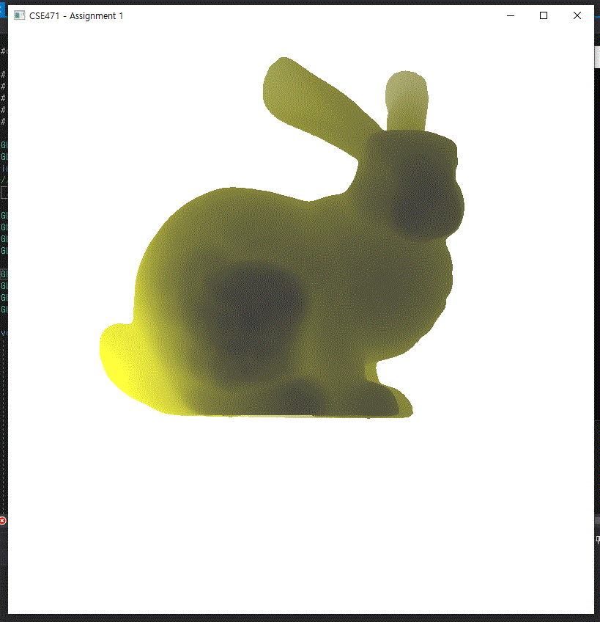

I success to render bunny with data. But, fail to implementation rotating.

Just panning and zooming in perspective was succeeded but rotating function was not working well.

**4. Conclusion**

In this assignment, the main problem is hard to know each OpenGL function is.

1),2) For example, an index buffer, it didn’t have to be put in an attribute. And putting index buffer as the third attribute without color buffer causes wired render image.

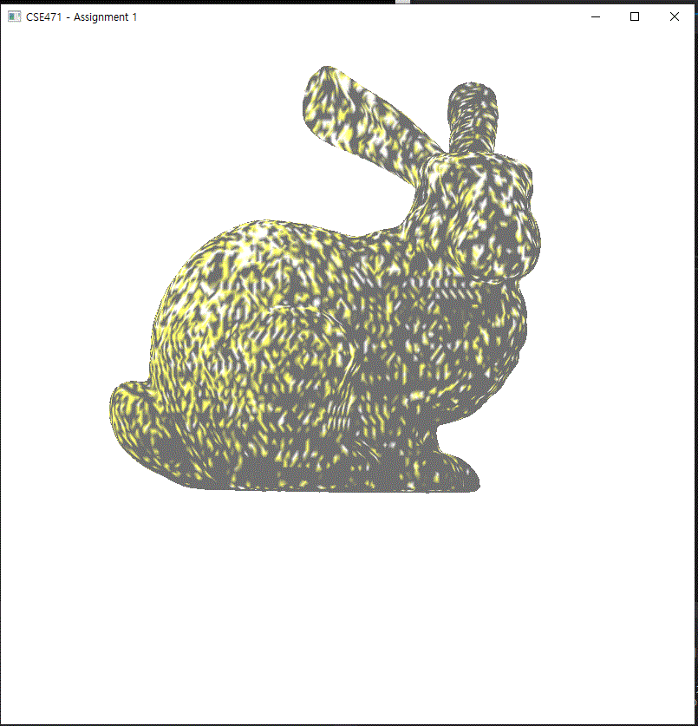

Like these example, there was a lot of trial and error. Moreover, to this day there is still a lack of understanding of the functions that process the matrix. This is what I supposed to do to go to the next step.

**5. Reference**

1)<https://stackoverflow.com/questions/24921350/why-no-glvertexattribpointer-for-index-buffer-object>

2) <https://community.khronos.org/t/why-no-glvertexattribpointer-for-index-buffer-object/72211>