Assignment#3 Texture Mapping and Off-screen Rendering

20131329 신선우 (전기전자컴퓨터공학부/학생)

**1. Introduction**

This assignment is Texture mapping and Off-screen rendering.

0. Trackball rotation.

1. 2D texture mapping. : mapping Minecraft character image to simple cube.

2. Environment mapping using static cube mapping.

**2. Method**

- 0. Trackball rotation.

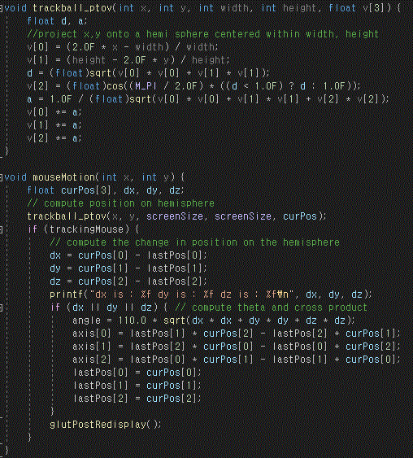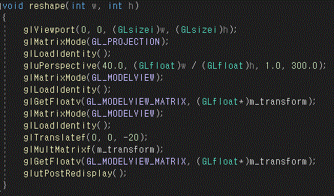

I implement trackball with assignment 1 skeleton code.

At this time, I only figure out how to use glgetflotv, glmultmatrix glpopmatrix, glpushmatrix.

- 1. 2D texture mapping.

Default skeleton code.

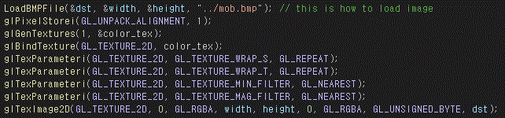

I used the default skeleton code of loading image and binding.

This code is the component of render_cube() function which I made.

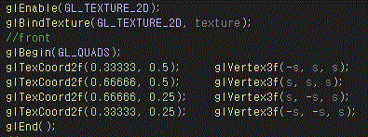

Variable s means the size and texture is the name of the bound texture.

-Render in display() function

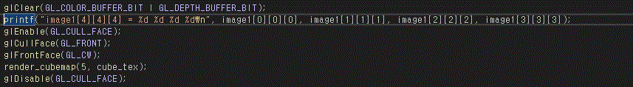

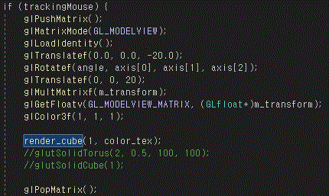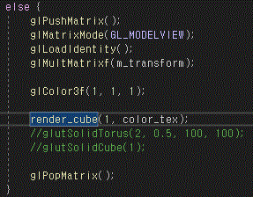

To differentiate background and object

I used push matrix and pop matrix to make rotation object only.

- 2. Environment mapping using static cube mapping.(Failed)

Initiation static cube map

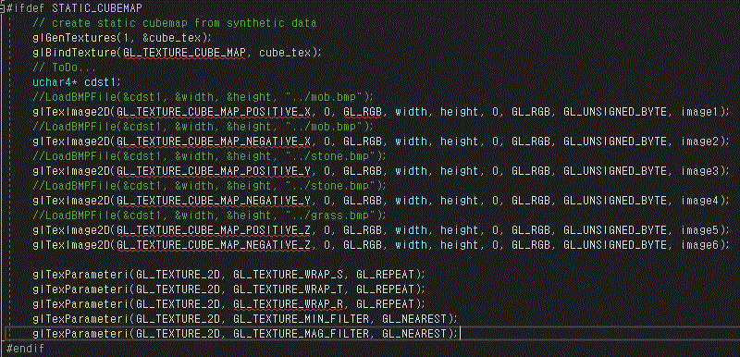



Render_cubemap function.

But

**3. Result**

0. Trackball rotation.

There is a video clip with rotation in the zip which name is ‘1.mp4’.

It moves like a real trackball.

1. 2D texture mapping. : mapping Minecraft character image to simple cube.

Simple cube texture mapping image with trackball rotation.

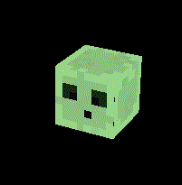

2. Environment mapping using static cube mapping.(Failed)

I success with rotation object only without rotating background.

But I failed to road checkerboard image to background and implementation cube map.

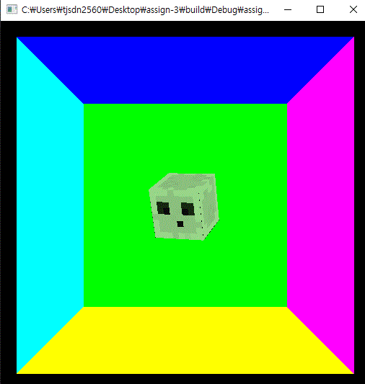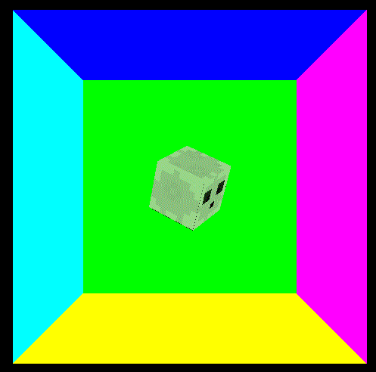

**4. Conclusion**

At this time, I have added the trackball function that has been delayed, but the cube map functions have failed to implement.